

Student name: Agne Eidukiene
Student ID: 2435270

Module name: Introduction to Health and Social Care
Module code: LCH4003_LON
Lecturer name: Mark Kane
Content page

Element 1 ……………………………………………………………. page

Element 2 ……………………………………………………………...page

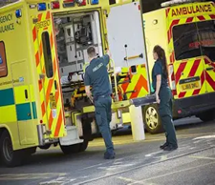
HEALTHCARE SERVICE AMBULANCE IN UNITED KINGDOM
Agne Eidukiene - Introduction to Health and Social Care - 2435270@student.uwtsd.ac.uk

-

Introduction. Ambulance services in the United Kingdom form a critical component of the National Health Service (NHS), providing emergency and urgent medical assistance to individuals experiencing illness or injury. When a 999 call is received, highly trained professionals – such as paramedics and emergency medical technicians – are dispatched to assess the patient, deliver immediate clinical care, and arrange safe transport to an appropriate healthcare facility when required. Ambulance services operate using advanced medical equipment, structured clinical guidelines, and coordinated communication system.
References
Jones, D., Massey, H., Smith, C., Freeman, A. & Jones, E., 2025. Reducing frequent caller use of ambulance services: a review of effective strategies. Journal of Paramedic Practice, 17(4).
Smith, X., et al., 2022. Staff perceptions of patient safety in the NHS ambulance services: an exploratory qualitative study. [online] Available at: https://pubmed.ncbi.nlm.nih.gov/35340577/.
NHS England (2023) Ambulance services. Available at: https://www.england.nhs.uk/ambulance/ (Accessed: 15 November 2025).
Brooker, C. and Waugh, A. (2023) Foundations of Nursing Practise: Fundamentals of Holistic Care. 3rd edn. London: Elsevier.
Blaber, A. and Harris, G. (2019) Clinical Skills for Paramedic Practice. Maidenhead: Open University Press.
Webster, C. (2002) The National Health Service: A Political History. Oxford: Oxford University Press.

Brief history of the Ambulance Service: Before 1948, ambulance services in Britain were run by many different groups such as local councils, charities like St. John Ambulance and the Red Cross, hospitals, and sometimes the police, which meant the service was uneven across the country. In 1948, when the National Health Service (NHS) was created, this changed – the NHS made local authorities responsible for providing ambulances, bringing all the different services together into one national system. From then on, ambulances became free to use, more organized, and began to follow the same standards across the country.
Why Ambulance Services Are Important. Ambulance services are a key part of the community. They make sure people get help in emergencies, no matter where they live. Tey also help people feel safe because they know someone will come if they are in trouble. Ambulance workers are trusted and respected because they save lives are care for people in challenging times. Ambulance services provide rapid medical care at the scene of emergencies, which can make the difference between life and death for peoples. Ambulance teams are available 24 hours 7 days, ensuring that help is always accessible, even in remote or hard-to- reach areas.
People Who Work in the Ambulance service. Many different people work in the Ambulance service. Paramedics give medical help and make fast decisions to save lives. Emergency care assistants help paramedics and drive the ambulance. Call handlers answer 999 calls and decide what kind of help is needed. All these people are well trained and work together as a team to help patients as quickly as possible.
Why Ambulance Services Are Important. Ambulance services are a key part of the community. They make sure people get help in emergencies, no matter where they live. Tey also help people feel safe because they know someone will come if they are in trouble. Ambulance workers are trusted and respected because they save lives are care for people in challenging times. Ambulance services provide rapid medical care at the scene of emergencies, which can make the difference between life and death for peoples. Ambulance teams are available 24 hours 7 days, ensuring that help is always accessible, even in remote or hard-to- reach areas.
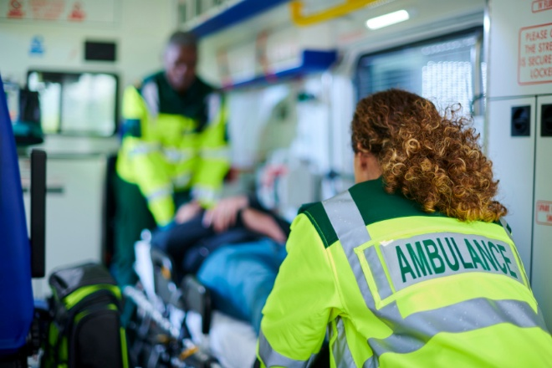
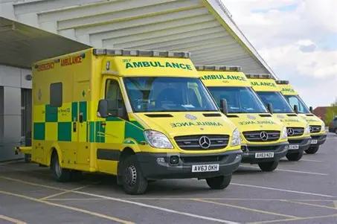
How Ambulance Service Works Today. NHS Ambulance Trust manages Ambulance service. Each part of the UK has its own trust that looks after it’s area. The service helps people in many ways. Main jobs of the Ambulance service include:
- Answering 999 calls when someone needs urgent help.
- Giving first aid and life-saving care before patients reach the hospital.
- Taking people safely to hospitals or care centres.
- Helping people who cannot travel alone to their medical appointments.
- Responding to big emergencies, such as fires, car crashes, or natural disasters.

Ways to Make the Ambulance Service Better. The Ambulance service can be made better with the right support and planning. Some ideas to improve it include:
- Increase staffing level to reduce pressure on ambulance workers and improve response times.
- Add more ambulances and advanced vehicles to meet the growing demand for emergency care.
- Improve communication systems between hospitals, control rooms, and ambulance teams for faster coordination.
- Use modern technology such as digital mapping, and real-time data sharing to reach patients more quickly.
- Support staff wellbeing will better mental health resources and training.
- Raise public awareness about when to call 999 or use other NHS services like 111, to help reduce unnecessary emergency calls.
Problems the Ambulance Service Faces. Even though the Ambulance service does an excellent job, it has some problems that make the work harder. Here are two big challenges they face today:
- **More people needing help. ** The number of calls for Ambulance has gone up a lot. People are living longer and more have health problems. Mental health emergencies are also becoming more common. This means Ambulance workers are busier and waiting times can be longer.
- **Waiting at hospitals. ** Sometimes Ambulances must wait outside hospitals before they can take patients inside. This takes times and stops them from going to new emergencies. These delays can be stressful for staff and worrying for patients.

Conclusion. To sum up, ambulance services are essential for keeping communities safe and healthy. They respond quickly in emergencies, whether someone is suddenly taken ill or injured in an accident. Ambulance team provide first aid, stabilize patients, and ensure they reach the hospital safely. Their quick action often prevents conditions from getting worse and can even save lives.
Ambulance workers are highly trained to handle a wide range of situations at any time of day or night, so help is always available. They also support people who cannot easily reach medical facilities, especially in remote or hard-to-access areas. With reliable vehicles, advanced equipment, and skilled staff, ambulance services ensure that everyone receives the care they need when it matters most.
Knowing that helps is always just a phone call away gives people peace of mind and makes the whole community feel safer. In this way, ambulance services are but also a key part re not only a vital part of emergency response but also a key part of building a caring and secure society.

Agne Eidukiene, 2435270@student.uwtsd.ac.uk, Introduction to Health and Social Care

The Origins and Structure of the National Health Service (NHS)
The National Health Service (NHS) is one of the most important parts of life in the United Kingdom. It was created to make sure that everyone could get healthcare, no matter how much money they had. The NHS began in 1948 and changed the way people in Britain received medical care. Before it was formed, there was no single system for healthcare, and many people could not afford to see a doctor when they were ill.
Before 1948, healthcare in Britain was very unfair. Wealthy people could pay for private doctors, but many working-class families had to rely on charity hospitals or local councils, which often had limited resources. If you were poor or unemployed, you might not get treatment at all. The Second World War made this problem even clearer. Many people were injured or sick, and the war showed how much the country needed a proper health system that could care for everyone.
In 1942, a report called the Beveridge Report was published. It was written by Sir William Beveridge, and it set out ideas for improving life in Britain after the war. The report talks about five main problems that society faced, one of which was “disease”. Beveridge suggested that the government should create a national health service that would be available to all citizens, paid for through taxes and national insurance. His ideas became the foundation for the NHS.
After the war, the Labour government, led by Prime Minister Clement Attlee, decided to put these ideas into action. The person responsible for creating the NHS was Aneurin Bevan, who was the Minister of Health. Bevan wanted a system based on three main principles: it should be available for everyone, free at the point of use, and based on need, not ability to pay. This meant that anyone could see the doctor or go to hospital without worrying about the cost. The NHS officially started on 5 July 1948, bringing together hospitals, doctors, nurses, dentists, and pharmacists under one national system. Although some doctors and politician were against it at first, the NHS soon became very popular and an important part of British life.
Since then, the NHS has changed many times. Today, there are four different NHS systems – one each for England, Scotland, Wales and Northern Ireland. In England, the NHS is managed by different organizations such as NHS England, Integrated Care Boards (ICBs), and local NHS Trusts. The aim is to make sure people get good care close to where they live, and that hospitals and local services work together. Over the years, different governments have tried to make the NHS more efficient, sometimes by bringing in private companies or by focusing on patient choice.
NHS faces many serious challenges today. The population is getting older, which means more people need long-term care. There are also not enough doctors, nurses, and other health workers to meet the growing demand. Funding is another big problem – the NHS often does not have enough money to keep up with modern medical costs. The COVID-19 pandemic made things worse, putting huge pressure on hospitals and staff. Many people are now waiting for long time for appointments, tests, and operations. Some people worry that these problems are damaging the original idea of the NHS – that everyone should get equal and timely care.
In conclusion, the NHS was created after World War II to make everyone could get free and fair healthcare. Its founding principles - being universal, comprehensive, and free at the point of use – still guide it today. Although the NHS is under great pressure, it continues to be a symbol of equality and care for all.
BBC News (2023) How the NHS was born – and what it does today. BBC News. Available at: https://www.bbc.co.uk/news/health-47666294 (Accessed:13 November 2025).
Beveridge, W. (1942) Social Insurance and Allied Services (The Beveridge Report). London: His Majesty’s Stationery Office.
NHS (2024) About the NHS. NHS England. Available at: https://www.nhs.uk/nhs-services/about-the-nhs/ (Accessed:13 November 2025).
Rivett, G. (1998) From Cradle to Grave: Fifty Years of the NHS. London: King’s Fund.
The King’s Fund (2024) Key facts and figures about the NHS. London: The King’s Fund. Available at: https://www.kingsfund.org.uk/ (Accessed: 13 November 2025).
Powell, M. & Williams, I. (2024) ‘What is a ‘National’ ‘Health’ ‘Service’? A keyword analysis of policy documents leading to the formation of the UK NHS’. Health Economics, Policy and Law, 19(3), pp. 323-336.

