
Implementation of hybrid technology (Into Engines) in different motorsport series
Technical Report Writing
Implementation of hybrid technology
(Into Engines) in different motorsport series.

Academic Skills ACHA4005

University of Wales Trinity Saint David
Wales Institute of Science and Art

Charlie Jones
2103718
November 2022

Contents
Introduction 3
What will my investigation be about? 3
What is the importance of hybrid of Hybrid Technology? 3
Aims and objectives 3
Literature Review 5
Discussion 7
References 9

Introduction

What will my investigation be about?

So, for my report I will be investigating the implementation of hybrid technology through internal combustion and through transmission in different motorsport series. And how hybrid technology in motorsport will in the future will change and motorsport in terms of how sustainable the cars and the series can be compared to now.

For example, of Motorsport series that are currently using hybrid technology, the main 3 series that use hybrid technology are Formula 1 and the World Endurance Championship/ IMSA Sportscar Championship, with the Le Mans Hyper cars and Le Mans Daytona h classes.

What is the importance of hybrid of Hybrid Technology?

The importance of Hybrid technology in motorsports in massive because in a way it is the future of a lot of motorsports series if they want to keep using the conventional internal combustion engine and along with the development of carbon neutral and natural organic fuels helping these internal combustion engines run cleaner. And along with the hybrid Technology with electric kinetic motors and sometimes heat motors recovering energy which would have been wasted in a conventional internal combustion engine. From braking and heat from exhaust gases is being converted back into electric and reused with in the engine again and then the cycle repeats

Aims and objectives
So, the aim of this report is to look at how hybrid technology is being implemented into motorsport through power units and gearboxes used in 4 wheeled motorsports series around the world.
What the current state of hybrid technology is like in motorsport.
And what is the future of hybrid technology in motorsport like in Formula 1 in 2026.

And to find out the answers to these aims I will use my personal knowledge, the use of journals from people in the industry. And other information sources with giving all these sources credit if I use anything that they have spoken about the aim I am researching about.

Literature Review

So, in Formula 1, hybrid technology has been around since 2009. With between the 2009 and 2013 season teams and their engine manufacturers had simple compared to now hybrid systems with the system only being a KERS (Kinetic Energy Recovery System). Which collects energy from braking and converts that energy into electric into an energy store. (Scarborough, 2020)

With the engines between 2009 and 2013 being 2.4l V8 natural aspirated with that simple KERS system. which had a peak output of around 850hp and this is with the restrictions of rpm, RPM and lifespan. (Scarborough, 2020)
(www.motorsport.com, 2011)
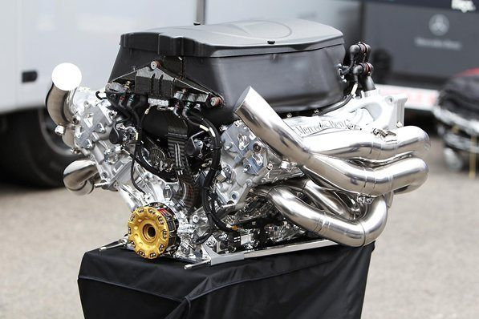

(Figure 1) A photo of a Mercedes FO108Y V8 F1 engine from 2011 (www.motorsport.com, 2011)

But in 2014 F1 and the FIA brought in a completely new generation of Power Unit being the 1.6l V6 turbo hybrid. Which have direct fuel injection into the combustion engine. (Scarborough, 2020)

With these V6 turbo hybrid engines being running at a maximum of 12,000RPM compared to their predecessor which ran at a maximum of 18,000RPM. But with having a more complex and powerful hybrid system which had come on leaps and bound between 2014 to the present.

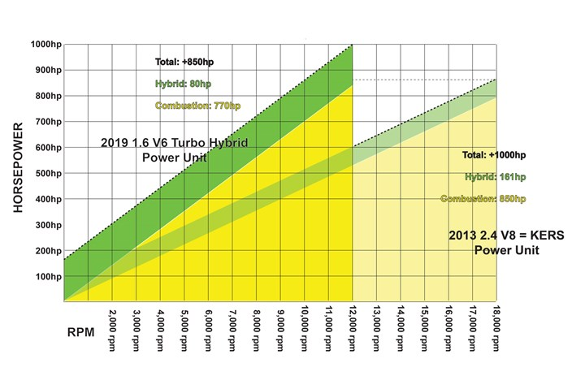
(Figure 2) A graph comparing the V8 to the V6 F1 engines RPM and Horsepower (Scarborough, 2020)

And they have become more complex with the introduction of the MGU-K (Motor Generator Unit – Kinetic) and MGU-H (Motor Generator Unit – Heat).
With the MGU-K doing pretty much the same job as what KERS did for the V8 power unit but the MGU-K recovers it energy from the turbocharger instead.
And when it comes to the MGU-H which wasn’t part of the V8 power unit. This MGU-H is connected to the Turbocharger and solves the problem of the turbo getting any lag (Mitchell, 2022) and drives the turbo at low RPM. As well as harvesting exhaust gases and heat into electrical energy which is stored in the energy store to be deployed when need be.

With for example the pole time at the 2014 Austrian Grand Prix was a 1:08.759 by Felipe Massa (Formula 1.com, 2014) and in 2016 in the same generation of car aerodynamically the pole time was a 1:07.922 (Formula 1.com, 2016) showing how the development of the hybrid engine and how much performance was gained. And if you were to look at the fastest time in 2020 the pole time set by Valtteri Bottas was a time of a 1:02.939. (Formula 1.com, 2020)

And when it comes to the future of the V6 turbo hybrid power unit, they will change in 2026 with the engines becoming more simple and cheaper to build and run as the current power units cost around $10.5 million (Carandbike Team, 2022).

And for the 2016 regulations the MGU-H will go from the power unit which could create issues with turbo lag, but the MGU-K will triple the amount of electrical energy with an increased amount of electrical energy will be recovered through the MGU-K.

Discussion

In this discussion section I will be discussing the implementation of F1’S V6 Turbo Hybrid engine and how it was implemented into the sport, where it is now currently and where this hybrid power unit technology will be going in the future.

And I will be using the work of (Scarborough, 2020), (Kanal, 2022) and (Anderson, 2022) who have looked at all of the life span of the V6 Turbo Hybrid from in the past in 2014 to the present day and also the future of the V6 Turbo Hybrid power unit especially in 2026.

So hybrid technology was implemented into Formula 1 fully back in 2014 with the brand new engine/power regulations at the time which saw the change from naturally aspirated 2.4l V8 engines with a simple KERS system to a for efficient 1.6l V6 Turbo Hybrid with a MGU-K (Motor Generator Unit – Kinetic) and also a MGU-H (Motor Generator Unit – Heat) along with the reintroduction of the turbocharger which works together with the MGU-H to help prevent turbo lag at low rpm and harvest heat into electricity from the exhaust as I’ve already said before.

And between back in 2014 to the current season just gone in 2022 there has been much improvement of these power units with increased amount of performance from all parts of the power unit. Helping teams being able to run the engine in higher deployment modes through the energy store and MGU-K. and can run the ICE (Internal Combustion Engine) in a richer setting to produce more combustion at the expense of burning less fuel meaning they can run these richer settings longer.

Also, since 2014 these V6 turbo hybrids have become more efficient without losing any performance. For example, the fast race lap set during the 2013 Belgian Grand Prix at Spa-Francorchamps (Kanal, 2019) (The longest circuit of the F1 calendar at a total circuit length of 7.004km (4.352 miles)).

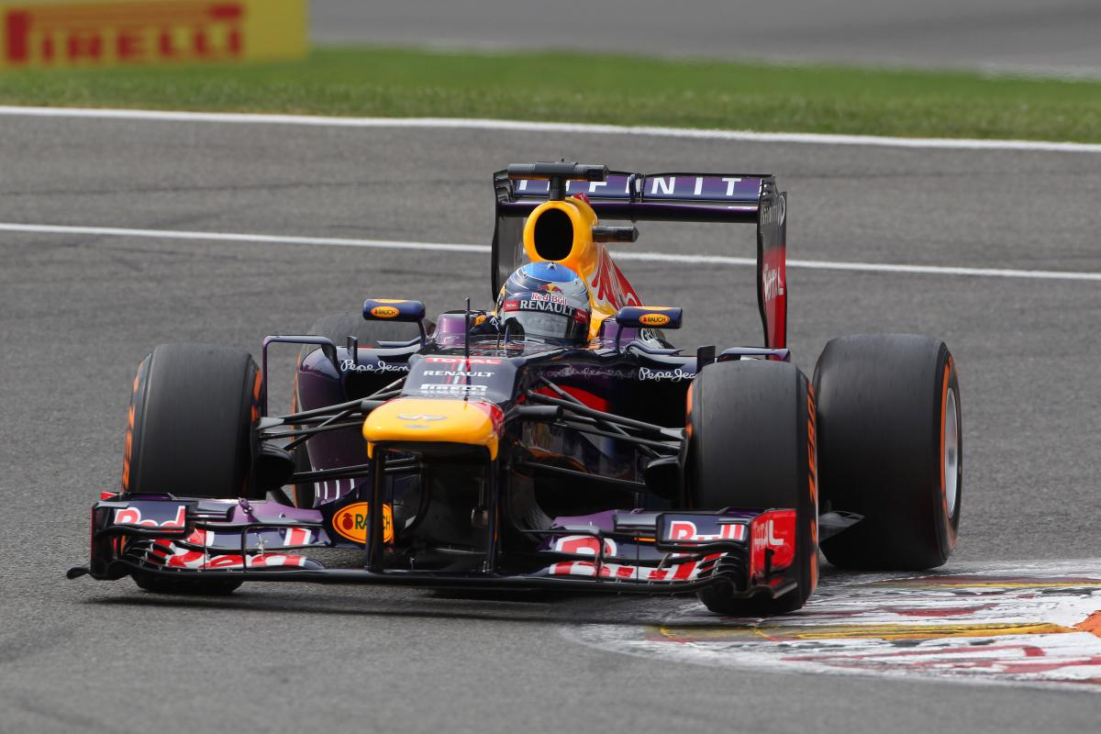
With Vettel’s fastest time during the Grand Prix was a 1:50.756 with him having approximately 135Kg of fuel. (Kanal, 2019). And then during the 2019 Belgian Grand Prix set the fastest lap during that Grand Prix was of a time of a 1:46.409 with him having 100kg of fuel over the course of the race (in a heavier car) (Kanal, 2019). Showing how much the efficiency of these V6 power units compared to the V8 power unit used in 2013 with the V6 power unit using 35Kg less of race fuel over the same amount of distance of the 44 lap (191.415 miles) Belgian Grand Prix.
(Figure 3) Sebastian Vettel during the 2013 Formula 1 Belgian Grand Prix (Llewellyn, 2013)

And as well as there being a massive improvement on thermal efficiency and CO2 emissions with the V6 power unit now having 20% more power compared the V8 power unit but produces 26% less CO2 emissions in the process (Kanal, 2019). And when it comes to the thermal efficiency the V8 power unit at the end of that era were a total of 29% thermal efficient.

But when F1 made the swap to V6 power units this thermal efficiency jumped up straight away to 40%. And over time with continuous improvement to the power unit the efficiency as of 2019 went up to 50% (Kanal, 2019) but the massive improvement won’t continue at the same rate as currently there is a development freeze of performance until the new concept and regulations of engines come in, in 2026.

And talking of the future of the V6 Turbo Hybrid in 2026 Formula 1 will see changes to the V6 power unit with the removal of the MGU-H. and these changes has seen car manufacturers like Audi and potentially Porsche coming into the sport as engine manufacturers and in terms of Audi also becoming a factory team joining forces with the Sauber team from the 2026 season onwards.

With these new regulations for 2026 will see the new V6 power units will run of fully sustainable fuels with absolutely no use of any fossil fuels from 2026 onwards (Kanal, 2022). With the fully sustainable fuel carbon will instead come from sources such as non-food source, general municipal waste and potentially out of the atmosphere as well. (Kanal, 2022)

Another area of the power unit that will change is in the electrical hybrid area with the MGU-H will go and the MGU-K will now produce 3 times as much electrical power more than what the currently electrical hybrid comments in the current power units. (Kanal, 2022). And this is through more braking energy that would have been wasted before. Can and will be collected through the MGU-K and will now deployed up to around 350kW compared to what it is now currently in 2022 which is around 120kW through both an MGU-H and MGU-K. (Kanal, 2022)

Along with these changes to both the electrical recovery and deployment and the use of sustainable fuels. And staying on the topic of fuel these new 2026 engines are hoped by F1 to only use around 70kg of fuel during a race. Which is dramatically less to what is currently used now in 2022 of around 100kg and to the extortionate amount of 160kg back in 2013 during the V8 era of power unit for the race. (Kanal, 2022)

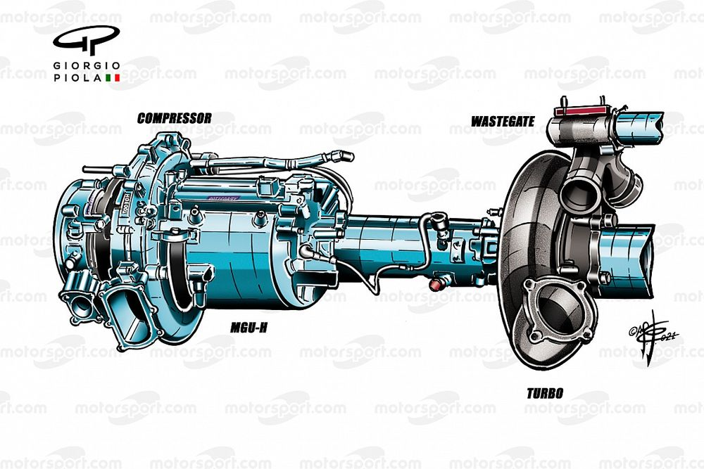
(Figure 4) A picture showing what the 2022 power unit looks like between the turbocharger and MGU-H (Piola, 2021)

And even though there is a reduction in the amount of race fuel these new power units will still produce 1,000+ horsepower around a weekend from qualifying to the race.

And even though there is a dramatic increasing in the use of electrical energy these new V6 power units will be even safer with the MGU-K being more enclosed and secure within the chassis right next to the battery (energy store) and control electronics. With all 3 of these high voltage devices and equipment being now contained within the safety cell which makes the safer all together. (Kanal, 2022)

Conclusion
Finish off the report with a well written section that shows your understanding and highlights the key findings from your investigation

This report and investigation have been conducted to look at the implementation of hybrid technology in motorsport series. And through research from creditable sources which have been referenced can see the use of hybrid technology in motorsports is growing and growing. And improves to this hybrid technology is constantly being done in both areas of performance and reliability and safety.

With the current power unit in Formula 1 can be used as an example with the performance and reliability of the power units now is incredible compared to previous years with teams now being able to complete 22 races in a season on 4 power units running very high-power modes. And if you compare it back to the start of this era in 2014 and even previous power unit era the reliability is incredibly better. With previous year teams would go through like 6-8 engines per season of around 15-16 races.

And the future of power units is looking even more promising with the example of what is happening in 2026 in Formula 1 with their new version and regulations with massive changes to the hybrid side of the power unit with the removal of the MGU-H and increase in performance and deployment of recovered electrical power from the MGU-K, with many more changes also. (Kanal, 2022)

And development of these new 2026 power unit is taking place now as the development of the current version of the power unit is frozen in terms of performance but not in terms of reliability. Where teams can make those reliability improvements to the power units to find more performance in a different way.

References
Anderson, B., 2022. 2026 F1 ENGINE RULES APPROVAL CLEARS WAY FOR PORSCHE AND AUDI. [Online]
Available at: https://the-race.com/formula-1/2026-f1-engines-rules-approval-clears-way-for-porsche-and-audi/
Carandbike Team, 2022. F1 Car Price | What Is The Cost Of Formula 1 Cars?. [Online]
Available at: https://www.carandbike.com/news/f1-car-price-what-is-the-cost-of-formula-1-cars-2747700
Formula 1.com, 2014. FORMULA 1 GROSSER PREIS VON ÖSTERREICH 2014 - QUALIFYING. [Online]
Available at: https://www.formula1.com/en/results.html/2014/races/905/austria/qualifying.html
Formula 1.com, 2016. FORMULA 1 GROSSER PREIS VON ÖSTERREICH 2016 - QUALIFYING. [Online]
Available at: https://www.formula1.com/en/results.html/2016/races/945/austria/qualifying.html
Formula 1.com, 2020. FORMULA 1 ROLEX GROSSER PREIS VON ÖSTERREICH 2020 - QUALIFYING. [Online]
Available at: https://www.formula1.com/en/results.html/2020/races/1045/austria/qualifying.html
Kanal, S., 2019. How F1 technology has supercharged the world. [Online]
Available at: https://www.formula1.com/en/latest/article.how-f1-technology-has-supercharged-the-world.6Gtk3hBxGyUGbNH0q8vDQK.html
Kanal, S., 2022. More efficient, less fuel, and carbon net zero – 7 things you need to know about the 2026 F1 engine regulations. [Online]
Available at: https://www.formula1.com/en/latest/article.more-efficient-less-fuel-and-carbon-net-zero-7-things-you-need-to-know-about.ZhtzvU3cPCv8QO7jtFxQR.html
Llewellyn, C., 2013. Belgian GP: Race results. [Online]
Available at: https://cdn.crash.net/styles/amp_1200/s3/hires/1394792.jpg?itok=fTWam_ta
Mitchell, S., 2022. Tech Explained: Formula 1 MGU-H. [Online]
Available at: https://www.racecar-engineering.com/articles/tech-explained-formula-1-mgu-h/
Piola, G., 2021. The opportunities and headaches of F1’s 2026 engine plans. [Online]
Available at: https://cdn-1.motorsport.com/images/mgl/6gpWVwx0/s1200/mercedes-compressor-and-turbo--1.webp
Scarborough, C., 2020. Hybrid F1 power: how does it work?. [Online]
Available at: https://www.carmagazine.co.uk/hybrid/how-f1-engine-works/
Scarborough, C., 2020. Hybrid F1 power: how does it work? Image. [Online]
Available at: https://car-images.bauersecure.com/wp-images/3926/720x0/hybridf1_07.jpg?scale=down
www.motorsport.com, 2011. Mercedes Feature - Accelerated Development with Petronas. [Online]
Available at: https://cdn-1.motorsport.com/static/img/amp/400000/410000/412000/412700/412773/s6_35003/f1-hungarian-gp-2011-mercedes-engine-during-nico-rosberg-mercedes-gp-f1-team-100th-race-ph.webp

