Module:

Material science and building services (ACBA 4006)

Prepared for:

Allan Nantel

Created by:
Jake Roberts

Table of Contents
Introduction 2
Burj Khalifa Construction History and Engineering 3
Willis (sears) Tower construction history and Engineering 4
conclusion comparisons…………………………………………….5

Introduction

This is a technical report in which I will cover the history of two different buildings from around the world. I have picked the Burj Khalifa in Dubai for my concrete structure and I have picked the Willis (sears) Tower in Chicago for my steel structure. During the report I will invidually go through the design, construction method and the potential impact on social and the environment. i will also write a conclusion contrasting the two against each other.

2.0 Burj Khalifa Construction History and Engineering
2.1 Introduction to the Burj Khalifa

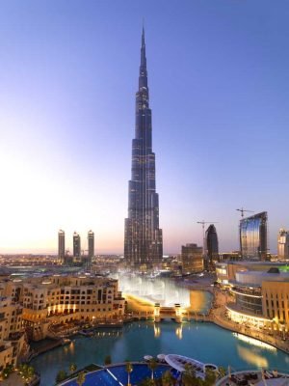
(E-architect, photos courtesy Emaar, 2020)

The Burj Khalifa is located on Sheikh Mohammed Bin Rashid Boulevard, Burj Khalifa street, Dubai, United Arab Emirates. The Burj Khalifa is the tallest free-standing structure in the world. The final height of the Burj Khalifa tally’s up to an impressive 828 meters (2,717 feet). The 280,000m2 (3,000,000ft) reinforced concrete multi-use structure. Is used for full residential apartments, commercial offices and a hotel. Along with being an impressive tourist attraction. The excavation works started on the 4th of January 2004.The structure was open to the public on the 4Th of January 2010 and since then the Burj has had over 20 million Visitors. (ref here)
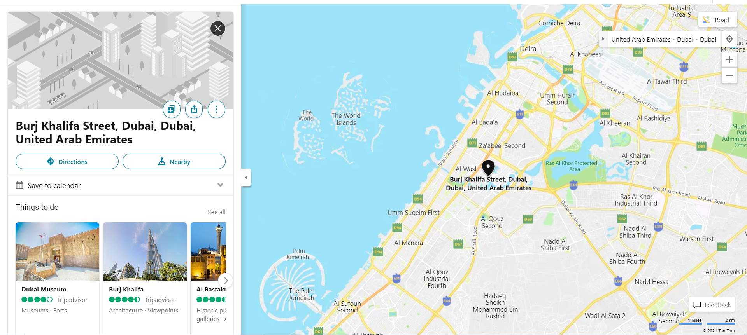
(Google Maps,2021)
2.2 Foundation and site conditions

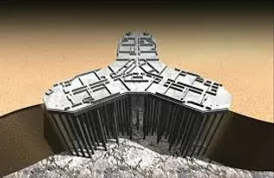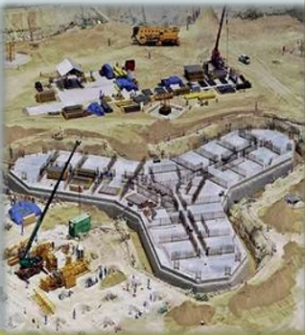
Crouthamel, Nunes and Coffey, 2015)

The foundation and shape of the Burj Khalifa was designed in Y shape using structural concrete, it was formed in this shape to reduce the wind resistance at the higher levels. The structure system is also presenting a natural buttress with a 6-sided central core. the Burj Khalifa’s Y shape corridors are formed using a high-performance concrete, these corridors are utilised for observations, businesses and Residential use (Crouthamel, Nunes and Coffey, 2015).

The Ground investigation for the site was phased. The sequence in which it was phased goes as followed; Phase I; 23 Boreholes (three with pressure meter testing) with depths up to 90m, Phase 2: 3 Boreholes drilled with cross-hole geophysics., Phase 3: 6 Boreholes (two with pressure meter testing) with depths up to 60m, 4: 1 Borehole with cross-hole and down-hole gophysics; depth = 140m. following these investigation boreholes of the ground conditions a detailed 3D foundation settlement analysis was carried out due to the geotechnical investigation and the pile load test. It was determined the maximum long-term settlement over time would be about a maximum of 80mm (3.1"). This settlement would be a gradual curvature of the top of grade over the entire large site. (Jamal, 2017)

Following the site investigation, it showed that the groundwater in which the substructure of the Burj was constructed in had high levels of chloride concentrations with up to 4.5% and sulphates of up to 0.6%. the concentration of sulphate and chloride showed more than the concentrates shown in sea water. When forming the piles and raft foundation the engineers had to take these concentrates in to consideration. “The concrete mix for the piles was a 60 MPa mix based on a triple blend with 25% fly ash, 7% silica fume, and a water to cement ratio of 0.32. The concrete was also designed as a fully self-consolidating concrete, incorporating a viscosity modifying admixture with a slump flow of 675 +/- 75mm to limit the possibility of defects during construction Due to the aggressive conditions present caused by the extremely corrosive ground water, a rigorous program of anti-corrosion measures was required to ensure the durability of the foundations. Measures implemented included specialized waterproofing systems, increased concrete cover, the addition of corrosion inhibitors to the concrete mix. stringent crack control design criteria, and cathodic protection system utilizing titanium mesh with an impressed current.” (Jamal, 2017)

The Foundations for the Burj consist of a pile supported raft foundation. The raft sits upon 194 bored cast piles. The piles are 1.5 metre in diameter and 43 meters long with a load capacity of 3,000s per pile. “The solid reinforced concrete raft is 3.7 meters (12 ft) thick and was poured utilizing C50 (cube strength) self-consolidating concrete (SCC). The raft was constructed in four (4) separate pours (three wings and the center core). Each raft pour occurred over at least a 24-hour period. Reinforcement was typically at 300mm spacing in the raft, and arranged such that every 10lh bar in each direction was omitted, resulting in a series of "pour enhancement strips" throughout the raft at which 600 mm x 600 mm openings at regular intervals facilitated access and concrete placement.” (Jamal, 2017) all concrete mixtures were sourced using local aggregates making it suitable for the ground and environmental conditions of both the humidity and water conditions.

. 2.3 Superstructure

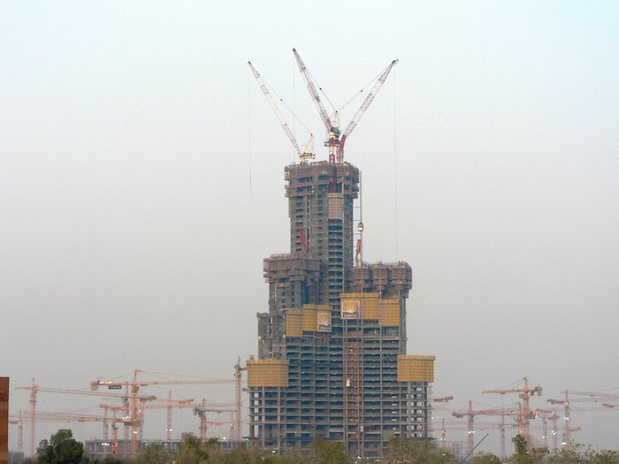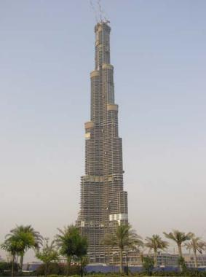
(Jamal,2017)
The superstructure of the Burj is mainly formed in a centre hexagonal reinforced concrete core wall. The concrete core walls are connected to the outside steel and pillars of concrete by concrete and steel’s panels of s series over conceptual level. “The core varies from 1400mm to 600mm in thickness. These walls are linked by a series of 900mm to 1200mm deep concrete link beams at each point” (Mathur and Ilango, 2020, p.p 1411). The concrete and linking of each pillar and beam. Provides the torsional resistance of the structure the centre hexagonal walls are buttressed by the wing walls and hammer head walls which behave as the webs and flanges of a beam to resist the wind shears and moments.
Outriggers at the mechanical floors allow the columns to participate in the lateral load resistance of the structure; hence, all of the vertical concrete is utilized to support both gravity and lateral loads. The wall concrete specified strengths ranged from C80 to C60 cube strength and utilized Portland cement and fly ash (Jamal, 2017). The concrete that was used for the Burj was pumped using Cranes. The suitability of the concrete is normally governed by the ability to pump the concrete. The material may not be viable if large quantities need to be placed by crane. This method has the potential to delay other works and also have a knock-on effect with the casting and production rates. The Burj produced the world record height for pumping of 601 meters during the final part of the core wall I November 2007. (Alred, 2010). Local aggregates were utilized for the concrete mix design. The C80 concrete for the lower portion of the structure had a specified Young's Elastic Modulus of 43,800 N/mm2 (6,350ksi) at 90 days. The wall and column sizes were optimized using virtual work.' La Grange multiplier methodology which results in a very efficient structure. The reinforced concrete structure was designed in accordance with the requirements of ACI 318-02 Building Code Requirements for Structural Concrete. (Jamal, 2017)The fine-aggregate percentage for tower mixes was approximately 50% and fly ash was used at a replacement level of 13–20% together with silica fume at 5–10%. A specially modified superplasticiser was developed for the project by BASF to achieve greater workability retention with early strength development (Alred, 2010)

3.0 Willis (sears) Tower construction history and Engineering
3.1 Introduction to Willis tower
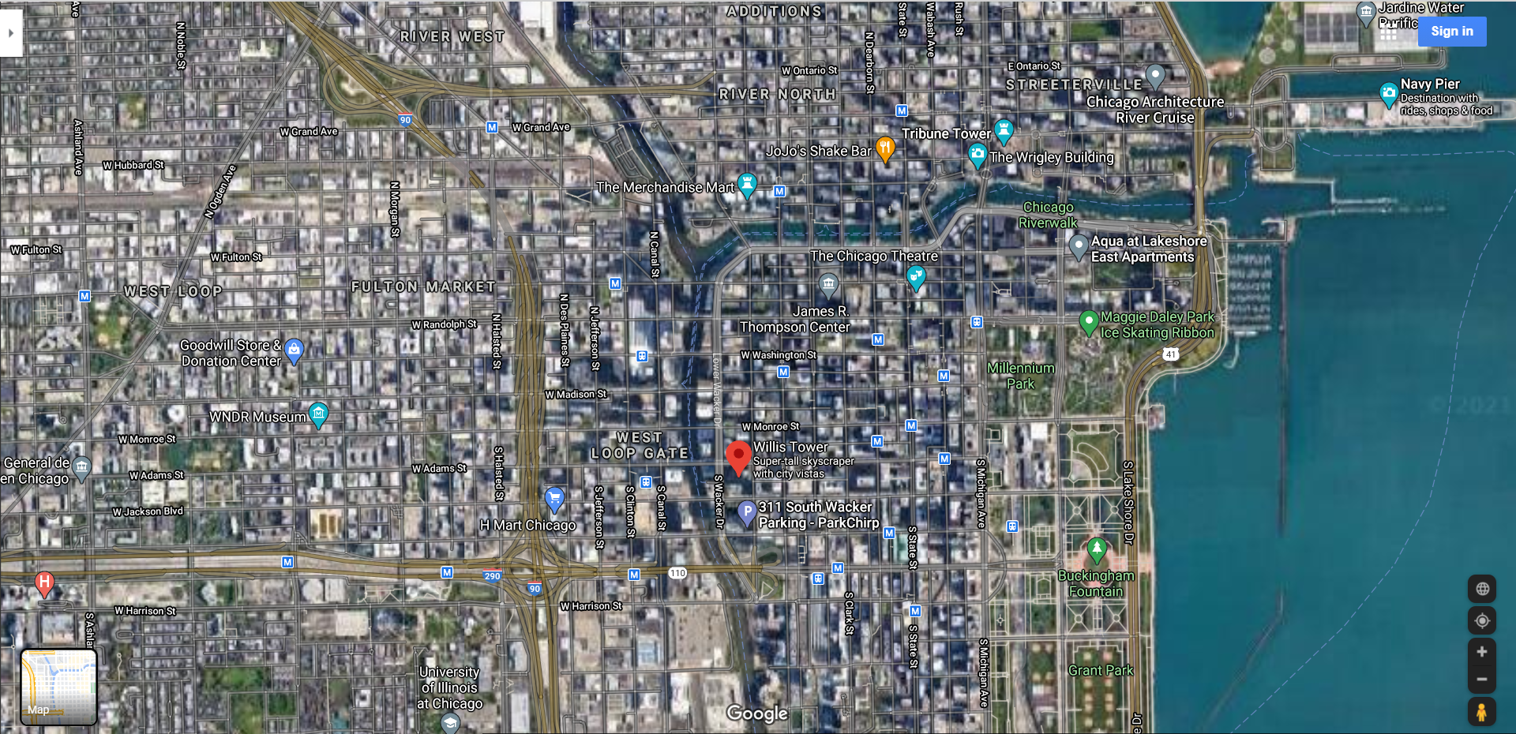

The Willis Tower is located in central Chicago in the state Illinois. Situated near the bank of lake Michigan. Chicago is famed for its architecture, in particular its modern skyline featuring famous skyscrapers. The Willis Tower (formerly known as Sears Tower) is a steel framed, 110 story building and the 2nd tallest building in the Western Hemisphere (Willistower.com, 2021). The construction for the tower started in 1970 and took an impressive 3 years to complete the construction. The tower was designed by Skidmore, Owings and Merrill, the same designers as the Burj Khalifa. Over 2000 workers constructed the Willis tower this would have supplied jobs for local tradesman in the early 1970s. The famous tourist attraction called the sky deck was opened in 1974 and attracts over 1.7 million visitors annually. The Willis Tower is currently owned by Blackstone, the tower is home to more than 100 businesses including law, insurance, transportation, financial companies and more (Willistower.com, 2021).
3.2 Structure and site conditions
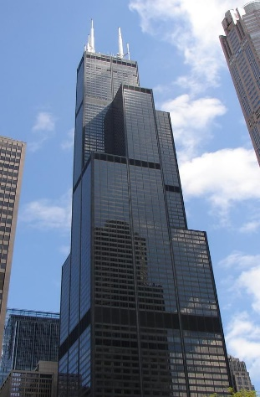
(Google,2021)

The Willis towers structural frame work is dominated by steel. The frame was assembled and bolted together on site. The glass curtain wall the external shell of the building consists of a black aluminium and bronze tinted glass. This serves as a insulator between the internal and external shell. This allows the structure to maintain a consistent temperature. This will in time limited the contraction and expansion of the steel frame. (Willis Tower (formerly Sears Tower) – Structural Engineering, 2021)

The Willis Tower structural system is formed from the bundled tube affect this gives the tower strength from Chicago’s famous conditions and the consistent pressures from the wind. The tubular system consists of “9 squares, each 75 feet across, placed in a three-by-three grid arrangement. Each square has 5 columns per side spaced 15 feet on centres, with adjacent squares sharing columns.” ( (Khan, 2011)
The nine structural bunded tubes are linked together by a reinforced concrete mat. You can see how the tubes rise at finish up the levels of the building. As the rise up the building at each certain height. The tubes on there own add strength to the structure. But the fact they are linked together through a truss system. Makes them stronger again. This resists the environmental strengths and prevents horizontal torsion and tension. Please see the image below showing the tubular system of the building.

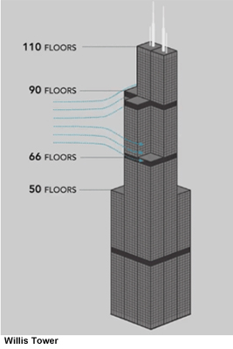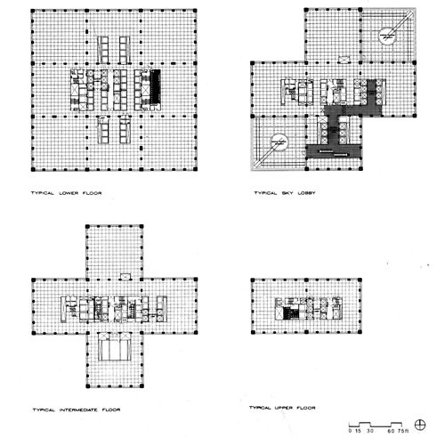
(Anon., 2021)

4.0 The Advantages and dis advantages for using concrete and steel

4.1 The advantages and dis advantages of concrete in construction.

Concrete is a material that is normally mixed together by two different materials to create a solid structural product. The most common lead materials for binding concrete are cement and lime. Cement and lime are normally mixed with aggregates to form the finished product. The most common aggregates used in concrete mixtures are sand, brick chips, stone chips, gravels, and shells. Most aggregates for projects are normally sourced by local quarry’s where available. This is best for the local environmental conditions. Concrete is a great way of constructing certain projects, as concrete can be moulded into many different shapes and if sourced locally can be inexpensive way of constructing due to importing the material. This will also shorten lead times during construction. Reinforced steel is normally added to the concrete to bind the components together making it more solid adding to the durability and sustainability of the concrete. Concrete can also be easily repaired if any damage over time appears. This can be done by spraying more material or adding additional resins to the re bind damaged areas. Concrete also gives a good thermal mass this is where it can absorb the heat during the day and release it through the night and in colder conditions. Concrete is also porous which gives it sustainability for extreme environments, this also helps with the moulding of the concrete. On the flip side concrete can expand and contract in high temperatures this is how vertical and horizontal cracks can appear over time. Concrete can also be pre casted off site and then put into place on site. The over option of application is to pump concrete on site this is an easy way of spraying and adding the mixture. This is normally the option when pouring in situ on high rise buildings such as the Burj Khalifa. The main issue with pumping the concrete on high rise buildings is the pumpability at height. This will generally be done using cranes this can have affects on other works and also cause lead times between pours. Water and freezing conditions can also create a defect and lead to cracking. Concrete can also react bad with other materials such as sulphates if the concrete is not protected. Concrete production is also bad for the environment due to the amount of carbon dioxide (co2) that is produced in the mixing of the cement and aggregate along with the machinery used to pump and transport the material. Concrete cant also be poured at a certain height due to not being able to pump at a certain height, steal in this instant is a better option for building at certain heights. Concrete also forms great fire resistance and does not need any sort of further protection against fire. Concrete has to be poured/pumped in dry conditions as if the mix is to wet the water will affect the shear strength this will also allow cracking and voids to appear when contracting and extracting. (Greenspec, 2021) (Sharma, 2017)

4.2 The advantages and dis advantages of steel in construction.

Steel is a very commonly used material in construction. It is normally used for different ranges of construction they can verity from new build dwellings, commercial build and sky scrapers as many other forms of construction. Steel is normally formed off site and is formed under extreme heat. Then transported to site, where the steel infrastructure is normally formed and bolted together. There can be more steel put into place to give steel frame work structural strength. Steel is a great product for construction for many reasons. The speed in which steel can be erected is a quicker process than using other materials such as concrete. You can erect steel in any conditions all year round regardless of the weather conditions. Steel can be one of the cheaper materials when reviewing projects. The material is also of lighter weight than concrete. Structural steel sustainability is great, steel can be recycled and used in other compacity’s this reduces the production process. Which in time reduces carbon emissions. Steel can be modifiable when in construction and post construction which is great for the clients and business needs. other materials like concrete are a lot harder to adapt. There are many dis advantages of using steel. Steel doesn’t have as good fire rating and generally either has to be intumescent painted or have fire prove cladding systems to protect the beams. This is a more expensive than using concrete. Steel has a higher maintenance rate than what concrete has this can be down to wear and tear, environmental conditions and chemical reactions with other substances with other materials which in all jeopardises the structural integrity of the steel. Unlike concrete steel is normally imported in from not local sources, there for you may have shortages. Steel also can be buckled under extreme stress from conditions and loadings. (Advantages of Steel - Midwest Steel, INC, 2021) (Disadvantages of steel structures | Demerits of steel construction | Civil Engineering Terms, 2021)

5.0 Conclusion

When looking into the designs and structural elements of both The Burj Khalifa and the Willis tower, along with the personal opinions of other professionals and factual information. Concrete is the better option for the deserts of Dubai due to local resourcing of aggregates and the climatic environment. concrete has great thermal mass for reflecting the high temperatures during the day. This also gives greater fire protection to the building than what steel would. When doing the site investigating there showed to be certain chemicals that re act with steel. Along with being next to the sea. This would create corrosion and high maintenance issues going forward. When studying the windy city of Chicago, the steel was the better option due to the extreme wind conditions and soring temperatures in the winter the way the Willis tower is a constructed allows the ability for storing energy using its frame work and glazed windows. But also, at the same time giving it climatic resistance with the dynamic way in which the structural tube system was constructed. Whilst keeping the co2 emissions down in a busy city full of other sky scrapers, due to the material being produced away from site.

6.0 Reference list

- Aldred, J., 2010. Burj Khalifa – a new high for high-performance concrete. Proceedings of the Institution of Civil Engineers - Civil Engineering, 163(2), pp.66-73.

- Civilengineeringterms.com. 2021. Disadvantages of steel structures | Demerits of steel construction | Civil Engineering Terms. [online] Available at: <https://www.civilengineeringterms.com/steel-structures/disadvantages-of-steel-structures-demerits-of-steel-construction/> [Accessed 1 March 2021].

- Constructioncitizen.com. 2021. [online] Available at: <https://constructioncitizen.com/sites/constructioncitizen.com/files/blog_attachments/willis-tower.jpg> [Accessed 1 March 2021]

- Crouthamel, A., Nunes, A. and Coffey, S., 2015. Burj Khalifa The Architecture. [online] Alexcrouthamel.wixsite.com. Available at: <https://alexcrouthamel.wixsite.com/burj-khalifa/architecture> [Accessed 1 March 2021].

- Green spec. 2021. concrete and sustainability. [online] Available at: <https://www.greenspec.co.uk/building-design/concrete-and-sustainability/> [Accessed 1 March 2021].

- Jamal, H., 2017. Design, Construction and Structural Details of Burj al Khalifa | Tallest Skyscraper Engineering Construction. [online] Aboutcivil.org. Available at: <https://www.aboutcivil.org/burj-khalifa-design-construction-structural-details.html> [Accessed 20 February 2021].

- Khan, F., 2011. Sears Tower - Fazlur Khan - Structural Artist of Urban Building Forms. [online] Khan.princeton.edu. Available at: <http://khan.princeton.edu/khanSears.html> [Accessed 1 March 2021].

- Mathur, V. and Ilango, S., 2020. Validating the Structural Behaviour and Response of Burj Khalifa: Analysis of the Full Scale Structural Health Monitoring Programs. Journal of Critical Reviews, [online] 7(10), pp.1409-1414. Available at: <http://www.jcreview.com/fulltext/197-1596625011.pdf?1614079849> [Accessed 1 March 2021].

- Sharma, S., 2017. ADVANTAGES AND DISADVANTAGES OF CONCRETE. [online] Civilengineering subject Tutorial. Available at: <https://civilengineering.blog/2017/09/12/advantages-and-disadvantages-of-concrete/> [Accessed 1 March 2021].

- SOM. 2021. Willis Tower (formerly Sears Tower) – Structural Engineering. [online] Available at: <https://www.som.com/projects/willis_tower_formerly_sears_tower__structural_engineering> [Accessed 1 March 2021].

- Willistower.com. 2021. History & Facts - Willis Tower. [online] Available at: <https://www.willistower.com/history-and-facts> [Accessed 23 February 2021].

