

University of Wales Trinity Saint David

Report on Entrepreneurship

Student: Nadya Markova
Student ID: 1919251
BA Business Management

Module: Entrepreneurship
Module Code: LCBB5001
Module Lecturer: Dr.Doreen Nyaa Amundam

Contents
Introduction 3
Part 1 - Warren Buffett 3
Part 2 – Business Plan 4
2.1 Exclusive summery 4
2.2 Motivation and Mission 5
3. Market Audit 6
3.1 Competitor analysis 6
References 7

Introduction

The aim of this report is to evaluate and understand the potential treats and basic skills which a successful entrepreneurial needs to adopt and therefore to build a profitable business. As an example has been given one of the greatest investors and top world entrepreneur – Warren Buffett. Part one of this report will be focused on the reasons and skills which enable Buffett to build such a successful business enterprise. Second part of the report is dedicated to a creation of a business plan with implementation of the main components and under the current COVID-19 circumstances.

Part 1 - Warren Buffett

Warrant Buffet is American investor and he is also the CEO and chairman of Berkshire Hathaway Company. The business operates in insurances and investment filed and now has more than 80 business lines (Buffett, W E, 2021). Otuteye, E. & Siddiquee, M. (2019) emphasise that beside the fact that there is authors who consider Buffett’s success to the simple luck, certainly there is more than that and this belongs to the personal skills and behaviour. Both stress the fact that without any doubt Buffett is one of the “well-known value investors” which initially was established by Benjamin Graham. However, Warren Buffet success has also been influence not only by the using an investment strategy but also of his behavioural and personal skills like his ability to be patience, persistence in what you do, as well as organizational skills and one of most important by Buffett is to not be overconfident and overestimate yourself. Furthermore, Otuteye and Siddiquee emphasize the effect of his well-developed reputation within the filed.
By implementing the Graham’s Value investing method, Buffet wants to shows how vital for the market investors’ physiological element is. Moreover, this reflects as well on the investment decision making. Another important principle which can be identify in Buffett’s method is using of “margin of safety” which he represents in one of his letters to his stakeholders as “wide moat” (Buffett, 2007, p.6) in order to keep or maintain competitiveness within the market.
As a conclusion, Warren Buffets’ performance has been mainly underlined by the low-risk and value investments, low – cost products, but at the same time with high quality, which means products which have high profitability, with expectation to grow and develop as well as strong market value.
Warrant Buffets’ strategy does not make a huge difference with others investors approach and type of methods they use. However, most of the academic and financial circles deny his way of doing business with investments. Himself, on other hand, also dismiss and argue the current social and economic systems which are been present by the academic studies. However, it is indisputable the fact that he becomes one of the most successful entrepreneur and business leader in the last century and also put him in the top 10 of the richest man in the world, stated by Forbes.

Part 2 – Business Plan

2.1 Exclusive summery

The last year has been very challenging for many organizations and business across the world. Covid – 19 left its mark not only demographically, but also it hit economically on local, national, and international level. Business had to pre-orientate and adopt new strategies, take fast and effective decisions in order to stay sustainable and within the target market. Thus, majority of the organizations moved their product fully online and include services as their main source of delivery the physical products still to their customers. On other hand the already established as service companies faced an extreme demand hence the service orientated organizations needed support from transport and logistic companies in order to meet expectations and to still deliver products to the final consumer. This report will give a detailed business plan of one of the transport companies operating in United Kingdom as a subcontractor logistic company names Kally and Stef LTD. Kally. and Stef LTD has been established in April 2020 as a solo business, more specifically as transport company which operates as a subcontractor and performs delivery services form other logistic companies.

2.2 Motivation and Mission

Covid – 19 did not pass the logistic industry and it was one the most affected areas where economically was hit by the negative outcome of the pandemic. Figure 1 shows the levels of growth in that filed, which are the lowest for last 2020 and since 2015.
Figure 1
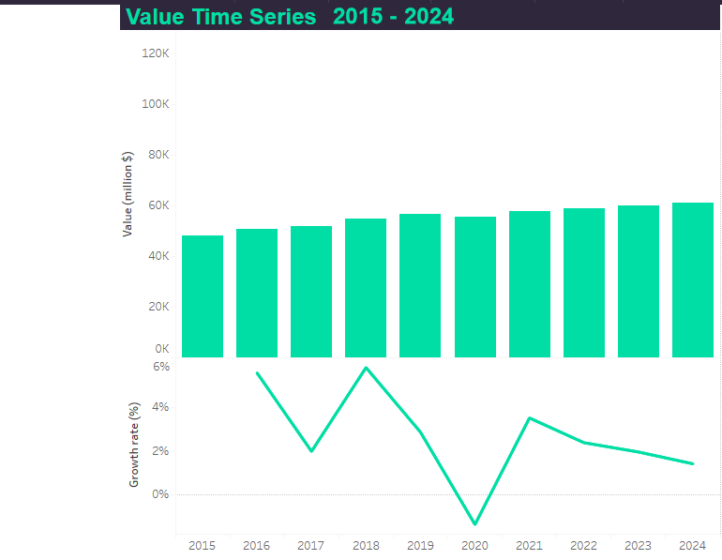
Source: MarketLine

Logistics faced unpredicted challenges during the year of Covid in term of two aspects: to keep and maintain the expected services levels and be able to handle the high demand of deliveries after. And to be able to manage the lack of staff, with the longstanding problem of shortages on drivers, which became even higher during the covid due to sickness and self-isolating. According to
Financial times, over 70% of the logistics companies are struggling for labour and The Guardian highlight that due to Covid-19 there is a loss of 100,000 lorry drivers. As a business which was establish in the heart of pandemic, Kally and Steff transport has been facing these challenges and experiences the losses in the business due to the same reasons mentioned above. One of the main motivations to start this kind of business is to help the transport filed with encouraging more people to start and become drivers as well as to motivate those once who already are to feel and understand the importance of their position and to feel appreciated. By experiencing the same frustrations, Kally and Steff LTD has seen motivated to change this and to win the trust of the drivers. Knowing the complexity of the driver job, the company will introduce a plan called “Trust “which has the purpose to encourage and at the same time to support lorry drivers.

3. Market Audit

3.1 Competitor analysis

In order to keep the business idea on the top and understand our place within the field, a competitor analysis has been conducted. Two of the main competitors of the company has been examine: Cross Transport LTD and Niki LTD both operating in the same subcontractor fields.
Table 2 - Competitor analysis

3.2 SWOT Analysis

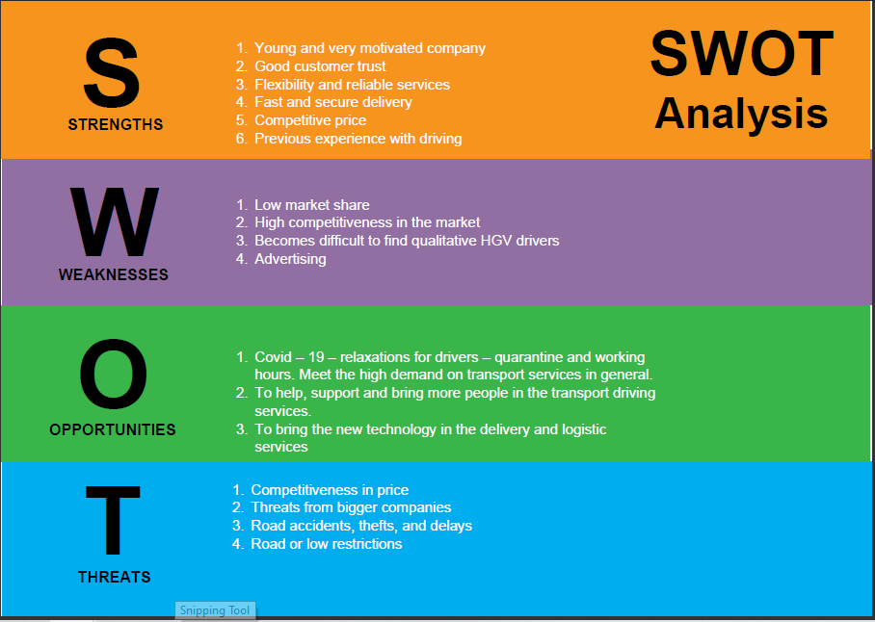
Strengths – the company is fairly new in the Market; it is a very motivated to achieve its goals and to become a leader in Subcontracting services. For a year of carrying out transport activities to and for other businesses the company manage to win its customers trust and has become a reliable partner in the challenging times of pandemic. It brings fats and secure delivery of goods on competitive price. Also, the owner is also a driver and is a huge example of no banders in between employee and employer.
Weaknesses – low market share with high competitiveness in the market. It requires better advertising and marketing plan in order to bring the services to the wider range of companies.
Opportunities – due to Covid – 19 and vas majority companies transfer into on-line shops and the high demand of delivery goods, foods and essential products to people and organizations, evaluate the huge value of HGV driver as key workers, hence the relaxation rules since last July which help the business to conduct its services. Technologies became a vital tool in term of security and visibility for that kind of business and give its customer piece of mind for their loads.
Threats – the low market entry and respectively the competitive prices. Also, the large and well-developed worldwide transport companies pose a threat to middle and low service providers. Another type of threats is that the logistics depends on the road conditions and drivers experiences and the business most common issues are road accidents, thefts and this led to delays. Road and low restrictions.

References

Buffett, W.E., 2021. The Essays of Warren Buffett: Lessons for Corporate America. Cardozo Law Review’s.
Buffett, W.E.: (2007) Letter to Berkshire Shareholders. (Accessed on 16/07/2021) http://www.berkshirehathaw ay.com/letters/2007l tr.pdf (2007)
GuruFocus.com: Warren Buffett: A 'Dull' Investment Strategy Can Be Profitable. 2020. Chatham: Newstex
https://www.ft.com/content/6655910e-8ef7-4a1f-9a67-745a8e1043da, Accessed on : 23/07/2021
https://www.theguardian.com/business/2021/jun/28/lorry-driver-shortage-uk-government-and-retailers-in-emergency-talks-covid-brexit , Accessed on: 23/07/2021.
Liu, Weihua et al., 2019. The framework for designing new logistics service product: a multi-case investigation in China. Asia Pacific journal of marketing and logistics, 31(4), pp.898–924.
Otuteye, E. & Siddiquee, M. 2019, "Buffett’s alpha: further explanations from a behavioral value investing perspective", Financial Markets and Portfolio Management, vol. 33, no. 4, pp. 471-490.
Ponciano, J. Accessed on 18/07.21 https://www.forbes.com/sites/jonathanponciano/2020/05/22/billionaires-zuckerberg-bezos/?sh=56bc40537ed6

