Module Name: Learning in the digital era
Module Code: ACCA 4025
Student Name: Andre Moura Dos Santos
Student ID: 2532860
Group Number: 4
Lecturers Name: Koushik Modak
My E-Portfolio Website Link.
https://sites.google.com/view/amdslde/home
23 March 2026
Universit of wales trinity saint david
LOndon campus

Assignment 1
Learning in the digital era

Table of Contents
Introduction 3
Main Body 3
Task 1 3
Task 1 (A); IEEE Referencing 3
Task 1 (B); Similarity Report Evaluation 3
Task 2 3
Task 2 (A); Mind Map 3
Task 2 (B); Academic Poster 3
Task 3 3
Task 3 (A); Automatic Referencing 3
Task 3 (B); Step by Step guide to reworks 3
Task 4 3
Task 4 (A); E-portfolio Creation 3
Task 4 (B); Evaluation of E-portfolio 3
Conclusion 3
References 3

Introduction
During this assignment, I focused on the core skills that I use every day as a student working and studying in the digital era. These skills are essential not only in daily life but also in work life and goals.

Main Body

Task 1: Essential Academic and Employment Skills for the future career Path

Task 1 (A); IEEE Referencing
For a career in app development/ software engineering, if you are determined in being successful in your academic and professional career you will need to perfect a set of essential skills that are used daily, not only for research but for your practical work life. The 6 core skills that I have researched, are critical thinking, Determination, Problem, Communication skills, Digital literacy and lastly creativity.

CRITICAL THINKING
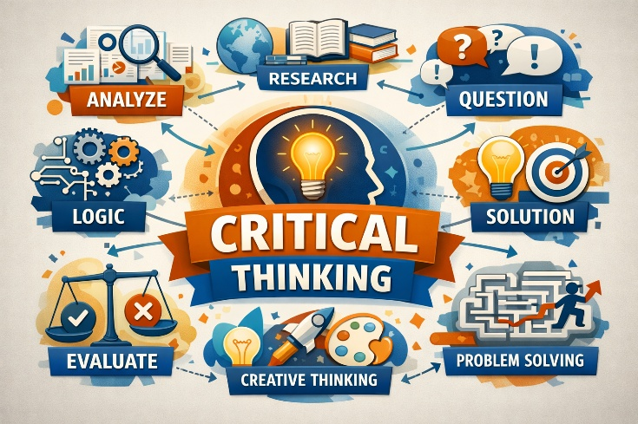
Critical thinking is the objective analysis and evaluation of an issue to form judgement. This could also link to attention to detail… If one small mistake is made your whole app could be jeopardised, you need to be able to see future problems and fix it before it even happens. An example of this is hackers therefore, app developers must create strong anti-hacking/backend to stop hackers in their tracks. [1]

DETERMINATION
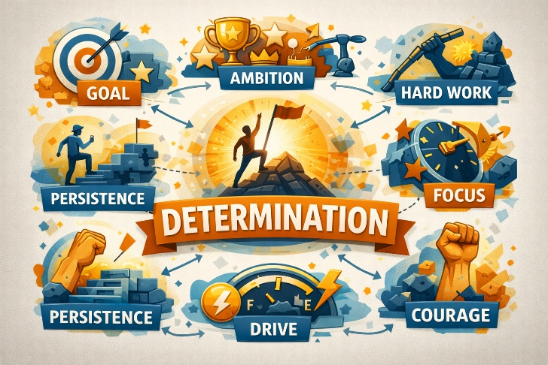
What I have discovered during my research is that one key skill you will need to be successful in this career as developer is determination. You will need to work on coding everyday not only because of funds but to become great at it, so it becomes effortless like speaking a language fluently. Same way athletes are determined to be the best so they train everyday sometimes twice a day, this is how you will have to look at coding. Like learning anything new you will reach obstacles you will need to overcome with hard work this is determination, completing tasks no matter how hard the task is. [2]

PROBLEM SOLVING
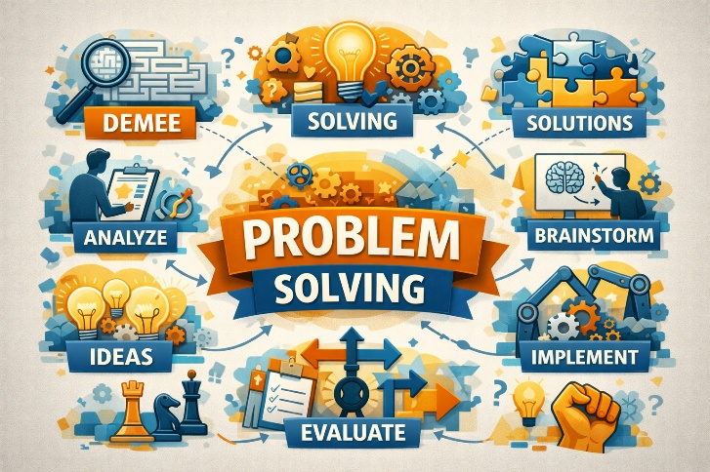
Problem solving is the art of analysing and defining an issue and coming up with a solution to fix the current problem. 1/3 of people in the workplace fail to show this important skill. You will need to be able to use your mathematical and scientific intellect to terminate any errors. [3]

COMMUNICATION SKILLS
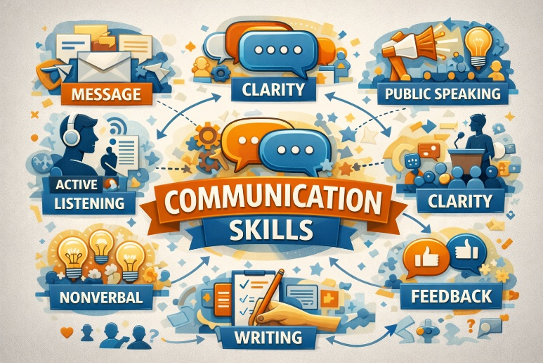
Communication skills are very important because you will need to be able to speak to your peer’s using language that they can understand. There will be times that your technical language does not resonate with your peers/team because they don’t understand the technical coding terms. Therefore, you can't level up if you can't explain complex concepts in simple terms. [4]

Task 1 (B); Similarity Report Evaluation
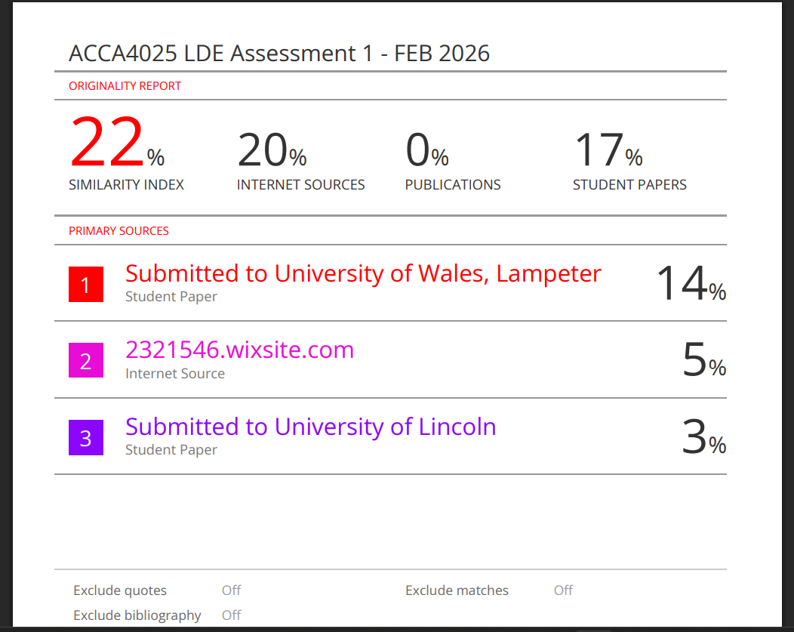
I believe the reasoning behind the percentage for the similarity report is because of the public task guide. The guide is public to the whole class therefore the format and wording may be similar to my other classmates. The way I can prevent this from reoccurring is by not following the guide exactly how it was presented in class and to use my own intellect to make my work different from everyone else. In my opinion, I would give myself under 10% for my similarity report if the guide that was used was not public.

Task 2: Collaborative Mind Map and Individual Poster

Task 2 (A); Mind Map
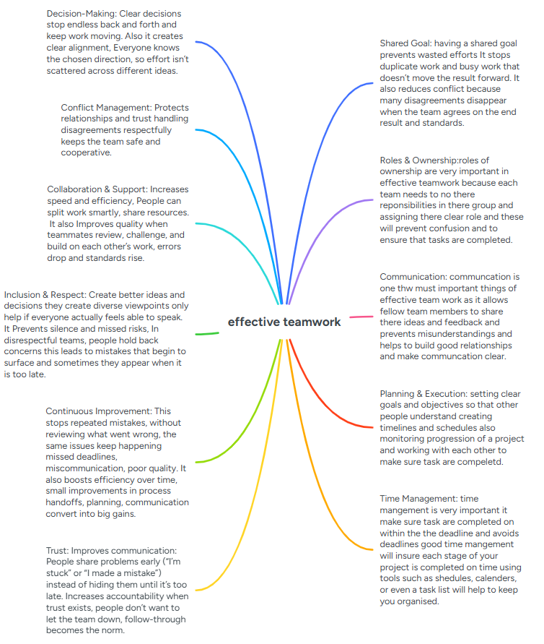

Task 2 (B); Academic Poster
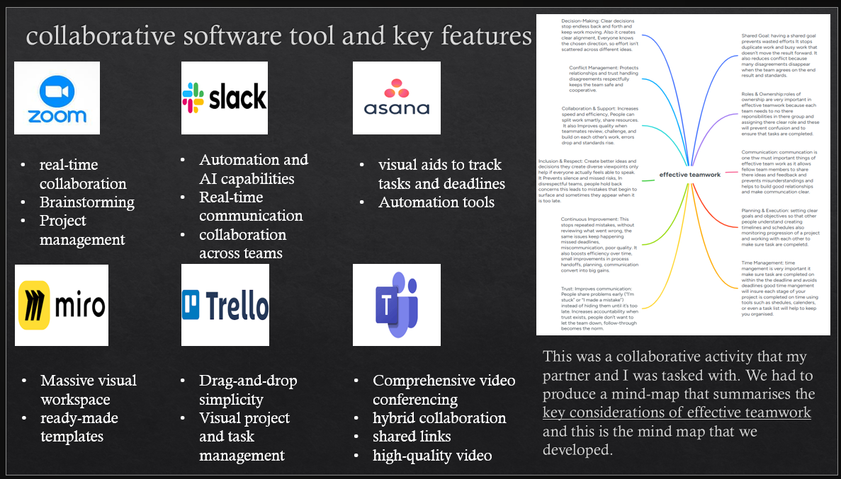

Task 3 Virtual Collaboration and RefWorks

Task 3 (A); Automatic Referencing
I have explored Tuckman’s stages of development the stage I will be emphasizing on is the “Storming” stage. Storming is the conflict stage; this is the stage where altercations and conflict is more likely to arise between group members. Group members may start to criticise or object the team’s main vision/mission, this causes disagreement and arguments because members characters begin to clash. The team’s behaviour begins to sway from positive to negative, they begin to compete instead of working together, they become easily irritated, communication becomes weak, some members try to take control of the group as somewhat of a power control or group domination then this can lead to alliances and favouritism. These challenges create even bigger problems for the team when it comes to virtually collaborating because this creates a stronger misunderstanding for the team, it de-motivates members and increases isolating and solitary thoughts. [1]
When team members start to lose trust in each other, they begin to believe that they’re thoughts and ideas are more correct than others they begin to think about what is right or what is wrong instead of thinking about the main team goal and finding the correct solutions. But also, without this conflict stage to overcome there will never be any honesty and actual constructive criticism within the group.
“Conflict is the journey to truth”, this is a very well-spoken line because without the team questioning each other, gathering each other’s opinions they will only have a tunnel vision towards the target but in most cases, this is not ideal. Teams need to question each other because this builds confidence in the team, this turns tunnel vision into viewing and understanding things from bird’s eye view/in multiple viewpoints. This creates an open mind of thoughts. Holding in your thoughts and questions can become frustrating and overwhelming, being able to speak what is on your mind will improve confidence and stop resentment from increasing and letting resentment increase can escalate to many harsher problems within your group. [1]

Communicating virtually, through things like texts, group chats and emails can be very difficult because of your wording/writing. Communicating like this is hard because your tone of voice is not as obvious as actual speech. Your message may come off different to what you have intended therefore, the recipient may understand your message in a different contrast. Such as, your message may have been said simply it may have been written as calm and straight forward to you, but the recipient may have understood it as if it was written with an assertive, dominant tone which is not as you have intended. In conclusion, it is best to speak through voice/video call rather than to speak through texts and emails just to avoid problems that could have easily been averted with just a bit of patience.[1]
Teams/organisations need to come up with specific roles for a specific team member, everyone’s role is important and slightly different. This is implemented to improve structure, as some members are natural leaders while others are creative and good with coming up with new ideas. Some roles may be harder for some and easier for others therefore knowing your role will turn someone’s weakness into a strength and vice versa if done wrong. [1]
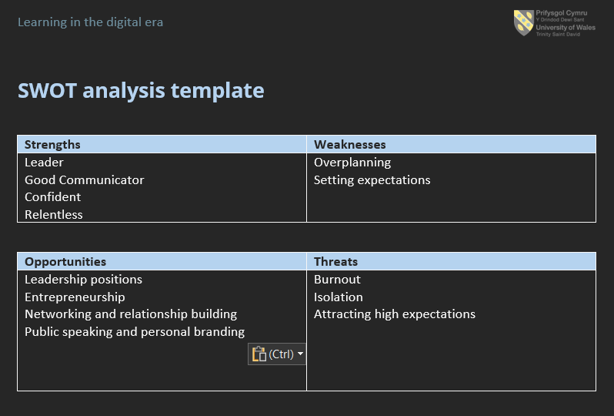

Task 3 (B); Step by Step guide to reworks
To organise my references properly, I used RefWorks. I uploaded the journal articles I selected, checked the reference details and explored the tools inside the platform.
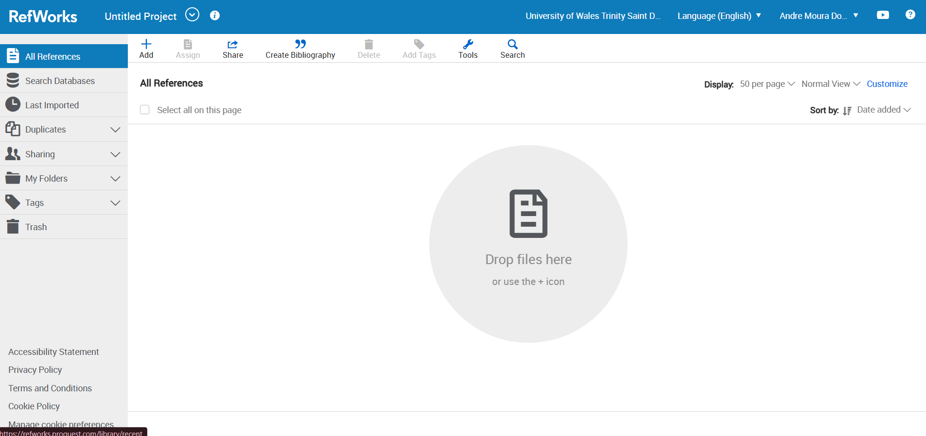
Screenshot 1, This is the RefWorks dashboard with nothing uploaded

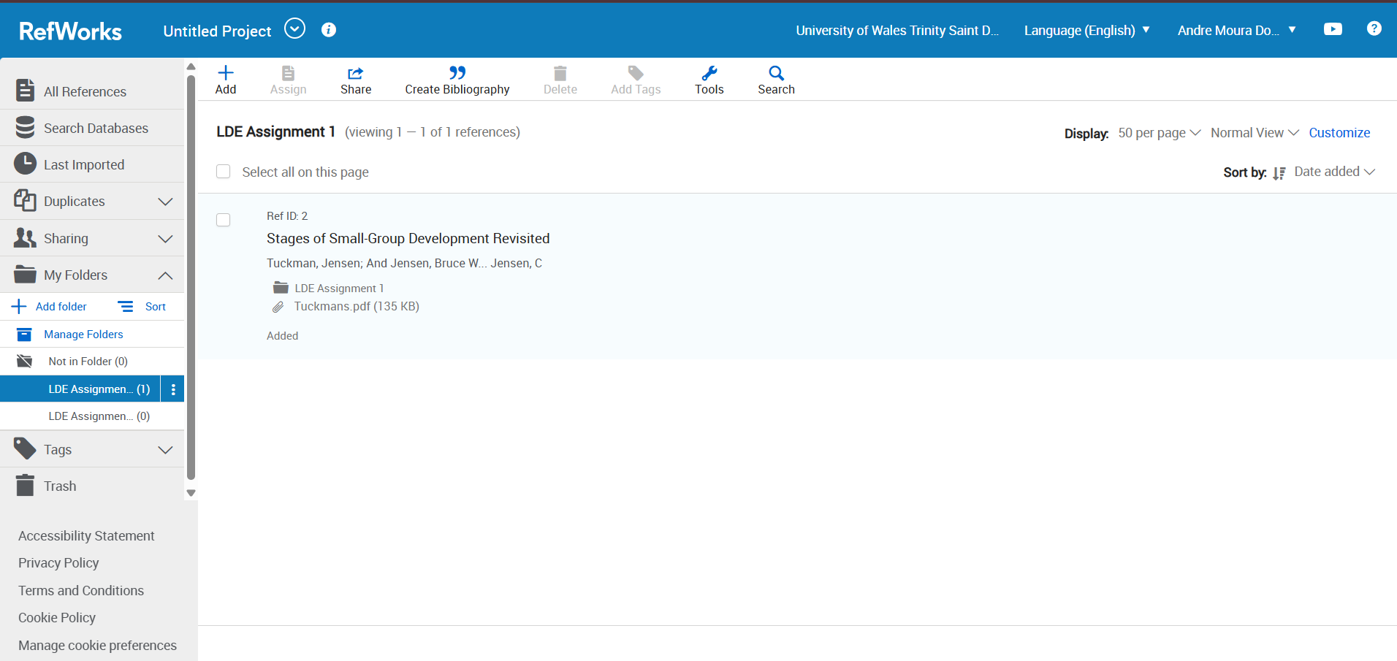
Screenshot 2, as you can see on the left, I have created two files “LDE assignment 1 and 2 also, the uploaded Tuckman’s PDF
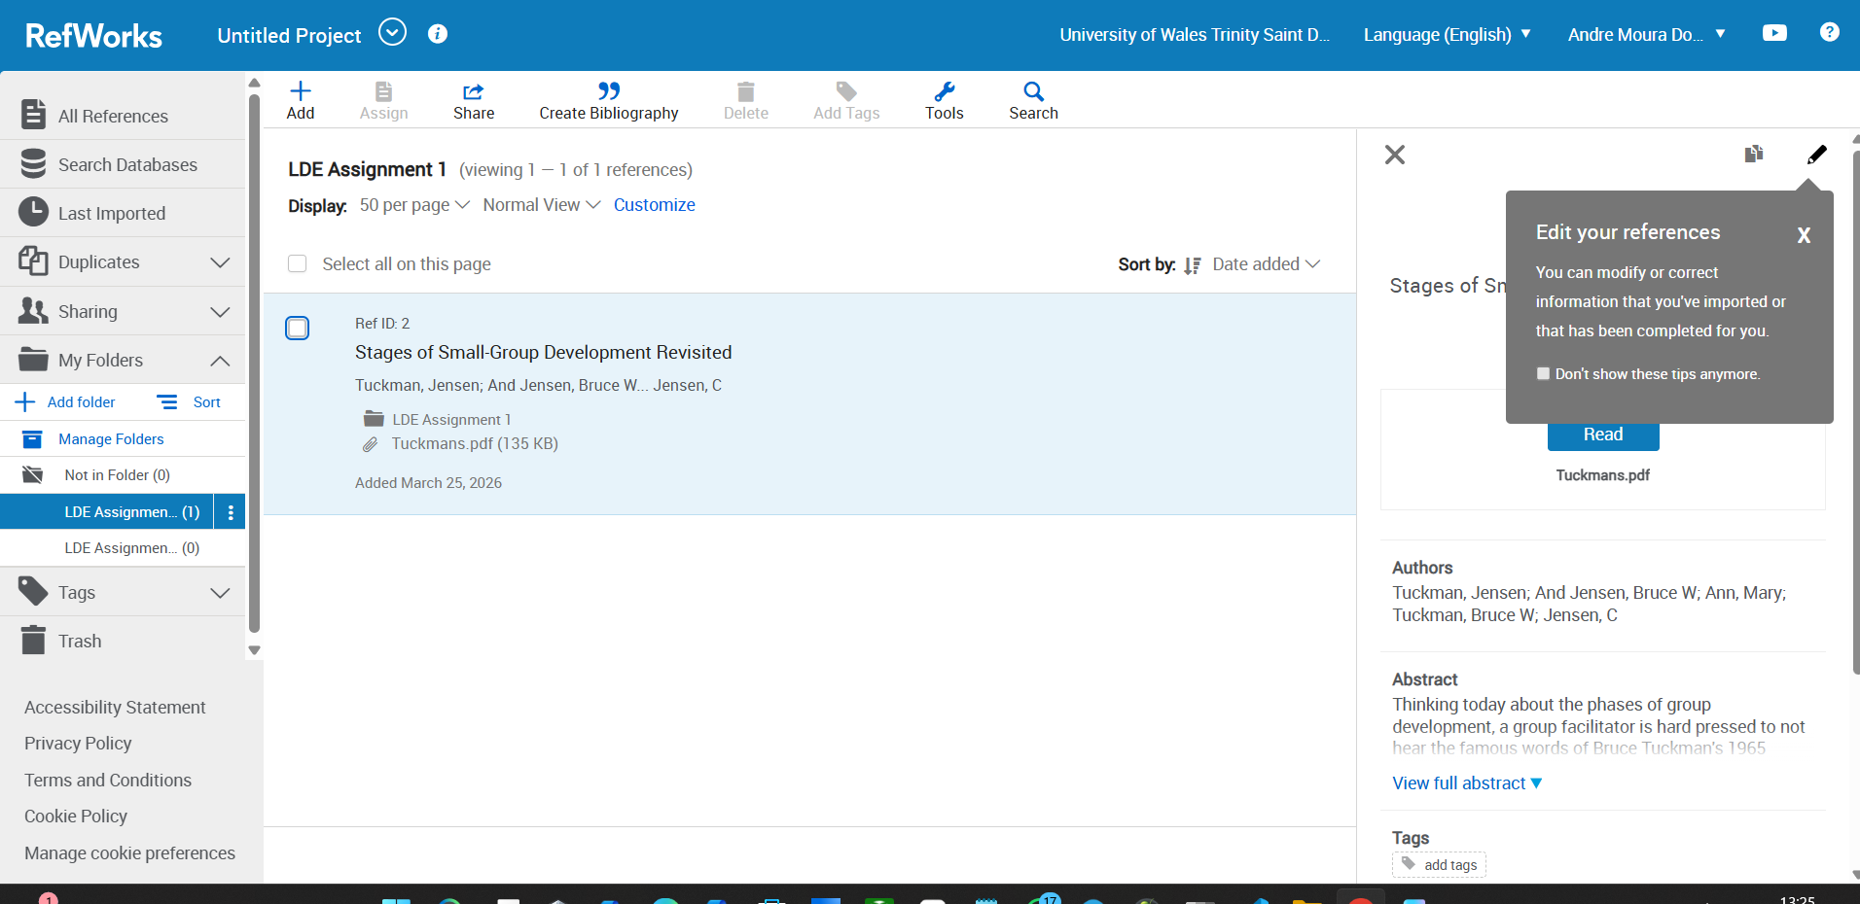
Screenshot 3, This the last screenshot that shows the “Create Bibliography” tool that I used to generate properly formatted references.
Altogether, these screenshots show the full process that I used to organise my sources for this assignment.

Task 4

Task 4 (A); E-portfolio Creation
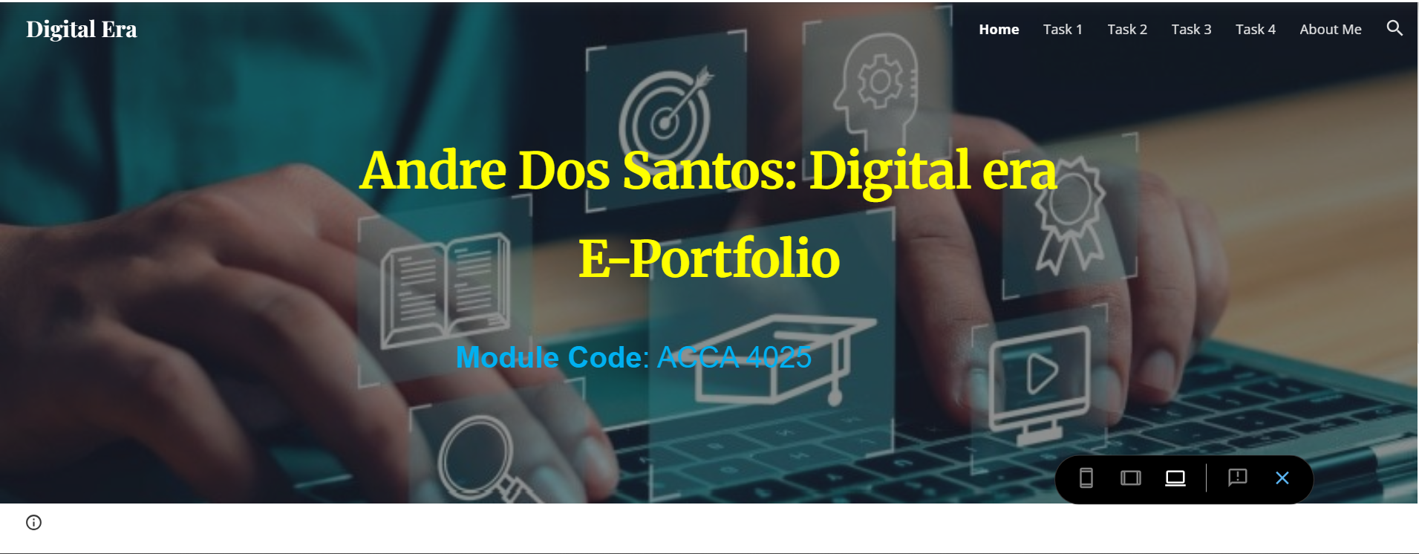
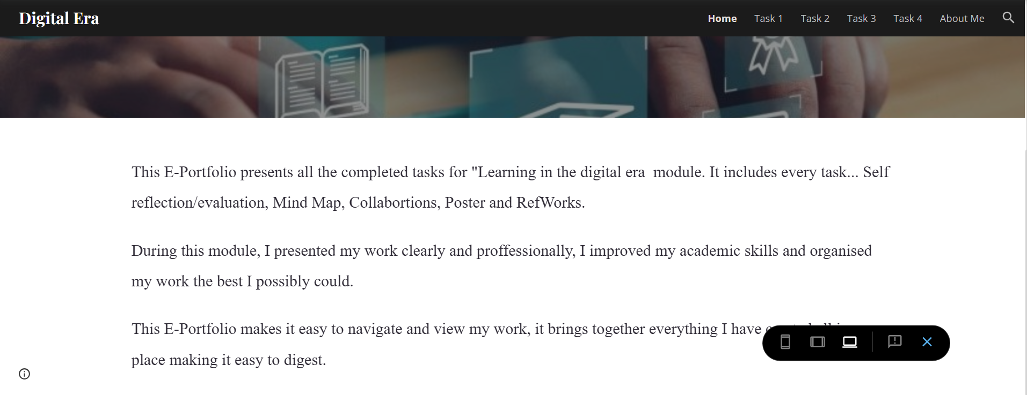
Screenshot’s Section 1 – Home Page
These screenshots show the home page of my e-portfolio. I designed it to look simple and professional. It’s the first page my tutor sees, and it links clearly to all the other tasks.

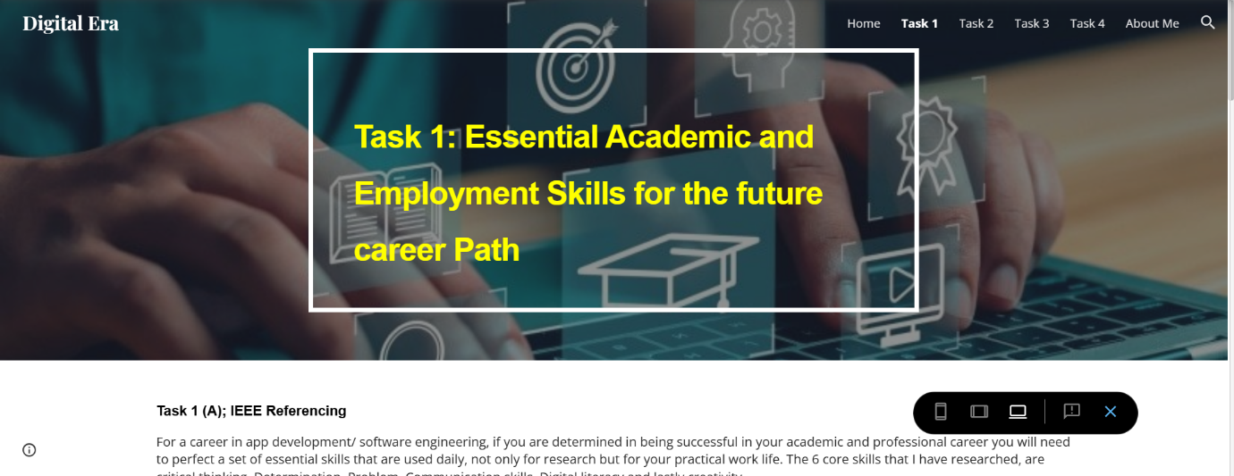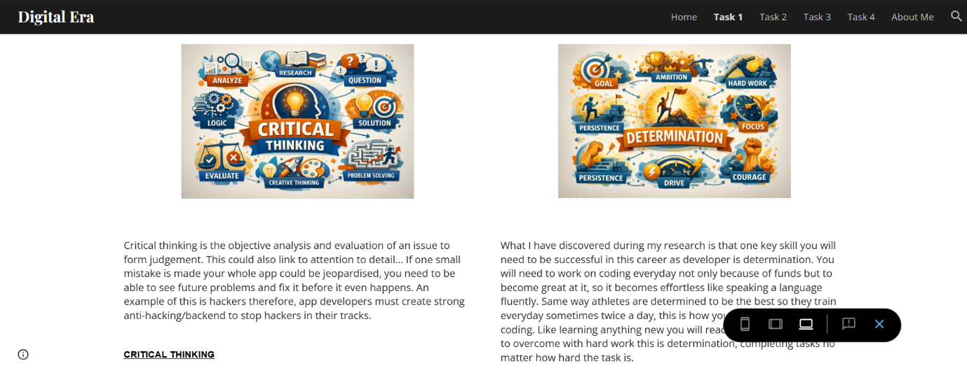
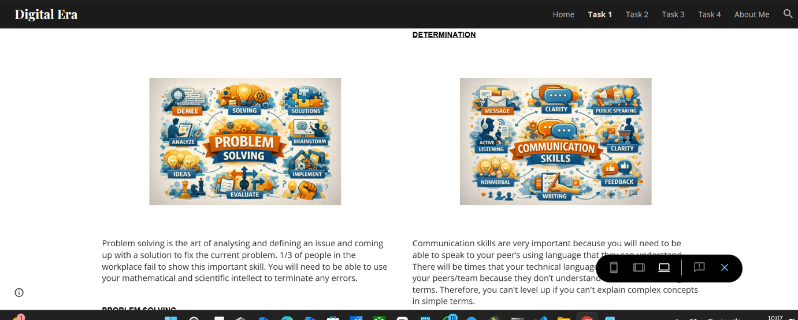
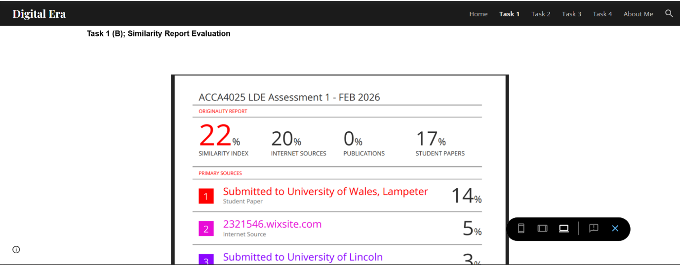
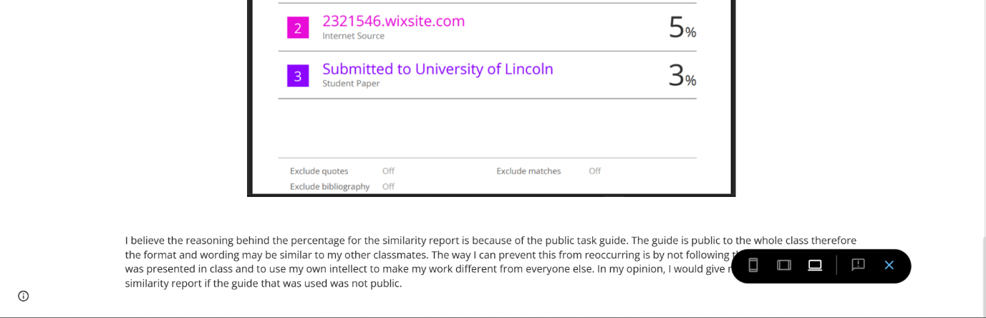
Screenshot’s Section 2 – Task 1 Page
These screenshots show my Task 1 page, where I uploaded the written word about academic skills as well as some supporting images, I organised the text and images into clear sections, so everything is easy to read as you keep scrolling downward. I also included the Similarity Report Evaluation and my reasoning for my report.

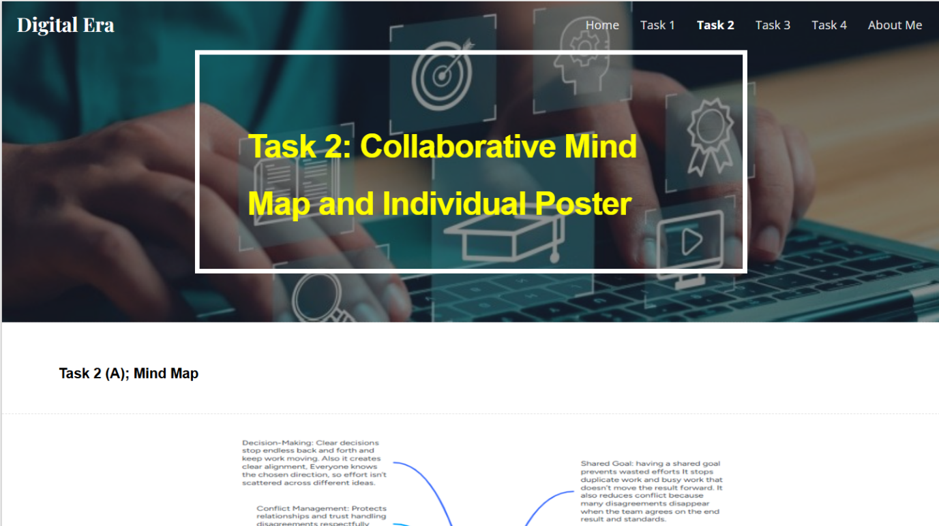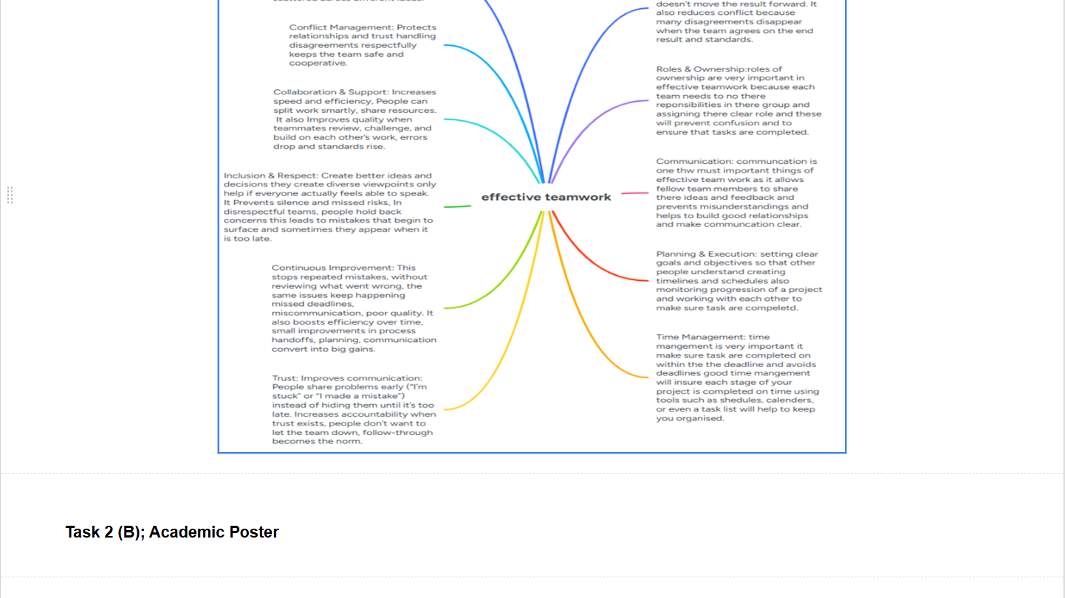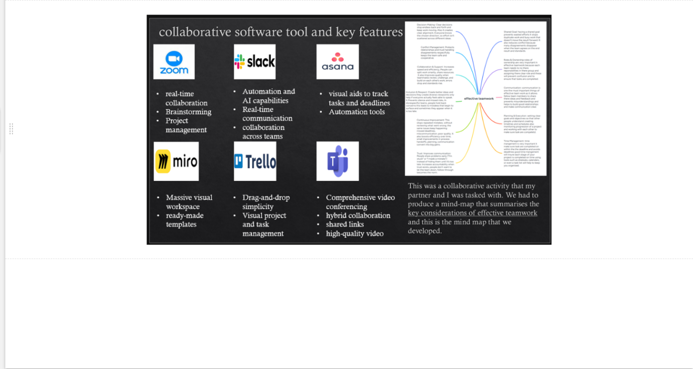
Screenshot’s section 3 – Task 2 Page
These screenshots show the Task 2 page with also my mind map and my A3 poster. I implemented both the visual images and my explanations to show how the ideas connect to teamwork.
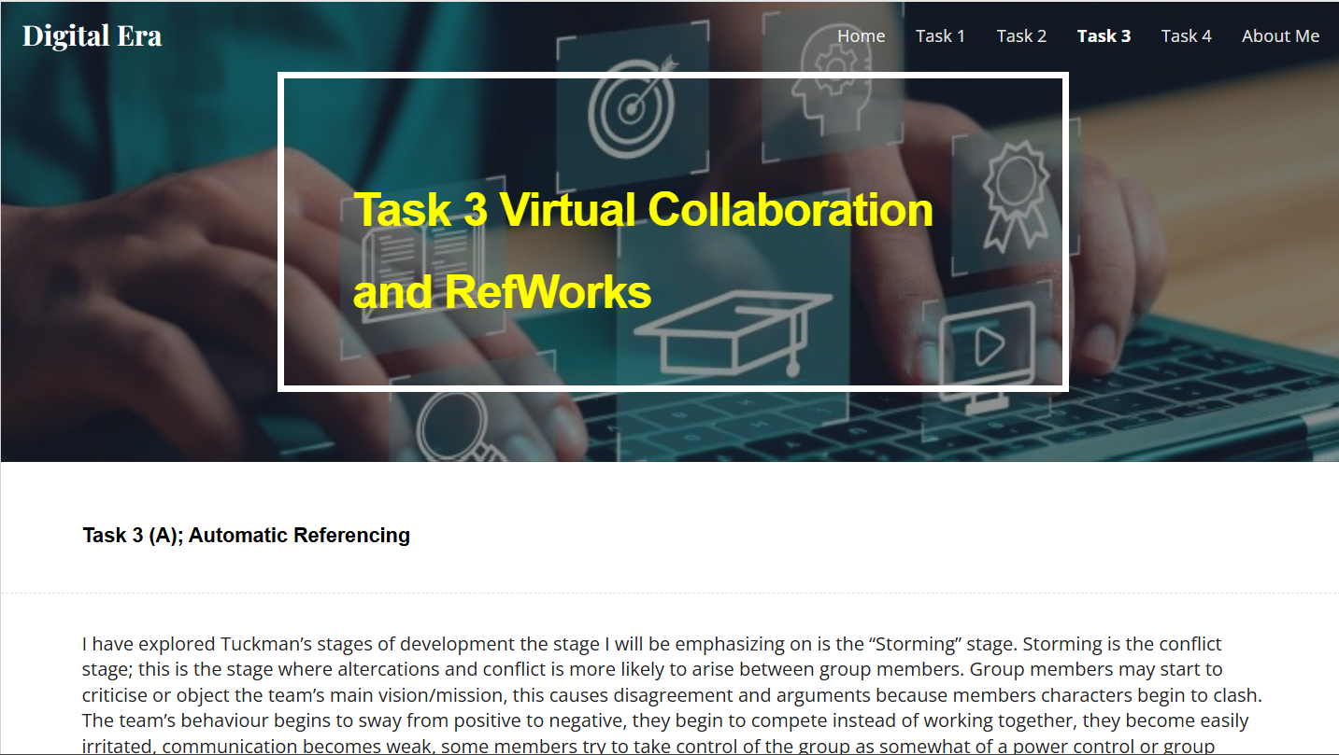
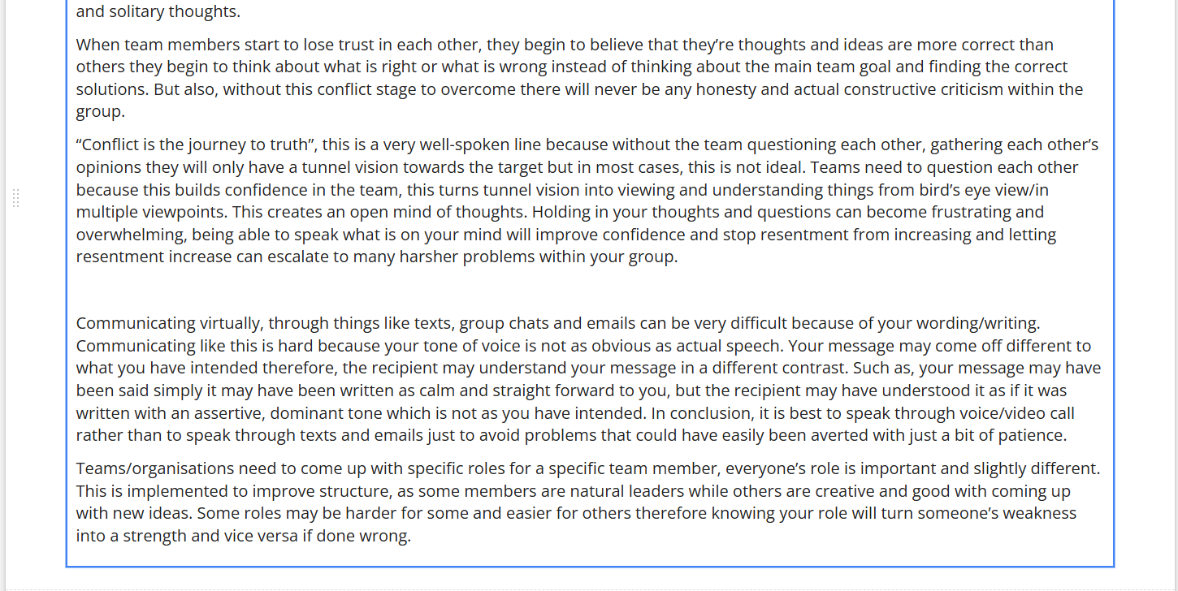
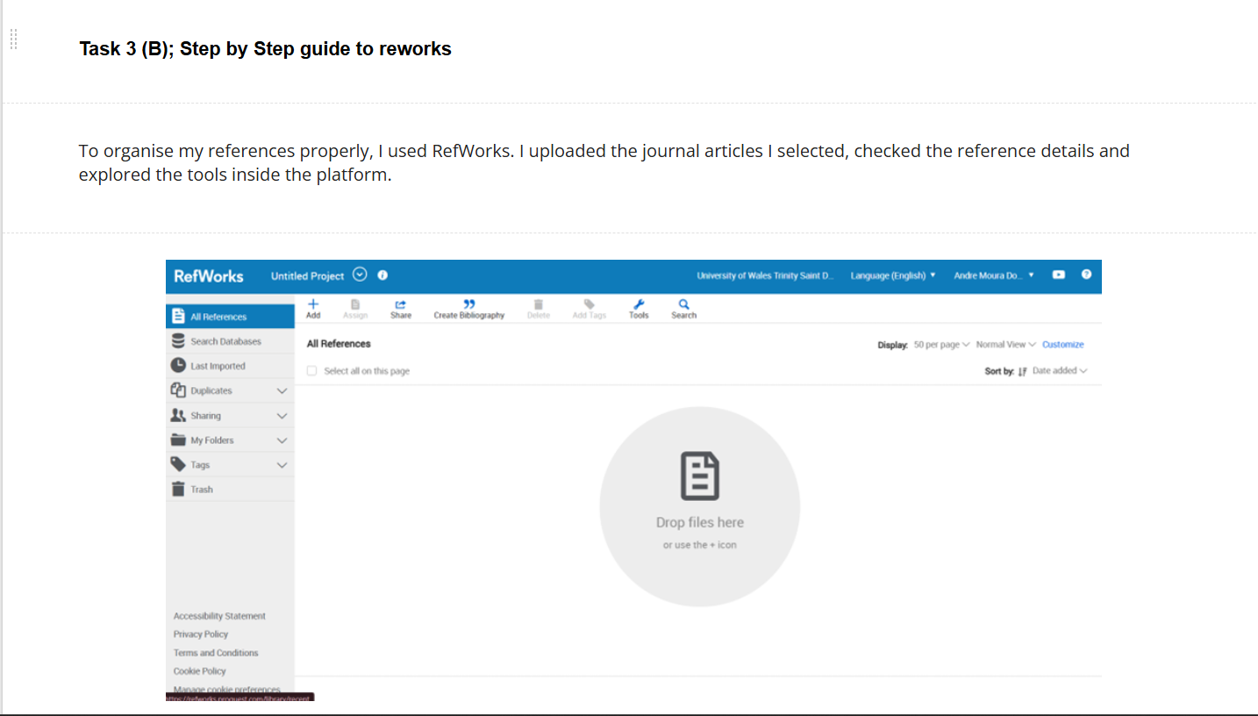
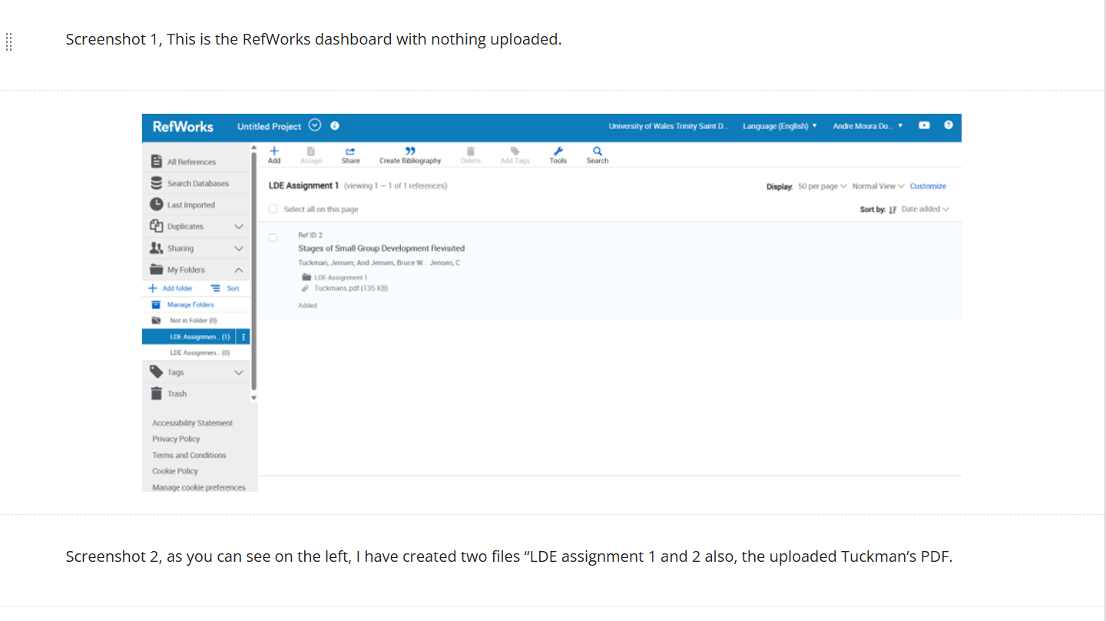
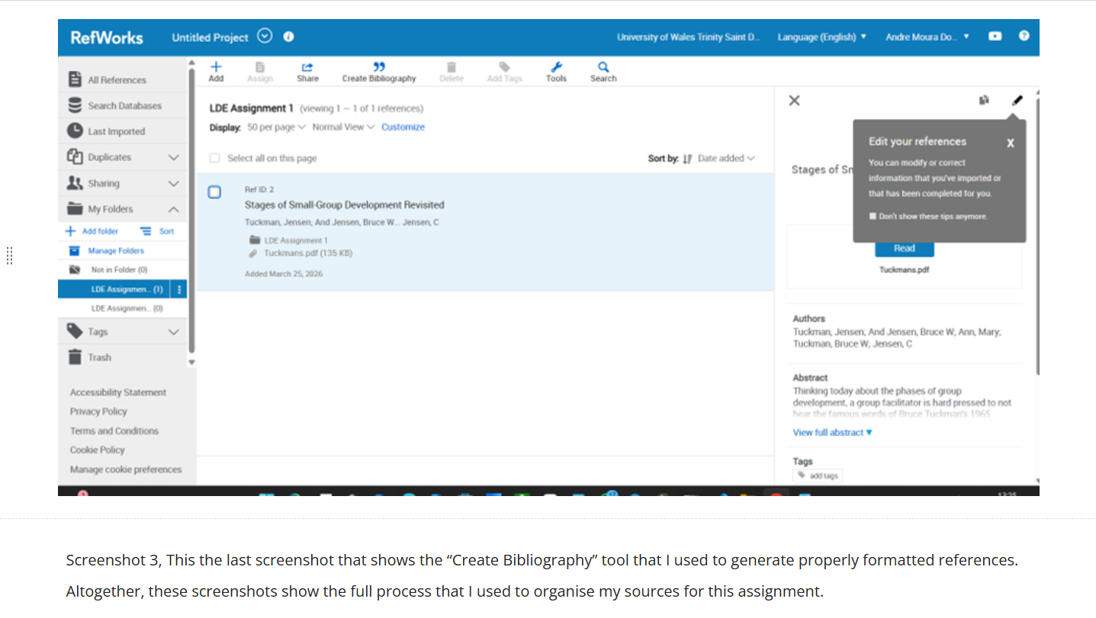
Screenshot’s Section 4 – Task 3 Page
These screenshots show my Task 3 page, where I explained how I used RefWorks and added the screenshots as support of the whole process. It proves that I followed the method properly and referenced everything as tasked.

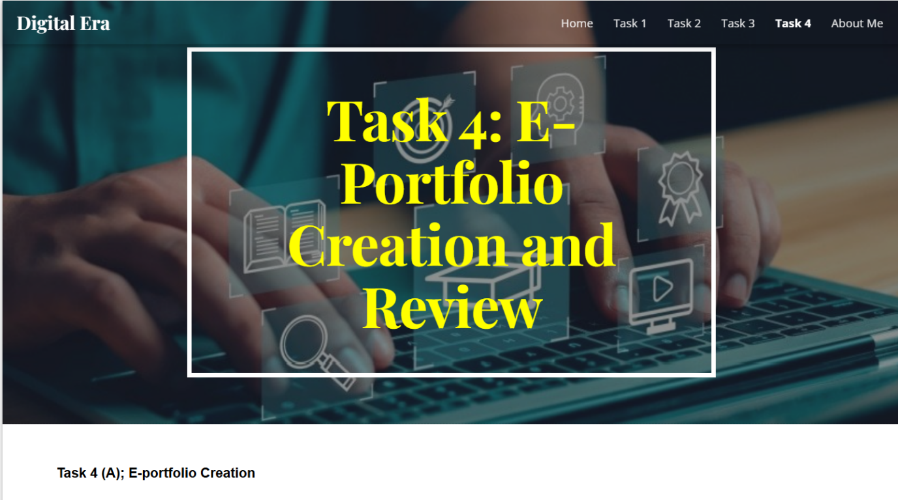
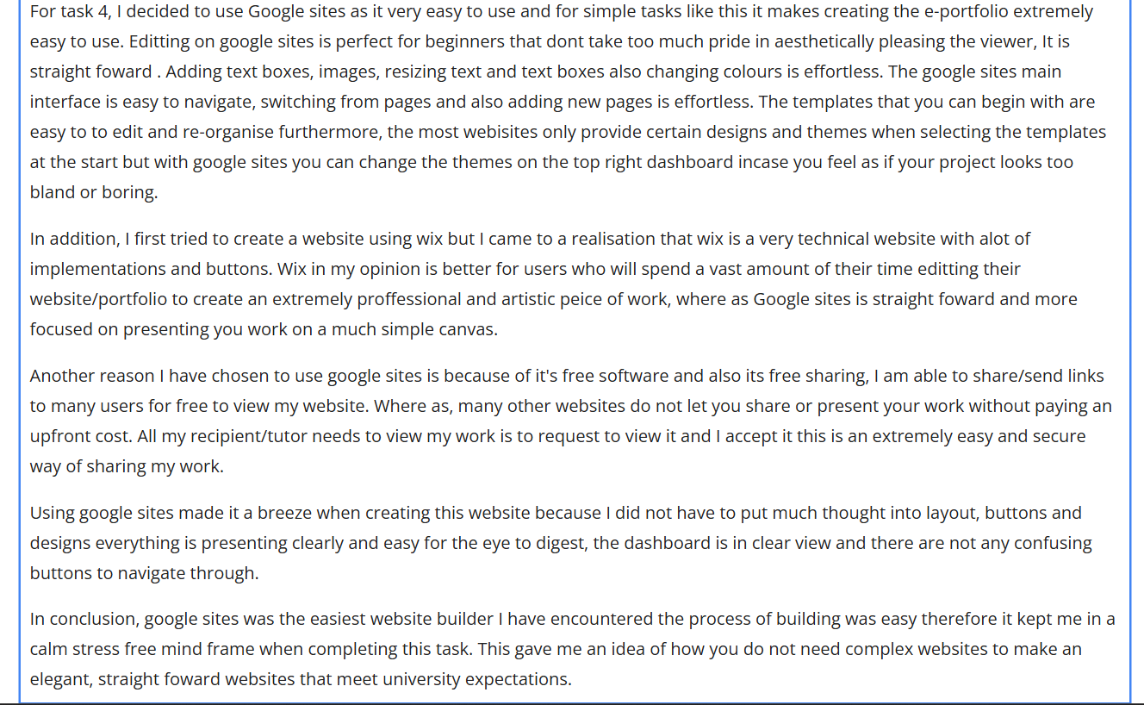
Screenshot’s Section 5 – Task 4 Page
These screenshots show my Task 4 page explaining how I built the whole e-portfolio using Google Sites. I wrote about the tools I used, my opinion, why I used it, why I prefer it and what I learned from creating everything using this online software.
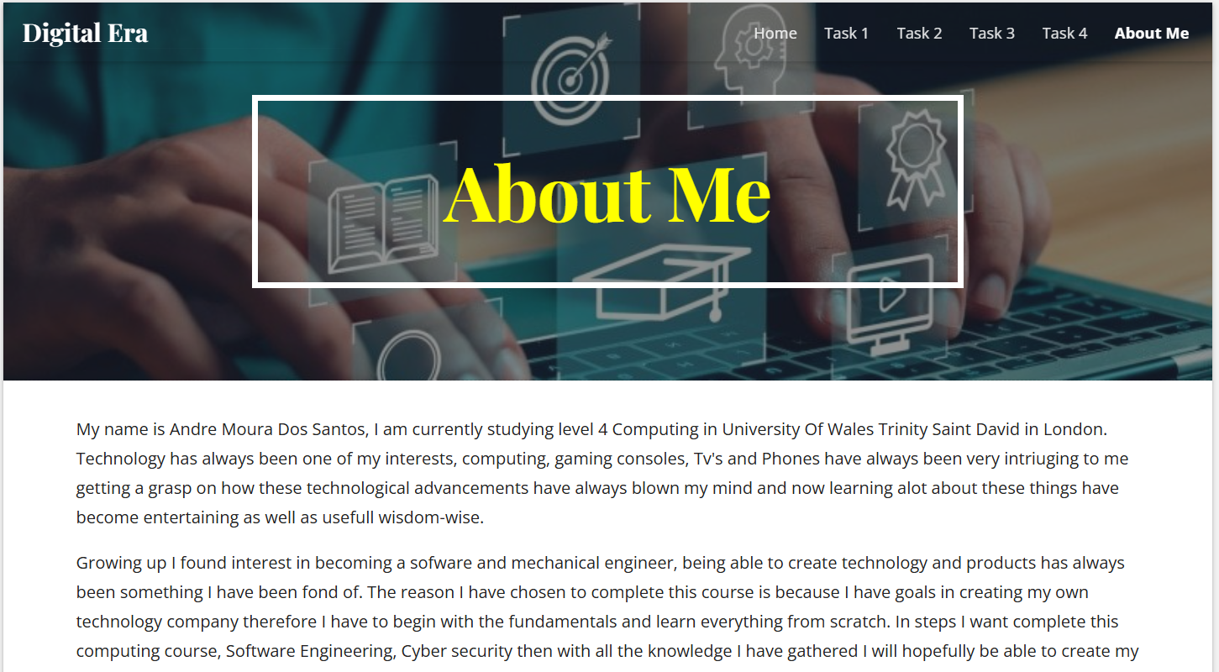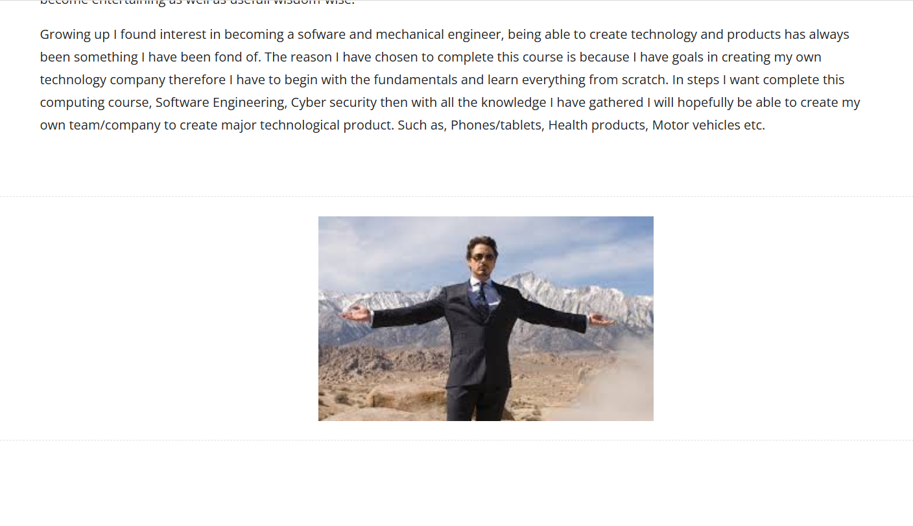
Screenshot’s section 6 – About Me Page
These screenshots show my “About Me page”. I wrote about my background, my goals in tech and in life, and why I’m interested in computing, software engineering and cybersecurity.

References
[1] J. Tuckman et al, "Stages of Small-Group Development Revisited," .

