Automatic Traffic Light Controller
Universitey of wailes Trinatey St David | Waterfront Campus, Swansea SA1 8EW
Electronics 1 (ACDA5002)
Joseph Gillespie (2214885)
2023

Abstract
This report has been broken down into three main sections that demonstrate the capabilities of using embedded C as a programming language to control a simple T-Junction traffic light system.
The first of these sections will provide information on the operation of traffic lights in the real world. Followed by the second section which will break down the construction of the traffic light circuit itself. Then within the third section, the embedded C program shall be examined in its operation before concluding with an overview of the success of the system and where it can be improved.

Table of Contents
Abstract 1
Table of Figures 2
Introduction 3
(1.0) Traffic Lights 4
(1.1) Traffic Light Specifications 4
(1.2) The Light Sequence 5
(2.0) The Circuit 6
(3.0) The Code 9
Conclusion 12
Bibliography 13
Appendices 14

Table of Figures
Figure 1 [2] 4
Figure 2 [4] 5
Figure 3 [4] 5
Figure 4 [5] 6
Figure 5 7
Figure 6 7
Figure 7 8
Figure 8 8
Figure 9 8
Figure 10 9
Figure 11 9
Figure 12 10
Figure 13 10
Figure 14 10
Figure 15 11
Figure 16 12

Introduction
Embedded C is seen as one of the most common go-to programming languages when it comes to coding microcontrollers in electronic systems. It shears this go-to state with languages like BASIC, Assembly, and C++, but what makes embedded C stand out above its counterparts is its adaptability, efficiency while running, and significantly cut development time when being made. It is these features that give Embedded C its popularity within the development community [1].
This report aims to demonstrate the capabilities of embedded C vier the example of a T-junction traffic light system. The report shall begin with a background study of the purpose, specification, and operation of real-world traffic lights. Allowing for a basic understanding of the purpose of the project and how it should present itself to a viewer.
This shall then lead to section 2.0, where the simulated construction of the traffic lights shall be examined. Hear, components such as the Pic16F877A will be explained in its overall purpose to the traffic light system and the general construction of the traffic light itself will be explored.
Following this, section 3.0 shall examine the embedded c used to control the system. This will be presented via a top-down flow chart showing the operation of the code itself. Alongside this, key sections of the code will be examined in depth to give a much better understanding of how the code is operating.
The report shall then end with a conclusion that will look back at the operation of the simulation highlighting its pros and stating any improvements that can be made if the project were to be repeated.

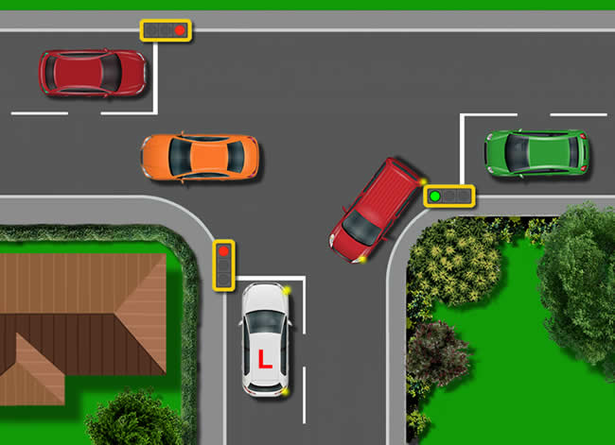
Figure 1 [2]

(1.0) Traffic Lights
Globally recognized and used in every country excluding Bhutan [3], the traffic light has become the pillar of traffic control. They are often seen at junctions, pedestrian crossings, major intersections, and even around road works to help control the safe flow of traffic. When a traffic light fails, accidents and traffic jams become a major issue in their absent areas.
As traffic lights are a global system, this report will concentrate on those seen in the UK. Within this section, UK traffic light specifications shall be examined to give a general understanding of how a traffic light should be presented.

Traffic Light Specifications
A commonly overlooked Vue when looking into traffic lights operation is their positioning. Traffic lights have set distances and visual lines of signs that need to be consistent throughout the UK. The reasoning behind this is to allow road users plenty of time to react, due to stopping distances of vehicles, and to give the road user clear sight of where they need to be positioned on the road while on approach to the lights.
Often, at junctions, there will be two sets of traffic lights covering each path of approach. The lights are split into primary and secondary signals with the primary being used as the first signal to be seen on approach to the junction and the secondary being the one for the driver to see when located at the stop line. The primary lights are often located between 1.5m to 2.5m away from the stop line at the junction [4]. With the secondary light tending to be located on the opposite side from the stop line. Figure 2 demonstrates this layout [4].
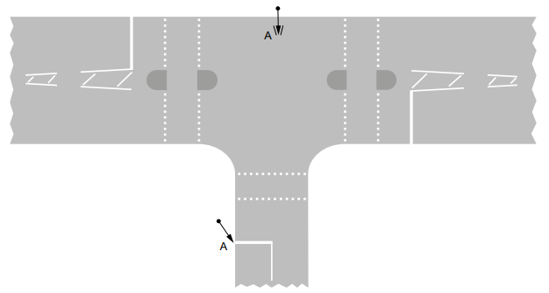
Figure 2 [4]

Alongside their location near the stop line, primary lights are required to be visible from varying distances depending on the speed at which traffic is set to travel on the given road. Figure 3 shows a comparison chart of recommended visual stopping distances to the speed at which a vehicle is traveling.
Figure 3 [4]

The Light Sequence
The lights within traffic signals are crucial to the operation of the system. If a light is on for too long or too short of a time, road users will become frustrated, and traffic will not flow. The same goes for the colours scheme of the light, if every traffic light had a different colour, road users would not know what to do when approaching junctions leading to accidents.
This is why the UK has set standards for its traffic lights. First, the colour scheme that is used is: Green which is used to represent go; Amber which is used to represent Stand Bay or caution; And Red is used to represent stop.
The colours also follow a set sequence which is: Red; Red, Amber; Green; Amber, then back to Red to begin the sequence again.
This pattern is visually represented in Figure 4.
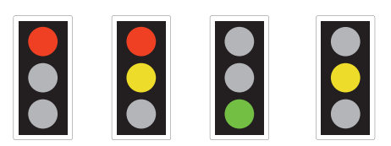
Figure 4 [5]
As the sequence sickles throw, certain lights have a set time at which they stay on. These lights are the amber light, which is set to stay on for 3 seconds, and the joint Red and amber light, which is set for 2 seconds [4]. The most likely reason for only two patterns of light to have a set time within the sequence is due to them being more intermediate signals in the sequence representing more a warning and a stand bay over a definite stop or go. For the solid red and green lights, the standards vary depending on the specifications required for that particular junction.
A point to note is when a pedestrian crossing is added to the overall sequence of the lights. There are two time periods at which the pedestrian lights and main traffic light share the same colour, that being red. They are safety brackets with the first overlap to allow traffic to clear the pedestrian crossing in the event of heavy traffic and the second to allow for any stragglers crossing the road to get across safely [4].
The timings for the crossing vary depending on the width of the crossing point, leading to timings varying from 6 to 12 seconds. This can be extended if the crossing has a detector on it for pedestrians but if the crossing has a countdown, that is the set time to cross [4].

(2.0) The Circuit
To demonstrate the operation of the embedded C code, a traffic light system was constructed within the designing program known as Proteus8. It is with this section that the traffic light circuit shall be examined with a look into the purpose of each component that makes up the T-junction system.
The traffic light system is composed of several different components, this being listed below:
- 7 Segment displayed x6
- Traffic light unit (consisting of 3 coloured LEDs, red, Yellow and green) x3
- Green LED x3
- Red LED x3
- Or Gate x3
- PTM Switch x1
- Pic16F877A x1
- Nodes x82
Each of these components play a critical roll in the operation of the system, with Figure 5 showing the formation of the T-junction and the positioning of each component.
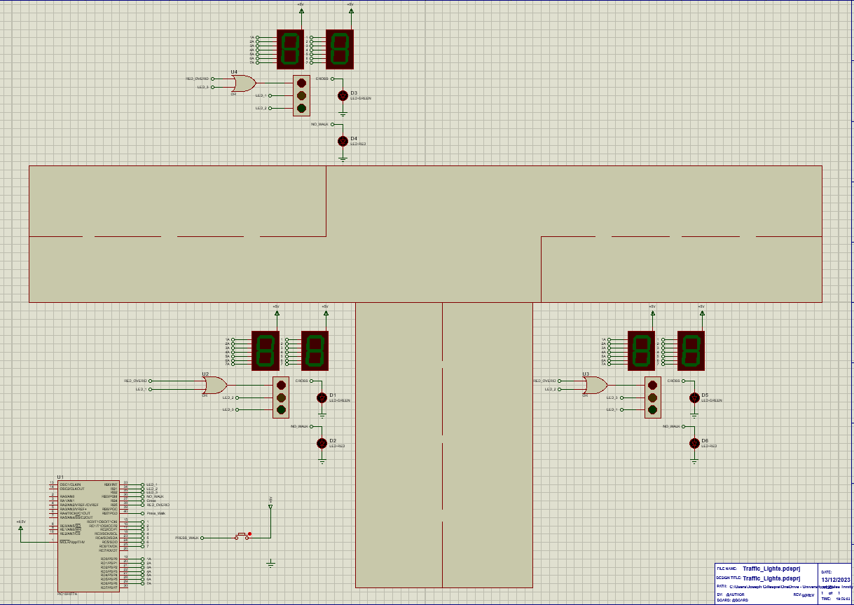
Figure 5
As it can be seen in Figure 5, there is 3 main compact traffic light systems located on the diagram with the Pic16F877A and the Push To Make (PTM) switch located in the corner. Theys sections are to represent each traffic light set up located on each rode leading to the junction with the Pic acting as the main control point for the overall circuit.
Looking further into one of the groped traffic light systems, there are two common Anode 7-segment displays. These displays work by producing a +5V onto the positive pines of the LEDs within. When a logic low accrues on the negative pin of a diode (produced by the Pic16F877A), that diode shall illuminate a segment within the display [6]. Theys displays are used to produce a count-up and to signify a light changeover once the count reaches a multiple of 10. Within a real-world scenario, these displays will tend to count down for pedestrian crossings and will not be presented to road users. Figure 6 shows the display in operation.
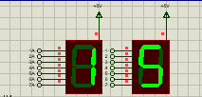
Figure 6
What can be said to be the most crucial part of the traffic light system, the compact traffic light set is a pre maid light system composed of the Red, Yellow, and Green LEDs used for traffic signals. This component has 3 inputs used to control each light within the traffic light. Theys inputs are connected to the Pic16F877A which ultimately sets the pattern of the light cycling through Red, Yellow, Green, and back to red. Figure 7 shows one of these compact traffic lights.
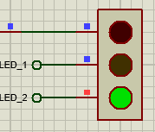
Figure 7
Located to the right of the compact traffic light system are two LEDs. These LEDs are to represent the pedestrian crossing lights and are made from one red light and one green light. These lights are offset from the main light and only turn green once all other lights are red.
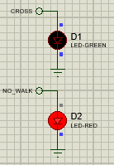
Figure 8

A stand-out feature with the groped traffic light systems is the use of an OR gate located on the red-light pin on the compact traffic light system. This OR gate has been placed on this pin to allow for two inputs to operate on the light input. These inputs are the red override and the standard sequence input.
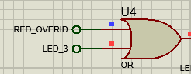
Figure 9
To make a clear simulation diagram within Proteus, labelled nodes are used to connect output pines from the Pic16F877A to the inputs of components through the system.
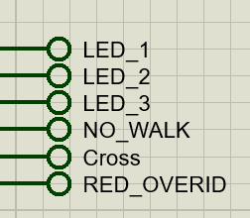
Figure 10
Mentioned in most of the operations of the other components within the T-junction circuit, the Pic16F877A is the main driving force and controller for all the lights and timers. It has been chosen to power this system due to it more than capable number of output and input pines allowing for all components to be connected, with some pines being left spear to allow for further development on the system in later incarnations. Figure 11 shows that pines RB0 to RB7 are being used to control the LEDs within the system. Pins RC0 to RC6 control the unites within the count. Pins RD0 to RD6 control the tens of the count and pin 1 (Vpp) takes the max input voltage of +5V to power the Pic [7].
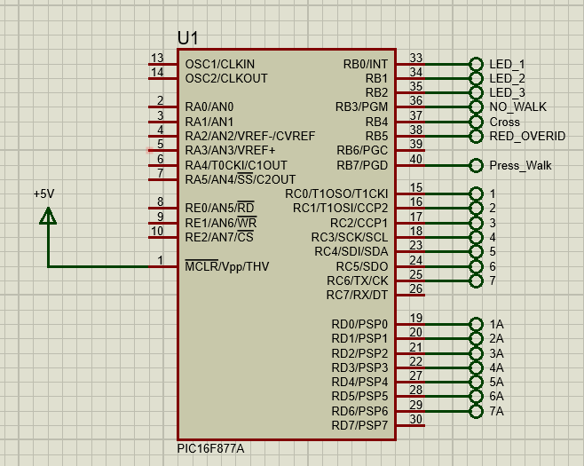
Figure 11

(3.0) The Code
As stated previously in section 2.0, the Pic16F877A is the main command point driving the T-junction traffic light system. Within the pic site code written in embedded C that allows the pic to operate as required. The embedded C has been constructed in the compiler known as MikroC where once it has been built successfully, it produces a Hex file within its saved point. This Hex file is transferred into Proteus vier the Pic16F877A leading to the visual operation of the overall circuit. Within this section, the code controlling the pic will be examined with explanations of its overall function and effects on the visual circuit.
The code starts with variables being set that are required upon later in its operation. This can be seen in Figure 12. Where in the first line of code “int” is used to allocate the integer i. This is used due to “int” using an 8-bit architecture saving memory within the Pic [8]. From here, “int” is assigned positive values within hexadecimal ranging from 0 to 9.
Following this is the “sbit” commands, these commands are used to set individual bites to the pines of the Pic. In the case of Figure 12, these bits are being allocated to individual LEDs within the circuit.
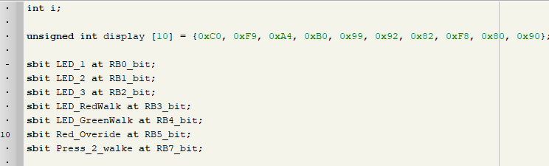
Figure 12
After variables have been assigned, the main body of the code begins. This is initiated by the “void main ()” command shown in Figure 13 below. The main body of code is all held within the {} brackets of the void main.
Figure 13
As the main body of code starts, the ports / pins of the pic are activated via the commands “TRIS” and “PORT”. These commands ready the use of the pines and clear them to a logic low (0) so that a known value is seen on their output. Shown in Figure 14 is the activation of ports B, C, and D on the Pic16F877A as they are the working outputs for the traffic light system. Ports B controls the LEDs fought the system and ports C and D control the 7-segment display.
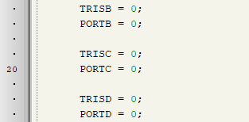
Figure 14
The main visual section of the code is seen next within a “do while” statement. This statement acts as a loop coursing the traffic light system to continually cycle throw its sequence until it is switched off. It is within this “do while” command that the lights are switched on and off and the 7-segment displays counts-up using the Hexadecimal values outlined at the very start of the code.
Within the main Lights section, the previously defined LED_1 to _3 is given a value. These LEDs are the ones connected to the primary traffic lights. What is shown in Figure 15 is that the 1st LED has been activated whereas the 2nd and 3rd are being held low. Due to the setup of the ports with the nodes, this command will have one of each colour on the primary traffic light illuminated. What can also be seen is that the “Red_Overide” is also set low meaning that the light can be any colour.
The pedestrian crossing in this example is also set to its red LED as the RedWalk variable has been set to a logic 1 high.
At the very end of each traffic light cycle is a for loop. This loop continues until the variable “I” is equal to the value 10. What is happening within this loop is as follows, Port C takes on the value of I which is set to 0 at the beginning of the loop after the set time of 100ms passes the value of I goes up by one using the Hexadecimal values stated at the beginning. Once I reach the value of 10, the second cycle begins. During this time Port D is set to one of the Hex values until the next cycle starts.
There are four cycles of this code with different LEDs being activated before the loop repeats itself.
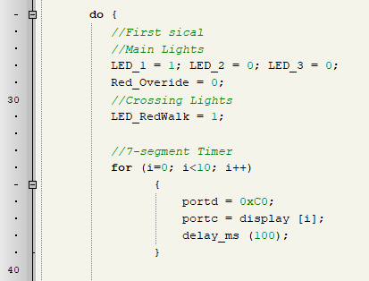
Figure 15
The full sequence of the code can be seen in the top-down flow chart shown in Figure 16 on page 11.

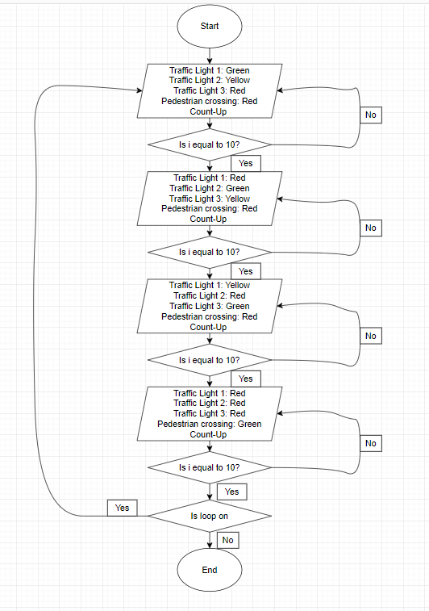
Figure 16

Conclusion
This report has shown the capability of using embedded C as a coding language to program microcontroller. The simple and top-level writing of the code makes embedded C easy to use and simple resulting in faster development times and quicker fault finding when testing compered to its competing languages.
In the event of the project being re-produced some simple adjustment will be made. Theys adjustments shall be, firstly making the counter count down from 40. This is to make the counter more realistic and relatable to the real-world comparison.
Another adjustment that will be added would be that of adding an operational PTM switch that activates the pedestrian crossing. This could be done by adding a interrupt into the cod within the chip. Adding to this and to the adjustment of code will be making the traffic lights sequence accurate to that of UK traffic light standards. This can be achieved by using more of the ports on the Pic16F877A giving each light their own port connection.
The final adjustment that can be added to this system is that of adding sensor units to the lights. This could be car sensors or pedestrian ones resulting in the light changing automatically when a vehicle is seen at the lights maximising the flow at the junction.

Bibliography

[1]Ravi, “Basics of Embedded C Program : Introduction, Structure and Example,” Electronics Hub, Oct. 17, 2017. https://www.electronicshub.org/basics-of-embedded-c-program/
[2]“Who Has Right of Way at a T-junction,” Learn Automatic. https://www.learn-automatic.com/tutorials/t-junctions/right-of-way-at-t-junction/ (accessed Dec. 17, 2023).
[3]“5 Things You Don’t Know About Bhutan,” OARS, Feb. 19, 2014. https://www.oars.com/blog/5-things-dont-know-bhutan/#:~:text=4.
[4]“Traffic Signs Manual.” Available: https://assets.publishing.service.gov.uk/media/5df0e29fed915d15f42c4820/dft-traffic-signs-manual-chapter-6.pdf
[5]“Light signals controlling traffic Traffic Light Signals.” Available: https://assets.publishing.service.gov.uk/media/560aa3f9e5274a036900001c/the-highway-code-light-signals-controlling-traffic.pdf
[6]Electronics Tutorials, “7-segment Display and Driving a 7-segment Display,” Basic Electronics Tutorials, Feb. 16, 2018. https://www.electronics-tutorials.ws/blog/7-segment-display-tutorial.html
[7]“PIC16F87XA Data Sheet 28/40/44-Pin Enhanced Flash Microcontrollers.” Available: https://ww1.microchip.com/downloads/en/devicedoc/39582b.pdf
[8]“Basics of Embedded C Programming: Introduction, Structure, Examples,” Total Phase Blog, Dec. 10, 2019. https://www.totalphase.com/blog/2019/12/basics-embedded-c-programming/#:~:text=Embedded%20C%20supports%20three%20different (accessed Dec. 17, 2023).

Appendices
Pictures of each stage of the traffic light system:
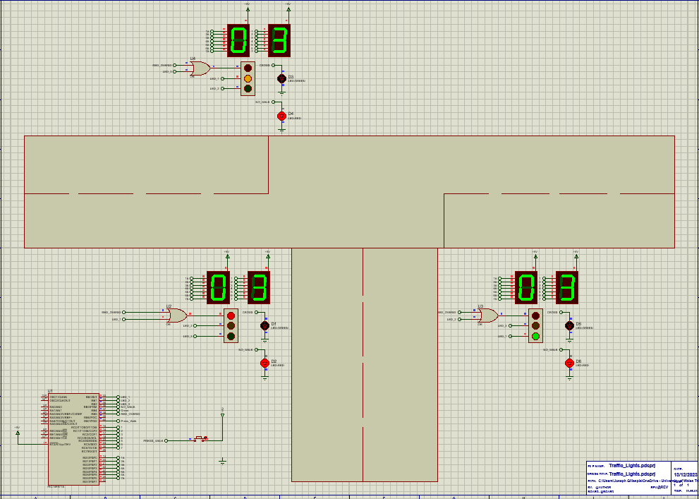
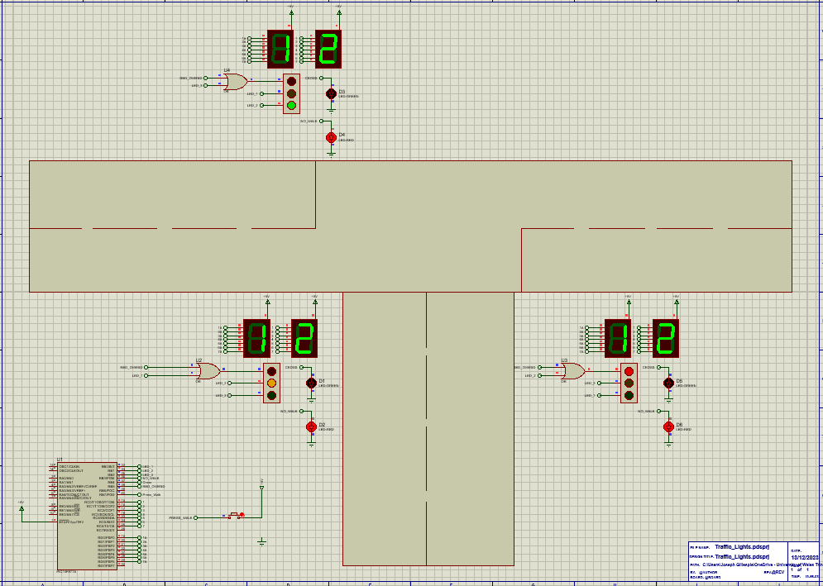
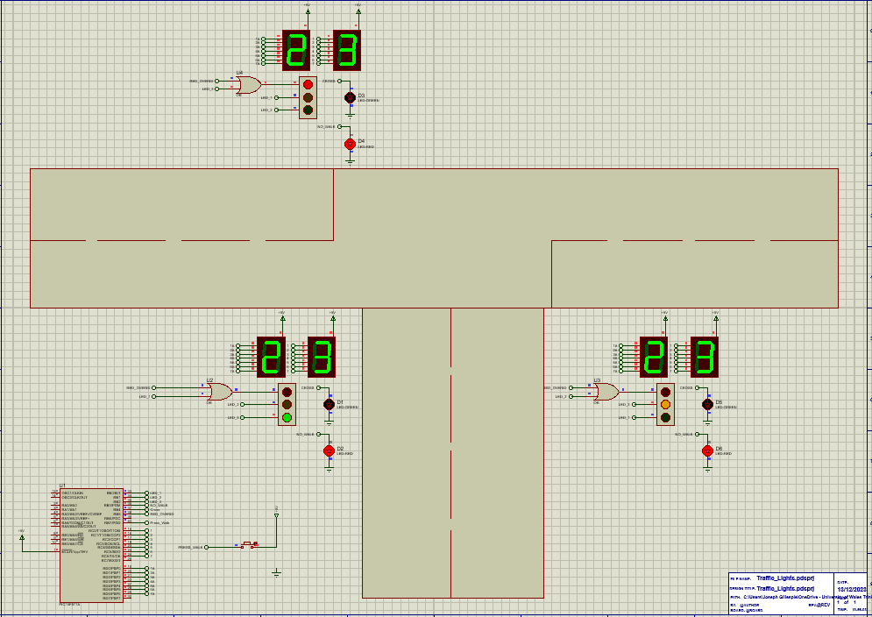
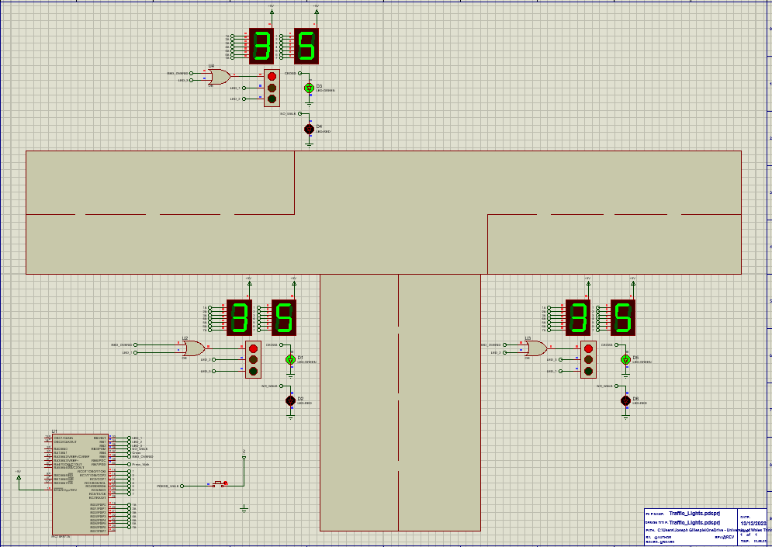

The following is all the embedded C code:


