

A Strategic HRM Analysis of Hermès

Assessment Component 2 Individual Report

Module: Principles of Human Resource Management
Module Code: LCBB5012_LON
Student Name: Anamaria Fermesanu
Student ID: 1907760
Lecturer: Dr. Nerys Dosseh

Table of Contents
1. Introduction 3
1.1 Purpose and scope 3
1.2 Key HR functions 3
1.3 Report structure 4
2. Internal and External Environment 5
2.1 The PESTLE framework 5
2.2 Usefulness and limitations 5
2.3 Linking PESTLE to HR functions 6
3. Organisation Application: Hermès International 8
3.1 Hermès at a glance 8
3.2 Global HR practices 9
4. Application of the PESTLE Model to Hermès' HR 11
4.1 Political factors 11
4.2 Economic factors 11
4.3 Social factors 12
4.4 Technological factors 12
4.5 Legal factors 13
4.6 Environmental factors 13
4.7 Country-specific differences 14
5. Conclusion 16
5.1 Summary 16
5.2 Future implications 16
References 18
List of Figures
Figure 1 — PESTLE framework applied to HRM 5
Figure 2 — The four core HR functions at Hermès 3
Figure 3 — Hermès flagship store ( 8
Figure 4 — Hermès workforce distribution by region 9
Figure 5 — Hermès artisan at work 10
Figure 6 — École Hermès des savoir-faire 12
Figure 7 — Relative intensity of PESTLE pressures by country 15

Introduction

1.1 Purpose and Scope

The field of Human Resource Management (HRM) is central to the process of translating organisational strategy into people performance. In multinational organisations, Human Resource management activities are performed within vastly divergent national environments; therefore, HR managers are especially vulnerable to uncontrollable forces. This report analyses the influence of the external environment on HR manager effectiveness in a multinational corporation through a case study of French luxury brand house Hermès International applying PESTLE analysis (Aguilar, 1967). The report focuses not only on discussing macro-environmental factors influencing HRM but also aims to analyse the way such factors interact with unique characteristics of specific countries to support HR effectiveness.

1.2 Key HR Functions

There are four key human resource functions underpinning this analysis. Recruiting enables the organisation to obtain the requisite individuals in the appropriate quantities and at a competitive price; recruitment is especially critical in a luxury house that relies significantly on craftsmanship (Armstrong and Taylor, 2023). Training and development provide the organisation with the skills that it requires and ensure that craftmanship skills are transferred from one generation to another within organisations such as Hermès. Performance management ensures that organisational goals are translated into specific actions by means of goal setting, performance reviews, and feedback. Employee relations help to foster the cooperation needed to enable the other human resource functions to function effectively, particularly in countries with a tradition of strong trade unionism (CIPD, 2024).
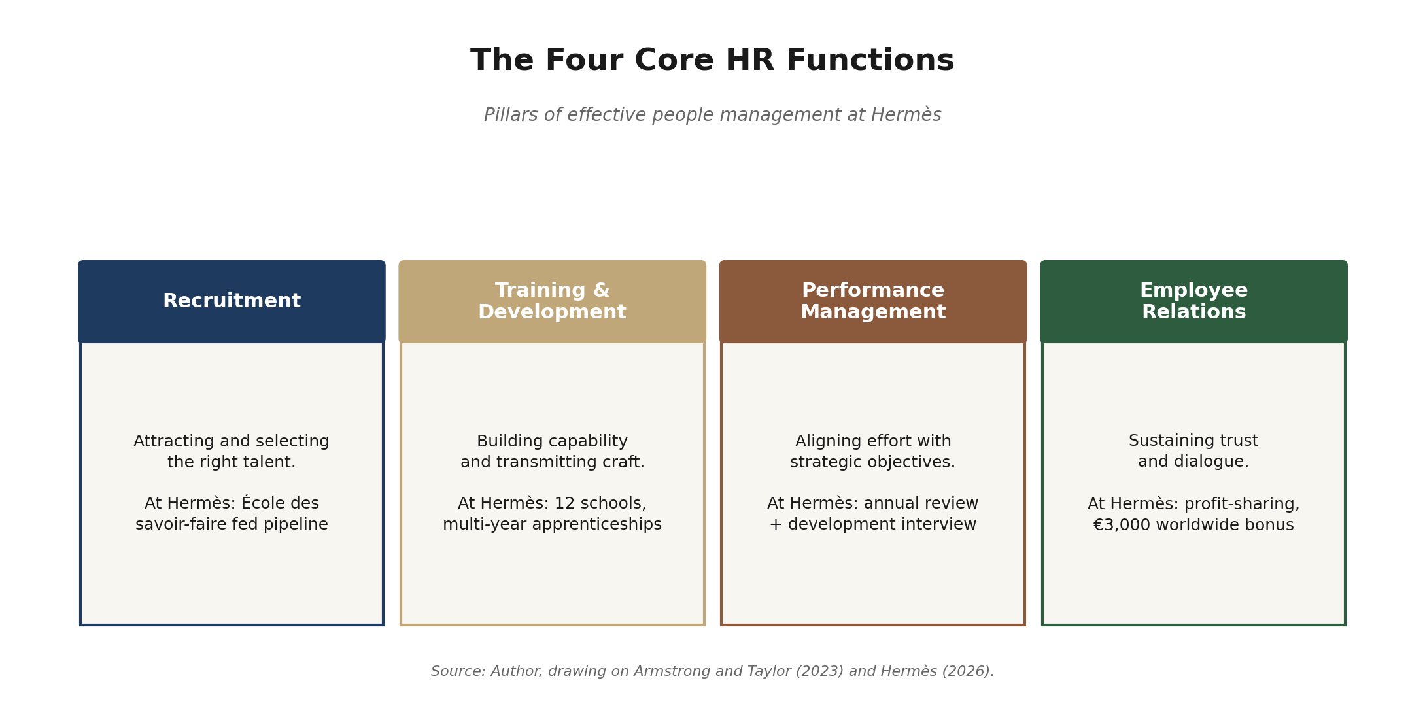

Figure 2: The four core HR functions and their expression at Hermès. Source: Author, drawing on Armstrong and Taylor (2023) and Hermès (2026).

1.3 Report Structure
This report is divided into five sections. The second section presents an introduction to the PESTLE analysis model, examines the strengths and weaknesses of using it as an environmental scanning tool, and discusses how each of its six elements relates to the HR functions outlined above. The third section introduces Hermès International, provides a description of the company's global HR strategies, and uses information from Hermès's 2025 annual report. The fourth section conducts the analysis, starting with the Political element, followed by the Economic, Social, Technological, Legal, and Environmental elements. The fifth section offers a conclusion and discusses the implications of the results for the future.

2. Internal and External Environment

2.1 The PESTLE Framework

PESTLE analysis refers to a strategic planning approach designed to perform an effective environmental scan. Initially created by Aguilar (1967), the method was later revised into its present six-element format by modern strategists (Johnson et al., 2020). Using PESTLE analysis, executives are tasked with identifying the Political, Economic, Social, Technological, Legal, and Environmental drivers that define the macro-environment within which an organisation operates. Every component represents a unique set of variables. The political aspect relates to the issues of political stability, foreign policy, elections, international trading conditions, and labour market policies. The economic element refers to the issues of economic growth and decline, rates of inflation and unemployment, and foreign exchange rates, among other costs related to conducting business operations. Social issues refer to demographic factors, cultural influences, social values, lifestyle changes, and consumer behaviour. The technological aspects are associated with rapid innovations, digital technologies, and automation capabilities. The legal elements encompass laws, regulations, employment laws, data privacy and protection, and health and safety requirements.
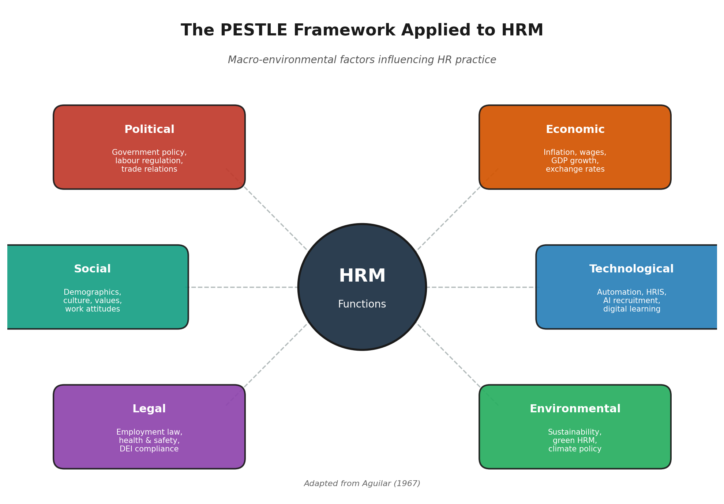
Figure 1: The PESTLE framework applied to HRM. Adapted from Aguilar (1967).

2.2 Usefulness and Limitations

Pestle is extensively applied due to its simplicity, completeness and applicability in comparing nations across the globe. PESTLE motivates the management to think outside in terms of opportunities and threats facing the firm, rather than inside in relation to internal strengths and weaknesses. In addition, the technique matches perfectly well with other internal approaches like SWOT, making it an effective way of analysing the strategies (Johnson et al., 2020). PESTLE's checklist nature is another advantage that has made it applicable in consultancies and HR (CIPD, 2024).

It should be recognized that the model itself suffers from some shortcomings. First, it is claimed that PESTLE offers only a static picture but fails to provide a dynamical approach towards interactions among factors; secondly, this framework heavily depends on the decision-making of analysts and fails to account for interrelation of the identified factors (Sammut-Bonnici and Galea, 2015). Furthermore, the model can lack focus on more micro-oriented aspects, such as a competitive strategy or the bargaining power of suppliers, hence, experts suggest the use of PESTLE combined with Porter's Five Forces Model or the SWOT analysis (Johnson et al., 2020). Finally, it is likely that PESTLE will fail to recognize employees as key actors in HR management, rather than passive subjects that have to deal with macroeconomic and political forces affecting organizations, thus, the use of this framework within HR implies the risk of considering the influence of macro-forces over the workforce only.

2.3 Linking PESTLE to HR Functions

Every PESTLE element impacts at least one key HR activity, and most impact more than one. The political environment determines the laws governing immigration, business relationships, and the political favouring of foreign workers, and therefore impacts the recruiting process of multinational corporations (Brewster, Mayrhofer & Farndale, 2018). Political turmoil, such as during election periods and policy changes, leads to uncertainty in labour force planning, while favourable industrial policies (like those in France concerning apprenticeships) facilitate training programs.
Economic trends influence how pay policies are set, recruitment numbers, and employee turnover rates. Inflation and wage inflation impact salary budgets, and unemployment rates affect negotiation capabilities. The fluctuations in foreign exchange rates make it challenging to coordinate reward strategies, particularly for HR professionals who must ensure pay parity across borders (CIPD, 2024). Recessions typically result in reduced training budgets, whereas periods of economic growth favour attracting talent.
There is an impact on employee relations and employer brand management owing to social factors. The emergence of new generations, such as the rise of Generation Z employees in the workplace, is one of these factors, where the Deloitte Gen Z and Millennial Survey for 2024 highlights that purpose and learning are key factors when choosing an employer (Deloitte, 2024). Another factor is cultural differences from country to country in terms of giving feedback and rewarding employees. Technological considerations are changing the entire HR value chain using cloud-based HRIS technology, AI-driven recruitment, online learning platforms and people analytics (Stone et al., 2015). This can greatly enhance efficiency, but there are also issues around algorithmic bias, surveillance and data protection that must be considered.
Legal considerations establish the minimum standards for HR through the laws on employment and discrimination, data protection laws such as GDPR, and country-by-country health and safety standards (Collings, Wood and Szamosi, 2018). The latest pay transparency regulations passed across both Europe and several US states are examples of new regulations that have been adopted (SHRM, 2024). Environmental considerations become increasingly important in HR as HR departments begin measuring environmental impact in addition to other performance metrics, and as HR becomes more involved in helping the company manage its environmental responsibilities (Renwick, Redman and Maguire, 2013). Together, the considerations give a manager useful criteria for determining what external threats or opportunities exist.

3. Organisation Application: Hermès International

3.1 Hermès at a glance

Hermès International is a luxury French company founded in Paris in 1837 as a saddles and harness manufacturer, and currently engaged in the production of products within fourteen creative disciplines such as leathergoods, clothing, watches, perfume, silk, etc. (Hermès, 2026). It employs 26,494 workers, including 16,349 employees working in France, and operates in more than fifty countries with a unique distribution system consisting of about 300 stores run by the firm (Hermès, 2026; Statista, 2024). For 2025, Hermès achieved consolidated sales amounting to €16 billion, reporting a double-digit increase in sales in Europe, Japan, Americas, and the Middle East, thus proving its title as a leader among other luxury brands (Hermès, 2026). As regards regions, the Asia-Pacific region accounts for almost half of the total sales, and Japan becomes one of the strategic markets of the company.

Figure 3: Hermès' global retail presence is built on around 300 directly managed boutiques. Source: Tripadvisor (2026)
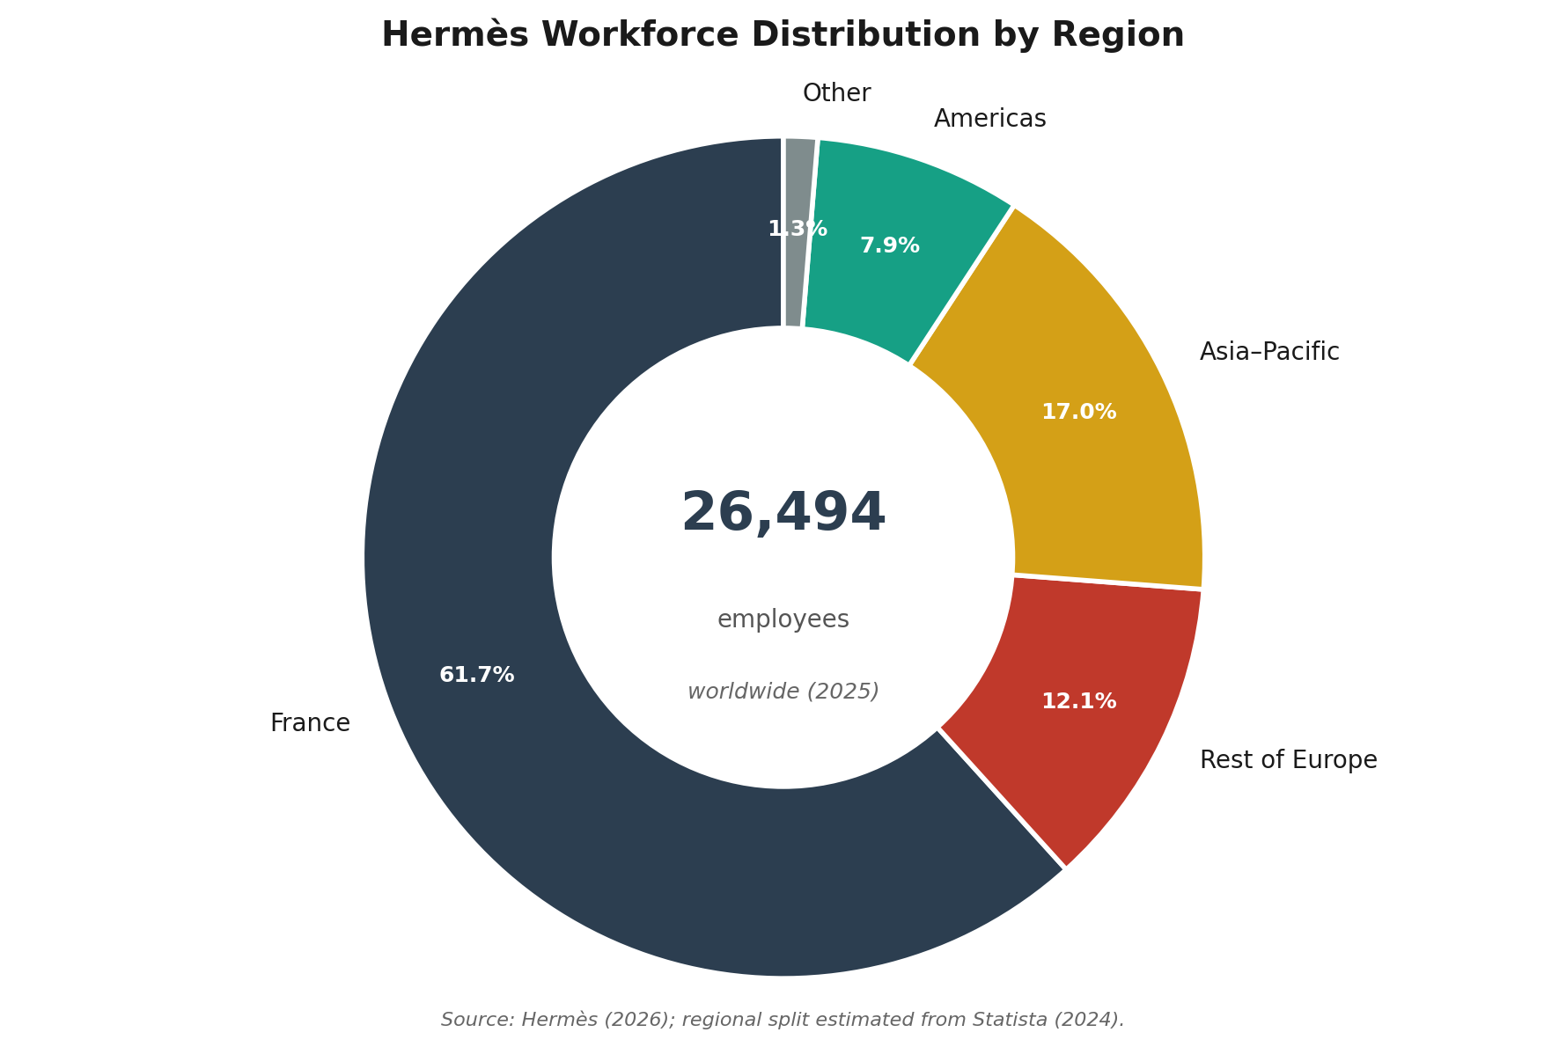
Figure 4: Hermès' workforce distribution by region (2025). Source: Hermès (2026); regional split estimated from Statista (2024).

3.2 Global HR Practices
The human resource practices of Hermès reflect the company's heritage as an artisanal firm. In France, hiring focuses largely on artisans and is supplemented by the school École Hermès des savoir-faire, an internal, state-approved center for apprentice education that prepares applicants for the national certification exam for the CAP Maroquinerie diploma in leather crafts. The École now operates out of twelve centres across France and admits applicants from diverse backgrounds, most of whom lack previous experience working with leather items (Hermès, 2026; CPP-Luxury, 2022). Apart from apprenticeships, Hermès has consistently invested in manufacturing in its regions, such as at its newly established factory at Les Andelys in Normandy, which will source labour from local leather workshops and the École (Hermès, 2026). Training and development focus on the long-term acquisition of skills, with performance management relying on the yearly performance evaluation that may be supplemented by mid-year review meetings along with the yearly development interview where individual career goals are reviewed (Hermès Finance, 2025). Employee relations consist of profit sharing and free share programs provided to all employees worldwide, done six times during the years 2007-2023. The company paid a bonus of €3,000 to each employee across the globe and a monthly raise of €120 in France in 2025 with overall turnover staying under 6%, while voluntary turnover amounted to 4.35% (Hermès Finance, 2025; Hermès, 2026). Beyond France, customer-oriented HR policies outside Europe such as those in Asia, the Americas and the Middle East concentrate on serving clients better and implementing global HR systems into different labour environments.

Figure 5: Multi-year artisan training underpins Hermès' production model and its in-house apprenticeship pipeline. Source: Hon, J. (2012, September 26). Meet your Hermes Artisans – The Festival des Metiers Recap. NEWS.

4. Application of the PESTLE Model to Hermès' HR

4.1 Political Factors
The political climate determines what HR managers at Hermès are able and unable to achieve internationally. France presents one of the toughest political climates within which HR operations can be performed in Europe, owing to extensive collective bargaining, mandatory employee representation via works councils, and direct government engagement in labour policies (Collings, Wood and Szamosi, 2018). But the French government's renewed interest in apprenticeship policy has, in turn, served as an enabling factor, as the reform in vocational education and training that occurred in 2018 provided Hermès with the legal environment in which the École Hermès des savoir-faire could be accredited as an institution (Hermès, 2026). In Greater China, where the firm’s operations are heavily concentrated in Asia, diplomatic ties between France, the EU and Beijing influence mobility, work permits and the degree of local content pressure on recruitment (Brewster, Mayrhofer and Farndale, 2018). Disputes over excessive spending and anti-corruption drives have historically led to slower sales and a reassessment of recruiting strategies by HR managers in earlier rounds. In the US, a new political agreement about production at home, tariffs and immigration policies is significant to staffing and talent acquisition in the supply chain. Thus, even if there is a global standard in place, such as the company-wide stock ownership plans of Hermès, its application in each country would vary politically (Hermès Finance, 2025).

4.2 Economic Factors
The economic environment can have both positive and negative impacts on the efficiency of Hermès HR. First, the strong level of luxury product demand allows Hermès to employ 6,200 additional staff members within three years and provide substantial remuneration, education, and bonuses (Hermès, 2026). Conversely, the post-COVID inflation rates in Europe and labour shortages in France may increase the costs of employing highly skilled workers. The fluctuating currency values of the euro, American dollar, Japanese yen, and Chinese yuan can affect the costs of HR management activities across regions (CIPD, 2024). The weakness of the Japanese yen, for instance, may decrease the remuneration costs when converted into euros; however, it may reduce the purchasing power of employees in Japan. As a result, HR managers need to formulate compensation schemes that will ensure the protection of real wages in high inflation environments while upholding internal equity across the globe, which was the objective behind the 2025 €120 per month salary increase in France and the global €3,000 bonus (Hermès, 2026). Training expenditure decisions are not only affected by wage trends but also by economic considerations: in a tight labour market, the expenses involved in recruiting a fully trained artisan may surpass those from investing in training over several years.

4.3 Social Factors

From a social perspective, Hermès must navigate generational issues. Young professionals, especially Generation Z members, look for a sense of meaning, flexible employment conditions, and psychological safety at their workplaces (Deloitte, 2024). However, the artisanal approach to crafting at Hermès hinges upon the traditional transfer of knowledge through slow and thorough teaching, which conflicts with quick career progressions. It takes about several years of training for a craftsperson to master the skills necessary to create a Birkin or Kelly bag from scratch. Hence, the École Hermès des savoir-faire is the appropriate HR strategy: the accreditation of a nationally recognised diploma and the acceptance of candidates without any leatherworking background converts a societal risk (decreased motivation to join a skilled trade) into an HR tool that appeals to young workers' desires for meaningful and visible work (CPP-Luxury, 2022; Hermès, 2026). Societal dynamics are also present in customer service-related positions: the company’s policy of fostering long-term relationships with clients in its stores necessitates hiring sales consultants who have excellent knowledge of cultural traditions and languages.

Figure 6: The École Hermès des savoir-faire trains around 450 apprentices across twelve French sites. Hermes (2026

4.4 Technological Factors

Technology is impacting HR operations at Hermès in a less profound way than would be seen in the pure technology sector, but the changes are apparent, nonetheless. The use of cloud computing systems in the collection and analysis of HR information, the use of AI for selection purposes and other online digital platforms is commonplace across luxury retail (Stone et al., 2015). In terms of Hermès specifically, however, the challenge becomes incorporating these tools in a way that allows for the management of its 26,000 staff without disrupting the craft-oriented culture that defines the company. As Hermès Finance states, almost 1,400 internal movements were made by the company in 2025.

Thus, technology must be combined with cultural sensitivity on the part of HR managers. Whereas algorithms can help accelerate the process of recruiting large volumes of retail staff, for instance, it will not help much in finding artisans capable of sensing leather goods. Moreover, whereas online courses may be appropriate for brand education and compliance modules, artisanal skills can only be learned from actual mentoring rather than via digital means.

4.5 Legal Factors
The legal component creates a challenging environment for compliance. Inside the European Union, the General Data Protection Regulation affects the processing and storage of candidate and employee information, while the EU Pay Transparency Directive will compel greater transparency on gender wage differences in the coming years (Collings, Wood and Szamosi, 2018). In France, the profit-sharing provisions of law accord with the voluntary policy at Hermès, but the need for consultations with the works council adds an additional process for any reorganisation.
Elsewhere outside the continent, the proliferation of new state laws in the US, especially around pay equity, non-compete clauses and DEI disclosures, has compelled luxury retailers, like Hermès, to adopt unified salary bands and revise employment agreements (SHRM, 2024). Across Asia, specific laws concerning working hours, severance packages and tax treatment of foreign workers exist in countries such as Japan, the People's Republic of China and Singapore. To the HR manager, the legal component of PESTLE highlights the necessity of having a robust local HR team with the backing of legal expertise in the centre and explains why the global luxury brands favour regional HR centres over centralised arrangements.

4.6 Environmental Factors

The environmental issue has become part of Hermès' HR policy. The company has set science-based emissions reduction goals by SBTi. Additionally, it uses its unique harmony standard in all new locations, with clear implications for HR, including site selection impacting artisan recruitment, building standards influencing workplace conditions, and sustainability metrics becoming an important factor for performance evaluation for leaders (Hermès, 2026; Renwick, Redman & Maguire, 2013). 'Green HRM', sustainable training, green volunteering via Sur les Ailes d'Hermès, and engagement connected to CSR activities have both positive employer branding impact on young talent attraction and raise the bar for HR managers' work (Hermès Finance, 2025). In general, for international HR departments, the environmental dimension is not secondary anymore; it is an integral part of HR activity.

4.7 Country-Specific Differences
These factors manifest themselves similarly but have very different impacts in other countries. In France, the main pressures are legal-political and economic because highly regulated labour relations and narrow artisan labour market conditions mean that HR needs to act through social dialogue and collective agreements, while the political favouring of the apprentice system in France supports efforts like those made by the École Hermès des savoir-faire (Collings, Wood and Szamosi, 2018; Hermès, 2026). In Japan, the most relevant pressures are social; because people are expected to stay in their jobs for many years and because they respect seniority and the company they work for, HR needs to tailor performance management and career paths (Brewster, Mayrhofer and Farndale, 2018). In Greater China, the political and economic pressures are unstable, which means that the actions of the HR department need to be constantly adjusted (Hofstede Insights, 2023). In America, legal changes have been swift in relation to pay transparency and DEI, whereas the social environment favors the branding efforts of employers who prioritize flexibility and inclusion (SHRM, 2024). The cultural dimensions of Hofstede can shed some light on such divergent trends, as power distance and collectivism in certain parts of Asia emphasize group-based recognition, but individualism and low power distance in America and Western Europe encourage individualistic performance-related pay (Hofstede Insights, 2023). As illustrated in Figure 7, there exists great variability in the intensity of each PESTLE pressure in relation to the four main markets of Hermès. For Hermès HR managers, effectiveness is thus contingent upon the concept of 'globally framed, locally executed,' where common values, craftsmanship, transmission, profit sharing, and so forth are transformed into national strategies. The downside of failing to strike this delicate balance between centralization and decentralization lies in a risk of alienating local staff members, violating local legislation, and losing the consistency of the Hermès brand promise.
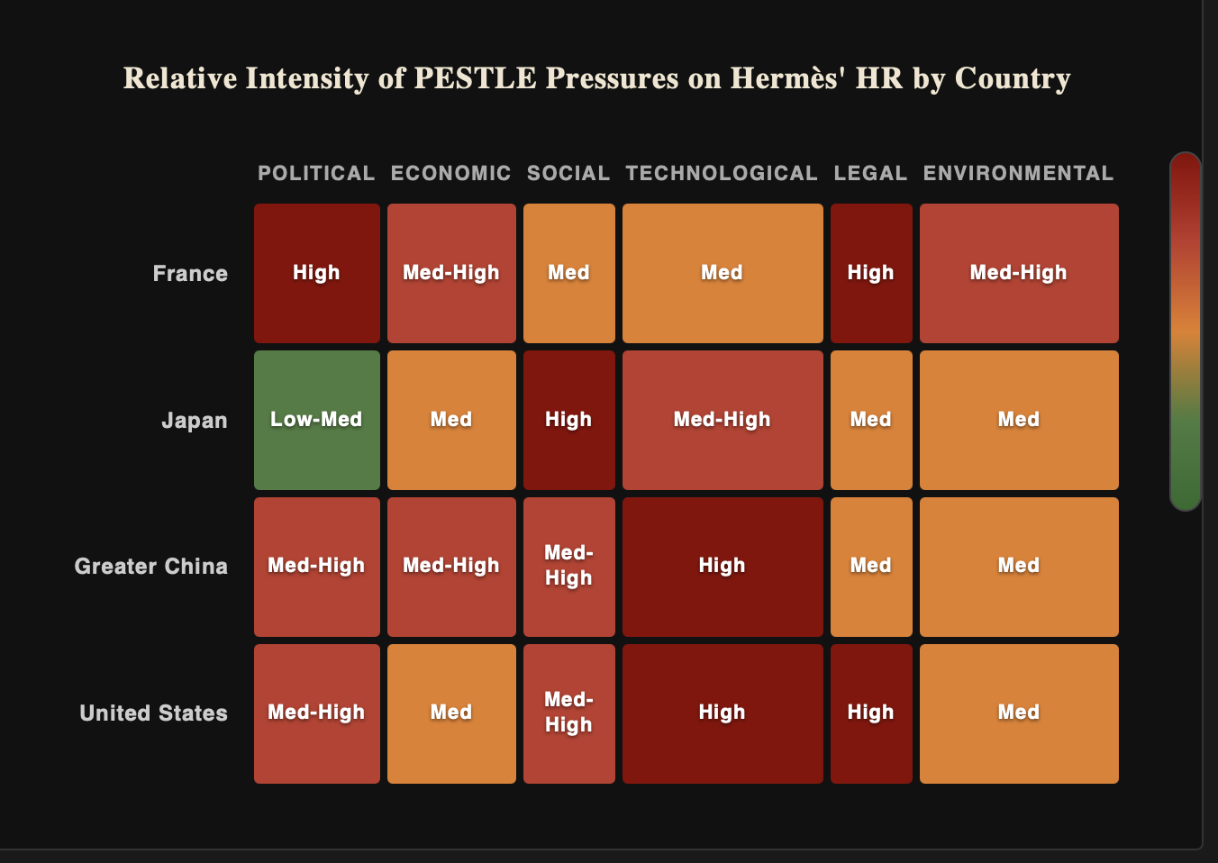
Figure 7: Relative intensity of PESTLE pressures on Hermès' HR by country. Source: Author's analysis based on Brewster, Mayrhofer and Farndale (2018), Hofstede Insights (2023) and SHRM (2024).
5. Conclusion

5.1 Summary

This study has applied Aguilar's (1967) PESTLE approach to assess the impact of the external environment on the effectiveness of HR management at Hermès International. This assessment indicates that the activities of HRM, such as HR management, recruiting, training, performance management, and employment relations, are constantly affected by various political and legal regimes, economic and monetary environments, generations, cultural attitudes, technology, and sustainability concerns. In the context of Hermès, all these issues come together in a unique way, where French labour laws and the effects of inflation affect the pay policy, where changes in demography and culture define the selection process for artisans through the École Hermès des savoir-faire, where technology helps achieve global mobility without losing the human-centric culture, and where sustainability is already part of being a leader and employer branding. Since the country-specific characteristics of culture, laws and regulations, and economy are significantly different between different nations, global HR practices require significantly different means of implementation, especially when it comes to France, Japan, Greater China, and the United States.

5.2 Future Implications
Future challenges for HR managers in multinational corporations will involve integrating three competencies. Firstly, they will require enhanced environmental scanning expertise in such a way that political, legal, and economic threats can be anticipated instead of being experienced; in unstable geopolitical situations, being able to predict recruitment difficulties within six to twelve months could become a legitimate competitive edge. Secondly, they will have to develop HR practices that are truly global, globally harmonized on values, ethics, and incentives, but locally adaptable on processes, communication styles, and labor market realities (Brewster, Mayrhofer and Farndale, 2018). Lastly, they will have to incorporate digital and sustainable competency into standard HR functions in such a way that artificial intelligence and green HRM are aligned with conventional personnel management. With respect to Hermès, in particular, whose competitive strength lies in the long-term transfer of skills, the difficulty that HR will face will be retaining its human core in the face of an ever more volatile environment. The growth of the École Hermès des savoir-faire, profit-sharing globally, and the inclusion of sustainability in key performance indicators for leaders indicate that Hermès is proactively engaging the macro-environment instead of merely adapting to it, an approach that other multinational HR departments may do well to emulate as the lines continue to blur.

References
Aguilar, F.J. (1967) Scanning the business environment. New York: Macmillan.
Armstrong, M. and Taylor, S. (2023) Armstrong's handbook of human resource management practice. 16th edn. London: Kogan Page.
Brewster, C., Mayrhofer, W. and Farndale, E. (eds) (2018) Handbook of research on comparative human resource management. 2nd edn. Cheltenham: Edward Elgar.
CIPD (2024) Labour market outlook: winter 2023–24. London: Chartered Institute of Personnel and Development. Available at: https://www.cipd.org/uk/views-and-insights/cipd-voice/ (Accessed: 26 April 2026).
Collings, D.G., Wood, G.T. and Szamosi, L.T. (eds) (2018) Human resource management: a critical approach. 2nd edn. Abingdon: Routledge.
CPP-Luxury (2022) 'Hermès expands École Hermès des savoir-faire', CPP-Luxury, 4 November. Available at: https://cpp-luxury.com/hermes-expands-ecole-hermes-des-savoir-faire/ (Accessed: 26 April 2026).
Deloitte (2024) 2024 Gen Z and Millennial Survey: living and working with purpose in a transforming world. London: Deloitte. Available at: https://www.deloitte.com/global/en/issues/work/genz-millennial-survey.html (Accessed: 26 April 2026).
Hermès (2026) 2025 Full-Year Results. Paris: Hermès International. Available at: https://finance.hermes.com (Accessed: 26 April 2026).
Hermès Finance (2025) Our teams. Paris: Hermès International. Available at: https://finance.hermes.com/en/our-teams/(Accessed: 26 April 2026).
Hofstede Insights (2023) Country comparison tool. Helsinki: Hofstede Insights. Available at: https://www.hofstede-insights.com/country-comparison-tool (Accessed: 26 April 2026).
Johnson, G., Whittington, R., Regnér, P., Scholes, K. and Angwin, D. (2020) Exploring strategy: text and cases. 12th edn. Harlow: Pearson.
Renwick, D.W.S., Redman, T. and Maguire, S. (2013) 'Green human resource management: a review and research agenda', International Journal of Management Reviews, 15(1), pp. 1–14.
Sammut-Bonnici, T. and Galea, D. (2015) 'PEST analysis', in Cooper, C.L. (ed.) Wiley encyclopedia of management.Chichester: Wiley, pp. 1–7.
SHRM (2024) State and local pay transparency laws: 2024 update. Alexandria, VA: Society for Human Resource Management. Available at: https://www.shrm.org/topics-tools/employment-law-compliance (Accessed: 26 April 2026).
Statista (2024) Distribution of employees of Hermès worldwide in 2023, by geographical region. Hamburg: Statista. Available at: https://www.statista.com/statistics/245927/ (Accessed: 26 April 2026).
Stone, D.L., Deadrick, D.L., Lukaszewski, K.M. and Johnson, R. (2015) 'The influence of technology on the future of human resource management', Human Resource Management Review, 25(2), pp. 216–231.

