BMSW6104 Strategic Management for SMEs
Name of the Student: Ionut Razvan Gradinaru
Student ID: 1906093
Name of the University: University Of Wales Trinity St David
Academic Year: 2022-2023
Executive Summary
Strategic management refers to the modification of the internal operational and planning infrastructure of a business to positively influence its market position. Strategic management can sometimes be the resolution of certain criticality faced in the market. Moreover, stagnant growth and financial overhead cost can also influence the necessity of strategic management. The report has conducted a study on Aamchi Mumbai; an Indian-Chinese restaurant in Manchester. The internal operational factor of the company has been discussed in the first portion of the report. The internal and external environmental analysis has been conducted using PESTLE and SWOT analysis. The report has also discussed the resource, competence, and strategic capability of the restaurant in the following portion. Furthermore, stakeholder mapping and its importance has been constructively discussed in the report. The corporate-level strategy and strategic evaluation courses have been investigated in the final portion of the report.

Table of Contents
1. Introduction 4
2. Strategic management in different contexts 4
2.1 Corporate level strategy 4
2.2 Business level strategy 5
3. Strategic management in practice 6
3.1 Strategic position 6
3.2 Strategic choices 6
3.3 Strategy into action 6
3.4 Development processes 7
4. Strategic analysis 7
4.1 PEST Analysis 7
4.2 BCG Matrix 9
4.3 Porter's Five Forces Framework 11
4.4 Definition of strategic groups 12
4.5 Description of critical success factors 13
5. Resource, competence and strategic capability 14
5.1 The strategic importance of resources 14
5.2 Description of core competencies through VRIO Framework 15
5.3 Understanding organisational capabilities using SWOT and TOWS matrix 16
5.3.1 SWOT Analysis 16
5.3.2 TOWS matrix 17
6. Stakeholder expectation and organisational purpose 19
6.1 The importance of governance stakeholder mapping 19
6.1.1 Governance stakeholder mapping 20
6.2 Ethical Issues and the Impact of governance stakeholders on strategic development in Aamchi Mumbai 21
7. Business-level strategy and different methods of achieving sustainable competitive advantage 22
7.1 Porter’s Generic Strategy 22
7.2 Different Methods of achieving sustainable competitive advantage 23
8. Corporate-level strategy 25
8.1 Product Diversity 25
8.2 International Diversity 25
8.3 Corporate parenting roles 26
8.4 Portfolio management 26
9. Strategic evaluation and selection for various strategic development methods 27
9.1 Internal 27
9.2 Acquisition 28
9.3 Alliance 28
10. Conclusion 29
Reference List 30

1. Introduction
The report aims to describe The strategic management for small and medium enterprises, especially in the UK. Aamchi Mumbai which is situated on Gatley Road will be selected here to describe strategic management in different contexts like business-level strategy and corporate-level strategy. According to Aamchi Mumbai (2020), Aamchi Mumbai serves the most popular Indian dishes such as butter chicken, onion bhaji, paneer jalfrezi, along with biryani, tandoori and dessert items. This restaurant is available for accepting online and telephone orders. According to Aamchi Mumbai (2020), they also deliver to the customer's home within a 2-mile radius only on Friday and Saturday. This restaurant has a 4.5 rating on Tripadvisor and is mostly known for its food, services and atmosphere. Furthermore, The report will describe the strategic management in practices and strategic analysis that will include PEST Analysis, BCG matrix, Porter's 5 Forces Framework along with the definition of strategy groups and critical success factors for the organisation. Both the SWOT and TOWS matrix will be used to evaluate the capability of the organisation whereas VRIO Framework will be used for describing their competencies. Additionally, the report will include business-level strategy and corporate-level strategy. The strategic evaluation and selection will be demonstrated through various development methods as well.

2. Strategic management in different contexts

2.1 Corporate level strategy
A corporate-level strategy refers to the multi-level strategy that could be employed by a company for defining its business goal. Additionally, it also refers to the company’s structure which helps to attain the goal. According to to Think Insights (2020), the nature and size of the business are important to develop its corporate strategy that aims to increase its profit, and revenue or expansion to a new location. Aamchi Mumbai is located in Cheadle and has great options for expansion to other locations in the UK. The corporate-level strategy of this restaurant includes serving vegetarian-friendly and gluten-friendly options for their customers along with various non-vegetarian dish options. Additionally, excellent service could help them to achieve a profitable allocation of their manpower and financial resources. Corporate level strategy is also important to get a larger company overview which will help them to rearrange the organisation as well. The restaurant follows a stable corporate strategy and is satisfied with its current market position.

2.2 Business level strategy
Business strategy refers to the strategic initiative pursued by the company to add value to its organisation along with its stakeholders. According to Creately (2019), a proper business strategy helps the company to achieve a comparative advantage in the current business market; henceforth, it is crucial for the success of the company. Business-level strategy determines different business factors such as suppliers, price, recruitment of employees and allocation of resources. Aamchi Mumbai is a small restaurant that has a few employees and they provide excellent service; this has become the business strategy. The price of the products they serve is quite high and they also maintain the quality of those products by supplying freshly prepared food to the customers. Being a small restaurant, they do not invest much in employee recruitment but they arrange frequent training for developing the capability of their employees. According to to Think Insights (2020), the restaurant has maintained safety precautions along with a routine cleaning to ensure protection for their employees as well as the customers.

3. Strategic management in practice

3.1 Strategic position
Strategic position refers to the relative position of a specific company within the entire industry. This position reflects the value that could be created by the company itself in a differentiated manner than they are rivals. According to Creately (2019), various restaurants serve multi-cuisine dishes but Aamchi Mumbai serves food prepared with fresh ingredients through dine-in, home delivery and take-out options. During the nationwide lockdown, restaurants offered their delivery service to the local community along with complimentary meals.

3.2 Strategic choices
Strategic choice refers to the decision undertaken by the farm about its future strategy. The future strategy of Aamchi Mumbai will determine the current situation evaluated by PEST analysis and SWOT analysis. Understanding the strength and weaknesses of the firm is important to determine the strategic choice of Aamchi Mumbai. This restaurant is quite popular on social media like Facebook and Instagram which might indicate the expansion of the operation to other areas.

3.3 Strategy into action
The strategy into action of Aamchi Mumbai could include the development of its menu into a multicuisine restaurant which not only serves Indian food but other dishes as well. According to Aamchi Mumbai (2022), the other dishes will include Italian dishes, Chinese dishes and British popular dishes as well. Aamchi Mumbai needs to hire talented local people for delivering their strategic choice into action. Additionally, they need to be determined that this idea would be implemented within the next 6 months.

3.4 Development processes
The process of research and identification of strategic options along with selecting the most promising won is called the development process. According to ‌Tripadvisor (2023), Aamchi Mumbai could develop its products and services by providing various kinds of Indian dishes rather than the foods of Mumbai. Adding several other breakfast and beverage options to the menu of the restaurant could make their development process significantly. Creating a meal package system or platter system will in hands the value of the company as well.

4. Strategic analysis

4.1 PEST Analysis
Factors | Description | Impacts
Political | - According to Boyles (2022), Brexit has caused an increase in labour costs in the UK by 1.3% in 2019.  - The recent instability in the UK has caused uncertainty for food businesses such as restaurants. | Increased labour costs and recent instability in the country could disallow Aamchi Mumbai to expand its service to other locations in the city itself.
Economic | - According to Harvard Business School (2023), the revenue of the food service industry was £78 billion in 2019 in the UK.  - The recent changes in the administration of the UK require planning how to deal with a soaring labour shortage, inflation and increasing interest rates in the country.  - According to Harvard Business School (2023), a British household spent £5 per week on average for eating out in a restaurant. | According to Aamchi Mumbai (2022), the growing revenue of the food industry could provide the potential for the restaurant to deal with other problems. Additionally, the newly-elected government needs to take action on reducing inflation as well.
Social | - British people visit restaurants 1.5 times a week which indicates a fondness for restaurants among the people.  - According to Boyles (2022), British people spend 25% of their annual income on eating out in a restaurant or on home delivery from their preferred restaurant.  - British people prefer old-fashioned English pubs and Chinese, Indian and Italian types of restaurants. | Aamchi Mumbai serves Indian food which is preferred by the British people after English and Chinese food. Frequent visits the British people to the restaurant could create a great opportunity for Aamchi as well.
Technological | - Various restaurants are pairing up with food service applications like Uber Eats, Deliveroo and others as people like to take home delivery using their smartphones.  - According to ‌Aamchi Mumbai UK (2020), the accounts of the restaurants are being managed by different software like Sage Business, QuickBooks and many more. | All the new technological facilities offered by the restaurant henceforth would be fruitful for the product development of the company as well.
Table 1: PEST Analysis for Aamchi Mumbai
(Source: Author)

4.2 BCG Matrix
Question marks  - The products which have an uncertain future belong to this category because of their low market share in a fast-growing market. Items like Peroni, gulab jamun, ras malai and others are quite popular in the country but these products are not being sold as the restaurant owner has expected. Similarly, alcoholic and nonalcoholic beverages are also question mark items but it has the potential to become star product if they gain great market share. | Stars  - Star products refer to high-growth and high-share products. A dominant market share with a rapid growth rate would be seen for lamb bhuna, Goan fish curry, butter chicken, kadai chicken, chicken tikka masala and palak paneer. According to ‌Aamchi Mumbai UK (2020), these items are responsible for generating huge revenue for the restaurant and require a lot of investment to maintain their quality and cells as well. These products could be turned into cash cows if they maintain their good position by generating a lot of revenue for Aamchi Mumbai.
Dogs  - Dog products have a low market share and generally, they operate slowly in a growing market. According to ‌Food Standards Agency (2022), vegetarian items like tadka dal, dal makhani, bhindi masala, aloo gobi and baingan bharta are dog products at Aamchi Mumbai. These products generate negative returns because most people do not like these vegetarian items. Henceforth it only drains the human and financial resources of the restaurant. | Cash cows  - Cash cows refer to the products which have a high share and low growth henceforth these products are the most profitable to the business. Aamchi Mumbai has different products that are liked by the people and they order those the most. Different kinds of biryani, lamb gosht, kabab and sizzler items are quite popular in the restaurant. These items do not cost much but ensure income for the restaurant.
Table 2: BCG Matrix for Aamchi Mumbai
(Source: Author)
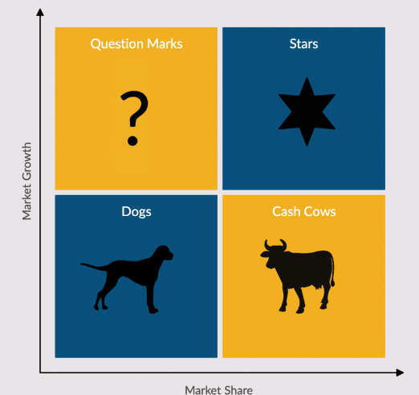
Figure 1: BCG Matrix
(Source: Harappa Education, 2021)

4.3 Porter's Five Forces Framework
Competitive rivalry: The restaurant industry in the UK has very high competition due to the presence of big restaurant chains along with coffee shop chains. According to Porter’s Analysis (2018), Edison Bar, MyLahore Manchester, The Mess Cafe and many more restaurants there in Manchester City could provide intense competition for Aamchi Mumbai. The share of the restaurant in comparison to these restaurants is very low because those restaurants have a higher number of outlets and franchises.
Suppliers’ power: The number of suppliers for raw material that helps to prepare foods in restaurants are higher in number. This could include local vendors as well as other supermarket chains. The availability of a higher number of suppliers with similar raw ingredients has reduced the power of the suppliers.
Buyers’ power: The bargaining power of the buyers is an important factor to consider in the market situation. A high buyer power could influence the price of the company's products and services. According to ‌Food Standards Agency (2022), the preference for Indian food is followed by British and Chinese food items, henceforth, Aamchi Mumbai is popular among buyers. Due to the less organisation of the buyers, their power is low in the UK restaurant industry.
The threats of new entrants: The UK has a moderate level of difficulty to open a new restaurant if they follow the hygiene guidelines and issue a licence. According to Porter’s Analysis (2018), the political stability of the country and the preference of people to eat in restaurants will allow different new restaurants to be set up but it is impossible to reach the height of big restaurant change. Henceforth, the threats of new entrants are low.
The threats of substitute products: Customers could easily switch from one restaurant to another as they could offer different cuisines. According to ‌Harappa Education (2021), the low switching cost of the customers is compromised by their loyalty. However, the restaurant could differentiate its products by maintaining their quality to reduce the high rate of substitute products.
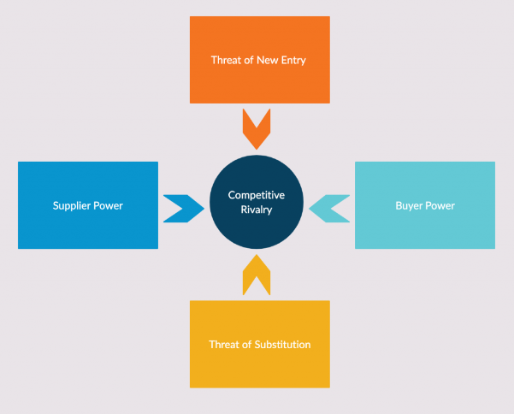
Figure 2: Porter's Five Forces Framework
(Source: Harappa Education, 2021)

4.4 Definition of strategic groups
The firms that follow similar business strategies or models are called strategic groups. It is used to examine the comparative environment in the business and to achieve sustainable computer success in the industry. According to the discussion made in Porter’s Five Forces framework, the level of competition is quite high along with the threats of new entrants. Henceforth, Aamchi Mumbai needs to maintain its strategic position by offering special varieties of the menu to the customers. According to ‌Thomas (2022), the restaurant chains like Edison Bar, The Mess Cafe and others sell food products henceforth all of them will try to capture a greater market share. Thus, strategic groups will be formed to respond to market competition and trends. Additionally, family restaurants, cafes, and fine-dining restaurants could differentiate themselves from each other by providing food at low cost, special offers, a variety of foods and many more.

4.5 Description of critical success factors
Industry factors: These factors indicate some specific characteristics of the food industry in the UK. According to the Food Safety Act 1990, businesses need to remove harmful content and always maintain the quality of the food. Additionally, providing tasty food is another critical success factor of the food industry. The food industry in the UK is competitive henceforth, Aamchi Mumbai needs to maintain its uniqueness and quality service to stay differentiated.
Environmental factors: Maintaining hygiene along with cleanliness is a major factor in getting success. The restaurants in the UK could also take care of recycling and waste management processes to enhance their brand image. Technological advancements like online delivery, and card payment service ordering through websites and applications have been popular environmental factors for the food industry.
Temporal factors: According to EHL Insights (2023), temporal critical factors refer to internal organisational changes which are usually short-lived. Thus, challenges and barriers could be reduced for the business by considering the temporal factors. The inclusion of a research and development team to find out about the variety of new dishes could provide a critical success to Aamchi Mumbai.
Strategic factors: Strategic factors refers to the competitive strategy of the business. Aamchi Mumbai is the first restaurant that serves the street food of Mumbai in Manchester City. The restaurant offers moderately priced dishes to the customers and it is known for its excellent food and service. According to ‌Thomas (2022), the cosy atmosphere along with a minimum space between the tables at the restaurant has allowed them to maintain privacy as well as hygiene during the post-pandemic period.

5. Resource, competence and strategic capability

5.1 The strategic importance of resources
Products and services: Aamchi Mumbai serves a variety of Indian dishes like butter chicken, paneer items, biryani and tandoori. The restaurant delivered to the home of the customers within a 2-mile radius only on Friday and Saturday. They provide gluten-free dishes and vegetarian options to their customers.
Workforce quality: the restaurant has few numbers of staff but they are well distributed in different departments like production, finance, marketing and HR team. According to EHL Insights (2023), these people are well efficient and maintain the quality of their work to provide excellent customer service. Continuous checking on raw materials, handling customer traffic, communicating with the marketing team for pricing strategy and hiring new people are some common responsibilities of these people to maintain their workforce quality.
The uniqueness of food: The food of Aamchi Mumbai is unique because they provide sizzlers, Tandoori starters, biryani, vegetarian items, pieces of bread, desserts, alcoholic drinks along with some non-alcoholic drinks as well. According to Moeuf et al. (2020), this variety is unable to be provided by most Indian restaurants in the UK because of the unavailability of raw materials.
Efficient order processing: People could order online and through telephone calls at Aamchi Mumbai. Thus, they would get prompt and quick customer service.
Strong management: The management team at the restaurant is composed of the board of directors in three senior managers. All of them are responsible for a holistic change of service to the restaurant. Additionally, kitchen staff and front house staff are well-informed about the special menu, enough supply of raw materials and customer traffic as well.
Marketing and communication: According to Moeuf et al. (2020), the marketing department actively and effectively promotes the restaurant on social media platforms such as Instagram and Facebook. Continuous posting about the new offers and dishes on social media has enabled the restaurant to get over 3,000 likes on Facebook as well.

5.2 Description of core competencies through VRIO Framework
Components | Valuable | Rare | Inimitable | Organised | Competitive Advantage
Products and services | Yes | No | No | Yes | Moderate competitive advantage.
Workforce quality | Yes | No | No | Yes | Moderate competitive advantage
Uniqueness of food | Yes | Yes | No | Yes | High competitive advantage
Efficient order processing | Yes | Yes | Yes | Yes | Long-term competitive advantage.
Strong management | Yes | No | Yes | Yes | High and long-term competitive advantage.
Table 3: VRIO Framework for Aamchi Mumbai
(Source: Author)
Evaluation: The above framework depicts the valuable resources of Aamchi Mumbai through the VRIO Framework. All these components are not rare but provide a high to moderate competitive advantage to the restaurant (Teece, 2019). These basic resources need to be maintained and organised to get a sustainable competitive advantage by Aamchi Mumbai. Most restaurants do not have an efficient ordering process but for this, Aamchi Mumbai would get a long-term competitive advantage.

5.3 Understanding organisational capabilities using SWOT and TOWS matrix

5.3.1 SWOT Analysis
Strength  - The three senior managers, kitchen staff, front house staff, accounting and IT team all are well trained making their service prompt and excellent.  - A variety of Indian street food menus with great taste demonstrate the restaurant's strength.  - According to ‌Tripadvisor (2023), using freshly prepared items and prompt delivery service within a 2-mile radius have proven their strength. | Weakness  - The price of the products is quite high compared to the other British and Chinese food available in the other restaurants in the city. These could keep Indian visitors away because these items are available in India at a comparatively lower price (Ferlie and Ongaro, 2022).  - Increasing labour cost in the country after Brexit has obstructed the path of recruiting people from overseas.  - Small space and availability of the restaurant only in Manchester city have prevented the people in nearby cities from tasting its dishes. It reduces the number of customers for the restaurants as well.
Opportunities  - Special offers along with a rooftop dining experience could attract more customers to the restaurant.  - They could develop a research and development team who will research the variety of Indian food and will find out the way to prepare them uniquely in the restaurant (Bogers et al., 2019).  - Expanding the area of service with a small amount of delivery fee could allow them to create a strong customer base. | Threat  - Aamchi Mumbai has only a single outlet in Manchester City and being a small restaurant they can't expand their number of outlets in other cities (Henry, 2021).  - Covid-19 and the recent inflation have soared the price of raw materials along with labour costs.  - Big restaurants like Edison Bar, MyLahore Manchester, and The Mess Cafe along with the outlets of Starbucks and others have provided a strong rivalry to Aamchi Mumbai.
Table 4: SWOT Analysis for Aamchi Mumbai
(Source: Author)

5.3.2 TOWS matrix
TOWS MATRIX | Opportunities | Threats
Strengths | - The efficient managers, front house staff, kitchen staff, HR, Marketing, Finance and IT department could help to develop the area of service of Aamchi Mumbai to the nearby cities like Salford, Stretford, Middleton and even in London (Fuertes et al., 2020).  - British people prefer Indian food because of its excellent taste and the use of spices. Providing special offers will enhance not only the sales of these food products but also ensure greater revenue for the restaurant. | - Aamchi Mumbai needs to pay higher wages to their staff because of the increasing labour cost in the UK after Brexit.  - The restaurant charges a slightly higher amount of money for providing Indian street food. They ensure the quality as well as the freshness of the ingredients which are being used for preparing the food. The high price of the food could impact the strength of the restaurant as well.
Weaknesses | - Increasing labour costs will prevent the restaurant from hiring people from different regions especially from outside the UK. Human power is necessary to open new restaurants in other locations. Thus, their opportunity could be hampered by the increasing labour cost (Peixoto et al., 2022).  - The restaurant does not have a research and development team to find out about unique Indian dishes. Additionally, the small space has prevented a greater number of customers from entering the restaurant at the same time. | - Having only one outlet does not allow the restaurant to serve a greater number of people especially those who stay outside Manchester City.  - The slightly high price of the food products compared to the Chinese and British food items in the UK has prevented people outside Manchester City from coming to the restaurant and getting service from them. Additionally, increasing labour cost And the increasing price of raw materials due to inflation has impacted their profit negatively which also prevents them from expanding their outlets to other locations.
Table 5: TOWS Matrix for Aamchi Mumbai
(Source: Author)

6. Stakeholder expectation and organisational purpose

6.1 The importance of governance stakeholder mapping
- Strategic direction: According to Shim et al. (2021), governance stakeholders like administration, senior management, and directors of Aamchi Mumbai determine the innovation in recipes, use of technologies in the kitchen, online presence, investment for new suppliers, new marketing outlook or use of sustainable materials in the restaurant, as well as other decisions.
- Financial oversight: Financial oversight and payable and receivable accounts of the company can only be analysed by the governance stakeholder of the company.
- Operation management: Changes in the activity infrastructure of the day-to-day operation of Aamchi Mumbai are handled by the kitchen staff and senior management in the company.
- Customer service: Customer service, fulfilling their needs, waiting for logistics, delivery conveniences, and many other factors are also decided by the front-house staff along with senior management in the restaurant.
- Regulatory compliances: According to Shim et al. (2021), Food Safety Regulations, Employment Laws, Licensing of the Kitchen, and Environmental regulations from the Department of Business, Energy & Industrial Strategy (BEIS) are aided by Aamchi Mumbai.
Table 6: Importance of governance stakeholders
(Source: Author)

6.1.1 Governance stakeholder mapping
Stakeholders | Description | Influence Level | Interest Level
Board of Directors | According to Mircheva et al. (2020), the board of directors decides where to invest, decision-making on strategic infrastructure, maintenance cost optimisation, supply-resourcing operations and many more. The Board of directors are also responsible for the holistic change of service in a restaurant like Aamchi Mumbai. | High | High
Senior Management | Senior management is responsible for the day-to-day operation modification in Aamchi Mumbai. There are 3 senior managers in the restaurant. | High | High
Kitchen staff and Chef | The kitchen staff and chef decided on the day-to-day special menu items. They investigate if the supply is enough to go for another week. Otherwise, kitchen staff contracts the suppliers to refill the inventory. | Low | High
Front-house staff | The front-house staff handles the customer traffic in the restaurant and communicates with the marketing team for a marketing boost. | Low | High
Accounting and IT team | According to Mircheva et al. (2020), the accounting and IT team evaluates if the inventory is enough to break even and communicate with the marketing team for pricing strategy. The sales value and resource allocations are modified by the decision of the accounting staff. | High | Low
Marketing and HR team | The marketing and HR team effectively promote the market recognition of Aamchi Mumbai. The hiring process of new kitchen staff and training programs are the major responsibilities of the HR team. | Low | Low
Table 7: Stakeholder Mapping
(Source: Author)
Keep Satisfied  Accounting and IT team | Manage Closely  Board of Directors, Senior Management
Minimum Effort  Marketing and HR team | Keep Informed  Kitchen Staff, Front-house Staff
Table 8: Stakeholder Matrix
(Source: Author)

6.2 Ethical Issues and the Impact of governance stakeholders on strategic development in Aamchi Mumbai
Food safety and hygiene are the most important ethical issues in a running restaurant business. Aamchi Mumbai has handled the hygiene issue proficiently for the last five years in a row. The company has a high retention rate with 11 employees working in the last 2 years. The restaurant didn't have to change any staff or employees during these two years. The intrinsic and extrinsic valence and instrumentality need to achieve the motivation index for the activation of ethical expectancy. According to Collins et al. (2019), the internal stakeholder in the company has the most hold on the ethical issues regarding how the service is being projected and how the income is being distributed.
The administration and higher management staff determine if the food safety and hygiene value is required to be boosted or not. The licence renewal operations and contract renewal decisions are also taken by the senior managers in Aamchi Mumbai (Harvard Business Review, 2020)‌.
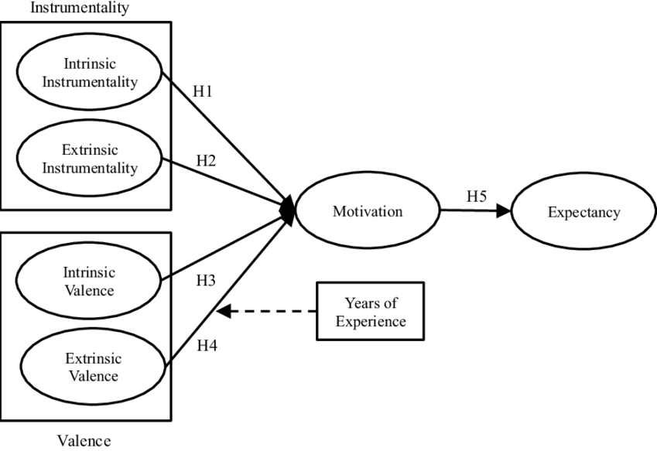
Figure 3: Strategic Moderation of a Business
(Source: Siering and Janze, 2019)

7. Business-level strategy and different methods of achieving sustainable competitive advantage

7.1 Porter’s Generic Strategy
Business-level growth requires proper identification of market growth directives. Aamchi Mumbai is a high-hygiene value restaurant in the Manchester locality. Aamchi Mumbai is one of the top 10 Good Food Guide restaurants according to the ranking in 2017. Therefore, the restaurant has a reputation maintained in the locality. Therefore, the restaurant needs to increase its product margin and diversity for better market capture.
Cost Leadership  Aamchi Mumbai needs to increase the variety of Indian dishes to circulate the temporary waste. Many other recipes allow the reuse of oil, fries, vegetables and spices used in Indian dishes without compromising hygiene (Harvard Business Review, 2020)‌. This can allow more food orders and less waste with streamlining opportunities. | Differentiation  According to Collins et al. (2019), differentiating the beverages, breakfast and dessert items can allow the restaurant to diversify its menu. Since Aamchi already serves Chinese food, availing of continental food cannot significantly disrupt the image of the restaurant.
Focused cost Strategy  Aamchi Mumbai needs to focus on niche markets such as office goers and daily takeout customers for the focused cost strategy. Narrowing down the cheap items and most sale items can allow the restaurant to minimise the cost even further. This can upscale the daily sales of these items along with the opportunity for regular inventory recirculation. | Focused Differentiation  Some strategic items like Biryani, Mughlai, Lassi, and Thali are required to be differentiated based on focused customer groups. Aamchi has witnessed high-value half and full-plate orders in these items. Creating packages for these items with different tastes and meat varieties can attract more customers to the restaurant.
Table 9: Porter’s Generic Strategy
(Source: Author)

7.2 Different Methods of achieving sustainable competitive advantage
Offering a rooftop Dining experience: According to Ozdemir (2020), the rooftop experience has become extremely popular in the United Kingdom. According to national statistics, there are more than 30,000 roof-top restaurant sites in the United Kingdom. Aamchi Mumbai is located on a house-owned property. The first and second floor of the property is not being used currently for major issues except inventory management. According to Ozdemir (2020), around 41% of the customers in the UK tend to focus on the dining experience before going to any restaurant. This can significantly change the customer traffic in the restaurant. With an intricate experience, Aamchi Mumbai can attract both local and travelling customers.
Promoting the high-quality and hygiene standards of Aamchi Mumbai: Promoting the hygiene standard is essential for direct marketing strategies. Keeping the restaurant separated from the niche market is the major foundation of market recognition. Aamchi Mumbai needs to constantly maintain and promote its high-quality standards. This can be promoted in social media vlogs and marketing content. The pamphlet and online order receipts can also be used for promoting the hygiene standard of the restaurant.
Digital Infrastructure for Facilitating and performance monitoring: According to Ketchen and Craghead (2020), changing the entire infrastructure online can allow the restaurant to minimise footsteps, and staff-countering each other in the hallway. Billing and order number queues can allow the customers to stay engaged while waiting. Moreover, the logistics and customer repeat orders can be tracked with the digitisation of service. This can enhance the logistics and aid in the further strategic decision of the company as an informative material.
Community engagement: The community engagement programs in an Indian restaurant need to promote awareness of Indian families, natives, and students in the locality (Harvard Business Review, 2020)‌. Furthermore, collecting funds for the education, and health services of the needed people can allow customers to get a good image of the restaurant.

8. Corporate-level strategy

8.1 Product Diversity
According to Brewer and Sebby (2021), there are certain continental cuisines an Indian restaurant can have to diversify its product and maintain supplier consistency, waste management as well as optimised operation cost.
New food with the same cooking equipment: Primarily, Aamchi Mumbai needs to sort out recipes that do not require new cooking equipment. This can optimise the cost of the investment for buying new equipment.
Indo-Chinese cuisine: Indo-Chinese cuisine has 21% popularity in the Manchester locality. Therefore, it can be a feasible idea for the streamlined revenue strategy for Aamchi Mumbai.
Scottish breakfast and American desserts: Breakfast and dessert menus are easily diversified without any cost of equipment. Aamchi already has a fryer and refrigeration unit to handle any new dessert or breakfast recipe.
Use of food supply to the maximum: Moreover, the restaurant needs to understand which items are wasted regularly and focus on dessert, breakfast, and main course items that can reuse the extra cutouts of the food products.

8.2 International Diversity
Aamchi Mumbai needs to hire people from different communities and ethnicities to increase the diversity index in the restaurant. According to Press et al. (2020), although the restaurant is primarily Indian, the approach to customer service needs to be inclined toward international standards. having people from different ethnicities can allow the customers to think of Aamchi Mumbai as a diversity-embracing organisation. Moreover, using continental food and recipes from the UK, Europe can further interest foreign tourists. The review from foreign tourists enhances the recognition of a company in a market (Harvard Business Review, 2020)‌. Therefore, diversity management in terms of penetrating the needs of international customers can enhance the business profitability and market recognition simultaneously.

8.3 Corporate parenting roles
Corporate parenting can be a viable option for Aamchi Mumbai for its limited market share and disclosure to the market. Associating with bigger food companies or Indian food restaurants in the Manchester locality can enhance the market operation expertise and intelligence of the restaurant. Corporate parenting will help the restaurant better negotiate with suppliers. The associated and synergic relation between bigger restaurant structures can help Aamchi Mumbai gain a competitive advantage against the other franchises and smaller clubs in the locality. The experiential marketing process can also be distributed to allied partners in terms of long-shelf-life products available in the bigger restaurant chains.

8.4 Portfolio management
Market research: The market research of food policies, current market trends, prices, and food varieties are required to be monitored so that Aamchi can convert its menu time-to-time.
Customer service monitoring: Customer service monitoring needs to be handled critically to assess the quality and attention of the customers to the service of Aamchi Mumbai. Since the restaurant is slightly understaffed, the senior managers need to participate in basic customer accommodation (Harvard Business Review, 2020)‌.
Cost and operation management: The cost of supplies and the operation process in Aamchi needs to be handled by the front-house staff and senior management of the company. The kitchen staff needs to frequently communicate the supply and inventory assessment to keep the senior management posted about inventory shortages or excess.
Training and community programs: The Human resource programs in a company increase its value and moral stand in the market. Aamchi Mumbai has a strong hold on the hygiene standards in the locality.
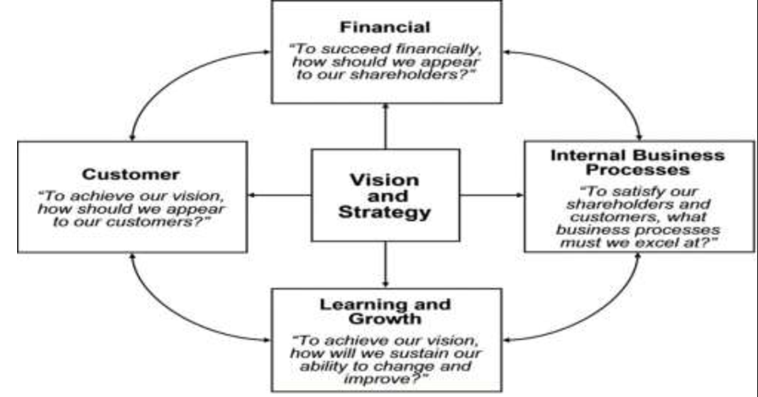
Figure 4: Corporate Portfolio Management
(Source: The Strategy Institute, 2021)

9. Strategic evaluation and selection for various strategic development methods

9.1 Internal
Evaluation includes revisiting the vision and mission statement and the objectives of Aamchi Mumbai for ensuring their relevancy and alignment with the restaurant’s strategic decisions (Martonhouse, 2023). Measuring the supply distribution and customer service performance of the restaurant impacting its day-to-day operations can help to identify the advantages and disadvantages of the restaurant's current strategies. This helps to understand the service capacity and inventory management of the restaurant (Martonhouse, 2023). It also helps to formulate plans for exploring opportunities and eliminating threats. Assessing the competitive positioning of the restaurant in the London market helps to evaluate the resources and capabilities like human resources, financial position and infrastructure. This might help the restaurant to be competitive and establish a strong position in Manchester.

9.2 Acquisition
Defining the strategic objective and reasons for considering an acquisition vividly helps to identify the improvement directive of Aamchi Mumbai. The restaurant is aiming to expand its current restaurant to other big cities in Britain by getting key capabilities, market share, and assets. Conducting research is important for finding potential acquisition targets in the restaurant sector in Manchester (Bragg, 2022). The acquisition targets are required to be aligned with the strategic objectives of Aamchi Mumbai by considering factors like brand reputation, financial performance, and market position. A comprehensive due diligence process is important for assessing the financial, legal, and operational aspects of the potential acquisition targets. This includes reviewing tax records, licences, contracts, permits, financial statements, and human resources.

9.3 Alliance
Alliance objectives are important for the consideration of a strategic alliance. This can help Aamchi Mumbai to achieve its goals through the alliance. Identifying potential alliance partners in the London restaurant market helps align the strategic objectives of the restaurant with the commonly shared goals of the partners. It includes considering factors like target market segments, brand reputation and complementary products and services. The strategic fit of the potential alliance partners must be evaluated to understand the existing business model, vision and long-term goals. Consideration of the alliance's alignment with the restaurant's core competencies, growth strategies market positioning is required to be prioritised. Evaluating risks and benefits associated with the strategic alliance is necessary to implement an accurate alliance strategic development process.

10. Conclusion
Strategic management is defined as the process of formulating, planning, evaluating and implementing organisational strategies for achieving the long-term goals and objectives of an organisation. This study has analysed the internal and external factors of the UK-based restaurant 'Aamchi Mumbai’ and has identified the opportunities and threats of the company through the use of strategic management. Aamchi Mumbai has proved to be a popular Indian restaurant situated on Gatley Road in the UK. The restaurant's key success relies on its variety of Indian dishes like paneer jalfrezi and butter chicken. The restaurant accepts orders by telephone and online. The restaurant is also engaged in the delivery of food within a 2-mile radius on Fridays and Saturdays only.
This study has emphasised the use of strategic management in strategic analysis that involves the PESTLE analysis that has helped to understand the real-time situation of the restaurant industry in the UK. The BCG matrix has also been included along with Porter’s five forces analysis for analysing the external factors that impact the operations of the restaurant. The definition of strategy groups and critical success factors for the organisation has also been discussed in this study. SWOT and TOWS analysis has been included for evaluating the strength and weaknesses of the restaurant and for finding out the true capability of the organisation.
This study has also included business-level strategy and corporate-level strategy that helps to identify the ways of operation that the organisation has adopted to provide a unique flavour to the citizens of the UK. The strategic evaluation and selection have been demonstrated through various development methods.

Reference List
‌Aamchi Mumbai UK, (2020). Aamchi Mumbai UK (@aamchimumbaiuk) on Instagram. Available at: https://www.instagram.com/aamchimumbaiuk/ [Accessed 21 April 2023]
Aamchi Mumbai, (2020). News | Aamchi Mumbai. Available at: https://www.aamchimumbai.co.uk/news [Accessed 21 April 2023]
Aamchi Mumbai, (2022). Aamchi Mumbai - Aamchi Mumbai added a new photo. Available at: https://www.facebook.com/aamchimumbaiuk/reviews [Accessed 21 April 2023]
Bogers, M., Chesbrough, H., Heaton, S. and Teece, D.J., (2019). Strategic management of open innovation: A dynamic capabilities perspective. California Management Review, 62(1), pp.77-94.
Boyles, M., (2022). What Is Business Strategy & Why Is It Important?. Available at: https://online.hbs.edu/blog/post/what-is-business-strategy#:~:text=A%20business%20strategy%20is%20foundational,and%20cost%20of%20raw%20materials [Accessed 21 April 2023]
Bragg, S. (2022). AccountingTools. Available at: https://www.accountingtools.com/articles/acquisition-strategy [Accessed 21 April 2023]
Brewer, P. and Sebby, A.G., (2021). The effect of online restaurant menus on consumers’ purchase intentions during the COVID-19 pandemic. International Journal of Hospitality Management, 94, p.102777.
Collins, C.M., Vaskou, P. and Kountouris, Y., (2019). Insect food products in the western world: Assessing the potential of a new ‘green’market. Annals of the Entomological Society of America, 112(6), pp.518-528.
Creately, (2019). The Top 7 Strategy Frameworks for Businesses with Editable Templates. Available at: https://creately.com/blog/strategy-and-planning/top-strategy-frameworks-for-businesses/ [Accessed 21 April 2023]
EHL Insights, (2023). 7 restaurant technology trends to watch in 2023. Available at: https://hospitalityinsights.ehl.edu/restaurant-technology-trends [Accessed 21 April 2023]
Ferlie, E. and Ongaro, E., (2022). Strategic management in public services organizations: Concepts, schools and contemporary issues. Routledge.
‌Food Standards Agency, (2022). Key regulations. Available at: https://www.food.gov.uk/about-us/key-regulations [Accessed 21 April 2023]
Fuertes, G., Alfaro, M., Vargas, M., Gutierrez, S., Ternero, R. and Sabattin, J., (2020). Conceptual framework for the strategic management: a literature review—descriptive. Journal of Engineering, 2020, pp.1-21.
‌Harappa Education, (2021). Critical Success Factors: Meaning And Examples. Available at: https://harappa.education/harappa-diaries/critical-success-factors-meaning-and-examples/ [Accessed 21 April 2023]
Harvard Business Review. (2020). How Restaurants Can Survive Right Now. Available at: https://hbr.org/2020/03/how-restaurants-can-survive-right-now [Accessed 21 April 2023]
Harvard Business School, (2023). Strategic Positioning. Available at: https://www.isc.hbs.edu/strategy/business-strategy/Pages/strategic-positioning.aspx#:~:text=A%20company's%20relative%20position%20within,be%20created%20differently%20than%20rivals. [Accessed 21 April 2023]
Henry, A., (2021). Understanding strategic management. Oxford University Press.
Ketchen Jr, D.J. and Craighead, C.W., (2020). Research at the intersection of entrepreneurship, supply chain management, and strategic management: Opportunities highlighted by COVID-19. Journal of Management, 46(8), pp.1330-1341.
Martonhouse, (2023). Internal Development Strategies for Business Growth - martonhouse.co.uk. Available at: http://www.martonhouse.co.uk/internal-development-strategies-for-business-growth/ [Accessed 21 April 2023]
Mircheva, N., Plompen, B. and Wynants, M., (2020). Restaurant industry's response to Covid-19. LBMG Strategic Brand Management-Masters Paper Series.
Moeuf, A., Lamouri, S., Pellerin, R., Tamayo-Giraldo, S., Tobon-Valencia, E. and Eburdy, R., (2020). Identification of critical success factors, risks and opportunities of Industry 4.0 in SMEs. International Journal of Production Research, 58(5), pp.1384-1400.
Ozdemir, O., (2020). Board diversity and firm performance in the US tourism sector: The effect of institutional ownership. International Journal of Hospitality Management, 91, p.102693.
Peixoto, M.R., de Alcantara, M.S. and Ferreira da Silva, J., (2022). Strategic Groups and Performance in Higher Education in Brazil. Latin American Business Review, 23(4), pp.309-341.
Porter’s Analysis, (2018). Porter’s five forces of Restaurant Industry. Available at: https://www.porteranalysis.com/porters-five-forces-of-restaurant-industry/ [Accessed 21 April 2023]
Press, M., Robert, I. and Maillefert, M., (2020). The role of linked legitimacy in sustainable business model development. Industrial Marketing Management, 89, pp.566-577.
Shim, J., Moon, J., Lee, W.S. and Chung, N., (2021). The impact of CSR on corporate value of restaurant businesses using triple bottom line theory. Sustainability, 13(4), p.2131.
Siering, M. and Janze, C., (2019). Information processing on online review platforms. Journal of Management Information Systems, 36(4), pp.1347-1377.
Statista, (2022). ‌Restaurant delivery and takeaway in the United Kingdom. https://www.statista.com/topics/4679/food-delivery-and-takeaway-market-in-the-united-kingdom-uk/#topicOverview [Accessed 21 April 2023]
Teece, D.J., (2019). A capability theory of the firm: an economics and (strategic) management perspective. New Zealand Economic Papers, 53(1), pp.1-43.
The Strategy Institute, (2021). Top 5 Strategy Frameworks Every Business Strategist Must Know. Available at: https://www.thestrategyinstitute.org/insights/top-5-strategy-frameworks-every-business-strategist-must-know [Accessed 21 April 2023]
Think Insights, (2020). Corporate Strategy - What Is It And Why Develop One? Available at: https://thinkinsights.net/strategy/corporate-strategy/#:~:text=Corporate%20strategy%20defines%20the%20destination,areas%20the%20firm%20operates%20in. [Accessed 21 April 2023]
‌Thomas, D., (2022). UK businesses plead for political stability as economic conditions worsen. Available at: https://www.ft.com/content/212a0a7f-f94b-4695-9a2d-4c1203482a90 [Accessed 21 April 2023]
‌Tripadvisor, (2023). Aamchi Mumbai. Available at: https://www.tripadvisor.co.uk/Restaurant_Review-g1237511-d6892351-Reviews-Aamchi_Mumbai-Cheadle_Greater_Manchester_England.html#REVIEWS [Accessed 21 April 2023]

