

Programme name: Master of Business Administration
Module name: Marketing Management
Code of the module: LCMB7024
Title of your submission:
Lecturer’s name: Laila Maazouz, Taonga Kaonga Sobere Snithers
Student name: Vedant Mukeshkumar Pandya
Student ID: 2541366
Word count: 2512
Submission date: 12/08/2026

Table of Contents
Element 1: Sustainable Brand Extension Poster Presentation 3
Element 2: Develop a Segmentation, Targeting, Differentiation, and Positioning (STDP) 4
Element 3: Marketing Mix (7P) 8
Element 4: Reflection 11
References 14

Element 1: Sustainable Brand Extension Poster Presentation
About Nike
Nike is a global leader in athletic footwear and apparel, well recognised for its innovation and sustainability commitment through its net-zero carbon commitment. Nike launched initiatives such as Flyknit and the Move to Zero campaign for its long-term commitment to material circularity and waste reduction (Soltanisehat and Jestratijevic, 2026).
The Brand extension
Nike Circular is a sustainable brand extension, which offers consumers in the UK a subscription service for professionally refurbished Nike shoes and sportswear. The customers can access authentic and high-quality products at an affordable monthly fee, while returning used items for refurbishment, repair and reuse.
Market trends
The brand extension responds to the increasing consumer demand for sustainable fashion. In 2025, approximately 64% of Gen Z preferred to purchase from sustainable brands (Watty, 2025). Moreover, the rising living costs encourage consumers to seek premium products at lower prices without compromising the quality. Nike Circular addresses these market trends by combining affordability and sustainability within one innovative service.
Sustainability and value
For the investors, Nike Circular would create recurring subscription revenue and enhance Nike's competitiveness in the expanding circular fashion market. For the customers, it will deliver premium performance with reduced environmental impact through lower textile waste and fewer carbon emissions. Nike Circular aligns with the United Nations Sustainable Development Goals (UNSDG) 12, which seeks to advance sustainable production and consumption (Nazibudin, Sabri and Abd Manaf, 2025).
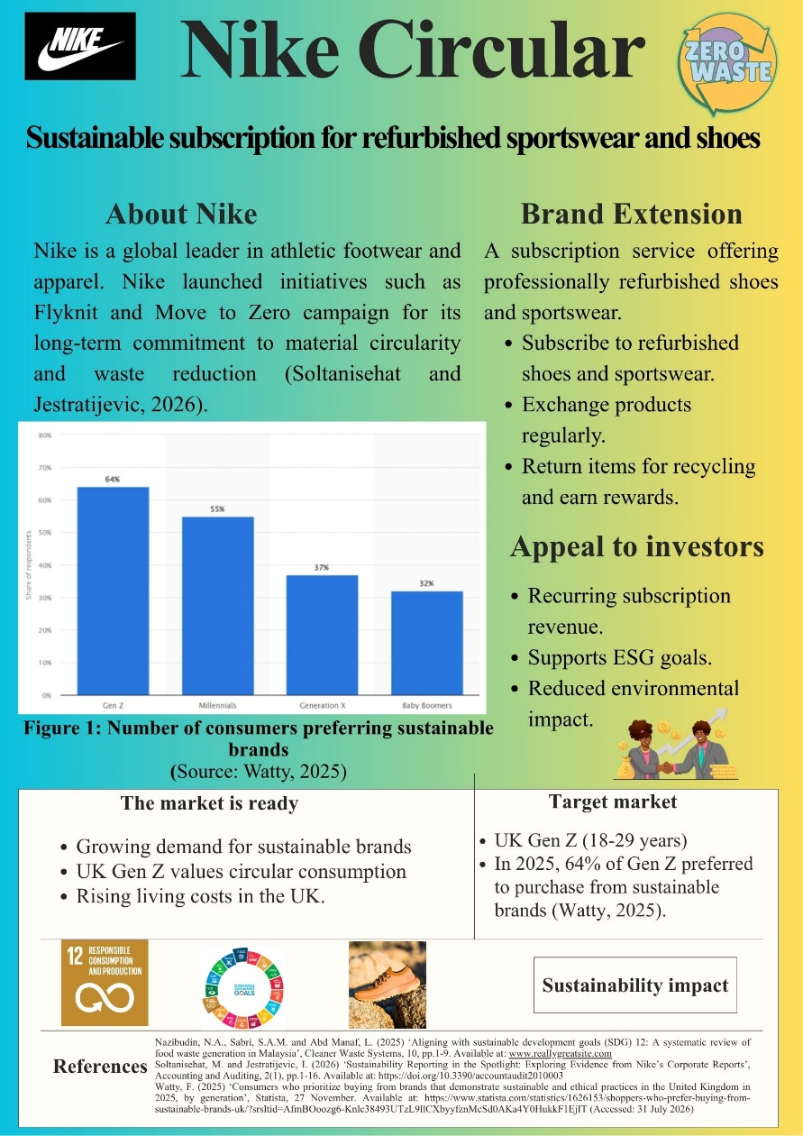

Element 2: Develop a Segmentation, Targeting, Differentiation, and Positioning (STDP)
Segmentation
Nike Circular will apply geographic, demographic, psychographic and behavioural segmentation.
Geographic segmentation: The sustainable brand extension will operate in the UK, focusing on major urban centres, such as London, Manchester and Birmingham. Manchester is one of the leading logistics locations in the UK, which helps businesses to move forward (Walkers Transport, 2026). Moreover, the government of the UK promotes sustainable consumption through circular economy initiatives (Gov.UK, 2026). This makes an attractive market for refurbished fashion products. Urban consumer also demonstrates higher participation in resale platforms, increasing the likelihood of participation.
Demographic segmentation
The key demographic segment involves Gen Z consumers aged between 18 and 29 years. This group involves university students, recent graduates and young professionals with low-to-middle disposable incomes. Gen Z seeks fashion brands reflecting their unique style and beliefs (Prashar and Kaushal, 2025). However, several Gen Z consumers face increasing financial constraints caused by high living costs. Thus, refurbished premium sportswear provides an attractive balance between affordability and brand prestige. Nike Circular offers men's and women's products across different sporting categories. The service also targets individuals who focuses the maintenance of lifestyles through running and recreational fitness activities.
Psychographic segmentation
Gen Z consumers in the UK prefer sustainability and ethical consumption when selecting brands. 54% of Gen Z are willing to spend 10% more on sustainable products (Campbell, 2022). In addition, Gen Z values experiences and convenience more than ownership. Nike Circular align with this mindset by enabling consumers to enjoy premium products without the financial commitment of permanent ownership. The established reputation and sustainability of Nike offer credibility that independent resale platforms often lack.
Behavioural segmentation
Nike Circular targets consumers who purchase athletic footwear and actively participate in fitness activities. Potential customers also demonstrate strong brand loyalty towards Nike while showing an increasing level of interest in refurbished products. Instead of replacing existing customers of Nike, the service extends the relationship by encouraging continuous engagement through monthly subscriptions and product exchanges.
Targeting
Nike Circular adopts the concentrated targeting strategy, specifically focusing on environmentally conscious Gen Z consumers within the UK. Concentrated targeting is the strategy which allows the organisation to target a specific segment of the market with specialised products and services (Perlego, 2026). Gen Z represents the most suitable target market for various reasons. Gen Z are concerned for the well-being of the planet and influence others to make sustainability-first purchasing decisions (Wood, 2022). They are also digitally connected and comfortable while using mobile apps for subscriptions and payments.
The economic conditions of the UK also strengthen the targeting decision of Nike Circular. Due to the rise in inflation, consumer prices in the UK increased by 30.7% from 2021 to 2026 (Harari, 2026). This encourages consumers to seek affordable alternatives without compromising product quality. Nike Circular thus addresses financial and environmental concerns simultaneously. From a strategic perspective, targeting Gen Z can reap significant other benefits. By engaging consumers through subscription services, Nike can strengthen emotional attachment and increase the probability of continued purchasing across other product categories throughout adulthood.
Differentiation
Differentiation allows an opportunity to the organisations to drive competitive advantages by offering unique products and services. Nike Circular differentiates itself through different characteristics. Unlike the peer-to-peer resale platforms, Nike Circular offers manufacturer-certified refurbishment. Each product undergoes professional inspection, cleaning and repair using the quality standards of Nike before redistribution. This reduces perceived risk regarding the authenticity and quality of the product. An improvement in product quality increases customer satisfaction, which in turn increases customer loyalty (Abigail, Sari and Saputra, 024). Apart from this, the subscription model introduces flexibility, which is unavailable within conventional retail channels. The customer can exchange products without repeatedly purchasing new items, which can increase convenience and support sustainable consumption.
Positioning
Nike Circular will position itself as the most trusted premium circular sportswear subscription service, combining athletic performance, affordability and environmental responsibility. Positioning is an effective way for the sellers to enhance their competitive advantage (Wang and Yang, 2024). Unlike the traditional resale platforms that facilitate second-hand transactions, Nike Circular offers refurbished products supported by the original manufacturer. Nike Circular places itself in the quadrant of low price and high sustainability and circular services, as illustrated in Figure 1. Rather than encouraging continuous consumption of newly manufactured products, Nike Circular promotes responsible access to premium sportswear through circular consumption. This positioning strengthens competitive differentiation along with appealing to Gen Z's environmental values and digital lifestyles.
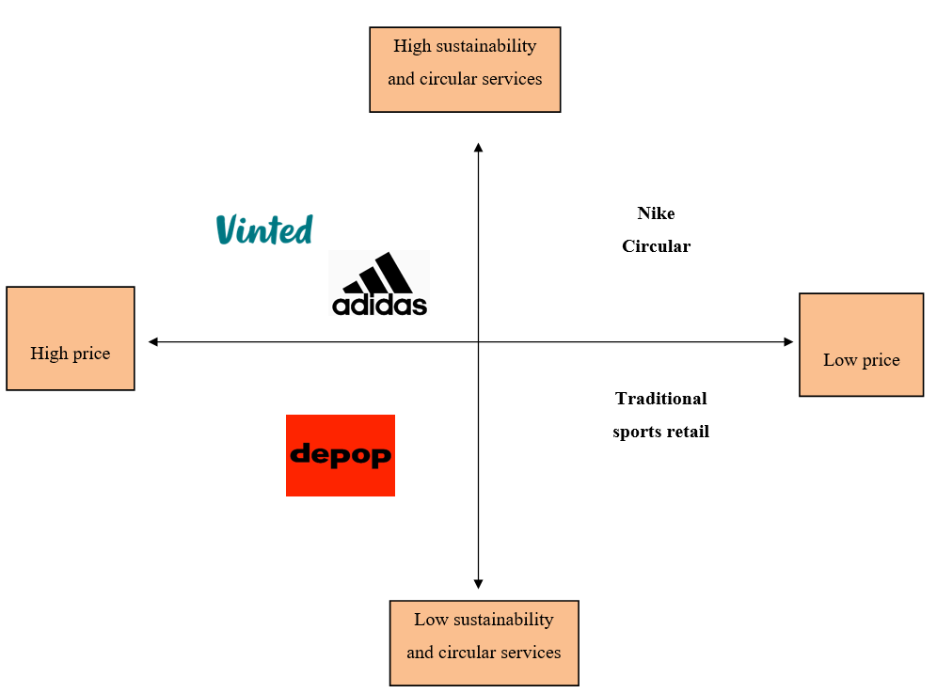
Figure 1: Positioning map
(Source: Self-developed)

Element 3: Marketing Mix (7P)
Product: Product is the key foundation of the value proposition of Nike Circular. Kotler’s three levels of product framework can be applied in this context, which consists of core, actual and augmented product (Aristogeni and Vitouladiti, 2023). The core product represents the key benefit sought by customers. For Nike Circular, this involves access to premium sportswear and footwear from Nike in an affordable and responsible way. Instead of purchasing ownership, subscribers can gain convenience, flexibility and participation in a circular economy, while enjoying the performance associated with the products of Nike.
The actual product involves the tangible and identifiable features delivered to customers. Nike Circular will offer professionally refurbished shoes that undergo repair before redistribution. The products will maintain the original design of Nike, performance quality and authenticity, differentiating the service from peer-to-peer resale platforms. The augmented product will offer additional services that can enhance customer value beyond the physical product. Subscribers can receive flexible product exchanges and repair services through customer support and loyalty rewards for returning used products.
Price: Nike Circular will adopt a subscription-based value pricing strategy, balancing affordability with the premium reputation of Nike. Value-based pricing helps in understanding the quantified value of a product (Tremblay, Poirier and Monfort, 2024). This strategy also allows for designing products to deliver desired value at the target price. In terms of this pricing strategy, three pricing tiers will be proposed. For the student plan, the monthly fee for subscription plan will be set at £19.99, and the features include one refurbished item every two months, free cleaning and recycling rewards. The standard plan will be £39.99, which involves features such as two products, regular exchanges and repairs and member rewards. The premium plan will be £69.99, involving features such as unlimited exchanges, priority access to exclusive collections and premium repair services. This tiered pricing structure can increase market accessibility, while enabling customers to select packages as per their financial circumstances and lifestyle needs. A value-based pricing strategy is the most suitable, since consumers purchase an integrated service instead of individual products. The key benefits involve flexibility, convenience and repair services, generating more value than conventional product ownership.
Place: Nike Circular will adopt an omnichannel distribution strategy, which combines digital convenience with physical accessibility. Omni-channel retailing fades the borders between online and offline retailing (Schrotenboer et al., 2022). The key distribution channel is the mobile application and official website of Nike, enabling customers to subscribe and browse available products. The physical stores of Nike throughout the UK can also function as collection and return centres. The customers can exchange products, request repairs or return worn items during regular shopping visits. This integration can lead to the reduction of transportation costs and strengthen customer engagement. Apart from this, home delivery remains a key component of the distribution strategy. By making partnerships with carbon-neutral logistics providers, the brand can minimise environmental impact, while maintaining efficient delivery times. Apart from this, integrating refurbishment centres within the existing distribution infrastructure of Nike can reduce implementation costs and maximise resource efficiency.
Promotion: Nike can adopt an integrated promotional strategy, combining push and pull marketing approaches. Pull strategies enhance brand loyalty and customer engagement, and the marketing activities create consumer demand (Mayxay, Johnson and Piricz, 2025). In the context of Nike Circular, digital channels such as Instagram can communicate the environmental and financial benefits of circular consumption through authentic storytelling. In 2026, the number of Instagram users in the UK was 39.1 million, among which 54.7% are women and 45.3% are men, as illustrated in Figure 2 (Thuy, 2026). Collaborations with fitness influencers in the UK can demonstrate how refurbished Nike products can maintain premium performance while reducing environmental impact.
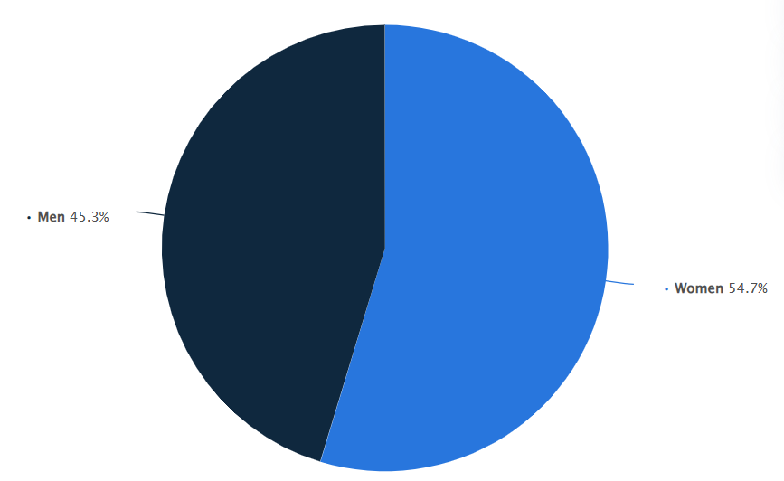
Figure 2: Number of Instagram users in the UK
(Source: Thuy, 2026)
The push strategy can support market penetration by encouraging intermediaries and existing channels to promote Nike Circular. Nike can introduce exclusive launch promotions, point-of-sale displays and enter into collaborations with university sports clubs, which can increase service awareness at the point of purchase. In addition, limited-time introductory offers and student discounts can also encourage trial, while reducing perceived risk among first-time subscribers.
People: People are a key component in service marketing, since service quality relies on interactions between the employees and the customers. Nike Circular requires continuous consumer engagement throughout the entire subscription lifecycle. The brand also requires different categories of employees, such as customer service representatives, retail store staff and digital support teams. Customer service representatives must be trained to explain the subscription plans and efficiently resolve inquiries. Customer service is a key factor in retaining customers and maintaining high profits (Metz, Ilieș and Nistor, 2020). The delivery personnel must influence consumer perceptions, since timely deliveries and convenient returns can contribute to the overall satisfaction of the customers.
Process: The customer journey begins with a subscription registration through the Nike application or website. Customers who mainly perceive the shopping process as seamless are more engaged and likely to purchase more (Cocco and Demoulin, 2022). Customers can select a subscription plan as per their preferences and also browse available refurbished footwear and sportswear. Following the selection of products, orders are directly delivered to customers using sustainable packaging and through carbon-conscious logistics partners. The returned products from consumers will enter the reverse logistics system of Nike, where they are inspected and quality-tested before re-entering circulation.
Physical evidence: The key physical evidence involves professionally refurbished footwear and sportswear of Nike that appear identical to new products, while meeting strict manufacturer quality standards. Recycled and reusable packaging can reassure customers that sustainability does not compromise performance. The digital application of Nike is another element of physical evidence. A user-friendly interface will be designed, featuring subscription management, repair requests and sustainability dashboards, which can enhance consumer perceptions. The user interface enhances immediate user engagement (Kiourexidou et al., 2024). The dashboard can communicate measurable environmental benefits, such as reductions in carbon emissions and water consumption.

Element 4: Reflection
Developing Nike Circular as a sustainable brand extension has enhanced my understanding of strategic marketing, sustainable business practices and brand development. Throughout the sustainable brand extension marketing strategy, I achieved valuable insights into the way organisations can incorporate environmental sustainability into marketing strategies. Instead of viewing sustainability as a corporate social responsibility initiative, the entire assessment demonstrated how sustainability can become a key source of competitiveness through innovation and long-term value creation.
One of the significant insights gained throughout this process was developing an in-depth understanding of brand extension strategy. Before the completion of this assessment, I considered brand extension as introducing new products under an existing brand name. However, researching Nike Circular allowed me to appreciate the way organisations can extend brands through innovative business models instead of physical products alone. Transforming the brand from a traditional sportswear retailer into a provider of subscription-based refurbished products indicates how brand equity can offer support to the transition towards a circular economy. Incorporating the concept of the circular economy is significant, since it allows the organisations to limit the negative impact on the natural environment (Kafel and Rudziński, 2024). This enhanced my perspective on strategic marketing and also demonstrated that successful brand extensions are necessary to be aligned with consumer expectations and organisational capabilities.
The assessment also strengthened my understanding of segmentation, targeting and positioning (STP). Carrying out the market analysis highlighted the significance of identifying consumer groups whose values align with organisational objectives. Selecting Gen Z consumers in the UK required thorough evaluation of demographic, psychographic and behavioural features rather than solely relying on age or income. I identified that sustainability-oriented marketing requires organisations to understand the digital lifestyles and purchasing motivations of consumers. Moreover, analysing the competitive environment of Nike enhanced my ability to justify strategic decisions using marketing theories rather than any form of personal opinion.
Preparing the poster presentation also contributed to my personal and professional development. Condensing the complex strategic information into a visually engaging format required adequate planning, prioritisation and communication skills. During the presentation, I developed greater confidence in explaining the marketing concepts within a limited time, along with the maintenance of audience engagement. The poster presentation encouraged me to communicate appropriately and confidently respond towards the questions. All these skills are transferable to professional marketing environments where communication and stakeholder engagement are essential.
Despite all these achievements, I identified various areas for improvement. I aim to strengthen my presentation skills by becoming more confident, while answering unexpected questions and using more advanced visual storytelling techniques. Future projects could also benefit from primary market research, including surveys or interviews with different customers to validate assumptions regarding the behaviour of consumers and subscription adoption. Overall, the assessment has enhanced my understanding of sustainable brand development, strategic market planning and circular economy principles, while improving communication and problem-solving skills. These competencies can support my future career by allowing me to develop innovative marketing strategies that create value for both the organisations and consumers.

References
Abigail, J., Sari, V.P. and Saputra, D. (2024) ‘The influence of product quality and online shopping experience (OSE) on consumer loyalty through customer satisfaction on local skincare products’, Procedia Computer Science, 234, pp.537-544. Available at: https://www.sciencedirect.com/science/article/pii/S1877050924003958/pdf?md5=080164ee3165964458084f95bd6ee22a&pid=1-s2.0-S1877050924003958-main.pdf
Aristogeni, V. and Vitouladiti, O. (2023) ‘AUGMENTED PRODUCTS, MARKET-SEGMENTS AND DEMAND IN THE CONTEXT OF TOURISM MARKETING. THE CASE OF CULTURAL ROUTES AND TOURS IN ATHENS’, ΑΡΧΕΙΟΝ ΟΙΚΟΝΟΜΙΚΗΣ ΙΣΤΟΡΙΑΣ, 35(1), p.51. Available at: https://archivesofeconomichistory.com/webdata/magaz/Volume%20XXXV_No1_2023.pdf#page=51
Campbell, V. (2022) Gen Z buyers: the future is ethical consumption. Available at: https://www.maersk.com/insights/growth/2022/11/03/gen-z-buyers-the-future-is-ethical-consumption (Accessed: 31 July 2026)
Cocco, H. and Demoulin, N.T. (2022) ‘Designing a seamless shopping journey through omnichannel retailer integration’, Journal of Business Research, 150, pp.1-47. Available at: https://www.sciencedirect.com/science/article/am/pii/S0148296322005653 (Accessed: 31 July 2026)
Gov.UK (2026) Circularity guidance for mayoral strategic authorities. Available at: https://www.gov.uk/government/publications/circular-economy-guidance-for-mayoral-strategic-authorities/circularity-guidance-for-mayoral-strategic-authorities (Accessed: 31 July 2026)
Harari, D. (2026) Economic update: The new Prime Minister, inflation and the cost of living. Available at: https://commonslibrary.parliament.uk/research-briefings/cbp-10975/ (Accessed: 31 July 2026)
Kafel, P. and Rudziński, K. (2024) 'The importance of the circular economy concept among organisations within the food sector and a management systems perspective’, Sustainability, 16(7), pp.1-18. Available at: https://doi.org/10.3390/su16072912
Kiourexidou, M., Kanavos, A., Klouvidaki, M. and Antonopoulos, N. (2024) ‘Exploring the role of user experience and interface design communication in augmented reality for education’, Multimodal Technologies and Interaction, 8(6), p.43. Available at: https://doi.org/10.3390/mti8060043
Mayxay, M., Johnson, F.L. and Piricz, N. (2025) ‘Benefits and Challenges of Push and Pull Strategies’, In 2025 IEEE 25th International Symposium on Computational Intelligence and Informatics (CINTI) (pp. 345-350). IEEE. Available at: https://www.researchgate.net/profile/Manonin-Mayxay-2/publication/399174052_Benefits_and_Challenges_of_Push_and_Pull_Strategies/links/697bf2ae64ca8a38208770d0/Benefits-and-Challenges-of-Push-and-Pull-Strategies.pdf (Accessed: 31 July 2026)
Metz, D., Ilieș, L. and Nistor, R.L. (2020) ‘The impact of organisational culture on customer service effectiveness from a sustainability perspective’, Sustainability, 12(15), pp.1-27. Available at: https://doi.org/10.3390/su12156240
Nazibudin, N.A., Sabri, S.A.M. and Abd Manaf, L. (2025) ‘Aligning with sustainable development goals (SDG) 12: A systematic review of food waste generation in Malaysia’, Cleaner Waste Systems, 10, pp.1-9. Available at: https://doi.org/10.1016/j.clwas.2025.100205
Perlego (2026) Concentrated Marketing. Available at: https://www.perlego.com/index/marketing/concentrated-marketing (Accessed: 31 July 2026)
Prashar, A. and Kaushal, L.A. (2025) ‘Nudging sustainable fashion choices: An experimental investigation on generation Z fashion consumers’, Acta Psychologica, 253, p.104727. Available at: https://doi.org/10.1016/j.actpsy.2025.104727
Schrotenboer, D., Constantinides, E., Herrando, C. and de Vries, S. (2022) ‘The effects of omni-channel retailing on promotional strategy’, Journal of Theoretical and Applied Electronic Commerce Research, 17(2), pp.360-374. Available at: https://doi.org/10.3390/jtaer17020019
Soltanisehat, M. and Jestratijevic, I. (2026) ‘Sustainability Reporting in the Spotlight: Exploring Evidence from Nike’s Corporate Reports’, Accounting and Auditing, 2(1), pp.1-16. Available at: https://doi.org/10.3390/accountaudit2010003
Thuy, D. (2026) ‘Distribution of Instagram users in the United Kingdom (UK) as of June 2026, by gender’, Statista, 17 March. Available at: https://www.statista.com/statistics/1315723/uk-instagram-users-by-gender/?srsltid=AfmBOoryfVZsEbxV7zppV-HtJT-9FwrXH6nIGWk94pLyoAcRGXLLGqWX (Accessed: 31 July 2026)
Tremblay, G., Poirier, A. and Monfort, L. (2024) ‘Value-based pricing: a potential solution to difficult pricing discussions and payers’ negotiations’, Journal of Medical Economics, 27(1), pp.344-347. Available at: https://doi.org/10.1080/13696998.2024.2317119
Walkers Transport (2026) Why Manchester Is One of the UK’s Leading Logistics Hubs. Available at: https://walkers-transport.co.uk/why-manchester-is-a-leading-logistics-hub/ (Accessed: 31 July 2026)
Wang, Z. and Yang, T. (2024) ‘Research on the product positioning strategy of the independent seller under platform encroachment’, Systems, 12(1), pp.1-22. Available at: https://doi.org/10.3390/systems12010036
Watty, F. (2025) ‘Consumers who prioritise buying from brands that demonstrate sustainable and ethical practices in the United Kingdom in 2025, by generation’, Statista, 27 November. Available at: https://www.statista.com/statistics/1626153/shoppers-who-prefer-buying-from-sustainable-brands-uk/?srsltid=AfmBOoozg6-Knlc38493UTzL9llCXbyyfznMcSd0AKa4Y0HukkF1EjIT (Accessed: 31 July 2026)
Wood, J. (2022) ‘Gen Z cares about sustainability more than anyone else – and is starting to make others feel the same’, World Economic Forum, 18 March. Available at: https://www.weforum.org/stories/2022/03/generation-z-sustainability-lifestyle-buying-decisions/ (Accessed: 31 July 2026)

