Sarah Blackburn: 2111668

Module: HPHI7106

Assessment: Four: Image Commentary

Word Count: c.2071

Submission date: 19/12/2021

This essay will look at a page from a copy of Froissart’s Chronicles commissioned by Baron Hastings. To begin with, the historical context in which this particular book was produced will be considered, looking at why Hastings might have chosen this specific work and what can be understood about gentry culture as a result. Next, it will examine the content of the first miniature in the book (Fig. 1 below), which depicts the ‘Duke of Burgundy returning with banners of his arms and a border of foliage…’. What is shown in the image will be described. The materials and methods used in creating the image will also be explored whilst trying to ascertain who the illustrator might be. Finally, this essay will look at the overall significance of the picture.
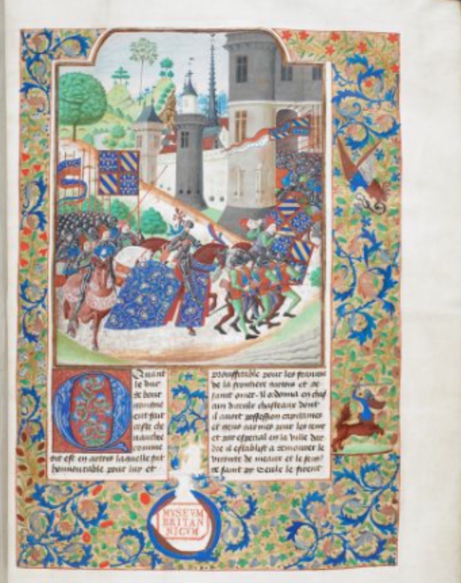
Fig.1 A Coloured miniature from Froissart’s Chronicle showing ‘The Duke of Burgundy with banners’. London, British Library, Royal_MS_18_E_I

According to the British Library, this copy of Froissart’s Chronicles was compiled in the last quarter of the 15th century. This copy of Froissart’s Chronicles was created in ‘Southern Netherlands (Bruges) for William, 1st Baron Hastings (c1430 – 1483)’. According to Janet Backhouse, Hastings attended Edward IV during his exile in Flanders in 1470-1. In exile, the King and his compatriots, were ‘entertained in Bruges by Louis de Gruthuyse, one of the great bibliophiles of the day’. It is possible that Baron Hastings established the connections needed for his copy of Froissart’s Chronicles during this time. It is believed that the King placed orders for books from Bruges after this introduction, so it is possible that Hastings did likewise. Although this copy of Froissart’s chronicles was made for Baron Hastings, it is thought that the Chronicles were intended as a gift from Hastings to Edward IV.

Froissart’s Chronicles were ‘something of a fashion item’ ‘in the latter part of the fifteenth century’; this is partly due to the material contained therein. The book was intended to be shown off; it was designed as a visual delight as an instruction book on how to behave and, as such, is part of the visual culture of the gentry culture of the late 15th century. Froissart’s Chronicles were popular as gentry families desired to associate their family with ‘historical events of national importance’ (Carol Meale quoted by Raluca Radulescu). One way this association was visually represented was by the inclusion of a family crest alongside the text or at the start of a book, as can be seen in the first miniature f. 12r in Baron Hastings’ edition of Froissart’s Chronicles where the arms and crest of the Baron are present. Although they are unfinished as they were never painted in this instance, all that can be seen are the graphite lines the illustrator used to outline the crest before painting began. Today the area intended to house Hastings’s crest instead features a rubber stamp of the British Museum in red which has the letters MVSEVM BRITAN NICVM on three separate lines. This stamp was used between 1753 and c.1836. Hastings unfinished crest shows the order in which the illumination would be done. First, an outline sketch would be made in plummet (or pencil) before this was then painted in. In some instances, the drawing and the painting would be done by different people, and to ensure that the correct colours were used, small letters relating to the colours required would be written on the picture, for example, ‘r’ for rouge. This is almost like a medieval version of paint by numbers.

A gold frame surrounds the main image. The British Museum describes it as ‘the return of the Duke of Burgundy, with banners of his arms’. The Duke is in the centre front of the image in front and behind him an army of Knights predominantly on foot and wearing plate armour. The Duke is foregrounded in the centre on his horse. The horse is depicted side on, allowing the viewer to see the rich blue and gold blanket that the horse wears. The colour blue is repeated throughout the border ‘of foliage, flowers, fruit, an eagle and snake armed centaur, etc.’ and in the main image, alongside gold blue could be an expensive colour to use as the most prized came from Afghanistan and was made of ‘lapis lazuli’. A cheaper alternative ‘was azurite, a bluestone rich in copper, found in many countries of Europe’., It is difficult to fully ascertain which type of ink was used for the blue in this instance. The image has only been viewed via a computer screen, invariably distorting the original colours. Given the sheer quantity of blue ink used, this might suggest that it is the more common and cheaper ink that has been used despite the inclusion of gold leaf. Froissart’s Chronicles focused on chivalric culture which is reflected in the images through the crests of the Duke of Burgundy’s crest and Hastings’s.

The Duke rides his horse in full plate armour with his visor up. Above his head, he has what appears to be the Fleur-de-lis of France, and his banner’ is in gold leaf above his helmet. The Fleur-de-lis is repeated throughout the image on the Duke of Burgundy's banners, of which there are four in the picture, three on the right-hand side and one on the left. The flags are split into quarters, with the top left corner and bottom right corner featuring the Fleur-de-lis and the bottom left corner and the top right corner being alternate blue and yellow stripes. The pigment for the yellow ink could be from one of two sources, saffron or volcanic earth.

Behind the Duke are three other men also on horses, and directly in front of the Duke, there is a group of eight men who are only wearing helmets and no armour instead; they're wearing tight hose of which the right leg is green, and the left leg is red alongside a particoloured tunic in red and blue which also has a green sleeve on the right-hand side. Red was one of the most common colours used in medieval manuscripts and, as with all other pigments used, came from a variety of sources. The main source used most in early manuscripts was ‘minium, red sulphide of lead’. So common was minium that the word ‘miniare’ became synonymous with the making of a manuscript painting. Together the cavalcade is moving from the left to the right of the picture, where they then enter what is presumably the fortified town of Burgundy. The stonework of the building is made up of a surrounding white wall the pigment of which would be from lead. At the corner of which is a square tower alongside this wall is also a cylindrical turret in grey. In the far background of the picture are hills scattered with trees, most of which are placed at the very pinnacle.

Unlike modern illustrated books, illuminated manuscripts of the 15th century do not always include the names of either the scribe or the illuminator as such it is not easy to know who worked on Hastings’s manuscript in this instance. This copy of Froissart’s Chronicles is one of four commissioned by Hastings, with Books II and IV being held by the British Museum, Book III being held by ‘J. Paul Getty Museum, Ludwig MS XIII 7’and Book I is lost. Of the three remaining books, it appears that the prominent artist for Book III is the only one to have been firmly identified by Scott McKendrick as the Master of The Getty Froissart. The British Museum lists two illuminators, the Master of the Chattering Hands and the Master of the Harley Froissart, who worked on the miniatures in this manuscript. According to Närä, the Master of the Harley Froissart relied heavily on heraldic display, particularly with ‘banners, standards and horse trappings’. Although it is difficult to establish whether the Master of the Harley Froissart was the artist of this particular miniature, it does have some similarities to his style in the prominent position of the Duke of Burgundy's banners as well as his horse’s blanket.

The book’s material is parchment, so that it will be made of either sheep, goat, or calves’ skin., Of these calves’ skin is the most expensive and unlikely to be used except for the most expensive and prized works, as this is usually termed vellum rather than parchment, it would seem likely that despite the beautiful nature of the manuscript, the British Library’s categorising the material as parchment would suggest that it is more likely to be the slightly cheaper more common sheepskin.

Hastings’s copy of Froissart’s Chronicles is significant because it visually shows more than just an image on a page. The whole book is a rich example of visual culture. What is depicted throughout the book expresses what is important to those who commissioned and consumed Hastings’s copy of Froissart’s Chronicles. In this instance, the focus on heraldic symbolism in the prominent of the Duke of Burgundy's Crest within the picture. The illuminations and the text combine to highlight the gentry, material and visual culture of the late 15th century.

In conclusion, this image highlights aspects of gentry culture, material culture and visual culture of the late 15th century, and as such, it helps to show what was important to those for whom the book was made. This copy of Froissart’s Chronicles is in keeping with the material culture used in the production of books in the late 15th century through the use of parchment as the medium for the page as well as the inks used from, blue and red which were ubiquitous at the time through to the inclusion of gold leaf which highlights the book’s consumption by the Gentry classes. The prominent use of blue and red ink also ties in to notions of visual culture as these colours were popular throughout the Middle Ages. The fact that the Duke of Burgundy is foregrounded in the picture as well as the repeated use of his Crest throughout the image displays both the Gentry culture and the visual culture of the late Middle Ages.

Bibliography

Alexander, Jonathan, J.G. Medieval Illuminators and Their Methods of Work (New Haven and London, Yale University Press, 1992)

Backhouse, Janet, The Illuminated Manuscript, (Oxford, Phaidon Press Ltd, 1979)

British Library, A Guide to British Library Book Stamps Collection Care Blog 23 September 2013. Available at <https://blogs.bl.uk/collectioncare/2013/09/a-guide-to-british-library-book-stamps.html>[Accessed 12 December 2021]

De Hamel, Christopher, A History of Illuminated Manuscripts (Oxford, Phaidon Press Ltd, 1986)

De Hamel, Christopher, Medieval Craftsmen Scribes and Illuminators, (London, British Museum Press, 1992)

London, British Library Royal_MS_18_E_I ‘Jean Froissart Chroniques’ (2021) Available at
http://www.bl.uk/manuscripts/FullDisplay.aspx?ref=Royal_MS_18_E_I [Accessed 17 December 2021]

London, British Library. Jean Froissart Chronicles’ Vol. 2 (2021) Available at https://www.bl.uk/collection-items/miniature-of-the-death-of-wat-tyler-from-jean-froissarts-chroniques [Accessed 19 December 2021}

Närä, Katariina, ‘Some Burgundian manuscripts of Froissart’s Chroniques, with particular emphasis on British Library Ms Harley 4379-80’ in The Online Froissart, ed. By Peter Ainsworth and Godfried Croenen, v. 1.5 (Sheffield: HIRIOnline, 2013) Available at https://www.dhi.ac.uk/onlinefroissart/apparatus.jsp?type=intros&intro=f.intros.KN-Burgundian [Accessed 7 December 2021]

Radulescu, Raluca, Chapter 6. Literature, in Radulescu, R and Truelove, A. eds, Gentry Culture in Late Medieval England (Manchester, Manchester University Press, 2005)

‘Jean Froissart Chronicles’ Vol. 2 (2021) London, British Library. Available at https://www.bl.uk/collection-items/miniature-of-the-death-of-wat-tyler-from-jean-froissarts-chroniques [Accessed 19 December 2021}
‘Jean Froissart Chroniques’ (2021) London, British Library Royal_MS_18_E_I Available at http://www.bl.uk/manuscripts/FullDisplay.aspx?ref=Royal_MS_18_E_I [Accessed 17 December 2021]
‘Jean Froissart Chroniques’ (2021) London, British Library Royal_MS_18_E_I
Ibid.
Janet Backhouse, The Illuminated Manuscript, (Oxford, Phaidon, 1979) p.70
Janet Backhouse, The Illuminated Manuscript, p.70
Katariina Närä, ‘Some Burgundian manuscripts of Froissart’s Chroniques, with particular emphasis on British Library Ms Harley 4379-80’ in The Online Froissart, ed. By Peter Ainsworth and Godfried Croenen, v. 1.5 (Sheffield: HIRIOnline, 2013) Available at https://www.dhi.ac.uk/onlinefroissart/apparatus.jsp?type=intros&intro=f.intros.KN-Burgundian [Accessed 7 December 2021]
Katariina Närä, ‘Some Burgundian manuscripts of Froissart’s Chroniques, with particular emphasis on British Library Ms Harley 4379-80’ in The Online Froissart,
Raluca Radulescu, Chapter 6. Literature, in Radulescu, R and Truelove, A. eds, Gentry Culture in Late Medieval England (Manchester, Manchester University Press, 2005) p.113
Jean Froissart Chroniques’ (2021) London, British Library Royal_MS_18_E_I
British Library, A Guide to British Library Book Stamps Collection Care Blog 23 September 2013. Available at <https://blogs.bl.uk/collectioncare/2013/09/a-guide-to-british-library-book-stamps.html>[Accessed 12 December 2021]
Christopher De Hamel, A History of Illuminated Manuscripts Medieval, (London, Phaidon, 1986) p.104
Christopher De Hamel, A History of Illuminated Manuscripts Medieval, p.105
‘Jean Froissart Chroniques’ (2021) London, British Library Royal_MS_18_E_I
Ibid
Alexander, Medieval Illuminators and Their Methods of Work, p.40
Christopher De Hamel, Medieval Craftsmen Scribes and Illuminators, (London, British Museum Press, 1992) p.62
Alexander, Medieval Illuminators and Their Methods of Work, p.40
Katariina Närä, ‘Some Burgundian manuscripts of Froissart’s Chroniques, with particular emphasis on British Library Ms Harley 4379-80’
Jean Froissart Chroniques’ (2021) London, British Library Royal_MS_18_E_I
Jonathan J.G. Alexander, Medieval Illuminators and Their Methods of Work (New Haven and London, Yale University Press, 1992) p.40
Alexander, Medieval Illuminators and Their Methods of Work p.40
Christopher De Hamel, Medieval Craftsmen: Scribes and Illuminators (London, British Museum Press, 1992) p.62
‘Jean Froissart Chroniques’ (2021) London, British Library Royal_MS_18_E_I
Katariina Närä, ‘Some Burgundian manuscripts of Froissart’s Chroniques, with particular emphasis on British Library Ms Harley 4379-80’ in The Online Froissart]
‘Jean Froissart Chroniques’ (2021) London, British Library Royal_MS_18_E_I
Katariina Närä, ‘Some Burgundian manuscripts of Froissart’s Chroniques, with particular emphasis on British Library Ms Harley 4379-80’ in The Online Froissart,
‘Jean Froissart Chroniques’ (2021) London, British Library Royal_MS_18_E_I
Christopher De Hamel, Medieval Craftsmen: Scribes and Illuminators (London, British Museum Press, 1992) p.8

