
BA Business Management
LCBB4004- Tushara Balendran
MARKETING FUNDAMENTALS
TASK 1- Blog
by Constantin Gabriel Tacea (2122369)



TALK ABOUT APPLE!

Apple is an American transnational corporation, an economic phenomenon in full dynamics, a huge empire with dynamic nature expanding all over the globe. Apple develops and sells electronics and software at international level. Among the most reputed objects sold there are: computers from Macintosh series, smartphones iPhone, portable devices iPod and the latest toys developed Apple, iPad tablets.
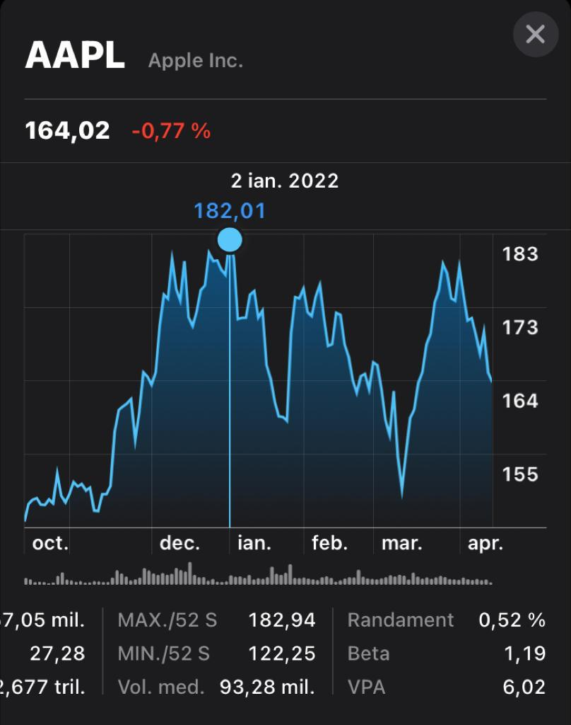
With over 500 stores all over the world and an online shop, where you can purchase any product offered, Apple represents one of the largest producers of electronics in the world. With an increased popularity and confidence, Apple managed to make history on the stock exchange market when in January 2022, was the first company who exceeded a market value of 3 trillion dollars, in other words, the value of an Apple share exceeded USD 182.85.

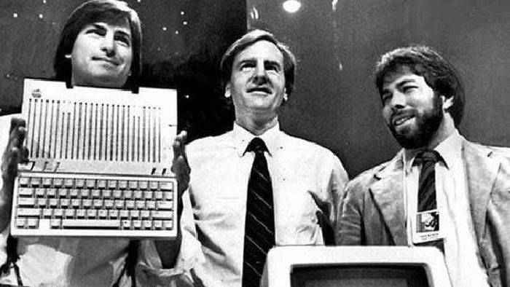3 friendships: Steve Jobs, Steve Wozniak and Ronald Wayne and the garage of the house of one of them:
You may think of the forming of an American rock adolescent band, but that was not how the Apple project was formed in 1976.

The first prototype was created by Steve Wozniak and presented to HP and resulted in a major failure, but the perseverance, desire and creative genius of the 2 Steves led to the revolutionizing of technology.
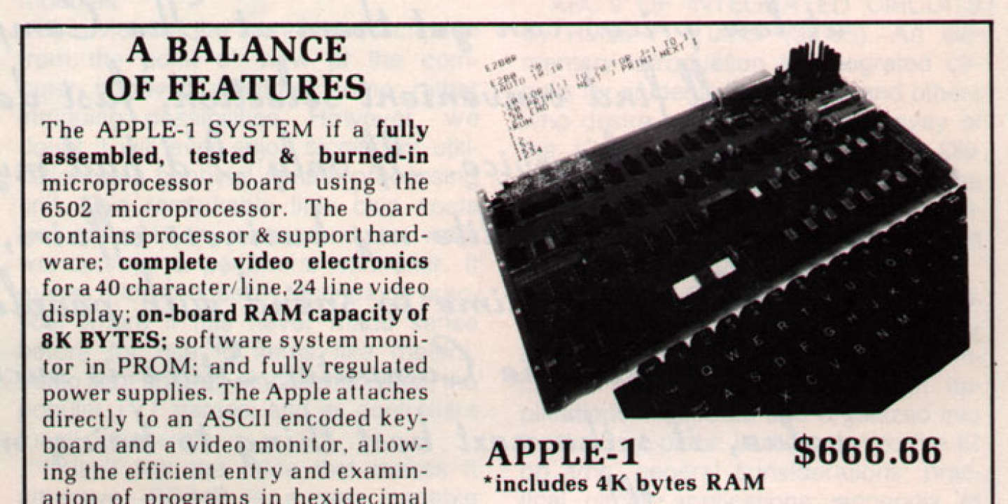
At that time the main opponents were: Xerox computer at USD 40.000 and Altair 8080 (IBM), but at a much better price (USD 666.66), sold without monitor, keyboard and casing and using a microprocessor borrowed from Motorola 6800 (much cheaper than the Altair microprocessor), Apple managed to have 50 orders from the owner of Byte Shop stores, and out of 200 it sold another 175, the remaining unsold computers were destroyed.
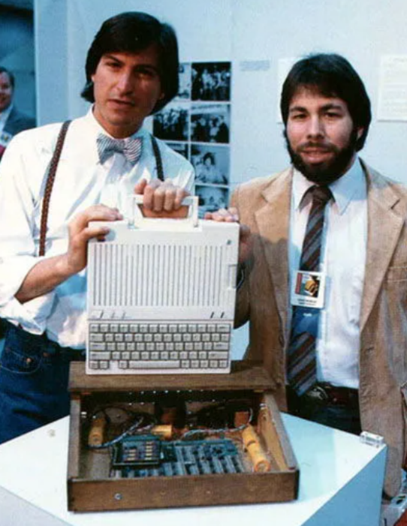
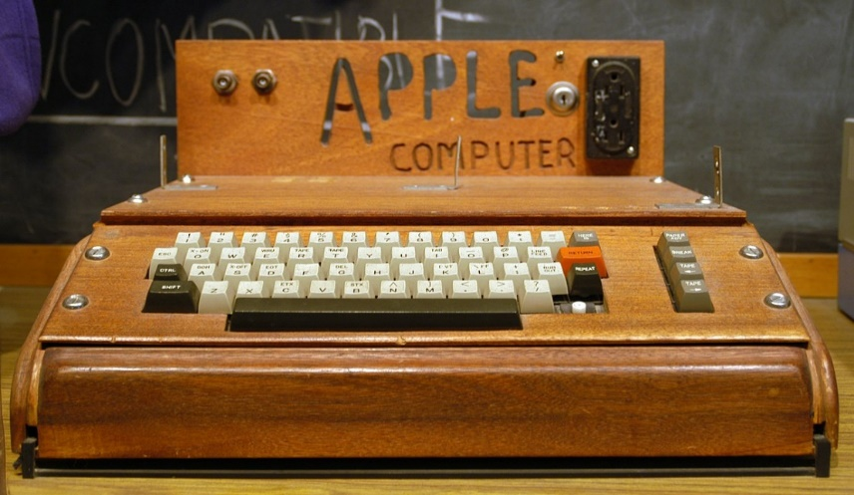
The success of Apple I brought funds which led to the realization of a better model, which distinguished up to 6 colors, it was famous and was called Apple II.

Apple III was the representation of failure, but an innovative step and a good strategy brought to the public was Lisa, a targeted product, being designed for the business users, which unfortunately was suspended so that the project called Macintosh could be implemented.
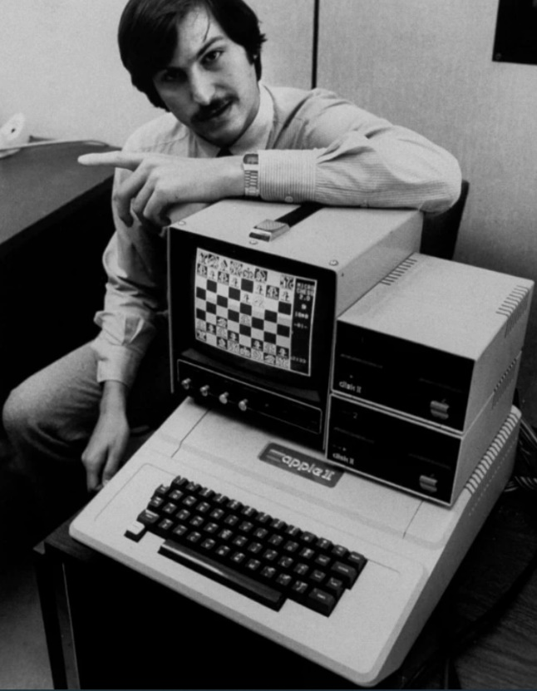
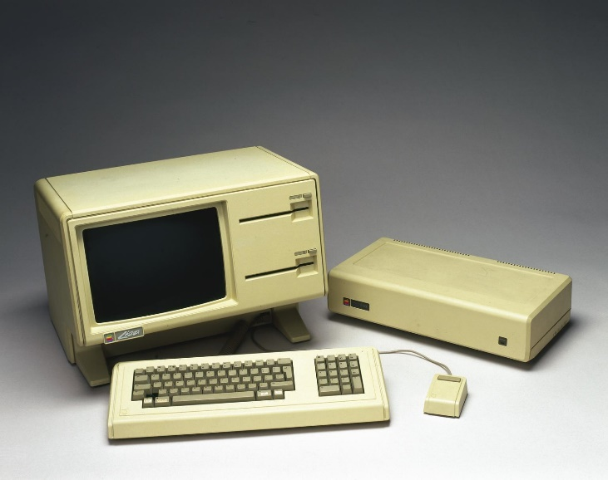
LISA…

APPLE II
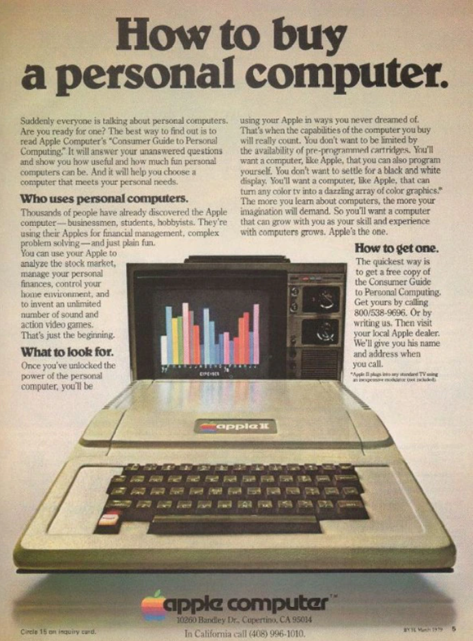

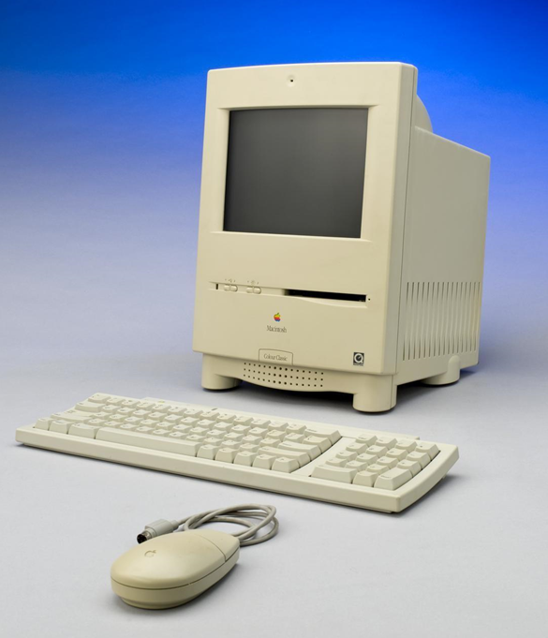
MACINTOSH

After trials, ups and downs of the company, Apple remained in the top list of preferences of consumers….

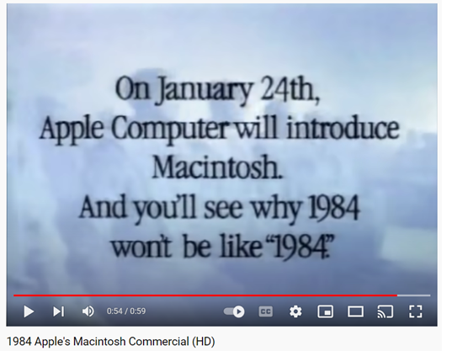
One of the most remarkable marketing ideas was used for the launching of the first Macintosh, which was based on the Book “1984”, in which people were liberated from Big Brother. The commercial was a huge success, although it did not present the computer in details, which led to controversies between the company leaders.
Now the commercial represents a landmark and a real triumph, being the most successful commercial in the American television.
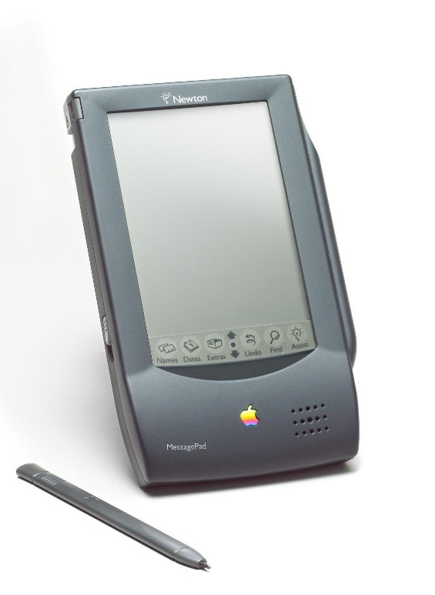
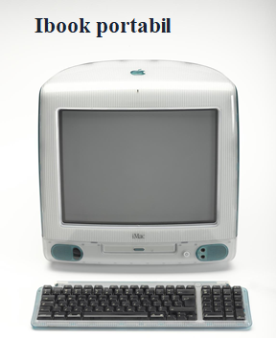
The first concept in the launch of Mac we know today was created in 1999 and has an impact on the future technology.

Apple climbed on the stage of great triumphs with the appearance of IPOD, an extremely loved device, and in 2007 the iPhone was launched, a masterpiece which was constantly improved from design point of view and technical specifications point of view. It did not last long and the tablet called iPod was brought to the public.

Innovation, unicity, diversity, special design, but common design between devices and adjustability led to the winning of autonomy of the company on the market and two statuses coveted by the competitor: “the most loved” and “the most expensive”.
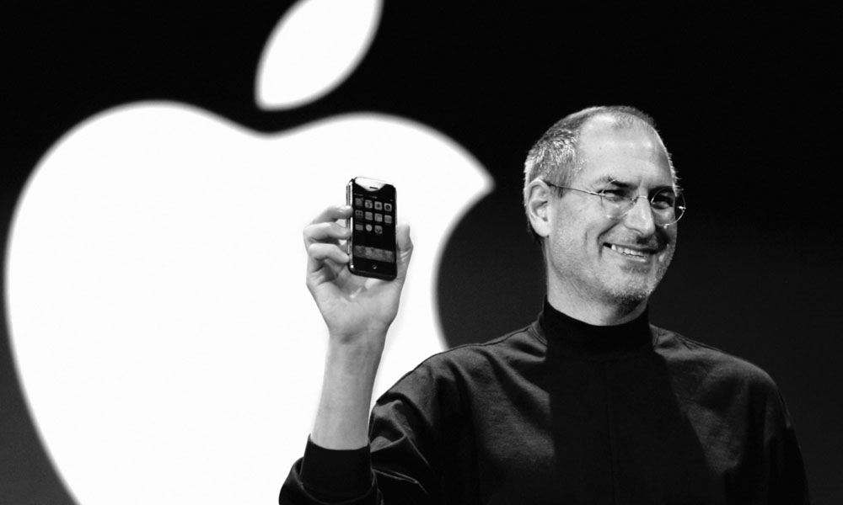
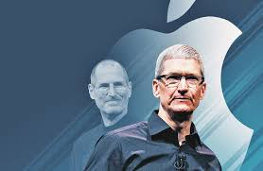
The death of the main founding member, Steve Jobs, in 2011, did not lead to decline, on the contrary, now it is the most prestigious company, and the launch of new products continued to develop with the new CEO, Tim Cook. An example is Apple Watch, which is not an innovation, but is the bestselling portable device.

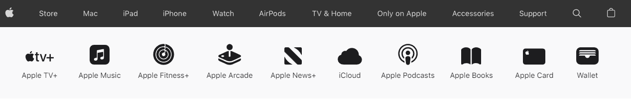
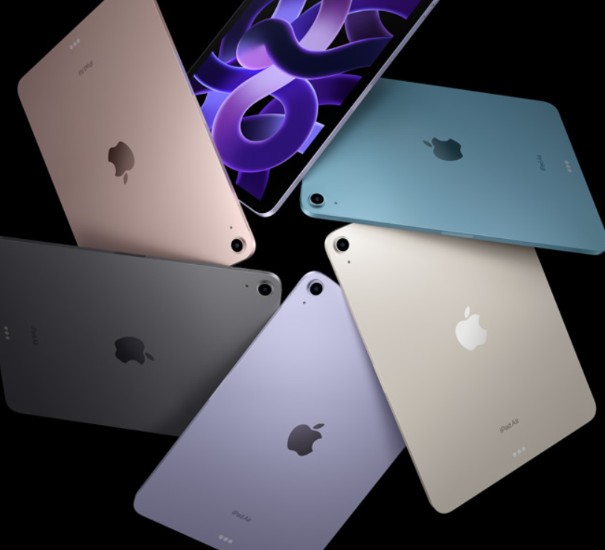
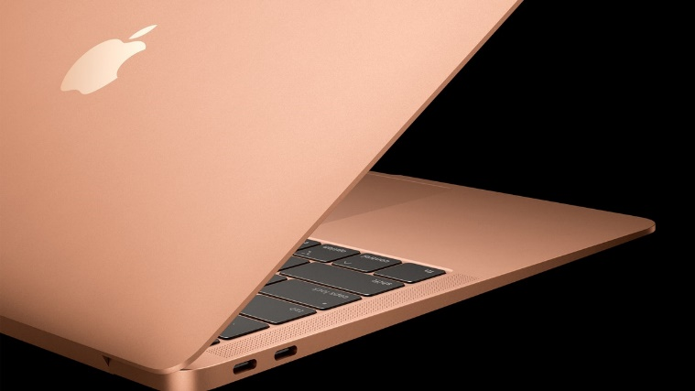

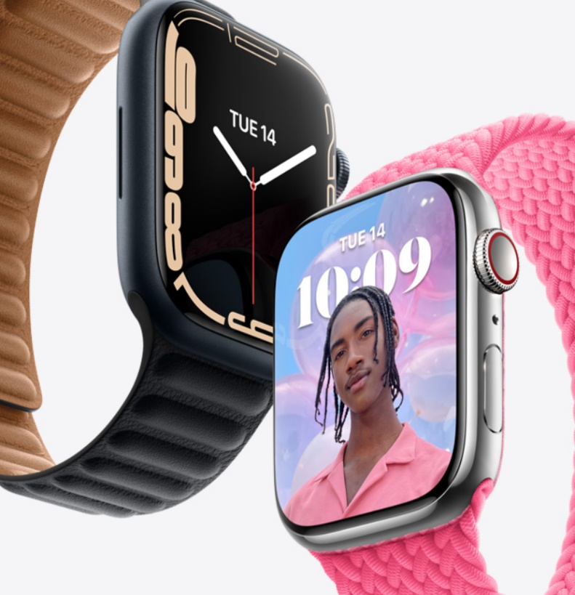
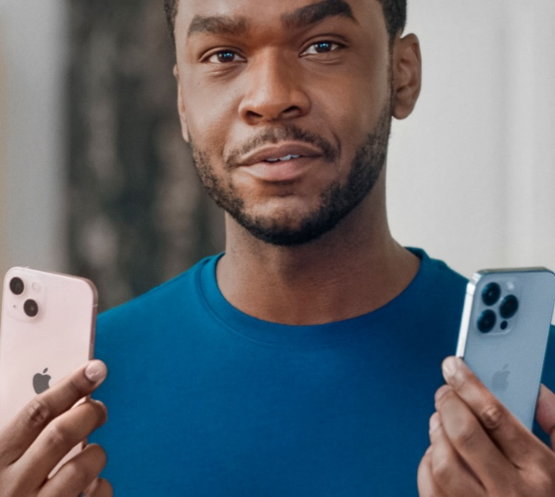

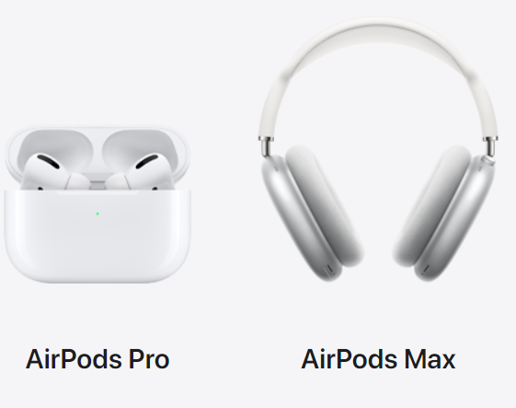

The images with the current products taken from Apple page do not require presentation, but the ”best-known bitten apple” is notorious.

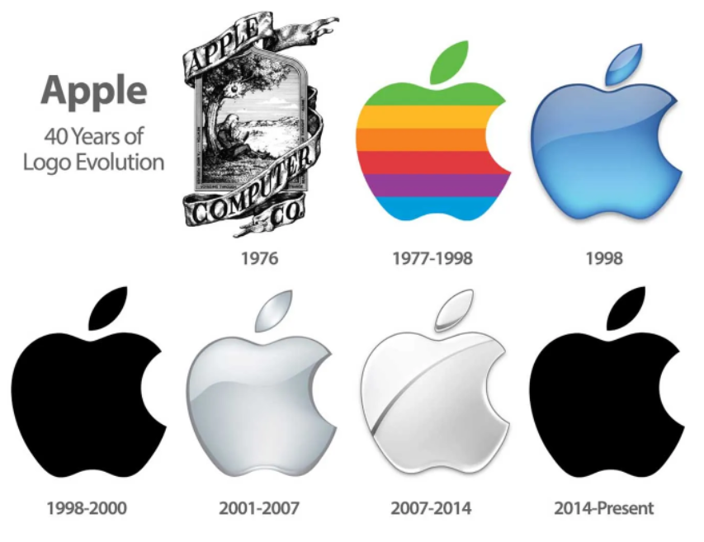

The first Apple Logo has on front-view Isaac Newton sitting under an apple tree, and in the next years the artistic vision went into a simpler and much more specific environment, under the form of a bitten apple, but colored, which represented the fact that the Apple computer displayed colored graphics. In the meantime, the shape was kept, but it renounced to the colors. The logo displays the knowledge and anarchy, but the bite expresses the ”desire” of novelty, knowledge and today it is expressed by the desire of the Apple brand.
The design of the new Apple accessories deserves attention, having in view the simplicity, elegance and refinement. To put it into a Romanian saying, ”The man sanctifies the place”, and to Jonathan Ive we owe the authenticity of the current Apple creations. He was not just the artistic Apple genius, but was also the voice from Apple commercials, until 2019, when he withdrew from the company. He is responsible for the appearance of Apple stores and the design of Apple Park construction.

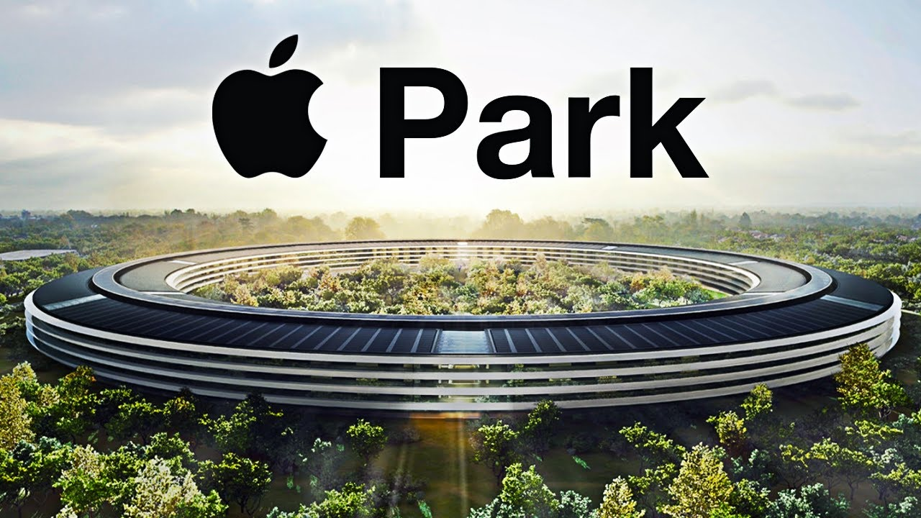
Apple is everywhere, anywhere and on any website, but the first physical stores opened in 2001. The Apple stores enjoy their popularity, brought the highest income recorded per square meter (about USD 60.000 /sqm) and a remarkable number of visitors in all the 518 stores from 25 countries (about 25,000 customers every day). Although we imagine the most expensive brand of the moment, in technology field, in exclusivity, central and luxurious places, in reality it is at the Mall, reporting a low payment of rents.
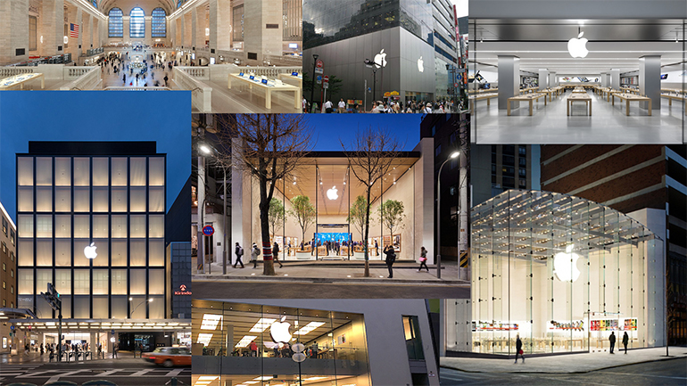
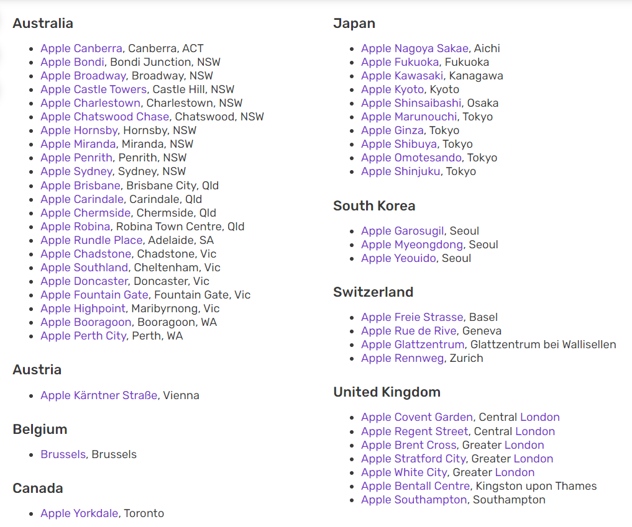
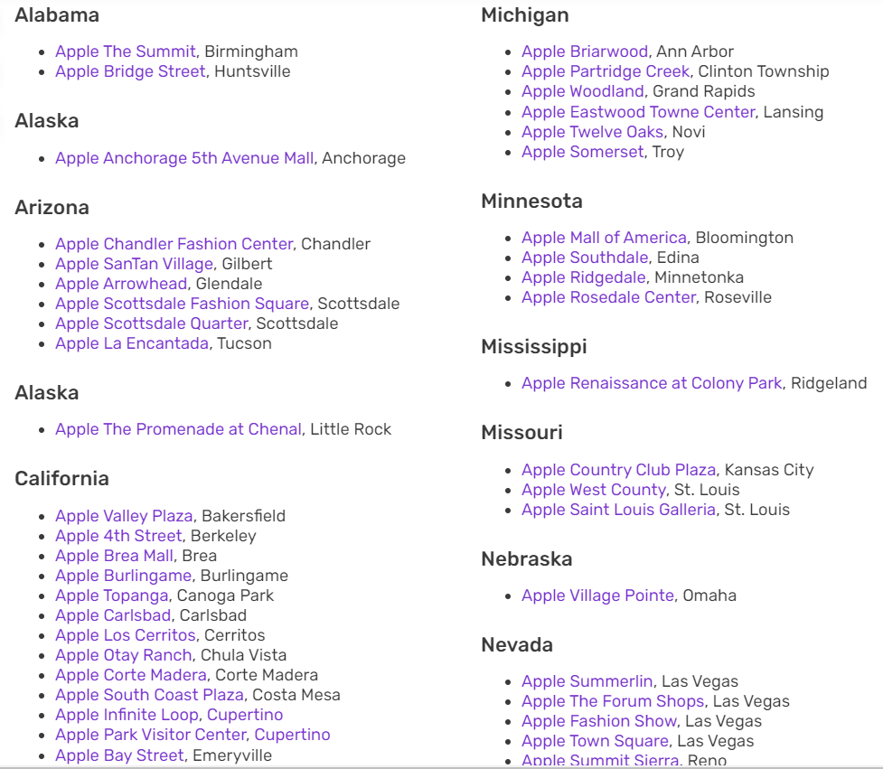

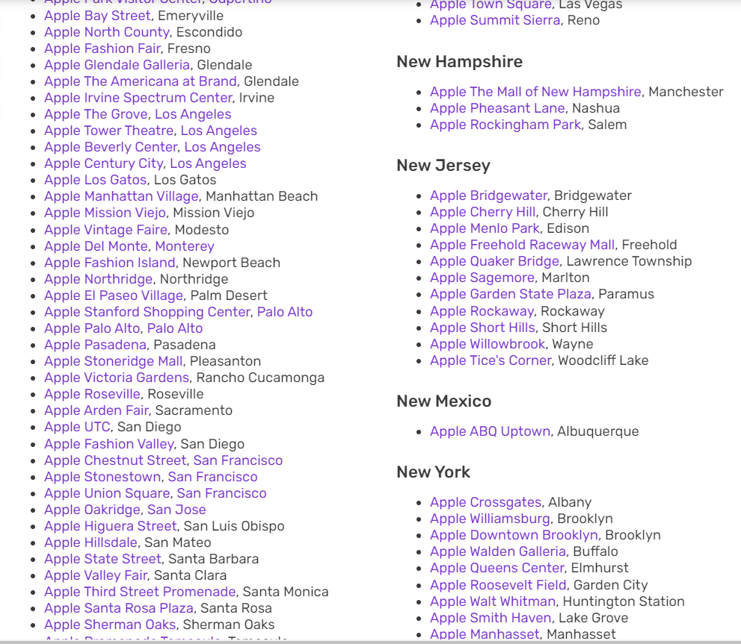
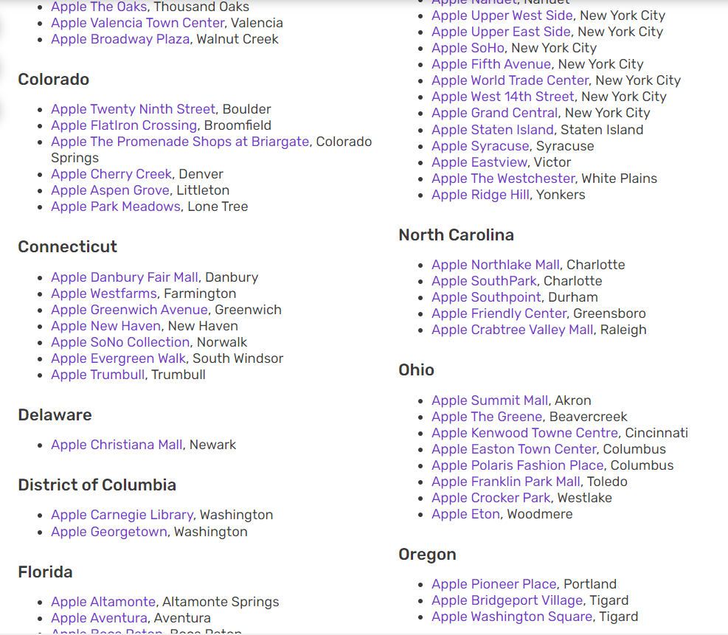
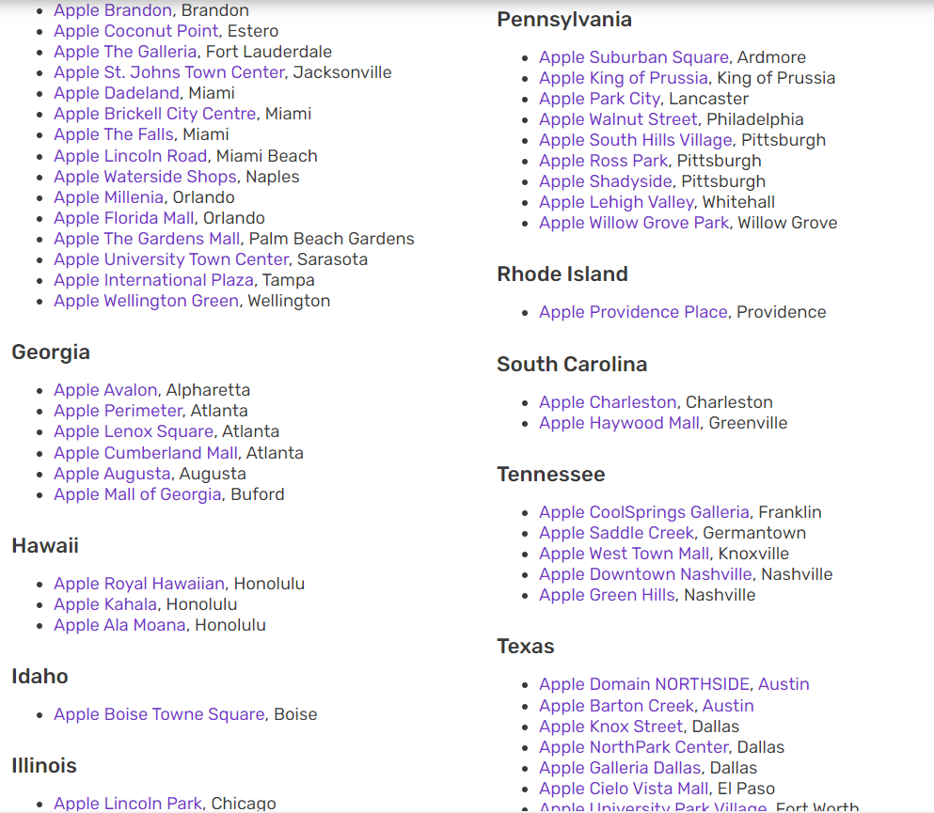
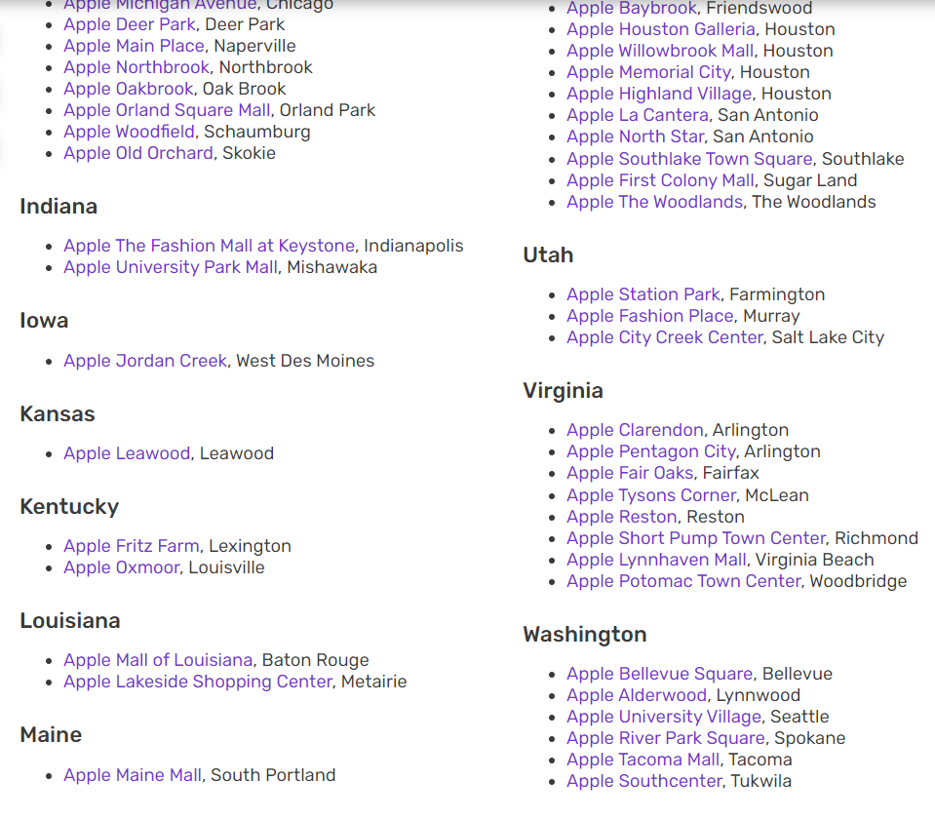
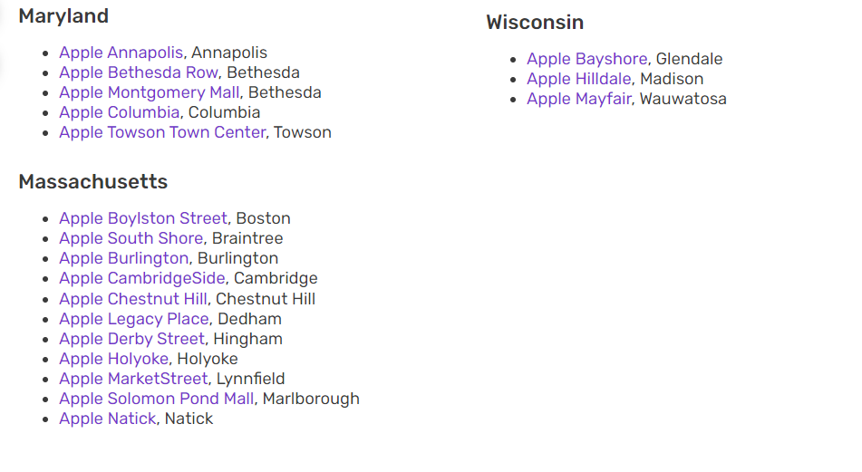
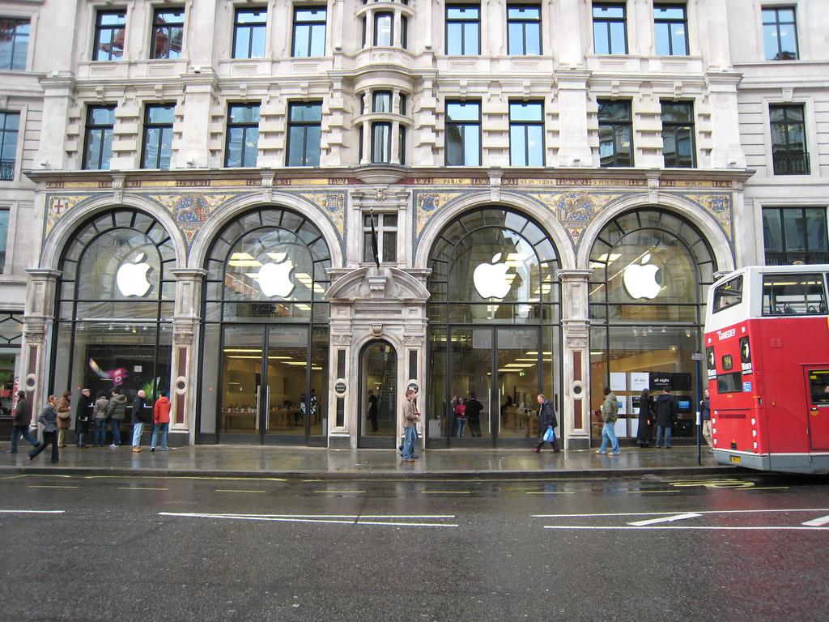
Apple Store London
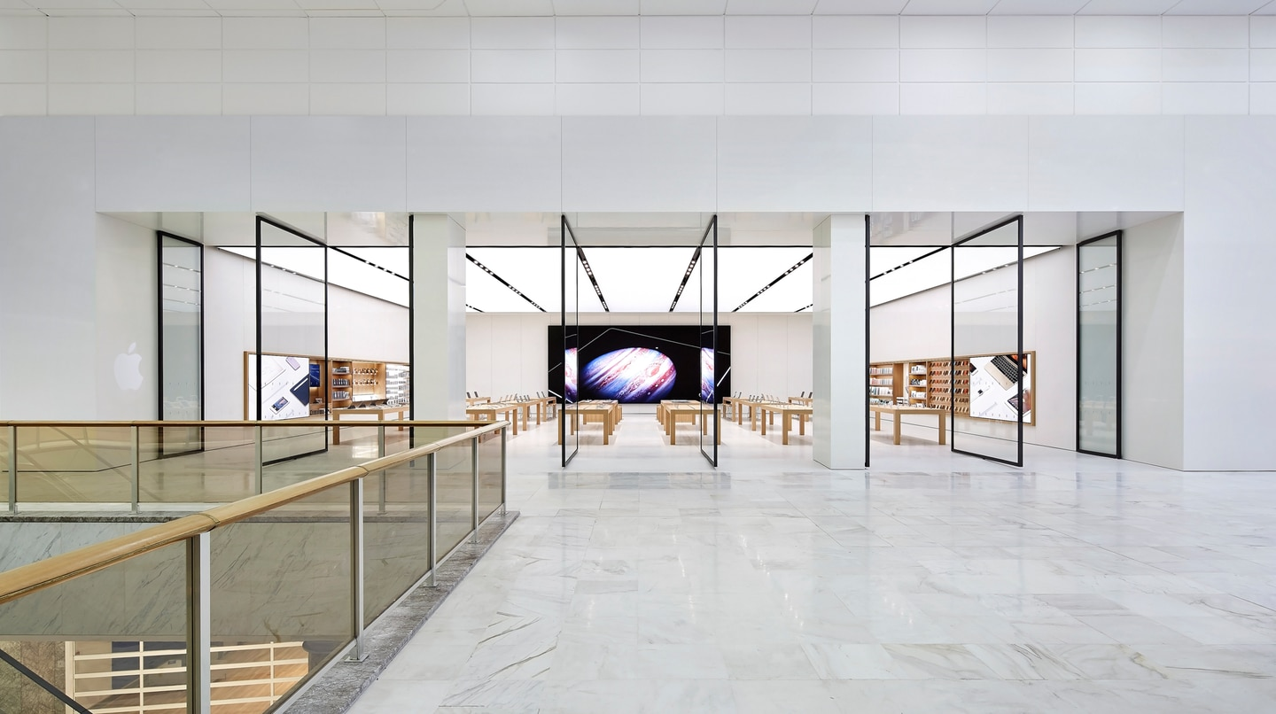
Upper West Mall Brent Cross Shopping Centre London

Apple makes its appearance in the mobile telephony collaborators, the electronics suppliers both physically and in the virtual space, being famous thanks to the most popular online store, the Apple Store.

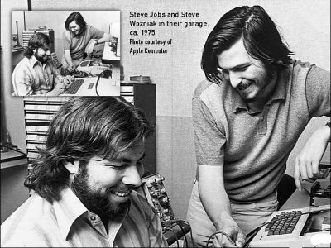

Apple is a unique concept regarding the promotion of its products. The launch of new products is always the event of the moment, from the lovers of Apple technology to the holders of Samsung. The event is presented to the whole world, broadcasted online, discussed in the TV shows from all over the world. Before any Apple event, rumors start to spread, controversies appear, but Apple does not reveal anything until the day of the big presentation.

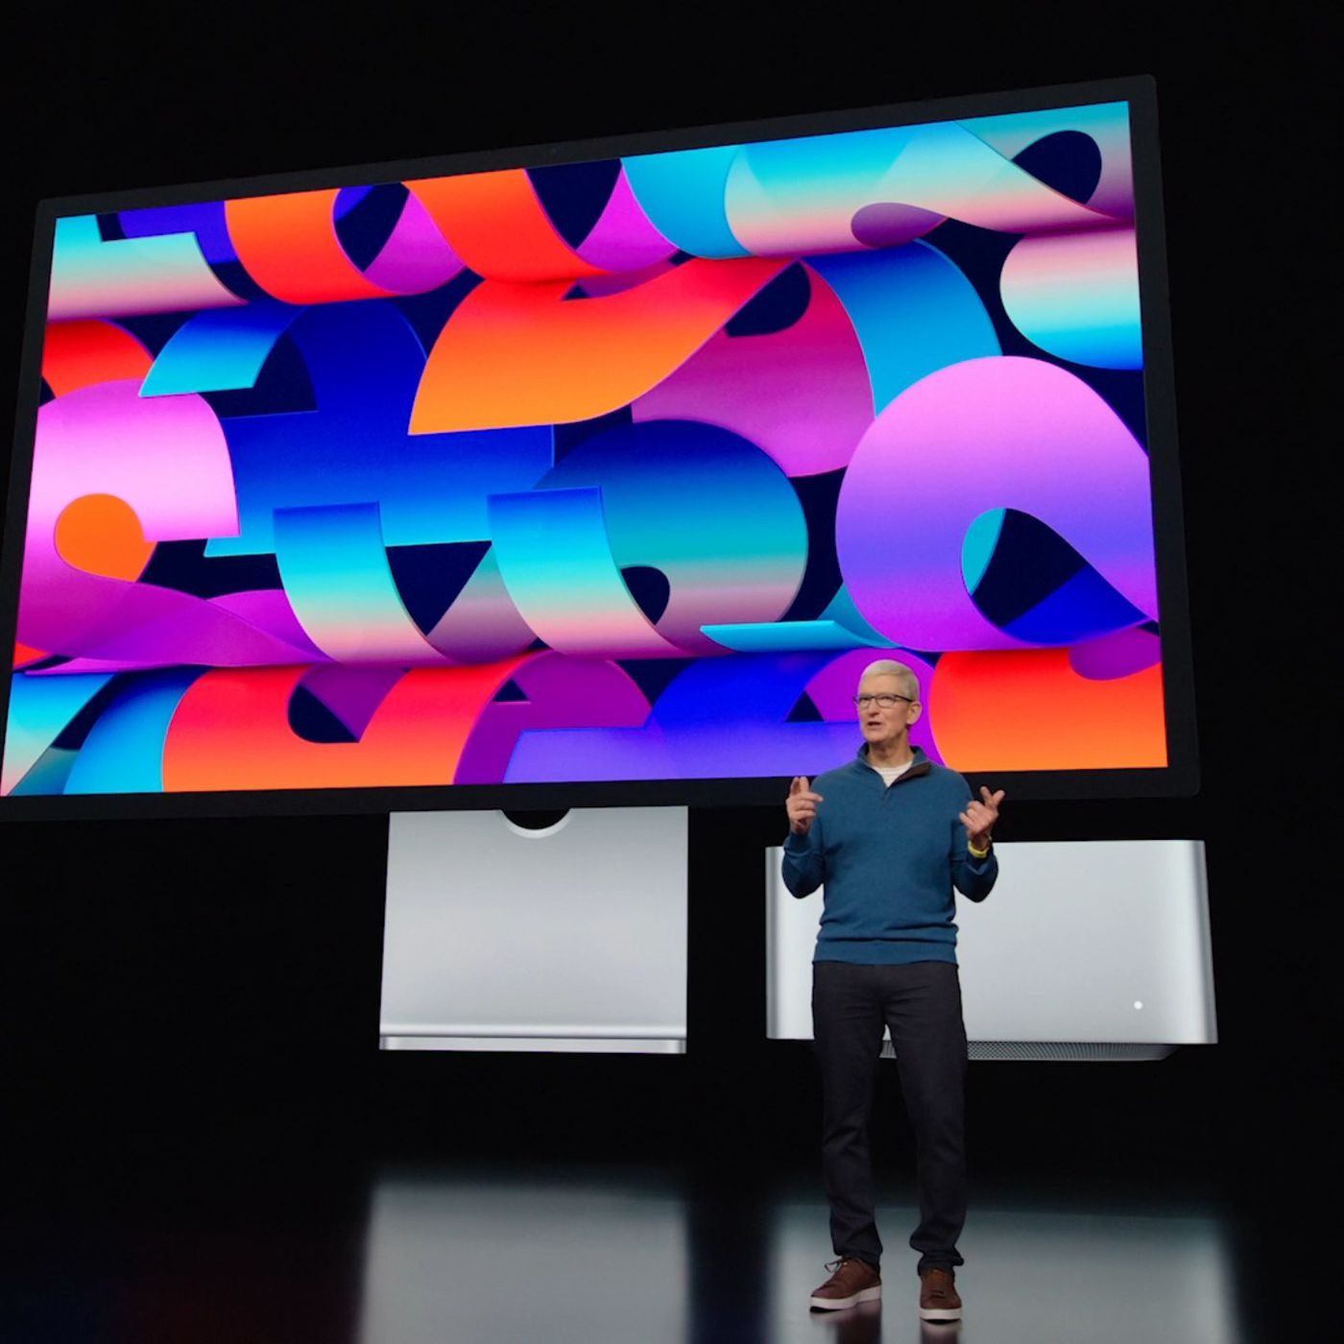

The Apple events can be seen on www.apple.com.
On March 8, 2022, the event brought to the public the new models: iPad Air 5, iPhone 13 and the long waited-for iPhone SE 3.
iPhone SE 3 is presented as the strongest, but also the cheapest model of iPhone. The Smartphone looks as its predecessor, SE2020, which is based on the design of iPhone 8, the latest model before Apple proceeded to Face ID. The authentication is with Touch ID and is the destination of nostalgic lovers of Apple, who were and remained in love with the” iPhone button”.
Apple resorts to all necessary marketing strategies to keep along all the fans of the IOS processor. In order to preserve the range with authentication by Touch ID, Apple implemented the bringing to life of an old model it constantly upgrades.
The Price. It is noteworthy how Apple, the most expensive range of electronic products, decided to address all wallets.

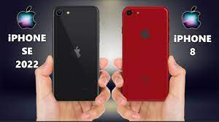
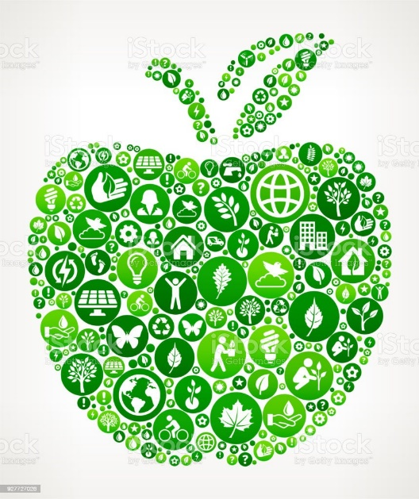

In the event, Apple highlighted the major problem faced with by the whole world, the global warming. They declared that they used recycled plastic for many components of the newly launched products. In addition, the Box does not present any plastic packaging and also the charger is not available with the smartphone.

CORPORATE COLLABORATION
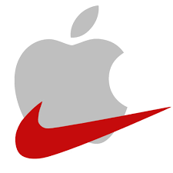

Although they are two big brands, who do not need any grand presentation, Nike and Apple resorted to a strategic partnership since the beginning of 2000s.

The collaboration between different brands has a common purpose, that of winning capital and financial resources. Thus, they became very popular, but Apple was no exception.

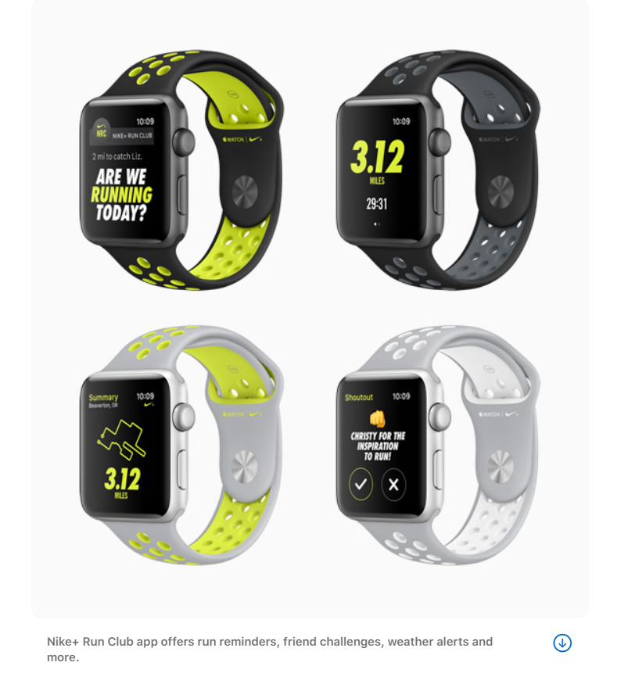
Apple developed an application for sport, while Nike made shoes for the Apple fans. Prosperity and innovation are two of the reasons for which Apple resorted to this kind of strategy, the common goal for both companies was the win-win profit.

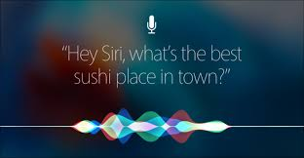

SIRI

The artificial friend from smartphone is always there for you and fulfils your wishes. We all know the voice of Siri, she is emblematic and is part of the life of Apple product users. They chose a feminine, easy to identify and warm voice.
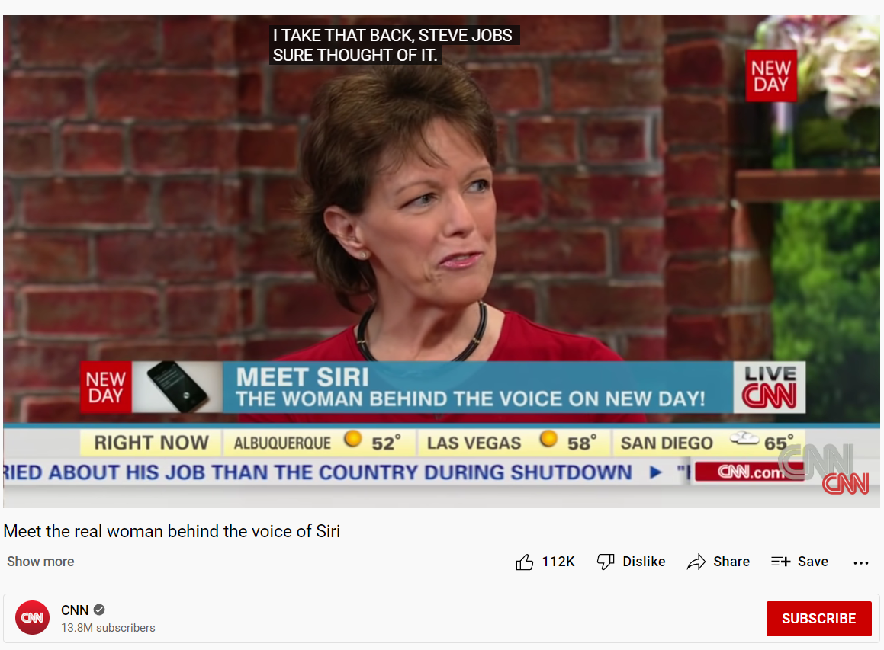

Being extremely popular and loved, CNN made available to the whole world by an interview the image behind the voice of Siri.
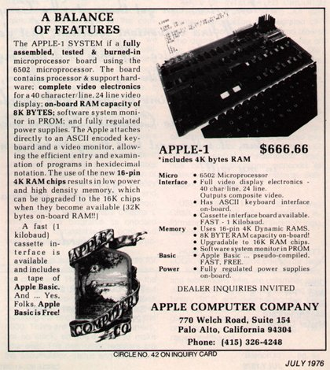

In 1976, the first Apple commercial presented the Computer Apple 1. Over the time the Marketing strategy took a new scope and implemented the best methods for Apple to be always on top.

Over time they ran commercials, which are now considered sexist. For example, the commercial which presented Apple II, has as protagonist the newscaster Dick Cavett who in a misogynist way asks a ”household wife” how to use Apple II “for household budgeting”.

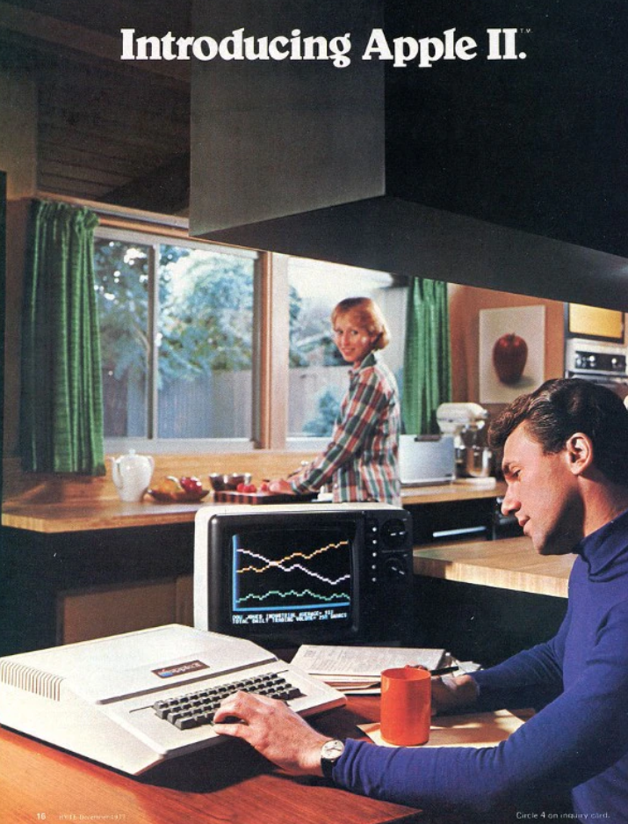

The movie “Mission Impossible” highlights Tom Cruise using Apple products.
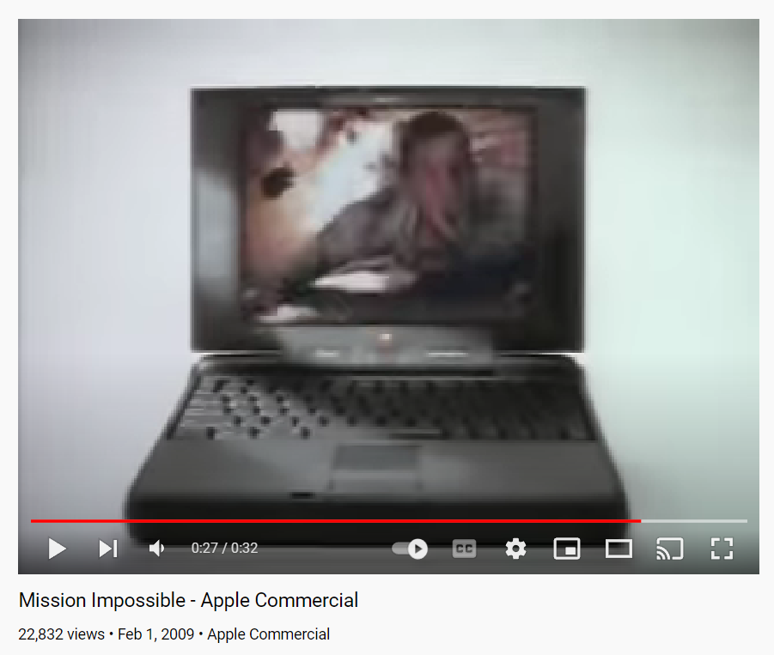
https://www.youtube.com/watch?v=26gQATqxE-c

Think Different

The campaign “Think Different” from 1997 represented the return of Steve Jobs to the company. In the commercial they presented characters who changed the world: Albert Einstein, Bob Dylan, Martin Luther King, Jr., Richard Branson, John Lennon (with Yoko Ono), Buckminster Fuller, Thomas Edison, Muhammad Ali, Ted Turner, Maria Callas, Mahatma Gandhi, Amelia Earhart, Alfred Hitchcock, Martha Graham, Jim Henson (with Kermit the Frog), Frank Lloyd Wright and Pablo Picasso.

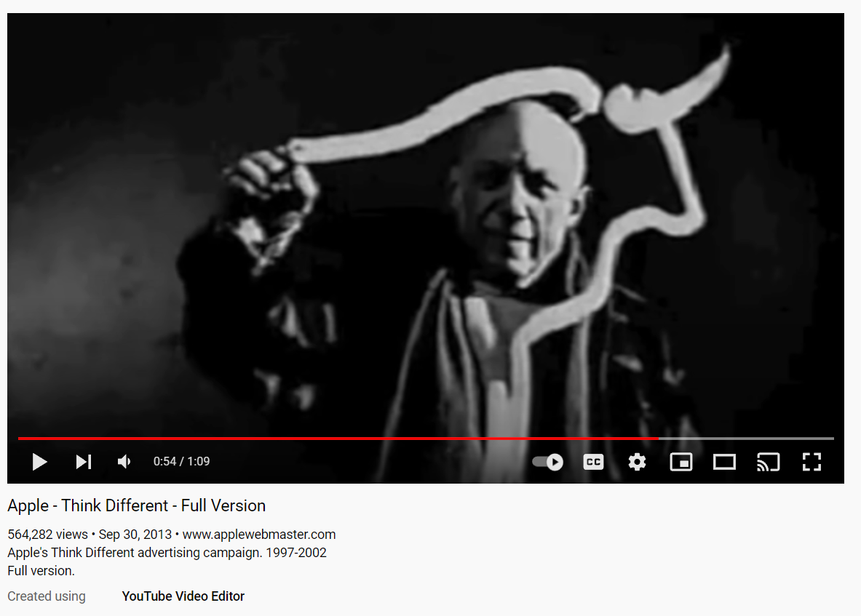
https://www.youtube.com/watch?v=5sMBhDv4sik

Get a Mac!

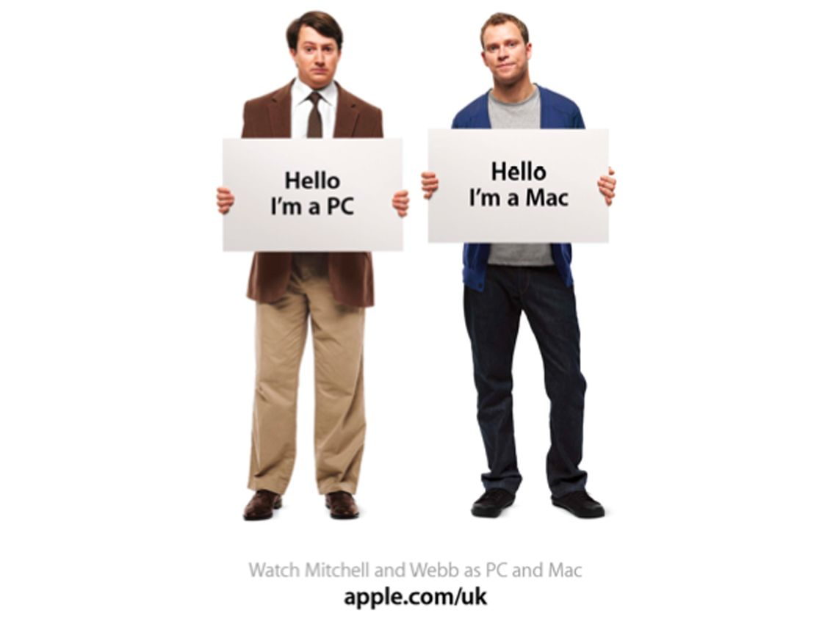

Over time, the marketing strategy used for the Apple commercials went to present the negative publicity of the main competitors. Practically Apple spoke of its rival, Microsoft, who uses a too complicated technology. (‘Get a Mac’ Campaign).

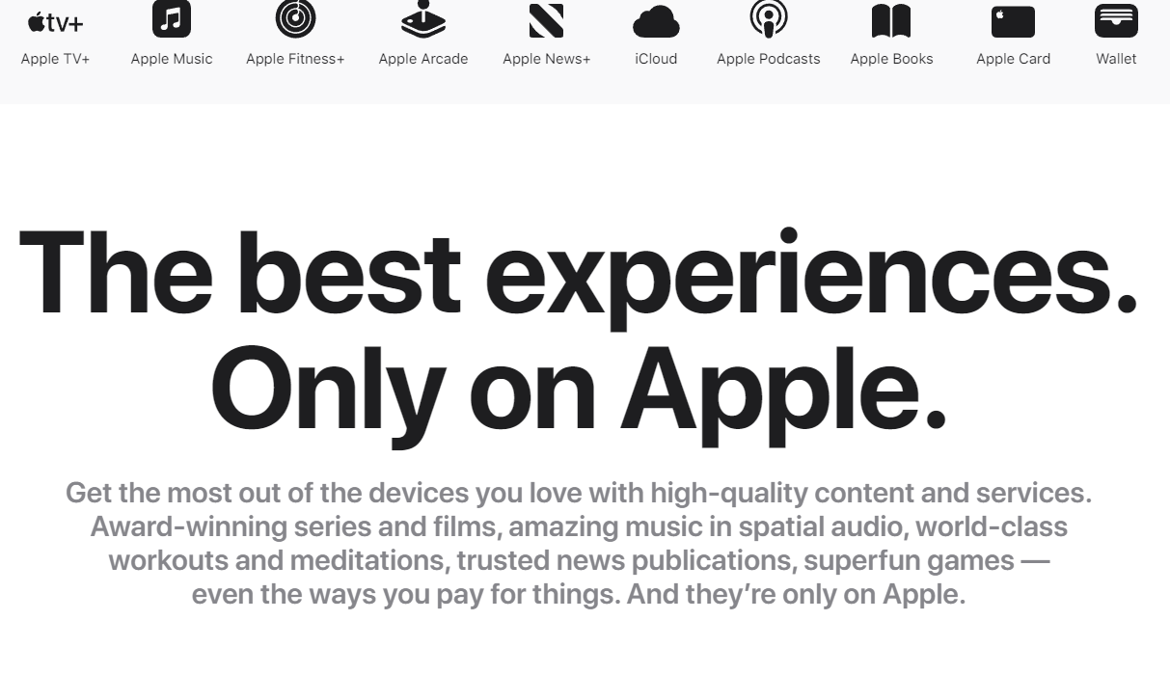

At a short visit on the website apple.com you notice the color and expressions full of optimism, unicity, class and refinement. Audacious, short and concise, the expressions on the website ask and answer your questions, make a short presentation of the products and make you feel happy giving you trust in the products presented.
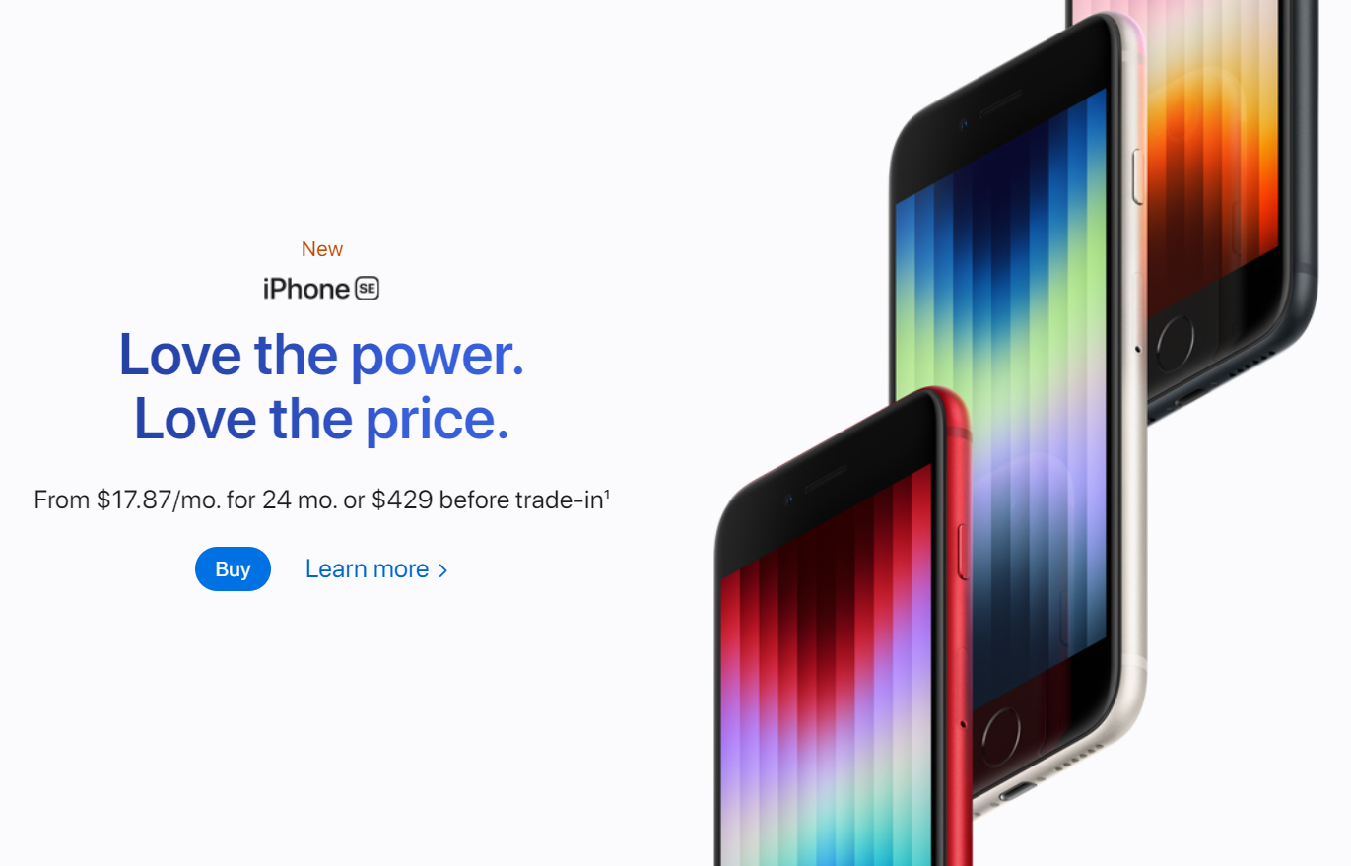
If you have an Apple product at home, just enter the website, there you will feel strong and special –
“Only on Apple”.

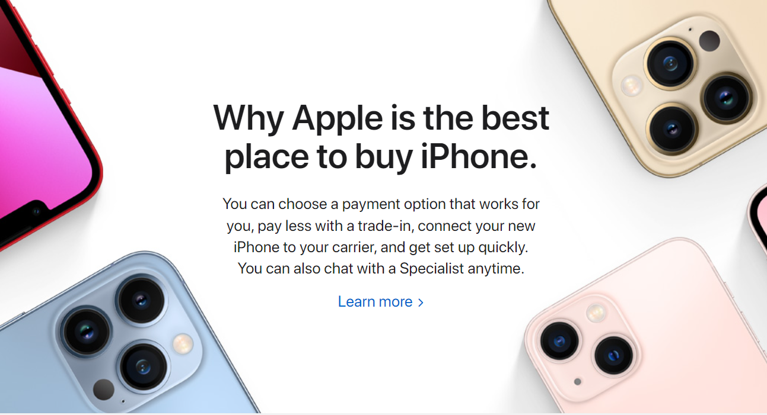
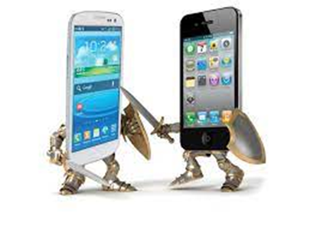

COMPETITION
APPLE vs SAMSUNG:

Apple is in disputes with Samsung and this is the main rival which the public associates Apple with. Apple was the company which sued Samsung, regarding the design of smartphones. Apple acted against Samsung and led to an interdiction for the trade in USA. Finally, the Supreme Court decided to end the trial.
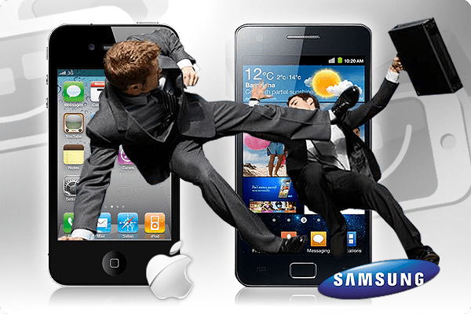

APPLE vs AMAZON:
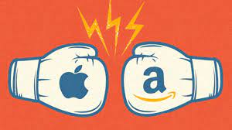
Apple opened a trial against Amazon, when they decided to make their own application for Kindle Fire. Because of using the term “App Store”, Apple notified and communicated the ”theft”. Even if the term “app.” was invented by Apple, it became very usual and used in various sectors. In other words, Amazon did not do anything wrong and retaliated, finally winning the right to use the term “Appstore”.

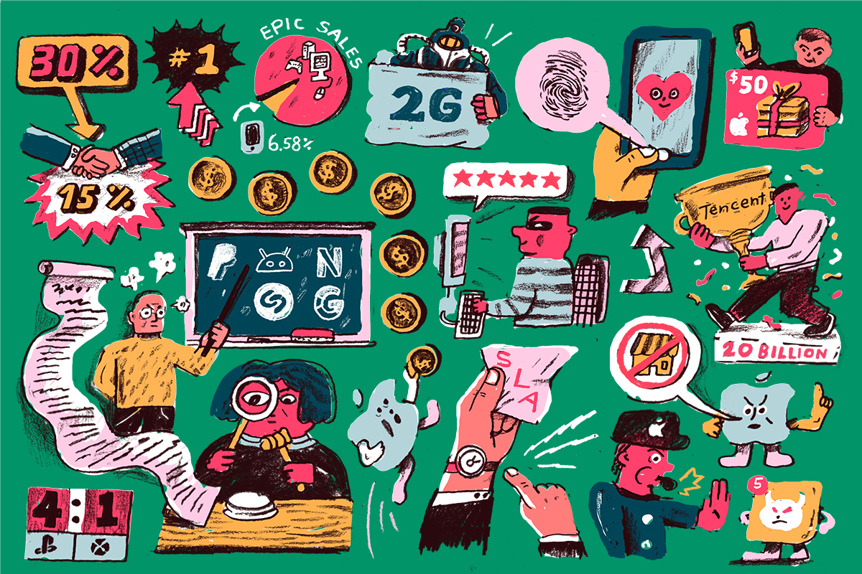

Also, these ”battles” waged by Apple are a good reason to remain in front of the public, to be seen, heard and keep the label of a fierce opponent, who protects and defends its products.

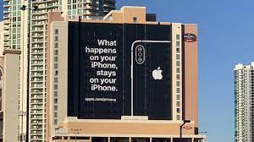
References:
- Walter Isaacson (2011), Steve Jobs.
- Ted Kang (2018), Samsung v. Apple: The Ill-fated Introduction of Apportionment-by-Component for Designs, Berkeley Technology Law Journal. Vol. 33, Annual Review, pp. 889-916 (28 pages)
Download at https://www.jstor.org/stable/26667669
- Zachary C. Flood (2016), Antitrust Enforcement in the Developing E-Book Market: Apple, Amazon, and the Future of the Publishing Industry, Vol. 31, No. 2, Annual Review, pp. 879-904 (26 pages)
Download at https://www.jstor.org/stable/26377775
- List of Apple Stores
Available at https://apple.fandom.com/wiki/List_of_Apple_Stores
[Accessed 18.04.2022]
- Janet Moredock, Jony Ive- British designer and executive
Available at https://www.britannica.com/biography/Jonathan-Ive
[Accessed 18.04.2022]
- Christoph Dernbach (2011), “1984″ – The famous Super Bowl Spot
Available at https://www.mac-history.net/apple-history-tv/ads/2011-07-12/1984-the-famous-super-bowl-spot
[Accessed 18.04.2022]
- Matthew Chapman (2016), The 10 best ads in Apple's 40-year history
Available at https://www.campaignlive.co.uk/article/10-best-ads-apples-40-year-history/1388877?src_site=marketingmagazine
[Accessed 19.04.2022]
- Finance.yahoo.com https://finance.yahoo.com/quote/AAPL/history/
[Accessed 17.04.2022]
- Meet the real woman behind the voice of Siri
https://www.youtube.com/watch?v=z2bTymnb1uE
[Accessed 19.04.2022]
- Mission Impossible - Apple Commercial
https://www.youtube.com/watch?v=5sMBhDv4sik
[Accessed 19.04.2022]
Apple - Think Different - Full Version
https://www.youtube.com/watch?v=5sMBhDv4sik
[Accessed 19.04.2022]
- 1984 Apple's Macintosh Commercial
https://www.youtube.com/watch?v=VtvjbmoDx-I
[Accessed 19.04.2022]
- Steve Jobs: How a Dreamer Changed the World
https://www.youtube.com/watch?v=5fI3zz2cp3k
[Accessed 17.04.2022]
- Apple.com, Iphone SE
https://www.apple.com/iphone-se/
[Accessed 19.04.2022]
- Apple.com, Apple Events
https://www.apple.com/apple-events/
[Accessed 19.04.2022]
- Apple.com, Apple nike
https://www.apple.com/newsroom/2016/09/apple-nike-launch-apple-watch-nike/
[Accessed 19.04.2022]
- Apple.com, Apple Store
https://www.apple.com/store
[Accessed 19.04.2022]
- Charles Arthur (2012), Samsung Galaxy Tab 'does not copy Apple's iPad designs
https://www.theguardian.com/technology/2012/oct/18/samsung-galaxy-tab-apple-ipad
[Accessed 19.04.2022]
- Gibbs, Samuel (2014), Steve Wozniak: Apple starting in a garage is a myth https://web.archive.org/web/20150425011132/https://www.theguardian.com/technology/2014/dec/05/steve-wozniak-apple-starting-in-a-garage-is-a-myth
[Accessed 17.04.2022]
- Denisco, Alison (2021), MacOS Monterey: What you should know about Apple's latest Mac software update
https://www.cnet.com/tech/computing/macos-monterey-what-you-should-know-about-apple-latest-mac-software-update/
[Accessed 18.04.2022]
- Bostic, Kevin (2013), Nuance confirms its voice technology is behind Apple's Siri
https://appleinsider.com/articles/13/05/30/nuance-confirms-its-technology-is-behind-apples-siri
[Accessed 19.04.2022]
- Kahney, Leander (2013), Jony Ive : the genius behind Apple's greatest products
https://en.wikipedia.org/wiki/Jony_Ive
[Accessed 18.04.2022]

Pictures:
- Apple I, https://ro.wikipedia.org/wiki/Fi%C8%99ier:Apple_I_Computer.jpg [Accessed 17.04.2022]
- WORK AT APPLE 1/ Steve Jobs, Steve Wozniak, https://www.ubergizmo.com/2014/10/working-apple-1-computer-sold-at-auction-for-905000/, [Accessed 17.04.2022]
- Advertisement Apple II , https://www.domusweb.it/en/design/2020/06/10/43-anni-di-apple-ii-il-primo-computer-che-voleva-fare-lelettrodomestico.html, [Accessed 17.04.2022]
- Steve Jobs and Apple II, https://www.domusweb.it/en/design/2020/06/10/43-anni-di-apple-ii-il-primo-computer-che-voleva-fare-lelettrodomestico.html, [Accessed 18.04.2022]
- Advertisment Apple II, https://www.domusweb.it/en/design/2020/06/10/43-anni-di-apple-ii-il-primo-computer-che-voleva-fare-lelettrodomestico.html [Accessed 18.04.2022]
- Lisa, https://www.jstor.org/stable/community.26313240?searchText=Apple+Lisa+personal+computer+system&searchUri=%2Faction%2FdoBasicSearch%3Fefqs%3DeyJjdHkiOlsiWTI5dWRISnBZblYwWldSZmFXMWhaMlZ6Il0sImNvbGxlY3Rpb25faWRzIjpbXX0%253D%26Query%3DApple%2BLisa%2Bpersonal%2Bcomputer%2Bsystem%26so%3Drel&ab_segments=0%2FSYC-6294%2Ftest_segment_1&refreqid=fastly-default%3A1b3e8a345eb31c77b9718ad5a0a43a23&searchkey=1650488511675 [Accessed 18.04.2022]
- Macintosh, https://www.jstor.org/stable/community.26318495 [Accessed 18.04.2022]
- Ibook portabil, https://www.jstor.org/stable/community.26436516, [Accessed 18.04.2022]
- Apple Newton MessagePad, https://www.jstor.org/stable/community.26313736, [Accessed 18.04.2022]
- APPLE PARK, https://i.ytimg.com/vi/FzcfZyEhOoI/maxresdefault.jpg, [Accessed 18.04.2022]
- Apple Store London, https://en.wikipedia.org/wiki/File:Apple_Store_London.jpg, [Accessed 18.04.2022]
- Upper West Mall Brent Cross Shopping Centre London, apple.com/uk/retail/brentcross/, [Accessed 18.04.2022]
- Samsung vs Apple, https://www.nextpit.com/Apple-vs-Samsung-Round-28-Cupertino-Strikes-Back, [Accessed 19.04.2022]
- https://www.theverge.com/c/22611236/epic-v-apple-emails-project-liberty-app-store-schiller-sweeney-cook-jobs, {Accessed 19.04.2022]

