Social Media Safety Sessions
Introduction
From the needs analysis research in the previous paper regarding social media and the issues surrounding, this project has been put in place to ensure the safety and knowledge of all children and young people. These workshops won’t prevent any dangers, but provide the knowledge and knowhow for parents, educational settings and children to stay safe online. As mentioned in the needs analysis report, a third of users from young adults, rest with 11-12-year olds. Many of these younger users experienced upset from a social media site. This projects aim is to equip young children, as well as parents on how to stay safe and secure online. Most parents have access to social media sites and are using the majority of them. However, parents are unaware of current trends that are floating around online by the younger generations. This project will allow parents to understand the latest trends online, and how they can keep communication open between their children. It will also allow parents to voice concerns and share knowledge on child locks on their technology.

Problem/issues identified
In the 21st Century, social media is becoming more of an issue than a benefit to many. Social media has become the cause of deaths, bullying and conflicts. Anyone can access almost any information that they choose to look for, with simply a click. The data shared, and searches that can easily be accessed get into the wrong hands, then anyone, especially children, are under harm. As mentioned in the needs analysis paper, the worrying number of young children using these sites – regardless of an age limit is becoming an increasing issue.

Children are naive and trusting to people who they do not know online, and develop relationships via these sites. By children allowing strangers into their lives, children are unaware of the consequences that could come. As a child, you tend to believe the best in everyone, and would lend trust to all, until that trust is taken away. Children need to understand that it is important to not share any personal information online, not just with strangers, but not publish any personal information that could be shared in any way.

Parents need to communicate the basics of staying safe online. Children should never meet up with anyone that they have met online, give away any personal information and report any inappropriate behaviour. All users need to be aware that age limits are set in place for a reason, one being that the content is not suitable for those under the age limit.

There are many things that happen on social media sites that parents/guardians are unaware of. Children are unlikely to communicate with a parent if they feel that they are unable to share something that their parent may not like. The aim of this project is to fill the gap between the lack of communication around social media and the issues that it brings with it.

Most sites have an age restriction of 13. As mentioned previously, children are able to find ways around this so that they can interact with their friends who are also using these sites. The most popular social media sites are Instagram, Twitter, Facebook, Snapchat and Tumblr. The sites that are aimed at younger children, seem to baby-like for the younger youth of today.

The sites mentioned above all include access to instant messaging which allows anyone to contact you, unless you have set a higher security on your profile. Some teens and children do not understand the dangers of talking to strangers through these chats, as they have not yet experience a negative outcome. When children interact with strangers and engage with these behaviours, they may or may not realise the consequences in doing so. Many children hide their conversations in they know that their parents disapprove of certain friends or behaviours.
ChatSlang, (2017) has a full list of terms that parents should recognize. Among them:
“9 or C9 – Parent in room
CD9 – Parents are watching
SPROS – Stop parents reading over shoulder
KPC – Keeping parents clueless
ASLP – Age/Sex/Location/Picture”
Listed above are only just a few of the acronyms that children are using to keep their parents from knowing what they are doing online. Parents should be made aware of these acronyms in order to understand what their child is doing.

Parents need to be accessing their child’s social media. Privacy is an issue here. No one likes their privacy being taken away from them, and for a teenager to experience this, is likely to explode or back fire. If parents are equipped to deal with this is in a way where they are able to protect their child without damaging the relationship, then these privacy issues can be minimized over time if communication is kept open.

Project description
The project itself will consist of six sessions, which will vary between workshops, games and sit in talks with parents. The project itself will not require any contribution from parents or schools, but just their willingness to listen. The aim of the workshops is to make it as fun as possible for the children, and for them to be able to ask questions. The Workshops will run for school ages 9-13 ( Year 5 to Year 7/8). Those ages have been specifically chosen due to the early introduction of technology to young children in the 21st Century.

Session 1 – Introduction with parents and children
Session 2 – Workshop with iPads and games – children only
Session 3 – Guest speaker – children only
Session 4 – Social Media sites – children only
Session 5 – Open questions
Session 6 – Parents and Children, what have I learnt?

Being able to equip children with the essential skills they need to be safe online is a need. Whitmore, (2002) identifies the positive impact teaching and developing skills can have.

The Grow Model, Whitemore, (2002) is as follows :
‘The GROW Model is an acronym standing for (G)oals, (R)eality, (O)ptions and (W)ill, highlighting the four key steps in the implementation of the GROW Model. By working through these four stages, the GROW Model raises an individual’s awareness and understanding of:
- their own aspirations;
- their current situation and beliefs;
- the possibilities and resources open to them; and
- the actions they want to take to achieve their personal and professional goals.
By setting goals which are inspiring and challenging as well as specific, measurable and achievable in a realistic time frame, the GROW Model successfully promotes confidence and self-motivation, leading to increased productivity and personal satisfaction. The Will element of the fourth stage in the model is the barometer of success. It relates to volition, desire and intention.’
Some websites, such as the NSPCC, have listed advice for young people and parents, on how to stay safe on the internet. It is important that all users, no matter what age, are informed about the dangers of Social Media, and the impact that it can have on lives. Users should be able to access the negative impacts of previous issues with social media, such as stories of children etc who have had the worst happen to them.

These websites are put in place for children to feel safe and talk to someone who is not necessarily in direct contact with them. Children often feel more comfortable to discuss issues with those they do not know. These websites help raise the awareness of the dangers of the internet, but also support both parents and children.
Meeting and chatting with stranger’s online poses risks to young people who might be vulnerable to grooming and online (and offline) forms of sexual abuse.

With the physical barrier of a screen, people feel that they have more power hiding behind someone that they may pretend to be, as they may not actually be like this in real life.
Many apps share the user’s location. This can put children at risk from others who actively seek out children with the intention of meeting in the real world. Sharing a location can also raise concerns with identity theft and privacy. Most apps do go through a process where they ask the user whether they would like to share their location or not.

This may expose children to explicit content, sometimes without their parents knowing. Some of this content can be illegal or simply inappropriate for children as it’s meant for adults.

Example letter
Dear Parents/Guardians,

The week commencing 19th February 2018, we will be offering Social Media Safety afterschool workshops for years 5-8 (age 13). These sessions will be run by volunteers who will all have an updated DBS. There is no fee for these workshops, but we do ask for parents to sit in on two of the sessions.
Session 1 – Introduction with parents and children
Session 2 – Workshop with iPads and games – children only
Session 3 – Guest speaker – children only
Session 4 – Social Media sites – children only
Session 5 – Open questions
Session 6 – Parents and Children, what have I learnt?

The workshops will run 3:15pm until 4pm every Monday, held in Dinas Powys Community Library ( opposite the school )

Please sign and give this form in to the school if you would like your child to attend.

Many Thanks,

Staffing

This letter will be given out to children in school, to take home to their parents. The school have a huge part to play in the community, and are always willing to see how they can get involved. The library is keen to have children through its doors to help develop their education where they can further their learning.

We will use volunteers from the local church who have strong links with the school and community, with one or two being IT specialists. All volunteers have an updated DBS to fall under the requirements of the local authority. Usually, projects like this are not fortunate enough to have willing volunteers to help from the goodness of their hearts. Dinas Powys as a community are fortunate to have a close community where there are others who would like to help the schools and children. All are aware of the issues around social media and are willing to promote awareness of issues. The school, library and church are all within walking distance of each other and share a carpark. This is perfect for the project as there are no issues around transport for the children or parents. Which leads on to the funding needs of the project.

There are no funding needs for the project, as all staff are local volunteers. The school have agreed to provide iPads for the children to use - those who do not have their own. The library have not asked for a hire fee of the space, as they want to support this project.

The maps below show Library location in Dinas Powys. 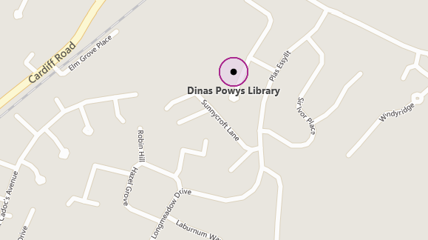
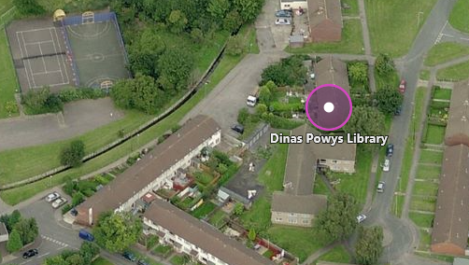

Worksheets and Games around social media will engage children into listening and using their own knowledge, as well as help from volunteers. Below are a few examples of games and worksheets that are centred around social media and internet safety. It makes learning fun for the children as after a long day at school, most children do not want to sit and listen to more information, that to them, may not seem like a dangerous issue.
Worksheets are a fantastic way of getting children to actively engage with their peers as well as adults. It gives a relaxed approach to work and findings, as children do not see it as work. They are happy to engage and play the games or complete worksheets.

This project will also improve the gap between peers. Having issues in common, draw children closer to each other, and gives them a voice. If children are comfortable around each other to speak up about their experiences online, in a safe space, it will encourage them to talk to their parents or teachers about this too.

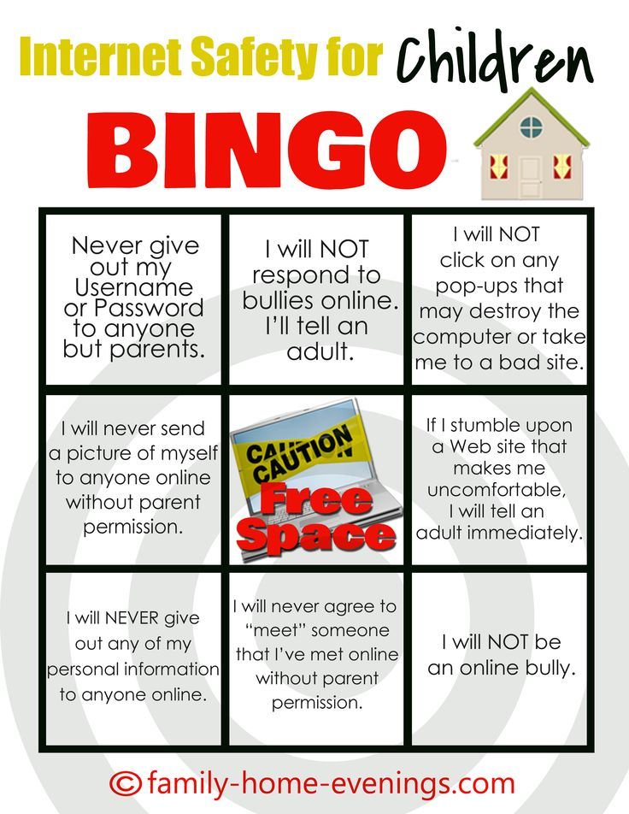

A SMART safety poster for children to visualise and learn the acronym.
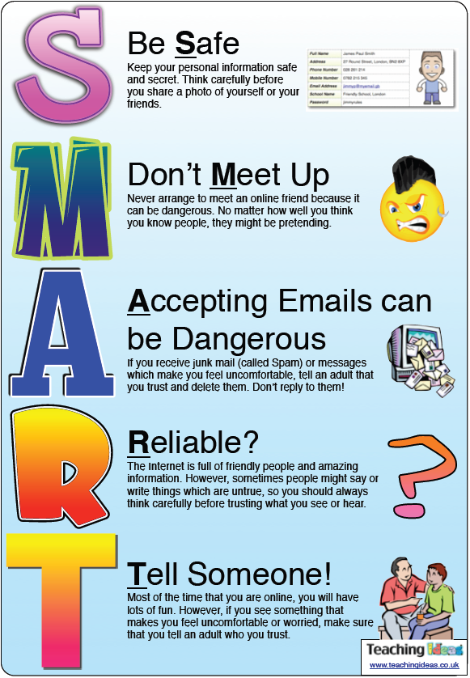

Once the project has run its course, we will offer a survey for both, parents and children to complete on their experience of the sessions, and whether it would be useful to run the course or a similar course in the future. The outcome of the project would be that children feel they have a voice to speak up about the issues that they are facing online and that the communication barrier between them and parents is lifted. We would hope that it provides children the knowledge to know right and wrong on the internet, and that they are aware of boundaries needed in place for them to stay safe and be protected.

The idea is that as social media becomes more of an issue, there will be more awareness around the internet. In 2015, 3.14 billion people were users of the internet. This is almost half of the world’s population. Even though security will become more sophisticated in trying to find the people who are the cause of these dangers, so will others be able to access information easily. A study from Cox Communications, (2015) found that “69% of teens regularly receive personal messages online from strangers. Many parents may be unaware of this because only 21% of teens who receive messages from strangers tell a trusted adult”. This is a common issue for social media users, we are not able to fully stop this happening, but through these sessions we are able to help equip young people and parents in the knowledge they need around using the internet and staying safe online.

If this is successful, we will have completed the aim of the project, which is to raise awareness for children and parents around the issues of social media. The best outcome from this project would be that all parties will have understood and learnt something from these sessions, even if it is one thing. If projects similar continued throughout the UK, we would see statistics on social media issues decrease. It is unlikely that all issues will disappear in the future, but an awareness and knowledge around social media and the internet will have an impact on these figures that have been listed in this project proposal and needs analysis.

References

Butin, D. W. and Seider, S. (2012) The Engaged Campus: Certificates, Minors, and Majors as the New Institutionalization (Community Engagement in Higher Education), London: Palgrave Macmillan.
Butin, D. W. (2010) Service-Learning in Theory and Practice: The Future of Community Engagement in Higher Education, London: Palgrave Macmillan.
Edwards, C. (2011) Communication and Community Engagement, Dubuque: Kendall Hunt.
NSPCC. (2013) Younger children networking sites report.
https://www.nspcc.org.uk/globalassets/documents/research-reports/younger-children-social-networking-sites-report.pdf

Sterling, S. R. (2001) Sustainable Education: Revisioning Learning and Change, Totnes: Green Books.
Redding, S., Murphy, M. and Sheley, P. (2011) Handbook on Family and Community Engagement, USA: Information Age Publishing.
Schuetze, H. G. (2010) The community engagement and service mission of universities, Leicester: National Institute of Adult Community Education
Watson, D. (2007) Managing Civic and Community Engagement (Managing Universities and Colleges: Guides to Good Practice), Maidenhead: Open University Press.

