

Modern and traditional construction. Managing the design and construction process/civil engineering technology

Name – Daniel Stone – Student ID: 1803523
Course - Construction management
Course Title – ACBA5000/ACBA5007
Lecture – Dr Juan Ferriz-Papi

Index
Page 1 – Index
Page 2 – Introduction
Page 3 – Site pictures of location
Page 4 & 5 – Types of excavation and implementation
Page 6,7 & 8 – Health and safety of excavation works and access and plant.
Page 9 & 10 – Drainage systems
Page 11-Basement construction
Page 12-Façade
Page 13 – conclusion
Page 14 – References
Page 15 & 16 – Appendix

Introduction

In this case study assignment, I have been assigned to design and implement certain tasks on a squared 20 story building with a 3-story underground car park, which is located at Swansea coastal marine (Paxton Streetcar park). I have been given a 30-meter died footprint to work off and to where the building is located which is in the center of the 30-meter plot. The tasks that have been assigned to me are, to implement what excavation is suitable for the works of the building and what access to the construction site will be needed as well as safety implications during the works of the excavation and how much plant is needed for the excavation, and a temporary drainage system to keep the ground water out during the process of the excavation. I will also go through solutions for the basement construction and explain the different types of basement solutions and techniques that apply to different basement methods. I will discuss drainage systems, and what types there are. I will also show the reasons to what drainage systems would suit the build due to the water level and the location. Finally, I will look at different facades for the vertical envelope and suggest which façade will be suitable for the building and the reasons to why it would be suitable along with a cross section drawing of the building detail of the façade.

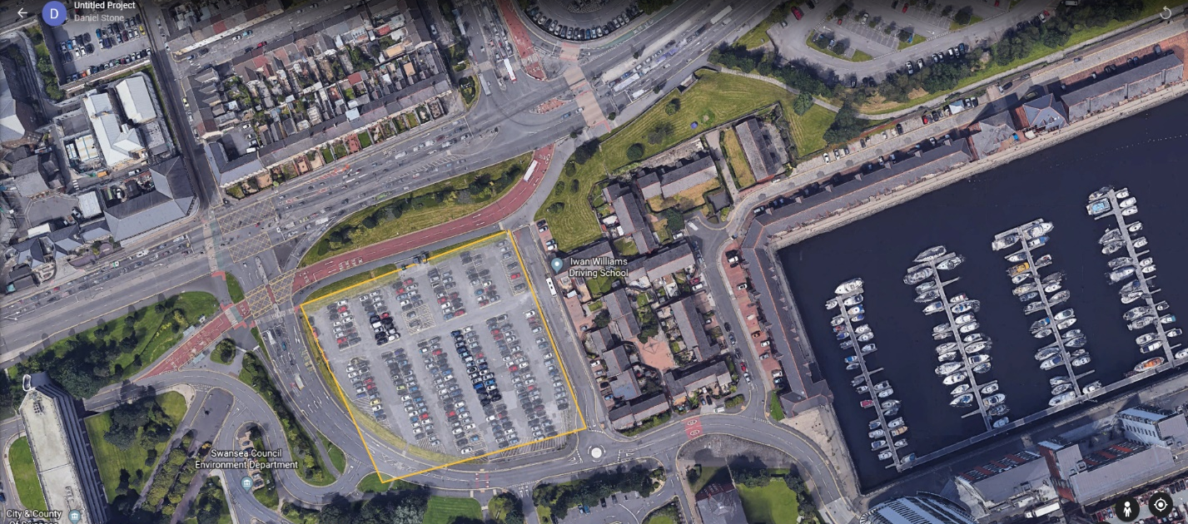
These are pictures of where the excavation works will take place for the building.

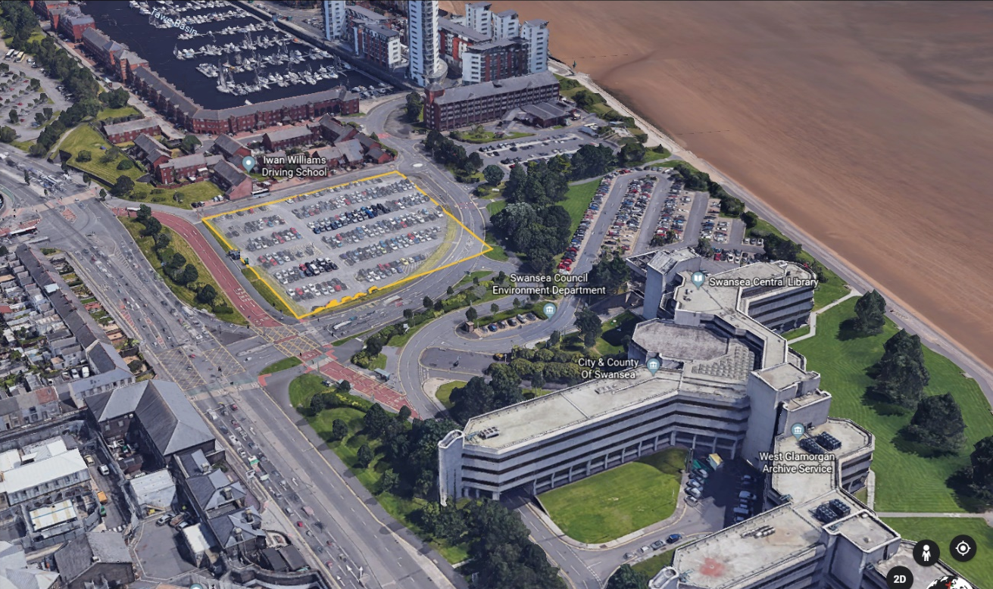

Here are the markings to where the excavation works will take place in Swansea inside the yellow marked lines the 30m squared 20 story building will be built in the middle

Types of excavations
There are many different types of excavation solutions that are used in the construction industry. There are two types of categories in excavation works, these categories are temporary excavation and permeant excavations.
Each excavation has its own capabilities and can be different in the type and conditions that is placed in this can also be dependent on the capability of its durability too.
Some temporary solutions are:
- Grouting
- Cofferdams
- Caissons
- Trench support
- Anchoring
And here are a few permanent solutions of excavation works.
- Diaphragm walls
- Pilling
- Steel sheet pilling (can be temporary)
Trench support excavation is usually defined when the length is bigger than the depth of the excavation. This excavation is usually used for the allowance of services such as pipelines or used for strip foundations. These excavated trenches are usually at depth of 6 meters deep. The excavation is carried out either by hand or using a mechanical digger.
Anchoring is another temporary excavation. This is used to tie back the use of temporary sheet excavation. The method of using this is to provide the usage of support in trenches and large excavations, where the working area is strut free and shore free. This is done by using a ground anchor which is a prestressed tendon that is then embedded and anchored in the soil or rock to give resistance to structural movements, a hole is pre-drilled and is then positioned carefully and calculated then the anchor is formed.
Sheet piling is a permanent and temporary excavation. This is used to control ground water and to support the excavation that’s taking place during the construction works. This works by setting closely set piles that are driven into the ground to keep the earth and ground water out of the excavation. A use of prestressed concrete sheet piles can be used, but steel sheet pilling is the most common type used in the construction industry. This works by the steel piles are hammered, pushed or vibrated into the ground. In order to keep the piles in the correct position during driving, temporary guide walls are erected which assist the stability of driving of the frame. The distance of the two sets of walling’s should be as large as it can be practical. After they have been set the ground is held stable by either cantilever action or props across the excavation.
Cofferdams are temporary excavation and is used for deep confined excavations in poor ground or in open water. This type of excavation can be made from steel sheet piles. There are two types of cofferdam excavations one being a single skin cofferdam and another being a double skin cofferdam.
Caissons are another type of temporary excavation. This type of method is used to construct foundations which are under the depth below the water table that exceeds 18m. this is a concrete box or cylinder which can be 3 to 15 meters in diameter. This works as the ground is being removed the caisson will drop down in the excavation which will support the ground water control, in additional help to this there can be concrete ring walls to be put in place for extra help with the water control.
After looking at the location of the excavation the excavation that I would implement on using is sheet pilling. This can be used as permanent or temperamental it will suit the grounds of where it is located, due to being near the coastal area meaning the water ground level is high. The sheet pilling will protect and control the ground water as its being built, there might be a need of temporary and permanent drainage system in the future of the works, also the sheet piling can be used as the basement walls and act like a retaining wall for the 3 story under car park.

Health and safety on the excavation works
Before the excavation can take place there are many health and safety precautions that are needed to be put into place. As it is taking place near a public area in Swansea precautions must be in place to protect the public. There will be a set of site hoarding and fencing around the Swansea car park which will stop access to the public. This will allow the machinery and workers to work on the site and will not have to worry about being a danger to the public.
Before starting the excavation and the construction site, there will be a need of research on the area and a bomb search squad to look through the ground before digging the excavation. The reason for the bomb squad is due to Swansea coastal previously being a part of the world war and may have unexploded bombs buried along the coast. By doing this a health and safety risk is being eliminated making the area safe for all construction workers and members of the public.

Access to the site
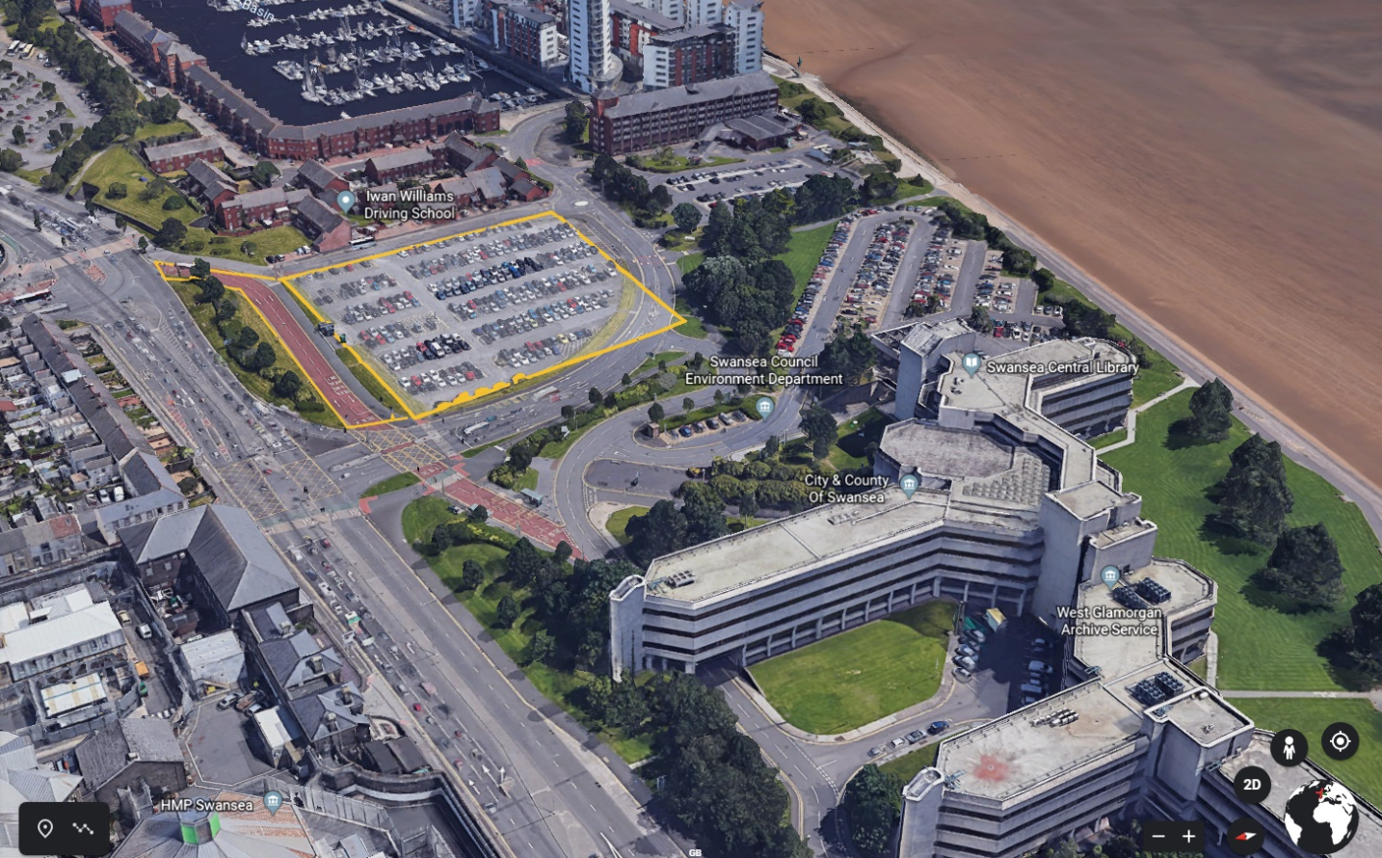
Using a safe way to gain access to the site for deliveries, plant and workers, it has been decided to close off the bus lane near the car park using it as An access route, this would be again fenced off from the public and the entrance will be manned by a worker.
Access in the excavation there will be a ramp put in place from the excavation so that the soil can be carried out and put into dumping lorries. These lorries will not be able to go down the slope and therefor will need a machine to carry up to the soil into a pile.
During the excavation work inspections will need to be carried out every day as the excavation is more than a 2-meter drop and will need some strengthening supports as the excavation is carried out this will stop the excavation with sheet piling from collapsing.

Description of plant needed

In order to proceed with this excavation there is a need of plant. They are needed for sheet pilling, there will be a need for 2 diggers, one to start hammering down the sheet piling once the sheet the sheet piling had been inserted into the ground the other digger will start the excavation down into the ground using a slope in the excavation to gain access in and out. There would also be a need for a dozer truck to pile the earth up ready for the other digger to dump into the soil trucks that will transport the soil 5 miles away from the construction site.
I also worked out how many soil trucks it would take to remove the soil from the excavation Which was 30m x 30m x 10m deep giving a volume of 9000m3 and a ton value of 16,200 each soil lorry can carry 29 tons so I did 16,200/29=558 lorries, it would take 70mins to load and dump working 8hrs = 480/70=7 lorries per day taking 79 days or removal.

Drainage systems
During the process of an excavation there will be a need of drainage systems in place these will either be permanent or temporary due rising ground water. There are many types of excavation drainage systems that can be put in place, that can remove or lower the risk of flooding in the excavation.
Temporary drainage
There are many types of temporary drainage systems that can be put in place while the process of the excavation works take place such as:
- Ground freezing
- Horizontal drains
- Sheet piling
- Pump systems
- Cofferdams
As I have chosen to go with sheet piling as an excavation and a couple of these temporary solutions while the excavation is taking place, I think would be suitable for this would be.
- Deep board wells
- Electro osmosis
Deep board wells - are used for ground that is not suitable for any other dewatering system, or if a normal board well exceeds its depth. This consists of a hole being drilled into the earth with a steel lining tube left in place around 300 mm to 600mm in diameter, while another steel pipe is placed inside the well which is known as the inner wall and then a submersible pump is placed to pump and control the volume of ground water.
Electro – osmosis - this is another temporary drainage system which is an expensive way of dewatering the ground. This solution of dewatering the ground is suitable in grounds that contain clay soils. The way this works is that most soils carry out a -VE charge and the water in the ground carries out a +VE charge. When its in clay the charges attract to opposite and using the electric osmosis it holds in a stable form and slows down the dewatering of the ground.
The temporary method of dewatering the ground while works take place is the electro osmosis. This is because most of the ground deep down becomes clay in the location and will react better with this system as well as the steel sheet piling creating a hold back on the ground water.

Permanent drainage systems
There are a few permanent dewatering systems that can be put in place once the excavation has been completed such as:
- Pressure grouting
- Thin grout membrane
- Slurry trench cut off
- Drainage
- Diaphragm walls
- Contiguous/secant pilling
The two main types of permanent dewatering systems that could possibly be used once the excavation is completed would be the drainage system and the thin grouted membrane due to both solutions’ suite ground soils with sand, silt and clay.
A drainage system is a good and cheap way of dewatering the ground permanently in clay soils. This is done by using a vertical drain solution, this consists of holes drilled into the ground at close centers, and filled with sand and geotextile, this allows the ease of access of ground water into the drainage system becoming a quick way of dewatering the ground.
With thin grouted membrane it can only be suitable if the soils contain sand, silt and clay. This works by piling steel sections or hollow rectangular sections into the ground. Once this has been done the sections are removed creating a void in the ground. The extracted steel sections are then grouted under pressure. Which is done by welding a steel diameter tube to the web of the section and forcing the grout membrane down the pile under pressure, which fills the void before the soil has a chance to collapse.

Basement construction and waterproofing solutions
For a basement to be constructed there are a few parts that must be taken into aspect, such as the excavation, walls and foundation being used for the basement and the waterproofing solutions.
The chosen excavation that is going to accommodate this building is going to be the sheet piling. This is due to the location of the building, there will be a need of a suitable excavation, this is why I have chosen to go with sheet piling, as of the high water mark on the building the sheet piling will keep the control of the ground water in the excavation.
As the building contains a 3-story car park underground the foundations will have to be deep in order to soupier this and the 20-story building the foundations that will be suitable for this would be concrete piles.
The next step to the basement or the underground car park is the walls. The most common and appropriate material for the basement walls and floors would be concrete as steel and pile sheets only use concrete for floors. This is also one of the materials I would use on this building, due to the cost and availability of concrete in Wales it’s resistance to water, which will support the moisture from the ground. It also has the good rate of durability underground and can provide a good and a stable structural surface for waterproofing membranes.
There are many ways to waterproofing your basement.
For example:
- Silicate based concrete scalers
- Concrete waterproofing coats
- Waterproofing paint
- Plastic sheeting and panels
As the choice of excavation and going with steel sheet piling this would also be my basement walls as it will act as a retaining wall. The ground structure would be supported by the pile foundation due to the ground level being deep. The steel sheet piles protect from ground water and be coated internal and external buy the solution waterproofing paint.

What is a façade?
The meaning of a façade in architectural term is the face of a building or structure.
There are functions that a façade can sustain. These are; to provide the separation between internal and the external environments, to allow acceptable levels of light into the building and have visual connection with the outside. A façade should provide access of ventilation and weather tightness, this means the elimination of water entry, the control of the are permeability and the resistance to wind.
To form a perfect wall of a façade there must be four main control layers. These four are:
Rain control layer
air control layer
vapor control layer
thermal control layer
But all these have different types of layers for example:
Cladding
Cavity
Insulation
Internal wall
Vapor control barrier
These play different parts such as protection again suns UV rays and temperature, they can also provide ventilation around the building, and create a stoppage of external water entering internally there are many more things that these layers can do for a building that are all positives.

Types of facades
There are many types of facades used within the construction industry.
Curtain walls
In-fill panels
Brickwork and masonry
Precast concrete panels
The façade that I will implement on using is Brickwork masonry is a non-load bearing wall when it is supported by the structural fame. It is usually designed for the resistance to rain and thermal insulation. This is supported by heavy beams. And on top of this I would use wooden cladding on the external brick work. This would be suitable as Swansea frequently has rain and it will protect it from the elements
Conclusion
To conclude I have chosen steel pile excavation for this project as it will be suitable for the location of the project, due to it’s high ground water table and the type of soil. The chosen material for the foundations of the building and for the underground car park is the concrete pile as it is a common foundation for deep basements. For the façade the chosen material was the concrete structure with a façade of masonry and brickwork added in with wooden cladding. This was chosen as it provides good thermal resistance and ventilation and weather resistance as Swansea coastline has a lot of wind and rain.

References

Article title: | Excavation FAQs
Website title: | Health and Safety Authority
URL: | https://www.hsa.ie/eng/Your_Industry/Construction/Construction_FAQ's/Excavations/#precautions

Website title: | Idc-online.com
URL: | http://www.idc-online.com/technical_references/pdfs/civil_engineering/Sheet_Piles_and_Dewatering.pdf

Article title: | Foundations
Website title: | Basements.org.uk
URL: | https://www.basements.org.uk/TBIC/Construction-Waterproofing/Foundations.aspx

Article title: | Construction methods
Website title: | Basements.org.uk
URL: | https://www.basements.org.uk/TBIC/Construction-Waterproofing/Construction-Methods.aspx

University of Wales trinity saint David- PowerPoints and notes
Lecture – Juan Ferriz-Papi

Appendix


