Student Name: Sophie Bridgewater
Student Number: 2005147
Programme of Study: Design Craft; Glass, Ceramic and Jewellery
Module: Ways of Perceiving/ADDA4023/C

TASK: Imagined exhibition space in 1500 words
Word Count: 1506 words

EXHIBITION TITLE: Art Nouveau at the House for an Art Lover
LOCATION: House for an Art Lover, Glasgow
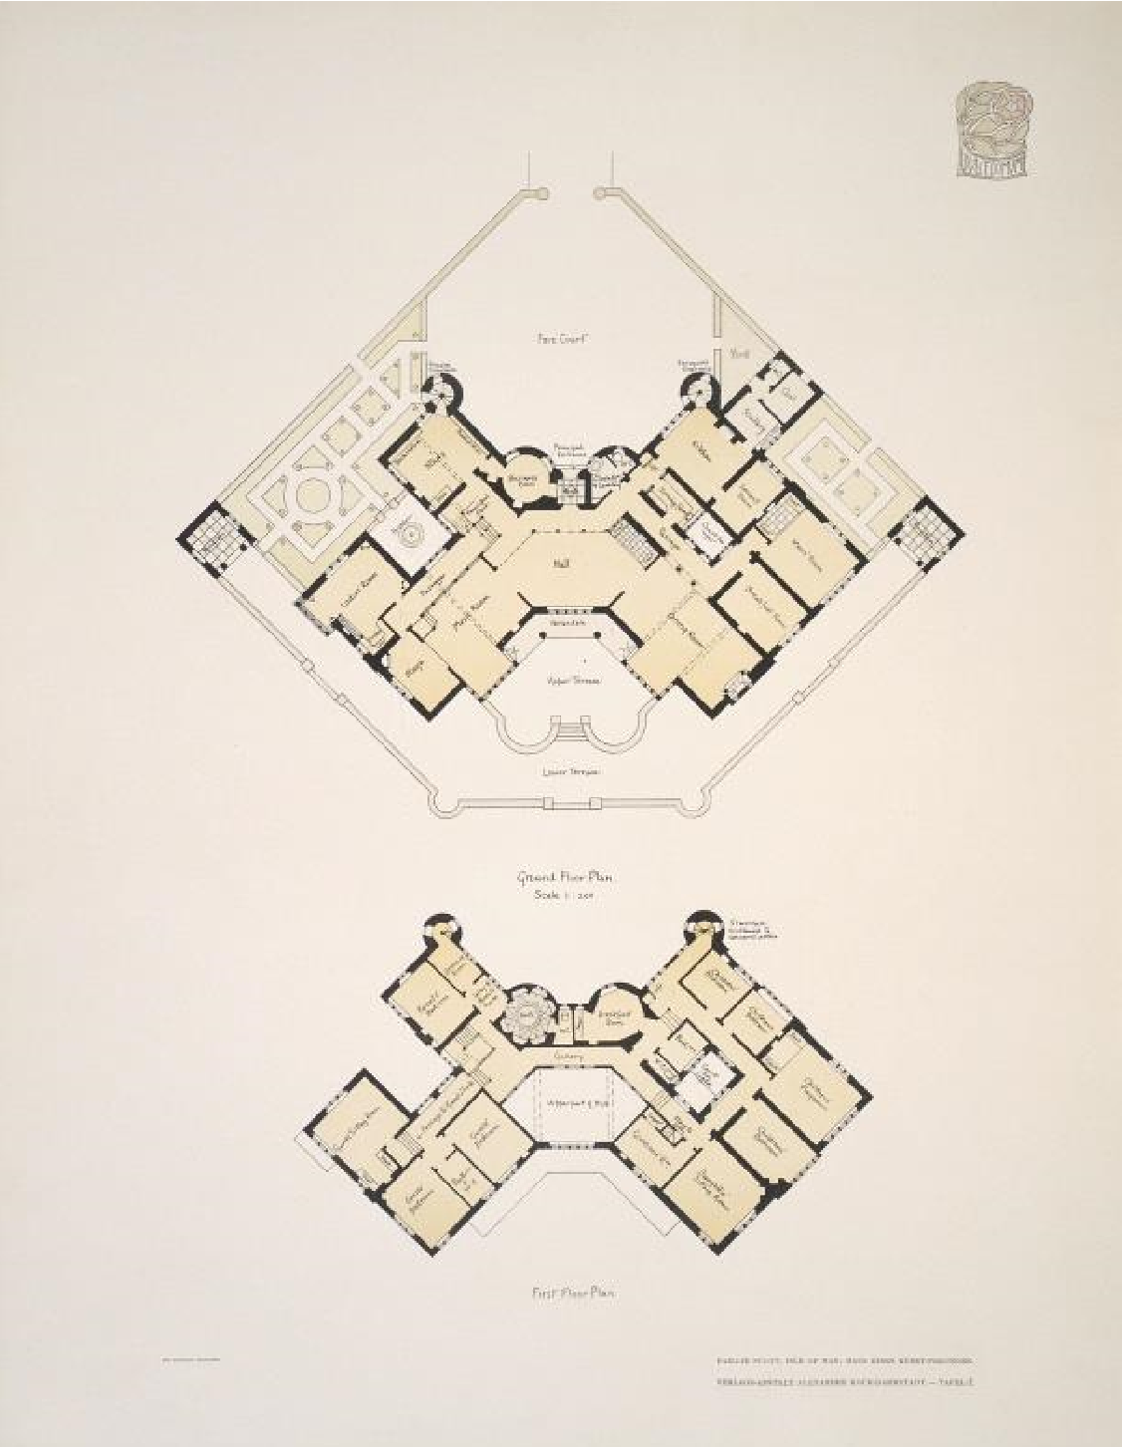
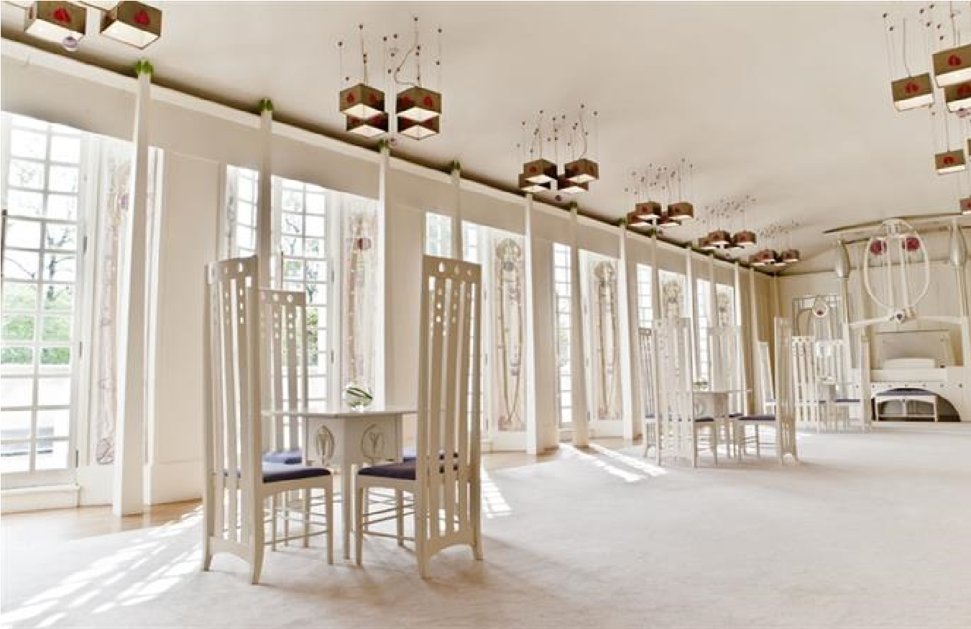
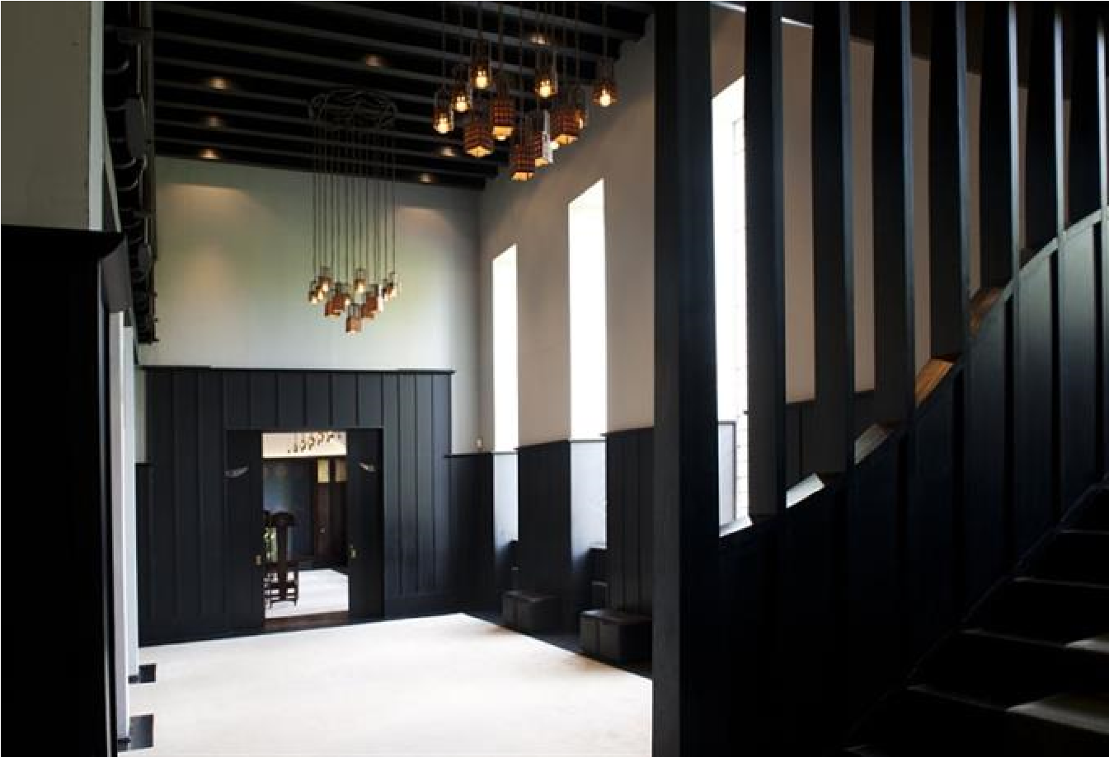
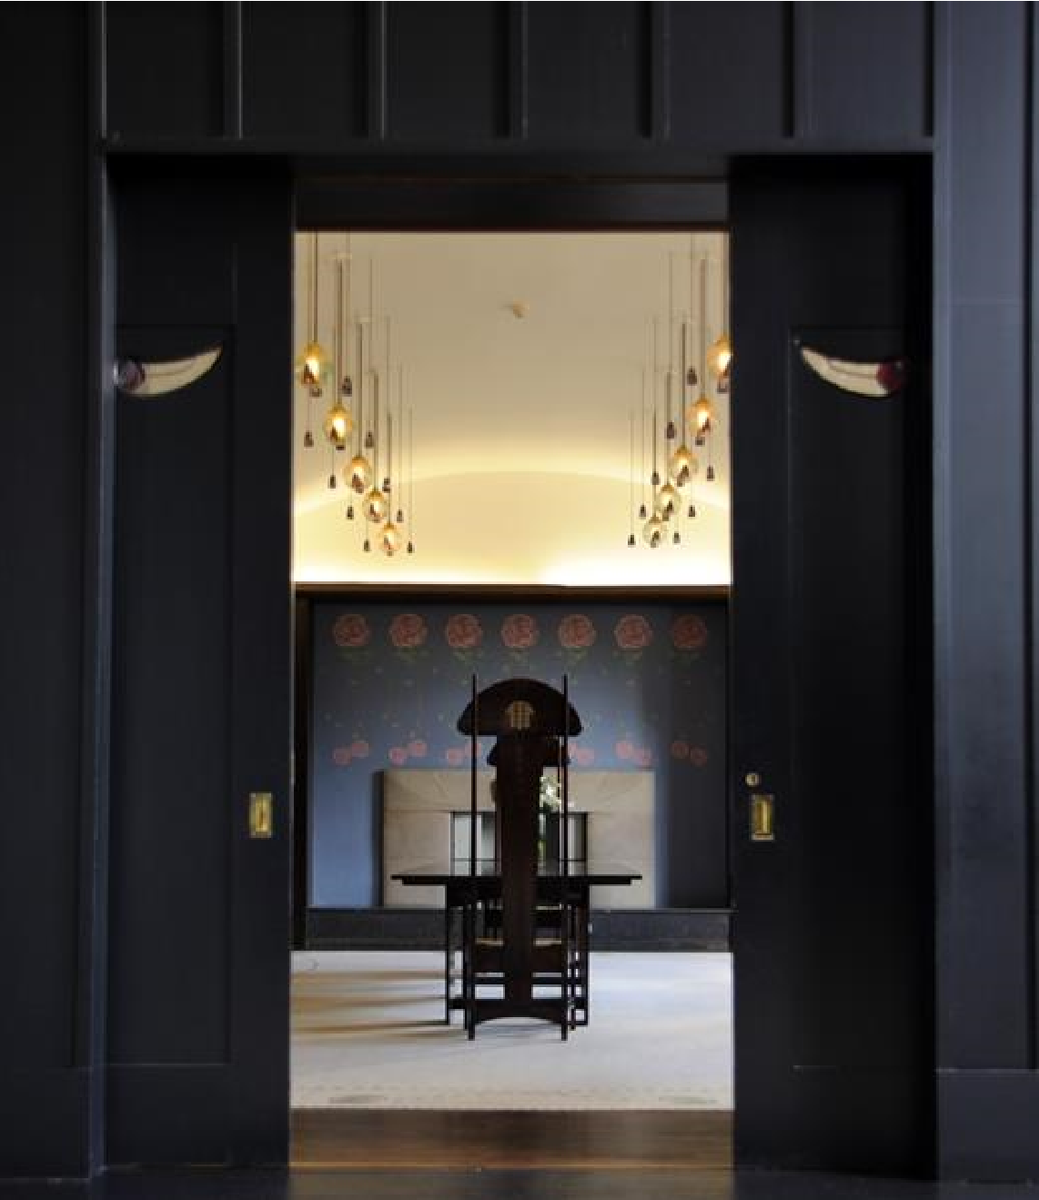

(
Gla.ac.uk,
2025)

One of the most striking and imaginative trends in art and design history began in the early 20th century with the beginning and rise of Art Nouveau. This movement aimed to interlace the connection between art and everyday life through its organic shapes, flowing lines, and strong connection to nature (Greenhalgh, 2000). Created by Charles Rennie Mackintosh, The House for an Art Lover provides a perfect venue for an exhibition that explores the beauty and intricacy of Art Nouveau. Society is in a place where we take nature for granted and neglect our planet; discussing a movement that highlights the beauty and significance of nature is an important start to better appreciate and take care of our home while providing inspiration to artists all over the world. This is what this exhibition is all about.
This exhibition, titled "Art Nouveau at the House for an Art Lover", will feature the works of five artists, each representing a different aspect of the movement, while using critical theory to unpack the underlying sociopolitical and aesthetic ideas that define Art Nouveau. The exhibition will explore the projects of Gustav Klimt, Louis Comfort Tiffany, Antoni Gaudí, Émile Gallé, and Charles Rennie Mackintosh. Using critical theoretical lenses such as Marxism, feminist theory, and postmodernism the exhibition examines how these artists both celebrated and complicated the movement's ideals.
Located in Glasgow, the House for an Art Lover is an impressive example of Mackintosh’s style, using elements of Art Nouveau with his unique vision. The house, full of organic forms, rich details, and integrated design, speaks clearly to Art Nouveau concepts (Charles Rennie Mackintosh, 1984). Mackintosh's approach to building, furniture, and decorating embodies the entire work of art (Gesamtkunstwerk) ideology by Richard Wagner that Art Nouveau promoted (TOTAL WORK OF ART: foundations, articulations, inspirations, 2021). The house's use of flowing lines, botanical motifs, and the merging of art and function make it an ideal setting for displaying the work of the movement's pioneering artists and producers.
One of the most famous figures associated with Art Nouveau is known as
Gustav Klimt (1862–1918) (Chilvers and Glaves-Smith, 2009). His works are renowned for their sensuality, intricate decoration, and symbolic content. His iconic painting The Kiss (1907–1908) embodies the movement’s emphasis on beauty, femininity, and asceticism (Witek, 2019). In this section of the exhibition, we will feature some of Klimt's most celebrated works, including 1. Portrait of Adele Bloch-Bauer I (1907) and 2. The Tree of Life (1909), exploring his approach to depict the female form.
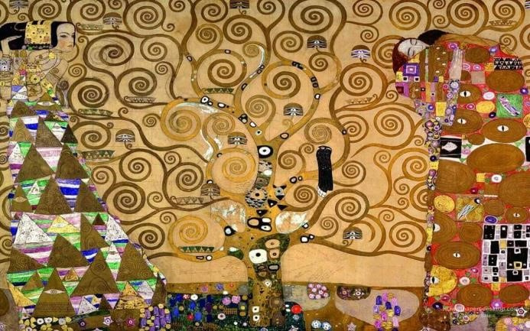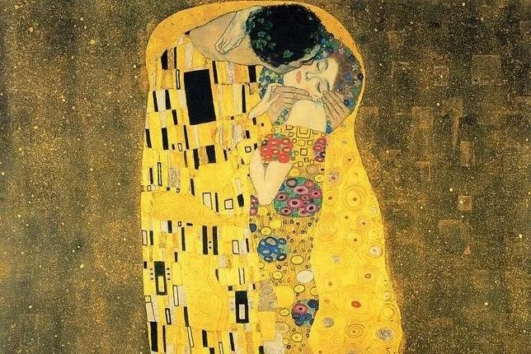

Figure 1. The Kiss (Gustav Klimt, 1907)
Figure 2. The Tree of Life (Gustav Klimt, 1909)
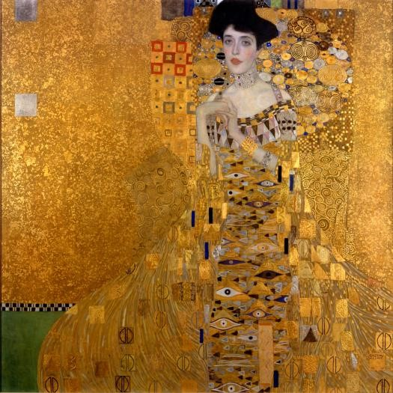

Figure 3. Portrait of Adele Bloch-Bauer I (Gustav Klimt, 1907)

Klimt’s work often includes women as leading figures, elegantly decorated and bathed in rich gold leaf (White, 2024). These women symbolise beauty, femininity, and power, but they are also victim to a patriarchal oppression that reduces them to objects of male desire. The exhibition can use Laura Mulvey’s concept of the male gaze, which suggests that women in art are often framed for the pleasure of the viewer (Rodriguez, 2023), to show the tension between the idealisation of women and the objectification embedded in Klimt’s art.
While Art Nouveau celebrated the beauty of the female form, it also reinforced traditional gender roles and power dynamics, as seen in The Kiss (1907). This section will challenge the notion that beauty alone can be empowering, allowing visitors to critically engage with the implications of the aesthetic choices made by artists like Klimt, who put women in the hands of men or covered them in gold in order to look beautiful.
The next section in the exhibition shows the works of Louis Comfort Tiffany
(1848-1933), an artist and designer who is often associated with the Art Nouveau movement through his glasswork, particularly his stained-glass windows, lamps, and vases. Tiffany’s work is characterised by vibrant colours and intricate designs and is hugely inspired by nature. In this section, visitors will have the opportunity to view a selection of Tiffany’s famous stained-glass lamps, such as the "Wisteria" and "Pink Lotus " designs.
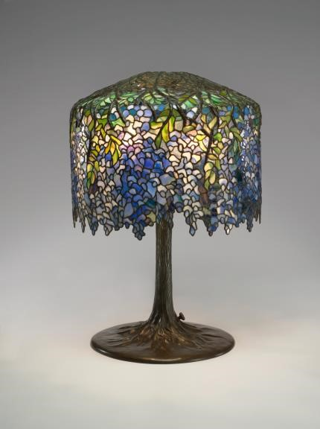
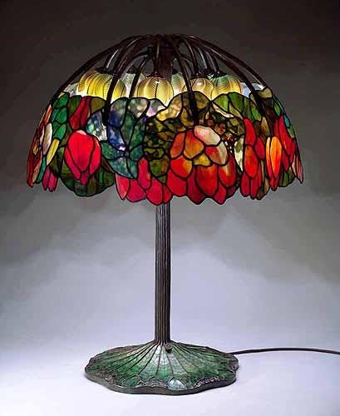

Figure 1. Wisteria (Louis Comfort Tiffany, 1901) Figure 2. Pink Lotus (Louis Comfort Tiffany, 1906)

Tiffany’s designs embody the style of Art Nouveau, merging nature and art with free-flowing lines and floral depictions (Banham and Shrimpton, 1997). However, this section of the exhibition can be seen with a Marxist lens, questioning the commodification of art in a capitalist society (Martin, n.d.). Tiffany's works, while they were hugely celebrated for their craftsmanship and artistic excellence, were often produced for the luxury market, making them inaccessible to many people. In this way, Tiffany’s Art Nouveau interpretation, while aesthetically beautiful, also underscores the class divide that persisted in the consumption of art and design (Morris et al., 2006). Visitors can use Marxist theory to explore the way Tiffany’s work, functioned within a capitalist system that valued beauty for its own sake, rather than as a tool for social change (Marx, 1867.) Visitors can think about the ways in which luxury and craftsmanship were intertwined in Art Nouveau and whether this reinforced social stratification.
The third section in the exhibition highlights the work of Émile Gallé (1846-1904), an artist who was one of the top figures in the Art Nouveau movement. His work is known for the use of natural forms and the merging of functionality with art. Gallé was known for his vessels and stained-glass windows, which were intricately designed with natural themes (De, 2016). In this section, we will show some of Gallé’s finest glasswork, including one of his "Poppy" vase designs and "Dragonfly" glass lamps, which illustrate how he mastered combining beauty with innovative functionality.
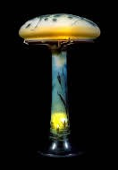
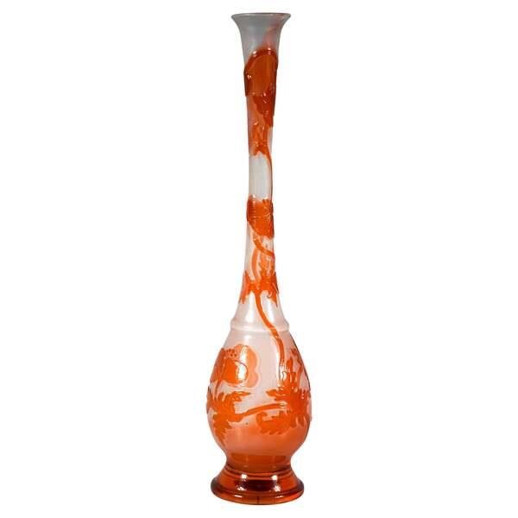

Figure 1, Poppy (Émile Gallé, 1890) Figure 2, Dragonfly (Émile Gallé, 1900)

Gallé’s work is a perfect example of Art Nouveau’s dedication to craftsmanship, but it also invites a deeper reflection on the relationship between art and the natural world (Weisberg and Menon, 2013). His glasswork often depicted nature in an elegant yet highly detailed manner, blurring the line between representation and abstraction (Riley and Bayer, 2003). In a Marxist analysis, Gallé’s pieces will be examined in terms of their production. While his designs embody the artisanal spirit of Art Nouveau, they were also part of a luxury market that made them accessible only to the wealthy, like the works of Tiffany (Ashby, 2021). This section can feature the contradictions inherent in Art Nouveau’s celebration of nature. While it idealised the natural world, it was often produced for those in the upper class of society to enjoy, rather than being accessible to all. By doing this, it is maintaining the social divisions that the movement sought to challenge.
The next section displays the work of Antoni Gaudí (1852-1926), an architect who is one of the most famous advocates of Art Nouveau in architecture. Gaudí’s buildings feature arching forms, vibrant colours and natural motifs, all characteristics of the Art Nouveau style (Williams, 2024). His architecture is often described as a combination of craftsmanship, nature, and spiritual symbolism (Joseluis, 2015).
In this section, visitors will be able to explore models, photographs, and architectural drawings of Gaudí’s work, with a focus on his use of organic forms. A post modernistic lens can be applied when exploring Gaudí’s work, challenging the modernist mark on rationality and geometry. Gaudí’s designs discard the modernist focal point on functionalism by embracing irregularity, complexity, and ornamentation (Tate, 2023). Postmodern theorists like Robert Venturi have argued that Gaudí’s rejection of modernist principles reflects a broader critique of the rationalist and functionalist tenets that were gaining dominance in early 20th-century architecture (Keskeys, 2016).
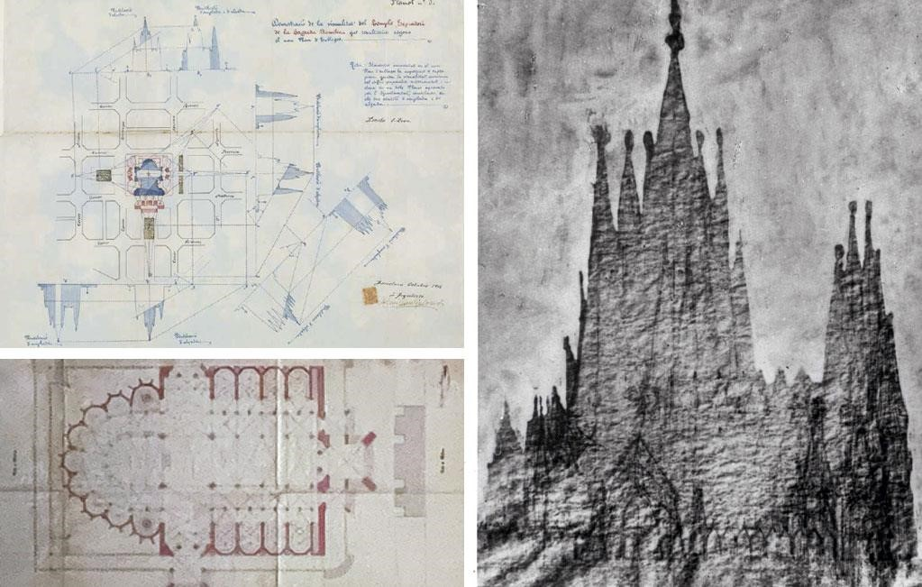

Figure 1. Demonstration of the visuality of the Temple: plan 1. (Antoni Gaudí, October 1916.)
Figure 2. (Bottom left) Church of the Sagrada Familia in Barcelona. (Antoni Gaudi, 1885.)
Figure 3. Holy Family, h. 1945. Original drawing by Gaudí, 1903-1926.

Gaudí’s work can be interpreted as eccentric, he continued to embrace local traditions and religion, and the organic forms of nature to create a new language of architecture that challenges the sterile simplicity of modernism. This section can invite visitors to reflect on the tensions between modernist and Art Nouveau ideals and to consider Gaudí’s legacy in the broader context of architectural evolution.
Finally, Charles Rennie Mackintosh (1868-1928) an architect, designer, and artist, Mackintosh’s work was rooted in the principles of the movement, blending organic forms with a more restrained approach. Mackintosh’s furniture designs, such as those for the Glasgow School of Art, and his architectural works demonstrate how he harmonised Art Nouveau with the
emerging modernist sensibilities of the early 20th century (Risebero, 1985)
In this section, the exhibition will showcase Mackintosh’s furniture, architectural drawings, and interior design, all marked by his distinctive aesthetic. Applying a postmodern lens, this section can examine how Mackintosh’s work can be seen as a critique of both the decorative excesses of early Art Nouveau and the rigidity of modernism. Mackintosh’s ability to create with beauty and functionality represents a key moment in the transition from the decorative to the functional in design history.

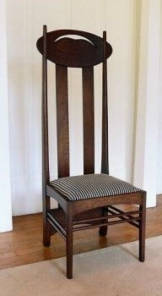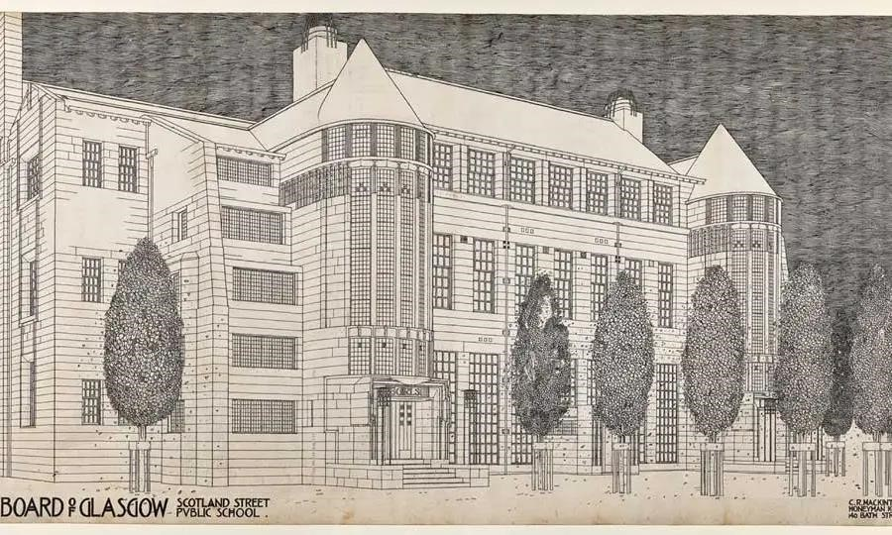

Figure 1. The Argyle chair (Charles Rennie Mackintosh, circa 1898)
Figure 2. Design for Scotland Street School (Charles Rennie Mackintosh, circa 1900)
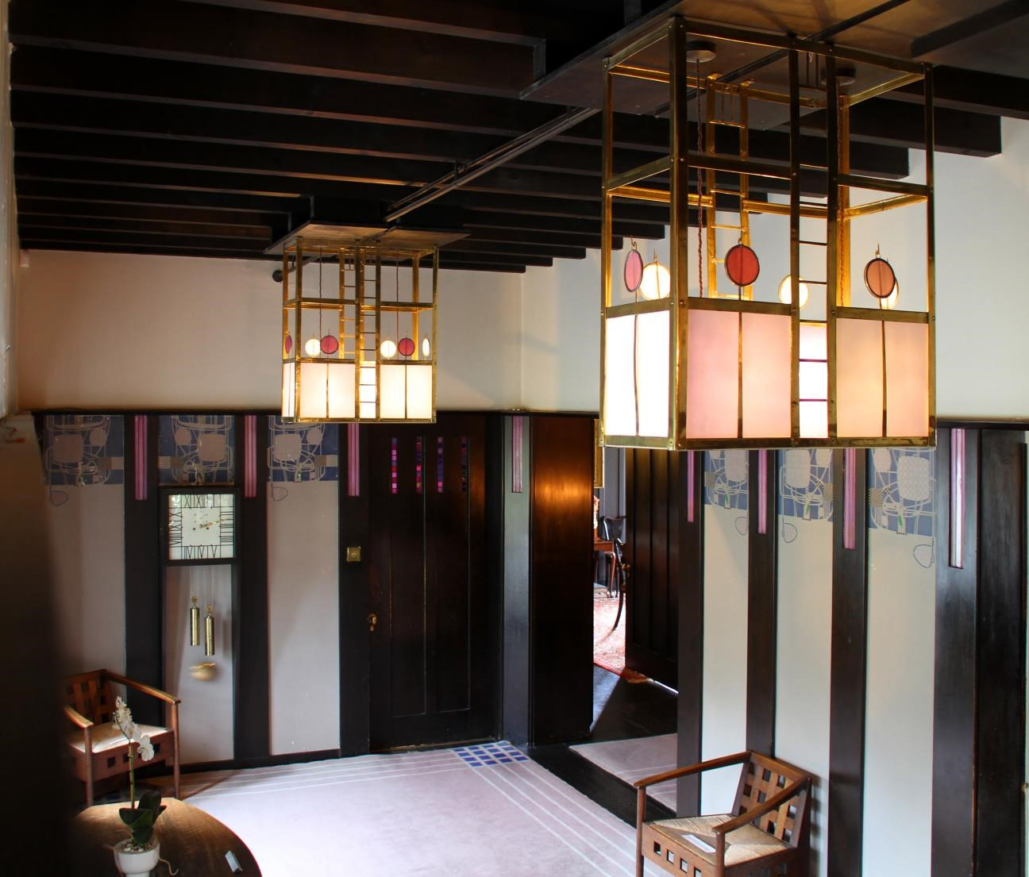
Figure 3. Hill House (Charles Rennie Mackintosh, 1904)
Art Nouveau at the House for an Art Lover will provide a multifaceted exploration of Art Nouveau, highlighting both its beauty and its contradictions. Through the works of Gustav Klimt, Louis Comfort Tiffany, Antoni Gaudí, Émile Gallé, and Charles Rennie Mackintosh, the exhibition will invite visitors to critically engage with the movement's aesthetic ideals while reflecting on the socio-political realities that shaped its development. After reflecting, I think it's easy to see that the movement had an accessibility issue; the luxury market it was part of was not affordable to most.

Reference List:
Ashby, C. (2021). Art Nouveau. Bloomsbury Publishing.
Banham, J. and Shrimpton, L. (1997). Encyclopedia of interior design. London ; Chicago: Fitzroy Dearborn Publishers.
Charles Rennie Mackintosh (1984). Mackintosh Architecture. John Wiley & Sons.
Chilvers, I. and Glaves-Smith, J. (2009). A Dictionary of Modern and Contemporary Art. Oxford University Press -01-01.
De, L. (2016). Radiance and Symbolism in Modern Stained Glass. Cambridge Scholars Publishing.
Dominic Witek (2019). Art Analysis: The Kiss by Klimt | Artsper Magazine. [online] Artsper Magazine. Available at: https://blog.artsper.com/en/a-closer-look/art-analysisthe-kiss-by-klimt/.
Gla.ac.uk. (2025). Mackintosh Architecture: The Catalogue—Images. [online] Available at: https://www.mackintosharchitecture.gla.ac.uk/catalogue/images/?filename=a399_002&xml=img [Accessed 7 Mar. 2025].
Greenhalgh, P. (2000). Art nouveau : 1890-1914. New York: Harry N. Abrams.
Joseluis (2015). Symbology and religion in Gaudí’s work. [online] Casa Batlló. Available at: https://www.casabatllo.es/en/news/symbology-religion-gaudi-work/.
Keskeys, P. (2016). Architecture’s Eternal Debate: ‘Less Is More’ vs. ‘Less Is a Bore’ - Architizer Journal. [online] Journal. Available at:
https://architizer.com/blog/practice/details/less-is-more-vs-less-is-a-bore/.
https://www.bristol.ac.uk/artontheline/journal_20071/articles/pdf/20071_02.pdf [Accessed 9 May 2023].
Martin, S. (n.d.). The absolute artwork meets the absolute commodity. [online]
Available at: https://chtodelat.org/wp-content/uploads/2009/10/martin_autonomy.pdf.
Marx, K. (1867). Economic Manuscripts: Capital Vol. I — Chapter Fifteen. [online] www.marxists.org. Available at: https://www.marxists.org/archive/marx/works/1867c1/ch15.htm.
Morris, W., Hemingway, A., Press, P. and Arbor, A. (2006). MARXISM AND THE HISTORY OF ART. [online] Available at: https://aklatangbayan.wordpress.com/wpcontent/uploads/2013/02/marxism-and-the-history-of-art.pdf [Accessed 10 Apr. 2025].
Riley and Bayer, P. (2003). The Elements Of Design : A Practical Encyclopedia Of The Decorative Arts From The Renaissance To The Present. New York: Free Press.
Risebero, B. (1985). Modern architecture and design : an alternative history. Cambridge, Mass.: Mit Press.
Tate (2023). Postmodernism. [online] Tate. Available at: https://www.tate.org.uk/art/art-terms/p/postmodernism.
TOTAL WORK OF ART : foundations, articulations, inspirations. (2021). S.L.: Berghahn Books.
Weisberg, G.P. and Menon, E.K. (2013). Art Nouveau. Routledge.
White, K. (2024). The Surprising Backstory Behind Gustav Klimt’s Obsession With Gold. [online] Artnet News. Available at: https://news.artnet.com/art-world/gustav-klimtgold-2543498.
Williams, L. (2024). 10 Most Famous Gaudi Masterpieces in Barcelona You Need to Know About. [online] Insight Vacations. Available at: https://www.insightvacations.com/blog/gaudi-barcelona/.

