

Module Name and CODE: LCBB5000 Data Handling and Business Intelligence A1
Student Name: Kaloyan Nenkov
Student ID:2024059

Table of Contents
Introduction: 3
Five Current trends in Business intelligence: 3
A. Unified data management and analytics: 3
B. Augmented Analytics: 4
C. 360⁰ business Analytics: 5
D. Business activity monitoring: 5
E. Embedded BI: 5
Conclusion: 6
References: 7

List of figures:
Figure 1:Unified Data Management and Analytics 4
Figure 2: Augmented Analytics 5
Figure 3: Embedded BI 6

Introduction:
The term "business intelligence" (BI) is used to describe a set of procedures, structures, and programs designed to transform unprocessed data into actionable intelligence that can increase a company's bottom line. It's a set of tools for analyzing information and learning useful things from data. Decisions at the strategic, tactical, and operational levels are all directly impacted by business intelligence (Howson, 2011). The quality of the data used in business decisions is enhanced with the help of Business Intelligence's visual representations of that data. When appropriately used, Business Intelligence tools may be a powerful resource for addressing the unique market trends of each industry and pinpointing the source of any issues plaguing a company's operations. Using business intelligence, it is also possible to manage and establish criteria for the many different types of business processes (tableau, 2020). In this report, five current trends in business intelligence will be discussed.

Five Current trends in Business intelligence:

Unified data management and analytics:
Integrating the BI stack has evolved reporting/visualisation tools into state-of-the-art BI and analytics platforms. The data preparation layer is experiencing much activity, with new additions and consolidations. This aids businesses in establishing connections, sifting through data, transforming it, and enriching it for analysis. The BI workflow, which already incorporates data integration, preparation, administration, and insights, is evolving to include the above features (Wieder and Ossimitz, 2015). An additional and possibly most important component of the BI full-stack strategy is AI/ML, which will revolutionise self-service analytics and make the intelligence program available to companies. When combined with automation capabilities, businesses have a robust BI system that can function without human intervention, allowing teams to make data-informed choices rapidly (Howson, 2011). The following figure represents it:
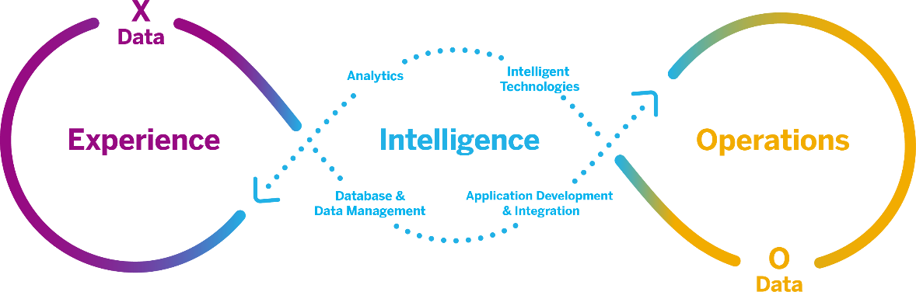
Figure 1:Unified Data Management and Analytics
Source: (Loshin, 2013)

Augmented Analytics:
The term "augmented analytics" refers to the implementation of enabling technologies such as machine learning and artificial intelligence to improve the quality of data experimentation and analysis in business intelligence (BI) platforms. Data analysts, both professional and novice, can benefit from the automation of a number of procedures in data science, machine learning, and artificial intelligence model construction, administration, and deployment (Gartner.com, 2020). The proliferation of devices and software is expanding the number of places where analytics can be used. For instance, the rise in popularity of business intelligence (BI) can be attributed to the development of natural language query (NLQ) capabilities into conversational experiences, and the delivery of in-context analytics is emerging as an essential feature for BI providers. In response, modern analytics platforms incorporate AI and ML capabilities at numerous junctures in any business workflow, making it possible to obtain contextual insights.
In the business world, decision intelligence is also gaining traction. Implementing machine learning at scale is aided by tightening the framework for best practices in decision-making (Jourdan, Rainer and Marshall, 2008). These facilitators help humans make better decisions. Automated insights are one such tool. It adds narrative insights to visuals, providing more ammunition to make smarter choices. The following figure represents the evaluation of augmented analytics:
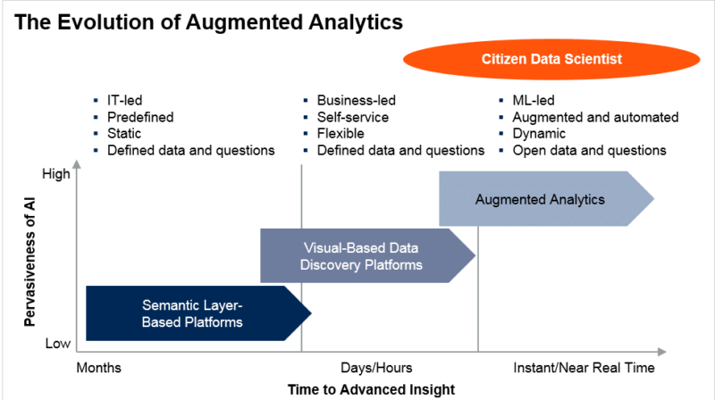
Figure 2: Augmented Analytics
Source: (Moss and Shaku Atre, 2003)

360⁰ business Analytics:
As the use of business applications increases in businesses of all sizes, business intelligence (BI) systems are becoming less data-specific and offering a wider variety of business app connectors. For data integrators, this development also presents new possibilities. Integrations of native apps and improvements in prebuilt, domain-specific data models reduce the time and effort spent on report and dashboard development, allowing businesses to gain insights more quickly. In addition, these models can be customised to meet the requirements of a particular company (Jelonek, 2017). With the help of auto-modelling and blending, analysing complicated datasets is getting easier and faster. This lays the groundwork for real-time, cross-functional analytics that can give a company a bird's-eye view of its operations.

Business activity monitoring:
Modern self-service BI and analytics solutions carefully monitor key performance indicators (KPIs). The intelligence embedded in these systems allows for proactive data analysis, identifying outliers, detecting significant changes in key performance indicators, Etc. With the rise in popularity of business applications that offer contextual integration, BI platforms can now notify users of critical data changes within the context of their current workflow, regardless of which application they are using (Loshin, 2013). This shortens the delay between receiving and responding to alerts, giving organisations a competitive edge. In the future, platforms can intelligently decide the important actions to be triggered based on insights as they occur, thanks to the enhancement of AI and ML capabilities.

Embedded BI:
Markets are seeing an increase in companies natively embedding BI into their existing applications for internal consumption, joining the ranks of independent software providers and business consultants. This is made feasible by compostable analytics, which takes advantage of low code / no code capabilities to build user-focused apps from pre-existing resources. Embedded BI incorporates the functionality of BI into the user interface of a current application, providing users and customers with new and updated information inside the familiar environment of their favourite operational programs (Jourdan, Rainer and Marshall, 2008). Embedding BI within functional or bespoke applications that customers rely on daily boosts adoption and adds more excellent value to the applications than conventional BI or analytics. When data is easily accessible, consumers can get deeper insights and take more informed actions.
BI suppliers continuously strengthen their API stacks for quicker development cycles by adding more prebuilt and reusable components and less hand coding. This also paves the way for teams to structure their functions according to the company's needs. As infused analytics becomes more commonplace, B2B applications will provide a more intuitive analytics experience integrated into their processes (Howson, 2011). Providing a comprehensive analytics solution inside the context of the user's current activity will reduce the need for users to switch between different applications to conduct various types of data analysis. The following figure presents how to start Embedded BI:
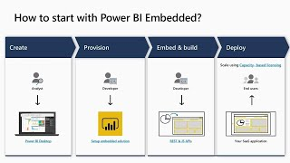
Figure 3: Embedded BI
Source: (Wieder and Ossimitz, 2015)

Conclusion:
Strategic decisions can benefit from the information uncovered by business intelligence (BI). Business intelligence software compiles past and present data and displays the results visually appealingly.BI is the system that an organisation uses to gather, store, and examine its data. With the help of BI, managers can better analyse data and use the resulting reports and insights to guide their decision-making processes. To help businesses make better use of their data, software developers create business intelligence (BI) solutions. Spreadsheets, reporting/query programs, data visualisation programs, data mining tools, and online analytical processing systems are just some of the many BI tools and software available (OLAP) (Howson, 2011). Self-service Business intelligence (BI) is a method of analytics that makes data accessible and explorable even for those without technical expertise. This report shows five trends of business analytics: Unified data management and analytics, Augmented Analytics, 360⁰ business Analytics, Business activity monitoring and Embedded BI.

References:
Gartner.com (2020). Definition of Augmented Analytics - Gartner Information Technology Glossary. [online] Gartner. Available at: https://www.gartner.com/en/information-technology/glossary/augmented-analytics [Accessed 5 Sep. 2022].
Howson, C. (2011). Successful Business Intelligence: Secrets to Making BI a Killer App. New York McGraw Hill Professional.
Jelonek, D. (2017). Big Data Analytics in the Management of Business. MATEC Web of Conferences, 125(1), p.04021. doi:10.1051/matecconf/201712504021.
Jourdan, Z., Rainer, R.K. and Marshall, T.E. (2008). Business Intelligence: An Analysis of the Literature1. Information Systems Management, 25(2), pp.121–131. doi:10.1080/10580530801941512.
Loshin, D. (2013). Business Intelligence. 10th ed. San Francisco, Calif.: Morgan Kaufmann ; Oxford.
Moss, L.T. and Shaku Atre (2003). Business Intelligence Roadmap: The Complete Project Lifecycle for decision-support Applications. Harlow: Pearson Professional Education.
Tableau (2020). Business intelligence: A Complete Overview. [online] tableau. Available at: https://www.tableau.com/learn/articles/business-intelligence#:~:text=Benefits%20of%20business%20intelligence [Accessed 5 Sep. 2022].
Wieder, B. and Ossimitz, M.-L. (2015). The Impact of Business Intelligence on the Quality of Decision Making – a Mediation Model. Procedia Computer Science, [online] 64(1), pp.1163–1171. doi:10.1016/j.procs.2015.08.599.

