Material Science and Building Services
ACBA4006
Student: 1910146

Contents

- Introduction………………………………………………………………pg. 3
- Steel Frame……………………………………………………………...pg. 3

Zaragoza Bridge Pavilion……………………………………...pg. 3
Zaragoza Bridge Pavilion continued………………………….pg. 4
Zaragoza Bridge Pavilion continued………………………….pg. 5

- Concrete Frame…………………………………………………………pg. 5
Lexicon…………………………………………………………...pg. 5
Lexicon Continued………………………………………………pg. 6

- Sustainability…………………………………………………………….pg. 6
Sustainability continued………………………………………..pg. 7

- Sustainability Zaragoza Bridge Pavilion……………………………...pg. 7
Sustainability Zaragoza Bridge Pavilion continued…………pg. 8

- Sustainability Lexicon…………………………………………………..pg. 8
Sustainability Lexicon continued……………………………..pg. 9

- Summary………………………………………………………………...pg. 9
Summary continued…………………………………………..pg. 10

- References……………………………………………………………..pg. 11
References continued………………………………………..pg. 12

Introduction

The following paper will look at two existing buildings in the world that are habitable, but their frames have been built using different building materials. One using a concrete frame, the other a steel frame, the paper will address how the frames are assembled and their advantages and disadvantages. The paper will also investigate the sustainability of the buildings and their impact at their respective sites. Then following on from this, the paper will look at how they have been built in conjunction with their setting.

Steel Frame

Zaragoza Bridge Pavilion

Fig 1
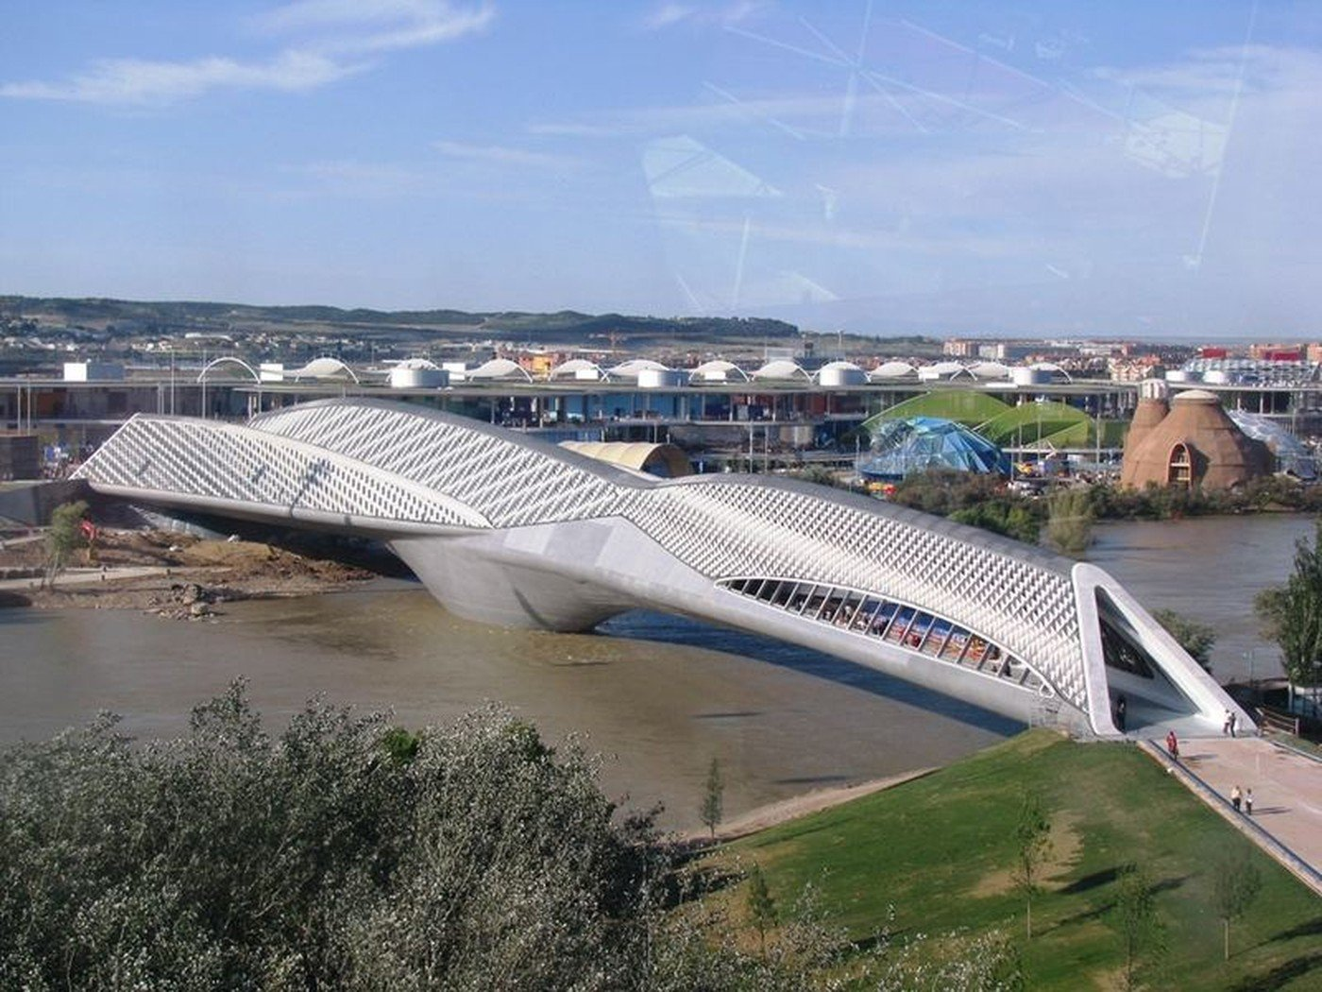
https://www.arch2o.com/zaragoza-bridge-pavillon-zaha-hadid-architects/

The Zaragoza Bridge Pavillion (fig 1) was built in Zaragoza Spain between 2005 and 2008. It was purposely built for the Zaragoza exhibition 2008 that was focused on water and sustainable development, the building itself is said to have been built with this in mind. The building was designed by Zaha Hadid, it is the only inhabited bridge in Spain. It is only one of a few builds in the world that merge two building typologies. The building is a combination of architectural elements and engineering infrastructure.
It is built over the river Ebro, according to Hadid, (2019) Architects, it is 280metres long and 6415m2, with a foundation 68.5metres deep, the deepest built in the country.
The structure has 4 intersecting pods/elements made of steel. All the pods are stacked precisely and the way they are interlocked gave the design many possibilities. These perform as both structural elements and spatial enclosures. This style allows the weight of the building to be distributed across the four trusses instead of a singular element. According to Jewell, (2013) this in turn leads to a reduction in the size of the load bearing members to span across its sections.
The centre of the bridge rests on a small island in the middle of the river, where 220'-deep central piles were used for support purposes. It was built with a gentle curving outline which is thought to have been inspired by natural conditions of water and goes with the theme of the expo, ‘water and sustainable development’ Hadid, (2019). During the design of the building, local climate conditions such as the wind, were considered especially when it came to the skin of the building. There are several openings that direct air into the interior to help cool on hot days. The outer skin of the building was done in a diamond shape and the cladding was inspired by shark scales, which is a permeable membrane.
According to Rieder, (2008) architect Zaha Hadid chose glass fibre reinforced concrete from the Austrian company, this was used to envelope the 280 metres of the Zaragoza Bridge Pavillion.
According to CEO Wolfgang Rieder, (2008) FibreC was used due to its sustainability, its composition was degradable, mineral and from raw materials which complied with the trend of expo, environmentally friendly and sustainable materials.
Due to using the material fibreC, Zaha Hadid was able to have creative freedom with the Zaragoza bridge pavilion design in terms of mouldability, colour and processing.
According to Plizzar and Mindess, (2019) the fibres are not included to increase the strength of the concrete but to instead act as a bridge across any cracks that may develop in the concrete as stress occurs. As long as the fibres have bonded well, and are stiff and strong, they will be able to sustain significant loads over large deformations during the post cracking stage. The fibres will provide more ductility and better toughness, the higher the fibre content and the more efficient the fibres are the more the toughness will increase.
Though the Zaragoza bridge pavilion was built between 2005-2008 and the use of the fibreC to wrap, the building was seen as a big step in construction and design, according to Prisco et al, (2009) argued that even though the use of Fibre Reinforced concrete was continually increasing, it was still limited to its potential, due to the lack of international building codes for FRC structural elements.

Concrete Frame
Lexicon
Fig 2
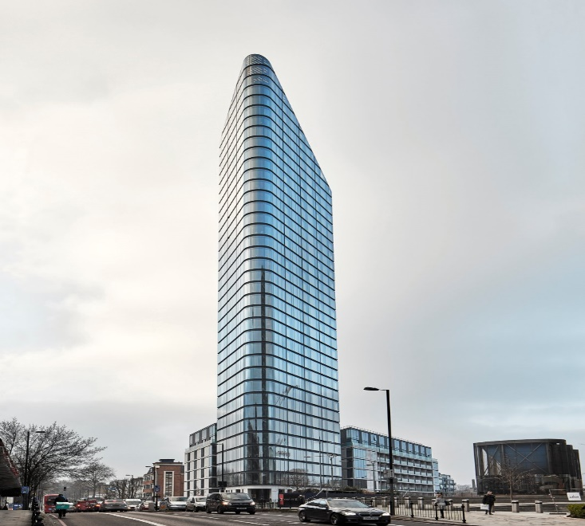
Photo © Paul Raftery https://aasarchitecture.com/2017/03/som-celebrates-completion-lexicon-london.html/

The Lexicon was completed in early 2017 and was a collaboration between mount Anvil and Clarion Housing Group. It was created by Skidmore, Owings and Merril, the same engineers who were behind the world’s tallest building, Dubai’s Burj Khalifa. According to Hanson, (2017) the concrete provider, hidden behind the buildings glazed appearance, are the structural columns, core and floorplates that are all made of concrete. Concrete was the material of choice due to the height of the building and the fact it was to be stood on a small footprint, also taken into consideration when deciding the build material was the wind, due to its height and possible wind conditions, concrete was thought best due to its significant wind resistance and fire resistance. Attached to the concrete structure is a curtainwall system. According to the architects the curtain wall is with glass channels set within a ventilated cavity, by using the curtain wall it helped with the builds sustainability

Sustainability
Due to the climatic changes the world is experiencing some major disasters, such as hurricanes, floods and severe droughts. According to Oxfam International (2017) simply put, changes in the global climate exacerbate climate hazards and amplify the risk of extreme weather disasters. Because of this there is a need to reduce the carbon footprint in the build industry looking at how materials are manufactured and what materials are sustainable, while also building for the future. According to Chaturvedi and Ochsendorf (2018) cement and steel are responsible for significant global carbon dioxide emissions, the greenhouse gas contributing most to climate change. Though the industry is now thriving to create more efficient structures through reduced consumption, the actual process of creating steel on concrete, the main materials for construction, still has some work to do in reducing their co2 emissions. According to Hermawan et al, (2015), steel CO2 emissions are 18.7 per cent, Cement 30, 3 per cent but pre-fabricated concrete is only at 2 per cent, see fig 3.

Fig 3 CO2 contribution from various construction materials
Hermawan et al, (2015)

Sustainability Zaragoza Bridge Pavilion
As the Zaragoza Bridge pavilion was to be built for Water and Sustainable Development expo, the design and build had to match that criteria. That is why fibreC was used for its structure on top of the steel frame. According to Rieder, (2017) they believe concrete is a sustainable material for future architecture. This is down to the fact of its durability and stability also the fact it is cheaper than steel. There is an ecological advantage to concrete also especially in the manufacturing of fibreC which was used on the Zaragoza Bridge Pavilion. FibreC uses a low amount of energy during production therefore minimizes CO2 emissions. Another advantage of using FibreC and again going back to why it was used for the Zaragoza Bridge Pavilion and was in keeping with its purpose, is the fact that FibreC is made up of purely raw materials which makes it recyclable. Due to Rieder’s quest to meet the demands of modern day architecture in terms of sustainability and that they have been awarded the leadership in energy and environmental design certificate is why, no doubt, that they were the chosen company to deliver the material for the project.
The structure of the building is sat upon a steel frame. The steels were ideally suited to this build due to the build site and the ease of using steel compared to concrete. The steels could be pre-fabricated and assembled on site saving time and increasing accuracy. According to Bulletin, (2016) the introduction of light, strong steel products sets the trend for new designs and less material. Through advances in the forming of steel, there are opportunities for complex cross sections which attributes to less material being used. These advances also support the building and design through innovation. As well as the benefit of using less steel, the fact that it can be disassembled for reuse or to be recycled is another plus for environmental causes.

Sustainability Lexicon
As with all modern day construction projects, sustainability is always at the forethought of the construction team. This was no different when it came to the lexicon. Though as the buildings frame and structure is made up of concrete it will have a mix of sustainability and environmental positives and negatives, though the curtain wall attached to the concrete structure definitely enhanced the buildings sustainability. According to Tarun, (2008) the production of Portland cement, an essential constituent of concrete, leads to the release of significant amounts of CO2. Thus it is not environmentally friendly to make, use or dispose of. In order for it to be made it causes environmental destruction and pollution through quarrying for aggregates and the energy used to produce it. In this instance the frame and structure of the building wouldn’t be great for the environment, but the supplier of the cement for the building Hanson, has an Eco plus range that can replace up to 70 per cent of the Portland cement with Ground Granulated blast furnace slag, which has a much lower level of CO2. Concrete structures have high thermal mass, this helps with keeping the rooms of the building cool during hot days which reduces the use of high energy air conditioning units. Airtightness is another reason why concrete framing can be preferred, it makes it easier to meet building regulations, such as Part L1A 2010. In the case of the lexicon where a flat slab was used, is another advantage of concrete due to its fast construction and minimum depths required. The curtain wall of the structure could be seen by many as just the aesthetics of the building largely because it can be shaped and designed in many different ways to make the building very attractive to look at. This however is just 1 of many positives to using a curtain wall. According to Chen et al, (2018) a curtain wall system (CWS) is one of the most popular elements for the external walls of large, multi-storey buildings. They are designed for many other reasons opposed to just the looks. They help protect the building from outside elements such as the wind and rain, though for this they have to be treated and this treatment needs to be done around every ten years. When it is treated correctly and glazed correctly the curtain wall also improve the thermal efficiency of the building. Though the curtain wall does not provide structural stability it can reduce the sway of the building by the way it is fitted which makes the structure more secure. Curtain walls can also slow the spread of fire, it acts as a barrier between floors preventing the fire from easily spreading, which in a tall building is very beneficial. There are varying methods of manufacturing and installation of curtain walls but the Unitised system seems to be the preferred method. According to Anderson, (2016) Unitised systems are manufactured in a factory and delivered to site as a finished product ready for installation, this ensures greater quality control and consistency. The latest in curtain wall material is aluminium which increases sustainability and environmental effects due to the fact it is efficient to fabricate and install as well as being fully recyclable.

Summary
Both the Lexicon and Zaragoza Bridge Pavilion were built with sustainability and the environment in mind due to climate change creating the need for change. There is no denying however as the Zaragoza Bridge Pavilion was built for an expo on sustainability that its overall design and material usage was more so influenced. From research it seems as if most if not all of the materials used in building the Zaragoza Bridge Pavilion are recyclable and were very efficient in the manufacturing of the materials, in contrast to the concrete structure of the Lexicon, where concrete has little to no recyclability. Concrete was used though as it was thought the best material for the job for the Lexicon due to its height and design and the environmental factors in the area it was built such as the wind at height. The same applies to the Zaragoza Bridge pavilion as in steel was the best material for the frame due to the fact it was built over a river and the steels could be made in a factory and then assembled on site. Overall as the construction industry stands, both steel and concrete are key materials in the process of creating buildings and will be for the foreseeable future. There are positives and negatives to both which is why for now they will both continue to be used. Being used together increases even more impressive building types and sizes, e.g. the shard that has a concrete basement, followed by structural steel from the ground up to level 40, then from level 41 to 69 is concrete followed again by steel to the top level 95. Though there is great advancement in the use of timber framing for such structures e.g. The Mjøstårnet building, it is still early days and the need for steel and concrete is still greatly required.

References
Anderson, S. (2016). Sustainability of concrete. Available at: https://www.cmswindows.com/news/curtain-walling-the-modern-way-with-unitised-aluminium/ (Accessed 8 January 2020).
Baddoo, N.R. (2008) Stainless steel in construction: A review of research, applications, challenges and opportunities Journal of Constructional Steel Research. Vol 64 p.p. 1199–1206.

Chaturvedi, Swati. And Ochsendorf, J. (2018). Global environment impacts due to cement and steel. Structural engineering international. Vol 14. Issue 3.

Chen, K. and Weisheng, L. (2018). Design for Manufacture and Assembly Oriented Design Approach to a Curtain Wall System: A Case Study of a Commercial Building in Wuhan, China, Journal of sustainability. Vol 10 issue, p 2211.

Hanson, (2017). Lexicon, Islington. Available at: https://www.hanson.co.uk/en/case-study/lexicon (Accessed 15 December 2019).
Jewell, N. (2013). Zaha Hadid's Bridge Pavilion in Zaragoza
Available at: http://buildipedia.com/aec-pros/featured-architecture/zaragozas-bridge-pavilion (Accessed 4 January 2020).
Marzuki, H., Puti, F., Muhamad, A. and Driejana, R. (2015). Procedia Engineering. Vol.125 pp 692-698.
Plizzari, G. and Mindess, S. (2019). Developments in the Formulation and Reinforcement of Concrete (2nd edn). Woodhead Publishing.
Prisco, M., Plizzari, G. and Vandewalle, L. (2009). Fibre reinforced concrete: new design perspectives. Volume 42, Issue 9, pp 1261–1281.
Reider, (2008). Architectural bridge building for the expo 2008. Available at: https://www.architonic.com/en/story/rieder-architectural-bridge-building-for-the-expo-2008/7000076 (Accessed 7 January 2020).
Shollock, B., Thakur, D. And Couchman, G. (2016) Why steel construction? Vol 41, issue 9.

Zaha Hadid Architects, (2019). Zaragoza Bridge Pavillion. Available at: https://www.zaha-hadid.com/design/zaragoza-bridge-pavilion/ (Accessed 17 December 2019).

R

