Approved Document: EC (Embodied Carbon in Construction Materials
To accompany the Building (Embodied Carbon of Construction Materials) (Wales) Regulations.

Guidance on achieving compliance with the Building Regulations for embodied carbon in Construction Materials.

Robyn Watts
BSc (Hons) Quantity Surveying.
Sustainable Development – ACBA5028

Publication Date: 9 December 2025

Introduction
What is an Approved Document?
In the construction and building industry, an approved document is a collection of guides covering technical areas that explain how to meet the building regulations in England and Wales.
What is Net Zero?
Net Zero refers to the balance between greenhouse gas emissions produced and emissions removed from the atmosphere.
Achieving net zero requires two significant steps:
1. Reduce emissions as close to zero as possible, through energy efficiency, renewable energy generation, and low-carbon materials and systems
2. Neutralise unavoidable emissions through verified carbon removal or long-term storage.
In 2019, the UK passed legislation committing to a 100% reduction in greenhouse gases by 2050, based on 1990 levels. As said,
“In 2019, following the recommendation of the independent Climate Change Committee, the UK passed legislation that committed the government to reducing its emissions by 100% against a 1990 baseline by 2050. This is commonly known as the ‘net zero’ target, and it is legally binding.” (UK Parliament)
Buildings are a significant source of environmental impact, contributing approximately 39%of carbon emissions when operational and embodied sources are combined. Of this total, 28% of the emissions come from the operational “in-use” phase – to heat, power, and cool them - while 11% of the emissions are attributed to embodied carbon emissions, which refer to carbon released during the construction process and material manufacturing. (WGBC,2019) The size of these emissions underscores the urgent need to rethink and transform modern building design and construction practices fundamentally. Without significant and evidence-based changes, the built environment will struggle to meet the UK’s net-zero targets.

Table of Contents
Approved Document: EC (Embodied Carbon in Construction Materials 1
1. Introduction 4
1.1 Scope 4
1.2 Purpose 4
1.3 Relationship with other documents 4
2. Application of Requirements 5
2.1 Buildings to which this document applies 5
2.1.1 New Buildings 5
2.1.2 Major Renovation and Refurbishment 5
2.2 Transitional Arrangements 5
3. General Guidance 5
3.1 Competence 6
4. Design Stage Assessment 6
4.2 Review by Building Control Body 7
4.3 Expected Outcomes of the Design Stage Assessment 7
5. Setting and Meeting Thresholds 7
5.1 Embodied Carbon Performance Thresholds 7
5.2 Basis and rationale for threshold choice 8
6. Consistency with Policy Context 8
7. Material Selection and Reduction Strategies 8
7.1 Material Hierarchy 9
7.2 Material Specific Guidance 9
7.3 Major Contributors to Embodied Carbon 10
8. Verification and Post-Construction Review 10
9. Worked examples 10
10. References 11
11. Appendix 12

1. Introduction

1.1 Scope
This approved document applies to all building work covered by the Building (Embodied Carbon of Construction Materials) (Wales) Regulations. The scope includes
- New residential, commercial, public, and mixed-use buildings
- Major refurbishment
- Structural alteration
The guidance covers all life cycles. Modules relevant to embodied carbon, including product stage emissions (A1-A3), transport (A4), construction processes (A5), maintenance and replacements (B2-B4) and end-of- life treatment (C1-C4). Although operational energy is not the focus of the document, interaction between operational and embodied carbon is acknowledged where relevant.
This scope ensures that the assessment and reduction of embodied carbon become routine parts of development activities, rather than optional sustainability add-ons.

1.2 Purpose
The primary purpose of this approved document is to support the reduction of greenhouse gas emissions associated with construction materials. The documents have three central functions:
1. Offering practical guidance for compliance
2. Promoting low-carbon design and early intervention
3. Supporting a circular economy in Wales

1.3 Relationship with other documents
The approved document EC is intended to be read alongside other approved documents:
- Approved document A – Structure
- Approved document L – Conservation of fuel and power
- Approved document C – Site preparation and resistance to containments.
- Approved document F – Ventilation
- Approved document M – Access to and use of buildings

2. Application of Requirements

2.1 Buildings to which this document applies
The approved document EC applies to all building work that falls within the scope of regulations 4 of the Building Regulations. This includes a broad spectrum of building types and project scales, reflecting the fact that embodied carbon is produced across all forms of construction.

2.1.1 New Buildings
All new buildings, regardless of type or scale, must follow the requirements for embodied carbon, whole-life assessment, and the associated performance thresholds set out in this document. These include:
- Residential buildings
- Commercial buildings
- Public buildings
Compliance shown throughout the design stage and through post-construction assessments provided to the BCB.

2.1.2 Major Renovation and Refurbishment
The requirements also apply to projects where the scale or nature of refurbishment results in substantial material and carbon impacts. These include:
- Structural alterations affecting the primary load-bearing system
- Significant replacement of primary construction materials
- Re-cladding or large-scale facade replacement
Where refurbishment projects meet the above criteria, a whole-life carbon assessment must be undertaken, and embodied carbon limits shown in line with the thresholds applicable to new buildings.

2.2 Transitional Arrangements
The transition to embodied carbon regulation must be managed carefully to avoid unfair disruption to projects already underway. Transitional arrangements ensure projects in place before the regulation comes into effect are not subject to different regulatory burdens.

3. General Guidance
This approved document guidance to support consistent and transparent assessment of embodied carbon in construction materials. All projects within the scope of the regulations must quantify and report embodied carbon using recognised standards. Early integration of carbon assessment into the design process is essential, ensuring material choices, structural strategies, and procurement decisions aligned with reduction principles and regulatory thresholds.

3.1 Competence
All assessments conducted by individuals with proven ability:
- life-cycle assessment
- Whole life carbon accounting
- Sustainable design and construction
Accreditations may include RICS, IEMA OR CIBSE certifications.

4. Design Stage Assessment
The design-stage assessment is a fundamental step in demonstrating compliance with the building regulations. Its purpose is to ensure that embodied carbon is evaluated, reduced where possible, and effectively managed before construction starts.
- Design-Stage Embodied Carbon Assessment (ECA)
The ECA must quantify the project’s embodied carbon for life-cycle stages A1–A5, following BS EN 15978 and the RICS Whole Life Carbon Assessment. The assessment should calculate baseline emissions for all significant building elements.
The design team must use the best available data, prioritising:
- product-specific Environmental Product Declarations (EPDs)
- manufacturer EPDs
- industry-average EPDs where necessary

- Material Inventory
A coordinated material inventory must be provided that outlines the type, quantity, and specification of all significant construction materials. The inventory should highlight elements that contribute most to embodied carbon—such as concrete, steel, façade systems, and structural floors—to support targeted carbon reduction.
Where BIM is used, the material inventory should be linked directly to modelled quantities to ensure consistency across design disciplines and improve traceability during post-construction review.
- Embodied Carbon Reduction Strategy
The reduction strategy must show how the project will meet the embodied carbon thresholds. It should include:
- evaluation of low-carbon structural and material alternatives
- design efficiency measures (e.g., optimisation of spans, reduction of over-specification)
- use of recycled, reused, or bio-based materials
- façade and foundation options assessed for carbon impact
- circular economy opportunities, including design for deconstruction
- procurement routes that prioritise low-carbon products

The strategy must also justify any high-carbon elements kept in the design and confirm that lower-carbon alternatives have been explored.

4.1 Review by Building Control Body
The BCB will assess whether the method is appropriate, the calculations are complete, and the proposed design can meet the embodied carbon limits. Construction must not begin until the BCB has formally approved the design stage assessment.

4.2 Expected Outcomes of the Design Stage Assessment
The design stage assessment must result in:
  - Clear quantification of embodied carbon
  - Evidence-based design optimisation
  - Robust documentation for regulatory approval
  - A carbon budget that the project must adhere to during Construction
  - Transparency and accountability within the design team

5. Setting and Meeting Thresholds
This section sets out the embodied carbon performance thresholds that must be met to follow the building regulations. The purpose of setting numerical limits is to show a consistent, measurable, and enforceable framework for reducing the carbon impacts of construction materials throughout Wales.

5.1 Embodied Carbon Performance Thresholds
All new buildings and major refurbishments must meet upfront embodied carbon limits. Thresholds apply to lifecycle modules A1-A5 and will follow BS EN 159878 and RICS Whole Life Carbon Assessment.
- Residential building - < 350-500kg. CO2e/m2 (LETI,2020)
- Commercial offices - <500-600kg CO2e/m2 (UKGBC)

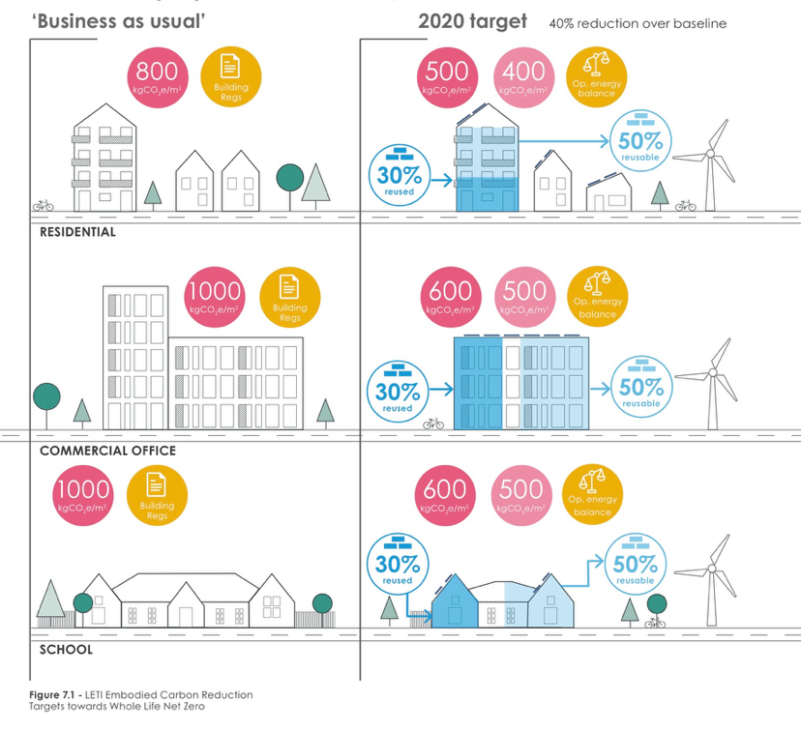
5.2 Basis and rationale for threshold choice
Figure 5.2 below shows LETIS comparative between current business as usual emissions and the 2020 target performance for residential and commercial buildings. The data shows that typical baseline emissions may exceed 800-1000 kgCO2e/m2 while best practise low carbon design can deliver reductions of 40% or more.
Figure 5.2 embodied carbon baseline vs 2020 targets for residential and commercial typologies. LETI,2020)

6. Consistency with Policy Context
The reduction of embodied carbon in construction materials directly supports the UK and Welsh Governments’ Net Zero targets. This approved document aligns with key sustainability frameworks and guarantees consistency with national and regional policy goals.
Pas 2080:2023 – Carbon management in infrastructure provides a structured approach to measuring and reducing whole-life carbon in construction projects.
LETI – offers practical guidance and benchmarks for operational and embodied carbon in buildings.
UKGBC – defines strategies to reduce carbon impacts across the lifecycle of buildings, supporting the integration of circular economy principles.

7. Material Selection and Reduction Strategies
Reducing embodied carbon in construction starts with careful material choice and design decisions. This selection outlines principles, strategies, and examples to guide project teams in achieving low-carbon construction.

7.1 Material Hierarchy
Avoid: design out unnecessary materials and elements: optimise layout and structural systems to reduce material demand.
Reduce: use less carbon-intensive materials, optimise dimensions, and avoid over-specification.
Reuse: salvage materials from the site and explore reuse of compensates or materials. Refit beams, bricks, or panels where structurally and aesthetically appropriate.
Substitute: replace high-carbon materials with lower-carbon alternatives. For example, use timber or engineered wood in place of reinforced concrete, or opt for recycled steel instead of new, virgin steel.
Recycle: use materials that hold recycled content and consider how they can be recycled at the end of their life.

7.2 Material Specific Guidance
Concrete: optimise mix design, reduce cement content, and specify supplementary cementitious materials. Consider recycled aggregates and low-carbon binders.
“Steel: use recycled steel, minimise overuse through design optimisation, and boost fabrication materials with lower emissions. Reused materials reclaimed from the built environment as part of the circular economy. For example, reusing steel can have a 97.5% lower embodied carbon than new steel.” (UKGBC)
Timber: use sustainably sourced or certified timber. Consider cross- laminated timber and engineered wood products to remove embodied carbon while mainstreaming structural performance
Finishes and cladding: prioritise low-carbon, durable finishes. Use local materials to reduce transport emissions.

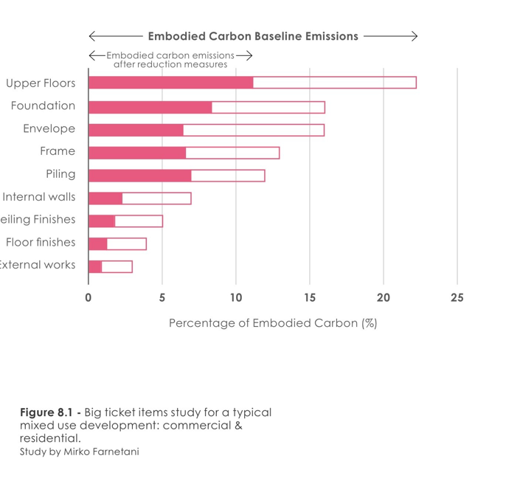
7.3 Major Contributors to Embodied Carbon
Figure 7.1 shows the typical distribution of embodied carbon across major building elements in a mixed-use development. The data shows that upper floors, foundations, and the building envelope, and the primary structural frame accounting for the largest share of upfront embodied carbon affected. These elements therefore are the most effective intervention points for care on reduction measures.
Figure 7.1- typical embodied carbon distribution and reduction potential across building elements (LETI 2020)

8. Verification and Post-Construction Review
Verification ensures the completed building aligns with the embodied carbon performance predicted at the design stage. The contractor must provide accurate as-built material quantities, updated EPDs, waste records, and transport data. These are compared with the approved carbon budget to show any deviations.
The Building Control Body reviews the final A1–A5 assessment and confirms compliance before issuing completion approval, ensuring transparency, accountability, and reliable embodied-carbon reporting.

9. Worked examples
The following worked examples show how embodied carbon assessments and thresholds apply in practises.
9.1. New Dwelling (timber frame)
A 120 m² timber-frame dwelling was assessed using BS EN 15978 and RICS WLCA guidance. Total embodied carbon for A1–A5 was 48,000 kg COe, resulting in 400 kg CO2e/m2, meeting the residential threshold. Key reductions included using 70% GGBS concrete, FSC-certified timber, and UK-manufactured components to reduce transport impacts. Off-site fabrication minimised waste, and the Building Control Body verified the as-built carbon report, confirming full compliance.

10. References
- House of Commons Library (2019) what is net zero? available at: https://commonslibrary.parliament.uk/what-is-net-zero/(Accessed Nov 2025).
- World Green Building Council (2019) World Green Building Week 2019. available at: https://worldgbc.org/wgbw19/ (Accessed 20th Nov 2025).
- Royal Institution of Chartered Surveyors (RICS) (2023) Whole Life Carbon Assessment for the Built Environment: Professional Standard available at: https://www.rics.org/content/dam/ricsglobal/documents/standards/Whole_life_carbon_assessment_PS_Sept23.pdf (Accessed 25th Nov 2025)
- British Standards Institution (BSI). BS EN 15978: Sustainability of construction works – Assessment of environmental performance of buildings – Calculation method. available at: https://standardsdevelopment.bsigroup.com/projects/2020-01551 (Accessed 1st Dec 2025)
- London Energy Transformation Initiative (LETI) available at: https://www.leti.uk (Accessed December 2025)
- UK Green Building Council UK available at: https://ukgbc.org (Accessed 2nd December 2025)
- UK Green Building Council (2024) what is embodied carbon in construction? Avaliable at: https://ukgbc.org/news/what-is-embodied-carbon-in-construction/ Accessed 6th December 2025)
- London Energy Transformation Initiative (2020) Embodied carbon primer available at: https://www.leti.uk/_files/ugd/252d09_8ceffcbcafdb43cf8a19ab9af5073b92.pdf (Accessed 7th December 2025)
- Royal Institution of Chartered Surveyors (RICS) (2023) Whole Life Carbon Assessment. Available at: https://www.rics.org/content/dam/ricsglobal/documents/standards/Reporting-template-summary.xlsx (Accessed 8th December 2025)

11. Appendix
Appendix A – Glossary
A1–A3 (Product Stage)
Life-cycle modules covering raw material supply (A1), transport to manufacturing (A2), and manufacturing processes (A3). Represent the “cradle-to-gate” embodied carbon of construction materials.
A4 (Transport to Site)
Emissions arising from the transportation of construction materials from the factory gate to the construction site.
A5 (Construction / Installation Stage)
Includes emissions from on-site construction activities, installation, construction energy use, and construction waste processing.
B2 (Maintenance)
Covers planned work to maintain the building fabric or services throughout the building's operational life.
B3 (Repair)
Covers localised repair activities due to damage, defects, or minor component failure.
B4 (Replacement)
Covers the environmental impacts of replacing elements or materials when they reach the end of their service life.
C1–C4 (End-of-Life Stage)
Life-cycle modules covering deconstruction/demolition (C1), transport of waste (C2), waste processing for reuse/recycling/recovery (C3), and final disposal (C4).
Building Control Body (BCB)
A Local Authority or Approved Inspector responsible for assessing compliance with the Building Regulations, including embodied carbon requirements.
Design Stage Assessment (DSA)
A mandatory embodied carbon assessment undertaken before construction, demonstrating compliance with embodied carbon limits for stages A1–A5.
Embodied Carbon (EC)
Greenhouse gas emissions associated with the extraction, production, transport, installation, maintenance, replacement, and end-of-life processing of construction materials.
Environmental Product Declaration (EPD)
A third-party verified document that reports the environmental impacts of a product based on a standardised life-cycle assessment (LCA), in accordance with EN 15804.
kgCO2e
Kilograms of carbon dioxide equivalent. The standard metric used to quantify greenhouse gas emissions.
Life-Cycle Assessment (LCA)
A method for quantifying environmental impacts, including embodied carbon, across the full life cycle of a building or product in line with BS EN 15978.
Net Zero
A condition where residual greenhouse gas emissions are balanced by permanent removal or storage of an equivalent quantity of carbon.
PAS 2080
A UK specification for managing carbon in buildings and infrastructure, guiding the reduction of whole-life carbon.
Product Stage
The stages A1–A3 of the life cycle represent the environmental impacts of raw materials extraction, processing, and manufacturing.
RICS Whole Life Carbon Assessment (WLCA)
The RICS professional standard provides a methodology for calculating and reporting whole-life carbon in the built environment.
Reuse / Reused Materials
Materials or structural components taken from existing buildings and used again without energy-intensive reprocessing.
Upfront Carbon
Embodied carbon released before the building is occupied, including life-cycle stages A1–A5.
Whole-Life Carbon (WLC)
Total greenhouse gas emissions across the entire life cycle of a building, including both embodied and operational carbon.

Appendix B – Whole Life Carbon Assessment Template.
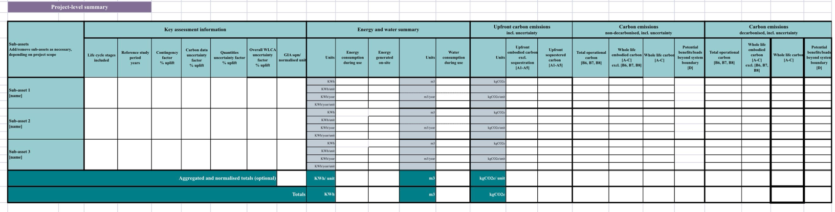
This template is included for illustrative purposes to show the reporting structure required under the proposed Embodied Carbon Regulations. (RICS, 2023)

