Database design and programing

Part A

Submitted By:
Sohaan Sureshkumar
2221048
Module: Databases and Application Development

Lecturer’s Name:
Carlene Campbell

Table of Contents
INTRODUCTION 4
1.1 AdventureWorks Cycles Case Study 4
ENTITY RELATIONSHIP DIAGRAM (ERD) 5
2.1 Conceptual ERD 5
2.2 Schema Diagram 6
DATABASE IMPLEMENTATION 7
3.1 Table Creation and Relationships 7
3.1.1 Manufacturer Table 7
3.1.2 Category Table 7
3.1.3 Product Table 8
3.1.4 Customer Table 8
3.1.5 OrderTable Table 9
3.1.6 OrderDetails Table 9
3.1.7 Feedback Table 10
3.2 Data Population 11
3.2.1 Manufacture Table 11
3.2.2 Category Table 11
3.2.3 Product Table 12
3.2.4 Customer Table 13
3.2.5 OrderTable Table 13
3.2.6 OrderDetails Table 14
3.2.7 Feedback Table 14
3.2.8 All Action Outputs For Population: 15
3.3 Testing Constraints 16
3.3.1 Primary Key Constraints 16
Test Case 1: Attempt Duplicate Primary Key 16
Test Case 2: Attempt NULL Primary Key 16
3.3.2 Foreign Key Constraints 17
Test Case 1: Insert with Non-Existent Foreign Key 17
Test Case 2: Attempt to Delete a Record with Existing Dependencies 17
3.3.3 Check Constraints 17
Test Case 1: Inserting an Invalid Price 17
Test Case 2: Inserting an Invalid Rating 18
TRANSACTIONAL SCENARIOS 19
4.1 Successful Transaction (COMMIT) 19
4.2 Failed Transaction (ROLLBACK) 21
PERFORMANCE TUNING ENHANCEMENTS 24
5.1 Important Query Requirements 24
5.2 Data Queries without Indexing 24
5.2.1 Fetching All Orders for a Given Customer 24
5.2.2 Checking Product Availability 25
5.3 Data Queries Indexing 25
5.3.1 Get order details for a particular order 25
5.3.2 Retrieving Product based on Category 26
5.3.3 Search Feedback by its Rating 26
5.4 Secondary Indexing Rationale 27
REFERENCES 28

INTRODUCTION

  - AdventureWorks Cycles Case Study

AdventureWorks Cycles is a leading bicycle manufacturing company located in the UK dealing in road bikes, mountain bikes, hybrid bikes, and cycling accessories. The company has been in operation for many years as one of the leading suppliers of cycling products and services and is currently planning to enhance its business by developing a new online marketplace. This new platform will help the cycling enthusiasts to search, select, and assemble products from various manufacturers across the globe [1].

In order to meet these requirements, AdventureWorks Cycles needs a solid data infrastructure to support a variety of business processes such as product listing, registration of customers, ordering, and feedback [2]. Also, the database must handle high concurrency, maintain data integrity and provide high performance for the frequently used queries.

The output of this paper is to Identify a suitable database for AdventureWorks Cycles and to design and execute a database that meets their business needs. This involves designing an ERD, designing a normalized database, checking data consistencies using transactions, and improving query performance using indexing.

ENTITY RELATIONSHIP DIAGRAM (ERD)

  - 2.1 Conceptual ERD

The conceptual ERD for AdventureWorks Cycles reflects the most basic level of database structure that is required to support the operations of the online marketplace [3]. This diagram emphasizes the main entities and their relationships to ensure that data is moved around the system in the most efficient manner possible in order to support business processes like listing of products, processing of customer orders, and managing feedback.
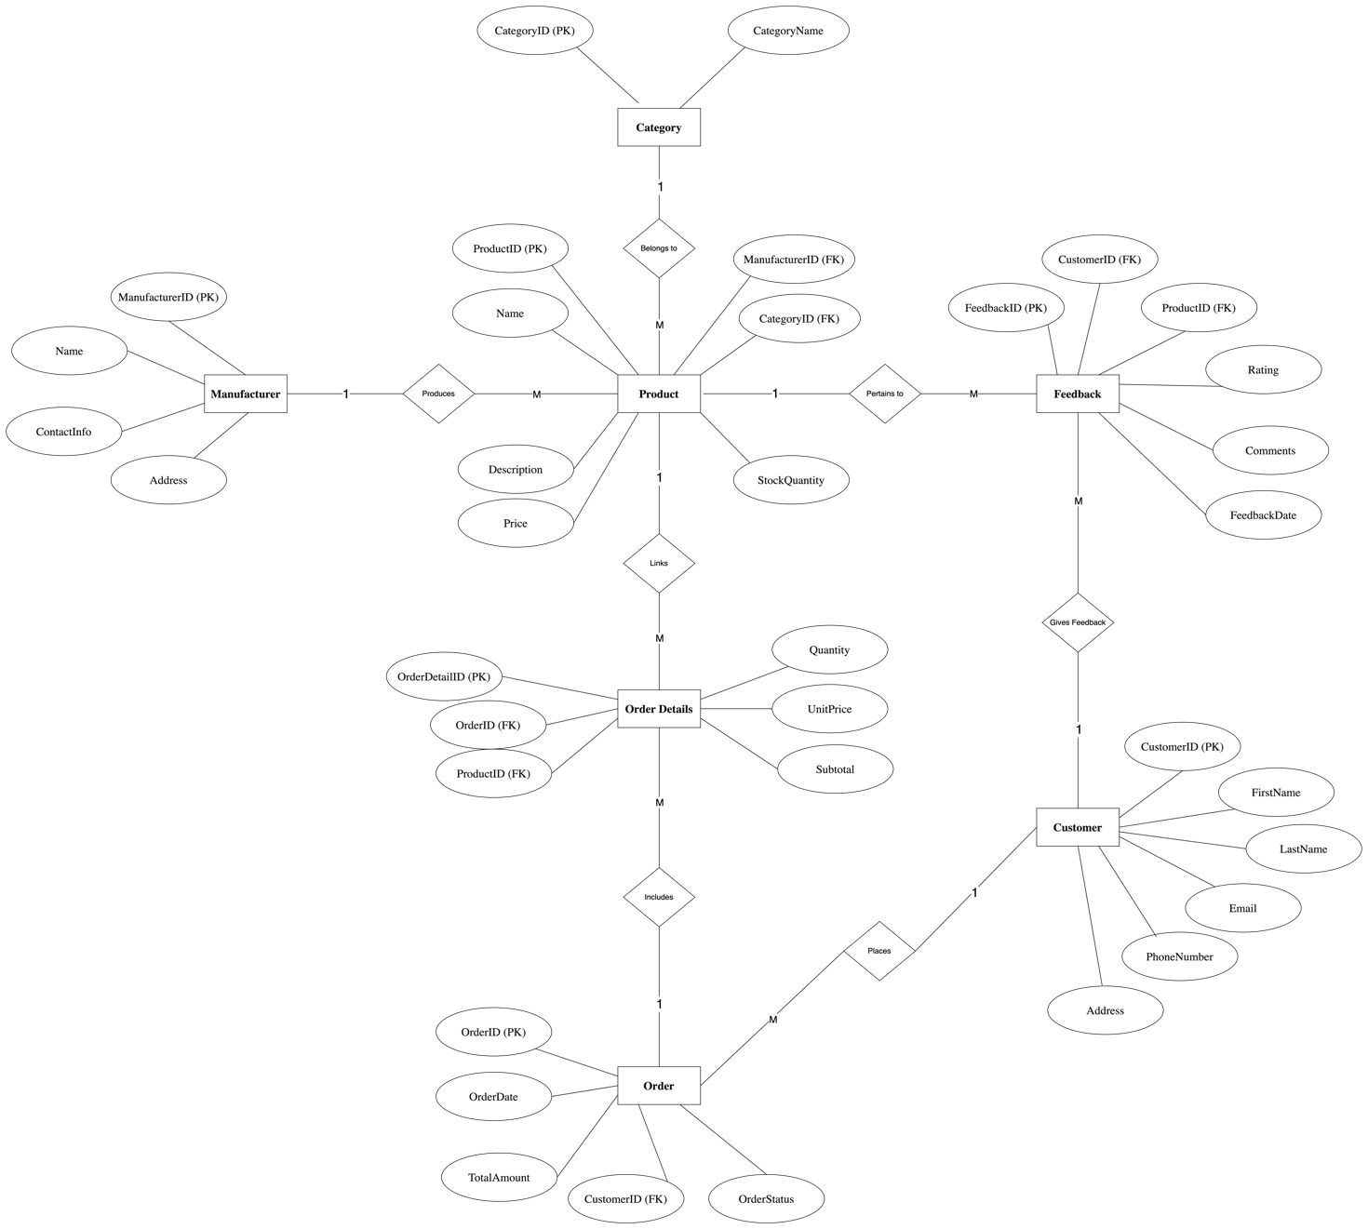
  - 2.2 Schema Diagram

The schema diagram below is a detailed representation of the database structure which includes all the tables, fields and the relationship between the tables as well [4].

DATABASE IMPLEMENTATION

  - 3.1 Table Creation and Relationships

  - 3.1.1 Manufacturer Table
The Manufacturer table contains information about the companies that produce the products for AdventureWorks Cycles. Every manufacturer has a unique identification number called ManufacturerID which is set as the PRIMARY KEY.

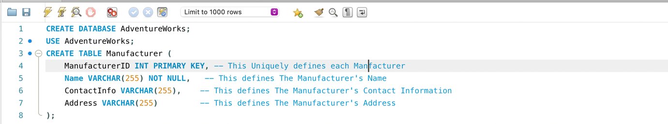

Action Output:

  - 3.1.2 Category Table
To improve product navigation, the Category table is used to divide products into general groups (i.e., road bikes, accessories).

Action Output:

  - 3.1.3 Product Table
The Product table contains information on products available in the market, such as price, description, and the quantity available in stock. It has Foreign keys to Manufacturer and Category tables [5].

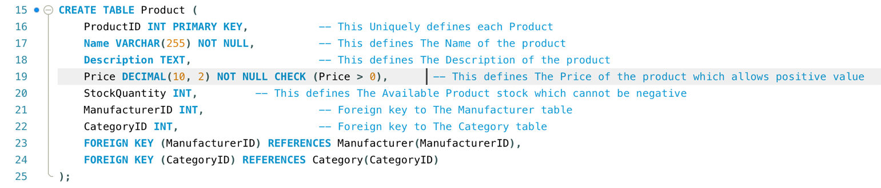

Action Output:

  - 3.1.4 Customer Table
The Customer table contains data about customers who make orders on the given platform.
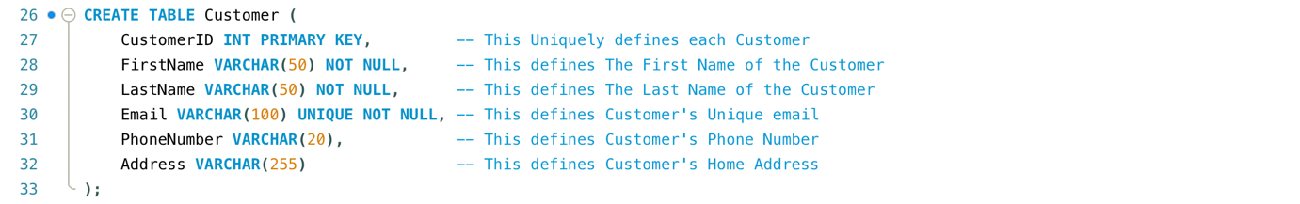

Action Output:

  - 3.1.5 OrderTable Table
The OrderTable contains information about the customer’s purchases including order date, the total amount and the status of the order.

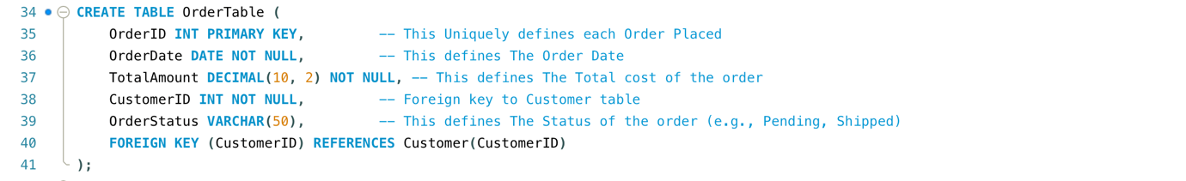

Action Output:

  - 3.1.6 OrderDetails Table
The OrderDetails table contains the details of every order made which include the quantity of the product, the price of the unit, and the sub-total [5].

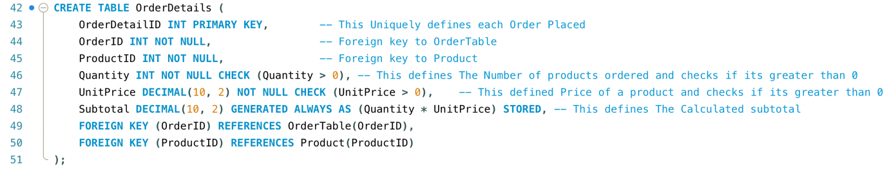

Action Output:

  - 3.1.7 Feedback Table
The Feedback table turn helps helps in the enhancing customer the in quality providing of feedback the and products reviews as along well with as ratings the for experience various of products the which customers. in

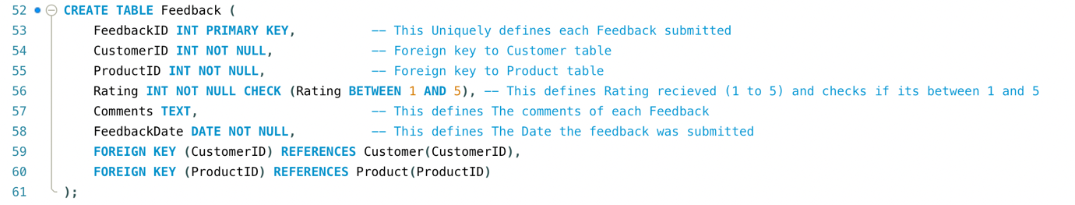

Action Output:

  - 3.2 Data Population

  - 3.2.1 Manufacture Table
We are inserting sample manufacturers into the Manufacturer table for companies that produce products for AdventureWorks Cycles. The manufacturer is linked to a unique ManufacturerID and has details such as the manufacturer’s name, contact information and address. This data is crucial to products being linked to their manufacturers.

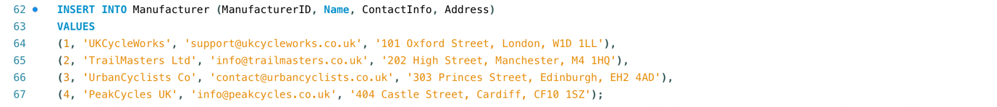

Output:
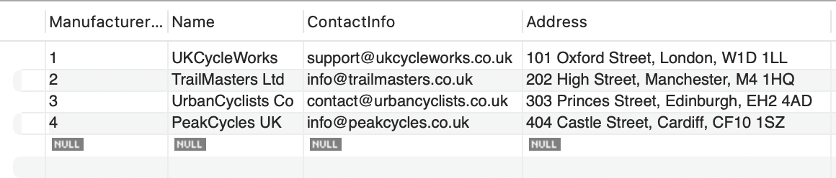

  - 3.2.2 Category Table

We are populating the Category table with various categories of products accessories. i.e. Each bikes category and is cycling assigned a unique CategoryID and a descriptive name. This data helps classify the products for easier navigation and management [6].

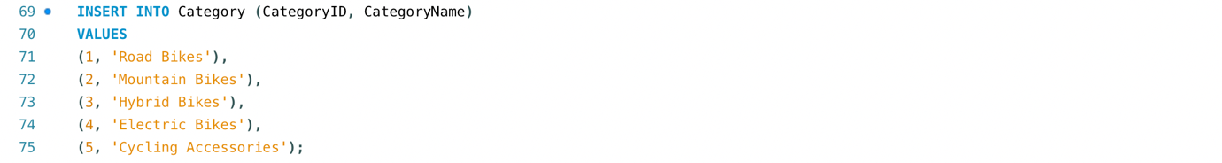
Output:
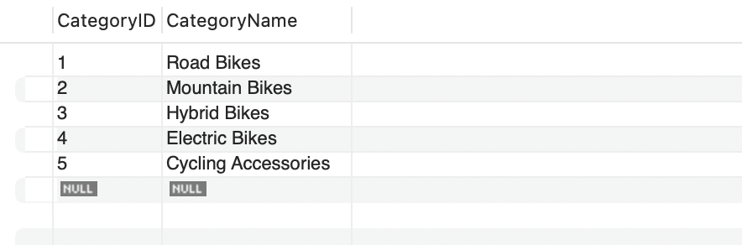

  - 3.2.3 Product Table
In this, we are entering certain products into the Product table, containing information such as the product name, the product description, the category price, to which quantity it belongs in.

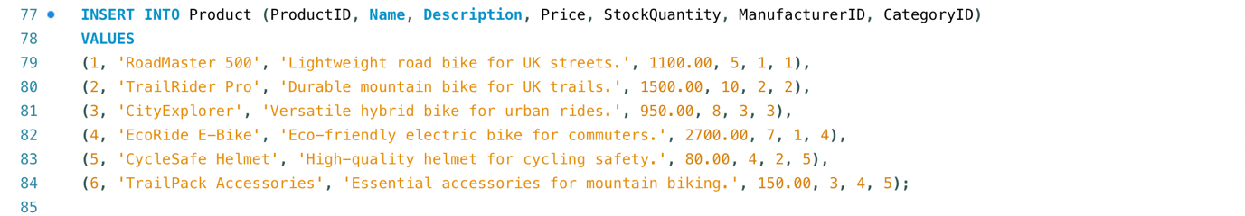

Output:
  - 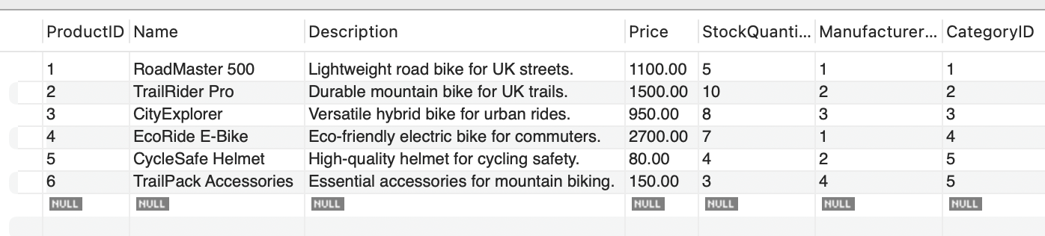

  - 3.2.4 Customer Table
In this, we are entering information about customers into the Customer table which includes the customer’s name, phone number, and address. Every customer has a CustomerID through which he or she is identified and which will be useful when it comes to processing orders and feedback.
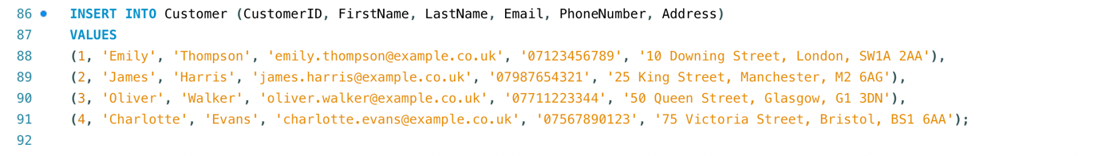

Output :
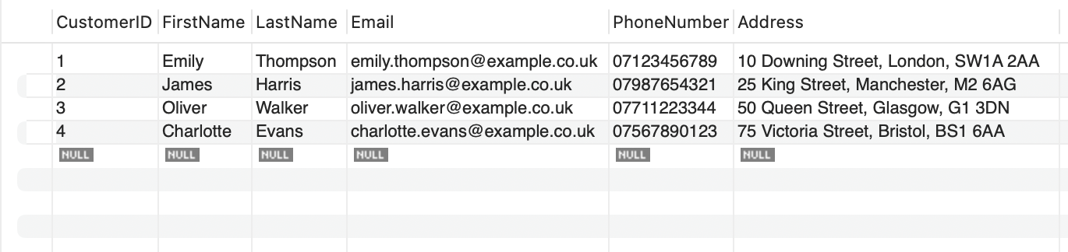

  - 3.2.5 OrderTable Table
We are creating sample orders in the OrderTable which includes all the Orders made by customers

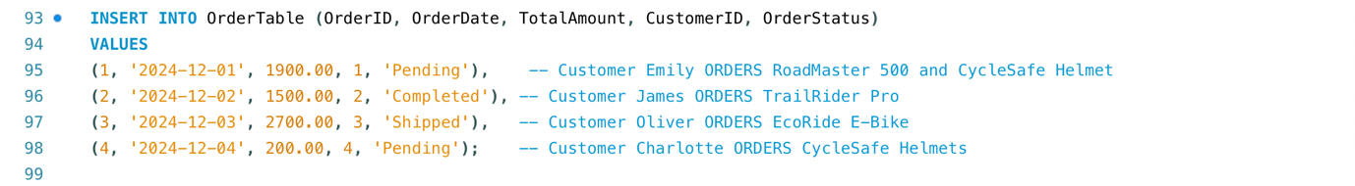

Output:
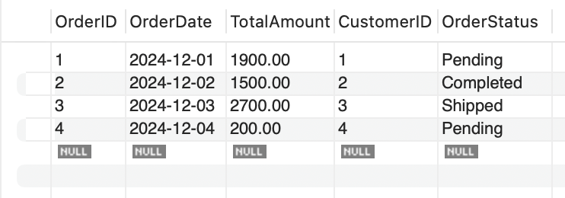

  - 3.2.6 OrderDetails Table
We are using sample information to populate the OrderDetails table with details about the products picked in each order. This table is used to hold the quantity and unit price of the items to calculate the subtotal of each order.

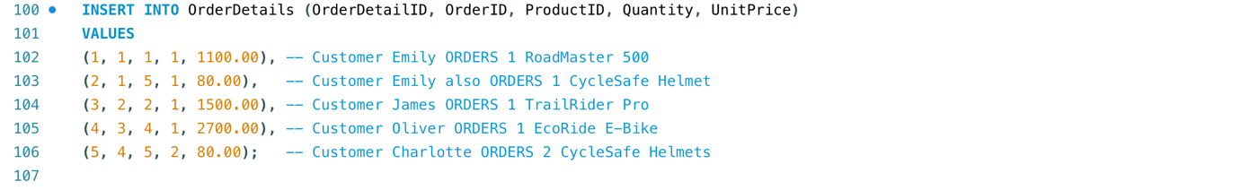

Output:
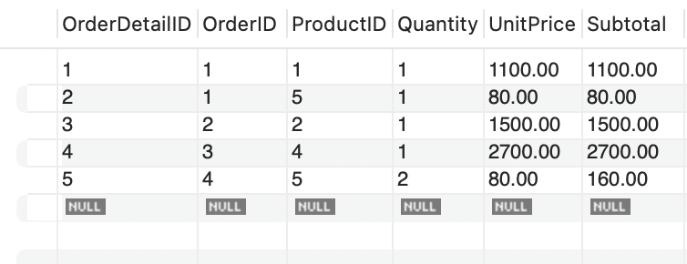

  - 3.2.7 Feedback Table
We are using this to populate the Feedback table with ratings and reviews of products that customers have purchased. This table is used to demonstrate customer feedback data for product evaluation and improvement [7].

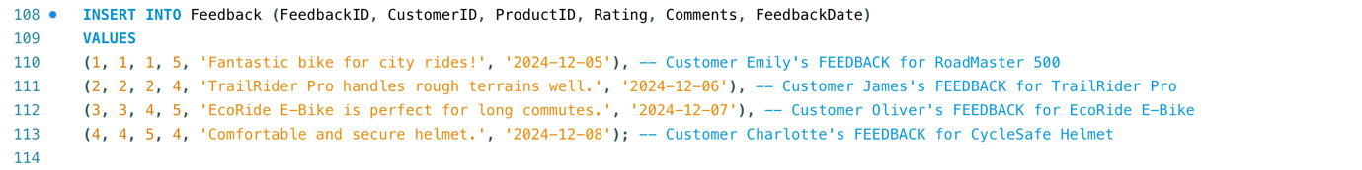

Output:
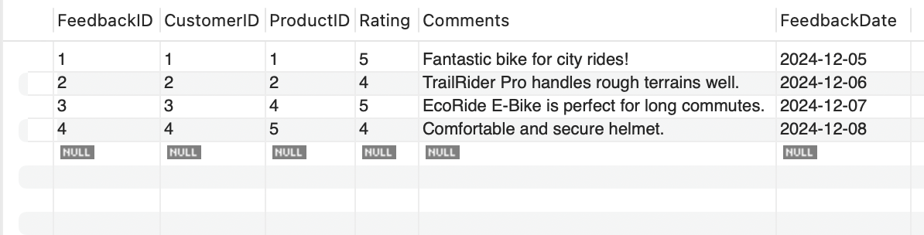

  - 3.2.8 All Action Outputs For Population:

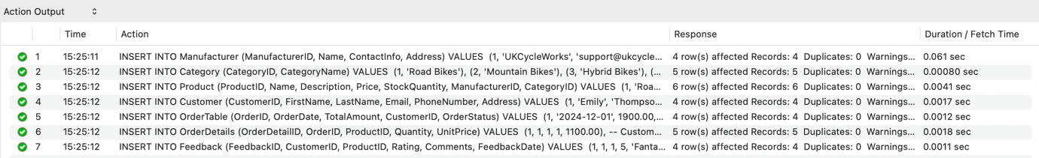

  - 3.3 Testing Constraints

  - 3.3.1 Primary Key Constraints

  - Test Case 1: Attempt Duplicate Primary Key

To verify that the database does not accept duplicate primary keys, we deliberately attempt to insert a duplicate CustomerID into the Customer table.

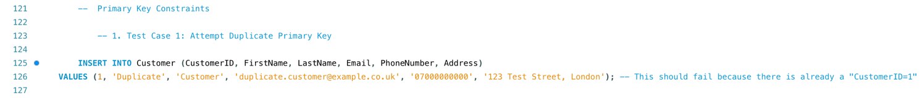

  - Test Case 2: Attempt NULL Primary Key
We try to insert a record into the Product table with a NULL value for ProductID, which is the primary key. This scenario shows that the database enforces the rule that primary keys cannot be null.

Action Outputs for both Tests

  - 3.3.2 Foreign Key Constraints

  - Test Case 1: Insert with Non-Existent Foreign Key
This is a test that tries to insert a record into the Product table with a non-existent ManufacturerID. This test ensures that the database does not allow a record to reference an invalid foreign key.

  - Test Case 2: Attempt to Delete a Record with Existing Dependencies

This shows what happens when we try to delete a record from the Manufacturer table which is being referenced by Product table. This test verifies that the database is preventing the deletion of a parent record when there are child records, thus ensuring the integrity of the relationships between the tables.

Action Outputs for both Tests:

  - 3.3.3 Check Constraints

  - Test Case 1: Inserting an Invalid Price
When we try to insert a product into the Product table with a negative price, this is contrary to the CHECK constraint which states that the Price column must contain positive value. This scenario is therefore valid to show that the database stops the insertion of invalid values that are not within the specified conditions.

  - Test Case 2: Inserting an Invalid Rating
In this test, we are entering a rating in the Feedback table outside of the 1 to 5 allowed range. This test guarantees that the database enforces the rule that ratings must be between 1 and 5, making sure that the feedback data is accurate and reliable.

Action Outputs for both Tests:

TRANSACTIONAL SCENARIOS

  - 4.1 Successful Transaction (COMMIT)
This is a successful order placement scenario when there is sufficient stock for the products ordered. This transaction involves adding a new order along with its details and decreasing the stock of the products purchased [8]. All operations being successful, the changes are committed, rendering the modifications irreversible.
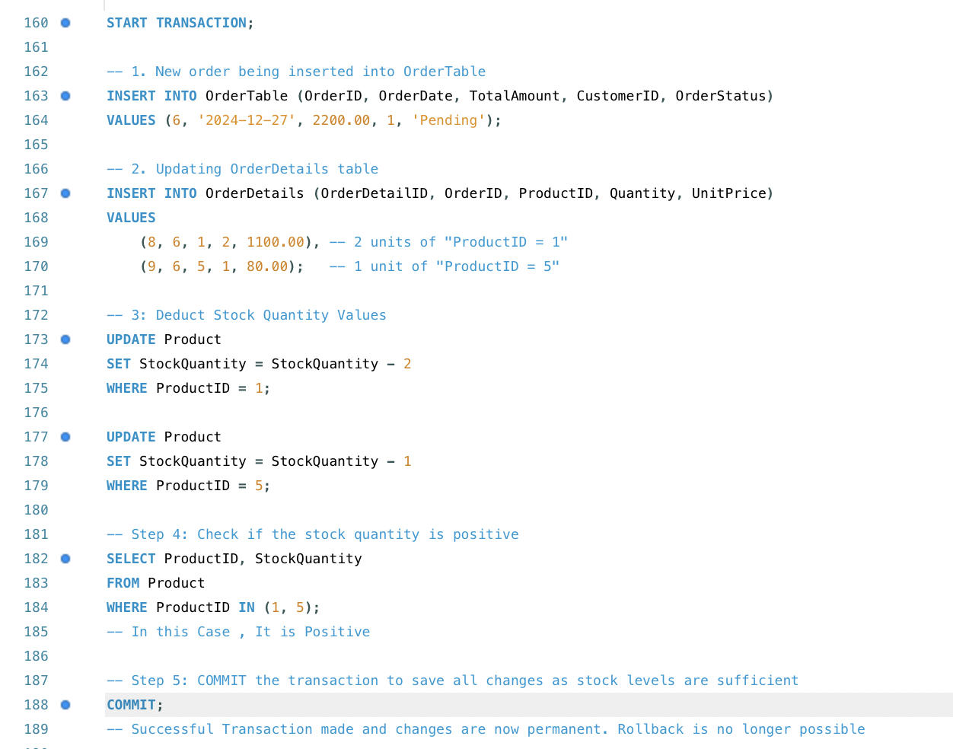

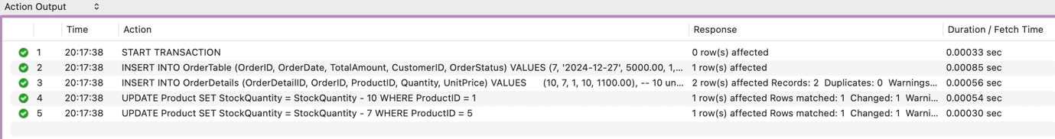
Now we let us check if there is available stock left

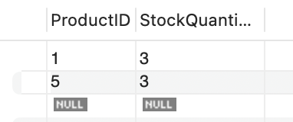

As we could see that there is availability after Deduction of the number of ordered units by customer for both products with Product ID 1 and 5, we can COMMIT the transaction to save the changed in our database.

Now if we check the Stock quantity and other table we are able to see that changes have been saved to the database

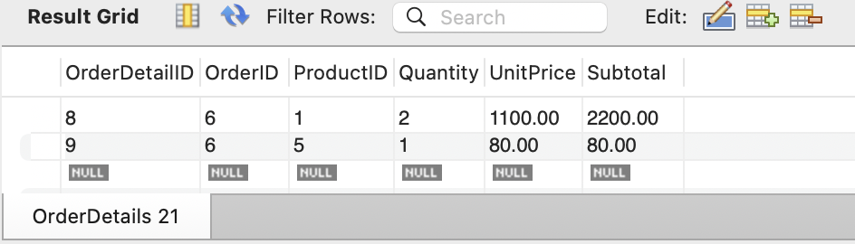

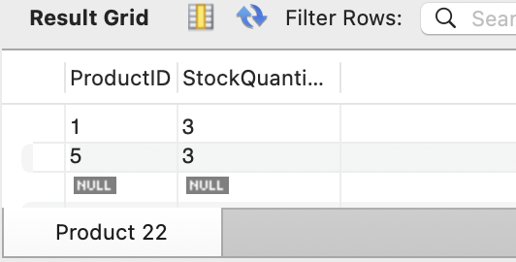

The transactional scenarios are started by the START TRANSACTION command that puts all related operations in a single logical unit. In the COMMIT scenario, a new order is inserted into the OrderTable, corresponding products and their quantities are inserted to the OrderDetails table, and then stock levels in the Product table are updated for the ordered quantities. Then, the stock levels are verified to be sufficient. When all operations are successful and the stock is positive, the COMMIT command is executed to make the changes permanent.

  - 4.2 Failed Transaction (ROLLBACK)
This is an example of an order placement being failed due to insufficient stock. When a customer tries to buy more quantities than what are available in the market, then the transaction is rolled back in order to maintain consistency so as to avoid saving any changes [8].
In the ROLLBACK scenario, a new order is similarly inserted, order details are added, but the quantities requested are greater than the available stock. When the stock levels are updated and verified, it finds that there is not sufficient stock for one or more products. Therefore, the ROLLBACK command is used to reverse all changes, so nothing incomplete or invalid is stored in the database.
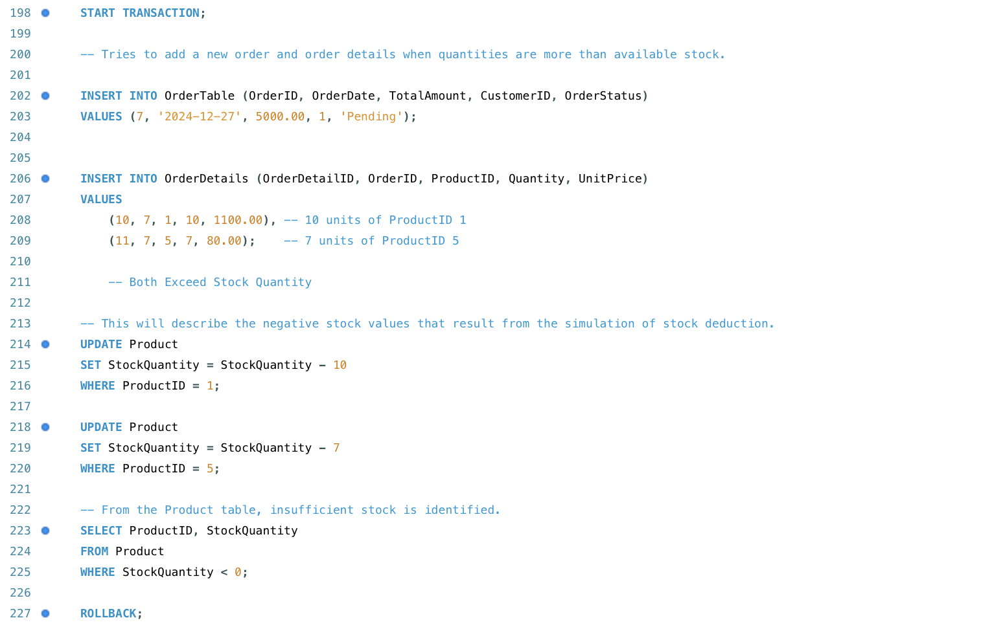
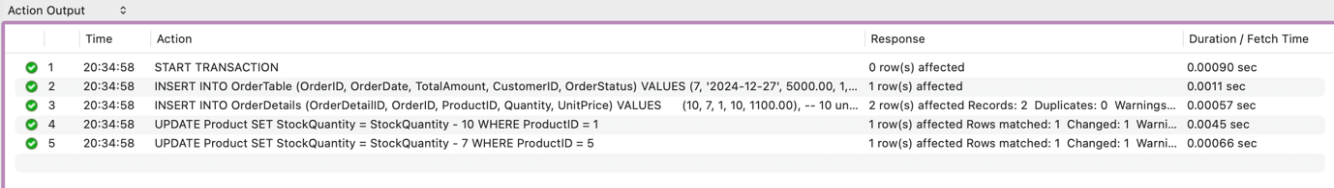

Let us check If we have stock left in this scenario.

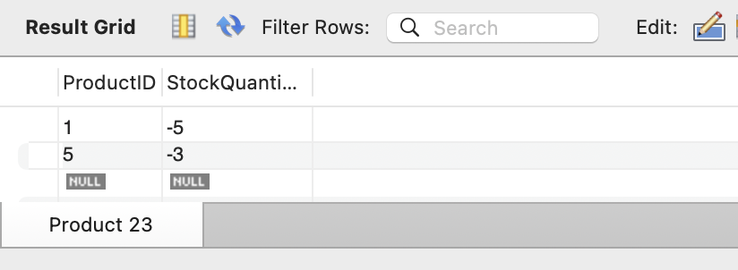

As the stock appears to be in negative value, the changes should not be saved as there is not enough stock and, in this case, we would have to rollback.

Now if we check the Stock quantity and other tables, we are able to see that no changes were saved in this transaction

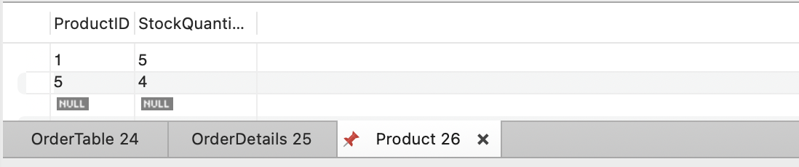

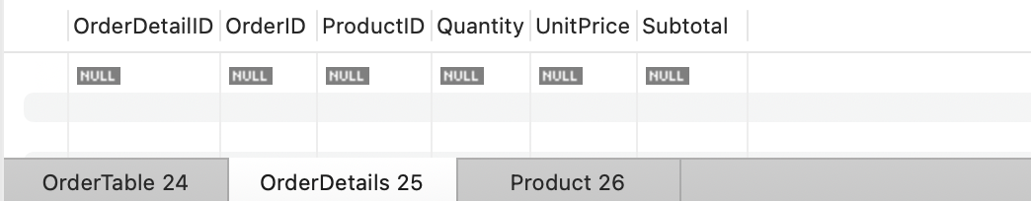

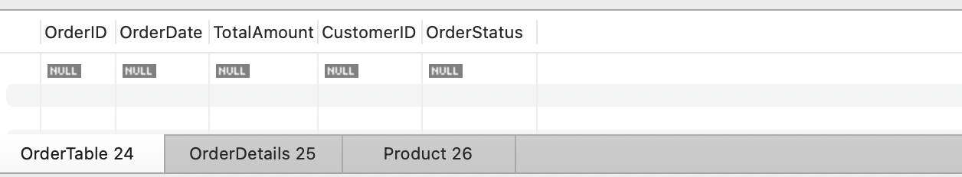

PERFORMANCE TUNING ENHANCEMENTS

  - 5.1 Important Query Requirements
From the business processes of AdventureWorks Cycles, several important queries that are likely to be executed frequently are evident. For example, customers have a need to look at their past orders, therefore, queries that fetch orders for specific customers should be highly prioritized. This is like stock availability, which is an important condition for timely order execution and requires checking product availability efficiently. Detail information for particular orders is also retrieved for order processing. Finally, customers and administrators are both able to browse products by category and analyse customer feedback based on ratings.

  - 5.2 Data Queries without Indexing
The initial queries were executed without any secondary indexes to establish a baseline performance. However, due to full table scans, execution times were longer, most notably with larger tables.
  - 5.2.1 Fetching All Orders for a Given Customer
This query is essential as customers often need to view their past orders.
  - 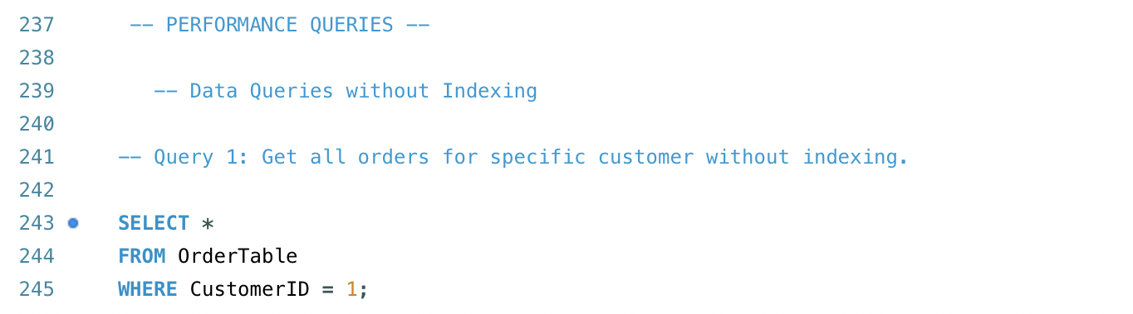

  - 5.2.2 Checking Product Availability
It is important to have enough stock on hand before customers place their orders.

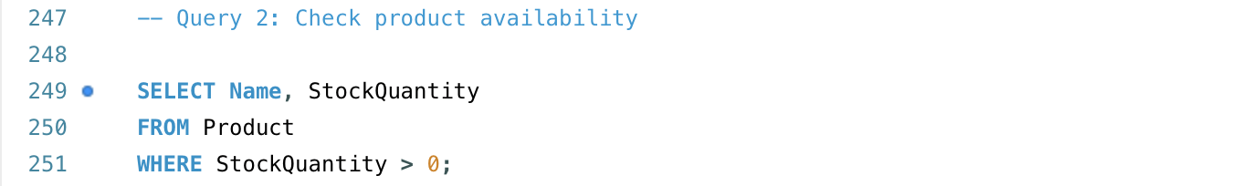

  - 5.3 Data Queries Indexing
After applying indexes, the execution times of queries were drastically reduced. This was because indexes enabled the database engine to quickly locate the relevant rows, thus preventing it from having to perform unnecessary scans [9].

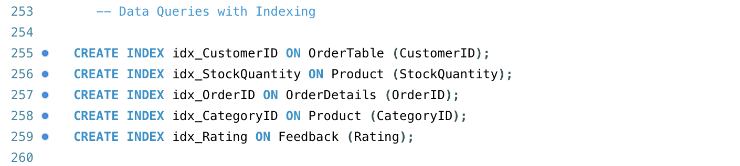
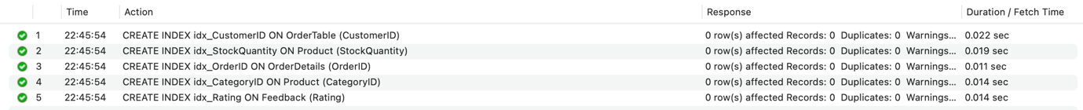

  - 5.3.1 Get order details for a particular order
This query is used to get detailed information about each order.
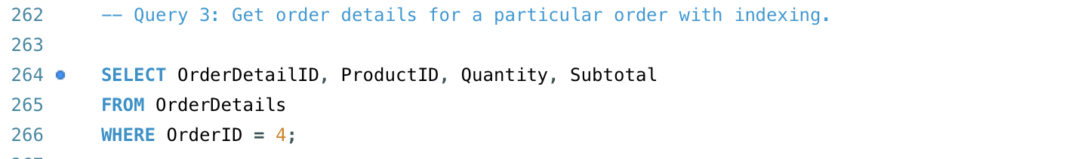
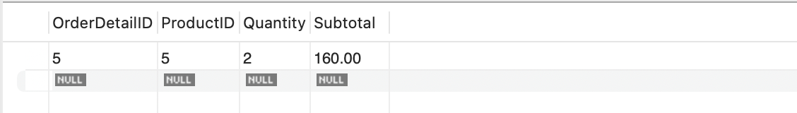

  - 5.3.2 Retrieving Product based on Category
Allows filtering as Products are often browsed by customers and administrators by their categories.
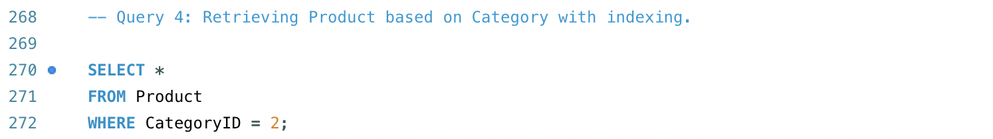

  - 5.3.3 Search Feedback by its Rating
This query is useful for finding highly rated products and understanding customer satisfaction.
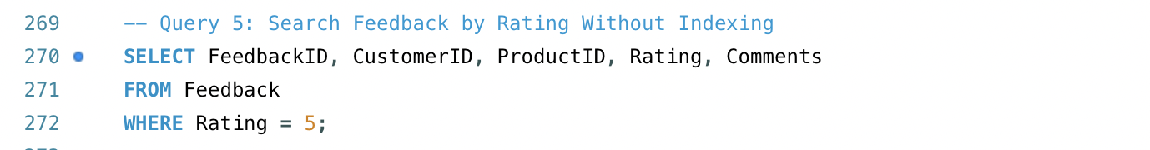

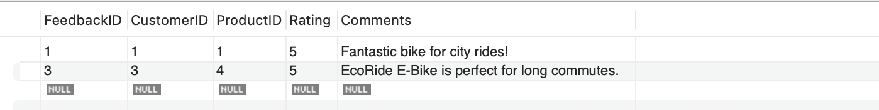

  - 5.4 Secondary Indexing Rationale
To enhance query performance, certain columns in the tables were identified to be candidates for secondary indexing in view of how often they are used in queries and in filtering data. The CustomerID in the OrderTable was indexed to enhance the speed of retrieving orders by customer [9].
In checking product availability, indexing the StockQuantity column in the Product table was useful.
Because getting order details by OrderID needed an OrderID index in the OrderDetails table. This optimization helped in product browsing by category, indexing the CategoryID column in the Product table, and in filtering feedback by ratings, indexing the Rating column in the Feedback table.
These indexes improved data retrieval efficiency by preventing full table scans and decreasing query execution times.

REFERENCES

[1]
“Learn some best practices and tips for developing a database that meets the specific needs and expectations of your business stakeholders. Discover how to choose the right database model, design the database schema, implement the database, test the d,” Linkedin.com, Dec. 25, 2023. https://www.linkedin.com/advice/0/what-best-ways-ensure-your-database-meets-1bgpc (accessed Jan. 08, 2025).

[2]
A. Manning, Databases for small business : essentials of database management, data analysis, and staff training for entrepreneurs and professionals. [Berkeley, CA]: Apress, 2015.

[3]
LucidChart, “What is an Entity Relationship Diagram (ERD)?,” Lucidchart, 2024. https://www.lucidchart.com/pages/er-diagrams

[4]
A. Dearmer, “Database Schema Design Guide: Examples & Best Practices,” Integrate.io, Jul. 16, 2021. https://www.integrate.io/blog/complete-guide-to-database-schema-design-guide/

[5]
C. Coronel and S. Morris, Database systems: Design, implementation, and management, 13th ed. Australia ; United States: Cengage Learning, 2019.

[6]
R. Peterson, “What is Normalization? 1NF, 2NF, 3NF & BCNF with Examples,” Guru99.com, Mar. 18, 2019. https://www.guru99.com/database-normalization.html

[7]
A. G. Taylor, SQL for Dummies. Hoboken, Nj: John Wiley & Sons, Inc, 2019.

[8]
E. Erkec, “Transactions in SQL Server for beginners,” SQL Shack - articles about database auditing, server performance, data recovery, and more, Feb. 10, 2021. https://www.sqlshack.com/transactions-in-sql-server-for-beginners/

[9]
“How to optimize SQL Queries using Indexes,” Educative: Interactive Courses for Software Developers. https://www.educative.io/answers/how-to-optimize-sql-queries-using-indexes

