Structure and Culture
Assessment – 1
Student: Paul Sebastian Parfene
ID Number: 1813737
Lecturer: Husam Helmi
Module: Introducing The Modern Workplace

Table of Contents
1. Introduction 3
2. The relationship between organisational structure, culture, people and performance. 4
3. The essential nature of managerial work 5
3.1 Role of leadership 6
3.2 Variables that determine effective management and leadership in an organisation 7
4. Understanding the behavioural approach to management 9
4.1 Factors affecting differences in individual behaviour in the organisation. 10
5. Conclusion 12
6. References 13

Table of Figures
Figure 1: Nature of Management 6
Figure 2: Mintzberg’s 10 roles of leadership 6
Figure 3: Factors affecting effective leadership and management 8
Figure 4: Behavioural Approach to Management 9
Figure 5: Factors Affecting Individual Behaviour 10

1. Introduction
Organisational structure and organisational culture are two of the key considerations for an organisation as these two are considered as two of the major influential factors to organisational success (Janicijevic, 2013). This report has been prepared to focus on the relationship between organisational structure and organisational culture and how these two organisational substances affect the employees and their performance in the organisation. Apart from this, the report also includes the nature of managerial works under which the role of leaders in an organisation and different variables or factors which affects the effectiveness of leadership and management in the organisation has been discussed. Lastly, the behavioural approach to management has been highlighted and different factors that affect individual behaviour in the organisation has been discussed in this report. All the discussion in this report has been made from the perspective of Sainsbury, which is one of the major retail organisations in the UK, in order to have a better understanding.

2. The relationship between organisational structure, culture, people and performance.
The term “Organisational structure’ has been defined by Momeni, Zohoori, Musram and Hosseinipour (2013) as “Organisational structure signifies a particular system following which the activities or operation of an organisation are directed with a view to attaining the ultimate goal of the organisation”. In accordance with Janicijevic (2013), there are three major types of organisational structures following which the operation of an organisation can be directed namely functional structure, divisional structure and, matrix structure. On the other hand, ‘Organisational culture’ has been outlined by Yasir and Majid (2017) as “the underlying beliefs, values, assumptions and ways of interacting which further contribute to the social and psychological environment of the organisation”.
Organisational structure determines the way of operation which the employees of the organisation follow in terms of accomplishing the operations and following any practice for a long time becomes the organisational culture. Hence, in accordance with Momeni, Zohoori, Musram and Hosseinipour (2013) organisational culture and organisational structure is interdependent since the organisational attitude, framework, policy, morale values and strategies are defined by the organisational structure which further forms the culture of the organisation. For instance, if a business organisation tends to follow a strict hierarchical structure, the authority of decision making in the organisation will be fixed which will be conveyed on the top management mostly and hence there will be lack of employee freedom regarding expressing their opinion and less involvement and engagement of the employees towards the organisational corporate objectives (Janicijevic, 2013). Since organisational culture denotes to what the organisation and its employees perceive, in case of such strict structure, such practice will have an adverse impact on the culture which will further affect the employee motivation and engagement and hence reduce the performance level of the employees (Yasir and Majid, 2017). On the other hand, in a flexible organisational structure, where power distribution is decentralised, the employee receives the right to express their opinion which is valued by the organisation. Therefore, the employees feel motivated and this positively increases the morale level of the employees which further enhances the performance level of the employees and as per Grint (2014) increased employee performance contributes in elevating the overall performance of the organisation.
Furthermore, McKinsey’s 7S model of corporate culture includes corporate structure as one of the hard components of forming the corporate culture of the organisation (Momeni, Zohoori, Musram and Hosseinipour, 2013). As per the traditional concept of management, the organisations were suggested to follow strict organisational culture to maintain the decision making power within the higher authoritative bodies but in the modern management concept, as per different scholars and researchers suggest that the organisational structure should be so flexible that it can connect all the employees with the corporate objectives (Yasir and Majid, 2017). In this regard, Janicijevic (2013) has provided that a strong corporate structure is the base of corporate culture as it determines the attitude of the employees towards the organisation and their superiors and subordinates. Organisational structure and culture by influencing the involvement and engagement of the employees affect the motivation and morale level of the employees which further affects the performance level since increased employee morale and motivation enhances their performance and decreased employee morale and motivation has a highly adverse impact on the employee performance (Yasir and Majid, 2017).

3. The essential nature of managerial work
The managers in an organisation deal with managing different functions and operations of the organisation and directing the employees regarding accomplishing the organisational operations so that the perceived objectives can be achieved (Daft and Lane, 2015). Grint (2014) has outlined the nature of management in an organisation as the following.

Figure 1: Nature of Management
Source: (Daft and Lane, 2015)
The functions of managers are always goal-oriented which means the managers always operates to achieve certain goals which are perceived by the organisation to achieve (Grint, 2014). On the other hand, Vardarlıer (2016) has mentioned, managerial functions as a distinct function comprised of different activities such as planning, organising, directing and controlling and it different from the functions of other employees or associates. Moreover, the functions of managers are not meant to be accomplished individually rather the managers are to accomplish the operations as a team with other employees (Grint, 2014). The roles and functions of managers regardless of any organisation or any other settings remains the same and hence it is regarded as universal. Another characteristics or nature of managers as demonstrated by Daft and Lane (2015) that managers tend to integrate the distinct operations and coordinate them towards achieving a common goal.

3.1 Role of leadership
Leaders in an organisation have to perform different roles while managing the operations of the organisation (Krzakiewicz and Cyfert, 2012). The role of leaders has been classified into 10 different roles of leaders under three distinct categories.
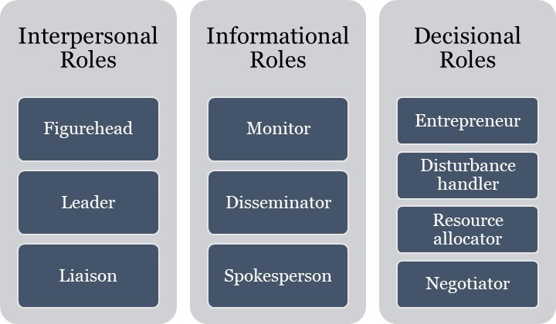
Figure 2: Mintzberg’s 10 roles of leadership
Source: (Zartler, 2016)
In the first category of leadership roles as provided by Mintzberg is the interpersonal role which is involved with providing information to the employees (Zartler, 2016). Under this role, the leader of Sainsbury works as Figurehead, where the leader has to be an authoritative person whom other employees follow (Vardarlıer, 2016). The second role of this model is the leader, where the leader leads his team to accomplish certain tasks and achieve the perceived goal of the organisation (Zartler, 2016). Further, the leader works as a liaison where the leader establishes effective communication with both internal and external contacts of the company.
The following category of a leadership role as per Mintzberg is the informational role where the leader processes information (Krzakiewicz and Cyfert, 2012). Under this role, the leader works as a monitor where the leader seeks out information associated with the company, industry and changes occurred in the business environment (Zartler, 2016). Also, the leaders of Sainsbury play the role of Disseminator and communicates useful information with the employees or his team (Vardarlıer, 2016). Further, the leader of the company plays the role of spokesperson where he represents the company and speaks for the company.
The last category of leadership role is the decisional role, where the leaders work as Entrepreneur by creating and controlling changes and opportunities for the company (Krzakiewicz and Cyfert, 2012). Another role of leaders under this category is Disturbance handler where the leader of Sainsbury tackles any obstacles occurred in the course of organisational functions and operations. The leaders of Sainsbury also play the role of Resource allocator where he makes sure that the resources of the company are allocated in such a manner which can achieve the maximum outcome (Zartler, 2016). Lastly, the leaders have to play the role of Negotiator where he negotiates with the employees, his team, or the organisations regarding performing his functions.

3.2 Variables that determine effective management and leadership in an organisation
There are several factors on which the effectiveness of management and leadership relies and those factors determines either the leadership in Sainsbury will be effective or not (Vardarlıer, 2016). The factors affecting the effectiveness of management and leadership are as follows.
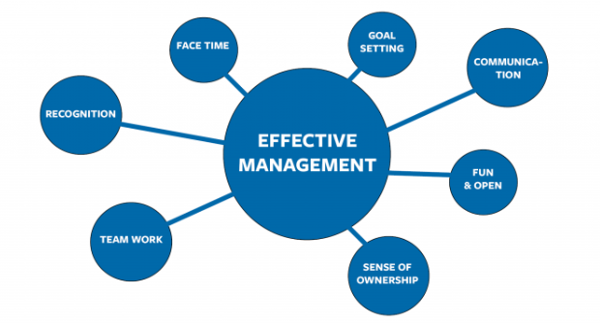
Figure 3: Factors affecting effective leadership and management
Source: (Grint, 2014)
In accordance with Daft and Lane (2015) “The effectiveness of managerial body or functions of leader relies on whether the managers or leaders are moving towards attaining the right goal or not”. Therefore, one of the major factors that affect the effectiveness of leadership is setting the right goals for the organisation. If the goal setting is not effective, regardless of maintaining all the other factors, the managerial or leadership effort will be in vain. Another factor influencing effective leadership is communication (Grint, 2014). Therefore, in order to ensure effective leadership, Sainsbury must have an effective communication system so that the vision and strategies of the organisation can be successfully communicated to all its employees. Moreover, the effectiveness of leadership is also dependent on the openness of the leaders as outlined by Vardarlıer (2016) that “Unless the leaders are not open to the employees, they will not be able to connect to the employees and so due to lack of communication and engagement the organisational will not achieve its perceived goals”. Again, the leaders are required to have sufficient control and authority over the employees so that the leader is obeyed and followed by the employees (Daft and Lane, 2015). Further, the extent of teamwork in the organisation also influence the effectiveness of leadership where strong teamwork can lead to more outcome (Grint, 2014). These are the factors on which the effectiveness of management and leadership is dependent.

4. Understanding the behavioural approach to management
In the classical approach to management, business organisations used to focus mainly on the outcome of the operations and therefore concentrated on the structure and the system only rather than employee welfare (Guleserian, 2017). Further, the research of different behavioural scientists has found that most effective outcome can be achieved by focusing on employee welfare than the system or structure as such concern of the organisation motivates the employees and enhances their performance which further contributes in generating more outcome by the operation of the company (Vardarlıer, 2016). Therefore, the behavioural approach to management mainly focuses on the relationship with the employees and their well-being. This managerial approach suggests that organisations can achieve more by keeping the employees motivated by fulfilling their needs and ensuring employee satisfaction rather than by setting tasks and demanding outcomes only (Guleserian, 2017).
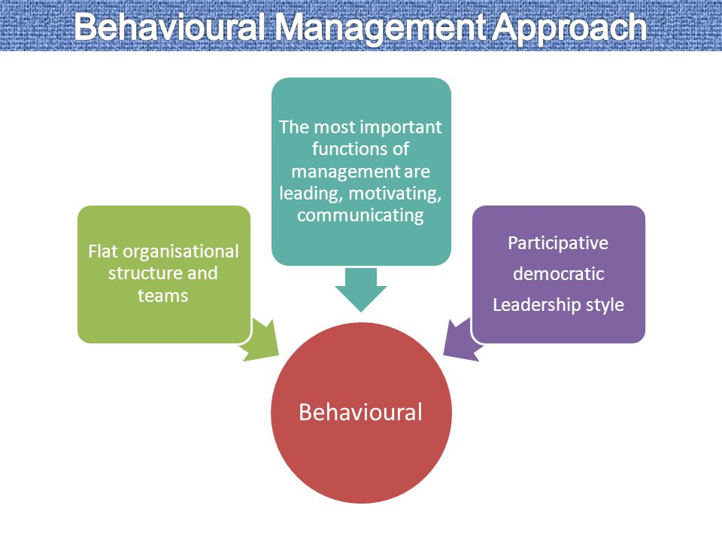
Figure 4: Behavioural Approach to Management
Source: (Guleserian, 2017)
Under the behavioural approach, organisations are suggested to have a flat organisational structure and team so that the employees can be felt valued in the organisation by making their opinion count in the operational process (Daft and Lane, 2015). Such practice highly motivates the employees and the most important function under this approach is leading and managing the employees in such a manner so that they feel motivated as the whole theory is based on the belief that motivated employees can achieve more (Vardarlıer, 2016). In this regard, this approach suggests that the organisation should adopt a participative and democratic leadership style where all the employees are involved in the operation which makes the employees more responsible and engaged with the operation and further enable the employees to perform better and contribute more in organisational productivity (Guleserian, 2017).

4.1 Factors affecting differences in individual behaviour in the organisation.
The behavioural approach of the management suggests that every individual have distinct behavioural aspects and therefore requires different treatment to be motivated (Lambert, Marler and Gueutal, 2018). Therefore, the managers and leaders must understand the behavioural aspects of every employee and also understand the factors which affect individual behaviour which is provided below.
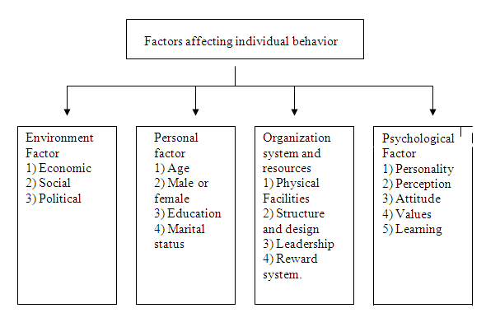
Figure 5: Factors Affecting Individual Behaviour
Source: (Lambert, Marler and Gueutal, 2018)
The first determinant factors of individual behaviour are the personal factors which comprised on the individual’s age, gender, education level, marital status and other biographic and physical characteristics (Lambert, Marler and Gueutal, 2018). Based on this personal characteristics different individuals will have different needs and wants, for instance, an employee aged 20 years cannot be motivated with the same things by which an employee aged by 60 years can be motivated. The individual behaviour is also dependent on different environmental factors around the individual including economic environment comprising employment level, wage rate etc.; social environment comprising social status of the individual, recognition etc.; and lastly by political factors comprising of the political belief of the individual, political perception and overview etc. (Vardarlıer, 2016). Moreover, individual behaviour relies on different organisational factors comprising of different facilities provided by the organisation such as healthcare facility, reward system etc. (Lambert, Marler and Gueutal, 2018). Lastly, some psychological factors determine and influence the behaviour of individual employees which includes the perception, learning, attitude, belief etc. if the employees.

5. Conclusion
Based on the above discussion made in this paper, it can be concluded that organisational structure and organisational culture has a strong correlation between each other where the organisational culture is perceived by the long practice of organisational structure and further organisational structure is influenced by organisational structure. Moreover, both organisational culture and organisational structure has potential impacts on the employees in the organisational and their performance and therefore the overall organisational performance as well.

6. References
Daft, R. and Lane, P., (2015). Leadership. Stamford: Cengage Learning.
Grint, K., (2014). Leadership, Management And Command. [Place of publication not identified]: Palgrave Macmillan.
Guleserian, B., (2017). A Cognitive—Behavioral Approach Improves Case Management Outcomes. Professional Case Management, 12(1), pp.55-59.
Janicijevic, N., (2013). The mutual impact of organizational culture and structure. Ekonomski anali, 58(198), pp.35-60.
Krzakiewicz, K. and Cyfert, S., (2012). The Role of Leaders in Managing Organisation Boundaries. Management, 16(1).
Lambert, A., Marler, J. and Gueutal, H., (2018). Individual differences: Factors affecting employee utilization of flexible work arrangements. Journal of Vocational Behavior, 73(1), pp.107-117.
Momeni, S., Zohoori, M., Musram, H. and Hosseinipour, S., (2013). RELATIONSHIP BETWEEN ORGANIZATIONAL STRUCTURE AND KNOWLEDGE SHARING CULTURE. INTERDISCIPLINARY JOURNAL OF CONTEMPORARY RESEARCH IN BUSINESS, 5(2), pp.518-524.
Vardarlıer, P., (2016). Strategic Approach to Human Resources Management During Crisis. Procedia - Social and Behavioral Sciences, 235, pp.463-472.
Yasir, M. and Majid, A., (2017). Relationship between determinants of organisational structure and knowledge sharing. International Journal of Business Excellence, 12(3), p.294.
Zartler, J., (2016). Mintzberg Model: 10 Different Roles Of A Successful Manager. [online] Medium. Available at: <https://medium.com/taskworld-blog/mintzberg-model-10-different-roles-of-a-successful-manager-77f9d87b773c> [Accessed 25 April 2020].

