Design and Hand-Coding of a Responsive Website: Rosebay Coast
Specification Report
Name: [Nafisa Anjum Athay]
Student Number: [2510700@student.uwtsd.ac.uk]
Group: 2
Course: [Introduction to Web and Database Concepts]
Date: 24 April 2026

Table of Contents
- Introduction
- Requirements
- Implementation
- Validation
- Evaluation
- Conclusion
- References
- Appendices

Introduction
This report documents the design, implementation and evaluation of Rosebay Coast, a responsive multi-page website created as a standalone coursework submission using HTML5 and CSS3. The website promotes a fictional coastal destination and was developed to demonstrate standards-based front-end development rather than reliance on a content management system, build pipeline or external framework. The decision to use a seaside leisure theme was deliberate because it creates a clear need for persuasive presentation, practical visitor information and intuitive navigation. This made it suitable for discussing both visual design and user-centred web development principles.
The main aim of the project was to produce a website that can be opened directly from the local file system by selecting index.html, while still appearing coherent, modern and usable across different screen sizes. In addition to meeting the minimum requirement of three pages, the completed website includes four connected pages: a home page, a route directory, a visitor information page and an about page. Together, these pages provide a small but realistic information architecture with clear internal linking and a consistent visual language.
This report also explains the rationale behind the design choices, describes the implementation process, summarises the validation approach and evaluates the finished website in relation to usability, accessibility and search engine optimisation. To strengthen the evaluation, the discussion refers to academic literature and compares two current live websites, GOV.UK and Argos, that illustrate contrasting approaches to large-scale web communication. The comparison of those live websites is based on pages accessed on 24 April 2026.

Requirements
The purpose of Rosebay Coast is to act as a promotional and informational website for a fictional coastal attraction. The site was designed for people planning a short leisure visit, including tourists, families, couples and casual walkers. These users are likely to want answers quickly rather than reading long uninterrupted text, so the website needed to support rapid scanning, low-friction navigation and strong visual hierarchy.
From a functional perspective, the project had several core requirements. First, the website had to contain a reasonable number of relevant pages, so a four-page structure was chosen. Second, it had to be fully responsive, meaning the layout needed to adapt to both desktop and mobile screens. Third, it had to rely only on web standards and open directly as a standalone local website. Finally, the design needed to look professional enough for academic submission while remaining realistic and easy to evaluate.
The planned site map was intentionally simple. The home page introduces the destination and its key benefits. The routes page allows users to compare walking options by difficulty, time and audience. The plan-your-visit page provides travel, facilities and accessibility information. The about page explains the project rationale and design approach. This structure supports progressive disclosure: the home page attracts attention, while the inner pages support practical decision-making.
Because the target audience includes casual and potentially first-time visitors, the content strategy focused on clarity, reassurance and consistency. Repeated navigation, short content blocks, descriptive headings, visible calls to action and predictable page structure were treated as design requirements rather than optional enhancements. In addition, accessibility and SEO were considered from the start so that the website would not only satisfy coursework requirements, but also reflect real-world front-end practice.

Implementation
The website was hand-coded using semantic HTML5 for structure and a single shared CSS3 stylesheet for presentation. This approach supported portability because all pages use relative links and local assets only. No JavaScript framework, package manager or server-side code was required. As a result, the website can be opened on another computer simply by extracting the files and launching index.html, which directly matches the submission requirement for a standalone site.
Visually, the design takes inspiration from lifestyle and travel websites. Instead of relying on a generic template, the interface uses a light pink seaside palette to give the pages a softer and more distinctive identity. Rounded panels, card layouts, shadow depth and layered gradients were used to give the site a finished visual style without depending on downloaded images. This was an efficient design decision because it reduced file complexity while still producing pages that look purposefully designed in screenshots.
The home page was structured as an entry point with a strong hero section, a short explanation of the website purpose, a benefits section and a three-step planning sequence. The routes page uses repeated cards so users can compare route length, difficulty and intended audience quickly. The visitor information page includes a semantic data table to present accessibility support clearly, while the about page provides project context. Reusing components across pages helped preserve consistency and reduced cognitive load for users who move through the site.
Responsive behaviour was implemented with CSS Grid, flexible containers and media queries. On larger screens, cards and content blocks appear in multiple columns to use space efficiently. On smaller screens, those layouts collapse into single columns to maintain readability and reduce horizontal scrolling. Navigation links become wrapped touch targets on narrow viewports, and the access table becomes horizontally scrollable when required. These choices were intended to maintain function rather than merely shrinking the same desktop layout.
Implementation also considered accessibility and maintainability. Pages use a consistent heading ladder, descriptive page titles and meta descriptions, a skip link for keyboard users, visible focus outlines and semantic structures such as nav, header, main, section, article, footer, table, caption, thead and tbody. Decorative elements were created through CSS rather than meaningless images, which avoided unnecessary alt-text noise. A single stylesheet further improves maintainability because site-wide refinements can be made in one place.
Screen captures of the completed pages were generated after the site was rendered locally in a headless browser, ensuring that the implementation section reflects the final state of the website rather than a design mock-up.
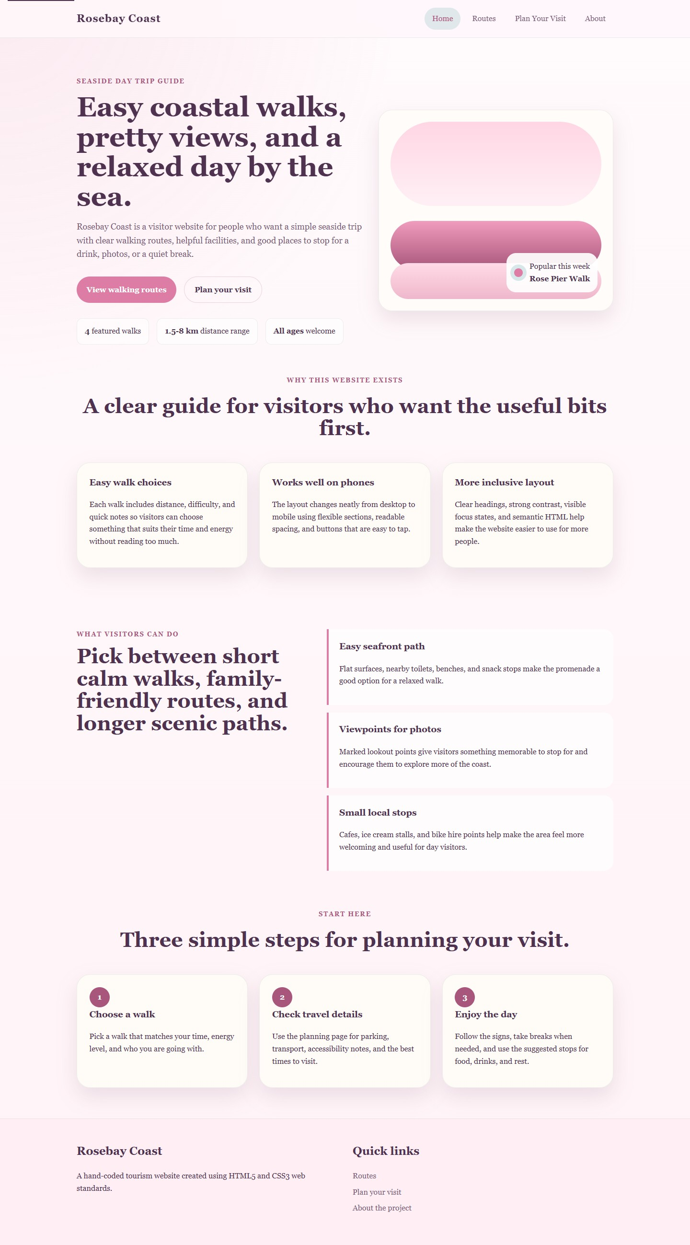
Figure 1. Home page screenshot.
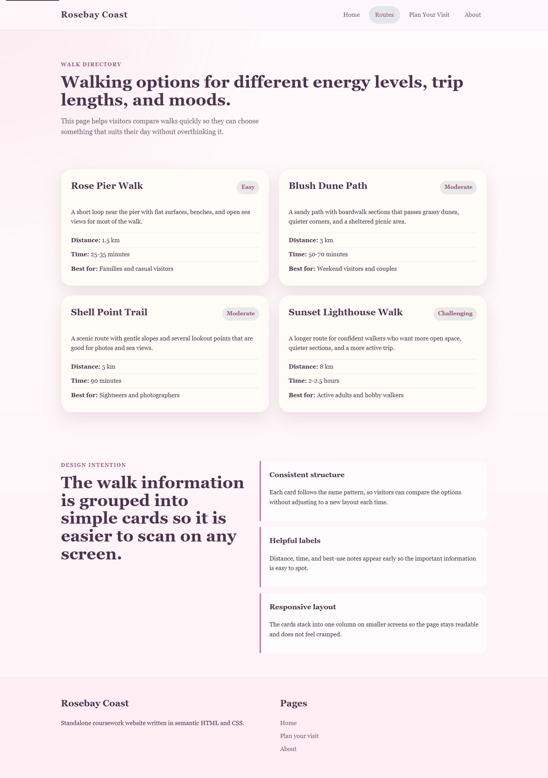
Figure 2. Routes page screenshot.
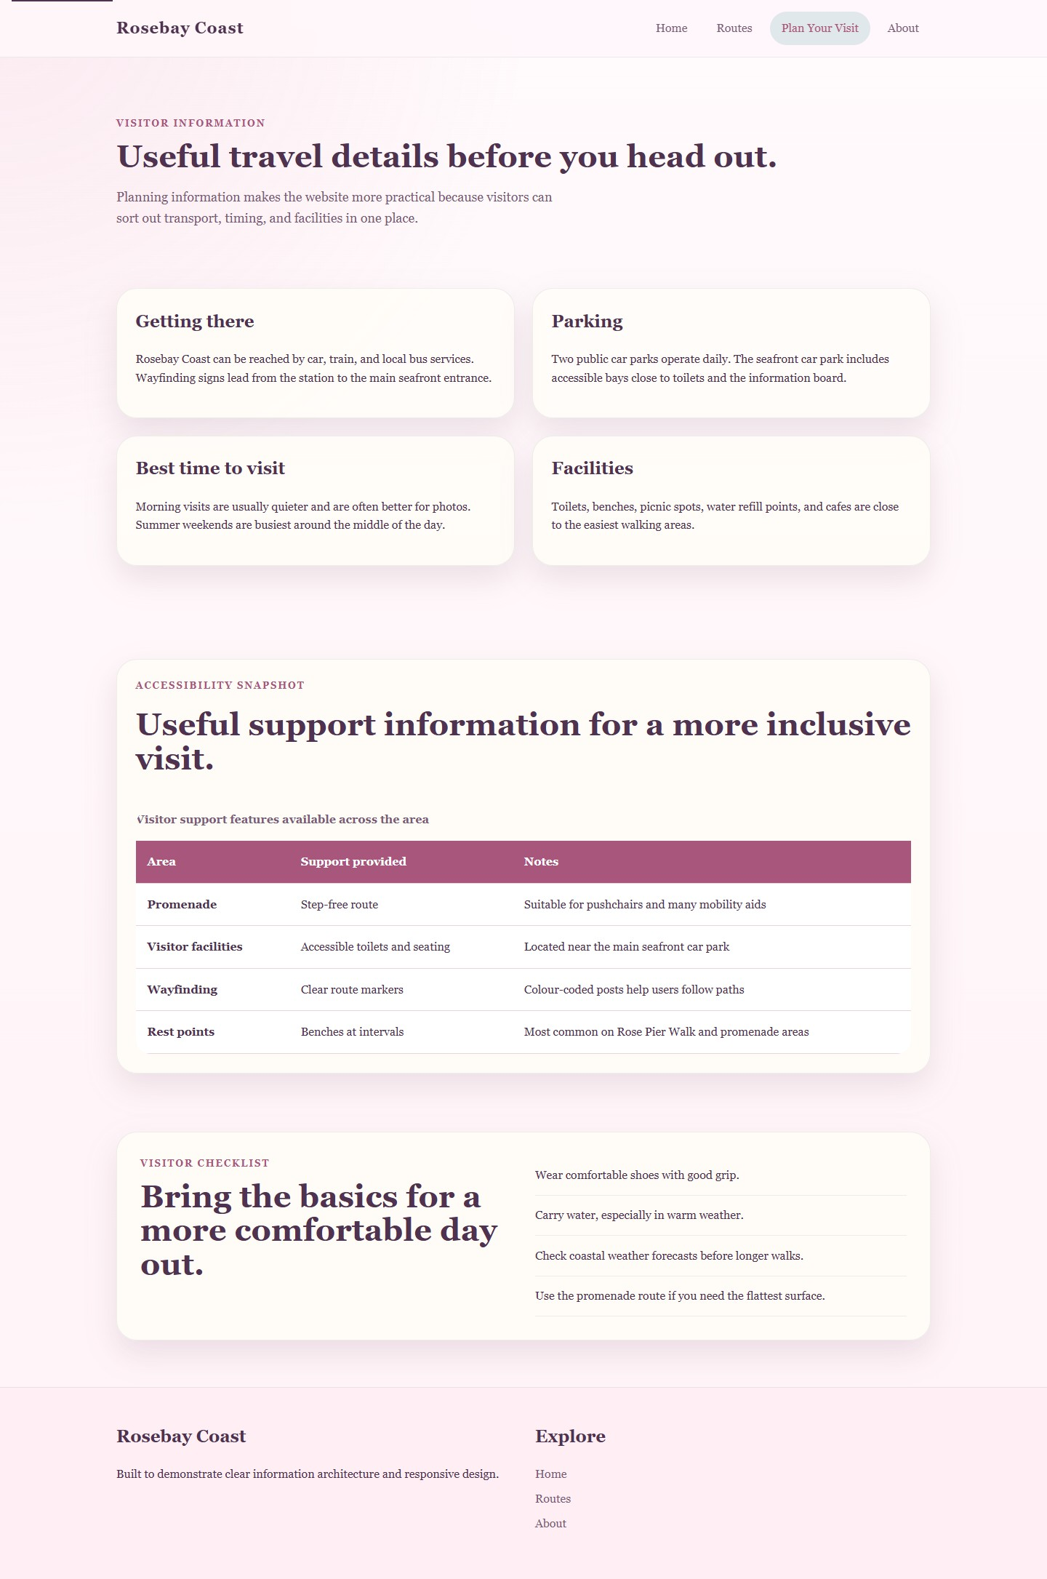
Figure 3. Plan Your Visit page screenshot.
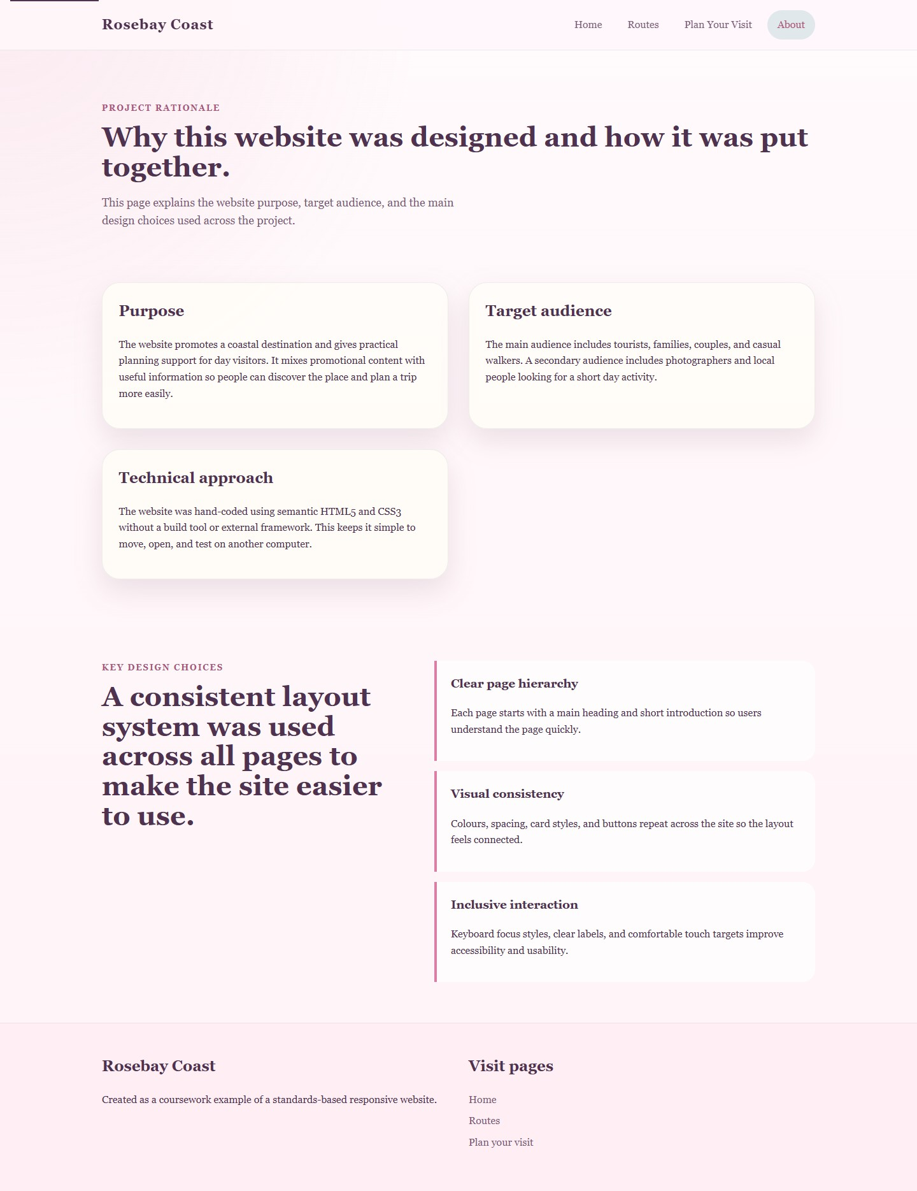
Figure 4. About page screenshot.

Validation
The assignment brief specifies validation of the home page HTML and the main CSS file. During development, the project was reviewed against W3C validation expectations and browser rendering behaviour. The index page and the shared stylesheet were checked for common syntax and standards issues including missing closing tags, duplicate structural elements, invalid nesting, absent table headers, malformed selectors and incomplete declarations. The completed files rendered without layout breakage across the generated page captures, which provided an additional practical confirmation that no major structural faults remained.
Two implementation issues were identified and corrected during development. The first was the need to ensure strong visible focus styling on interactive elements, which supports keyboard accessibility and improves perceived usability. The second was the handling of tabular content on smaller screens; the table container was adjusted so the content can scroll horizontally instead of forcing an unreadable compressed layout. These corrections were made before final export, leaving a cleaner and more robust final build.
If the files are pasted into the online W3C Markup Validation Service and W3C CSS Validation Service immediately before submission, the relevant files are ready for direct checking. The W3C Markup Validator is described as a free service that helps check the validity of web documents [6], making it an appropriate final pre-submission verification step for coursework.

Evaluation
Usability refers to how efficiently, effectively and comfortably users can achieve their goals on a website. In practical web development, usability is strongly influenced by navigation, readability, consistency, information grouping and feedback. Lee and Kozar argue that website usability should be treated as a multi-dimensional construct rather than a single vague quality, and they developed empirically validated instruments for examining those dimensions [1]. Their work is useful here because it reinforces the idea that a website should not be judged only by appearance; organisation, learnability and task support matter just as much. Similarly, a review of website design and user engagement highlights recurring usability factors such as navigation, organization, simplicity and readability [2]. These ideas influenced Rosebay Coast through its card-based structure, short sections, repeated navigation and clear calls to action.
Accessibility is the practice of making web content usable by people with a wide range of disabilities, devices and assistive technologies. W3C explains WCAG 2.1 through the four foundational principles of being perceivable, operable, understandable and robust [5]. Accessibility is therefore not a specialist add-on applied at the end of a project; it is part of good structure, inclusive interaction design and compatible code. Paul’s study of 65 Indian e-government websites found that the majority did not meet WCAG 2.1 Level A conformance, showing that accessibility problems remain common even on important public websites [3]. That finding is significant because it demonstrates why a student website should take accessibility seriously even when it is small in scale.
Search engine optimisation (SEO) refers to the design and content practices that help a website be understood and indexed by search engines. Good SEO often overlaps with good structure because descriptive titles, meaningful headings and useful content improve both discoverability and user comprehension. Álvarez-García’s study of 480 webpages examined the use of three key meta tag areas: the title tag, header tags and the meta description, showing how these elements contribute to web localisation and search visibility [4]. For this project, that evidence supports the inclusion of unique page titles, descriptive meta descriptions, clear heading structure and thematic keywords such as coastal walks, routes and visitor planning.
The finished Rosebay Coast website performs reasonably well in relation to usefulness. In terms of utility, it provides a coherent set of visitor tasks: discovering the destination, comparing walks and planning a visit. In terms of usability, the visual system is consistent, buttons are clear and page sections are easy to scan. In terms of content, the information is concise but purposeful. One future improvement would be to add a contact page or map page to deepen realism. Another would be to add light interactivity, such as route filtering, although that would need to be introduced carefully to avoid harming accessibility.
On-page SEO techniques were applied throughout the site. Each page has a unique title element, a meta description, descriptive heading structure and internal links that clarify the relationship between pages. Keyword usage remains natural rather than repetitive, which is important because search optimisation should support relevance rather than produce awkward writing. The site also uses semantic HTML, which provides clearer structure to both browsers and crawlers.
Accessibility was considered using the WCAG 2.1 POUR principles. Perceivable: headings, contrast and spacing were designed to support visual clarity, while decorative panels avoid misleading alt text. Operable: keyboard users can use a skip link, visible focus states and consistent navigation. Understandable: labels, link text and section organisation are predictable and written in plain language. Robust: semantic HTML elements and clean structural markup should improve compatibility with assistive technologies and future user agents. The site is not presented as perfectly compliant, because formal automated and manual accessibility auditing would still be needed in a production context, but the implementation does reflect the core WCAG mindset.
To place the project in a wider context, two live websites that serve broad public functions were compared: GOV.UK and Argos. GOV.UK demonstrates exceptional clarity in layout and task orientation. Its homepage foregrounds search, plain language categories and high-priority services, while also including a skip link and an explicit accessibility statement [7]. Argos, by contrast, supports a more commercial browsing model with dense navigation, category depth and promotional content [8]. In usability terms, GOV.UK is calmer and easier to scan, whereas Argos offers breadth but can feel visually crowded. In accessibility terms, GOV.UK publicly states that the site is only partially compliant and lists known issues, which shows institutional transparency [7]. Argos also publishes an accessibility statement, but that statement acknowledges problems such as links without accessible names, weak labels on some controls and difficult colour contrast in places [9]. In SEO terms, both sites use strong page titles and headings, but GOV.UK’s information architecture is more text-forward and semantically transparent, while Argos must balance SEO with commercial merchandising. In mobile responsiveness, both sites adapt for smaller screens, although GOV.UK’s simpler information structure appears less cognitively demanding than Argos’s promotion-heavy shopping interface. Overall, GOV.UK is the stronger model for this coursework because its design is more directly aligned with usability, accessibility and information clarity.

Comparison of Two Live Websites
Area | GOV.UK | Argos | Judgement
Usability | Simple homepage structure, strong se | arch visibiliVery feature-rich but much denser, wity, plain labels, | lear service categories and low visual clutter.h heavy promotional content
Accessibility | Skip link present and public accessibili | ty stat ment expl ins testing and known i | ssues.
SEO structure | Descriptive title, clear headings and to | pic-based information architecture.
Mobile friendliness | Task-oriented structure appears likely t | o remain readable and manageable on sResponsive commerce layout is availa | ble, but volummall screens.
GOV.UK is easier to scan and learn quicklydeeper cate
Accessibility statement acknowledges problems such as unlabeled links, control labeBoth disclose issues, but GOV.UK commun Strong commercial headings and categories, but merchandising density can reduceBoth use SEO conventions, but GOV.UK is
GOV.UK offers the calmer mobile experien of promotions and catego y d

Conclusion
This project demonstrates that a responsive, visually polished and standards-based website can be produced effectively using only HTML5 and CSS3. Rosebay Coast satisfies the main technical requirements of the brief by providing more than three related pages, using a consistent responsive layout and functioning as a standalone site without any development environment dependencies. The report also shows how implementation decisions can be supported by academic research and evaluated using professional criteria rather than personal opinion alone.
The final website is strongest in its consistency, readability and clear structure. Its main limitation is scale: as a coursework project, it offers a compact information set rather than the depth or interactivity of a live commercial or public service platform. However, that controlled scope also made it possible to focus on good front-end fundamentals such as semantic markup, responsive layout, accessible interaction and page-level SEO. With additional development time, the next steps would be to extend the content, run formal validator submissions, conduct user testing and carry out automated accessibility checks using tools such as WAVE or axe.

References
- Y. J. Lee and K. A. Kozar, "Understanding of website usability: Specifying and measuring constructs andtheir relationships," Decision Support Systems, vol. 52, no. 2, pp. 450-463, 2012. doi: 10.1016/j.dss.2011.10.004.
- M. B. Ryan, A. J. Sharts-Hopko and K. W. Anatchkova, "A Literature Review: Website Design and UserEngagement," Online Journal of Communication and Media Technologies, vol. 6, no. 3, pp. 1-30, 2016.
- S. Paul, "Accessibility analysis using WCAG 2.1: evidence from Indian e-government websites," UniversalAccess in the Information Society, vol. 22, pp. 663-669, 2023. doi: 10.1007/s10209-021-00861-9.
- C. Álvarez-García, "Relevance of Meta Tags and Search Engine Optimisation (SEO) Strategies in WebLocalisation," Íkala, Revista de Lenguaje y Cultura, vol. 30, no. 2, 2025. doi: 10.17533/udea.ikala.356108.
- World Wide Web Consortium, "Introduction to Understanding WCAG 2.1," W3C WAI, 2025. [Online].
Available: https://www.w3.org/WAI/WCAG21/Understanding/intro. [Accessed: 24-Apr-2026].
- World Wide Web Consortium, "About the W3C Markup Validation Service," W3C, [Online]. Available: https://validator.w3.org/about. [Accessed: 24-Apr-2026].
- Government Digital Service, "Welcome to GOV.UK" and "Accessibility statement for www.gov.uk,"
GOV.UK, [Online]. Available: https://www.gov.uk/ and https://www.gov.uk/help/accessibility. [Accessed:
24-Apr-2026].
- Argos, "Argos homepage," [Online]. Available: https://www.argos.co.uk/. [Accessed: 24-Apr-2026].
- Argos, "Accessibility Statement for Argos," [Online]. Available: https://help.argos.co.uk/help/accessibility-statement. [Accessed: 24-Apr-2026].

Appendices
Appendix A to E contain the requested HTML and CSS listings.

site/index.html
<!DOCTYPE html>
<html lang="en">
<head>
<meta charset="utf-8">
<title>Rosebay Coast | Seaside Walks, Day Trips and Coastal Views</title>
<meta name="description" content="Rosebay Coast is a responsive visitor website about seaside walks, local stops, and simple day-trip planning i
<link rel="stylesheet" href="assets/css/main.css">
</head>
<body>
<a class="skip-link" href="#main-content">Skip to content</a>
<header class="site-header">
<div class="container top-bar">
<a class="brand" href="index.html">Rosebay Coast</a>
<nav class="site-nav" aria-label="Primary">
<a aria-current="page" href="index.html">Home</a>
<a href="routes.html">Routes</a>
<a href="plan.html">Plan Your Visit</a>
<a href="about.html">About</a>
</nav>
</div>
</header>
<main id="main-content">
<section class="hero">
<div class="container hero-grid">
<div class="hero-copy">
<p class="eyebrow">Seaside day trip guide</p>
<h1>Easy coastal walks, pretty views, and a relaxed day by the sea.</h1>
<p class="lead">Rosebay Coast is a visitor website for people who want a simple seaside trip with clear walking routes, helpful faciliti
<div class="hero-actions">
<a class="button button-primary" href="routes.html">View walking routes</a> <a class="button button-secondary" href="plan.html">Plan your visit</a>
</div>
<ul class="hero-stats" aria-label="Quick highlights">
<li><strong>4</strong> featured walks</li>
<li><strong>1.5-8 km</strong> distance range</li>
<li><strong>All ages</strong> welcome</li>
</ul>
</div>
<div class="hero-card" aria-hidden="true">
<div class="card-panel sky"></div>
<div class="card-panel sea"></div>
<div class="card-panel sand"></div>
<div class="waypoint">
<span class="waypoint-pin"></span>
<div>
<p>Popular this week</p>
<strong>Rose Pier Walk</strong>
</div>
</div>
</div>
</div>
</section>
<section class="section">
<div class="container">
<div class="section-heading">
<p class="eyebrow">Why this website exists</p>
<h2>A clear guide for visitors who want the useful bits first.</h2>
</div>
<div class="feature-grid">
<article class="feature-card">
<h3>Easy walk choices</h3>
<p>Each walk includes distance, difficulty, and quick notes so visitors can choose something that suits their time and energy without
</article>
<article class="feature-card">
<h3>Works well on phones</h3> <p>The layout changes neatly from desktop to mobile using flexible sections, readable spacing, and buttons that are easy to tap.</p>
</article>
<article class="feature-card">
<h3>More inclusive layout</h3> <p>Clear headings, strong contrast, visible focus states, and semantic HTML help make the website easier to use for more people.</p>
</article>
</div>
</div>
</section>
<section class="section section-accent"> <div class="container split-layout">
<div>
<p class="eyebrow">What visitors can do</p>
<h2>Pick between short calm walks, family-friendly routes, and longer scenic paths.</h2>
</div>
<div class="checklist">
<div class="check-item">
<h3>Easy seafront path</h3> <p>Flat surfaces, nearby toilets, benches, and snack stops make the promenade a good option for a relaxed walk.</p>
</div>
<div class="check-item">
<h3>Viewpoints for photos</h3> <p>Marked lookout points give visitors something memorable to stop for and encourage them to explore more of the coast.</p>
</div>
<div class="check-item">
<h3>Small local stops</h3> <p>Cafes, ice cream stalls, and bike hire points help make the area feel more welcoming and useful for day visitors.</p>
</div>
</div>
</div>
</section>
<section class="section">
<div class="container">
<div class="section-heading">
<p class="eyebrow">Start here</p>
<h2>Three simple steps for planning your visit.</h2>
</div>
<div class="steps-grid">
<article class="step-card">
<span class="step-number">1</span>
<h3>Choose a walk</h3>
<p>Pick a walk that matches your time, energy level, and who you are going with.</p>
</article>
<article class="step-card">
<span class="step-number">2</span>
<h3>Check travel details</h3>
<p>Use the planning page for parking, transport, accessibility notes, and the best times to visit.</p>
</article>
<article class="step-card">
<span class="step-number">3</span>
<h3>Enjoy the day</h3>
<p>Follow the signs, take breaks when needed, and use the suggested stops for food, drinks, and rest.</p>
</article>
</div>
</div>
</section>
</main>
<footer class="site-footer">
<div class="container footer-grid">
<div>
<h2>Rosebay Coast</h2>
<p>A hand-coded tourism website created using HTML5 and CSS3 web standards.</p>
</div>
<div>
<h2>Quick links</h2>
<ul class="footer-links">
<li><a href="routes.html">Routes</a></li>
<li><a href="plan.html">Plan your visit</a></li>
<li><a href="about.html">About the project</a></li>
</ul>
</div>
</div>
</footer>
</body>
</html>

site/routes.html
<!DOCTYPE html>
<html lang="en">
<head>
<meta charset="utf-8">
<title>Rosebay Coast | Featured Walks</title>
<meta name="description" content="Browse Rosebay Coast walks with distance, difficulty, terrain notes, and visitor guidance.">
<link rel="stylesheet" href="assets/css/main.css">
</head>
<body>
<a class="skip-link" href="#main-content">Skip to content</a>
<header class="site-header">
<div class="container top-bar">
<a class="brand" href="index.html">Rosebay Coast</a>
<nav class="site-nav" aria-label="Primary">
<a href="index.html">Home</a>
<a aria-current="page" href="routes.html">Routes</a>
<a href="plan.html">Plan Your Visit</a>
<a href="about.html">About</a>
</nav>
</div>
</header>
<main id="main-content">
<section class="page-hero">
<div class="container">
<p class="eyebrow">Walk directory</p>
<h1>Walking options for different energy levels, trip lengths, and moods.</h1>
<p class="lead narrow">This page helps visitors compare walks quickly so they can choose something that suits their day without overthin
</div>
</section>
<section class="section">
<div class="container route-grid">
<article class="route-card">
<div class="route-header">
<h2>Rose Pier Walk</h2>
<span class="route-badge">Easy</span>
</div>
<p>A short loop near the pier with flat surfaces, benches, and open sea views for most of the walk.</p>
<ul class="route-meta">
<li><strong>Distance:</strong> 1.5 km</li>
<li><strong>Time:</strong> 25-35 minutes</li>
<li><strong>Best for:</strong> Families and casual visitors</li>
</ul>
</article>
<article class="route-card">
<div class="route-header">
<h2>Blush Dune Path</h2>
<span class="route-badge">Moderate</span>
</div>
<p>A sandy path with boardwalk sections that passes grassy dunes, quieter corners, and a sheltered picnic area.</p>
<ul class="route-meta">
<li><strong>Distance:</strong> 3 km</li>
<li><strong>Time:</strong> 50-70 minutes</li>
<li><strong>Best for:</strong> Weekend visitors and couples</li>
</ul>
</article>
<article class="route-card">
<div class="route-header">
<h2>Shell Point Trail</h2>
<span class="route-badge">Moderate</span>
</div> <p>A scenic route with gentle slopes and several lookout points that are good for photos and sea views.</p>
<ul class="route-meta">
<li><strong>Distance:</strong> 5 km</li>
<li><strong>Time:</strong> 90 minutes</li> <li><strong>Best for:</strong> Sightseers and photographers</li>
</ul>
</article>
<article class="route-card">
<div class="route-header">
<h2>Sunset Lighthouse Walk</h2> <span class="route-badge">Challenging</span>
</div> <p>A longer route for confident walkers who want more open space, quieter sections, and a more active trip.</p>
<ul class="route-meta">
<li><strong>Distance:</strong> 8 km</li>
<li><strong>Time:</strong> 2-2.5 hours</li>
<li><strong>Best for:</strong> Active adults and hobby walkers</li>
</ul>
</article>
</div>
</section>
<section class="section section-accent"> <div class="container split-layout">
<div>
<p class="eyebrow">Design intention</p>
<h2>The walk information is grouped into simple cards so it is easier to scan on any screen.</h2>
</div>
<div class="checklist">
<div class="check-item">
<h3>Consistent structure</h3> <p>Each card follows the same pattern, so visitors can compare the options without adjusting to a new layout each time.</p>
</div>
<div class="check-item">
<h3>Helpful labels</h3>
<p>Distance, time, and best-use notes appear early so the important information is easy to spot.</p>
</div>
<div class="check-item">
<h3>Responsive layout</h3>
<p>The cards stack into one column on smaller screens so the page stays readable and does not feel cramped.</p>
</div>
</div>
</div>
</section>
</main>
<footer class="site-footer">
<div class="container footer-grid">
<div>
<h2>Rosebay Coast</h2>
<p>Standalone coursework website written in semantic HTML and CSS.</p>
</div>
<div>
<h2>Pages</h2>
<ul class="footer-links">
<li><a href="index.html">Home</a></li>
<li><a href="plan.html">Plan your visit</a></li>
<li><a href="about.html">About</a></li>
</ul>
</div>
</div>
</footer>
</body>
</html>

site/plan.html
<!DOCTYPE html>
<html lang="en">
<head>
<meta charset="utf-8">
<title>Rosebay Coast | Plan Your Visit</title>
<meta name="description" content="Plan a visit to Rosebay Coast with travel advice, accessibility notes, seasonal tips, and local facilities.">
<link rel="stylesheet" href="assets/css/main.css">
</head>
<body>
<a class="skip-link" href="#main-content">Skip to content</a>
<header class="site-header">
<div class="container top-bar">
<a class="brand" href="index.html">Rosebay Coast</a>
<nav class="site-nav" aria-label="Primary">
<a href="index.html">Home</a>
<a href="routes.html">Routes</a>
<a aria-current="page" href="plan.html">Plan Your Visit</a>
<a href="about.html">About</a>
</nav>
</div>
</header>
<main id="main-content">
<section class="page-hero">
<div class="container">
<p class="eyebrow">Visitor information</p>
<h1>Useful travel details before you head out.</h1>
<p class="lead narrow">Planning information makes the website more practical because visitors can sort out transport, timing, and facili
</div>
</section>
<section class="section">
<div class="container info-grid">
<article class="info-card">
<h2>Getting there</h2>
<p>Rosebay Coast can be reached by car, train, and local bus services. Wayfinding signs lead from the station to the main seafront entra
</article>
<article class="info-card">
<h2>Parking</h2>
<p>Two public car parks operate daily. The seafront car park includes accessible bays close to toilets and the information board.</p>
</article>
<article class="info-card">
<h2>Best time to visit</h2>
<p>Morning visits are usually quieter and are often better for photos. Summer weekends are busiest around the middle of the day.</p>
</article>
<article class="info-card">
<h2>Facilities</h2>
<p>Toilets, benches, picnic spots, water refill points, and cafes are close to the easiest walking areas.</p>
</article>
</div>
</section>
<section class="section section-accent">
<div class="container table-wrap">
<div class="section-heading left-align">
<p class="eyebrow">Accessibility snapshot</p>
<h2>Useful support information for a more inclusive visit.</h2>
</div>
<table class="access-table">
<caption>Visitor support features available across the area</caption>
<thead>
<tr>
<th scope="col">Area</th> <th scope="col">Support provided</th> <th scope="col">Notes</th>
</tr>
</thead>
<tbody>
<tr>
<th scope="row">Promenade</th>
<td>Step-free route</td> <td>Suitable for pushchairs and many mobility aids</td>
</tr>
<tr>
<th scope="row">Visitor facilities</th>
<td>Accessible toilets and seating</td>
<td>Located near the main seafront car park</td>
</tr>
<tr>
<th scope="row">Wayfinding</th>
<td>Clear route markers</td>
<td>Colour-coded posts help users follow paths</td>
</tr>
<tr>
<th scope="row">Rest points</th>
<td>Benches at intervals</td> <td>Most common on Rose Pier Walk and promenade areas</td>
</tr>
</tbody>
</table>
</div>
</section>
<section class="section"> <div class="container tips-panel">
<div>
<p class="eyebrow">Visitor checklist</p>
<h2>Bring the basics for a more comfortable day out.</h2>
</div>
<ul class="tips-list">
<li>Wear comfortable shoes with good grip.</li>
<li>Carry water, especially in warm weather.</li>
<li>Check coastal weather forecasts before longer walks.</li>
<li>Use the promenade route if you need the flattest surface.</li>
</ul>
</div>
</section>
</main>
<footer class="site-footer">
<div class="container footer-grid">
<div>
<h2>Rosebay Coast</h2>
<p>Built to demonstrate clear information architecture and responsive design.</p>
</div>
<div>
<h2>Explore</h2>
<ul class="footer-links">
<li><a href="index.html">Home</a></li>
<li><a href="routes.html">Routes</a></li>
<li><a href="about.html">About</a></li>
</ul>
</div>
</div>
</footer>
</body>
</html>

site/about.html
<!DOCTYPE html>
<html lang="en">
<head>
<meta charset="utf-8">
<title>Rosebay Coast | About This Website</title>
<meta name="description" content="Learn about the purpose, target audience, and design approach used to create the Rosebay Coast coursework webs
<link rel="stylesheet" href="assets/css/main.css">
</head>
<body>
<a class="skip-link" href="#main-content">Skip to content</a>
<header class="site-header">
<div class="container top-bar">
<a class="brand" href="index.html">Rosebay Coast</a>
<nav class="site-nav" aria-label="Primary">
<a href="index.html">Home</a>
<a href="routes.html">Routes</a>
<a href="plan.html">Plan Your Visit</a>
<a aria-current="page" href="about.html">About</a>
</nav>
</div>
</header>
<main id="main-content">
<section class="page-hero">
<div class="container">
<p class="eyebrow">Project rationale</p>
<h1>Why this website was designed and how it was put together.</h1>
<p class="lead narrow">This page explains the website purpose, target audience, and the main design choices used across the project.</p>
</div>
</section>
<section class="section">
<div class="container prose-grid">
<article class="prose-card">
<h2>Purpose</h2>
<p>The website promotes a coastal destination and gives practical planning support for day visitors. It mixes promotional content with u
</article>
<article class="prose-card">
<h2>Target audience</h2>
<p>The main audience includes tourists, families, couples, and casual walkers. A secondary audience includes photographers and local peo
</article>
<article class="prose-card">
<h2>Technical approach</h2>
<p>The website was hand-coded using semantic HTML5 and CSS3 without a build tool or external framework. This keeps it simple to move, op
</article>
</div>
</section>
<section class="section section-accent">
<div class="container split-layout">
<div>
<p class="eyebrow">Key design choices</p>
<h2>A consistent layout system was used across all pages to make the site easier to use.</h2>
</div>
<div class="checklist">
<div class="check-item">
<h3>Clear page hierarchy</h3>
<p>Each page starts with a main heading and short introduction so users understand the page quickly.</p>
</div>
<div class="check-item">
<h3>Visual consistency</h3> <p>Colours, spacing, card styles, and buttons repeat across the site so the layout feels connected.</p>
</div>
<div class="check-item">
<h3>Inclusive interaction</h3> <p>Keyboard focus styles, clear labels, and comfortable touch targets improve accessibility and usability.</p>
</div>
</div>
</div>
</section>
</main>
<footer class="site-footer">
<div class="container footer-grid">
<div>
<h2>Rosebay Coast</h2> <p>Created as a coursework example of a standards-based responsive website.</p>
</div>
<div>
<h2>Visit pages</h2>
<ul class="footer-links">
<li><a href="index.html">Home</a></li>
<li><a href="routes.html">Routes</a></li> <li><a href="plan.html">Plan your visit</a></li>
</ul>
</div>
</div>
</footer>
</body>
</html>

site/assets/css/main.css
:root {
--bg: #fff3f7;
--surface: #fff9fb;
--surface-strong: #fde7ef;
--ink: #4f3250;
--muted: #7a5c77;
--line: #ebd3dc;
--accent: #dd7ca4;
--accent-deep: #a8567b;
--sand: #f1c5d6;
--warm: #fff0f4;
--shadow: 0 18px 40px rgba(120, 78, 106, 0.14);
--radius-lg: 28px;
--radius-md: 20px;
--radius-sm: 12px;
}
*,
*::before, *::after { box-sizing: border-box; }
html { scroll-behavior: smooth; }
body { margin: 0; font-family: Georgia, "Times New Roman", serif; color: var(--ink); background:
radial-gradient(circle at top left, rgba(221, 124, 164, 0.12), transparent 28%), linear-gradient(180deg, #fffafc 0%, var(--bg) 100%); line-height: 1.6; }
img { max-width: 100%; display: block; }
a { color: inherit; }
.skip-link { position: absolute; left: 1rem; top: -3rem; background: var(--ink); color: #fff; padding: 0.75rem 1rem; z-index: 100; }
.skip-link:focus { top: 1rem; }
.container {
width: min(1120px, calc(100% - 2rem)); margin: 0 auto; }
.site-header { position: sticky; top: 0; z-index: 20; backdrop-filter: blur(14px); background: rgba(255, 247, 250, 0.88); border-bottom: 1px solid rgba(25, 50, 60, 0.08); }
.top-bar { display: flex; align-items: center; justify-content: space-between; gap: 1rem; padding: 1rem 0; }
.brand { font-size: 1.4rem; font-weight: 700; letter-spacing: 0.03em; text-decoration: none; }
.site-nav { display: flex; flex-wrap: wrap; gap: 0.5rem; }
.site-nav a { padding: 0.65rem 1rem; border-radius: 999px; text-decoration: none;

color: var(--muted); }
.site-nav a[aria-current="page"],
.site-nav a:hover, .site-nav a:focus-visible { background: rgba(10, 124, 134, 0.12); color: var(--accent-deep); }
.hero, .page-hero { padding: 5rem 0 3rem; }
.hero-grid,
.split-layout,
.prose-grid, .footer-grid { display: grid; gap: 2rem; }
.hero-grid { grid-template-columns: 1.1fr 0.9fr; align-items: center; }
.hero-copy h1,
.page-hero h1,
.section-heading h2,
.split-layout h2, .tips-panel h2 { margin: 0 0 1rem; line-height: 1.08; font-size: clamp(2.2rem, 4vw, 4.3rem); }
.page-hero h1,
.section-heading h2,
.split-layout h2, .tips-panel h2 { font-size: clamp(1.9rem, 3vw, 3rem); }
.eyebrow { margin: 0 0 0.75rem; text-transform: uppercase; letter-spacing: 0.14em; font-size: 0.82rem; color: var(--accent-deep); font-weight: 700; }
.lead { font-size: 1.12rem; color: var(--muted); max-width: 62ch; }
.narrow { max-width: 55ch; }
.hero-actions { display: flex; flex-wrap: wrap; gap: 1rem; margin: 2rem 0; }
.button { display: inline-flex; align-items: center; justify-content: center; min-height: 48px; padding: 0.85rem 1.3rem; border-radius: 999px; text-decoration: none; font-weight: 700; }
.button-primary { background: var(--accent); color: #fff; }
.button-secondary { background: transparent; border: 1px solid var(--line); }
.button:hover,
.button:focus-visible,
.site-nav a:focus-visible, .footer-links a:focus-visible { outline: 3px solid rgba(10, 124, 134, 0.35); outline-offset: 2px; }
.hero-stats,
.route-meta,
.footer-links, .tips-list { padding: 0; margin: 0; list-style: none; }
.hero-stats { display: flex; flex-wrap: wrap; gap: 1rem; }
.hero-stats li { background: rgba(255, 255, 255, 0.6); border: 1px solid rgba(25, 50, 60, 0.08); padding: 0.85rem 1rem; border-radius: var(--radius-sm); }
.hero-card,
.feature-card,
.step-card,
.route-card,
.info-card,
.prose-card,
.tips-panel, .table-wrap { background: rgba(255, 253, 248, 0.88); border: 1px solid rgba(25, 50, 60, 0.08); border-radius: var(--radius-lg); box-shadow: var(--shadow); }
.hero-card { min-height: 420px; padding: 1.5rem; position: relative; overflow: hidden; }
.card-panel { border-radius: 999px; position: absolute; }
.sky { inset: 1.5rem 1.5rem auto 1.5rem; height: 42%; background: linear-gradient(180deg, #ffd6e4, #fff0f5); }
.sea { inset: auto 1.5rem 5.4rem 1.5rem; height: 24%; background: linear-gradient(180deg, #f09cbe, #a8567b); }
.sand { inset: auto 1.5rem 1.5rem 1.5rem; height: 18%; background: linear-gradient(180deg, #ffdbe7, #efb7cb); }
.waypoint { position: absolute; right: 2rem; bottom: 2.4rem; display: flex; gap: 0.85rem; align-items: center; padding: 0.95rem 1rem; background: rgba(255, 255, 255, 0.92); border-radius: var(--radius-md); max-width: 240px; }
.waypoint p, .waypoint strong { margin: 0; }
.waypoint-pin { width: 18px; height: 18px; border-radius: 50%; background: var(--accent); box-shadow: 0 0 0 8px rgba(10, 124, 134, 0.16); }
.section { padding: 1rem 0 4rem; }
.section-accent { padding: 4rem 0; }
.section-heading { display: grid; gap: 0.5rem; margin-bottom: 2rem; text-align: center; }
.left-align { text-align: left; }
.feature-grid,
.steps-grid,
.route-grid, .info-grid { display: grid; gap: 1.5rem; }
.feature-grid { grid-template-columns: repeat(3, minmax(0, 1fr)); }
.steps-grid { grid-template-columns: repeat(3, minmax(0, 1fr)); }
.route-grid { grid-template-columns: repeat(2, minmax(0, 1fr)); }
.info-grid,
.prose-grid, .footer-grid { grid-template-columns: repeat(2, minmax(0, 1fr)); }
.feature-card,
.step-card,
.route-card,
.info-card, .prose-card { padding: 1.6rem; }
.step-number { display: inline-grid; place-items: center; width: 42px; height: 42px; border-radius: 50%; background: var(--accent-deep); color: #fff; font-weight: 700; }
.split-layout { grid-template-columns: 0.9fr 1.1fr; align-items: start; }
.checklist { display: grid; gap: 1rem; }
.check-item { padding: 1.3rem 1.4rem; background: rgba(255, 255, 255, 0.72); border-left: 4px solid var(--accent); border-radius: 0 var(--radius-md) var(--radius-md) 0; }
.check-item h3,
.feature-card h3,
.route-card h2,
.info-card h2,
.prose-card h2,
.step-card h3,
.tips-panel h2, .site-footer h2 { margin-top: 0; }
.route-header { display: flex; gap: 1rem; align-items: baseline; justify-content: space-between; }
.route-badge { padding: 0.35rem 0.75rem; border-radius: 999px; background: rgba(15, 82, 87, 0.1); color: var(--accent-deep); font-size: 0.92rem; font-weight: 700; }
.route-meta li { padding: 0.35rem 0; border-top: 1px solid rgba(25, 50, 60, 0.08); }
.table-wrap {
padding: 1.6rem; }
.access-table { width: 100%; border-collapse: collapse; overflow: hidden; border-radius: var(--radius-md); background: #fff; }
.access-table caption { text-align: left; padding: 0 0 1rem; color: var(--muted); font-weight: 700; }
.access-table th, .access-table td { padding: 1rem; border-bottom: 1px solid var(--line); text-align: left; vertical-align: middle; }
.access-table thead th { background: var(--accent-deep); color: #fff; }
.tips-panel { display: grid; grid-template-columns: 1fr 1fr; gap: 2rem; padding: 2rem; }
.tips-list li { padding: 0.9rem 0; border-bottom: 1px solid rgba(25, 50, 60, 0.08); }
.site-footer { padding: 3rem 0 4rem; background: #ffeef4; border-top: 1px solid rgba(25, 50, 60, 0.08); }
.footer-links li + li { margin-top: 0.5rem; }
.footer-links a { text-decoration: none; color: var(--muted); }
@media (max-width: 900px) {
.hero-grid,
.split-layout,
.feature-grid,
.steps-grid,
.route-grid,
.info-grid, .prose-grid, .footer-grid, .tips-panel { grid-template-columns: 1fr; }
.hero { padding-top: 3rem; }
.hero-card { min-height: 320px; }
}
@media (max-width: 640px) { .top-bar { flex-direction: column; align-items: flex-start; }
.site-nav { width: 100%; }
.site-nav a { flex: 1 1 42%; text-align: center; }
.hero-copy h1,
.page-hero h1,
.section-heading h2,
.split-layout h2, .tips-panel h2 { font-size: clamp(1.8rem, 8vw, 2.4rem);
}
.waypoint { left: 1.5rem; right: 1.5rem; bottom: 1.5rem; max-width: none; }
.access-table { display: block; overflow-x: auto; }
}

