
APPENDIX GA36d

LEVEL 7 ASSESSMENT SPECIFICATION

Student name: | Hollie Davies. | Student ID number: | 1400771
Programme: | Secondary PGCE
Module: | Investigating Contemporary Issues in Secondary Education
Module code: | ECSP7001 | Contribution to Overall Module Assessment (%): | 100%
Lecturer: | Shân Samuel-Thomas | Internal Verifier:
Assignment Title: | Investigating Contemporary Issues in Secondary Education | Word count (or equivalent): | 5,000 words
Submission deadline: | January 28th 2019 | Return date of provisional marks & written feedback: | February 19th 2019
Submission method: | All written assessments, where practical and possible, must be submitted via Turnitin unless otherwise instructed by the Lecturer. (Please DO NOT put this assessment specification into Turnitin or it will match many similarities with other students’ submissions.)  Alternative submission method (if applicable):  Late submission of the assessment will result in a late penalty mark. Penalties for late submission: Up to one week late, maximum mark of 50%. Over one week late, 0%. Only the Extenuating Circumstances Panel may approve a change to submission dates.
Academic honesty / referencing: | Academic honesty is required. In the main body of your submission you must give credit to authors on whose research and ideas your work is based. Append to your submission a reference list that indicates the books, articles, etc. that you have used, cited or quoted in order to complete this assessment.

Module Learning Outcomes
(from module syllabus)
Upon successful completion of this module, students should be able to:
- Critically evaluate current priorities identified by the Welsh Government and the Estyn inspectorate along with their arrangements to secure change;
- Demonstrate an advanced critical ability to reflect upon, discuss and critique the impact of contemporary priorities and initiatives on whole school/college organisation and development processes;
- Critically examine processes adopted by schools to identify areas for development along with the role of Estyn in supporting change and strategic planning procedures to secure improvements in learning and teaching;
- Demonstrate a systematic, creative and comprehensive knowledge and understanding of school improvement processes driven by contemporary issues to support improvements in standards of teaching and learning;
- Critically review research evidence showing sound judgment of complex data to support pedagogic decisions;

TASK DESCRIPTION

ASSESSMENT
Prepare a paper for school governors which explores critically a school initiative or system that is identified in the school / college action plan (This could include a school improvement plan, a departmental improvement plan or a recent ESTYN inspection report) Include a well referenced, evidence based action plan of next steps on the area of focus.
Some of the areas which are likely to be included in the Departmental Improvement Plan could be the development of strategies within a subject area to:
- Embed aspects of literacy, e.g. extended writing;
- Further develop numeracy;
- Strengthen the use of Welsh in lessons;
- Improve planning for the inclusion of Y Cwricwlwm Cymreig within schemes of work
- Develop subject based strategies to respond to the poverty agenda;
- Prepare for the implementation of the Donaldson curriculum;
- Improve the inclusion of Assessment for Learning within lessons.

Details of Assignment:
This assignment is to be carried out during PTE 1 and consists of a paper prepared for a board of governors within a school or college.

The word count for this assignment is 5000 words

Recommended structure:

Your paper should include:

- A clear introduction to explain the context of the topic you will be discussing and why it is important;
- An overview of your school or college’s Departmental Improvement Plan;
- A thorough explanation of how the topic you have chosen from the Departmental Improvement Plan relates to the whole School (College) Improvement Plan (SIP);
- A critical review of why the role of strategic planning to secure improvement is important, along with clear references to professional and academic research to support your stance;
- A critical evaluation of what literature and key research notes about your particular topic along with suitable references;
- An in-depth critical analysis of evidence which notes why work within the topic you have decided to focus on needs to be improved, e.g. Estyn inspection reports, a departmental review, Key Stage data, external examination results, etc.;
- A detailed critical review of how your school/college is responding, i.e. what are they doing to improve, what new strategies have been put into place and how does this link with key literature and research?
- A critical analysis of the progress made to date along with examples of learners’ work, where appropriate;
- Explain how this relates to what the literature/key research says;
- Next steps – what actions would you recommend to drive this initiative further and why?
- References.
- Appendices – e.g. Departmental School (college) Improvement Plan, whole School (college) Improvement Plan, examples of leaners’ work, images, etc.

GUIDANCE FOR Students IN THE COMPLETION OF TASKS

NOTE: The guidance offered below is linked to the five generic assessment criteria overleaf.

- Engagement with Literature Skills
Your work must be informed and supported by scholarly material that is relevant to and focused on the task(s) set; you should make use of scholarly reviews and primary sources, as appropriate (for example, refereed research articles and/or original materials appropriate to the discipline). You should provide evidence that you have accessed a wide range of sources, which may be academic, governmental and industrial; these sources may include academic journal articles, textbooks, current news articles, organisational documents, and websites. You should consider the credibility of your sources; academic journals are normally highly credible sources while websites require careful consideration/selection and should be used sparingly. Any sources you use should be current and up-to-date, mostly published within the last five years or so, though seminal/important works in the field may be older. You must provide evidence of your research/own reading throughout your work, using correctly a suitable referencing system, including in-text citations in the main body of your work and a reference list at the end of your work.

- Knowledge and Understanding Skills
At level 7, you should be able to demonstrate a systematic understanding of knowledge, and a critical awareness of current problems and/or new insights, much of which is at, or informed by, the forefront of your academic discipline, field of study or area of professional practice, with a comprehensive understanding of techniques applicable to your own research or advanced scholarship. Your work must demonstrate your growing mastery of these concepts, principles, current challenges, innovation and insights associated with the subject area. Knowledge relates to the facts, information and skills you have acquired through your learning. You demonstrate your understanding by interpreting the meaning of the facts and information (knowledge). This means that you need to select and include in your work the contemporary concepts, techniques, models, theories, etc. appropriate to the task(s) set. You should be able to explain the theories, concepts, etc. meaningfully to show your understanding. Your mark/grade will also depend upon the extent to which you demonstrate your knowledge and understanding; ideally each should be complete and detailed, with comprehensive coverage.

- Cognitive and Intellectual Skills
You should be able to: evaluate critically current research and advanced scholarship in the discipline; evaluate methodologies and develop critiques of them and, where appropriate, to propose new hypotheses; deal with complex issues both systematically and creatively to make sound judgements in the absence of complete data. Your work must contain evidence of logical, analytical thinking, evaluation and synthesis. For example, to examine and break information down into parts, make inferences, compile, compare and contrast information. This means not just describing what! But also justifying: Why? How? When? Who? Where? At what cost? At all times, you must provide justification for your arguments and judgements. Evidence that you have reflected upon the ideas of experts within the subject area is crucial to you providing a reasoned and informed debate within your work. Your choice of methodologies to gather data and information must be rigorously defended. Furthermore, you should provide evidence that you are able to make sound judgements and convincing arguments using data and concepts. Sound, valid, persuasive conclusions are necessary and must be derived from the content of your work. Where relevant, alternative solutions and recommendations may be proposed.

- Practical Skills
At level 7, you should be able to demonstrate originality in the application of knowledge, together with a practical understanding of how established techniques of research and enquiry are used to create and interpret knowledge in the discipline. This includes acting autonomously in planning and implementing tasks at a professional or equivalent level, originality in tackling and solving problems, and decision-making in complex and unpredictable contexts or situations.

You should be able to demonstrate mastery of the leading edge subject-related concepts and ideas as they relate to real world situations and/or particular contexts. How do they work in practice? You will deploy models, methods, techniques, and/or theories, in those contexts or circumstances, to assess current situations, perhaps to formulate plans or plausible, justifiable recommendations to solve problems, or to propose new models, or to create artefacts, which may be innovative and creative, thereby demonstrating your understanding of how the boundaries of knowledge are advanced through research and/or application. This is likely to involve, for instance, the use of real world artefacts, examples and cases, the application of a model within an organisation and/or benchmarking one theory or organisation against others.

- Transferable Skills for Life and Professional Practice
Your work must provide evidence of the qualities and transferable skills necessary for postgraduate-level employment in circumstances requiring sound judgement, personal responsibility and initiative in complex and unpredictable professional environments. This includes demonstrating: the independent learning ability for continuing professional development to advance existing skills and acquire new competences of a professional nature that will enable you to assume significant responsibility within organisations; that you can initiate and complete tasks, projects and procedures, whether individually and/or collaboratively, to a professional level; that you can use appropriate media to effectively communicate information, arguments and analysis in a variety of forms for a variety of audiences; fluency of expression; clarity and effectiveness in presentation and organisation. Work should be coherent and well-structured in presentation and organisation.

Student FEEDBACK FORM

This section details the extent to which the assessment criteria are demonstrated by you, which in turn determines your mark. The marks available for each category of skill are shown. Lecturers will use the space provided to comment on the achievement of the task(s), including those areas in which you have performed well and areas that would benefit from development/improvement.

Generic Assessment Criteria | Marks available | Marks  awarded
1. Engagement with Literature Skills
.
2. Knowledge and Understanding Skills

3. Cognitive and Intellectual Skills

4. Practical Application Skills

5. Transferable Skills for Life and Professional Practice

Assessment Mark (Assessment marks are subject to ratification at the Exam Board. These comments and marks are to give feedback on module work and are for guidance only until they are confirmed. ) | Late Submission Penalties (tick if appropriate) |  | %
 | Up to 1 week late (50% Max) |  | %
 | Over 1 week late (0%) |  | %

GENERIC ASSESSMENT CRITERIA

Level 7
In accordance with the Framework for Higher Education Qualifications, at the end of Level 7 students should be able to demonstrate: a systematic understanding of knowledge, and a critical awareness of current problems and/or new insights, much of which is at, or informed by, the forefront of their academic discipline or area of professional practice; a comprehensive understanding of techniques applicable to their own research or advanced scholarship; originality in the application of knowledge, together with a practical understanding of how established techniques of research and enquiry are used to create and interpret knowledge in the discipline; conceptual understanding that enables the student to evaluate critically current research and advanced scholarship in the discipline to evaluate methodologies and develop critiques of them and, where appropriate, to propose new hypotheses. They will be able to deal with complex issues both systematically and creatively, make sound judgements in the absence of complete data, and communicate their conclusions clearly to specialist and non-specialist audiences. They will demonstrate self-direction and originality in tackling and solving problems, and act autonomously in planning and implementing tasks at a professional or equivalent level to continue to advance their knowledge and understanding, and to develop new skills to a high level. They the qualities and transferable skills necessary for employment requiring the exercise of initiative and personal responsibility; decision-making in complex and unpredictable situations/professional environments; and the independent learning ability required for continuing professional development.

Level 7 | FAIL | MARGINAL FAIL | SATISFACTORY  (Pass) | GOOD | VERY GOOD | EXCELLENT
Category | F | E | D | C | B | A
Engagement with literature (including current research, referencing,  academic conventions and  academic honesty) | Poor engagement with essential reading. No evidence of wider reading. Reliance on inappropriate sources, and/or indiscriminate use of sources. Heavily reliant on information gained through class contact. Inconsistent and weak use of referencing. | Engagement with a very limited range of relevant and credible sources. Some omissions and minor errors.  Referencing conventions evident though not always applied accurately or consistently. | Engagement with an appropriate range of research-informed literature, including sources retrieved independently. Some over-reliance on texts. Referencing may show minor inaccuracies or inconsistencies. | Engagement with a wide range of research-informed literature, including sources retrieved independently.  Selection of relevant and credible sources. Very good use of referencing, with no/very few inaccuracies or inconsistencies. | Engagement with an extensive range of relevant and credible literature, informed by the latest research. Consistently accurate application of referencing. | Exceptional engagement with an extensive range of relevant and credible literature, informed by the latest research. High-level referencing skills consistently and professionally applied.

Knowledge and understanding (A systematic, conceptual understanding of knowledge, and a critical awareness of current problems and/or new insights, much of which is at, or informed by, the forefront of the discipline; a comprehensive understanding of techniques applicable to their own research) | Gaps in knowledge, with only superficial systematic understanding. Some significant inaccuracies and/or irrelevant material. No critical awareness of current problems, insights, or latest research within the discipline. | Limited knowledge and systematic understanding of the concepts and principles within the subject area, which to some marginal extent, is informed by current research and scholarship. Some critical awareness of current problems and/or new insights, but often under-developed. | Knowledge is accurate and reasonably detailed. A systematic understanding of the field of study informed by, to some extent, current research and scholarship, A critical awareness of current problems and/or new insights though this may be under-developed occasionally. | Knowledge has a well-defined focus, which is reasonably extensive, coherent and detailed, with a critical awareness of current problems and/or new insights. Exhibits good understanding of the breadth and depth of contemporary and established views, and the work is, at least in part, well-informed by current research and scholarship. | Excellent mastery of a complex and specialised area of knowledge. A systematic, excellent understanding of the concepts of the subject informed by current research and scholarship. Highly critical awareness of current problems and/or new insights. A critical, awareness of how the boundaries of knowledge are advanced through research. | Exceptional mastery of a complex and specialised area of knowledge. An exceptionally critical awareness of current problems and/or new insights. An outstanding understanding of the concepts of the subject, well-informed by current research and scholarship. A critical, sophisticated and nuanced awareness of how the boundaries of knowledge are advanced through research.
Cognitive and intellectual skills  (Critical evaluation of current research and methodologies and develop critiques of them and, where appropriate, to propose new hypotheses; make sound judgements in the absence of complete data.) | Largely descriptive work, with superficial use of critical evaluation of research and methodologies. Absent or weak development of hypotheses and judgements. Information accepted uncritically, uses generalised statements made with scant evidence and unsubstantiated opinions. Ideas sometimes illogical and contradictory. | Limited attempt at critical evaluation/ critique of current research and methodologies, tending towards description.  Limited attempt to propose new hypotheses. Can deal with complex issues but not systematically or creatively. Some evidence to support emerging judgements but these may be underdeveloped or with a little inconsistency / mis-interpretation.  May assert rather than argue a case. | Some critical evaluation/ critique of current research and methodologies, though slightly underdeveloped in places, Proposes adequate but limited new hypotheses, where relevant. Can deal with complex issues but not fully systematically or creatively. Ability to make judgements based on data (that may be incomplete) but with some tendency to assert/state opinion rather than argue on the basis of reason and evidence. | Sound critical evaluation/ critique of current research and methodologies, Proposes new hypotheses, where appropriate. Can deal with complex issues systematically and with some creativity. Ability to make sound judgements based on data (that may be incomplete) | Excellent critical evaluation/ critique of current research and methodologies, Proposes innovative hypotheses, where appropriate. Can synthesise complex issues systematically and creatively. Ability to investigate contradictory or incomplete information and make strong, persuasive, arguments and sophisticated judgements. | Exceptional critical evaluation/ critique of current research and methodologies, Proposes innovative hypotheses, where appropriate. Exemplary systematic and creative synthesis of complex issues.  Ability to investigate contradictory or incomplete information and make strong, persuasive, arguments and sophisticated, nuanced, judgements. Potential for journal publication or doctoral research.
Practical skills  (Originality / creativity in the application of knowledge, tools and techniques and in tackling and solving problems in complex and unpredictable professional situations; practical use of established techniques of research and enquiry to create and interpret knowledge in the discipline.) | Rudimentary application of methods, materials, tools and/or techniques but without consideration and competence. Flawed appreciation of the context of the application.  Weak understanding of the application of theory to practice, with only occasional evidence of making appropriate links between the two. Weak problem-solving skills in complex and unpredictable contexts. | An awareness and mostly appropriate application of well-established methods, materials, tools and/or techniques, with occasional errors.  Basic appreciation of the context of the application. Theoretical knowledge and understanding applied in practice, but not always making logical links between the two.  Can identify problems and propose basic solutions without fully appreciating the complexity of unpredictable contexts. | An appropriate application of standard methods, materials, tools and/or techniques.  Clear appreciation of the context of the application. Mainly consistent, accurate and logical application of theory to practice, making appropriate links between the two.  Can identify problems and propose mostly appropriate solutions in complex and unpredictable contexts, with elements of originality. | A very good application of a range of methods, materials, tools and/or techniques.  Very good consideration of the context of the application, with perceptive insights. Can identify problems and propose appropriate solutions in complex and unpredictable contexts.  Evidence of originality and creativity. | An advanced application of knowledge, methods, materials, tools and/or techniques.  The context of the application is well considered, and insightful.  Can identify complex problems and propose excellent solutions. An excellent grasp of techniques applicable to own research or advanced scholarship.  Shows originality in application of knowledge and techniques, and of how established techniques of enquiry create and interpret knowledge in the discipline. | Exceptional application skills in complex, unpredictable, contexts, drawing skilfully on the latest research within the discipline. Can identify complex problems and propose sophisticated, original solutions.  An outstanding application of techniques applicable to own research or advanced scholarship.  Shows originality in application of knowledge and techniques, and of how established techniques of enquiry create and interpret knowledge in the discipline with assimilation and development of cutting edge processes and techniques.

Transferable skills for life and professional practice  (Exercise of self-direction, autonomy and personal responsibility; plan and implement tasks at a professional level; independent learning; use appropriate media to communicate effectively and professionally to a variety of audiences; fluency of expression; systematic approach; clarity and effectiveness in presentation and organisation.) | Communication medium is poorly designed and/or not suitable for the audience.  Work is poorly presented in a disjointed manner. It is loosely, and at times incoherently, structured, with information and ideas often poorly expressed. Weak use of language and/or inappropriate style. Weak independent initiative (or collaboration, if relevant). Limited evidence of the skills required in professional, postgraduate employment. | Can communicate in a suitable medium but with some room for improvement.  Mostly ordered presentation and structure in which relevant ideas / concepts are reasonably expressed. Work may lack coherence in places. Can work as part of a team, but with limited involvement in group activities.  Demonstrates some but not all of the basic skills required in professional, postgraduate employment, with some areas of minor weakness. | Can communicate effectively in a suitable format, but may have minor errors.  Mostly coherent, organised work, in a suitable structure and is for the most part clearly expressed. Can work effectively independently and/or as part of a team, with clear contribution to group activities.  Demonstrates the skills required in professional, postgraduate employment, with some areas of strength and some of minor weakness. | Can communicate well, confidently and consistently in a suitable format.  Work is coherent, fluent, well-structured and organised. Can work very well autonomously and/or as part of a team, with a good contribution to group activities.  Demonstrates comprehensive professional, postgraduate employment skills. | Can communicate professionally confidently and consistently in a suitable format.  Work is coherent, very fluent and is presented professionally. Can work autonomously with initiative. Where relevant can work professionally within a team, showing leadership skills as appropriate, managing conflict and meeting obligations. Demonstrates excellent professional, postgraduate employment skills and a strong appetite for further development. | Can communicate with an exceptionally high level of professionalism.  Work is remarkably coherent, very fluent and is presented professionally. Can work outstandingly well and professionally within a team, showing advanced leadership skills. Demonstrates exemplary professional, postgraduate employment skills and a strong appetite for further development.

A pivotal approach.
It is well known to a majority that negative behaviour has always, and will continue to be a challenging part of work within the Secondary of learning. At School X a ‘pivotal’ approach towards ensuring the implementation of Qualified Teacher Status Standard 3.4 which focuses on creating a calm and purposeful learning environment is taken (The Qualified Teacher Standards, Wales 2009). This pivotal approach will be discussed as part of the School’s development plan throughout the course of this piece as well as to what it aims to achieve regarding the outcomes for both students and staff alike. As part of this essay School X’s pivotal approach to behaviour management will be critically evaluated when aiming to ensure constant progression so that the school’s maximum potential is reached.
There are many features that are needed according to Estyn, the Welsh Education inspection board, in order for a school and its day to day management being classed as ‘excellent’. (Estyn, 2016). According to Estyn there are 5 most important areas that need to be monitored and inspected on a regular and recurring basis. (Estyn, 2016). Categorised using the letters ‘IA’ meaning inspection areas a Common Inspection Report (Estyn, 2016) is put in place generically for all schools. The areas of inspection are therefore as follows; IA1- Standards, IA2-Wellbeing and attitudes to learning, IA3-Teaching and learning experiences, IA4-Care, Support and Guidance and IA5- Leadership and management. These areas are then ranked depending on performance in each area from Excellent, Good, Adequate and Unsatisfactory. (Estyn, 2016). As part of School X’s most recent inspection, despite performing excellently across all 5 areas (School X Inspection Report, 2015) there is still a day to day struggle away from the inspection, and included in this is the ability and focus upon managing behaviour. As part of School X’s development plan for 2018/2019 one of the highlighted aspects of the projects is to focus on the pivotal approach that is therefore titling this piece.
The role of strategic planning is a purposeful one throughout schools as it allows the culmination of ideas and a shared vision to be omitted as part of the schools progression goals as well as ethos (Middlewood and Lumby, 2010 P.18). Teaching in Wales is of course of an inclusive nature to the highest of qualities throughout all schools in the twenty-first century (OECD, 2018 P.2). It could be said that strategic planning in some senses is needed more to ensure progress and development within the secondary sector, as in order for a strategic plan to emerge collaboration across departments and the whole school in genera must first take place(OECD, 2018 P.11). It is therefore the purpose of this piece to highlight how strategic planning leads to an overarching goal being implemented and over time completed. This is not to say that strategic planning is always effective and possible, a school has many areas of organisation that need to be addressed. In order for a School and Department development plan to succeed a ‘razor sharp focus must be placed on implementation’ (Tracy, 2012 P.28).
It is clear that within education equality is now ensured for all within schools (Education Wales, 2017, P.3) although this does only mean it is only done teachers. All adults within the secondary sector, from parents with children in local communities attending schools, in the same way, governors and external entities must be aware of what’s happening within school environments in order to provide the best possible succession in schools (Fidler, 2002 P.3). Estyn categorised that last year out of twenty seven schools half of sectors monitored in the Secondary environment are categorised as ‘good’ with a sixth being categorised in their areas as ‘excellent’ (Estyn Annual Report, 2018, P.38). It is also clear that through implementation of future measures like the Donaldson Curriculum by 2021 (Donaldson, 2018) that standards will be as difficult as ever to attain the best results for all schools. In order for School X to succeed in the future of their school life, as part of many meetings and staff training sessions in which it has been mentioned and highlighted, a sense of collaboration and shared progressive goals for every aspect and area of improvement must be acknowledged by everyone involved, and is again therefore why this piece is being shared with you.
Strategic planning in itself must not just be another required form that is filled out and then put away for the remainder of the school year. Instead, strategic planning must be a continually focus as part of the schools constant development and goals. This means that strategy must come into the way those in the secondary sector plan and think, leading ultimately to the making of strategic decisions (Fidler, P.12). If something is not emitting the sought results, perhaps revaluation should occur rather than trying to force it to work. Therefore, evaluation should also take place as part of the strategic planning process in order to ‘make a valid choice a number of possible strategic options should be formulated’ (Fidler, P.18), Implementation only occurs after approval (Sybouts, 1992) so all aspects considered in regards to this piece will be valid but must be managed in order to succeed in their aims. (Fidler, p.19).
School X has highlighted various areas of improvement as part of their personal School Development Plan. Included in this is; aims, objectives, activities, resources, costs and success criterion and seek to establish unified approach to improving standards in various contexts. Combined and formulated by members of staff at the school, each project seeks to therefore improve outcomes through better target setting and performance monitoring. (Wilkins, 2016). The first SDP project aims to reduce the attainment gap for boys with additional learning needs. Its objectives include enabling students within this context to reach level 2 and 3 threshold. Secondly, Key performance indicators and the desired focus on particularly STEM subjects is an important aspect of which pupils, parents and governors alike are being made aware of as part of the SDP. Furthermore, the enhancement of Welsh and bilingualism through development of strategies to ensure evident incidental Welsh has also been made a focus across daily working areas of the school (Curriculum and Assessment Authority for Wales, 2003). Additionally as part of the SDP is to develop areas of literacy, including reading writing and oracy and embed the best strategies across the curriculum after evaluations (Welsh Government, 2014). As well as this, progression by reporting has been highlighted as part of the School X’s SDP as it has been made clear that pupils should know what is expected of them and that effort and attainment should be acknowledged. (Dean, Hubbel, Pitler and Stone, 2012 P.21). Partnership as part of the year 6 transitional period has also been made a focus as part of School X’s personal development. Positive speakers are used on behalf of the school in order to encourage independent and resilient learners and learning alike with appropriate pedagogical approaches to accompany as part of the partnerships presented for this period. More Able and Talented or ‘MAT’ students have also been a target for objectives seeking to enthuse self-confidence and to develop subject knowledge to build upon attaining accreditation for a National Challenge award (Nace.co.uk, 2018). Development on the whole of the curriculum does not happen solely through teachers as previously mentioned learners and stakeholders also play a vital role of consultation and is therefore again highlighted in the SDP for School X. Another point ensues that staff and pupil wellbeing is enhanced as part of the school day supported by consistency and progress teams are another aspect of the SDP along with a knowledge by all of what is meant by outstanding teaching and learning in order to ensure the best results possible throughout the context of the school. Digital competency has also been pinpointed in the school development portfolio and thus therefore all staff must be equipped as well as the correct facilities provided in order to access digital resources (Welsh Government, 2016). The final points as part of the SDP include opportunities for staff growth in terms of one that addresses leadership potential. Finally as part of School X’s SDP is the implementation of the positive behaviour system or ‘pivotal approach’, which refers back to the purpose of this piece.
As well as a whole school improvement plan, A departmental improvement plan or ‘DIP’ is also put in place in order to try and ensure progression across all classrooms in terms of department. In the same way the SDP is used the Departmental Improvement Plan seeks to create a unified vision with shared objectives in order for measureable progress occur departmentally (Gitlow, 2001 P.181). School X’s DIP includes support for students at Key Stage 4 in order to achieve their global grades as well as personal targets for example through the continuance of excellent teaching and learning. This extends towards A Level or Key Stage 5 in School X which has a sixth form that allows Religious Studies as an option. As well as this, included in the DIP is the influence of the Estyn Thematic approach (Estyn, 2017) and aims to highlight the interconnectedness that applied to learning. (Meier, Knoester, D’Angela. 2015 P.28).Similarly as acknowledged as part of the whole School Improvement Plan, the implementation of the Digital Competence Framework within the key stage 3 areas of learning in order to ensure that lifelong skills and learning are factors are instilled within the entire curriculum of School X as modernity continues to influence the curriculum and what needs to be taught, then learned by students. The conclusion of School X’s social studies development plan includes building schemes of learning that allow for accreditation at Key Stage 4. It is therefore not a departmental issue that is being over seen as part of this piece. But again something the entire work force must commit too (Bush and Coleman, 2000 P.7-8).
The pivotal approach adopted was introduced to me as part of bridging week at School X before I was even aware that my first placement as part of my Post Graduate Certificate in Education would be situated here. The emphasis upon the promoting positive behaviour shone through the entirety of all that was demonstrated. This was again emphasised further as part of my induction and welcome to School X. The head of this pivotal movement at School X has also hosted a personal and additional session on the pivotal approach adopted at the school. It has been thoroughly explained how at School X how a ‘PIP’ and ‘RIP’ approach, which are abbreviations for ‘Praise in public’ and ‘Reprimand in private’ has been taken across the entirety of the school. (Pivotal Education, 2019). The basis of this approach is adapted based on the works of Paul Dix who has influenced measurable change to behaviour, relationships and learning since 2001. (Pivotal Education, 2019). The purpose of the approach is to highlight the fact that individuals are diverse, with no exception being within the context of schools. This therefore means the learning, progress and ultimately behaviour of students will be differentiated dependant on the individuals. (Pivotal Education, 2019). The ways in which this strategy is used steers away from the usual punitive approach that has been focused upon throughout the course of history within the context of education, maybe a change could be needed in order to ensure students development in all areas. (Smith, Fisher and Fray, 2015 P.6). As told by Dix himself ‘the only behaviour we can control completely is our own’ (Pivotal Education, 2018 1:06) and therefore punishing others for behaviours unlike our own should not be discounted, but managed effectively. In order to do this as part of the Pivotal approach, pinpointed instead of the disruptive behaviour is the positive behaviour and the examples provided by individuals in order to establish expectations for all students (Dix, 2017 P.13). In this way, what is expected is highlighted and praised for all to see. In contrast the negative or disruptive behaviourisms are focused upon only between the adult hosting and the child misbehaving, rather than the entirety of the class being disrupted. This then relates to ‘five pillars of pivotal practise’ (Behaviour Management Resource Bank, 2019).
The five pillars of pivotal practise are the foundation of motivations and solutions for classroom behaviour and management. And as previously mentioned, when dealing with behaviour, recognised as the first pillar is calm and consistent adult behaviour and control as teachers. (Pivotal Education, 2019) .We are the adults of course and should have the self-control that we expect students to have and set clear, strong examples. The second pillar distributes first attention to best conduct. This means that we as adults and staff members are enthusiastic about our school days and presenting again the acknowledgement of the positive behaviour and encouragement of this (Pivotal Education, 2019). The second pillar also recognises how positivity must also be accompanied by assertiveness for example, when dealing with behaviour the negatives should be removed and rather the focus shifted to what is expected, not what has been done (Pivotal Education, 2019). This is said to be based on the fact that behaviour will never be able to have a complete and permanent fix (Morgan and Ellis, 2011 P.9) but rather behaviour must be seen as part of the learning process. (O’Brien, 2012 P.4). This links vital pedagogical approaches such as meeting such QTS standards, for example in this sense 2.7 which acknowledges the strategies that are needed in order to promote positive behaviour (The Qualified Teacher Status Standards, 2008 2.7) as well as knowing how mutual trust and respect built between students and teachers can enhance these presented and demonstrated strategies. (The Qualified Teacher Status Standards, 2008 1.2). All these factors must be considered when attempting to manage behaviour in the classroom and is why the focus of this piece has and will be the pivotal approach to behaviour management at School X as well as in other school contexts. Furthermore, the third pillar of pivotal practise put in place is relentless routine (Paul Dix, 2017). Students know when entering a classroom to remove their bags and coats, get all their equipment out and should stand behind their chair whilst the register is being taken. As this approach was only put in place last year, observations have demonstrated that year seven now do this naturally as they have been introduced to this routine since their induction to the school. In contrast, year eleven sometimes have to be reminded of the required behaviour that should be demonstrated by the entirety of the class. Proving the influence this approach can have when established correctly. The fourth pillar deals with the scripting of difficult conversations. School X lays out their scripted conversations as follows; ‘I have noticed that’, ‘I need you too’ and ‘I know you can do this/you are better than this/thanks for listening’. The aim of the scripted conversation if to be able to demonstrate consistency and equality (Pivotal Education, 2018) with the messages supplied to the students demonstrating off-task behaviour. The final pillar of the foundations of the pivotal approach is a restorative follow up. The purpose of restorative practise is to ensure that all negative thoughts and feelings towards previous situation (Pivotal Education, 2018). This could be in terms of mending relationships between friendship groups and classmates but also if a student feels hostile towards a teacher after possible misbehaviour or misunderstanding. In such cases of mediation between teacher and student, another staff member must be present to ensure nothing escalates the situation that is already present and possible dangerous to be a part of.
The pivotal approach adheres to the 95% of learners that are eager to please and ready to learn, rather than the additional 5% that might need alternate approaches to learning in order for them to succeed (Pivotal Approach, 2018 2:40). This again is highlighted further as part of Pivotal whereby the underlying factors are the basis of respect and safety for everyone straying away from ‘us and them’ demonstrated throughout the course of education. (Pivotal Approach 2018, 2008 2:50). The outcomes of the pivotal approach therefore lead to less detentions whilst allowing the individual to address their own behaviour personally before a structured restorative conversations are used as part of restorative practise. This has been proven and is currently in practise across a thousand schools in the United Kingdom. Behaviour management on the whole will never be easy or simple and as with everything in regards to the world of adolescence, the manoeuvres we must make have to constantly adapt in order to suit our situations and scenarios accordingly. An interesting way this has been put is ‘everyone is looking for the missing piece of their jigsaw, the problem is everybody’s jigsaw is unique’ (Derrington and Goddard, 2008 P.9). It is therefore recognised as part of this quotation that classroom and individual events are unpredictable (Ming-tak and Wai-shing, 2008 P.11) and in order for an individual to be in control, consistent expectations must be laid out for success (Stronge, 2007 P.46). In order to do this, a teacher must consider if pupils are willing to work and in order to influence their engagement, creative exciting material must be supplied (Ellis, Morgan and Reid, 2013 P.76) and can be the difference between an outstanding or adequate lesson. Additionally, home-school relations can play a key role when attempting to manage behaviour. (Ellis, Morgan and Reid, 2013) although as highlighted throughout the course and entirety of this piece, this is again not always the case. Especially when parents are not involved as maybe sought (Miller, 2003 P.99). The purpose of the Pivotal approach despite the constant flotation of the behaviour management aspect of schooling, aims to reward those that abide by the rules and therefore is recognising the students who behave correctly, rather than supplying infamy to the disruptors within a classroom scenario.
There is always room for improvement within the context of the secondary sector. Sometimes things could seem as if they are going completely to plan until the very last moment. Behaviour management improvement could be given through focus upon a unified approach, identified as part of the pivotal approach and in School X’s behaviour policy is the process of being; respectful, ready and safe (School X behaviour policy, 2018). This is posted across classrooms and hallways at School X and I have observed many lessons where these words have been emphasised, including usage of the words myself. Going forward this is continually highlighted, with a weekly reminder in the form of mention in briefings and by colleagues alike. And again, the policy regards the expectations for all staff as demonstrative role models of positive behaviour (School X behaviour policy, 2018). It is extremely important through adaptation of this approach that a unified and consistent message is shared. This does not mean though that this is always possible. An example of this was in a form class where all but three students had their personal planners signed. The result meant that students were asked again individually. Some the next did had achieved their target and were rewarded with positive praise for the whole class to see. The remaining pupils were again reprimanded in private and this time it was said that if the necessary task was not completed, that another staff member would have to be involved. The following morning students were asked again if they had their planners signed. At this stage the majority of the class had achieved what was sought by the teacher, although there were still two students who had not yet acknowledged that they were not ready to learn without the communicative aspect with parents. It was explained again of the importance privately and a last chance was given but had no impact. The final step of the process meant that the assigned teacher was encouraged to contact the parent themselves to ensure the completion of the task. Although this caused a negative reaction on the students part and the relationship between the students and teacher needed repairing. This meant that a conversation was mediated and a compromise was agreed in order for the same occurrences not to be repeated in future circumstances. Demonstrated here is an escalated response to behaviour management which is adopted and again outlined throughout the context of the school that acknowledges restorative practise (School X behaviour policy). E.g. In departmental emails and meetings. Furthermore, there are also expectations included for governors as well as visitors (School X behaviour policy, 2018). It is important to mention here again not only the inclusive nature of School X but the importance of co-operation as part of all involved in the school. The graduated response should be based on severity and sometimes is not appropriate for minor sanctions (School X behaviour policy, 2018). There are now only variations of misdemeanours that could cause a pupil exclusion, these are based on policies targeting; Aims and ethos, child protection, safeguarding, anti-bullying, complaints, attendance, accessibility, E-safety, acceptable use, uniform, equal opportunities, substance misuse and offensive weapons and use of restraint and reasonable force. Exclusion takes place only in the most extreme circumstances, and students would always be sought for part time exclusion rather than permanently removing a student from the entirety of their education (School X behaviour policy).
There are initiatives put in place in order for students to be encouraged to follow the behaviour policy of School X. Positive praise is given as often as possible in the forms of postcards home, verbal praise, subject achievement awards, house assemblies and annual presentation evenings (School X behaviour policy). But this again does not necessarily ensure behaviour can always be managed this way. For example, throughout the context of the school it has been demonstrated that year sevens will respond more positively to post cards being sent home to reward good behaviour than year ten would. This is because at this stage of adolescence the focus is on social status rather than personal achievements (Hillier, Thompson and Thompson, P.200). A way of combatting this at School X is factoring in other positive opportunities for pupils, for example in year eleven, the chance to attend prom.
The pivotal approach is not in any way an easy fix. It takes constant mindfulness of one’s own behaviour before any change will be seen in students behaviour as first you should be able to practise what you preach by becoming the required role model intended, internally and externally for all to see (Beadle and Murpy, 2013 P.2, P.35). However it is a model that ensures both staff and students progression alike, whilst learning alongside one another the ideal ways to behave. For example what is not expected is also outlined as part of the pivotal approach to education, adults involved in the life of the school would never expect to be seen shouting at, humiliating, being negative about, or showing aggression towards students (School X behaviour policy). But as human beings this can sometimes in itself be a challenge when our emotions get the better of us. So again the pivotal approach must be seen as a focused, progressive journey for all involved.
At School X the short term goals are put in place in order to equate to the long term goals and future of the school. School X aims to ensure the constant growth of not only the learners in classrooms is that make up daily life of the school, but also influence all surrounding all member of staff alike. By having an ‘attention to best conduct first’ (Pivotal Education, 2018) rule in place, staff become more flexible in terms of allowing themselves to adopt their focus upon the positives demonstrated making up the majority of the class. This in itself could be seen as a process of strategic planning in order to shift focus from negativity to positivity. As a result of the implementation of the Pivotal approach adopted by School X disruptive behaviour had been minimised more than it has in the past. Students are reminded constantly of examples of their good behaviour and as a result they try to continue their behaviour which has proved effective in multiple cases. Additionally, those within the teaching profession should always evaluate the situation presented to them and apply repercussions accordingly as previously mentioned.
In conclusion, throughout the course of this piece it has been outlined and evaluation has taken place in regards to the role and purpose of strategic planning as part of School X. As well as this, the purpose of strategic planning in terms of department has been highlighted in regards to the uncertainties of the future (Fidler, 2002 P.19). But what has also been discussed as part of the entirety of this piece is how behaviour will never be able to be solved. This is in terms of overnight and in the distant future. So this piece is not to say that the implementation of the pivotal approach will solve behaviour issues all together throughout the entirety of all schools in existence. Although what it does allow is for students to recognise themselves how they are presenting themselves to the world, and what it means to be a well-rounded person by regulating their own behaviourisms. This approach would be best suited for a school that attempts to apply a unified and respectful outlook in terms of all individuals to gather the best experience possible and potential through all areas of the school, focusing on the constant future progression for those that will learn lessons that will stay with them for the rest of their lives whilst being a part of School X.

References.
- Annual Report 2017-2018. (2019). Wales: ESTYN.
- Beadle, P. and Murphy, J. (2013). Why are you shouting at us?. London: Bloomsbury Pub.
- Bush, T. and Coleman, M. (2002). Leadership and strategic management in education. London: Paul Chapman Publishing.
- Dean, C., Pitler, H., Hubbell, E. and Stone, B. (2012). Classroom Instruction that Works: Research-Based Strategies forIncreasing Student Achievement. Second Edition. 2nd ed. United States of America: McREL.
- Dix, P. (n.d.). When the adults change, everything changes. Great Britain.
- Donaldson, G. (2018). Successful Futures. Independent Review of Curriculum and Assessment Authority.
- Education in Wales our National Mission. (2017). [PDF] Wales: Welsh Government, p.3. Available at: https://beta.gov.wales/sites/default/files/publications/2018-03/education-in-wales-our-national-mission.pdf [Accessed 17 Jan. 2019].
- Ellis, G., Morgan, N. and Reid, K. (2013). Better behaviour through home-school relations. London: Routledge.
- Estyn report on School X.
- Estyn.gov.wales. (2019). Common inspection framework | Estyn. [online] Available at: https://www.estyn.gov.wales/inspection/inspection-explained/common-inspection-framework [Accessed 17 Jan. 2019].
- Estyn.gov.wales. (2019). Inspection explained | Estyn. [online] Available at: https://www.estyn.gov.wales/inspection/inspection-explained [Accessed 17 Jan. 2019].
- Fidler, B. (2002). Strategic management for school development. London: Sage.
- Gitlow, H. (2001). Quality management systems. Boca Raton, Fla.: St. Lucie Press.
- Hillier, Y. and Thompson, A. (2007). Readings in post-compulsory education. London: Continuum.
- Lumby, J. and Middlewood, D. (2010). Strategic management in schools and colleges. Los Angeles: Sage.
- Mai-Tak, H. and Wai-Shing, L. (2008). Classroom Management: Creating a positive learning environment. Honk Kong: Honk Kong University Press.
- Meier, D., Noester, M. and D'Andrea, K. (2015). Teaching in themes. New York: Teachers College press.
- Miller, A. (2003). Teachers, parents and classroom behaviour. Maidenhead: Open University Press.
- Nace.co.uk. (2019). www.nace.co.uk |. [online] Available at: http://www.nace.co.uk/ [Accessed 18 Jan. 2019].
- Nectar.northampton.ac.uk. (2008). Whole-Brain Behaviour Management in the Classroom: Every Piece of the Puzzle - NECTAR. [online] Available at: http://nectar.northampton.ac.uk/1453/ [Accessed 17 Jan. 2019].
- Pivotal Education. (2018). About Us - Pivotal Education. [online] Available at: https://pivotaleducation.com/about-us/ [Accessed 17 Jan. 2019].
- Pivotal Education. (2018). Behaviour Management Resources. [online] Available at: https://pivotaleducation.com/classroom-behaviour-management/resource-bank/ [Accessed 26 Jan. 2019].
- Pivotal Education. (2019). Managing positively and reducing exclusion. [online] Available at: https://pivotaleducation.com/classroom-behaviour-management/resource-bank/pillar-2-first-attention-to-best-conduct/managing-positively-and-reducing-exclusion-2/ [Accessed 17 Jan. 2019].
- Pivotal Education. (2018). Pivotal Behaviour Management Training Packages. [online] Available at: https://pivotaleducation.com/staff-behaviour-training/ [Accessed 17 Jan. 2019].
- Pivotal Education. (2018). The Pivotal Approach to Behaviour Management - Pivotal Education. [online] Available at: https://pivotaleducation.com/about/behaviour-management/ [Accessed 17 Jan. 2019].
- Pivotal Education. (2018). Transform Behaviour - Pivotal Education. [online] Available at: https://pivotaleducation.com/ [Accessed 17 Jan. 2019].
- Qualifications and Curriculum Assessment authority for Wales. (2013) Wales. Welsh Government.
- School X behaviour policy (2018).
- Smith, D., Fisher, D. and Fray, N. (2015). Restorative practise for positive classroom management. Alexandria: ASCD.
- Stronge, J. (2007). Qualities of effective teachers. Alexandria: Association for Supervision and Curriculum Development.
- Strategic Education Governance. (2018). [PDF] p.11. Available at: http://www.oecd.org/education/ceri/SEG-Project-Plan-org-framework.pdf [Accessed 17 Jan. 2019].
- Sybouts, W. (1992). Planning in school administration. New York: Greenwood Press.
- Ten tips for equity in education. (2018). [PDF] Policy Brief, p.2. Available at: https://www.oecd.org/education/school/39989494.pdf [Accessed 17 Jan. 2019].
- Thematic approach to learning. (2017). [PDF] Wales: Welsh Government. Available at: https://www.estyn.gov.wales/thematic-reports [Accessed 18 Jan. 2019].
- Tracy, D. (2013). School improvement. United Stated of America: Xlibris Corporation.
- Welsh government (2009). The Qualified Teacher Status Standards Wales. Wales. Welsh Government.
- Welsh Government (2016). Digital Competence Framework. Wales. Welsh Government.
- Wilkins, A. (2016). Modernising school governance. Great Britain: Routledge.

Appendix A
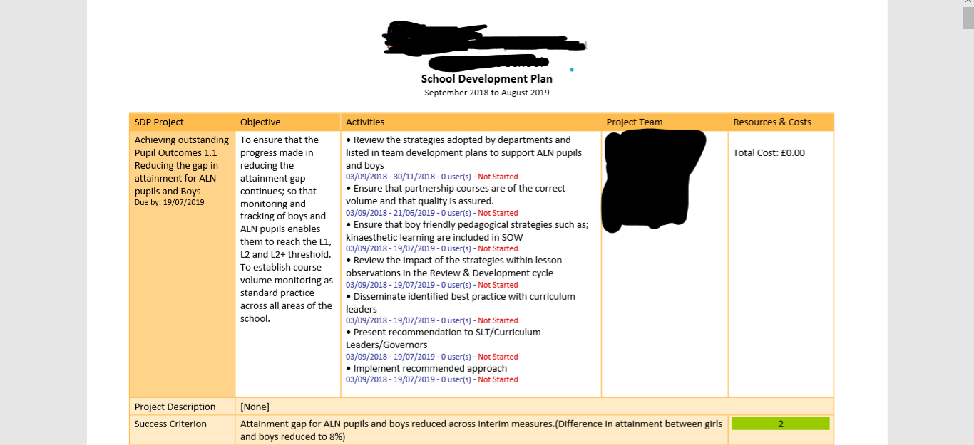
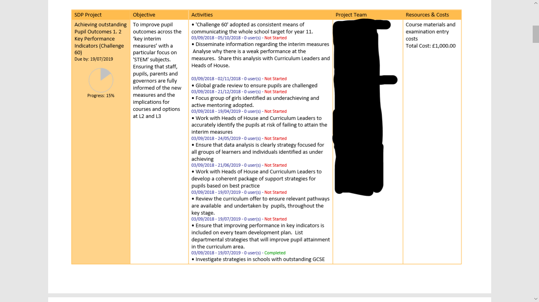
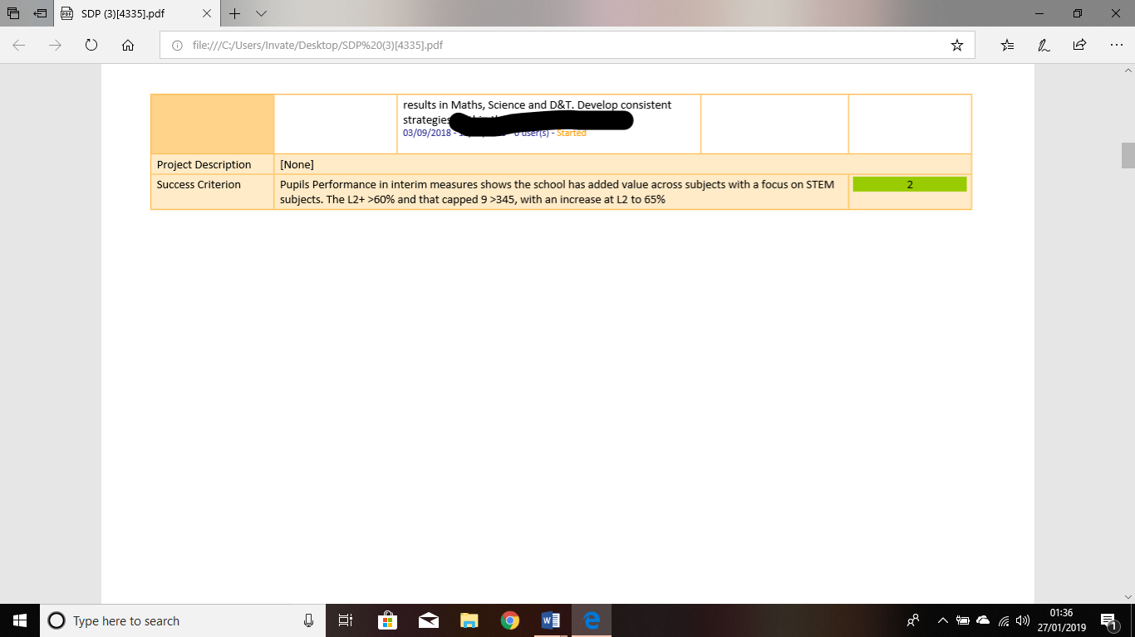
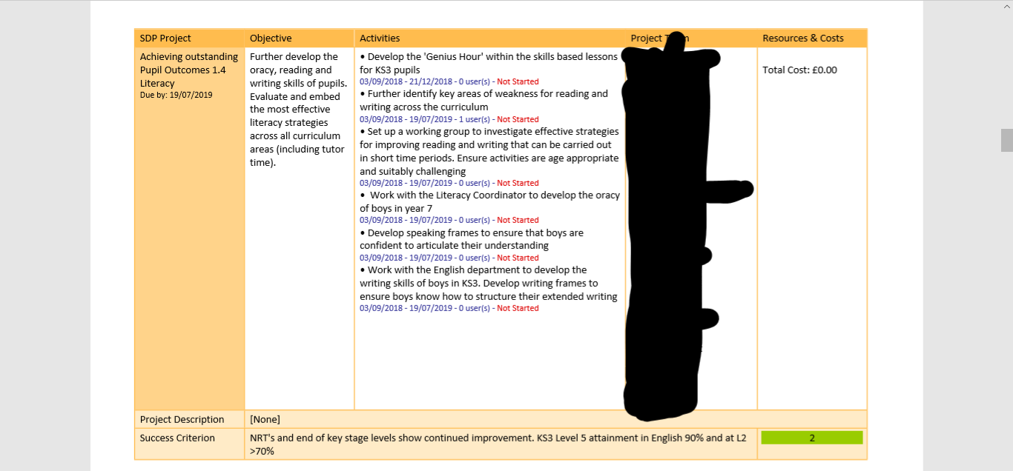
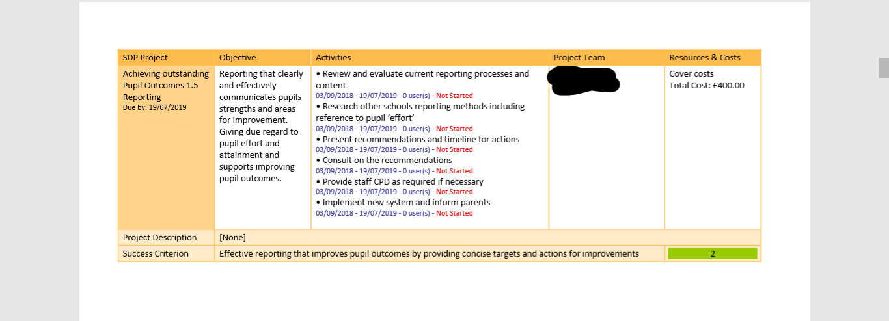
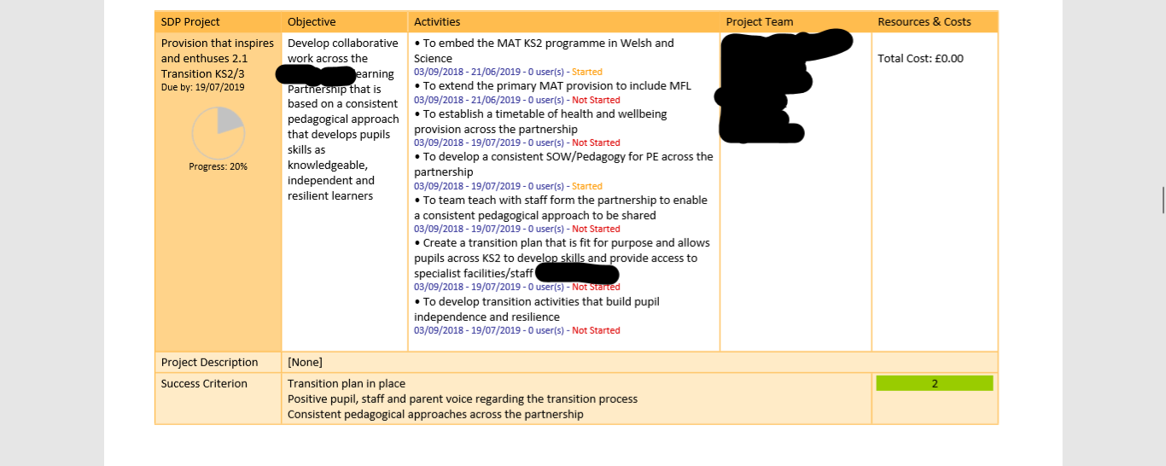
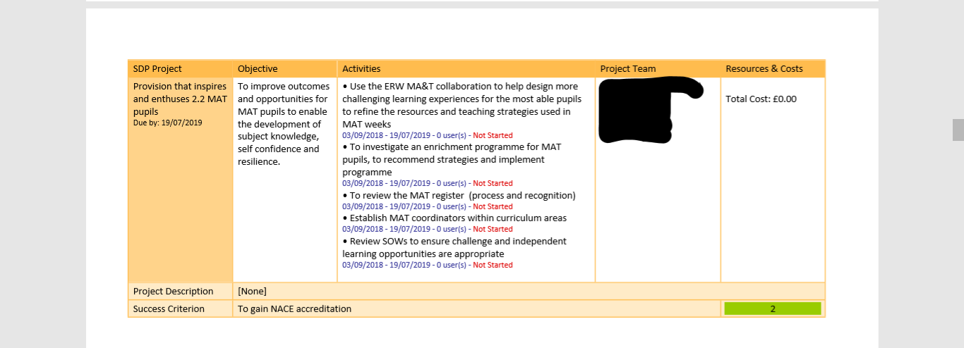
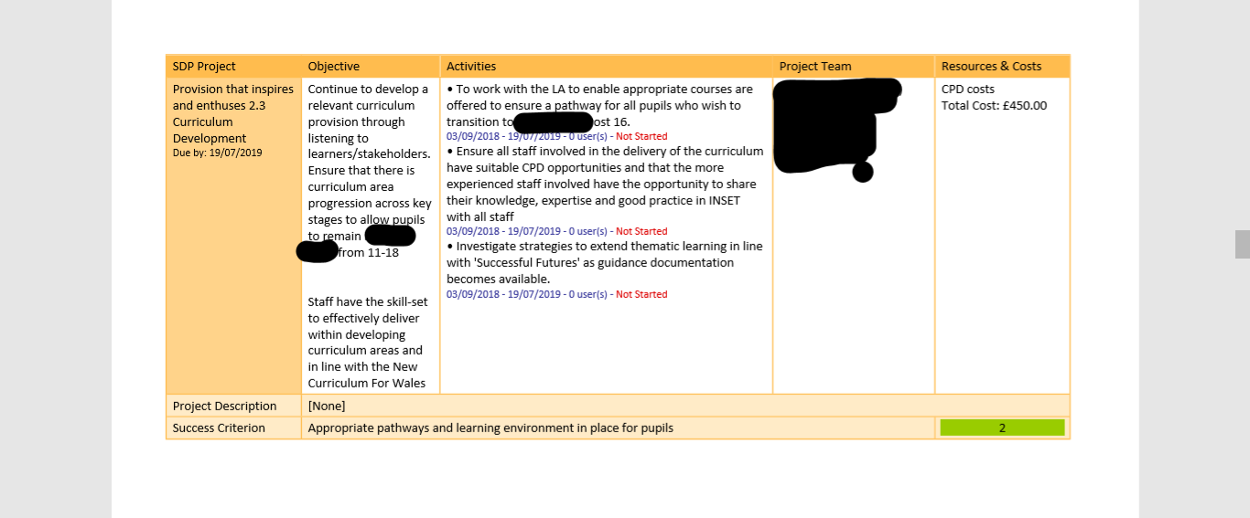
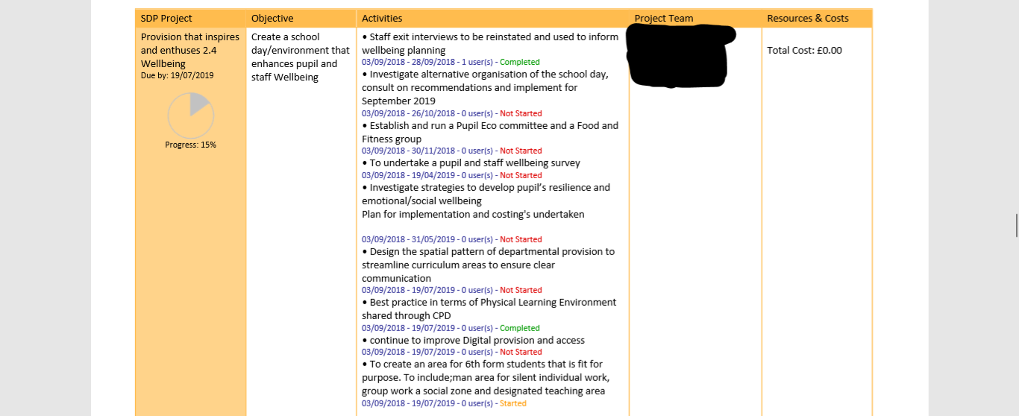

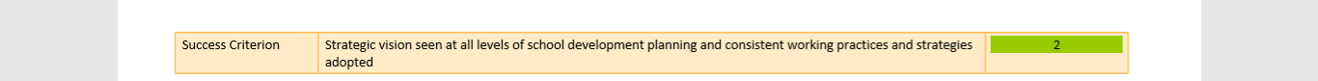
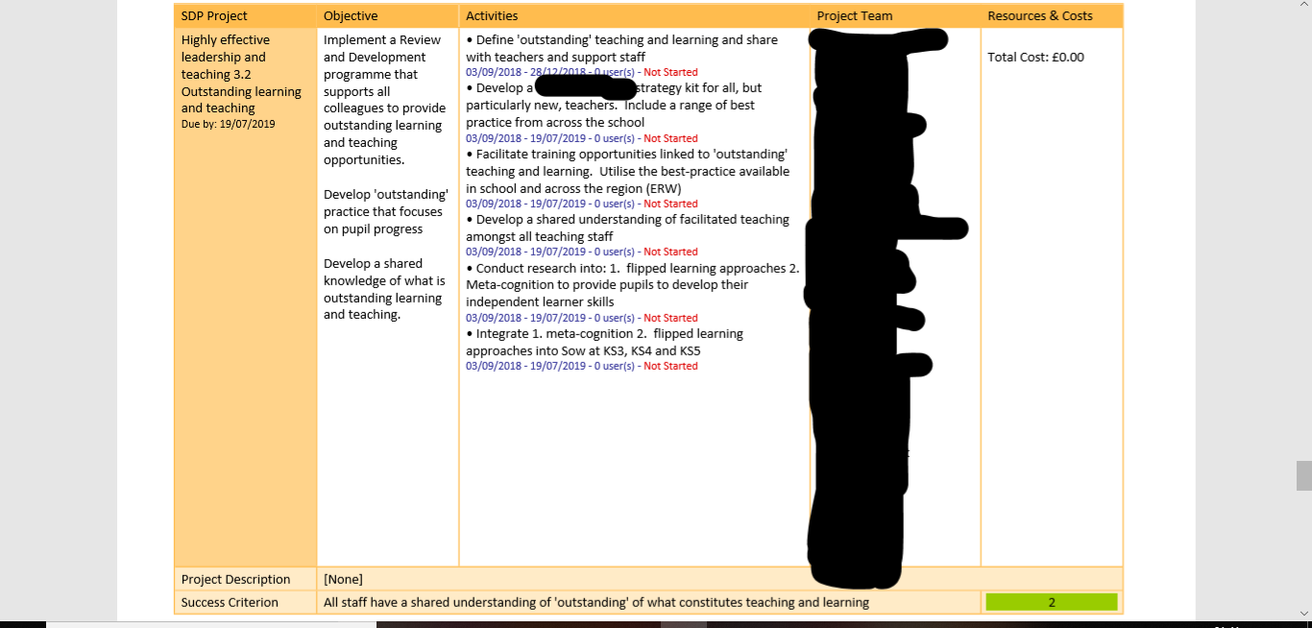
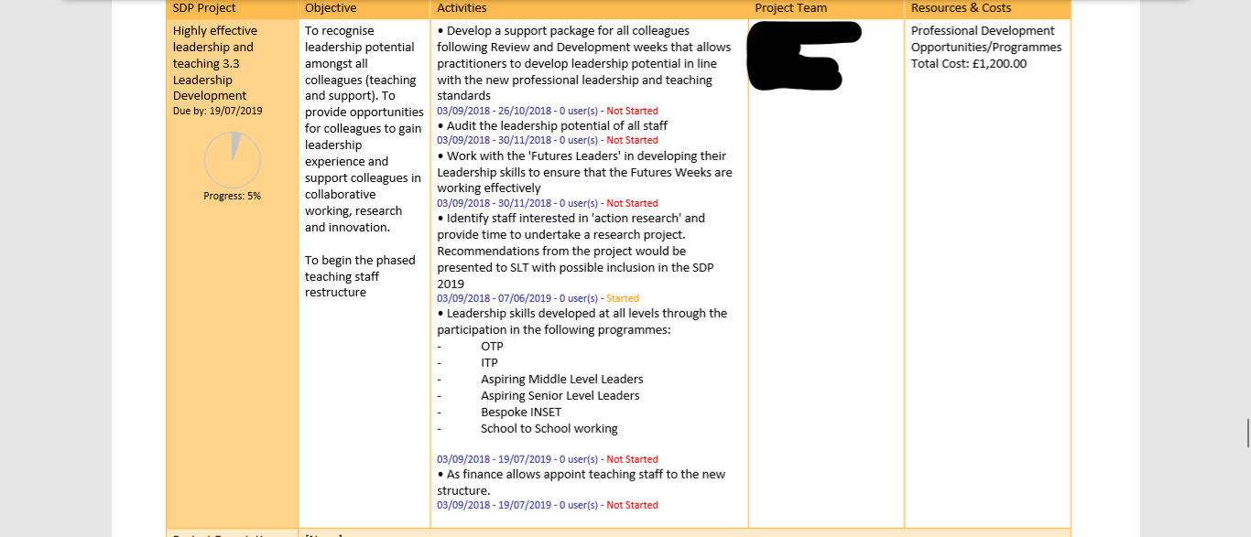
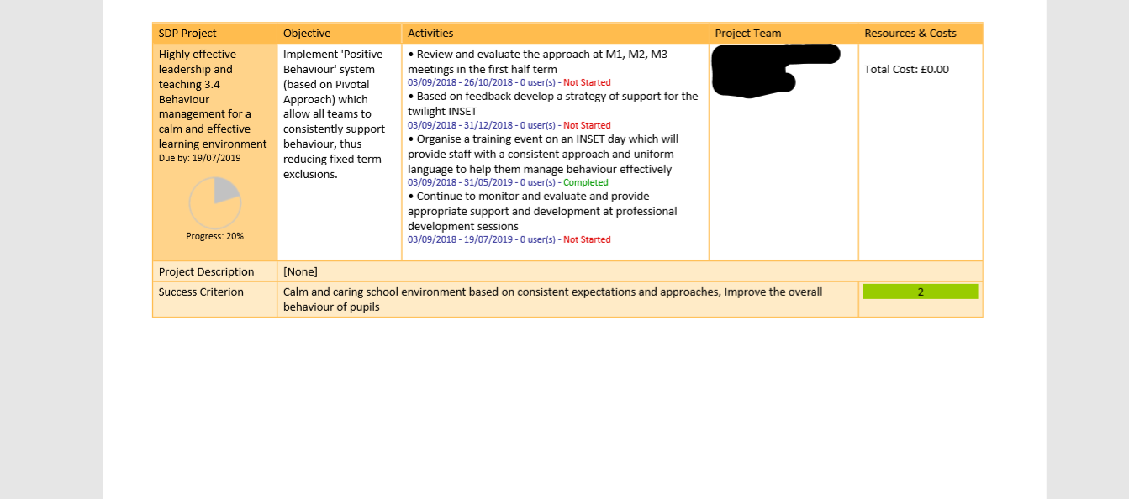
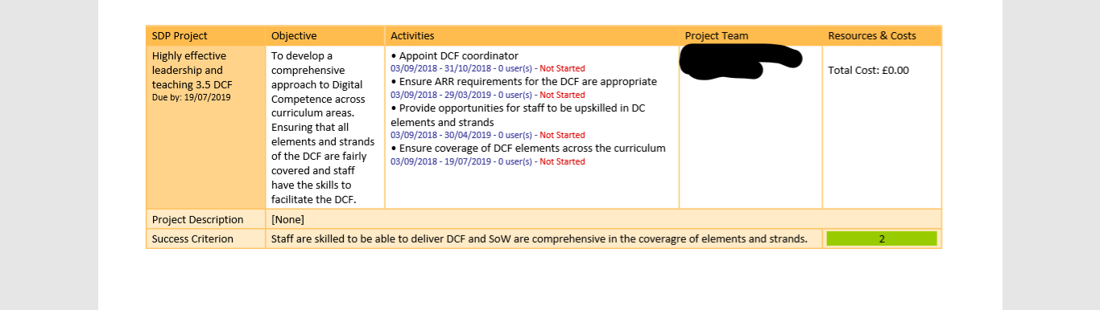

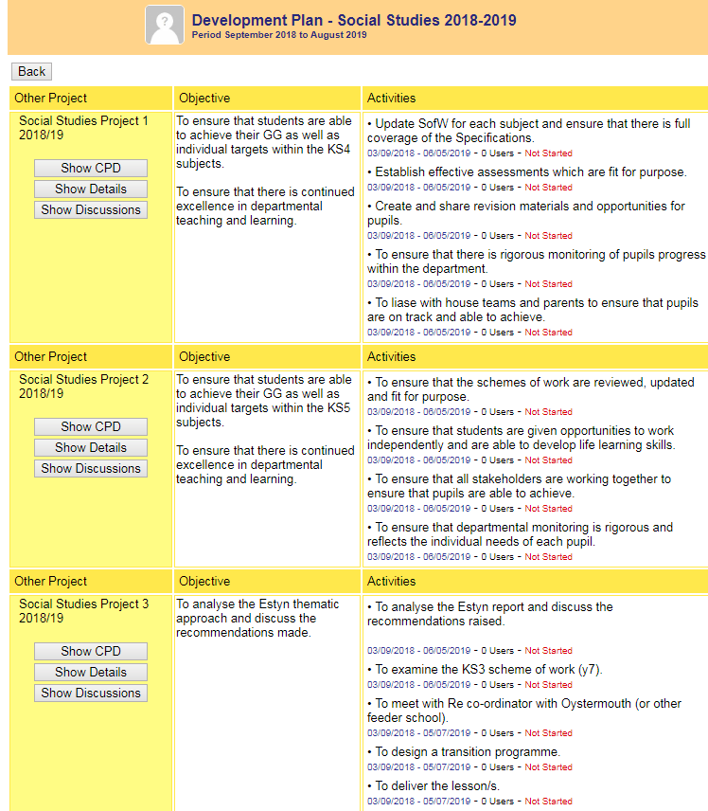
Appendix B



