Curtis Rees 2003711
Embedded C Assignment due 07/05/2021
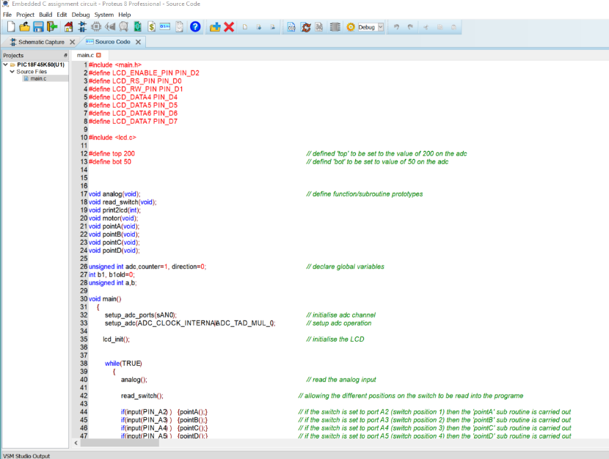
Unable to upload the proteus files on Moodle so I’ve screenshotted the code.



