How has COVID-19 has been an unprecedented challenge for global businesses?
Tutor: aNTHONY Burns

Global BUSINESS CHALLENGES (BMSP4001)
Callum Cresser

Over the last 12 months the world has changed significantly. The events that are currently occurring around the world are both unprecedented and ever changing. The effects of the COVID-19 virus have caused whole countries to be brought to a standstill. Social distancing has been implemented at levels never seen before. Restrictions and lockdowns are becoming the new normal in day to day life as the whole world attempts to combat the spread of the virus.
Despite these measures, COVID-19 has been able to spread on a global level and is affecting all continents on the planet. It is important to understand how the virus has been transmitted so prevalently as the ways in which countries are trying to combat the spread has both positive and negative connotations towards businesses.
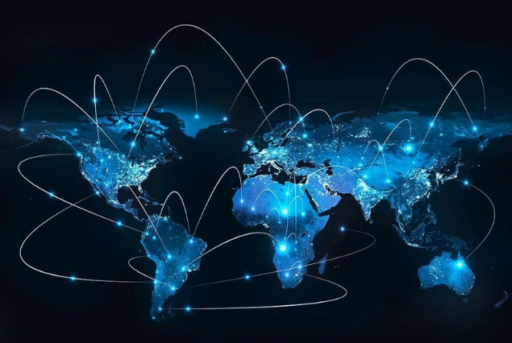
The increase in globalisation over the last half century means the world has been increasingly interconnected. The ability to travel across the globe has been made exceptionally easier due the increasing prevalence of airline companies giving people the opportunity to fly from country to country. Although this can be seen as a positive thing as it improves trade of goods and services, it also has its disadvantages. The increase in travel between countries means that the risk of transmission of COVID-19 would be higher as unaware carriers of the virus may spread it across continents without realising.
Cities being more densely packed has also influenced how the virus has spread more rapidly. The increase of available jobs and capital within them means more people are attracted to the population centres. As a result, more and more people are living almost on top of each other. This means that COVID-19 was able to spread rapidly through cities. With a lack social distancing pre pandemic, built up areas with a high population density would have made the caused the virus to spread even more rapidly.
This article will explore how the spread of COVID-19 and the resulting lockdowns have affected businesses. From the smaller, local independent businesses and looking at how the pandemic has impacted their livelihoods to the larger multinational corporations.
There are several ways in which businesses have been affected COVID-19, some of which are negative.
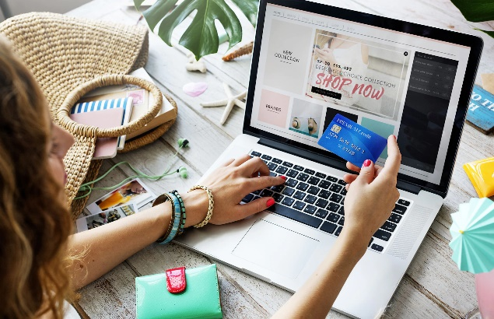
One example of this is how the pandemic is how it has affected the service industry. The rampant spread of COVID-19 forced numerous countries to grind to a halt, forcing governments to implement lockdown measures. The lockdown restrictions meant that shops selling non-essential items would have to close. This had a number of negative impacts for businesses of all sizes. Within the UK, the date for the closing of shops was 23rd of March 2020. There was no prior public warning of this therefore businesses were unable to put in place preparations to protect themselves. This had a tremendous effect as it closed thousands of stores across the country almost immediately. This meant that shops that would sell non-essential items lost their revenue from in store shoppers. This is especially hard for small businesses as they are unable to compete with prices and the demand when it comes to online shopping. As a result, independent shops had very little means of income during the lockdown. Larger companies like Amazon, mobile phone companies and clothing stores still had ways in which they could sell goods to their customers, with large websites built to deal with a high demand. This led to the multinational corporations not being impacted so harshly as they would have the means to sell products online.
Although larger companies still had ways of generating income, the number of employees within those businesses is significantly higher than in small businesses. One third of the people employed in the private sector in the UK work for large companies (D. King, 2020) The majority of these jobs within the UK are in the service industry, where services or goods are provided or sold to customers. Therefore, by closing non-essential shops it creates huge job uncertainty and the possibly of massive redundancies. The UK government introduced a furlough scheme that would pay a percentage of employee wages in order to minimise job losses. Initially this protected countless jobs as companies with reduced income due to the pandemic were able to continue to keep people employed. However, the scheme was scheduled to end on October 31st and many companies made redundancies in anticipation for this. Towards the end of lockdown from July to September the number of job losses rose to a record of 181,000 (Ben King, 2020). This shows that although support for job security was in place initially, it is not permanent, and companies are already looking to cut cost through redundancies. Reasoning behind this can be placed down to the loss of revenue from businesses who are missing out on shoppers in store due to continued lockdown measures.
The hospitality industry is another that has been heavily affected by COVID-19. Mainly pubs, clubs and restaurants. Like retail shops, they have been forced to close in line with the lockdown measures. However, due to the nature of the business, companies within the entertainment and hospitality industry are unable to make money online. These businesses have set costs and the goods that they sell are not able to be sold online. Any stock owned by bars or restaurants as lockdown started would have to be either given or thrown away. By losing their only significant source of income it has left those businesses in extremely difficult situations. Alongside the furlough scheme, the UK government attempted to support small business and businesses in the entertainment sector by offering grants. Businesses within the hospitality sector can claim up to £25,000 from their councils (Department for Business, Energy & Industrial Strategy, 2020).
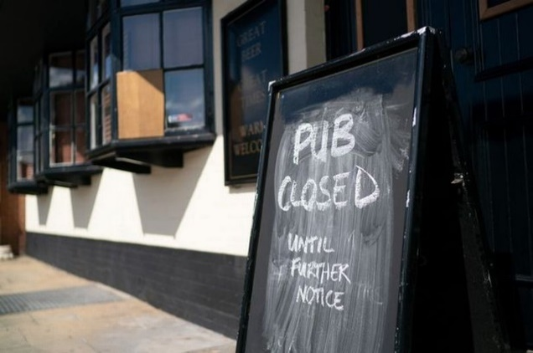
Although the government grants for small businesses have helped protect a number of business, allowing certain businesses to avoid closure. It appears it has not done enough to support businesses within the hospitality sector, especially pubs. Another way in which the hospitality industry has been affected by COVID-19 is down to curfews. These restrict the hours in which venues can operate. Businesses such as pubs and restaurants have been affected by this as it has cut of several hours in which they would normally operate. These restrictions have put even further strain on businesses as it significantly as they can no longer generate any income after 10pm. This has led to large number of pubs having to shut down. Since the beginning of 2020, over 300 pubs have closed down and are set to be demolished or repurposed. The number of pubs in England and Wales has dropped to 40,748, with 87 closing within the last two months (Nikkie Thatcher, 2020).


This is evidence that shows that pubs have been impacted seriously by COVID-19 and despite support from the government are shutting their doors at a significant rate.
There are numerous businesses that have a very little support from the government. Many businesses within the entertainment industry have been left short of funds since the beginning of lockdown in March. A good example of this are football clubs. The football industry is one that is saturated with money at the very, with players potentially earning up to millions of pounds per year. However, the clubs in the leagues below are extremely reliant on the income they receive from match day fan attendances. As part of the restrictions put in place by the government due to COVID-19, fans are no longer allowed to attend games. This creates huge monthly financial losses for almost every club. Whilst clubs in the top division are payed huge money in TV rights and sponsorships, the lower league teams cannot survive without fans in the stadiums (Martha Kelner, 2020).
Such is the case with any other business, football clubs have consistent financial outgoings, with paying employees being the main costs. Even with the financial support of the government through the furlough scheme, it is unlikely that clubs will be able to stay afloat. The head of the lower leagues in England have predicted potential losses of £250m between the 72 clubs across leagues. This is expected to become a reality as games are unlikely to restart until 2021 (Paul McInnes, 2020). These kinds of losses can be put down to the effects of COVID-19. Clubs can no longer offset the impact of their spending with the money brought in by the fans attending games. Until a vaccine is available on mass, stadiums will not be able to open at full capacity. For football clubs this is not sustainable from a business perspective and therefore there may be a rise in the number of clubs that move into administration and then move into liquidation.
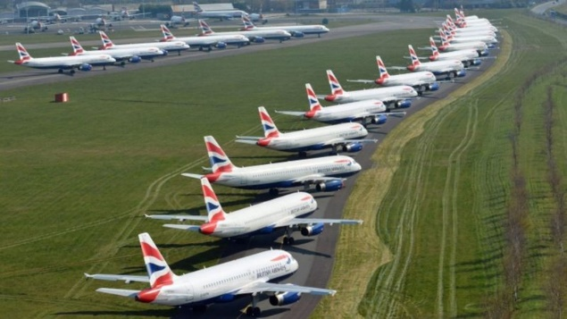
One of the more clearly impacted areas of business impacted by the pandemic is the tourism and travel companies. As the pandemic began to spread around the world, many governments restricted travel to countries with high rates of infection, with some stopping flights into their countries completely. During the lockdown in the UK all non-essential travel was blocked. The number of holidays that were cancelled was substantial and airlines were made to give refunds on tickets. This has had a severe effect on travel companies. The travel sector anticipates more companies closing down as they cannot adapt to tackle the challenges of the pandemic. Several companies could no longer operate and closed, including Cities Direct who had been operating for over 20 years (Isabel Choat, 2020). This has also led to a high number of job losses within the industry. National geographic report that as of 2nd of April, British Airways were set to put 36,000 jobs on hold (Elizabeth Becker, 2020). This research shows that even large travel companies have not been able to avoid the impacts of COVID-19. It also shows that the travel and tourism industries are in jeopardy of collapse.
One example which can have both positive and negative points is how people have been encouraged to work from home. Working from home where possible was one of the guidelines the government gave when introducing the lockdown in the UK. This impacted how businesses would work as employees would not travel into the office on a daily basis. One of the ways that this has positively impacted businesses is that working from home can make people more efficient. In a survey conducted by The Institute for Employment Studies, it showed that 49% of people felt a though they were more productive at home. This can be put down to time spent in meetings and having less distractions at home than in the office (Beth Mason, 2020). For businesses, improved productivity can only be a good thing as it will improve how well employees complete their jobs. A more productive workforce will make more money for the business. The removal of the daily commute is also a positive impact that come from working from home, this eliminates the stress of getting to work, therefore, employees are likely to spend more time doing work. There are also some negative impacts of working from home. Without the interactions of the workplace, some people may feel isolated. This can have an affect on the business as the employee may not work to their full potential. Another disadvantage for businesses in having employees working from home is the cost of providing the equipment needed. During the pandemic, bank workers were asked to work from home as customer service call centre operators. In order to be able to complete their role in a safe manner for the customer, they needed to use secure computers and phones to access customers accounts. The companies would have to supply these to their employees at cost for themselves.
Although there have are significant negative impacts of the pandemic, there have also been some positive impacts. Whilst some businesses have struggled to adapt to the changes, some have managed to overcome the challenges and thrive.
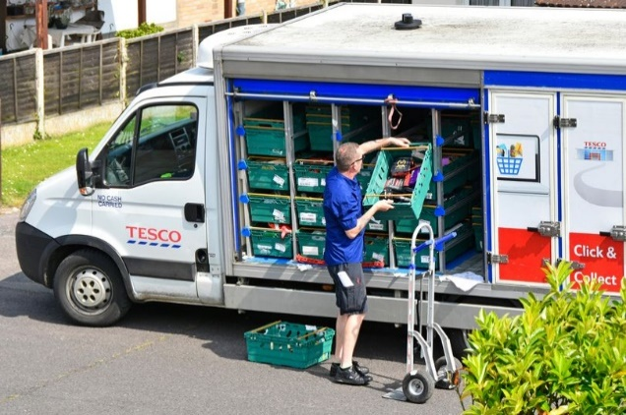
A good example of this is the way in which supermarkets have thrived since the start of the pandemic. Spurred on due to the panic created by lockdowns, the sales of food and other produce is growing at the fastest rate since 1994 (Carina Perkins, 2020). The way in which people are purchasing their food has also changed. With growing concern about the transmission of COVID-19, online orders of food and drink have increased. This rise can be put down to the option of getting goods delivered instead of having to collect it from the store. This has caused the strain on the delivery services to be increased. In turn, this has created the opportunity for extra job to be made available. Supermarket chain Tesco has stated it is creating 16,000 permanent jobs to order to cope with the growth of the online business. 10,000 of the jobs created will collect customer orders, with 3,000 jobs will go to delivery drivers in order to distribute those orders (Tom Houghton, 2020). Evidence like this shows how supermarkets have adapted very well t the pandemic and have continued to be successful.
One of the most concerning effects of the COVID-19 pandemic is the closure of small businesses. While some were able to avoid permanently closing down others were not. Despite the difficult conditions, some businesses have flourished. One example of this is the video conference company Zoom. As the COVID-19 pandemic forced the population to work and socialise online, the usage of Zoom increased dramatically. At the height of usage, 300 million people a day used the app for work, school or to keep in touch with friends and family (Natalie Sherman, 2020). Zoom managed to adapt in order to gain success. The app was made free to use after lockdowns around the world started. This resulted in the huge increases in users and sales across the world.
2020 has been an extremely challenging year for businesses. There have unprecedented changes to overcome. Some businesses have not been able to adapt and with no end to the pandemic in sight it appears that the difficult times will continue into the near future. Others have been able to turn the changes into positive things and are flourishing. It appears as though larger companies have been the best equipped to deal with lockdowns whereas small businesses have struggled. Although support has been available for businesses it seems that it has not gone far enough. Small businesses, local pubs and restaurant are vital to local economies and they are the businesses that are struggling the most. Without more support they will continue to close permanently at a high rate.

References
https://www.bbc.co.uk/news/business-52660591 - Ben King 2020
https://www.statista.com/statistics/676671/employees-by-business-size-uk/ - D. Clark 2020
https://www.morningadvertiser.co.uk/Article/2020/09/14/How-many-pubs-have-closed-by-September-2020 - Nikkie Thatcher 2020
https://www.gov.uk/guidance/check-if-youre-eligible-for-the-coronavirus-retail-hospitality-and-leisure-grant-fund - Official Government Website
https://news.sky.com/story/coronavirus-losing-football-clubs-to-covid-19-would-be-a-national-outcry-12075525 - Martha Kelner, 2020
https://www.theguardian.com/football/2020/sep/23/football-league-expects-to-get-government-money-to-keep-clubs-alive-efl - Paul MacInnes, 2020
https://www.theguardian.com/travel/2020/sep/10/travel-industry-fears-covid-19-crisis-will-cause-more-holiday-comapnies-to-collapse - Isabel Choat, 2020
https://www.nationalgeographic.com/travel/2020/04/how-coronavirus-is-impacting-the-travel-industry/ - ELIZABETH BECKER. 2020
https://www.employment-studies.co.uk/news/remote-working-really-so-bad-benefits-working-home-during-covid-19 - Beth Mason, 2020
https://www.thegrocer.co.uk/consumer-trends/what-impact-is-coronavirus-having-on-the-uk-grocery-market/605195.article - Carina Perkins, 2020
https://www.business-live.co.uk/economic-development/tesco-creates-16000-new-permanent-18818934 - Tom Houghton, 2020
https://www.bbc.co.uk/news/business-52884782 - Natalie Sherman, 2020
Photos
https://datafloq.com/read/we-should-embrace-technology-change-globalisation/5273
https://www.telegraph.co.uk/technology/connecting-britain/shop-online/
https://www.watfordobserver.co.uk/sport/18533487.covering-football-coronavirus---like-inside-empty-stadiums/
https://www.bbc.co.uk/news/uk-england-london-52089046
https://www.mirror.co.uk/money/tesco-makes-another-big-change-22250483

