LCBB6001
International Business Communications
Practical: Individual Presentation
Student Name: Iulia Andreea Flita
Student ID: 2027759

Slide 1

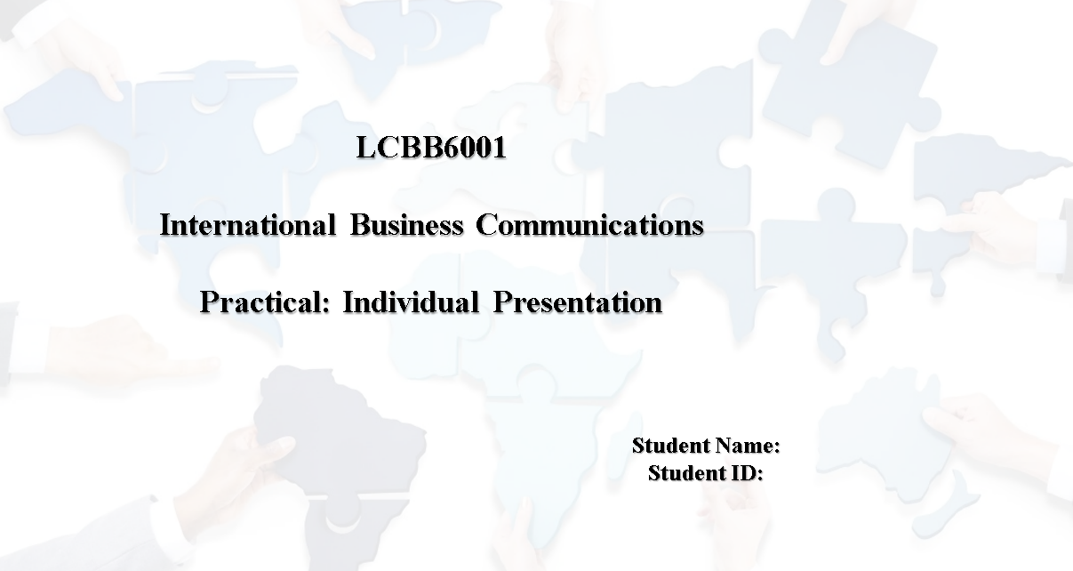
Slide 2
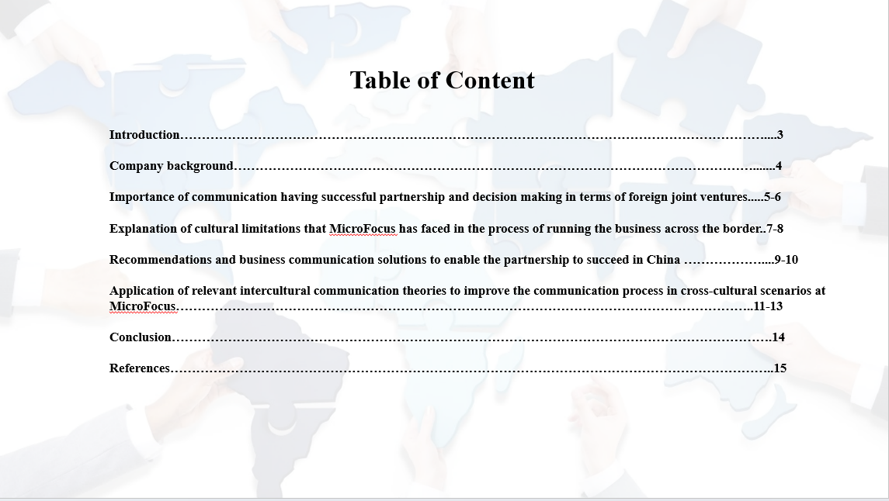
Slide 3
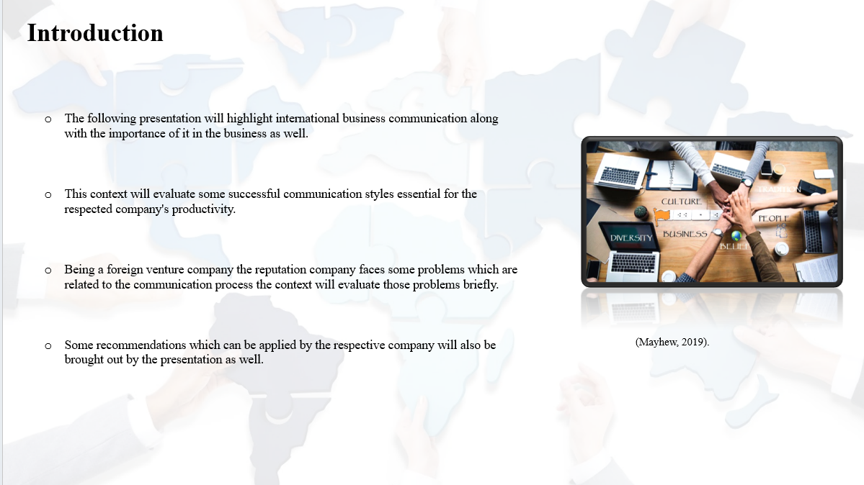
Note

Introduction
The following presentation will highlight international business communication along with the importance of it in the business as well. A global company based in the UK and spreading its venture to China, MicroFocus, has been chosen for further discussion. This context will evaluate some successful communication styles essential for the respected company's productivity. Being a foreign venture company the reputation company faces some problems which are related to the communication process the context will evaluate those problems briefly. Some recommendations which can be applied by the respective company will also be brought out by the presentation as well. Further, some relevant communication theories which can improve the communication process will be mentioned in the following presentation.

Slide 4
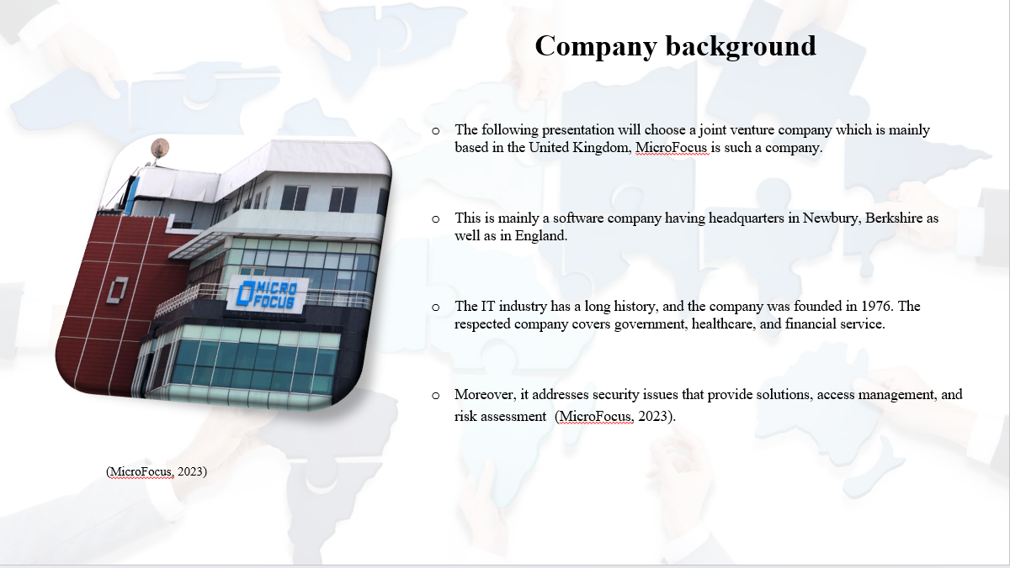

Note

Company background
The following presentation will choose a joint venture company which is mainly based in the United Kingdom, MicroFocus is such a company. This is mainly a software company having headquarters in Newbury, Berkshire as well as in England. The IT industry has a long history, and the company was founded in 1976. The respected company covers government, healthcare, financial service, telecommunication and many more like that. MicroFocus provides some kind of solutions which can support the development of the lifecycle. Moreover, it addresses security issues that provide solutions, access management, and risk assessment. The respected company offers some tools which can improve collaboration as well as the productivity of other companies. Moreover, MicroFocus has grown thoroughly through its acquisition as well as mergers over the years (MicroFocus, 2023)
Slide 5

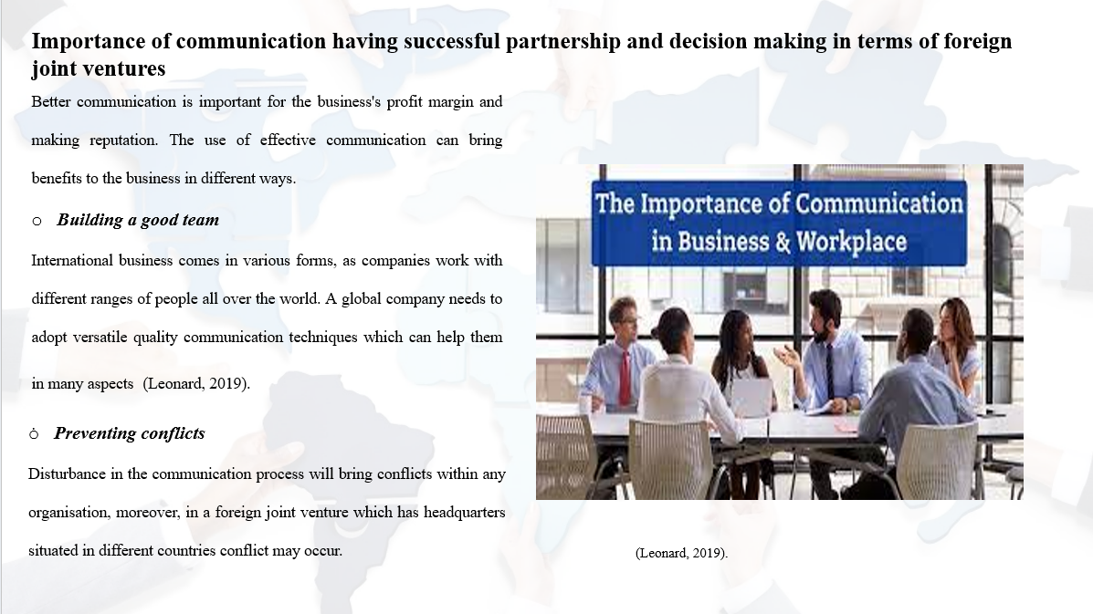
Note

Importance of communication having successful partnerships and decision-making in terms of foreign joint ventures
Better communication is important for the business's profit margin and making reputation. The use of effective communication can bring benefits to the business in different ways.
Building a good team
International business comes in various forms, as companies work with different ranges of people all over the world. A global company needs to adopt versatile quality communication techniques which can help them in many aspects. Communication can increase positive practices of foreign joint ventures and make a good team perform quickly (Leonard, 2019).
Preventing conflicts
Disturbance in the communication process will bring conflicts within any organisation, moreover, in a foreign joint venture which has headquarters situated in different countries conflict may occur. Good communication will reduce those conflicts and address problems in the right way.

Slide 6
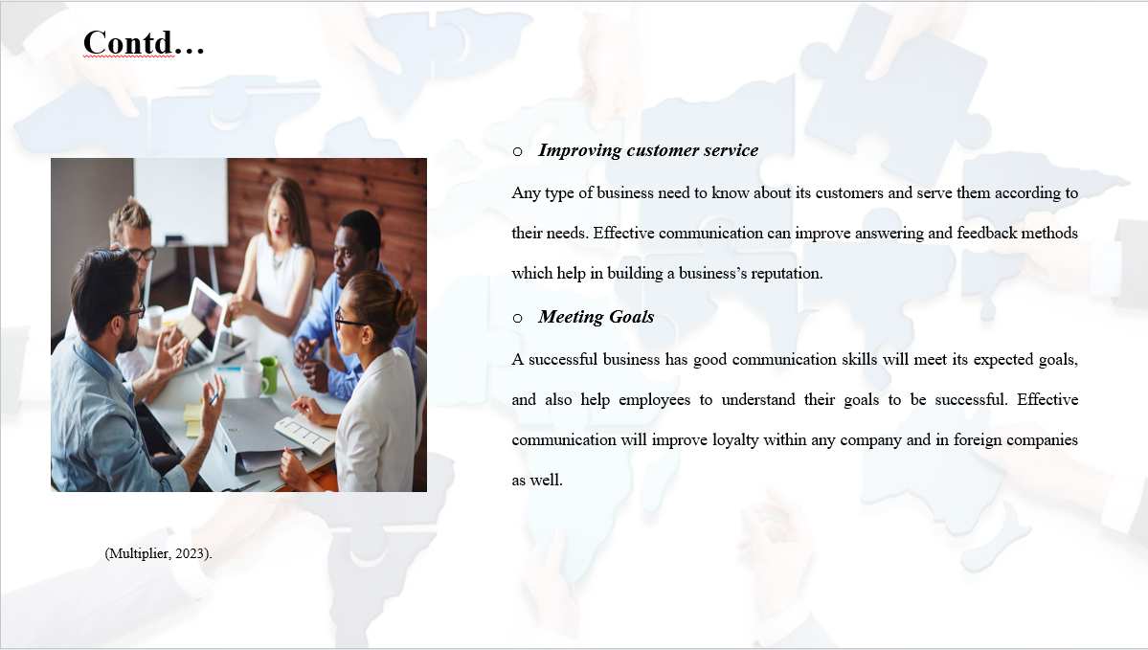
Note
Improving customer service
Any type of business need to know about its customers and serve them according to their needs. Effective communication can improve answering and feedback methods which help in building a business’s reputation. Additionally promotes a business community between organisations and customers.
Meeting Goals
A successful business has good communication skills will meet its expected goals, and also help employees to understand their goals to be successful. Effective communication will improve loyalty within any company and in foreign companies as well.

Slide 7

Note

Explain the cultural limitations that MicroFocus has faced in the process of running the business across the border
International businesses can face many kinds of problems while running the business across the border. The challenges related to international business will be discussed further,
Managing the team
Developing an effective team is important for any business and managing this is also important for any foreign ventured business. Maintaining strong work will benefit the company and it can spread its branch throughout the world. Employees regularly interact with their manager to maintain a work culture, however, for international business, it is getting very tough to manage employees all over the world (Multiplier, 2023).
Language obstacle
International businesses face language obstacles, as the language barrier is the most significant challenge for international business. By hiring fluent employees into the business the company will face difficulties to explain their goals to the customers as well. Significant employees maintain a comfortable global business to operate smoothly.

Slide 8
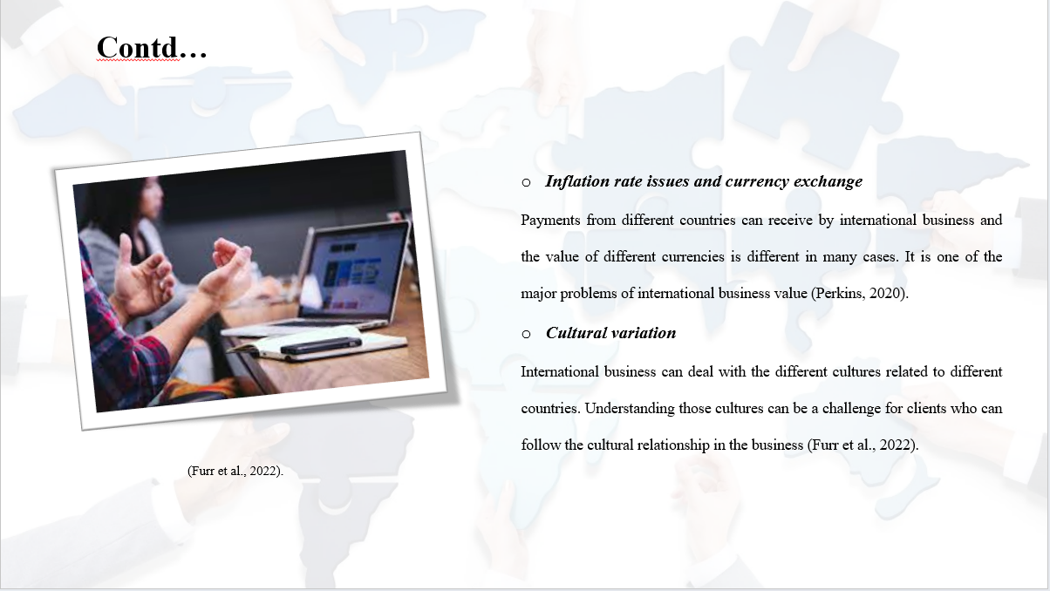
Note
Inflation rate issues and currency exchange
Payments from different countries can receive by international business and the value of different currencies is different in many cases. It is one of the major problems of international business as the value of currency consistently fluctuated for various amounts of business sectors (Perkins, 2020).
Cultural variation
International business can deal with the different cultures related to different countries. Understanding those cultures can be a challenge for clients who can follow the cultural relationship in the business. Reduces complexity in international business and makes the company more fruitful in the market as well (Furr et al., 2022).

Slide 9
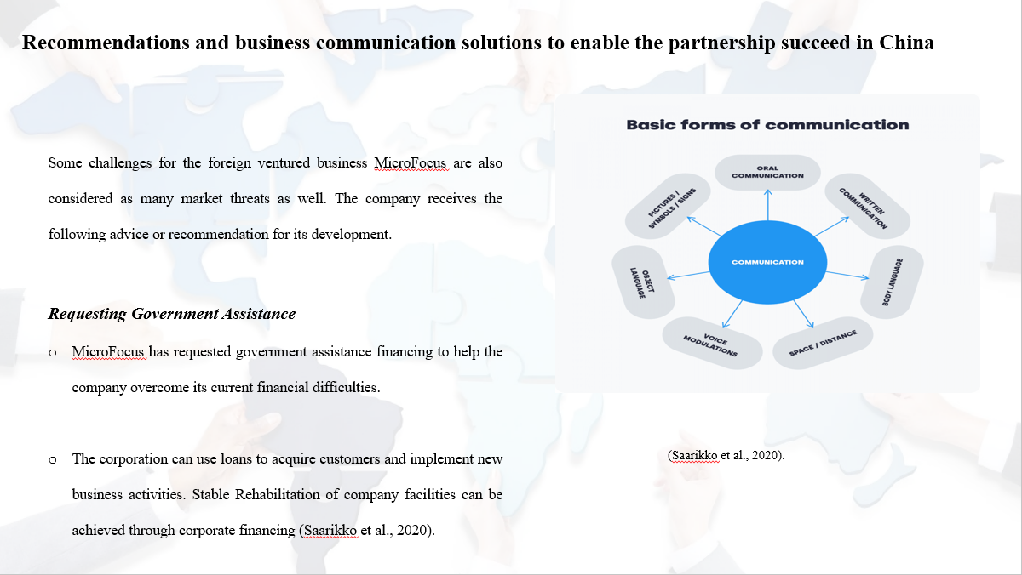
Note

Recommendations and business communication solutions to enable the partnership to succeed in China
Some challenges for the foreign ventured business MicroFocus are also considered as many market threats as well. The company receives the following advice or recommendation for its development.
Requesting Government Assistance
MicroFocus has requested government assistance financing to help the company overcome its current financial difficulties. The corporation can use loans to acquire customers and implement new business activities. Stable Rehabilitation of company facilities can be achieved through corporate financing. So many employees will be motivated to come to the office and do their work uninterruptedly (Saarikko et al., 2020).

Slide 10
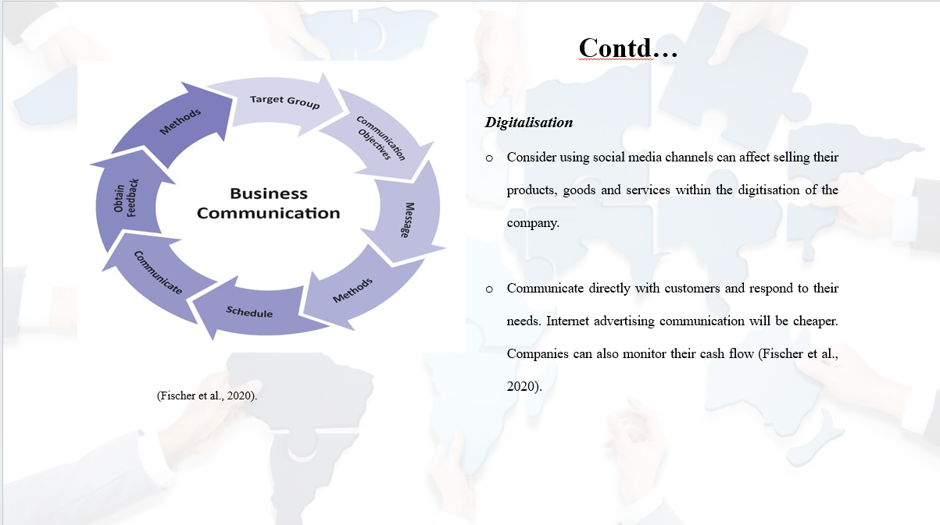
Note
Digitalisation
Consider using social media channels can affect selling their products, goods and services within the digitisation of the company, it can benefit to access a large customer base. Creating products allows the respected company to communicate with each other. Communicate directly with customers and respond to their needs. Internet advertising communication will be cheaper. Companies can also monitor their cash flow (Fischer et al., 2020).

Slide 11
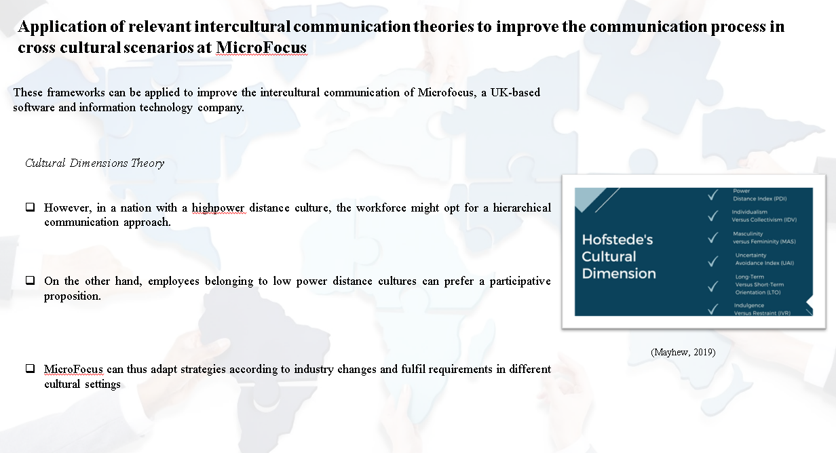
Notes

Application of relevant intercultural communication theories to improve the communication process in cross cultural scenarios at MicroFocus
After analysing the challenges and difficulties that ventures can face, many experts and scholars have come up with various intercultural communication theories. These frameworks can be applied to improve the intercultural communication of Microfocus, a UK-based software and information technology company.
Cultural Dimensions Theory
Applying to Geert Hofstede's Cultural Dimensions Theory, the venture can easily identify the cultural differences of their employees, customers and shareholders. However, in a nation with a highpower distance culture, the workforce might opt for a hierarchical communication approach. On the other hand, employees belonging to low power distance cultures can prefer a participative proposition. The theory also shows individualism vs. collectivism, masculinity vs. femininity, avoiding ambiguity, long-term vs. short-term orientation and indulgence vs. restraint as fundamental components of culture. MicroFocus can thus adapt strategies according to industry changes and fulfil requirements in different cultural settings (Mayhew, 2019).
Slide 12
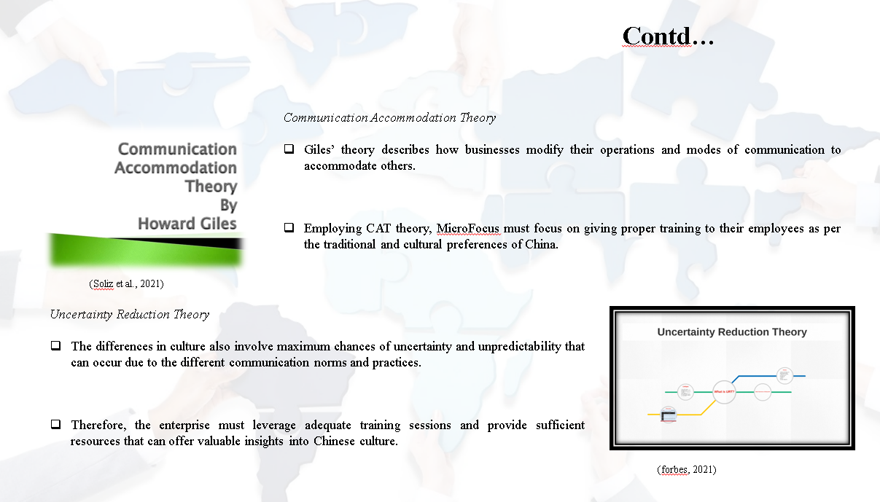
Notes
Communication Accommodation Theory
Giles’ theory describes how businesses modify their operations and modes of communication to accommodate others. Employing CAT theory, MicroFocus must focus on giving proper training to their employees as per the traditional and cultural preferences of China. The administration can implement such learning or training sessions to train the staff members to communicate more effectively and minimises the chances of confusion or misunderstanding. Therefore, the British corporation must adjust its way of commercial communication if it hopes to penetrate an Asian market, particularly China. To ensure successful commerce, the communication gap is a significant disadvantage in business that must be addressed (Soliz et al., 2021).
Uncertainty Reduction Theory
The differences in culture also involve maximum chances of uncertainty and unpredictability that can occur due to the different communication norms and practices. However, the venture can utilise the URT framework to minimise the chances of uncertainty and can identify the challenges beforehand. Being a UK-based company, it can be difficult for MicroFocus to enter the Chinese market and many unfortunate situations can arise that are inevitable. Therefore, the enterprise must leverage adequate training sessions and provide sufficient resources that can offer valuable insights into Chinese culture. This is imperative to be familiar with their communication styles, cultural values and practices and beliefs to foster understanding and better communication.
Slide 13
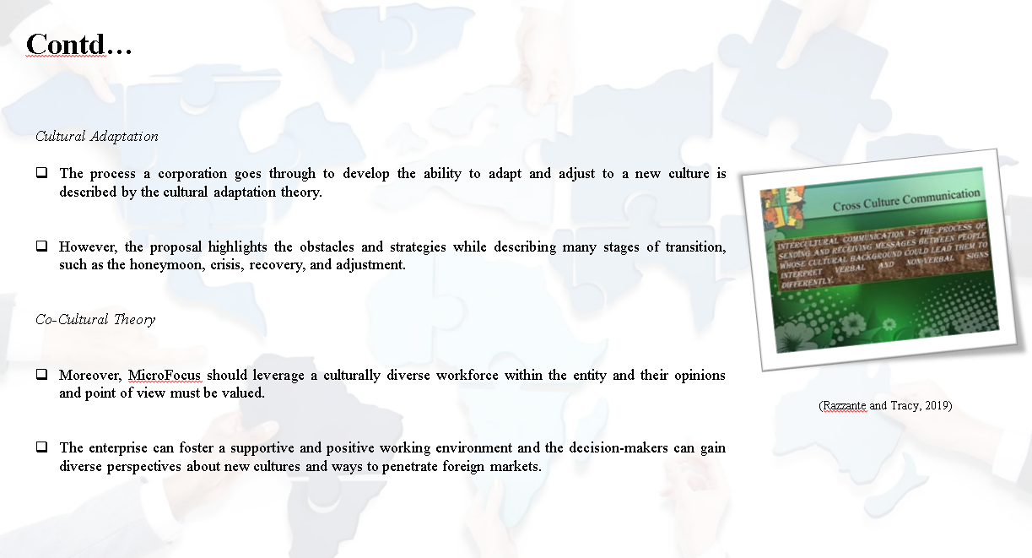
Notes
Cultural Adaptation
The process a corporation goes through to develop the ability to adapt and adjust to a new culture is described by the cultural adaptation theory. Public opinion, trends and preferences significantly shift when a business enterprise is expanded from one continent to another. However, the proposal highlights the obstacles and strategies while describing many stages of transition, such as the honeymoon, crisis, recovery, and adjustment. Thoroughly following the steps can assist Microfocus in anticipating persistent issues that they can resolve before they have an adverse impact on business operations. Therefore, the company must ensure that they develop a workforce that can adapt to the changes and accept the cultural value of China (forbes, 2021).
Co-Cultural Theory
Moreover, MicroFocus should leverage a culturally diverse workforce within the entity and their opinions and point of view must be valued. The enterprise can foster a supportive and positive working environment and the decision-makers can gain diverse perspectives about new cultures and ways to penetrate foreign markets (Razzante and Tracy, 2019).

Slide 14
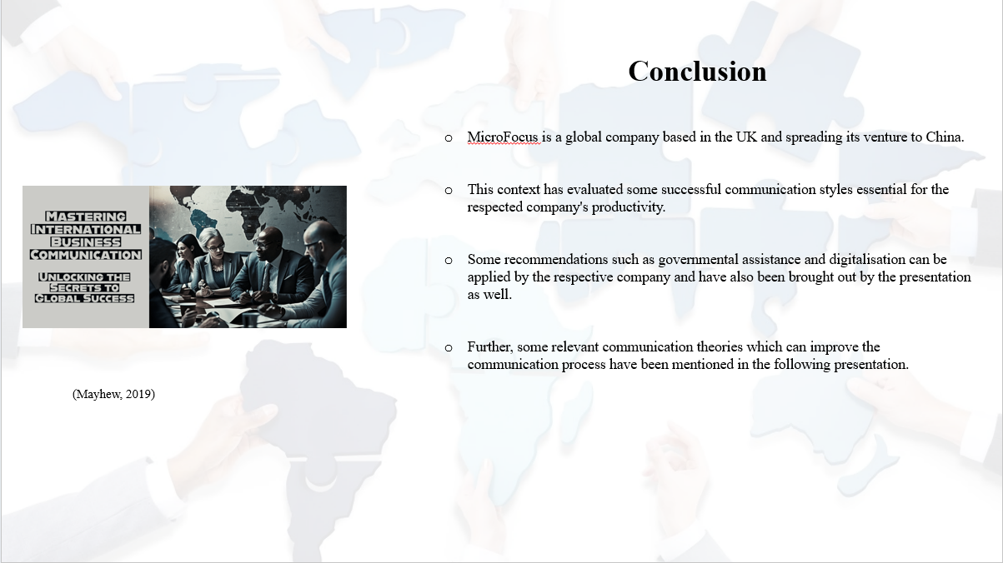
Note

Conclusion
The following presentation has highlighted international business communication along with the importance of it in the business as well. MicroFocus is a global company based in the UK and spreading its venture to China. This context has evaluated some successful communication styles essential for the respected company's productivity. A foreign venture company's reputation company faces some problems which are related to the communication process the context has evaluated those problems briefly. Some recommendations such as governmental assistance and digitalisation can be applied by the respective company and have also been brought out by the presentation as well. Further, some relevant communication theories which can improve the communication process have been mentioned in the following presentation.

Slide 15
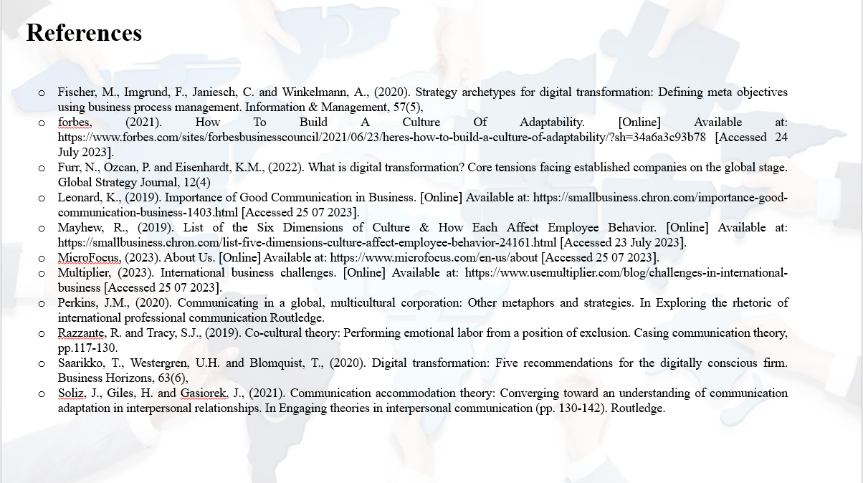
Note

References
Fischer, M., Imgrund, F., Janiesch, C. and Winkelmann, A., (2020). Strategy archetypes for digital transformation: Defining meta objectives using business process management. Information & Management, 57(5),
forbes, (2021). How To Build A Culture Of Adaptability. [Online] Available at: https://www.forbes.com/sites/forbesbusinesscouncil/2021/06/23/heres-how-to-build-a-culture-of-adaptability/?sh=34a6a3c93b78 [Accessed 24 July 2023].
Furr, N., Ozcan, P. and Eisenhardt, K.M., (2022). What is digital transformation? Core tensions facing established companies on the global stage. Global Strategy Journal, 12(4)
Leonard, K., (2019). Importance of Good Communication in Business. [Online] Available at: https://smallbusiness.chron.com/importance-good-communication-business-1403.html [Accessed 25 07 2023].
Mayhew, R., (2019). List of the Six Dimensions of Culture & How Each Affect Employee Behavior. [Online] Available at: https://smallbusiness.chron.com/list-five-dimensions-culture-affect-employee-behavior-24161.html [Accessed 23 July 2023].
MicroFocus, (2023). About Us. [Online] Available at: https://www.microfocus.com/en-us/about [Accessed 25 07 2023].
Multiplier, (2023). International business challenges. [Online] Available at: https://www.usemultiplier.com/blog/challenges-in-international-business [Accessed 25 07 2023].
Perkins, J.M., (2020). Communicating in a global, multicultural corporation: Other metaphors and strategies. In Exploring the rhetoric of international professional communication Routledge.
Razzante, R. and Tracy, S.J., (2019). Co-cultural theory: Performing emotional labor from a position of exclusion. Casing communication theory, pp.117-130.
Saarikko, T., Westergren, U.H. and Blomquist, T., (2020). Digital transformation: Five recommendations for the digitally conscious firm. Business Horizons, 63(6),
Soliz, J., Giles, H. and Gasiorek, J., (2021). Communication accommodation theory: Converging toward an understanding of communication adaptation in interpersonal relationships. In Engaging theories in interpersonal communication (pp. 130-142). Routledge.

