Project Management
  - Name
James Edward Millns

Student No
1708455

Email
1708455@student.uwtsd.ac.uk

Course
BSC (Hons) Software Engineering

Module Name
Project Management

Module Code
ACDA5004

Lecturer
Susan Maw

Table of Contents
Table of Figures 3
1. Introduction 4
2. Risk Management 5
2.1 Risk Impact and Probability 5
2.2 Risk Exposure and Reduction Leverage 7
3. Sustainability Issues 8
3.1 First Order 8
3.2 Second Order 9
3.3 Third Order 9
4. Ethical and Legal Issues 10
4.1 Professional Code of Conduct 10
4.1.1 Public Interest 10
4.1.2 Professional Competence and Integrity 10
4.1.3 Duty to Relevant Authority 10
4.1.4 Duty to the Profession 10
4.2 Ethical Issues 11
4.3 Legal Compliance 12
5. Quality Assurance. 13
5.1 Functionality 13
5.2 Reliability 14
5.3 Usability 15
5.4 Efficiency 17
5.5 Maintainability 18
5.6 Portability 19
6. Conclusion 20
7. References 21

Table of Figures
Figure 1: Risk impact and probability key. 5
Figure 2: Risk Identification, probability and impact table. 5
Figure 3: Probability Impact Matrix 6
Figure 4: Risk Exposure Table 7
Figure 5: Risk Reduction Leverage Table 7

Introduction
During the Project Management module, the group were required to design and implement a product that would assist search and rescue workers in areas affected by natural disaster. The group decided to design and develop a phone application that would allow workers to track and record civilian locations on their smart phones.
To effectively manage the project, the risks need to be identified and their probability and impact need to be outlined with possible solutions being assessed. The issues regarding sustainability need to be identified in respect to the direct, indirect and long-term impact of the product’s development and implementation.
The respective code of conduct needs to be outlined and analysed, the ethical issues needs to be considered and the legal ramifications need to be analysed and followed.
To assure quality of the product, the following elements need to be created –
- Specific pass requirements.
- Measurable results.
- Achievable goals.
- Realistic targets.
- Time constraints.

Risk Management

Risk Impact and Probability
Risk management is a large part of project management, if it is not monitored then the project can often end in disaster [1]. To identify the risks and their severity, a probability impact matrix is needed to be made to find out where resources would be best spent to prevent the project from being delayed [2].
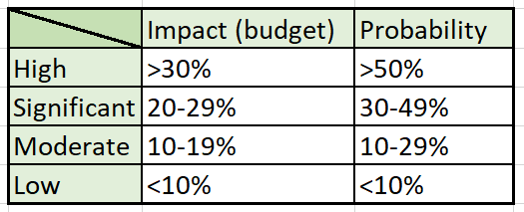
Figure 1: Risk impact and probability key.
The Figure above shows the ranges implied in the following table and matrix with regards to how the risk could impact the project’s budget and how probable they are to occur.
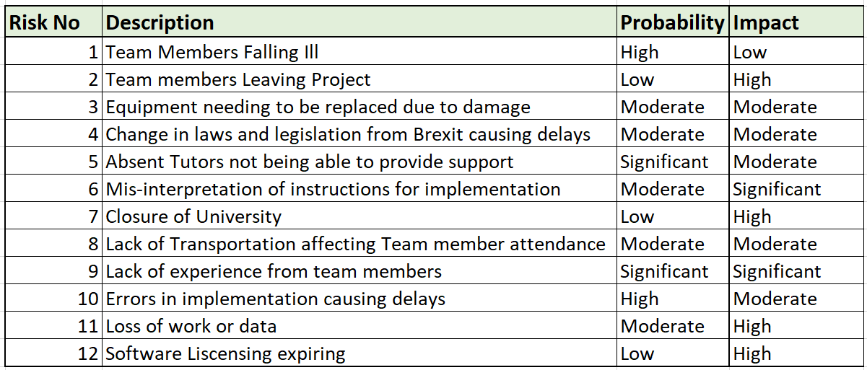
Figure 2: Risk Identification, probability and impact table.
The Figure above shows the identification of twelve risks that could occur which would impact the project. For context, the project’s budget is the time the project needed to be completed in, which is 86 days (Wed 24/10/18 – Tue 15/01/19). For example, if a risk would delay the project by seven days, then that would be less than ten percent of the project’s budget, which would be considered a low impact.
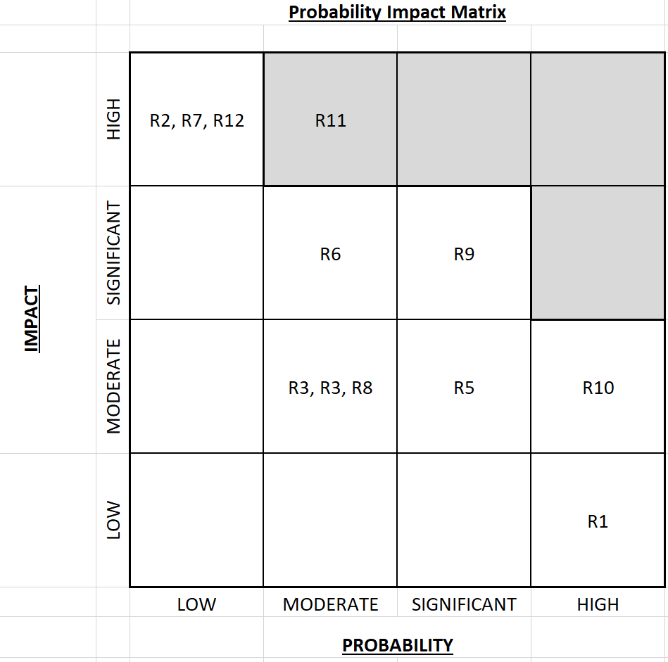
Figure 3: Probability Impact Matrix
The matrix shown in the figure above lays out the identified risks (as seen in figure 2). The purpose of this matrix is to identify the risks which can be tolerated by being in the white zone, to the risks that cannot be tolerated which are past the tolerance line in the grey boxes [2]. The risks that are in the greyed boxes need to be dealt with and have measures taken to either reduce the impact, probability or both [2].
The risk identified as being above the tolerance line was risk eleven which was the loss of data. This risks impact and probability could be reduced by purchasing an external hard drive for backing up the data. This may take a few days as the order time needs to be factored in, and a day for someone to spend on backing up the data [2].

Risk Exposure and Reduction Leverage
The risk exposure is a calculation which multiplies the probability of a risk and its impact on the budget, this calculation works best with currency values, so for context, each day in the budget was estimated to have a £5 value giving the project a budget of £430 (86 x £5 = £430) [2].
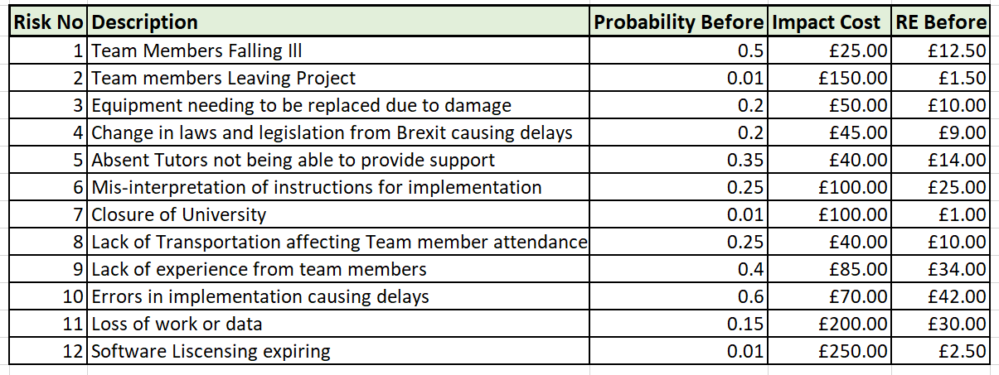
Figure 4: Risk Exposure Table TOF
The risk exposure estimates how much the real impact of a risk has on a project, it gives a guide line on how much of the budget should be spent to reduce the probability or impact of the risk [2].
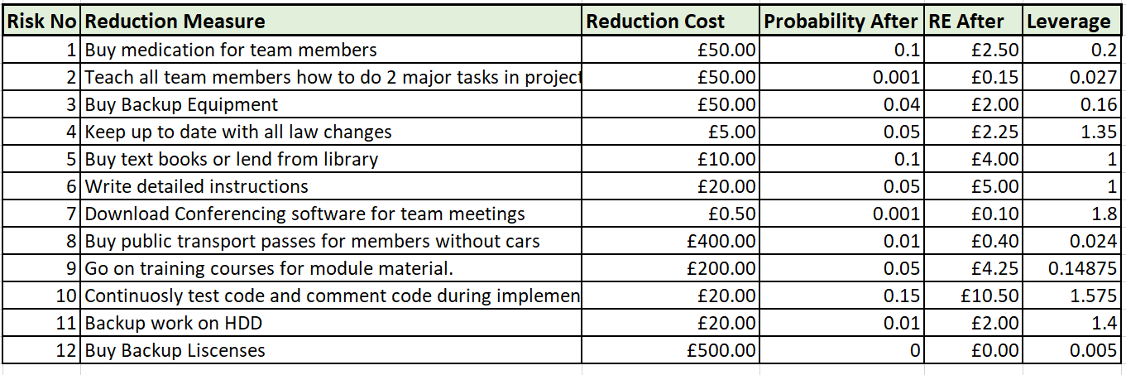
Figure 5: Risk Reduction Leverage Table TOF
The figure above shows the measure that were devised to reduce their respective risks. The cost of these reduction measures was estimated, then the probability of the risk impacting the project after the measure had been implemented was also estimated.

With this the Risk Reduction Leverage can be calculated
“(RE before – RE After)/ Cost of reduction” [3].
If the Leverage is greater than or equal to 1, then it is worth implementing the reduction measure [3].

Sustainability Issues

First Order
The development of the application involves the use of electronic equipment, which brings the sustainability issues of E-Waste with it [4][5]. The manufacture of electronic equipment like circuit boards and electronic components requires valuable materials like metals and plastics which are a finite resource [4] [5]. If disposed of irresponsibly, the environment can be affected in negatives ways, and if not addressed in the long term, a potential shortage of the valuable materials required to manufacture the required equipment could come about [4] [5]. Therefore, it is important that throughout the design, development and implementation, all electronic waste produced should be responsibly recycled or disposed of correctly to prevent environmental harm and unsustainable waste [4] [5].
Most of the design and development of the project will be carried out on the university campus, which means the universities carbon footprint will be affected [6] [5]. Through the development of the project, the team members will be using meeting rooms and computer services provided. This implies the use of electricity to light rooms and run computers, and the use of gas to heat the rooms the meetings take place [5]. Therefore, it is important that the energy be used responsibly and the consumption be reduced as much as possible. Ways this can be achieved are as –
- Opening a window blind to light up a room instead of using the lights if able.
- Wearing warmer clothes instead of relying on the heating system.
- Making sure computers are turned off and not left on standby when not in use [6] [5].
Doing this will reduce the carbon footprint of the university caused by the development of the project which reduced the green house gas emissions and prevents further harm to the environment [6] [5].

Second Order
The implementation of the product has the potential to create employment opportunities locally and in implemented areas [7] [5]. People will be needed to operate and maintain the servers that host the web application, people will need to program updates and improvements where the company is based [7] [5]. Communications experts in the emergency services will be required to respond to requests of search and rescue workers on the field [7] [5]. Local people can be trained to work as rescue workers and operate the application, so they can respond to disasters as quickly as possible [7] [5].
A benefit the implementation of the product is it will reduce the response time from the authorities to assist in area’s affected by disaster [7] [5]. Rescue workers will be able to communicate with other workers on the field in a timely manner and notify other workers of areas that have already been searched, which means the efficiency of the rescue effort will increase leading to more saved lives [7] [5].
Civilians who are injured can be helped easier by the workers who have the application as they can request specific aid from the local authorities and log their position on the map which will be relays to the emergency services[5]. The rescue workers can then move on from the injured civilian to assist others in more urgent need[5].

Third Order
If the implementation of the product is successful, it could be adopted by other emergency sectors like the police force in highly populated areas, or hospital staff getting reports of patient’s conditions worsening or improving[5].
The long-term implementation could affect already existing employment opportunities by replacing certain roles or making certain roles obsolete, like communication technicians on the field or certain search and rescue roles could be automated[5].
The more the product is implemented the more dependant the population would become on technology, which at some point could be an issue if a vulnerability in the system is exploited causing wide spread issues [6][7] [5].

Ethical and Legal Issues

Professional Code of Conduct
The implementation of the product will place the team in a position of responsibility as a company. A part of the responsibility is to adhere to professional standards set by the British Computer Society (BSC) Code of Conduct and the Institute of Electrical and Electronics Engineers (IEEE) Code of Conduct [8][9].

Public Interest
The company must have the public interest in mind, ensuring not to put their safety at risk with the implementation of the equipment required to host the network on the field [8][9]. This can be done by ensuring all electrical equipment that could cause harm is kept protected and secure from the public by using locked electrical cabinets or durable cable covering [8][9].

Professional Competence and Integrity
The company must ensure that fully qualified personnel are the only ones able to manage and maintain the equipment of their respective roles, no personnel are permitted to change or implement any software or hardware items they are not trained with [8][9].

Duty to Relevant Authority
The employees must ensure they adhere to requirements set by the relevant authorities and exercise professional judgement to avoid a situation that could result in conflict with said authority, for example, disclosing sensitive confidential information of the company for personal or a third party’s gain [8][9].

Duty to the Profession
The employees must be respectful of others in a professional manner, avoiding unfair treatment and avoiding causing harm to other members, their property, reputation or employment [8][9]. The company must not retaliate to any act of misconduct performed by a member of the IEEE or other person [8][9].

Ethical Issues
The application needs to conform to the W3C’s guidelines for web application accessibility to ensure any user with impaired ability can use the application [10]. This includes the use of high contrasting colour pallet, readable text and understandable user interface layout [10].
Due to the nature of the application, real time locations and the personal information of individuals will be tracked and communicated to a mobile device [8][9]. This means that if individuals with ill intent gain access to this information, it could put civilians or employee’s safety at risk [8][9]. Hence security measures need to be put in place to prevent sensitive information like a vulnerable individuals name or location falling into the wrong hands [8][9].
A system needs to be implemented to reduce the risk of employees misusing the information stored [8][9]. A common reason an employee would do this would be if they were going to be fired or made redundant in the company [8][9]. A way to reduce this risk is to backup all systems so in the case of sabotage, the system can be properly restored [8][9].

Legal Compliance
The application needs to ensure the user’s personal and private data is protected in accordance with the Data Protection Act 2018 [11]. The following principles outlined in the Act must be adhered:
- The first data protection principle is that the processing of personal data for any of the law enforcement purposes must be lawful and fair [11].
- The law enforcement purpose for which personal data is collected on any occasion must be specified, explicit and legitimate, and personal data so collected must not be processed in a manner that is incompatible with the purpose for which it was collected [11].
- Personal data processed for any of the law enforcement purposes must be adequate, relevant and not excessive in relation to the purpose for which it is processed [11].
- Personal data processed for any of the law enforcement purposes must be accurate and, where necessary, kept up to date, and every reasonable step must be taken to ensure that personal data that is inaccurate, having regard to the law enforcement purpose for which it is processed, is erased or rectified without delay[11].
- Personal data processed for any of the law enforcement purposes must be kept for no longer than is necessary for the purpose for which it is processed [11].
- Personal data processed for any of the law enforcement purposes must be so processed in a manner that ensures appropriate security of the personal data, using appropriate technical or organisational measures [11].
Brexit needs to be considered, as international laws relating to the transmission of data across a network could affect the implementation of the system [12]. Certain access to digital content could be restricted, which needs to be worked around to ensure the system functions in a satisfactory manner [12]. The application needs to be compliant with foreign laws regarding the transfer of digital information from UK based servers to foreign servers and vice versa [12].

Quality Assurance.

Functionality
Suitability Application needs to show up to 50 devices in a five kilometre radius on a map [13].
Application needs to allow users to report and record up to 100 locations of interest or avoidance and have their locations shown at the same within a five kilometre radius on a map [13].

Accuracy Application needs to show device location with ten meter accuracy with updates every five seconds [13].

Interoperability Application can operate on 90% of devices which run android and able to communicate the data to servers over the internet with a five second maximum response time [13].

Security Application needs security measures installed which only allow authorized personnel to access, this can be achieved with facial recognition or finger print recognition technology [13].

Reliability
Maturity Application needs to have bug report option installed during beta stage for at least two years [13].
Bug reports need to be read and corrected by staff within 72 hours during beta [13].
Patch updates need to be pushed out every one to three months depending on patch size [13].

Fault-Tolerance Application cannot hard crash more than ten times on a device in a week [13].
Application needs to run for two hours straight without crashing [13].
Application needs to be stressed tested for faults and crashes for one week before the patch updates are pushed out [13].

Recoverability Application needs to recover from a hard crash and reboot within thirty seconds [13].
Application cannot be down for more than ten hours every month for scheduled updates and maintenance [13].

Usability
Understandability Application should be available in twenty different languages after five years of coming out of beta [13].
Application needs to be tested with focus group of fifteen professionals for feedback and upgrades [13].
Upgrades implemented based on focus group’s feedback given over four weeks [13].
Test system with twenty individuals with 90% successfully understanding and passing the test [13].
Learnability Application needs an intuitive user interface that only requires one to two hours maximum of training [13].
Application needs inbuilt tutorial which lasts at least five minutes [13].
Developers are to provide support within three hours of user’s help request [13].
Operability All functions implemented in the application need to be no more than four button presses / finger taps away from any screen or menu [13].
Application needs icons and buttons which 90% of users can recognise and understand [13].
Application needs to have options to allow for different methods of screen control for users with specific interface apparatus e.g. a stylus or remote control [13].
For the application to be correctly calibrated so the application correctly responds to user input e.g. touch screen accuracy [13].

Attractiveness Applications icons, text and buttons need to be clear and sharp on 90% of devices [13].
Application should have 5 options to customise colour theme to accommodate for users with visual differences e.g. colour blindness [13].

Efficiency
Time Behaviour While the application is running, the map should update and load within two to five second to be satisfactory, if it loads in under that time then it is optimised, however if it loads in longer time then it needs to be improved [13].

Resource Utilisation Application should not use more than one gigabyte of the devices ram averaged over one minute [13].
Application should not use more than 50% of the phone’s central processing unit resources averaged over one minute [13].
Application needs to run on low specification phones with two gigabytes RAM with a duo core CPU at two gigahertz [13].

Maintainability
Analysability Faults in application need to be logged on device so they can be identified within two minutes of investigation [13].
Application needs to have an error report system which allows user to report any faults that occur and send the report of the origin and nature of the fault to the main server for later investigation [13].

Changeability Application needs to be constructed with object-oriented programming with comments explaining code, so it can be understood and changed by any programmer authorized to do so [13].
Application source code needs to be backed up every week so in the event of a bug fix causing more problems it can be reverted to a previous version seamlessly [13].

Stability Updates need to have under a 20% risk of the application crashing or exhibiting unwanted results [13].
Application code needs to be modifiable and stable to prevent unexpected results occurring [13].

Testability Application needs to be implemented with test harness code to allow for repeatable and consistent test parameters to give more accurate and conclusive results [13].

Portability
Adaptability Application needs to function on 95% of mobile phone devices. This can be achieved by developing it as a web application which the device can access through the inbuilt internet browser [13].

Co-Existence Application needs to have the ability to function on all web browser for mobile phones like Opera, Chrome, Firefox, Edge and IE [13].
Application needs to function on devices which have been installed with other third-party software like anti-virus and anti-malware suites like AVG and Avast [13].

Replaceability Application needs to function on a replacement device in the event the current device encounters a fatal error. This will be done by developing the application as a web application, so it can be accessed the same from any device [13].

Conclusion
To ensure the project was manage appropriately, the potential risks were identified, and their impact and probability was outlined in a probability impact matrix [2][3]. These risks were then evaluated and suitable methods to reduce the respective risks were devised, this then allowed for the calculation of the reduction leverage which identified the reduction methods worth implementing [2][3].
Key areas of concern identified in this area were –
- Loss of data.
- Changes in Law.
- Poor implementation of code.
The sustainability of the development and implementation of the product was analysed and the first, second and third order impacts were discussed, and the findings suggested the product’s negative impact would be increased GHG emissions and power consumption, which could be reduced with responsible action [4][5][6][7]. The positive impact would be the saving of lives in areas of disaster [4][5][6][7].
The BCS and IEEE code of conduct were outlined with an investigation of the possible ethical issues that the product would bring about, and possible ways to handle these issues were identified [8][9]. The legal implications about data protection and the effects Brexit could have on the product were discussed and the findings showed that the transmission of data and the access to certain digital content being restricted would be the biggest cause of complication [11][12].
SMART measures were made for the functionality, reliability, usability, efficiency, maintainability and portability were created to ensure the quality of the product was assured at all stages of the development [13].

References
[1] A. Mishra and D. Mishra, “Software project management tools,” ACM SIGSOFT Softw. Eng. Notes, vol. 38, no. 3, p. 1, 2013.
[2] J. L. Ferguson, “Excessive risk exposure: A question of ethical decision-making,” 2014.
[3] “Risk Reduction Leverage.” [Online]. Available: http://syque.com/improvement/Risk Reduction Leverage.htm. [Accessed: 30-Jan-2019].
[4] X. Zeng, C. Yang, J. F. Chiang, and J. Li, “Innovating e-waste management: From macroscopic to microscopic scales,” Science of the Total Environment, vol. 575. pp. 1–5, 2017.
[5] G. Silvius, “Sustainability as a new school of thought in project management,” J. Clean. Prod., vol. 166, pp. 1479–1493, 2017.
[6] “Sustainable Energy-without the hot air,” 2009.
[7] M. U. Ben-Eli, “Sustainability: definition and five core principles, a systems perspective,” Sustain. Sci., vol. 13, no. 5, pp. 1337–1343, Sep. 2018.
[8] “Trustee Board Regulations Schedule 3 v5-Code of Conduct for BCS Members BCS, THE CHARTERED INSTITUTE FOR IT TRUSTEE BOARD REGULATIONS-SCHEDULE 3 CODE OF CONDUCT FOR BCS MEMBERS.”
[9] “IEEE - IEEE Code of Ethics.” [Online]. Available: https://www.ieee.org/about/corporate/governance/p7-8.html. [Accessed: 30-Jan-2019].
[10] W3C, “Web Design and Applications - W3C,” webpage, 2016. [Online]. Available: https://www.w3.org/standards/webdesign/. [Accessed: 15-Dec-2018].
[11] “Data Protection Act 2018.”
[12] “Digital Brexit Planning for a successful digital future outside of the EU.”
[13] K. Kinser, “Questioning Quality Assurance,” New Dir. High. Educ., no. 144, pp. 15–25, 2008.

