

Virtual learning environment (VLE) – Moodle on students’ learning experience at the University of Wales Trinity Saint David London Campus

Student name: Desislava Kubovcikova
Student number: 2115207
Module Title and Code: Digital Skills and Research Methods (BMSW4003_LON)
Lecture name: Asim Satti

Table of Contents
Introduction to VLE 3
Advantages of distance learning 4
Easy and simple to use 4
Flexible and convenient 6
Cost effective 7
Mobile access 7
Disadvantages of distance learning 8
Challenges and future of distance learning 10
Conclusion 12
References 14

Introduction to VLE
Distance learning has significantly increased in popularity among educators, students and even business organisations due to its numerous advantages and external drivers’ influence, such as the COVID-19 pandemic. In a post-COVID world, approximately 64% of middle schools use digital learning tools on a daily basis and more than 80% have taken actions to implement a virtual learning environment in their operations (Moran, 2021). Since 2020, more than 95% of universities moved classes online and apply digital platforms for sharing resources and for communicating with students (Moran, 2021). In addition, 81% of students claim that the e-learning tools provided by their education organisation help them significantly in order to improve their grades (Moran, 2021). As shown below, students express a strong preference towards digital learning tools and would use them even after the pandemic.
Figure 1 – Preferences for post-pandemic use of e-learning tools
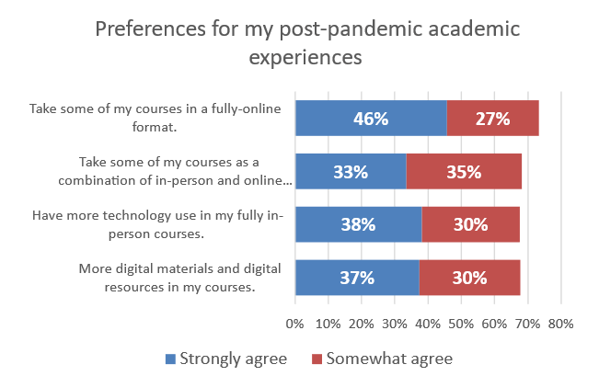
Source: Moran (2021)
By definition, a virtual learning environment (VLE) is a learning management system which is designed and aimed at supporting the teaching and learning process over a digital network; thereby, allowing participation from remote locations (Alhogail and Mirza, 2011). It is integrated with university administrative systems and provides them with numerous opportunities for enhancing and enriching the quality and effectiveness of the education process. Especially since the outbreak of the pandemic, VLEs are perceived as one of the most successful and appropriate solutions for education organisations to cope with such challenges and operate efficiently in times of crisis.
This paper aims to examine the benefits and drawbacks of VLEs in the context of Wales Trinity Saint David London Campus. The analysis is conducted on the basis of primary and secondary data.

Advantages of distance learning

Easy and simple to use
There are many advantages of VLEs which are obtained by universities, teachers and students. One of them refers to the ease and simplicity of using such platforms. As stated by Alves et al. (2017), this is the main reason of the direct link identified between the use of distance learning and academic performance of students. Dung (2020) also supports this view by suggesting that the combination of easy access and resource availability tends to positively affect learners’ motivation to perform better and improve academic achievements.
This is also confirmed by the primary data collected from ten participants regarding the use of Moodle at the university.
According to 70% of the participants, Moodle is very easy to use. Easiness to use is also pointed out by 80% of participants as an advantage they like most about the platform.
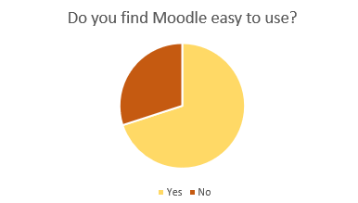
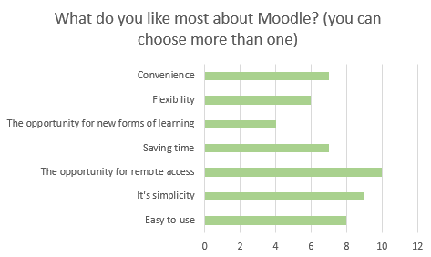
It should be noted that the easiness of use depends significantly on two main factors – the design of the platform and its tools provided to learners on one side and the assistance and guidance provided by tutors on the other side. As reported by the surveyed students, teachers have been very helpful in this regard, which results in greater enjoyment and easiness of use of digital resources. This also contributes to an improved level of efficiency and quality of education.
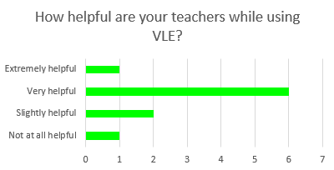

Flexible and convenient
Flexibility and convenience are two of the other most common advantages identified by both primary (see figures above) and secondary data. Arslan and Kaysi (2013) suggest that VLEs provide a high degree of convenience, as they allow the provision of feedback and resources by tutors and access by students at any time 24/7. Also, as all resources are organised at one place, this leads to greater convenience of accessing materials, past papers, exam information, course resources, past performance track records and everything else needed by both educators and students; thereby, further increasing the overall quality of learning process (Arslan and Kaysi, 2013). The opportunity to provide materials through a digital channel also allows the use of different types and formats of resources, further increasing the flexibility of the teaching and learning process (Arslan and Kaysi, 2013). Thus, it is possible to better address the specific needs of learners.
This is also confirmed by the students at the university. As visible below, the majority of them considers digital resources as quite helpful and useful.
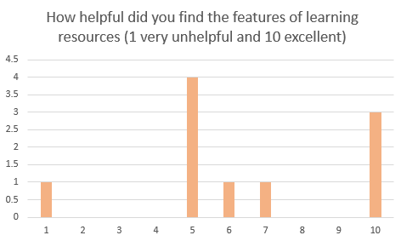
This is also evident by the time spent online on Moodle, which is between three and five hours per day for 60% of the participants and between six and eight hours per day for 20% of the respondents.
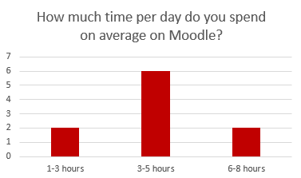

Cost effective
Apart from the advantages mentioned above, the use of VLEs and online learning tools is also cost effective and affordable for universities (CIF Training, 2018). This is due to the fact that it is not necessary for students or educators to travel (Arkorful and Abaidoo, 2014). The high cost efficiency is also achieved from elimination of the need for printed materials and the provision of hard-copy resources in cases they can be substituted with digital alternatives. There is also an opportunity to teach more students at once due to lack of physical restriction of traditional learning environments (Arkorful and Abaidoo, 2014; Posey, 2010). Furthermore, distance learning allows universities to conduct entirely online classes and courses, which can be added to their existing portfolio; thereby, maximising efficiency of operations.

Mobile access
Another significant advantage of distance learning is the mobile access delivered to both teachers and students. The remote access ensured by VLEs allows the involved stakeholder groups to participate in the educational process from different locations, regardless of geographical and physical barriers (Arkorful and Abaidoo, 2014). This was crucial during the pandemic and the lockdowns when social distancing was prioritised and face-to-face classes could not be organised. This also leads to higher motivation of students, as it allows them to use resources from everywhere and establish own pace and convenience, which also contributes to improved academic performance and achievements (Alhogail and Mirza (2011). The mobile access also provides opportunities to use resources from different devices, depending on the availability and capabilities of students. This is also confirmed by the primary data collected. As shown below, students use laptops, desktop, tables and smartphones for distance learning purposes, confirming the importance of this advantage and the variety of equipment used.
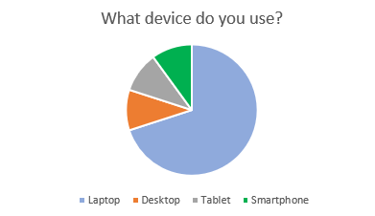

Disadvantages of distance learning
Despite the advantages experienced by having an effective VLE implemented in the educational process, there are also some drawbacks. They have to be monitored by the universities and controlled by the use of appropriate tools and mechanisms.
The effectiveness of distance learning often depends significantly on the degree of self-discipline students have (CIF Training, 2018). This is the case as, in the majority of time, resources are used according to individual convenience and self-pace of learners. Also, as classes are conducted online, it is more difficult for direct teacher supervision to take place. As a result, students need to use self-discipline to stay focused and obtain the maximum benefit and value of the lesson. Due to all this, distance learning can turn out to be more difficult and challenging for students who tend to procrastinate or experience issues in managing own time and focusing on study tasks (CIF Training, 2018).
Furthermore, distance learning is impersonal and lacks direct human interaction which can also negatively affect students’ motivation and engagement in the learning process, as well as communication and social skills (CIF Training, 2018). The virtual environment tends to be perceived as more automatic and mechanical and not so social; thereby, having an adverse impact on students’ motivation and engagement, especially in cases where learners with greater social needs are discussed (Alhogail and Mirza, 2011). This can demotivate students significantly and affect their willingness and ability to study in the long-run, even if digital learning is replaced by conventional learning environment.
In addition to that, as distance learning is entirely delivered through digital channels and various pieces of software and hardware. Thus, it remains quite dependent on the quality, maintenance and performance of integrated and used technology. This makes the process vulnerable to different potential technological issues which can jeopardise the education process (CIF Training, 2018). Classes can be interrupted, resources may not be accessible and/or interactions between students and teachers may not be possible. This can lead to many additional problems. For example, if a technological problem occurs during an exam or any other form of assessment, students would not be able to complete it. This is a risk with potential long-term impacts on their track record, performance and grades. Technological issues can lead to loss of material, wasting time to fix the problem and decreasing motivation, engagement and focus during class time (Arslan and Kaysi, 2013).
The reliance on technology and lack of direct supervision may also provoke and encourage the use of academic dishonesty practices, such as cheating on exams. This can be more difficult to be tracked down and identified by invigilators when conducting the exam online and, in this way, may decrease the quality and output of the education process.
Another disadvantage of distance learning is its inappropriateness for any type of educational content. For example, practical experiments in chemistry or biology can hardly be taught online and not in a specific lab environment (O’Leary, 2003). The substitution of conventional learning environment with digital options in these cases may discourage the interest and motivation of students; thereby, imposing risks on their comprehension and understanding of the material.
The impact of various disadvantages of VLEs on student performance and motivation are also evident from the primary data collected. Participants identify several main areas for improvement of Moodle, including easier menus/tabs, more user-friendly interface, more resources available, better guidance of tutors and improved technical support.
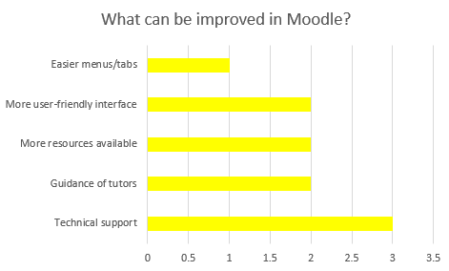

Challenges and future of distance learning
Distance learning is a trend which appears to be quite sustainable in the future. Regardless of the associated drawbacks and issues, the benefits and opportunities delivered to universities, teachers and students are considered to be quite significant and offsetting the risks. This, however, means that all challenges for the proper implementation of VLEs in specific organisational context should be carefully considered and addressed. As also evident by the primary data collected, students generally enjoy Moodle and the corresponding opportunities provided by distance learning at the university. However, 30% of respondents feel below average when this platform is assessed. This is an important piece of information worth being investigated in more details in the future.
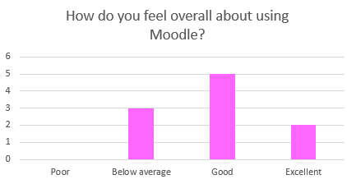
The main challenges associated with distance learning are related to the drawbacks identified in the previous section and the tactics which can be used by universities to propose alternative solutions. Edvantic (2021) proposes a 12-elements online learning challenges grid, shown below, outlining the main concerns when distance learning is applied. These include solving technical issues, providing adequate instruction and ensuring effective communication, delivering continuous feedback, addressing digital and technical skills gap, adopting required changed from traditional to digital organisational model, ensuring proper time management, planning appropriate assessment, addressing and considering how different learning styles will be fulfilled, changing course design and lesson planning, increasing collaboration and adaptability and exploring ways to maintain high student engagement, focus and motivation (Edvantic, 2021).

Figure 2 – Distance learning challenges
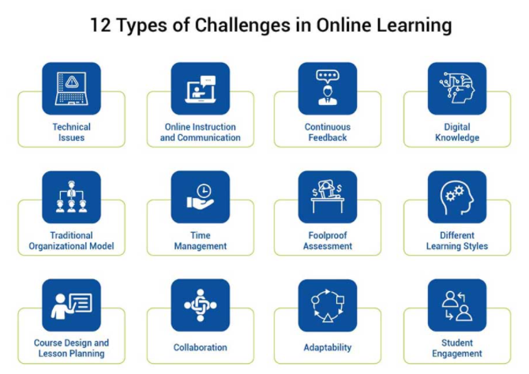
Source: Edvantic (2021)
Every university should address these challenges based on individual context in terms of learning needs, curriculum design, resources and staff capacity. Regardless of these challenges and implications, e-learning is a trend which has grown with more than 900% since 2000 (Moran, 2021). This ratio is expected to increase significantly during the next decade (Moran, 2021). The majority of education institutions are investing in distance learning capabilities which are expected to become a main source of distinction on this competitive market.

Conclusion
To sum up, the COVID-19 pandemic has been just one of the drivers outlining the importance and value of VLEs and distance learning for education organisations. E-learning has become a necessity for many organisations due to restrictions on physical movement and contact during lockdowns. The contemporary situation has revealed the importance of digital channels for teaching and learning purposes, as well as the wide pool of opportunities available to users. Nevertheless, there are many challenges and drawbacks which need to be considered when deciding to implement e-learning at university. The advantages of this method; however, tend to outweigh the existing drawbacks. This is proven not only by relevant academic work and statistics, but also by the primary data collected at Wales Trinity Saint David London Campus and discussed as a part of the report.

References
Alhogail, A. and Mirza, A. (2011) Implementing a Virtual Learning Environment (VLE) in Higher Education Institution: a Change Management Approach, Journal of Theoretical and Applied Information Technology, Vol. 31(1), pp. 42-52.
Alves, P., Miranda, L. and Morais, C. (2017) The Influence of Virtual Learning Environments in Students’ Performance, Universal Journal of Educational Research, Vol. 5(3), pp. 517-527.
Arkorful, V. and Abaidoo, N. (2014) The Role of E-learning, the Advantages, and Disadvantages of Its Adoption in Higher Education, International Journal of Education and Research, Vol. 2(12), pp. 397-410.
Arslan, F. and Kaysi, F. (2013) Virtual Learning Environments, Journal of Teaching and Education, Vol. 2(4), pp. 57-65.
CIF Training (2018) The Advantages and Disadvantages of Virtual Learning, [online] Available: https://ciftraining.ie/2018/01/advantages-disadvantages-virtual-learning/ [Accessed: 26 December 2021]
Dung, D. (2020) The Advantages and Disadvantages of Virtual Learning, IOSR Journal of Research and Method in Education, Vol. 10 (3), pp. 45-48.
Edvantic (2021) Learning Blues: The Key Challenges and Solutions for Online Education, [online] Available: https://www.edvantic.com/blog/learning-blues-the-key-challenges-and-solutions-for-online-education [Accessed: 26 December 2021]
Moran, M. (2021) 30+ eLearning Statistics 2021: Facts, Trends, Demographics and More, [online] Available: https://startupbonsai.com/elearning-statistics/ [Accessed: 25 December 2021]
O’Leary, R. (2003) Virtual Learning Environments, [online] Available: https://www.alt.ac.uk/sites/default/files/assets_editor_uploads/documents/eln002.pdf [Accessed: 26 December 2021]
Posey, G. (2010) The Advantages and Disadvantages of the Virtual Classroom and the Role of the Teacher, [online] Available: http://swdsi.org/swdsi2010/SW2010_Preceedings/papers/PA126.pdf [Accessed: 26 December 2021]

