MODULE TITLE: BUSINESS SKILL

ASSIGNMENT TITLE: ANALISYS SWOT AND PDP TO FIND A JOB

STUDENT NAME: EMANUELA STAN

STUDENT ID NUMBER: 1815346

LECTURER NAME: DALE CLARK





Introduction………………………………………………………………………………3
SWOT…………………………………………………………………………………….3-4
Personal Development Plan……………………………………………………………5
Academic and Employability Skills……………………………………………………..6
Conclusion………………………………………………..............................................7
References………………………………………………………………………………..8

I have to set up a report using SWOT and PDP to separate my educational and work capacities and to include how I hope to use these aptitudes to get another profession in the motel and cabin industry.
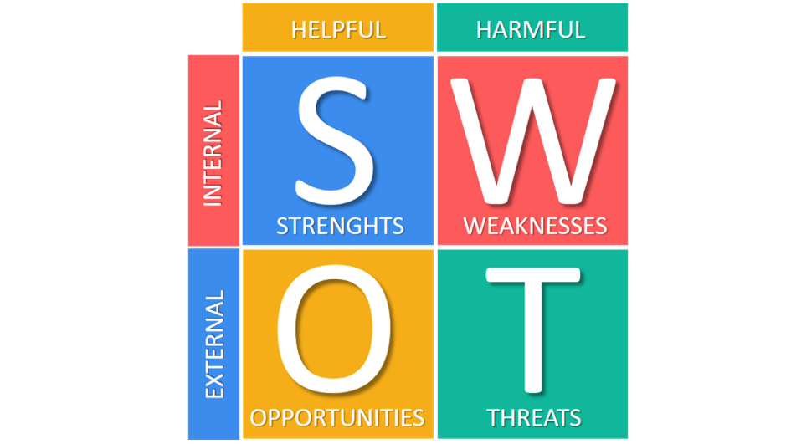

Introduction

For this errand, I have been assigned to build up an individual SWOT that disengages my present sharp and employable aptitudes. Using this information, I will be able to know how to plan to use these aptitudes to find future work in the hotel business.

By managing my very own uncommon examination and have found that in the cabin business and past, care is fundamental, and administrators look for excellent aptitudes in their future managers.

That is the reason, by finishing a certified SWOT examination, it is surprisingly a mind blowing structure for understanding your central focuses, short comings and dangers, understanding that I the necessary aptitudes to be used in the motel business, yet I realise that I still lack the sufficient knowledge and know what I must do to obtain it.
In the end the ultimate goal I to soak up as much information and practical experience possible to ascertain a position within the management work place.

THE SWOT ANALYSIS OF EMOTIONAL PERSONAL COMPETENCES

SWOT investigation is, truth be told, a strategy that distinguishes qualities and shortcomings and analyses the chances and dangers of a venture, activity or individual and can be utilized as an asset report thing.

When all is said in done, there are two manners by which a SWOT examination can be utilized: for expert or individual purposes. For individual purposes, SWOT examination can be utilized to screen an individual's vocation, taking note of the aptitudes and issues that this individual has. In an expert setting, SWOT examination can be utilized to quantify the productivity of a business or undertaking.
Personal SWOT Analysis

John Maxwell, in his book the 15 Laws of Personal Development, conceptualized this principle as the Law of Intention. "Development does not just happen on its own. a need for growth to grow. No one has ever developed by chance.

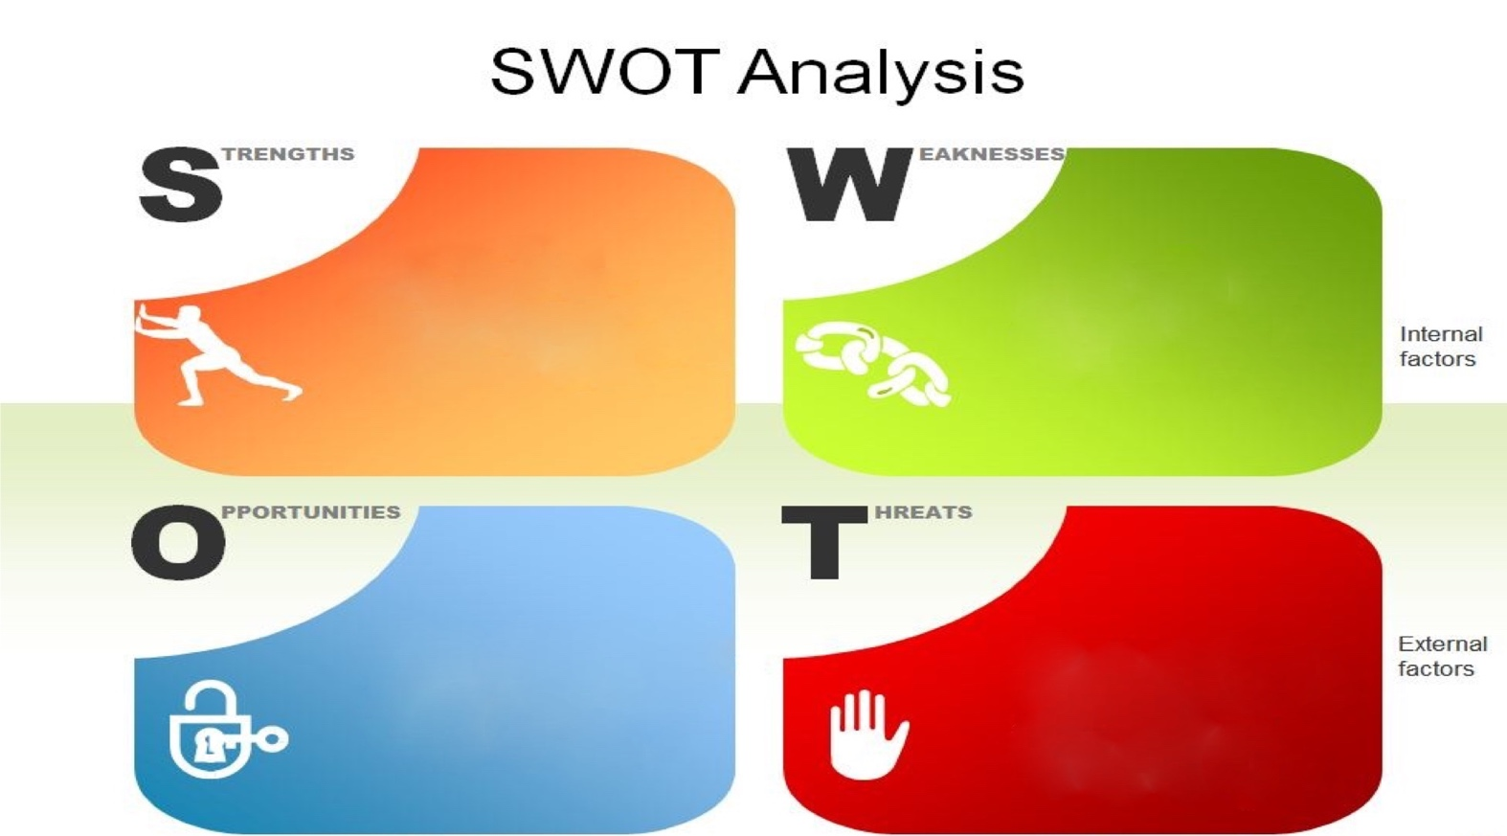

-organization
- the fact of feeling
uncomfortable when you
have to talk in front of a crowd
- holding off
projects
-poor listening skills.
- very good project
management skills
-the ability to improve a product or regroup
- Working experience with large
teams of people
- Very good skills in customer service

- Go to post-
graduate courses and
finish your license courses
- I want to enrol in a public
speaking course
- I'm looking for more opportunities to speak to an audience
-Other candidates
have graduate degrees
in this field
- Others do better than I can to
speak in public
-I'm too trusting and naive

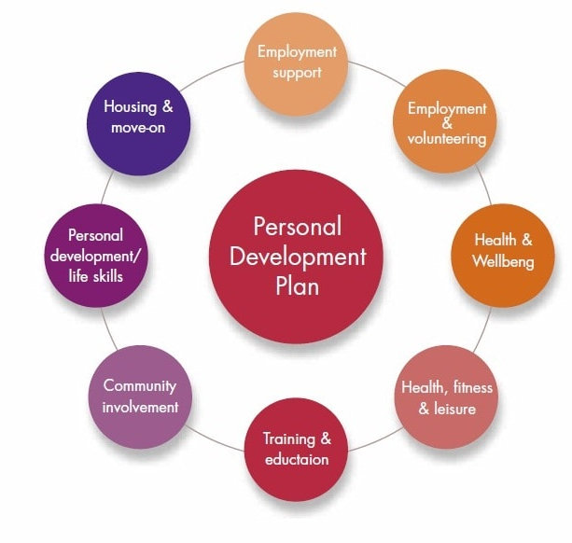

Personal Development Plan

I solidly accept that an individual and expert improvement plan ought to be actualized at any rate from pre-adulthood. An individual arrangement - even exactly - is important to develop, create, change us. It is incredibly valuable for everybody's future, for the eventual fate of our youngsters (since they duplicate us in what we do) and particularly for the fate of this nation.

John Maxwell, in his book, the 15 Laws of Personal Development, conceptualized this rule as the Law of Intention. "Improvement does not simply occur alone." There is a requirement for development. Nobody has ever created by some coincidence.

The Personal Development Plan is the irreplaceable apparatus for individual or corporate achievement. A Personal Development Plan (PDP) must contain in any event the accompanying sections:

- core values,

- the individual SWOT investigation and the technique to be followed in this regard,

- individual jobs, jobs/bearings of action, association, arranging,

- association of the recharging and constant advancement movement.

Clearly, there are demotivating factors we all in all know, anyway we need to fight them: I'm on edge about not stirring up, it's not the time now, I haven't the foggiest how to make myself, before I start I should be influenced it's the best way I'm not in a similar class as the others, what others will say if I don't get consequently. My personal growth plan fuses the going with: Improving my English language to make progress for the duration of regular daily existence, to do all that I have proposed, it is absolutely critical to impart in English easily. I can do this by taking some English activities, both on the web and with an instructor. I in like manner need to chatter with various understudies or different people imparting in English. This should be conceivable by going to courses, various activities formed by the school, distinctive social affairs.

 | What would I like to achieve in the following three to a half year? | What would I like to achieve in the following a half year to two years? | What would I like to achieve in the following a few years?
What are my general goals that I need to achieve in this timeframe? | -learn to listen to others more frequently  -make small steps to speak in front of others  -express myself better | -listening to others expands knowledge  -get rid of fear to stand in front of others  -be confident when expressing myself | -utilise new found listening skills to better myself  -happily, talk to an audience with confidence  -express myself positively
What exactly do I have to learn? Which ventures do I have to deal with? | -be organised  -do not hold off doing a project  -learn how to plan a project from start | -be prepared  -start doing better project  -finish it in time | -be positive  -start doing project in a week or so  -add more useful information
Which way will I secure the aptitudes and information? How am I going to do this task? | -be ready  -plan it out  -refer to the question | -be communicative with the teacher to find more information out  -set it out | -be on point  -always refer to the question and add a lot of information

Academic and Employability Skills
Employability capacities are normally seen as crucial abilities for a few, work positions and in this way have ended up being essential for an individual's business achievement at practically any level inside a business circumstance.
Employability aptitudes consist of abilities and skills that aid graduates to pick up work and be effective in their chosen careers as they explore their way through the vastness of this dynamic work place. In the work place you need show the managers that you have what it takes to lead through the skills you gained and use all your experiences to show them your capabilities.
8 basic employability aptitude
1. Correspondence listen and get it
2. Collaboration add to profitable working connections and results
3. Critical thinking apply critical thinking procedures over a scope of regions
4. Self-administration have an individual vision and objectives
5. Arranging and sorting out see present moment and long haul arranging
6. Innovation have a scope of essential IT abilities
7. Learning-have excitement for progressing learning

8. Activity and endeavour make an interpretation of new thoughts enthusiastically

Conclusion

Like most individuals, I have likewise made plans for my future and will strife do all that I have to reach my ultimate goal. I truly like the travel and inn industry, this is the reason I picked this course and I know I need to work hard in this business. That is the reason I chose this university as it had this fantastic course to get to know everything that is required to accomplish this.

I for one think about that in the travel industry and lodging industry you have numerous offices and the chance to consolidate work with delight through various outings and knowing various nationalities, you begin to know the traditions and customs of individuals from various societies.

In the wake of finishing my examinations, I need to work in the travel industry or similar fields, we all know what it takes to succeed in this profession and how hard and competitive it can be! However we also know the rewards it brings. Considering that at present I have no experience in the business, I plan to begin working in the lodging industry and start at the bottom, then develop myself further as I go along after which I propose to progress on a higher position, for example, management.

I think this post is perfectly suited for me and I'm certain I can deal with the difficulties that come with dealing with various cultures, needs and so on, regardless of whether it's a vocation that requires a great deal of information and expertise, it presents you loads of fulfilment.

Reference

Bridgewater UK. (2018). What is a Personal Development Plan and What Can it Mean for you? [online] Available at: https://www.bridgewateruk.com/2016/09/care plan/[Accessed 14 July 2019].

· Lowden, K., Hall, S., Lewin, J. furthermore, Elliot, D. (2018). [online] Educationandemployers.org. Open at: https://www.educationandemployers.org/wp-content/moves/2014/06/employability_skills_as_pdf_-_final_online_version.pdf [Accessed 15 July 2019·

Mindtools.com. (2018). SWOT Analysis – Discover New Opportunities, Manage and Eliminate Threats. [online] Available at: https://www.mindtools.com/pages/article/newTMC_05.htm [Accessed 16 July 2019].

· ZEHR, A. (1988). NEW OFFICE ECONOMY open at: http://connection.ebscohost.com/c/articles/328988/new-office-economy-putting-dynamically obvious requesting schools, [Accessed 17 July 2019].

· Youthcentral.vic.gov.au. (2018). Employability Skills | Work Skills | Youth Central. [online] Available at: https://www.youthcentral.vic.gov.au/organizations and-purposes for living/plan-your-work/8-work aptitudes you-should-have [Accessed 17 July 2019].

Employability Skill (2019) Available at: https://careerwise.minnstate.edu/livelihoods/employability-skills.html [Accessed 17 July 2019].

