Business Information Technology
Application Development Report
Application Development
Runa Bibi (1702463)
10-12-2018

Table of Contents

Introduction 2
Application Development Concepts 2
Web design principles 2
Usability and User Experience (UX) 2
Requirements 3
Design 5
Implementation 6
Evaluation 14
References 19

Introduction

The following report will contain web design principles and usability and user experience. It will also contain a description of the website being made and the requirements of the website. Design principles that have been implemented in the website and functionality of the main scripts and classes that provide core functionality to the website will be described. An evaluation of the finished website including verification and validation of requirements and assessment of its design, usability and content will finalise the report, followed by references.

Application Development Concepts

Web design principles

One web design principle is visual hierarchy [1]. One way this can be implemented is by using colour i.e. classifying information using different colours, so you can represent each category of information with a colour [2]. Size is another way to establish hierarchy in a website. Whatever you think the user will want to reach first should show its importance by being larger than other elements in the website to allow the user maximum chance for engagement [3]. A popular layout for websites is the ‘F-shaped pattern’ [4]. This is the most natural way for reading for must users i.e. left to right as well as top to bottom [4]. It is important to keep the content simple and not have any unnecessary functions or design elements because the user will have visited the website to perform an action and will not want anything making it harder for them [5]. Another important web design principle includes the “paradox of choice” [6]. This is the idea that the more choice a user has, the less likely they are to make a choice. Therefore, it is important to keep your choices cohesive and keep your navigation menu short and simple [6].

Usability and User Experience (UX)

Usability is the ease of use and access to a website [7]. Responsiveness is an important part of usability which is formatting the website, so it can be viewed on any device the user wishes to choose e.g. a mobile phone or tablet [8]. Remaining consistent throughout your website is vital in designing an effective user experience since it will make your content clearer and make it easier for the user to navigate your website, making them less likely to leave [9]. Morville states to have a meaningful user experience information has to be: useful, usable, desirable, findable, accessible and credible [10]. Another tip for good user experience is to make use of white space as it makes content more comprehensible and according to Crazy Egg user attention increases by 20% when there is white space surrounding titles and text [11].

Requirements

The website will be about the show ‘Brooklyn Nine-Nine’. Its purpose will be to inform people of its basic plot, episodes so far and main characters as well as encourage users to start or continue watching the show. The target audience is fans of the show and people who want to find out more about the show. As shown by its recent renewal thanks to fans after being cancelled, the show is relevant in highlighting issues and portraying healthy relationships and representation which makes the website relevant.

I will be using the IEEE software requirements specification technique [12] to document the main requirements of the website.

Scope
The website will inform its users of the show Brooklyn Nine-Nine and be used to find out any of the latest news about the show in one place. It will encourage users to watch the show or continue to watch the show.

Product Perspective
The website will be its own product, but the information will be gathered from other sources. It will be accessed through the web via a client server model.
Product Functions
The website will allow the user to get quick access to information on Brooklyn Nine-Nine and keep up to date with any news. They should be able to access the website on many different platforms including desktop and mobile.

User Classes and Characteristics
The typical user of the website should have knowledge on using the internet and by keeping the website consistent and easy to use, it will make it user-friendly enough for anyone to use.

Operating Environment
This will be on the web and so the user will require a browser which supports HTML5.

Design and Implementation Constraints
The website must be designed and implemented by the deadline 10/12/2018. It will be made in Visual Studio and must include JavaScript.

Hardware Interfaces
Any device that the user uses to access the website must have access to the Internet.

Software Interfaces
The browser which is used must have HTML5 support.

Functional Requirements
- The user should be able to access what they need to find out in less than 3 clicks
- High priority
- This will increase the relevance of the website and make it more reliable, so it is important as more users will visit
- The website will not have more links than necessary and have pages clearly labelled so this should be successful
- The user should be able to read all text clearly and see all images regardless of browser
- High priority
- This requirement can be maintained using breakpoints and viewports
- The website should be user-friendly and make use of design principles
- High priority
- The user should able to find relevant information on Brooklyn Nine-Nine
- High priority
- All vital information will be included in the website
- The user should be able to read news on Brooklyn Nine-Nine
- High priority
- Up-to date news articles will be linked on the homepage of the website
- The articles may be taken down so this will be regularly checked by the administrator

Performance Requirements
The website should be responsive so that there are no delays from the user interaction to the action being taken. For example, any time a link has been clicked its destination page should be reached in less than 2 seconds to avoid user frustration. Also, any time a button is clicked the response should seem instantaneous.

Safety Requirements
As the website is not taking any sensitive information on the user but is mostly an informative website it does not require substantial security. However, the browsing should still be secure using HTTPS.

Software Quality Attributes
- Adaptability – The website will be adaptable for many browsers
- Reliability – The information will be updated by the administrator and stay reliable
- Usability – The website will be user-friendly and have suitable navigation

I will be using the breakpoints 480px for small devices, 767px for medium devices and 979px for large devices. The meta viewport setting [13] will be implemented on all the web pages. I have used equal column sizes i.e. col-sm-6 so that they will automatically stack for mobile view. This keeps the text readable and the images good quality to view.

Design

I have used the design principle of the ‘F-shaped pattern’ so information goes from left to right and from top to bottom which makes the overall experience and readability more enjoyable. I have also used minimal links on the header and footer so whatever the user wants to find can be done quickly. Also, the website is responsive, so the website can adapt to any major browser and mobile view. I have also used text size to show priority of the text.

Implementation

The following are the JavaScript functions I have used in the website.
- This function was used to hide the episodes when you first open the website and to click a button to reveal them
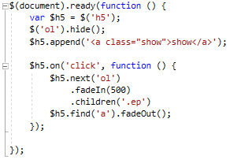
- This function was used to show the episode which the events were being described from on the ‘Peraltiago’ page
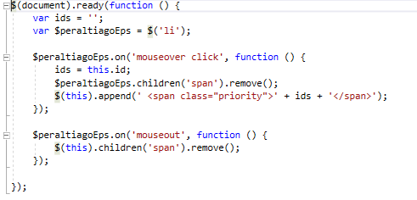
- This function added functionality to my slideshows on the ‘Peraltiago page’
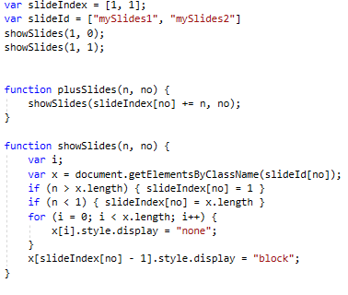
- This function allows the user to add a comment on the fans page
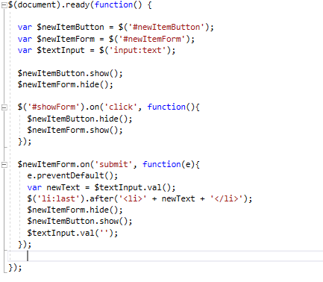

The following are screenshots of the website.
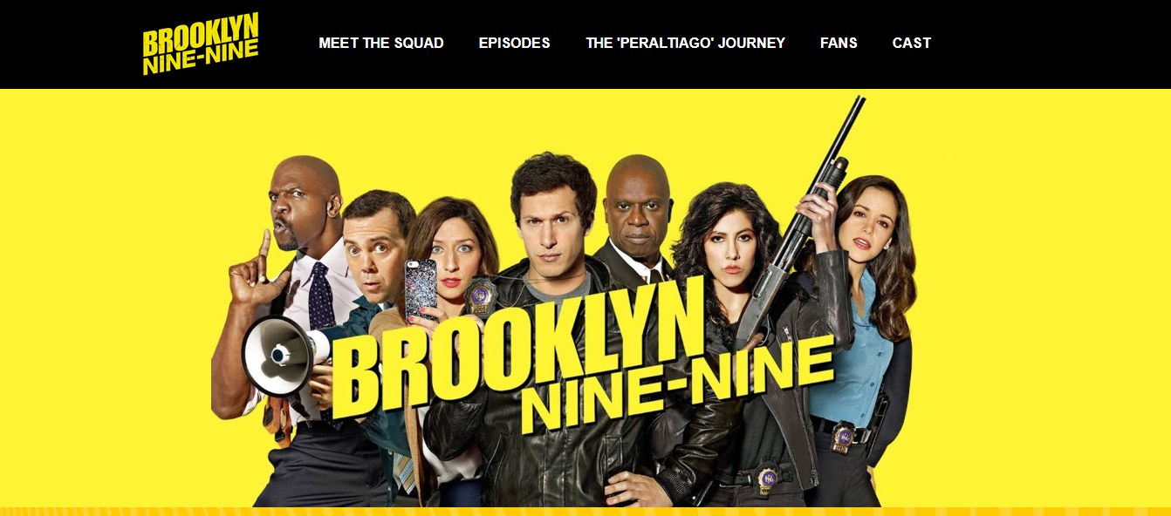
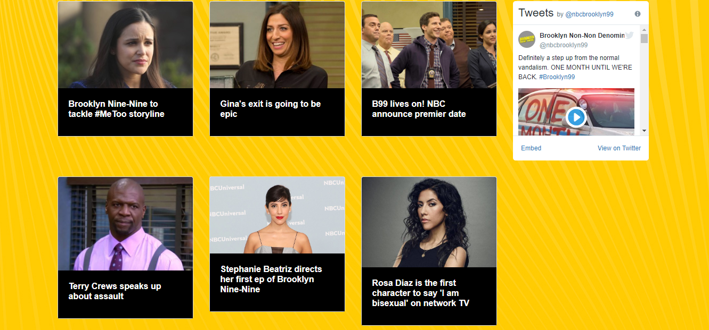

Mobile view:
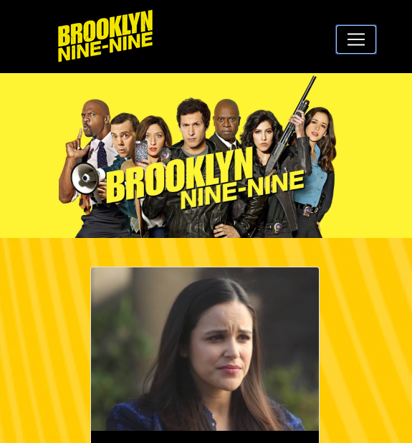
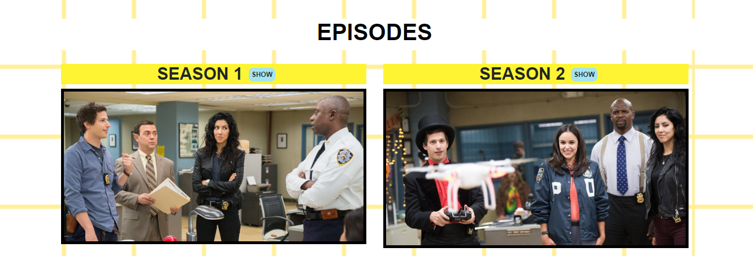
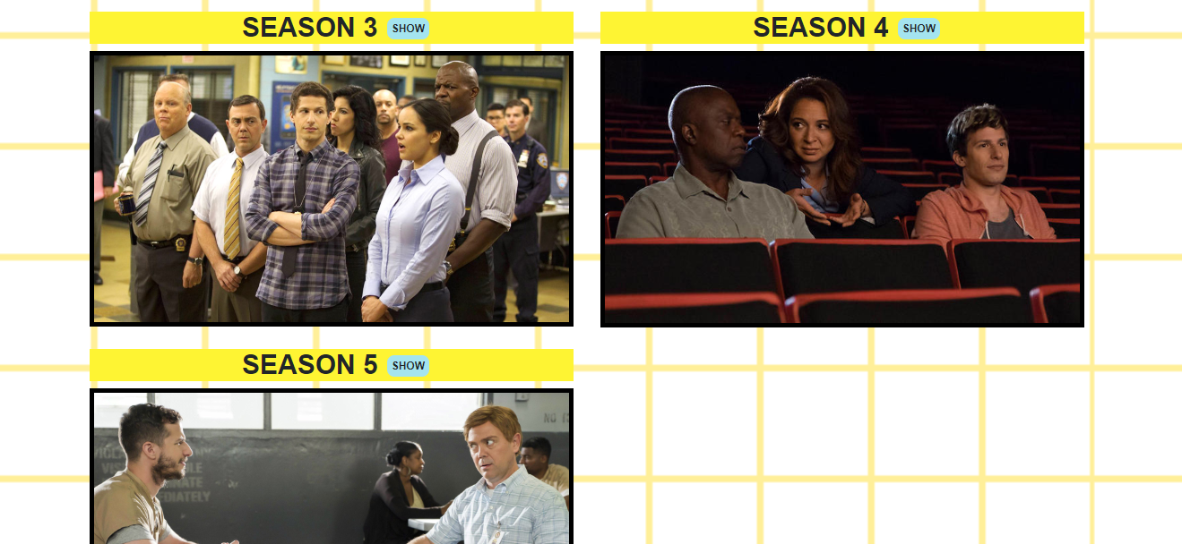
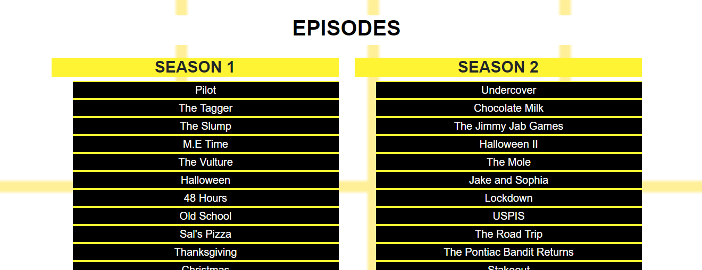

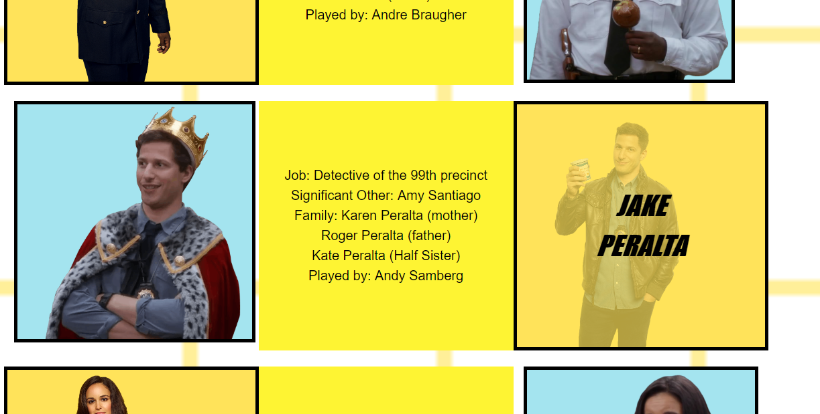
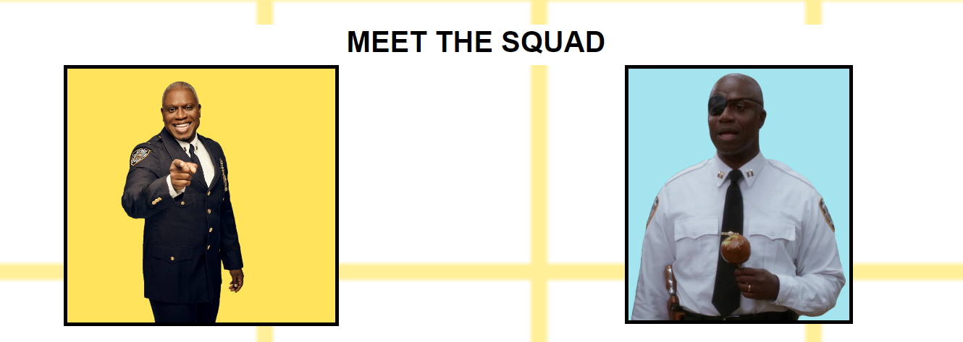

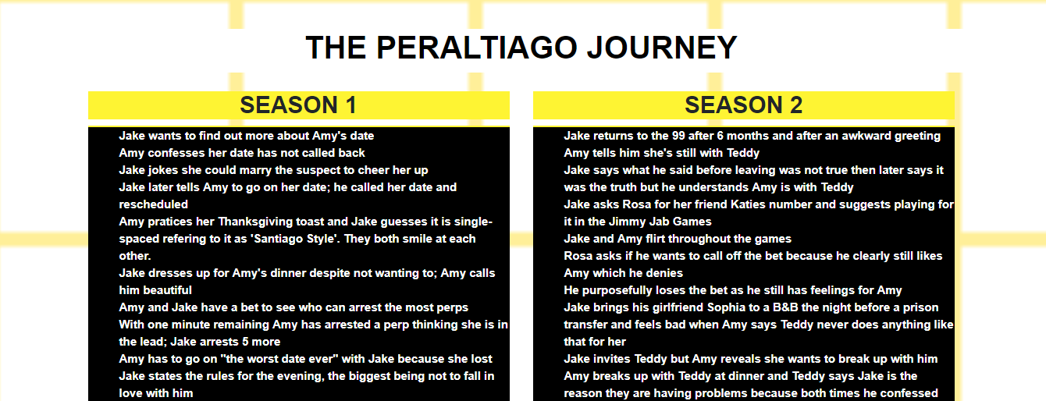
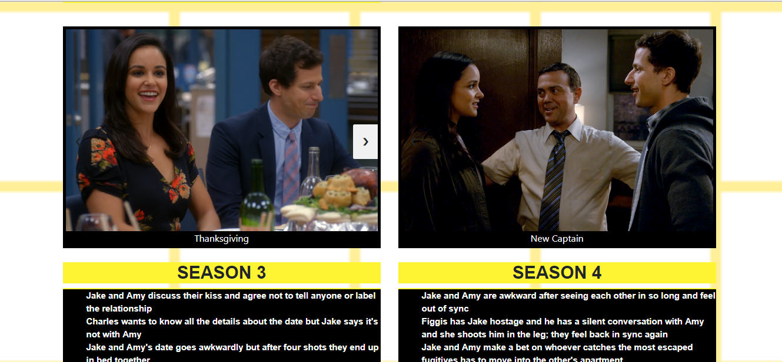
Mobile view:
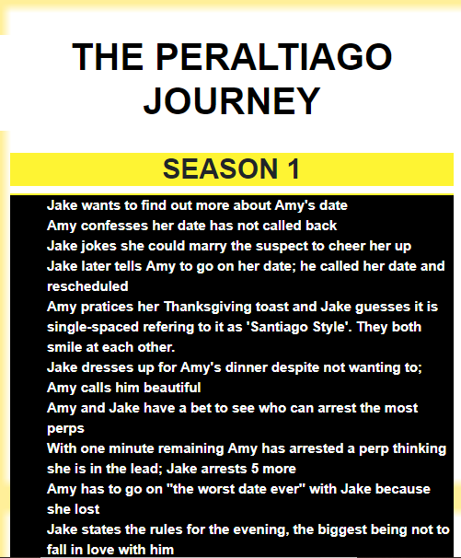
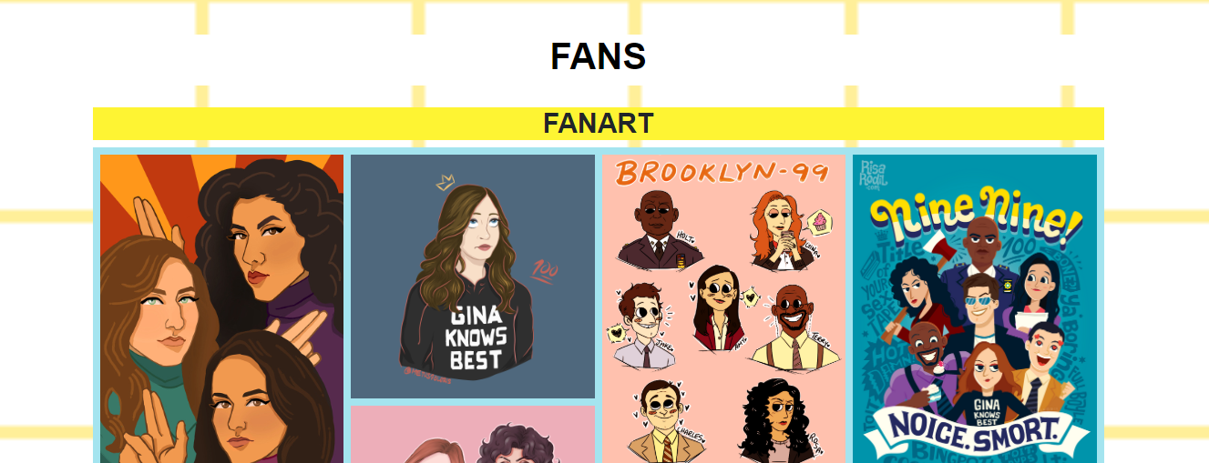
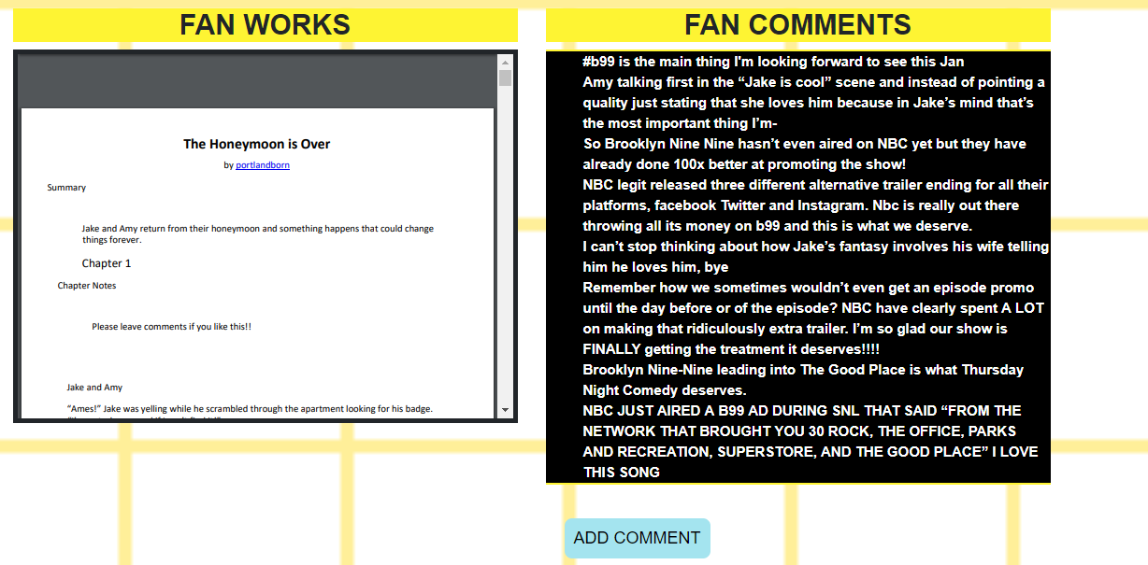
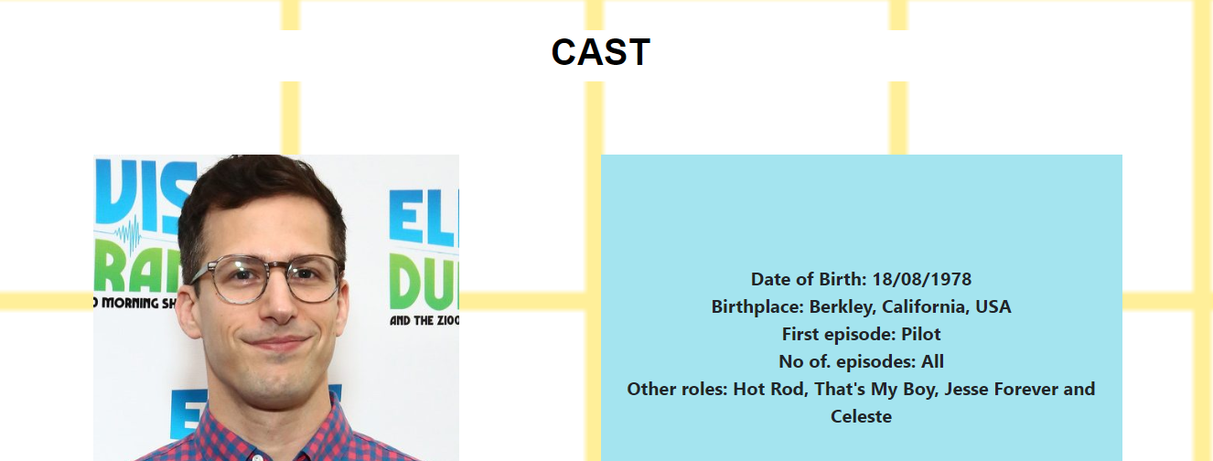
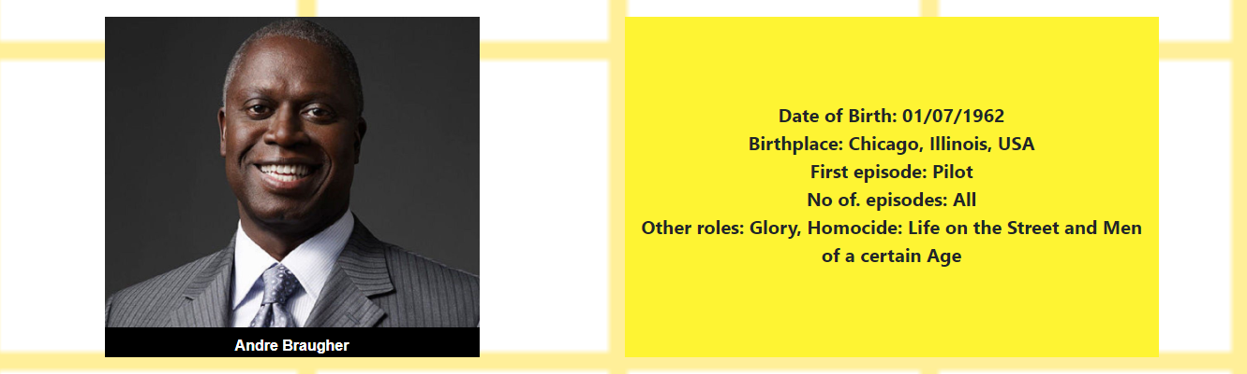

Evaluation

- Testing R1: The user should be able to access what they need to find out in less than 3 clicks
- Task: Finding Season 3 episodes
- Done in two clicks
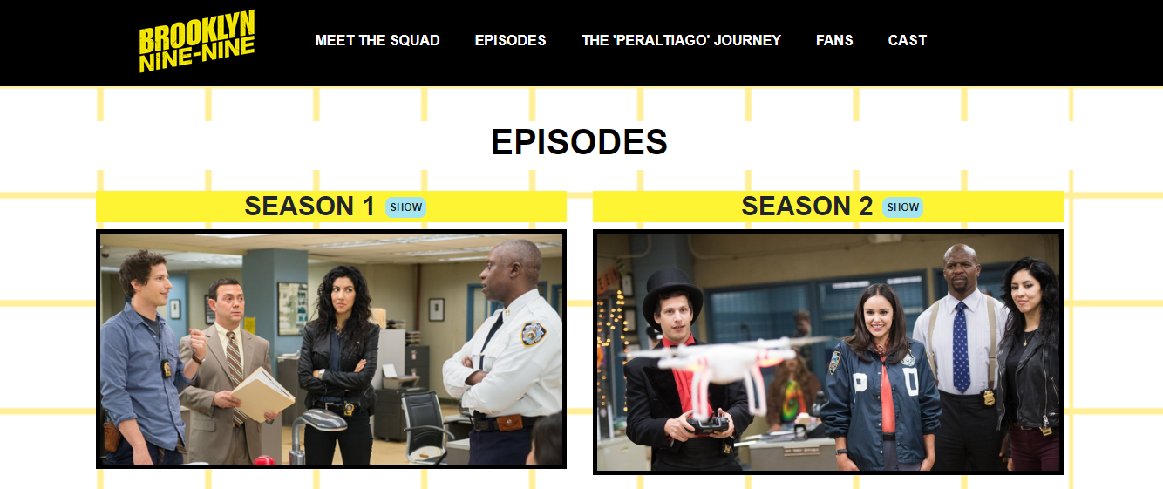
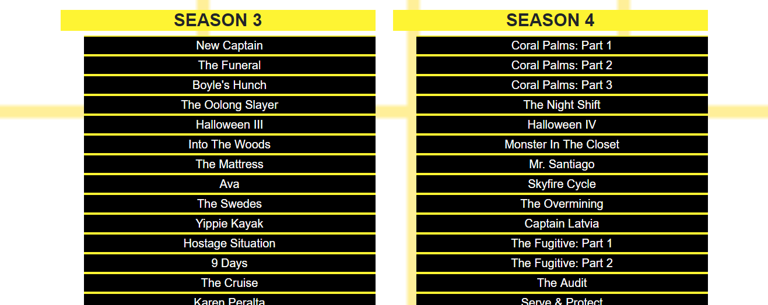
- Task: Finding out about Amy Santiago
- Done in one click
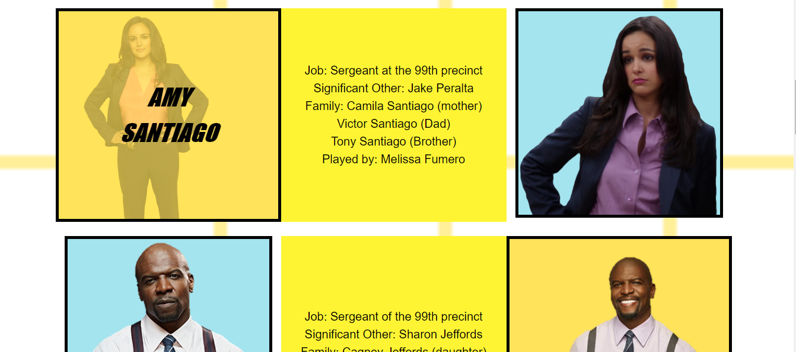

- Testing R6: The user should be able to read all text clearly and see all images regardless of browser
- Navbar is still readable
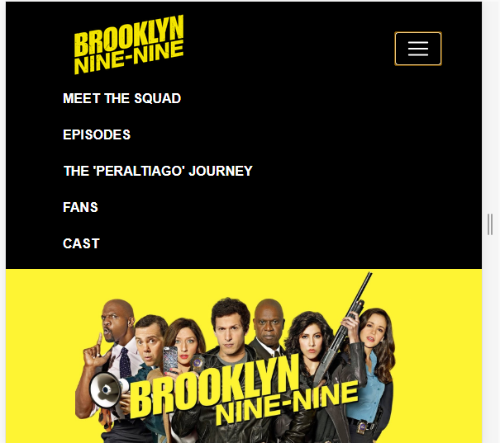

- Links still readable and images still clear
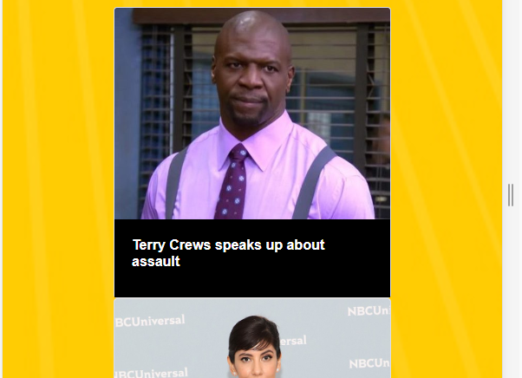
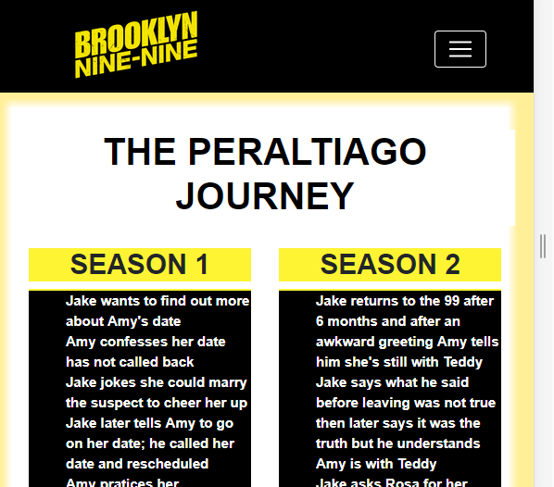
- Testing R5: The user should be able to read news on Brooklyn Nine-Nine
- Relevant news articles can be found on the homepage
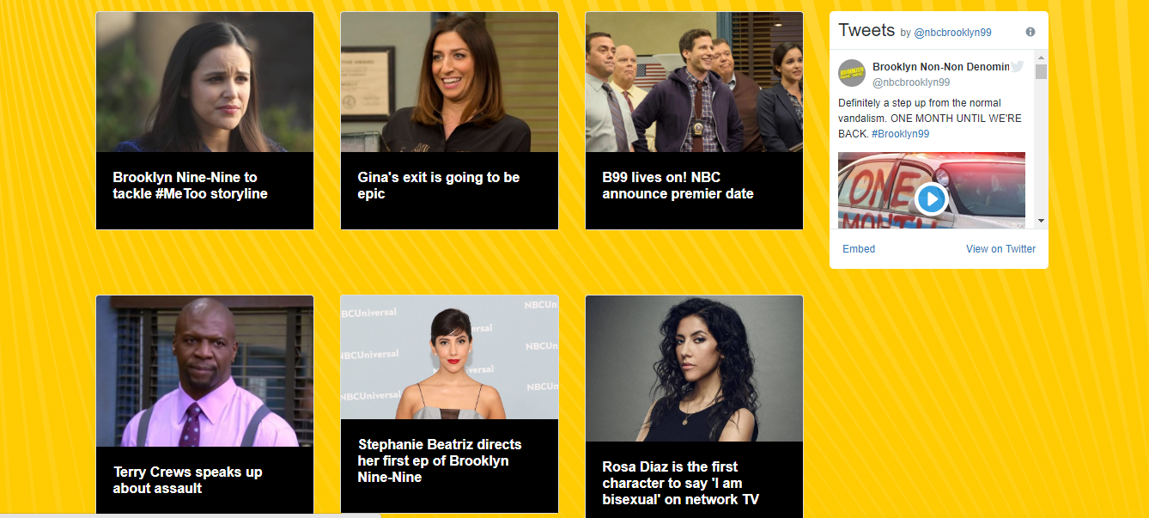
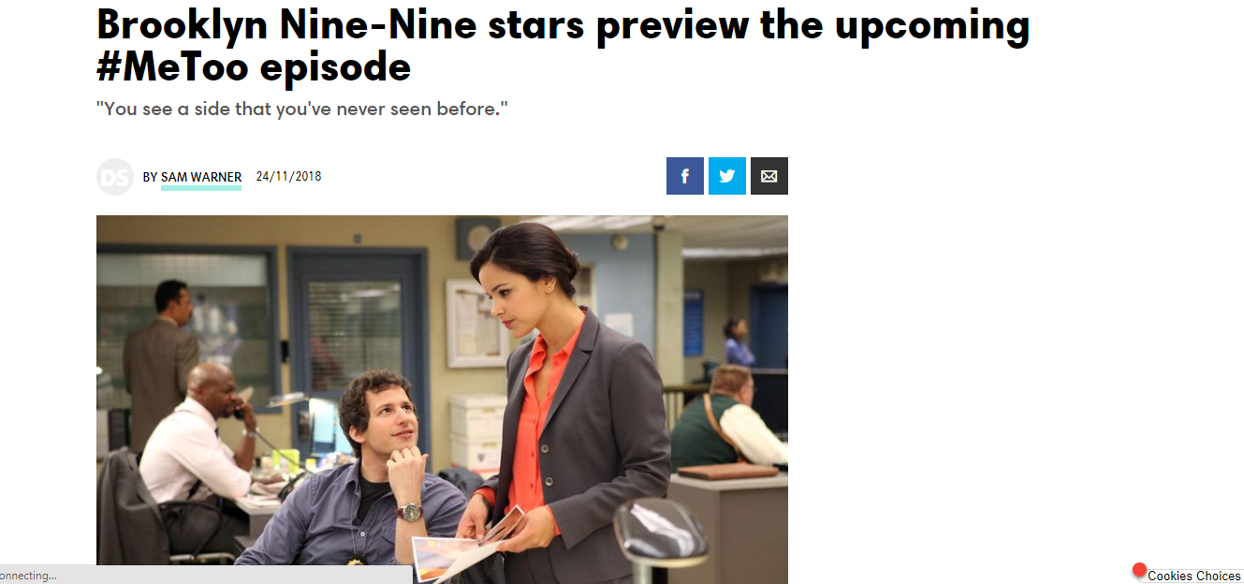

The overall website follows a consistent theme and is a smooth user experience. There is sufficient information on each page that is relevant and useful. The font is simple and readable. Also, all the images are clear regardless of browser size. Future recommendations could include more security for user comments to ensure that nothing explicit or harassing gets through. There could also be more information on the cast and possibly more pictures, so it is more substantial. Some of the images could also be resized just to have an overall cleaner look e.g. on the meet the squad page.

References

[1] | P. Laja, "8 Effective Web Design Principles You Should Know," 17 May 2012. [Online]. Available: https://conversionxl.com/blog/universal-web-design-principles/. [Accessed 20 November 2018].
[2] | B. Jones, "Understanding Visual Hierarchy in Web Design," 28 September 2011. [Online]. Available: https://webdesign.tutsplus.com/articles/understanding-visual-hierarchy-in-web-design--webdesign-84. [Accessed 20 November 2018].
[3] | J. Cao, "The 5 pillars of visual hierarchy in Web design," 30 April 2016. [Online]. Available: https://thenextweb.com/dd/2015/04/30/the-5-pillars-of-visual-hierarchy-in-web-design/. [Accessed 20 November 2018].
[4] | M. McConnell, "9 PRINCIPLES OF GOOD WEB DESIGN," 16 February 2018. [Online]. Available: https://www.feelingpeaky.com/9-principles-of-good-web-design/. [Accessed 20 November 2018].
[5] | E. Devaney, "8 Guidelines for Exceptional Web Design, Usability, and User Experience," [Online]. Available: https://blog.hubspot.com/blog/tabid/6307/bid/30557/6-guidelines-for-exceptional-website-design-and-usability.aspx. [Accessed 20 November 2018].
[6] | M. Biroscak, "3 Web Design Principles Every Beginner Should Know," 4 October 2016. [Online]. Available: https://www.jimdo.com/blog/3-web-design-principles-for-beginners/. [Accessed 20 November 2018].
[7] | Interaction Design Foundation, "Usability," [Online]. Available: https://www.interaction-design.org/literature/topics/usability. [Accessed 20 November 2018].
[8] | B. Litwin, "An Introduction to Usability and User Experience in Web Design," 11 July 2018. [Online]. Available: https://www.a2hosting.com/blog/usability-and-user-experience/. [Accessed 20 November 2018].
[9] | A. Smith, "9 Rules For UX Design," 23 May 2018. [Online]. Available: https://usabilitygeek.com/rules-for-ux-principles/. [Accessed 20 November 2018].
[10] | Usability.gov, "User Experience Basics," [Online]. Available: https://www.usability.gov/what-and-why/user-experience.html. [Accessed 20 November 2018].
[11] | D. Jiminez, "10 Tips That Can Drastically Improve Your Website's User Experience," [Online]. Available: https://blog.hubspot.com/marketing/improve-your-websites-user-experience. [Accessed 20 November 2018].
[12] | K. Weigers E, "IEEE Software Requirements Specification Template," 1999. [Online]. Available: https://web.cs.dal.ca/~hawkey/3130/srs_template-ieee.doc. [Accessed 23 November 2018].
[13] | W3Schools.com, "Responsive Web Design - The Viewport," W3Schools, [Online]. Available: https://www.w3schools.com/css/css_rwd_viewport.asp. [Accessed 26 November 2018].

