

BSc level 6 in Health and Social care

Assessment 1

Student name: Edit Tingyela
Student ID: 1917242

Module name: Living with Care: The Older Person
Module code: BMHP6009
Lecturer name: Diola Bijlhout

Table of Contents
Introduction 3
Meaning of elderly person 4
UK 4
Hungary 4
Statistics on the ageing population 5
UK 5
Hungary 6
Theories of loneliness and isolation 8
Comparison between two countries 9
“The impact of loneliness and isolation on an older person living within a care setting.” 9
UK 9
“Current legislation and policies that deal with or aim to raise awareness or reduce loneliness and isolation in the elderly” 10
UK 10
Hungary 11
“Local, national and global provision of services for the older person in line with current initiatives and policy “ 11
UK 11
Hungary 12
“The prospective future of the care of the older person; what changes could be made to the programmes aimed at addressing the problem of loneliness among the elderly “ 12
UK 12
Hungary 13
“Use of technology for the provision of care provision to lonely older persons. “ 13
UK 13
Recommendation 14
Conclusion 15
Referencing 16

Introduction

This report evaluates the impact of loneliness and social isolation on the elderly population by comparing two countries, UK and Hungary. According to WHO (2021) both the number of older person and the proportion of older persons in the population is growing globally. The estimated age of 60 years and older will be 2.1 billion by 2050, which is double as of now. It is a big economic and social challenge for the health care systems and governments worldwide. Ageing of biological leads to physical and mental damage such as dementia, diabetes, and depression, and not uncommon to have several conditions at the same time. According to NHS (2021) older people have an effect on health by social isolation and loneliness such as depression and other damage to physical health and wellbeing. Despite all of these as stated by WHO (2021) there are differences in how can people age. Some younger people have significant decreases in capacities while others are fitter and healthier in their old age. Because life is longer, there are opportunities both personally and socially such as further education, changing careers, find new hobbies. Taking advantage of these opportunities depends on the health of an ageing society. Attitudes toward older age are often associated with negative thoughts such as that the elderly are a burden to society. Discrimination facing to elderly is also challenging. (WHO,2021). According to United Nations (2019) new approaches are needed to masseur ageing to understand what population ageing means and develop clearer perspectives about social protection and healthcare needs. As stated by (WHO,2021) collaboration between governments, professionals and private sectors is needed to tackle this complex problem globally. Firstly the report shows the meaning of an elderly person and statistics are provided. After all theories of loneliness and isolation are introduced. During the part of the comparison between the UK and Hungary, the impact of loneliness is discussed and current legislation and policies are examined in both countries. Local, national and global provider of services for the older person is compared, above all examination of the potential future of the care of the elderly is made. Evaluation is created to determine how could address the problem of loneliness and isolation of the elderly people, and what type of changes could help. Within the services, the applied technology for the lonely older person is shown. Finally, recommendations are made.

Meaning of elderly person

UK

According to Hanratty, B. et al. (2018) the people in the UK prefer to avoid moving to care homes if there are available alternatives. 1 in six of the population aged 85 or over live in care homes, all together 400000 people.
According to Office for National Statistics (2019) informal care is a very important part of the care system in the UK with 2 million adults receiving it. One in five people aged 50 to 69 years works as an informal carer. In 2016 two or more chronic illnesses have 29% of the elderly in age 60-64. This number is rising to an older age. Half of all people work beyond the State Pension Age (SPA). As stated by Office for National Statistics (2019) “There is a lower level of income inequality among retired households than non-retired households”
As stated by Centre for Ageing Better (2022) people historically growing older are renters rather than owners and it is steadily improving with 65-year-olds now living alone reached at a 67% rate between 2000 and 2019. People in that age range are not capable to rely on themselves so it endangers other people's life, at least 1 in 5 homes have that condition. Almost 9000 people died in England because their homes were not heated up. It is a major financial risk for older people to rent, because of the pension rate and high rent prices, they spend more than half of their pension on rent. The rise of older residents renting also not just financial risks but health risks as well regarding the poor conditions of the houses that are being rented therefore endangering the lives of those who live there leading up to respiratory and cardiovascular diseases.

Hungary

According to Gyarmati, A. (2019)1.3 million old people aged 65 or above have some form of disability in Hungary. From that, just 7% of old people can access home help. 3 % of old people can be rich to enter a nursing home for special care. The waiting list is very long, nursing care accommodation was not found in the last 7 years. Elder people lack information about what type of basic social services entitled to, only one-third of elderly people know. In Hungary, there is the neoliberal approach to the elderly care policy, the primary aim to minimise expenditure. There is stagnation in both areas, care funding and the number of carers as well in contrast the number of patients is increased. Access is very limited to state-funded care, therefore families especially women would shoulder the care responsibility. According to the data, the number of caregivers for the elderly compared with the EU states is particularly low, just 8-10% of the adult population.
According to Daily News Hungary (2021) 91,3% of people live in their own homes in Hungary, compared with Europe citizens, where the number is just 69,9%. The Hungarian culture is based on the nation, Hungarians are determined to have their apartment or house. After socialism, there was a possibility of buying former rental apartments, and the wave of home purchases was triggered by this situation.

Statistics on the ageing population

According to United Nations (2019) “by 2050, 1 in 6 people in the world will be over the age of 65, up from 1 in 11 in 2019.
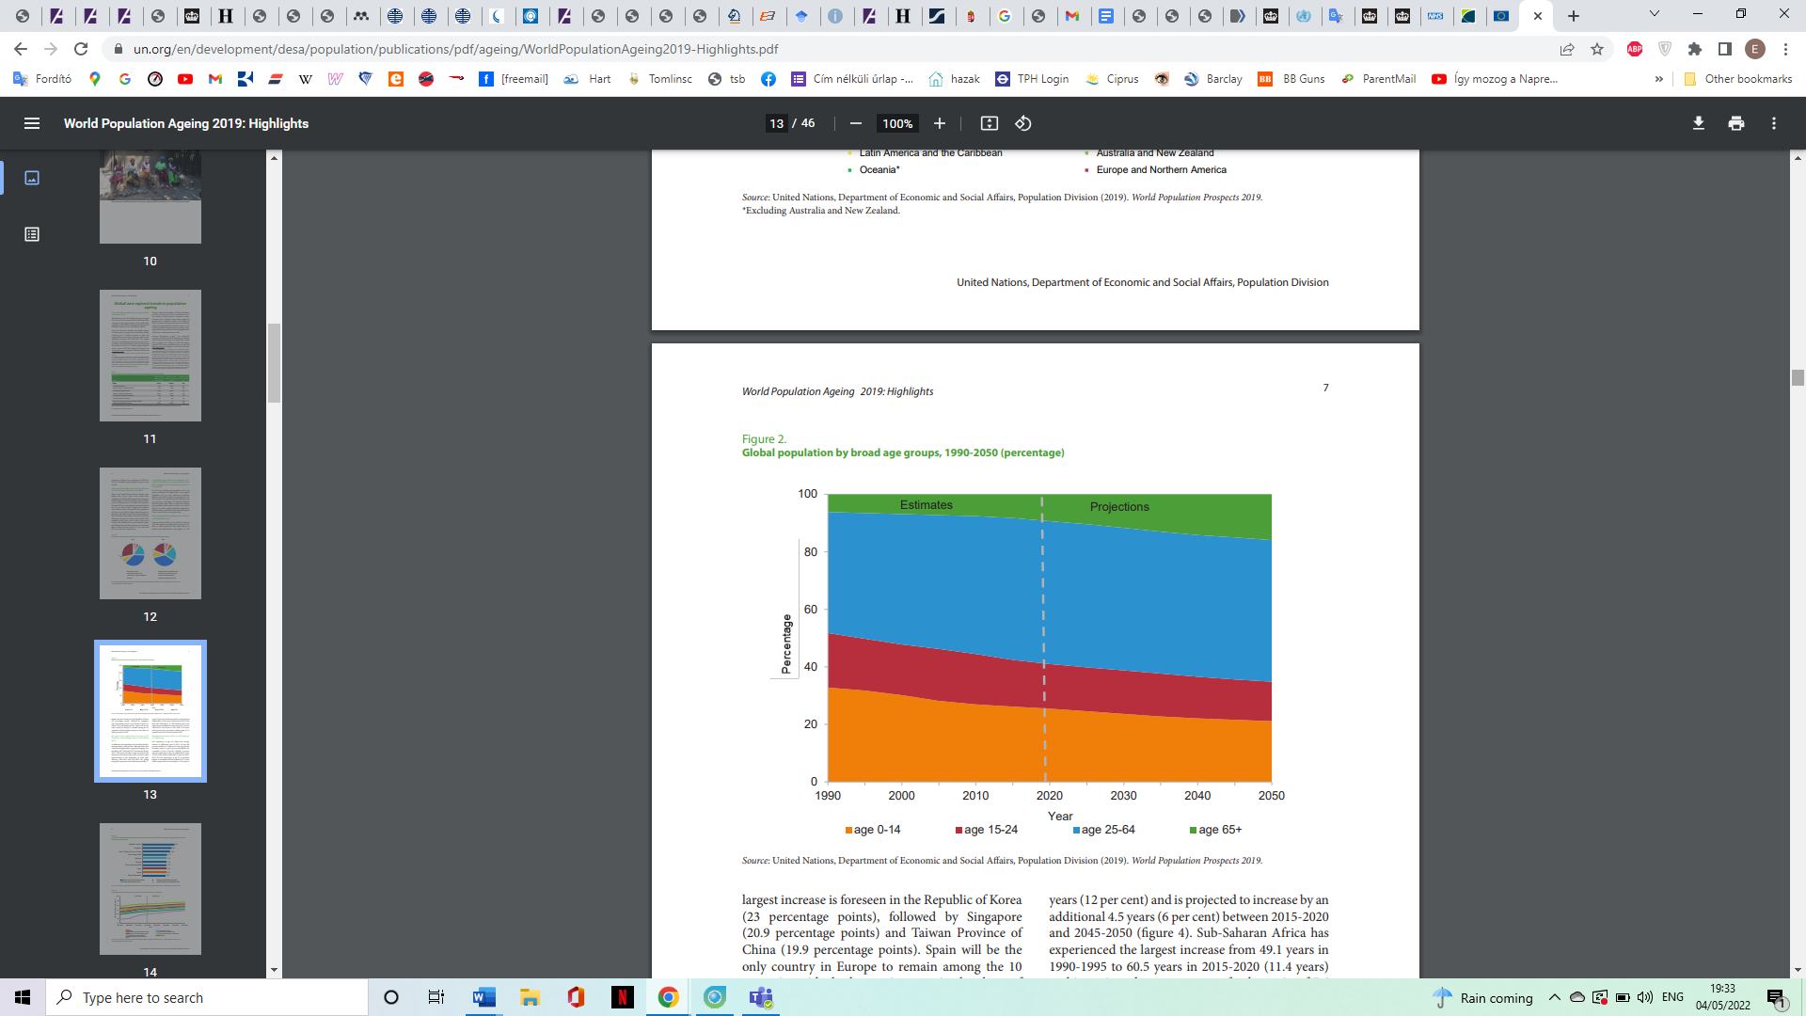
(United Nations, 2019)
Figure1: “Global population by broad groups, 1990-2050 (percentage)”

UK

According to Centre for Ageing Better (2022) there are 19% of the total population almost 11 million people aged 65 and over. It is projected, that in 10 years this will have grown to 22% of the total population which is nearly 13 million people. Life expectancy is declining and the years to spend in good health, without restricting illness is also decreasing. 62.4 years are for men and 1.5 years less for women.

According to the Good Care group (2022)
- “Over 1m older people report feeling lonely all the time, or often
- 49% of over 65s cite television or pets as their main source of company
- 49% of over 75s live alone
- 12% of older people state they never spend time with family
- 46% of over 65s confirmed they spent time with their family on most or all days, compared to 65% – 76% for other age groups
- 9% of older people feel trapped in their own home
- 600,000 leave the house once per week or less
- 41% of older people feel out of touch with the pace of modern life”

Hungary

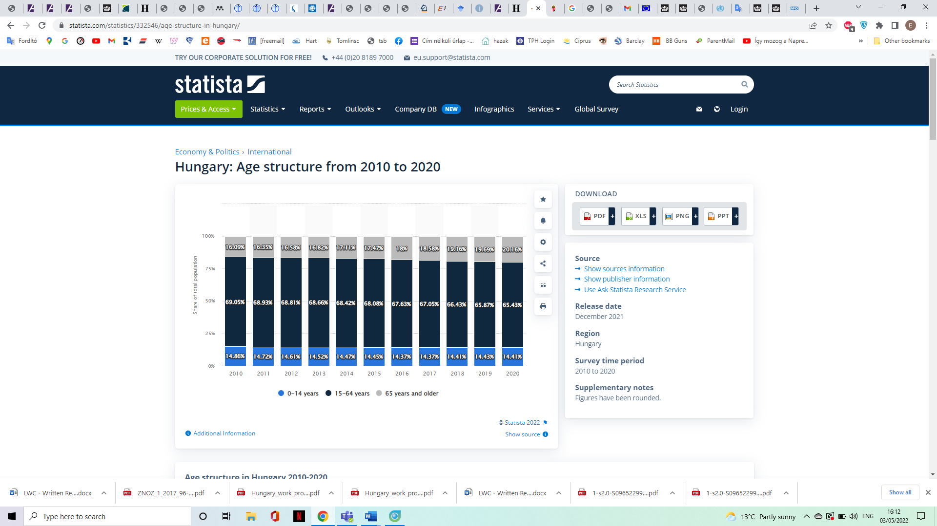
(Statista, 2022)
Figure2: “Hungary: Age structure from 2010 to 2020”
According to Statista (2022) as the chart above shows there is the rapid ageing of the population in Hungary, in 2010 there was 16.09 per cent of Hungary`s total population were aged 65 years and older and in 2020 there was 20,16 per cent of Hungary`s total population were aged 65 years and older.

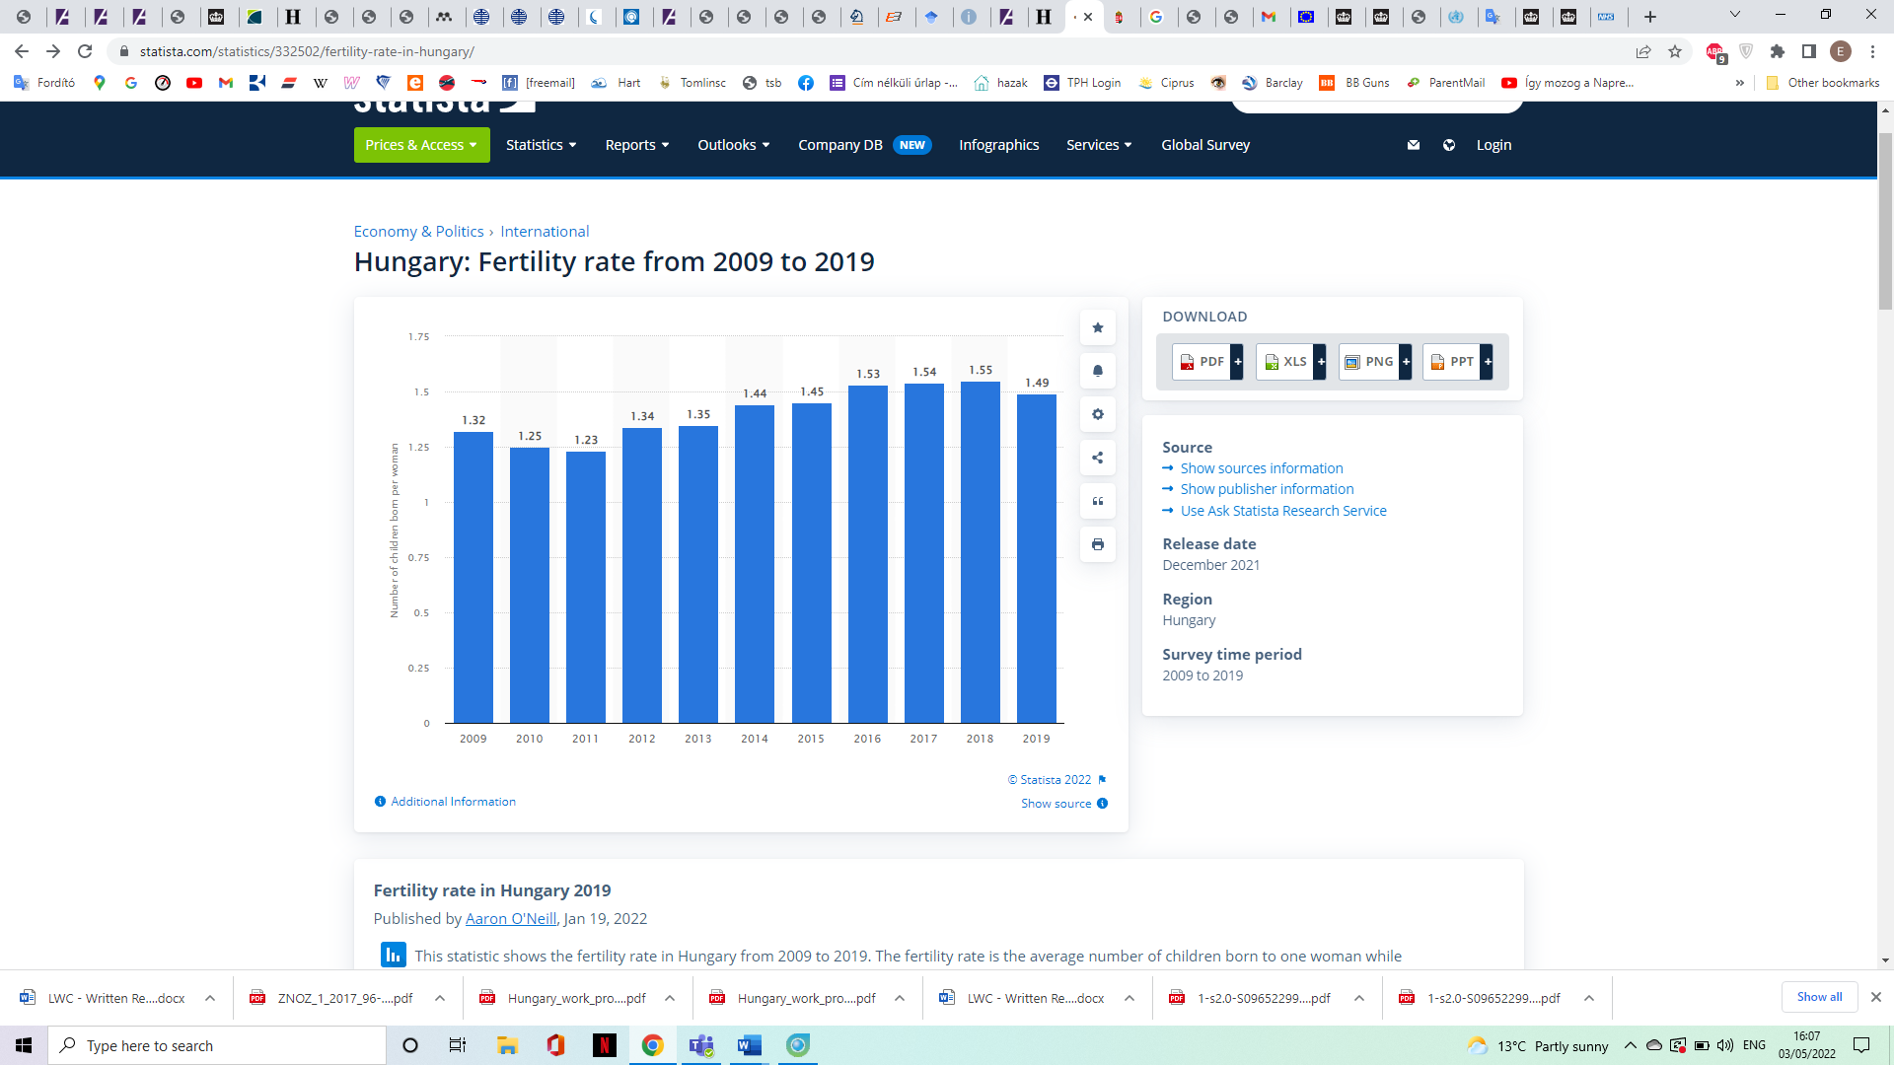(Statista, 2022)
Figure3:” Hungary: fertility rate from 2009 to 2019”

According to Statista (2022) as the chart above shows, 1.49 children were born per woman in 2019 which is not enough for the necessary replacement rate.
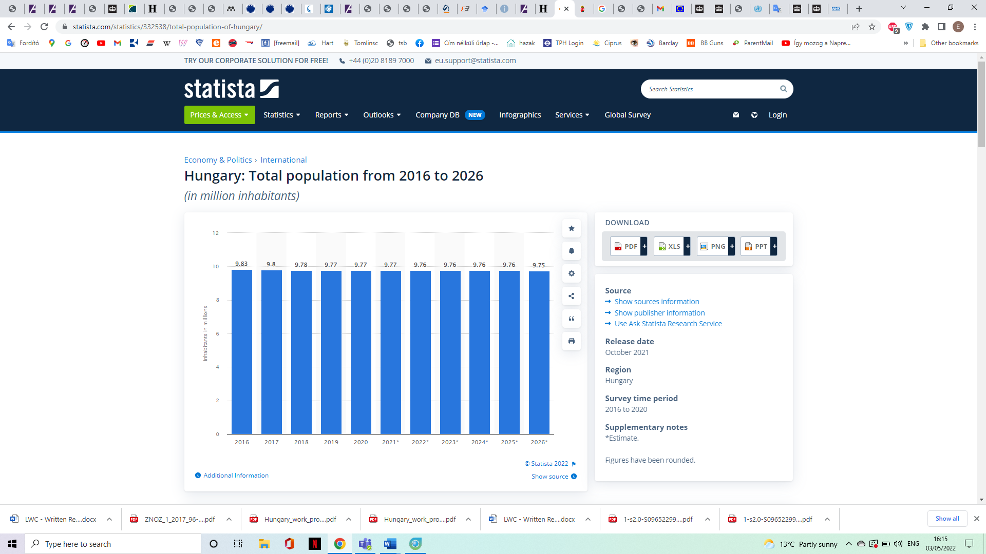
(Statista, 2021)
Figure4: “Hungary: Total population from 2016-2026”

According to Statista (2021) as the chart above shows, there is constantly declining the total population of Hungary from 2016 to 2020. Subtracting the conclusions from the statistics it can be concluded that, the population of Hungary is declining and is ageing.
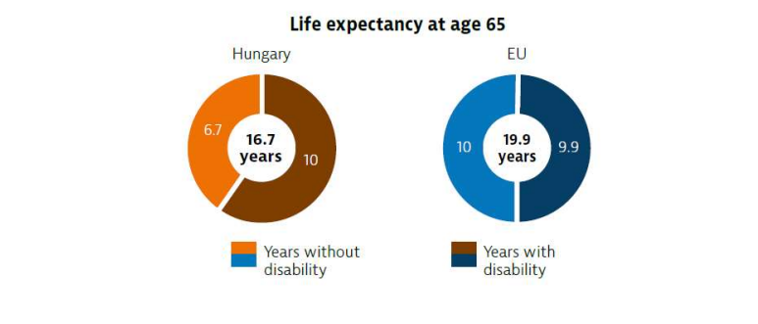
(OECD.org, 2019)
Figure5: “Life expectancy in age 65”
According to OECD.org (2019) as the chart above shows life expectancy above the age of 65 is 16,7 in Hungary, compared with the EU, which is 19,9 years. Hungarians having at least one chronic illness aged 65and over is 12 percentage points higher than the EU average. Basic activities of daily living are limited to one in six aged 65and over.

Theories of loneliness and isolation

Disengagement Theory
According to Crossman, A. (2019) it is a functionalist theory, the process of disengagement from social life, the social roles and relationships that were central to their life in adulthood. Disengagement theory is thinking about this progress as a beneficial process.
Symbolic Interaction
According to Crossman, A. (2020) Social experience and identities are the basic aspects of the theory. Experiencing being old or young is a social construction.
More theories are: Continuity Theory, Social Breakdown Reconstruction Theory, Modernization Theory, Gerotranscendence, Activity Theory

Comparison between two countries

“The impact of loneliness and isolation on an older person living within a care setting.”

UK

As a study stated by Hanratty, B. et al. (2018) Care home has different people living there regarding their characteristics such as age, health, dementia, and impairments. There is no evidence that people who live alone would move into a care home, it is also unclear if outside influences such as social isolation or feelings of loneliness have a part in it. Functional decline is a high risk for those who live alone and lonely, this increases their need for care. People who have a low level of social interactions are more likely to move into a care home in a study done in the USA and Sweden.
According to Hanratty, B. et al. (2018)
- “Loneliness is an independent risk factor for entry to a care home.
- The association between loneliness and care home admission persists after taking into account established risk factors such as age, disability, memory problems and social isolation.
- Unlike other risk factors, it may be modifiable.
- Reducing loneliness amongst older adults may prevent or postpone some admissions to care homes.
- Identifying effective interventions to address loneliness amongst older adults should be a priority.”

According to NHS (2021) there is a serious effect on older people's mental health such as depression by loneliness, and also physical health and well-being are declined. This age group is especially vulnerable.
According to GOV.UK (2021) During the pandemic of COVID-19, the studies show that there was a relationship between age and the impact of COVID-19 on mental health and well-being, the older people were less vulnerable than younger.

“Current legislation and policies that deal with or aim to raise awareness or reduce loneliness and isolation in the elderly”

UK

According to GOV.UK (2022) 2018 loneliness strategy was announced by the government to set out the guide work on loneliness. The objectives were:
- to feel free and open to talk about loneliness and be able to get help.
- Policymakers are considering relationships and loneliness
- Evidence-based loneliness is being improved and decisions are based on it. Everyone can rich the information.
According to GOV.UK (2022) Tackling Loneliness Network was improved by the government in 2021 to arrange for 70 organizations such as a group of high-profile charities, businesses and public figures to work together about four tasks:
- “Tackling loneliness in young people
- Tackling loneliness in older people
- Local and place-based approaches to tackling loneliness
- Digital inclusion”

Communications and insights such as sharing data and research are shared by the government’s Digital Platform, the Tackling Loneliness Hub.

According to Campaign to end loneliness (n.d.) there are present health and social care policies about Loneliness and isolation:
The Care Act 2014 for the local actors to take action to reduce loneliness and isolation.
- “Better Care Fund and Loneliness
- Adult Social Care, Public Health and NHS Outcomes Frameworks
- Transforming Primary Care
- NHS Five Year Forward View and New Models of Care Vanguards”

Hungary

According to European Comission (2018) Characteristics of the health care policies are separated. There is a dual system with its own legislation and financing, health care and social care. The system mainly places the burden on families or else leaves the needs of older people unmet. Local governments, churches, non-profit organisations and the central government are the main providers of social care. The main health care provider is the Central Government. (LTC)
In 2017 a Pilot Project was launched, designed with limited healthcare services in combination with residential social care. The quality of private home care could improve with the training which is provided but is difficult to find and assessed.

“Local, national and global provision of services for the older person in line with current initiatives and policy “

UK

According to HM Government ( 2018) Chatty Café Scheme was launched by Costa Coffee in 300 stores to create ‘Chatter and Natter’ tables allowing the conversation to customers.
According to HM Government ( 2018) there was an attempt to support people to gain basic digital skills, this was led by the Future Digital Inclusion and Widening Digital Participation programme where they spent 9.5millin to support 800,000 people. Also, there is a gov tech fund which includes a competition launched in July 2018 which makes funding available for startups to see how digital technology can help battle loneliness. There are also plans to create a transport network that makes people more connected by being able to make connections to their community.
According to NIHR (2021) People are not allowed to visit care homes because they are permitted and care home residents do not have a lot of social contacts anymore, this adds to the issue of loneliness and isolation in older people living in care. Video Technology allowed people in care homes to socialize more and partly take in quizzes and it was very low cost.
According to GOV.UK (2020) digital innovation was found under the TechForce19 challenge for the vulnerable people to look after their mental health during the pandemic isolation.

Hungary

According to Gyarmati, A. (2019) certain basic social services such as catering and home help are under the rule of municipal governments. 80% of elderly inhabitants are guaranteed care services in some areas but it is not uncommon for just a few per cent, the basic social services are unevenly distributed.

“The prospective future of the care of the older person; what changes could be made to the programmes aimed at addressing the problem of loneliness among the elderly “

UK

According to Centre for Ageing Better (2022) there are different fields to take action in, regarding Health, Housing, Work, and Communities.
Health: - Establishing life expectancy, and coordinated action reduces growing health inequalities.
Housing: - Focused action to do regulation about that, all new homes are suitable for the future requirements regarding the poor-quality housing crisis.
Work: - In over 50s challenging to go back to work and need support, there is a labour market ageism. Need action to format workplaces where the longer working time is supported.
Communities: - Create a new community which is supportive for the people to be active, and allow the community services and the voluntary sectors to help people be more healthy as they grow older.

Hungary

There are poorly paid workers in the field, need to reform it. Proper social investment should be made to achieve the quality of life of the elderly. Determine the LTC services needs is also important. Long-term care should be becoming a separate field of social protection and the authorities should be the investors rather with a helper attitude. The insurance market does not been prepared to offer products for future long-term care costs, it is necessary for the good quality of care.

“Use of technology for the provision of care provision to lonely older persons. “

UK
According to Age UK (2021) lack of digital skills is the risk of not being able to access the communications platforms to have a relationship with people and also not being able to rich in the key services such as GPs and other health services, online shopping, online banking. Tackling this problem AGE UK provide digital courses for the elderly.
According to HM Government ( 2018) lunch a new £400,000 Digital Inclusion Innovation Fund by the Department for Digital, Culture, Media and Sport inclusion loneliness as criteria for bidding.
According to MHA (2022) Within the Dementia Carehome setting was successfully use robotic pats to give companionship to the residents and reduce loneliness.
GOV.UK (2022) digital innovation for the vulnerable old people:
- Feebris- in the care homes for the residents, helps the carers assign the day-to-day health needs
- Team kinetik digital platform -helps manage community-led volunteer programmes.
- Vine health - for the patient experiencing cancer
- Alcuris ltd – if the loved one has been left alone the family has the comfort of a loved one`s safety and informal about the need for a care plan
- Ampersand- health self-management apps
- Aparito- remote monitoring technolog

Recommendation

According to AGE UK (2021) the Government should be responsible and a leader for society’s response to the ageing population. Most people believe that society’s structure is more important than individual decision making. Public Platforms have a meaningful way to steer the narratives and ageing through their work. They represent the experiences of older age and avoid stereotypic people in their portrayal and instead show natural experiences.
According to AGE UK (2018) Tackling loneliness should be the outcome that these commissioners are striving for and making these actions the most effective so that the changes become visible. Such changes could be as in the example:
Foundation services:
- detect lonely individuals
- get to know and understand the specific circumstances of an old person’s loneliness and respond to it individually
- Support individuals who are experiencing loneliness to be able to use the full range of services and work for them
- Keeping people active and engaged with the community by transport and by using appropriate technology
Help people:
- Build up new connections
- Reconnect with old relationship
- Thinking differently about the relationship

Every experience with loneliness is unique, psychological support, one to one activities and also group-based services need to fit all different types of experienced isolation or loneliness.
According to AGE UK (2018) the prevention of loneliness and helping people overcome requires organisations that have people who have their skills to have conversations that help people to know that they are suffering from loneliness and show them the reasons for it, understand their needs and aspirations and work with these people to identify improvements. Such examples are like GPs, social care workers, police support workers and fire and rescue services, shopkeepers, publicans, hairdressers so on. This strategy needs funding for support and services locally that work together and this should be more than just social activities. There is a role to fund these local services that help to prevent loneliness as well as national government funding.
According to Hanratty, B. et al. (2018) reducing overall welfare costs is important to find ways to avoid, prevent or delay moving to care homes.
Especially recommendation for Hungary, according to the Euro Carer (2020) needs training for the carers and recognition of the carer`s skills.

Conclusion

The meaning to be elderly is quite different in UK and Hungary. In 19% of the total population aged 65 or over in the UK, while in Hungary this number is 20,16%. Both country population is ageing. In the UK the elderly are renters rather than owners compared with Hungary where 91,3% of people live in their own homes. Informal care is a very important part of the care system in the UK with 2 million adults receiving it, in contrast just 7% of old people can access home help. In Hungary, the health care policies are not as clear as in the UK. There are in Hungary poorly paid workers in the field, big reform needs to tackle it. The states should reassess their role in the care because the crisis will grow and more and more vulnerable old people are without care.

Referencing

AGE UK (2018) All the Lonely People: Loneliness in later life (Online). Available at: https://www.ageuk.org.uk/globalassets/age-uk/documents/reports-and-publications/reports-and-briefings/loneliness/loneliness-report_final_2409.pdf (Accessed: 24 April 2022).
Age UK (2021) Helping older people get online. (Online). Available at:
https://www.ageuk.org.uk/our-impact/programmes/digital-skills/
(Accessed: 25 Apryl 2022).

AGE UK (2015) Promising approaches to reducing loneliness and isolation in later life (Online). Available at: https://www.ageuk.org.uk/globalassets/age-uk/documents/reports-and-publications/reports-and-briefings/health--wellbeing/rb_jan15_promising_approaches-loneliness_and_isolation.pdf (Accessed: 21 April 2022).
AGE UK (2021) Reframing Ageing (Online). Available at: https://ageing-better.org.uk/sites/default/files/2021-07/Reframing-ageing-public-perceptions.pdf (Accessed: 21 April 2022).
Campaign to end loneliness (n.d.) Loneliness and isolation in existing health and social care policy(Online). Available at: https://campaigntoendloneliness.org/guidance/policy-landscape/(Accessed: 21 April 2022).
Centre for Ageing Better (2022) The State of Ageing 2022 summery (Online). Available at:
https://ageing-better.org.uk/sites/default/files/2022-04/The-State-of-Ageing-2022-online.pdf (Accessed: 26 April 2022).

Crossman, A. (2019) Disengagement Theory (Online). Available at: https://www.thoughtco.com/disengagement-theory-3026258 (Accessed: 29 April 2022).

Crossman, A. (2020) What is symbolic interactionism (Online). Available at: https://www.thoughtco.com/symbolic-interaction-theory-3026633 (Accessed: 29 April 2022).

Daily News Hungary (2021) Number of homeowners record-breaking in Hungary (Online). Available at: https://dailynewshungary.com/record-number-of-homeowners-in-hungary/ (Accessed: 26 April 2022).

Euro Carer (2020) towards carer friendly societies (Online). Available at:
https://eurocarers.org/country-profiles/hungary/ (Accessed: 26 April 2022).

European Comission (2018) ESPN Thematic Report on challenges in long term care Hungari 2018 Hungary (Online). Available at:
file:///C:/Users/tined/Downloads/HU_ESPN%20thematic%20report%20on%20LTC%20(1).pdf (Accessed: 29 April 2022).

GOV.UK (2021) 7. Age Spotlight. (Online). Available at:
https://www.gov.uk/government/publications/covid-19-mental-health-and-wellbeing-surveillance-spotlights/covid-19-mental-health-and-wellbeing-surveillance-report-spotlight-age-groups (Accessed: 26 April 2022).

GOV.UK (2022) Government`s work on tackling loneliness (Online). Available at:
https://www.gov.uk/government/collections/governments-work-on-tackling-loneliness (Accessed: 26 April 2022).

GOV.UK (2022) Digital innovations tested to support vulnerable people during COVID-19 outbreak (Online). Available at: https://www.gov.uk/government/news/digital-innovations-tested-to-support-vulnerable-people-during-covid-19-outbreak (Accessed: 26 April 2022).
Gresz, M., Borbás, F. F. and Dózsa, C. ( 2016) `A description of the utilization of long term care and elderly care facilities in Hungary`, International Journal of Integrated Care, 16(6),
Gyarmati, A. (2019) Aging and care for the elderly in Hungary (Online). Available at:https://library.fes.de/pdf-files/bueros/budapest/15482.pdf (Accessed: 22 April 2022).
Hanratty, B. et al. (2018)`Loneliness as a risk factor for care home admission in the English Longitudinal Study of Ageing`, Age and Ageing, 47 (6), pp. 896–900.
HM Government ( 2018) A Connected society A strategy for tackling loneliness (Online). Available at: https://assets.publishing.service.gov.uk/government/uploads/system/uploads/attachment_data/file/936725/6.4882_DCMS_Loneliness_Strategy_web_Update_V2.pdf (Accessed: 28 April 2022).MHA (2022) Robotic Pets Are a Hughe Succes in MHA Dementia Care Homes. (Online). Available at:
https://www.mha.org.uk/news/latest-news/robotic-pets-are-huge-success-mha-dementia-care-homes/
(Accessed: 28 April 2022).
NHS-National Healthcare Service (2021) Loneliness in Older People (Online). Available at:
https://www.nhs.uk/mental-health/feelings-symptoms-behaviours/feelings-and-symptoms/loneliness-in-older-people/
(Accessed: 21 April 2022).

NIHR-National Institute for Health and Care Receorces (2021) Virtual quise involving several care homes are feasible and might reduce loneliness and social isolation (Online). Available at: https://evidence.nihr.ac.uk/alert/virtual-quizzes-involving-several-care-homes-are-feasible-and-might-reduce-loneliness-and-social-isolation/ (Accessed: 21 April 2022).

OECD.org (2019) State of Health in the EU Hungary Country Health Profile 2019 (Online). Available at: https://www.oecd.org/hungary/Hungary-Country-Health-Profiles-2019-Launch-presentation.pdf (Accessed: 28 April 2022).
Office for National Statistics (2019) Living longer: caring for later working life (Online). Available at: https://www.ons.gov.uk/peoplepopulationandcommunity/birthsdeathsandmarriages/ageing/articles/livinglongerhowourpopulationischangingandwhyitmatters/2019-03-15 (Accessed: 28 April 2022).

Statista (2022) Hungary: Age structure from 2010 to 2020 (Online). Available at:
https://www.statista.com/statistics/332546/age-structure-in-hungary/ (Accessed: 23 April 2022).

Statista (2022) Hungary: Total population from 2016-2026 (Online). Available at:
https://www.statista.com/statistics/332538/total-population-of-hungary/ (Accessed: 23 April 2022).

Statista (2022) Hungary: fertility rate from 2009 to 2019 (Online). Available at: https://www.statista.com/statistics/332502/fertility-rate-in-hungary/ (Accessed: 23 April 2022).
United Nations (2019) World population Ageing 2019 Highlights (Online). Available at: https://www.un.org/en/development/desa/population/publications/pdf/ageing/WorldPopulationAgeing2019-Highlights.pdf (Accessed: 22 April 2022).
the Good Care group (2022) Loneliness and care home (Online). Available at: https://ageing-better.org.uk/sites/default/files/2021-07/Reframing-ageing-public-perceptions.pdf (Accessed: 22 April 2022).
WH0-World Health Organisation (2021) Aging and health (Online). Available at: https://www.who.int/news-room/fact-sheets/detail/ageing-and-health (Accessed: 21 April 2022).

