Student Name | Cristina Stici
Student number | 1814630
Module Title | Digital skills and researches
Module code | BMSK4003
Lecturer: | Balendran Kandasamy

Table of Contents
Introduction 3
Evaluating modern technologies 4
Web conferences 4
Exploring Facebook 9
Facebook for marketing 9
Facebook for information gathering and communication 9
My online presence 10
Facebook Account 10
Twitter Account 11
LinkedIn account 12
References………………………………………………………………………………………………………………………….13

Introduction

In the last 20 years the modern technology has changed radically. The internet aids in making connections between billions of people around the world. Family and friends are capable to talk and see each other no matter their location.
I have been following mobile technology passionately for decades. Initially, mobile devices were not very mobile, and their movement required a strong arms and back. They should always be near the electrical outlet, due to absence of batteries. Technology behindthese devices have greatly improved as compared to the past, especially during the last decade.Mobile gadgets have improved significantly to become significantly powerful, more useful and powerful. The gadgets are in every place and they play an increasing role in our day-to-day lives. Mobile technologies, such as phones, tablets and laptops, make life better than ever. This happens in a number of ways, not least, this makes communication a chore. Through the devices, we are able to keep in contact with people from different walks of life and it has even enabled businesses to operate more efficiently.
Today's forms of electronic communication are social networks, so you can conclude that social networks are websites that allow people to interact with each other, the most often cited social networks in marketing are considered Face book, Instagram, Twitter, Linkedln. About all this I will discuss in this evaluation.

Evaluating modern technologies

In this section I have discussed about:
Web Conferences (advantages and disadvantages).
Comparison: Skype and Google Hangout.

Web conferencing
Web conferencing is a very important aspect of the mobile devices. It enables sharing of the individual applications, and real time sharing in one or more devices. The platforms are either delivered through the internet or via software. Below are the advantages and the disadvantages of web conferencing.

Advantages:
- Desktop Sharing and Application
A very important advantage of web conferencing is the fact that it gives a platform for sharing applications. The information can be presented as a PowerPoint, Microsoft excel or as a word document and many more.
- Increase Productivity
Improving Web Conferencing performance saves travel time, he only way to save your time. Thanks to online collaborations, companies can now advertise their products directly without wasting a lot of time to plan.
- Easy to train employees
Since web conferencing allows people to interact efficiently, it can also be used to provide training to the employees.
- Improving Customer Relationships
Through proper application of the web conferencing tools, good customer relations can be established. With web conferencing, it is very easy to solve the existing problems and also to get direct feedback from the customers.
- Businesses are not dependent on location
One of the advantages of web conferencing is the fact that they allow your organization to run without restrictions. One can easily take charge of all the operations and manage them using webinar tools. This technology is improving t a high rate and currently the employers and the team members work as a team. (WebConferencing.org 2010)

Disadvantages / Concerns
Web conferencing is expensive, because for example if it’s a meeting, the people need to have access to the suitable software and hardware. Fast internet connection also goes a long way in web conferencing.
There is need to have a very fast data channel whereby different companies ensure a very efficient connection. However, there is bound to be some delays for example if one individual cannot afford the package.
If any of the participants have problems with the equipment, there are requirements that are needed to make the meeting successful. The first requirement is software, internet and lastly proper equipment that support web-conferencing.
In some cases, the camcorder might not be able to detect all the parts at the same time. There might be bad clarity or slow reception. Sometimes the difference in time zones is a hindrance so if a meeting is already scheduled, they have to stay awake in order to sit for the meeting.
Online presence can not be compared to a face to face meeting. Human contact is very important for improving the customer relations and they give people a sense of support and they can easily understand each other. Most companies use the online meetings to brief the shareholders but still have face to face meetings to discuss other issues at hand. (Online Sciences ,2018)

Comparing Skype and Google Hangout
Features | Skype | Google - Hangout
Mobile/landline calling | Calls from one device with skype to another are free; a skype sub must be present. | With Google voice and hangouts phone calls can be made efficiently
International calling | International calls from Skype to another Skype are free however, a call in a mobile phone goes for $13.99 monthly | All international and local calls from hangouts to hangouts are free.
Audio/video conference | Video conferencing is free and up to 10 people can video chat. | In the hangout can participate up to 10 participants.
File share | Skype allows you to share files via IM or audio/video calls. | Hangouts' integration with Google Drive allows you to sharing documents and photo.
Call/chat history | The room can remain open until it is closed by the organizer. It’s possible to see the past calls/ chat history by clicking on one contact. | With hangout, you can easily save the past chats and they are stored in the Google drive.
Social media integration | Skype integrates with Facebook and Outlook. | Hangouts works directly with Google+, YouTube and Google Drive.
(Essential Guide ,2013)

Exploring Facebook

Facebook for marketing

Facebook for information gathering and communication

Facebook enables people from all walks of life to come together and share their ideas and thoughts. It creates connections and business has grown with Facebook. More than a gathering place of people Facebook is the platform for a business to sell by ensuring good customer relations and self-promotion. It is the website to go to for both small and large corporations and it helps to ensure that the brand is marketed.

Facebook business page
Businesses are now at par with the modern technology and they utilize it to market their products and services. The business pageallow companies to identify themselves, not only by posting product and service offerings, but also through exchanging images, links and publications on the custom page to understand the nature of the business better.
A Facebook business page allows an individual to market their brand and expose their human part. On face book, the customers get to post their feedback and these critics help to grow a business.
Finally, you should take into consideration what you want to see your key public. Share videos, links, pictures, any social media content only if it is connected to the business and it appears to capture the target audience.

Facebook Ads
Facebook has a column to the side for advertising. The ads ensure that a business page is seen by more people and this increases the chances of the item to sell. The ads are an image with a link that anyone who can see it can click and go straight to the business page.
The introduction of Face books advertisings a good marketing strategy and is also one of the possible ways to increase the number of likes or increase the number of clicks on the site.
Facebook ads have the following features:
• Demographic targeting according to Facebook data on location, age, interests and education.
• Capacity to have advertising budgets.
• Testing of advertising, whereby you can simultaneously run multiple versions of advertising to compare the design and setting of advertising.
• Built-in tools to measure the effectiveness of ads.
The use of Facebook ads is very useful in increasing the number of likes and views- when an individual is interested in your page, he becomes a subscriber and he can see any new updates on his news feed. The more the subscribers, the more the customers. Eventually, the business expands because more people are willing to buy from your page.
Messages promoted by Facebook
Facebook's promoted Facebook posts allow Facebook page owners are charged a fixed rate so that their individual Facebook posts increase the number of subscribers, which increases the reach and number of impressions of a certain post.
Some companies ask - why should I pay so that my messages are viewed by my users? Not every user who likes your page will view your posts.

Sponsored stories

Sponsored stories are a part of Facebook interaction where a user can share, for example links with his friends.
The moment two or more friends of the user like a page, the user will pay attention to the page. It is created in such a way that the user can see what the friends are liking and this enables them to do so. It creates a network and that is how businesses grow on facebook. The businesses can also see the demanded offers and claim them.

Face book open graph

Facebook open graph allows companies to tag user actions in their application. Many interactions on face book are usually published on the open graph each day.

Enterprises can also create third-party applications that ensure connection with the user when a notification on Facebook pops up or when performing any other action in the application. Facebook's open graph helps to creates interactive options that are not just tied to the standard “like” and “comment”. The messages ask users to “listen”, “try”, “and read” - the business of business depends on creativity.
Spotify is also a good example of the open graph and it helps to make Facebook a better marketing tool.

Facebook Exchange

Facebook Exchange is a good platform in which the advertisers use Facebook ad with retargeting and real-time bidding. The target market is identified by the history of online presence.The moment a user views a product page on merchant's website, but doesn’t purchase anything; he can then show the same ad on Facebook using FBX.

While advertising on retargeting on Facebook was transmitted only to the columns, recently the ads began to show in the news feeds, as the most valued real estate. This is amazing news for the FBX advertisers, since the number of responses to ads in news feeds is 10-50 times higher than the ad placement in the top right column. (WordSream,2019)

Facebook has features that stand out. It has utilised modern technology to enable users to connect with each other both at a personal level and also at a business level. Through the interaction, people are able to buy goods and services, and businesses are able to grow. Joining the social media platforms is no longer an option but a necessity to ensure growth. Currently people don’t have to communicate personally; message is enough to finish a meeting. With continuous growth, it is expected that more platforms like face book will emerge and this will make our lives very easy and efficient.

My online presence
The pictures below represent my online presence on Facebook, twitter, and Linked in. I am an active member of social media and through the presence I get access to different websites and I can share freely with friends.

Facebook Account
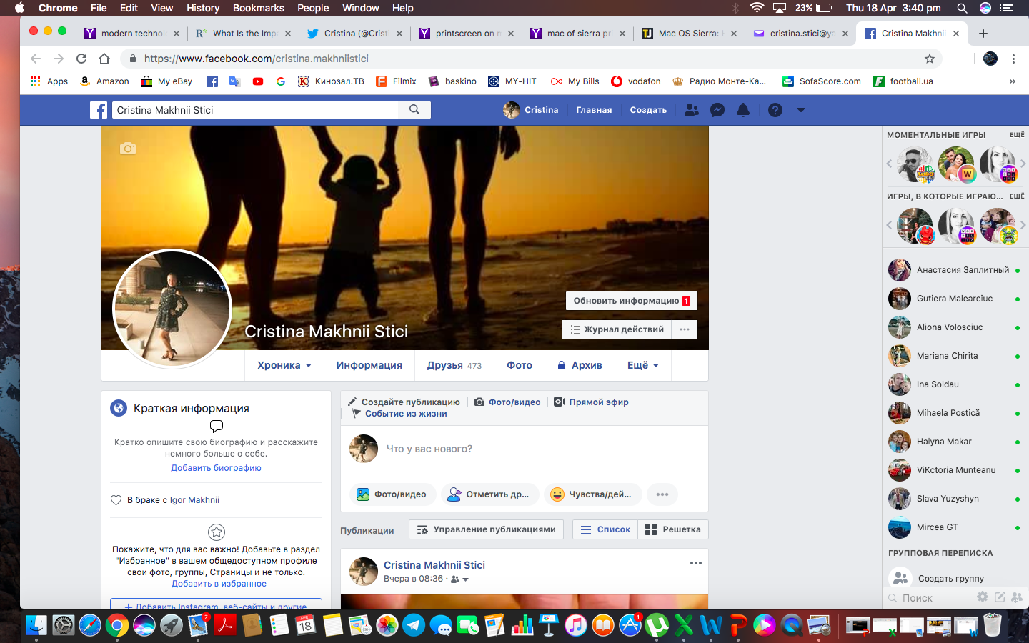

https://www.facebook.com/cristina.makhniistici

Twitter Account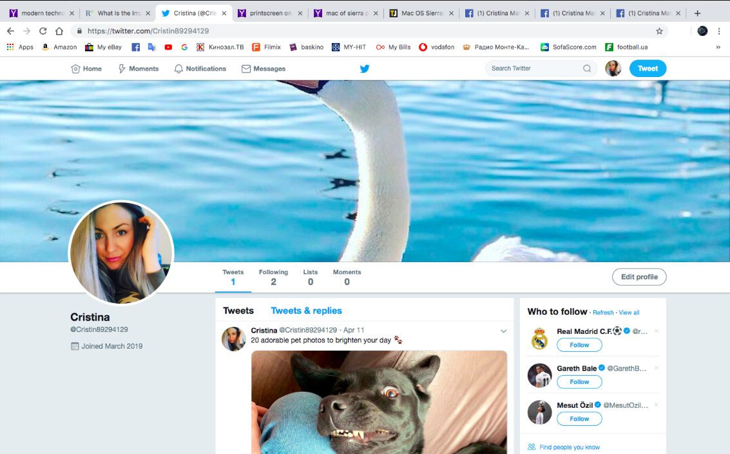

https://twitter.com/Cristin89294129

LinkedIn 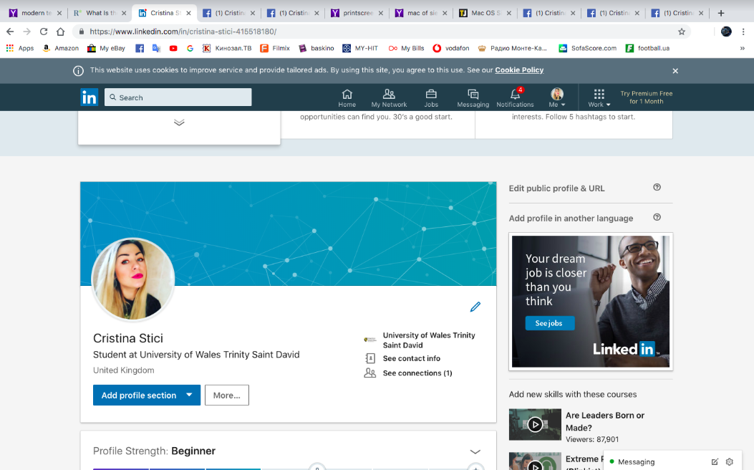

https://www.linkedin.com/in/cristina-stici-415518180/

References:
WebConferencing.org 2010, 5 Advantages of Web Conferencing, viewed 28 April 2019,
http://webconferencing.org/5-benefits-of-web-conferencing/

Online Sciences 2018, Web Conferencing uses advantages and disadvantages, viewed 26 April 2019,
https://www.online-sciences.com/computer/web-conferencing-advantages-and-disadvantages/

Essential Guide 2013, Google Hangouts vs. Skype: A comparative look, viewed 27 April 2019,
https://searchunifiedcommunications.techtarget.com/feature/Google-Hangouts-vs-Skype-A-comparative-look

Words ream 2019, 7 Ways to use Facebook for Marketing, viewed 25 April 2019,
https://www.wordstream.com/blog/ws/2013/04/15/facebook-marketing

