APPLE

Student name: Irina Bejenari
Student number: 1812797
Lecturer: Dr Kenny Tang
Module number: LCBB4003
Module name: Introducing the Modern Workplace

Table of Contents
INTRODUCTION 1
OVERVIEW OF ORGANIZATION 2
FACTORS OF ORGANIZATIONAL STRUCTURE AND CULTURE OF THE APPLE INCORPORATION 4
RELATIONSHIP BETWEEN STRUCTURE, CULTURE, PEOPLE AND ORGANIZATIONAL PERFORMANCE 6
THEORIES AND MODELS OF THE ORGANIZATIONAL DESIGN AND CULTURE 7
CONCLUSION 11
REFERENCES 12

INTRODUCTION
The Organisational culture reputable business values, working structure, and employee’s different behaviors, it has been provided to organization several analysis that the specified corporate culture exists in the organization and manages various operational activities. Organizations are able to identify human resources development helpful for supporting strategies and several objectives of the organization. In this report, organization analyzing factors of structure and culture of the organization which contributes to the performance of the apple incorporation and provides more benefits to the organization by applying the different theory of the organizational culture. It also mentions in this assignment that the relationship between structure, culture, people and organizational performance are considered in the analysis of organizational process and structure. Some theories and models of the organizational design and culture like Charles Handy model and Edgar Schein model represent a different overview of the organizational culture and structure. At last, the impact of models of the organizational culture in the apple incorporation discussed in brief.

OVERVIEW OF ORGANIZATION
Apple incorporation is the multinational technological organization which develops, design and program electronic devices for customers. This organization manufactures software for computers, smartphones, and other electronic devices and gadgets. Apples Inc. is one of the largest organizations in the world; it comes in the top 5 organizations in the world where Amazon, Google, and Facebook are also considered. Apple Inc. has been established in 1976 by Steve Jobs who was one of the co-founders of this organization (Apple, 2012). The culture of this organization is very healthy and the organization also provides essential things to the employee to work effectively without any other thought process. The atmosphere of Apple and the process of managing organizational activities are very smooth and effective which have been formalized for employees or friends in this organizational language (Apple, 2012).


FACTORS OF ORGANIZATIONAL STRUCTURE AND CULTURE OF THE APPLE INCORPORATION
Apple is a 3rd rank holder in fortune 500 lists, this organization is one of the biggest influencers in the world which has been the separate design of software and hardware, the products of the organization is having advanced technology for the customers (Alvesson, 2015). They have an impressive marketing strategy which provides excellent service to customers and the users of this organization are very loyal towards the products and its services (Apple, 2012).
STRUCTURE OF THE ORGANISATION
Apple follows the traditional structure at the workplace to managing internal organizational activities. They use hierarchical organizational structure in their process which helps to set up effective communication among the internal department of the organization (Cueto et al., 2013). They define their structure by the divisional process and it refers to IOS and MacOS. The organizational structure helps them to bifurcate all the operational activities and manages effectively (Huda et al., 2014).
CULTURE OF THE ORGANISATION
Organizational culture of Apple is very creative and innovative; they use various approaches and strategies to handle a high level of operational activities for maintaining the quality of products and services. Horizontal differentiation and integrating Mechanisms applies in this incorporation for managing organizational tasks and activities and helps to assign roles and responsibility of the individual or team (Huda et al., 2014). The organization uses essential decision-making approaches which help to take required decisions which have been helpful for the organization to achieve its desired objectives (Alvesson, 2015). They manage their formal culture in the organization and the internal environment of apple is healthy and innovative, every employee has a creative thinking process and also has effectual skills for performing their tasks effectively. The organization provides information to their employees about the organizational values, goals, and norms which have been helpful for the organization to manage their tasks. The organization have a centralized culture where they connect to each other, it makes a remarkable impact on the culture of Apple (Cueto et al., 2013).

ORGANIZATIONAL STRUCTURE OF APPLE

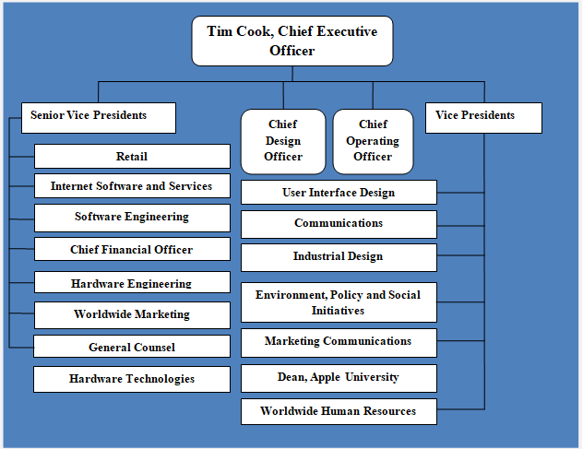
Figure 1: Apple Organizational Structure
Source: McNeil (2013)
This hierarchical form of Apples organizational structure has been introduces by late Steve Jobs in order to concentrate on creative and innovative idea and also for systematic business. There are various modification has been done by current CEO Tim Cook in 2011. They make it decentralization for taking decisions and it has been helpful with innovatively and creatively done. Encouraging and motivating employees and other members of the organization to enhance their efficiency for their betterment as well as organization.

RELATIONSHIP BETWEEN STRUCTURE, CULTURE, PEOPLE AND ORGANIZATIONAL PERFORMANCE
In this competitive market, Apple Inc. is a leading organization which makes an effective impact on their internal organizational structure and culture. Within the organization, culture, structure, people, and organizational performance are keen to make an effective impact on the organization process and Apple knows that the people and internal culture and structure are very effective of this organization to maintain their monopolistic image (Rasula et al., 2012). There are several structures they use in the organization but the main structure is horizontal, it manages organizational activities at a centralized level. As per the observation, Apple employees are more productive and have more skills and knowledge to maintain the quality of the product and services and they use their full energy and use passion to make it possible (Lee et al., 2012).
Organizational culture builds with the base of effective employees and managing organizational activities which have been efficiently performed by their employees and these employees have that potential to manage the team and provides full efforts to achieving organizational objectives. Apple uses approaches for managing effective culture in the organization like as Charles Handy model and Edgar Schein model of organization culture. Employees and other staff of this organization work with full of passion and manages their tasks effectively, Apple set up different thought process within the organization which helps to think like they are the owner of the organization and work with that motive (Lee et al., 2012).
As per the punch line of the organization, “Think Different” it represents the motive of the organization to look different in the process as well as in products. The organization takes control of the organizational activities and several resources which have been effectively responding to the growth of the company (Alvesson and Sveningsson, 2015). Apple manages its portfolio according to managing the organizational process which has been helping to identify the organizational culture and their structure for better ways of development (Rasula et al., 2012).

THEORIES AND MODELS OF THE ORGANIZATIONAL DESIGN AND CULTURE
CHARLES HANDY MODEL
Charles Handy Model has been introduced in 1955 by the well-known philosopher who has focused on organization culture. According to Handy, there are four types of culture in the organization which has been followed by the organization (Russo et al., 2013).

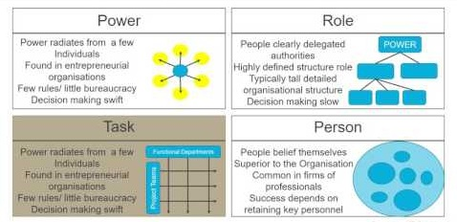
FIGURE 2: CHARLES HANDY MODEL
SOURCE: RUSSO (2013)
Power Culture:In various organizations, they use power culture in their organizational process, it refers that the power has been provided to few people and they are authorized to use and give instructions to other employees (Motesharrei et al., 2014). Theyplay an essential role to make effective decisions but from the observation, other employees are not able to share their opinions and view an open forum because employees have to follow the instructions what authorized people give them. In the case of Apple, they use centralize culture in the organization and in this process employees have the liberty to share their opinions and ideas in some cases(Russo et al., 2013).
Role Culture:In this culture, each and every employee are responsible to perform their roles and responsibility conferring to their qualification, specialization, and their attentiveness. The organization has done the changes in organizational process which help to achieve organizational goals. In this case, various employees of the organization have the liberty to do what they want to make it creatively and innovative(Alvesson and Sveningsson, 2015). In this culture, employees are willing to take challengesand fulfill their tasks effectively. Power comes with responsibility (Motesharrei et al., 2014).
Task Culture: tasks culture refers to the team task which has been done by the group of employees and specialists for accomplishing any of organizational tasks and activities. The accomplishment of task and activities are essential for the organization which is to be good to utilize all the resources and skills by the group of employees(Turner, 2014).
Person/Support Culture:This culture represents that every employee of the organization feels that he's superior and having a unique personality(Russo et al., 2013). The organization gives special treatment to the employee and appreciate their work with rewards, bonus and other things to motivate them (Motesharrei et al., 2014).

EDGAR SCHEIN MODEL OF ORGANIZATION CULTURE
According to Edgar Schein model, the organization doesn’t adopt a particular culture instantly. Instead, it is built and changed with the changing times as the employees go through different changes due to external factors. This helps in adapting to the changing times (Martinez et al., 2015).
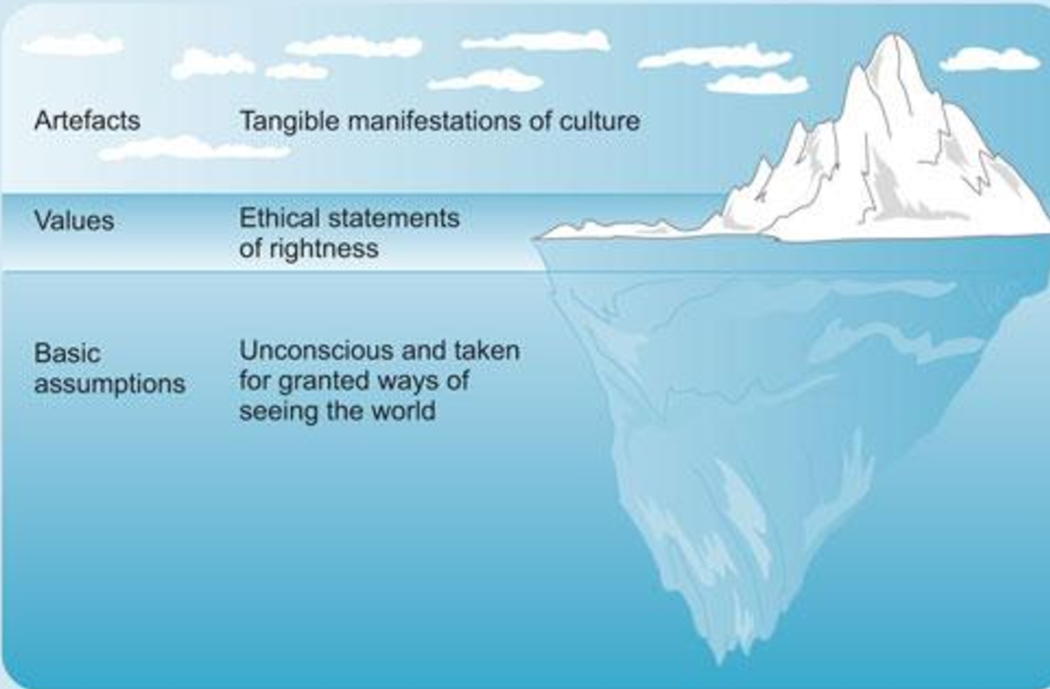
Figure 3: Edgar Schein Model
Source: Martinez (2015)
Artifacts
Artifacts refer to the environment that can be seen, heard and felt. It may be the dress code or the interior design. These factors play a major role in creating and maintaining the culture of the organization (Cacciattolo, 2014).
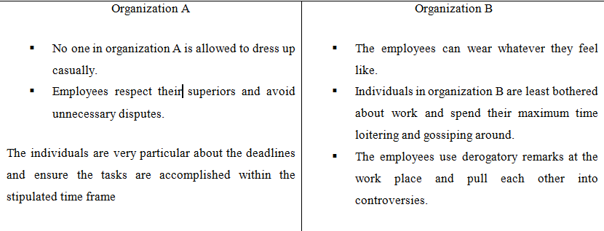
FIGURE 4: ARTIFACTS
SOURCE: CACCIATTOLO (2014)

Values
The values carried by the employee plays a major role in deciding the culture of an organization. According to Edgar Schein, the way of thinking, their sincerity, and attitude towards their work create a huge impact on the working culture(Alvesson and Sveningsson, 2015). Organizational culture must be in favor of employees what they want and how they work but it should be good. Working culture has been decided by the employees thinking and their ways of managing their roles(Martinez et al., 2015).
Assumed Values
As it is human nature to keep some hidden beliefs and secrets which are difficult to scale but also plays a significant role in deciding the depths of working culture. It differs with their preferences according to their gender, nature and interpersonal behaviorrelations (Cacciattolo, 2014). In this culture, there are some hidden facts in the organization culture which affects the most. Organizational culture has been very flexible because it has been adopting changes from the external environment (Martinez et al., 2015).

IMPACT OF MODELS OF THE ORGANIZATIONAL CULTURE IN THE APPLE INCORPORATION
Apple Inc.’s organizational culture is a crucial aspect for the betterment of organization activities and it helps to get more success (Jones, 2013). Organizational culture of Apple has been very specific and derived which maintain the business behaviors among employees, beliefs, values, and philosophy. Organizational performance varying by the performance of the employees and also what input incurred uses to motivate and encourage them. Employees of Apple Inc. has been giving full efforts to accomplish their tasks effectively so that they consider in the organizational culture of the company (Büschgens et al., 2013).
There are various models has been introducing for providing analysis of the organizational behavior of this company. Charles handy model and Edgar Schein model of organization culture represent various aspects of internal culture and also share various methodologies to achieve good by executing these in the organization (Alvesson, 2015). The most effective impact of the models has the changes and flexibility of culture by the diversity in people or in their culture or how they treat activities and tasks to complete. The organization has been defined uses a horizontal structure which leads to the centralized culture in the organization. This effectiveness of the culture makes employees more productive and increase the overall performance of the organization.
According to Tsai and Yang (2013) organizational culture are flexible and it impacts to the organization to help to set clear objectives and this would be achieved by the employees of the organization, there are various changes has be opt by the [organization in their working process to make it more effectual (Büschgens et al., 2013).
Superior performance models of the organizational culture boom the performance of the company by managing all the aspects of the organization which helps to enhance the revenue of the company (Jones, 2013). Apple Inc. has a large number of employees and the management and evaluation or their performance are done by organizational models and human resources management also support to internal organizational culture to maintain their curriculum (Tsai and Yang, 2013).

CONCLUSION
Apple Inc. is one of the largest technological organization which produce creative and innovative software and hardware. This organization manages various operating activities in the organization which helps to make effective organizational culture. In this report, discussed the analyzing factors of organizational structure and culture of the company which has been contributed to various aspects to the performance of the Apple incorporation. Structure and culture of the organization have been explained by using several models like Charles Handy model Edgar Schein model of organization culture represent the different aspects or internal culture of Apples Inc. Relationship between structure, culture, people and organizational performance are very necessary for increasing organizational performance and also set up an effective culture in the organization. At last, the impact of models of the organizational culture in Apple Inc. provides a brief observation of their internal culture and the growth of the organization.

REFERENCES
BOOKS
- Alvesson, M. and Sveningsson, S., 2015. Changing organizational culture: Cultural change work in progress. Routledge
- Apple, M.W., 2012. Knowledge, power, and education: The selected works of Michael W. Apple. Routledge.
- Jones, G.R., 2013. Organizational theory, design, and change. Upper Saddle River, NJ: Pearson,
JOURNALS
- Büschgens, T., Bausch, A. and Balkin, D.B., 2013. Organizational culture and innovation: A meta‐analytic review. Journal of product innovation management, 30(4), pp.763-781.
- Huda, A.B., Parveen, S., Rather, S.A., Akhter, R. and Hassan, M., 2014. Effect of incorporation of apple pomace on the physicochemical, sensory and textural properties of mutton nuggets. International Journal of Advanced Research, 2(4), pp.974-983.
- Cueto, J.A., Vega, I.A. and Castro-Vazquez, A., 2013. Multicellular spheroid formation and evolutionarily conserved behaviors of apple snail hemocytes in culture. Fish & shellfish immunology, 34(2), pp.443-453.
- Lee, S., Gon Kim, B. and Kim, H., 2012. An integrated view of knowledge management for performance. Journal of Knowledge management, 16(2), pp.183-203.
- Martinez, E.A., Beaulieu, N., Gibbons, R., Pronovost, P. and Wang, T., 2015. Organizational culture and performance. American Economic Review, 105(5), pp.331-35.
- Tsai, K.H. and Yang, S.Y., 2013. Firm innovativeness and business performance: The joint moderating effects of market turbulence and competition. Industrial Marketing Management, 42(8), pp.1279-1294.
- McNeil, L.M., 2013. Contradictions of control: School structure and school knowledge. Routledge.
WEBSITES
- Cacciattolo, K., 2014. Understanding organisational cultures. European Scientific Journal. Available on: https://eujournal.org/index.php/esj/article/view/4782/4596 (Accessed on 25 July 2019).
- Russo, G.M., Tomei, P.A., Linhares, A.B.J. and Santos, A.M., 2013. Correlation between organizational culture and compensation strategies using Charles Handy's typology Performance Improvement. Available on: https://onlinelibrary.wiley.com/doi/abs/10.1002/pfi.21359 (Accessed on 25 July 2019).
- Rasula, J., Vuksic, V.B. and Stemberger, M.I., 2012. The impact of knowledge management on organizational performance. Available on: http://ojs.ebrjournal.net/ojs/index.php/ebr/article/view/85 (Accessed on 25 July 2019).
- Motesharrei, S., Rivas, J. and Kalnay, E., 2014. Human and nature dynamics (HANDY): Modeling inequality and use of resources in the collapse or sustainability of societies. Available on: https://www.sciencedirect.co/science/article/pii/S0921800914000615 (Accessed on 25 July 2019).

