

Market structures
(Essay)

Student name: Elena Rumenova Sotirova
Student number: 2028225
Module name: Management economics
Module code: LCBB5003
Lecturer: Vasilios Tavlaridis
Date deadline: 21st October 2022

Contents: page
Introduction …………………………….…………………………………………………....3
Market Structure Perfect Competition.……………………………………………….……3
Market Structure Monopoly…………..………………………………...……….……….....5
Monopolistic Competition ………………….………………………..………….…..….…..6
Duopoly………………….……………………………………………………….…………..7
Oligopoly…………………………………………………………………………….……….8
Conclusion………………………………………………………………………………….10
Reference list…………………………………...…………………………………………..11

Introduction
Generally, the more precisely a market is defined, the more likely it is that one or more enterprises will be deemed dominant. Focus has also been placed on techniques of directly gauging market power, obviating the requirement to define marketplaces in some circumstances (Market, Power In and Competition 2021). Markets control economic life, from purchasing and selling raw materials to delivering the finished product to the consumer. It is impossible to imagine a world without markets. In reality, modern economies are 'market economies,' in which financial choices study strategy via the interaction of businesses, customers, and employees in a market environment (Sloman et al.2019). For a better knowledge of the market, the market structure is underlined. In business, market structure categorises industries according to the intensity and nature of their product and service competition. It is determined by the elements that influence the behaviour and outcomes of companies listed on a given market. The number of buyers and sellers, the ability to negotiate, the degree of concentration, the degree of product diversification, and the simplicity or difficulty of entering or leaving the market are a few of the factors that influence the structure of a market and will be examined in this essay (Corporate Finance Institute, 2022).
Market structure perfect competition
Examining market structure focuses primarily on four industry characteristics: the quantity and size distribution of sellers (buyers), the level of differentiated products and substitutability, the conditions of entry and exit, and the nature of price and quality-related information dissemination. In economics, five primary market structures or kinds are typically examined: perfect competition, monopoly, monopolistic competition, duopoly, and oligopoly (Kapunda, 2017, p.25).
Four factors typically characterise perfect competition:
- Numerous businesses give a product or service to a market with many consumers.
- No restrictions are preventing new firms from entering the market. Consequently, the typical competitive firm will generate little economic profit.
- All companies manufacture and sell identical essential products. Therefore, firms compete solely based on pricing. Additionally, all consumers have complete knowledge of rival prices. Thus, all commodities must be sold at the same price on the market.
- Companies and customers are price takers. Each company sells a small portion of the industry's overall output; hence, its activities do not affect the price. Each company accepts the price as it is, which is decided by supply and demand. Similarly, every consumer is a price taker who has no impact on the market price.
It is essential to keep in mind that these conditions represent the ideal form of perfect competitiveness. Some competitive markets in the real world meet all four characteristics of the letter. Numerous additional real-world marketplaces are effectively completely competitive because their conditions are comparable to these. Using perfect models creates accurate price and output forecasts for marketplaces with ideal competition (Samuelson and Marks, 2022, p.219-220).
Market power is the ability of a company to set the price for its goods. In perfect competition, many vendors supply the same item, and a single company has almost no influence over its product's pricing. In addition, a company cannot charge a more excellent price than its rivals because every company provides the same product. In this market system, the interaction between supply and demand determines the price for all players. A company has little market strength and is only a price taker. It can only decide whether to enter the industry and how much production to generate (Keat et al. 2014, p.338).
The markets exemplify this category of the need for agricultural goods (e.g., corn, coffee, wheat), financial instruments (e.g., stocks, bonds, foreign currency), metals (e.g., gold, silver, platinum), and the global petroleum sector. In any market, the items are standardised objects, and supply and demand are the most precise drivers of their sale price (Keat et al. 2014, p.340.)
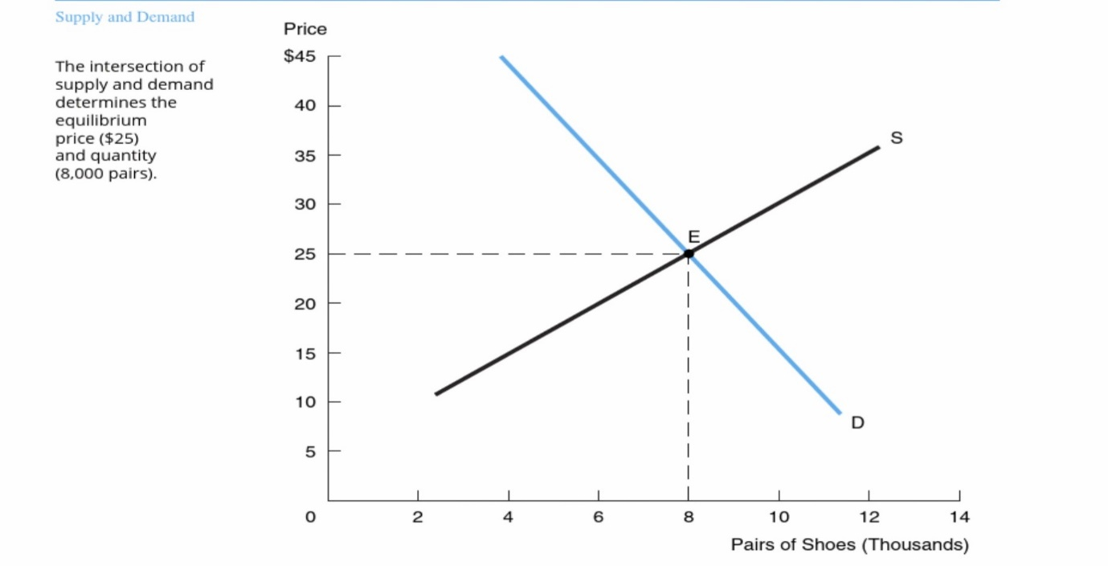
Figure 1: Perfect Competition Supply and Demand (Samuelson and Marks, 2022, p.216)
It is precisely for this reason that sellers occasionally form cartels to raise prices or prevent them from lowering. This is shown by OPEC and the International Coffee Growers Association, which band together to control costs by limiting their product supply Keat et al. 2014, p.340.)
Market structure Monopoly
A monopoly is a market structure where only one seller is present. The instance of absolute trust is significant in and of itself but also due to its applicability to cases of near monopoly, in which a handful of enterprises control a market. The monopoly model also describes the behaviour of cartels, which are groupings of producers that determine prices and outputs collectively. There are two primary factors to consider while considering a monopoly. One must first comprehend monopolistic behaviour or how a monopolist who maximises profits controls pricing and production. Second, one must recognise that entry barriers are a prerequisite for monopoly since they hinder other enterprises from joining the market and participating on an equal basis with the monopolist (Samuelson and Marks, 2015, p.245).
By evaluating the pricing and output choice of a monopolist. As the sole manufacturer, the monopolist can increase prices without fear of losing customers to a competitor who may offer a lower price. Even though the monopolist controls the industry's output, it cannot raise prices indefinitely. Its best pricing and output strategies are determined by market demand. Because the monopolist is the sector, the monopolist's demand curve is essentially the industry demand curve (Samuelson and Marks, 2015, p.245).
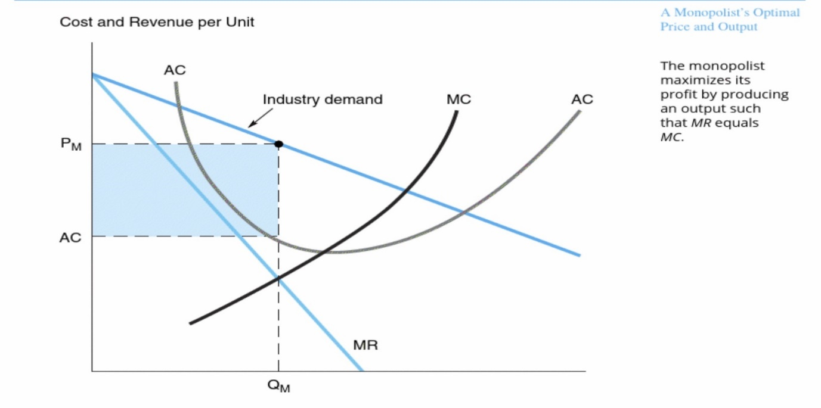
Figure 2: Monopoly Supply and Demand (Samuelson and Marks, 2015, p.245)
If the monopolist increases the price, fewer units will be purchased, and the resulting equilibrium will not maximise profits. In the long run, this equilibrium will persist if obstacles persist, demand remains constant, and costs are maintained (Intelligent economist, 2022).
Monopoly examples provide numerous monopolistic businesses; however, they are primarily theoretical. In a capitalist economy, monopolies are prevalent; nevertheless, governments ensure that monopolists do not abuse their position by charging excessive prices for their services and products. Moral laws are enacted to regulate the monopolistic pricing of corporations.
Monopolistic competition
Monopolistic competition is a market structure that combines elements of monopolistic and competitive markets. In monopolistically competitive markets, entry and departure are unrestricted, but product differentiation is permitted (Economics Help, 2019).
The monopolistic competition model is the foundation of modern commerce, growth, and industrial geography theories. It is also commonly used in empirical studies of trading. However, it is reasonable to explain that this model has significant flaws. First, preferences are not flexible since substitution flexibility is constant and identical across varieties. Second, company entry and market conditions do not affect prices and market size. This defies economic theory and industrial structure in general—particularly those who have long emphasised the significance of entry in market pricing decisions. Third, there is no scale impact, meaning that the size of businesses is independent of the number of customers. Such a result goes against empirical evidence. For instance, Holmes and Stevens (2004) found that the correlation between company size and market size varies between services and manufacturing. The price and scale of enterprises are independent of their geographical location. The allocation of demand. However, it is generally established that firms profit closer to their major markets, with distance comprising more than fifty per cent of the decision (Zhelobodko et al., 2012).

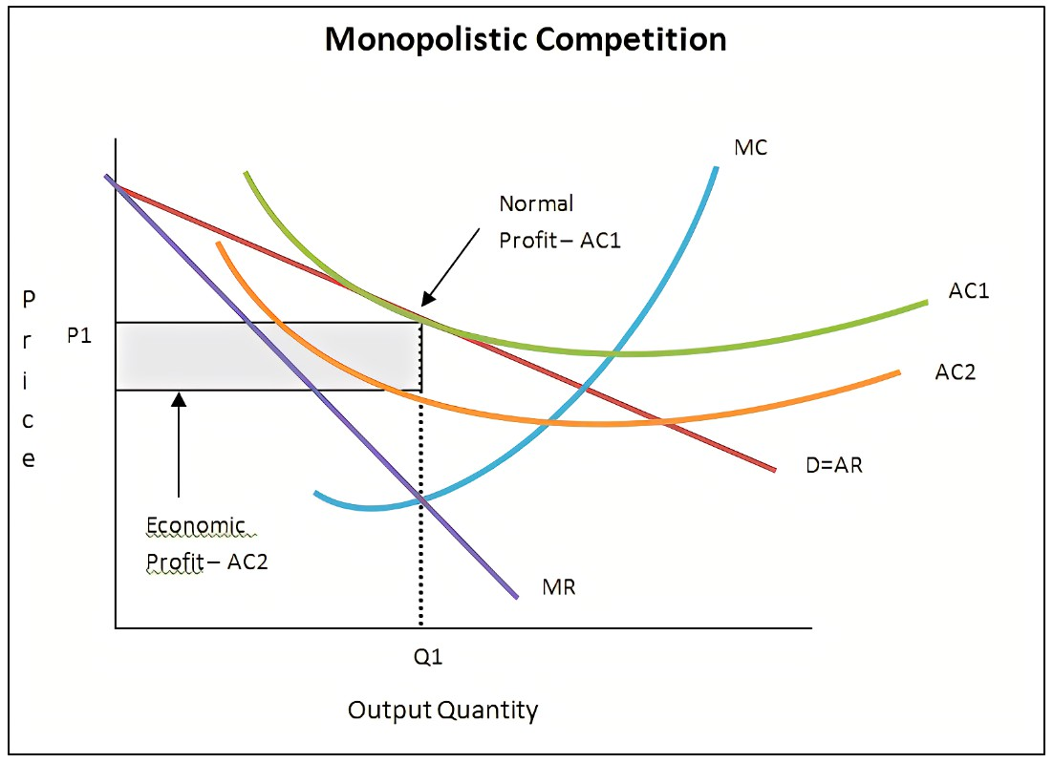
Figure 3: Monopolistic competition supply and demand short run (Economic Thoughts with Glenn, 2012)
Some examples of monopolistic competition are:
- Restaurants - compete on both pricing and meal quality. Product differentiation is essential to the success of a firm. To open a new restaurant, there are a few obstacles to overcome.
- Hairdressers. A service that will enhance the reputation of a company's hair-cutting services.
- Clothing. Clothing with designer labels focuses on brand and product uniqueness.
Globalisation has enhanced the variety of television programmes broadcast by international networks. Consumers can pick between indigenous channels, imports, and new services like Netflix (Economics Help, 2019).
Duopoly market structure
A duopoly is comparable to an oligopoly, a competition dominated by a few enterprises. In a duopoly, a specific market or industry is dominated by just two companies (this is in contrast to the more widely known case of a monopoly when just one company dominates). In scarce instances, this means that they are the only two competitors in the entire market (this rarely occurs); however, in practice, duopoly typically indicates that the two companies have a significant amount of influence, and their acts, as well as their relationship with one another, powerfully shape their industry. Duopoly markets are perfectly competitive. Therefore, entry barriers are frequently high for those wanting to enter the market. However, other smaller businesses stay in addition to the two dominant enterprises (Intelligent economist, 2022).
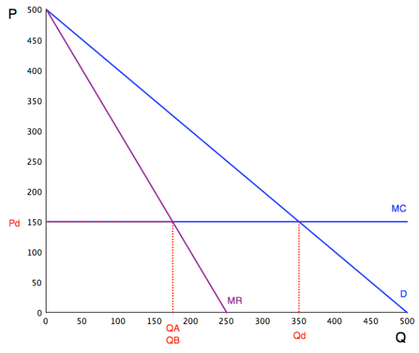
Figure 5: Duopoly supply and demand (mnmeconomics, 2011)
Numerous examples of duopoly appear. Here are several of the most popular:
- MasterCard and Visa Electronic Payments
- Coca-Cola and Pepsi constitute soft drinks.
- Boeing and Airbus are aircraft producers.
The benefits of a duopoly are few big competitors; businesses can create much greater profits; in practice, consumers must almost always select between two options. Consumers do not have to sift through dozens of opportunities to find the most satisfactory service or product for their needs because the market has been streamlined. To be more competitive, financial resources can be allocated to improving the quality and functionality of existing products and services rather than developing new ones (mnmeconomics, 2011).
Oligopoly
An oligopoly is a condition in which numerous companies compete in a particular market. Only enough enterprises can profit from what is made in industries with greater competition. It appears that entry barriers consisting of information costs, economics of scale, franchisees, and patents are adequate to keep new competitors away. Consequently, it is reasonable to conceptualise oligopoly as imperfect competition without free entry and monopolistic competition as perfectly competitive with free admission.
Oligopoly-focused international trade economists have emphasised the significance of oligopoly profits. With monopolistic or perfect competition, no income is measured by the return on all opportunity costs (Ruffin, 2009).
In many oligopolistic businesses, one company holds the largest market share and sets the pricing for the whole industry. In the past, dominating businesses have included General Motors in the automobile sector, Du Pont in the chemical industry, and U.S. Steel. Walmart among bargain stores, eBay in online auctions, FedEx in overnight delivery, Procter & Gamble in a range of consumer products, Intel in microchips, and Microsoft in PC software, to name a few, currently have dominating market shares (Samuelson and Marks, 2015, p.276).
In practice, the dominant firm takes the initial (and most significant) strategic decision in the marketplace, with the companies responding to its moves. The dominating firm's most important strategic priority is anticipating the supply reaction of the competitive periphery. Suppose, for instance, that the dominant firm believes that any price increase will result in a substantial increase in supply by the other firms and, consequently, a significant decrease in its net demand. In other words, the net direction of the dominant firm is the more price elastic the rivals' supply response is. Under these conditions, the dominant firm should refrain from increasing the market price (Samuelson and Marks, 2015, p.277).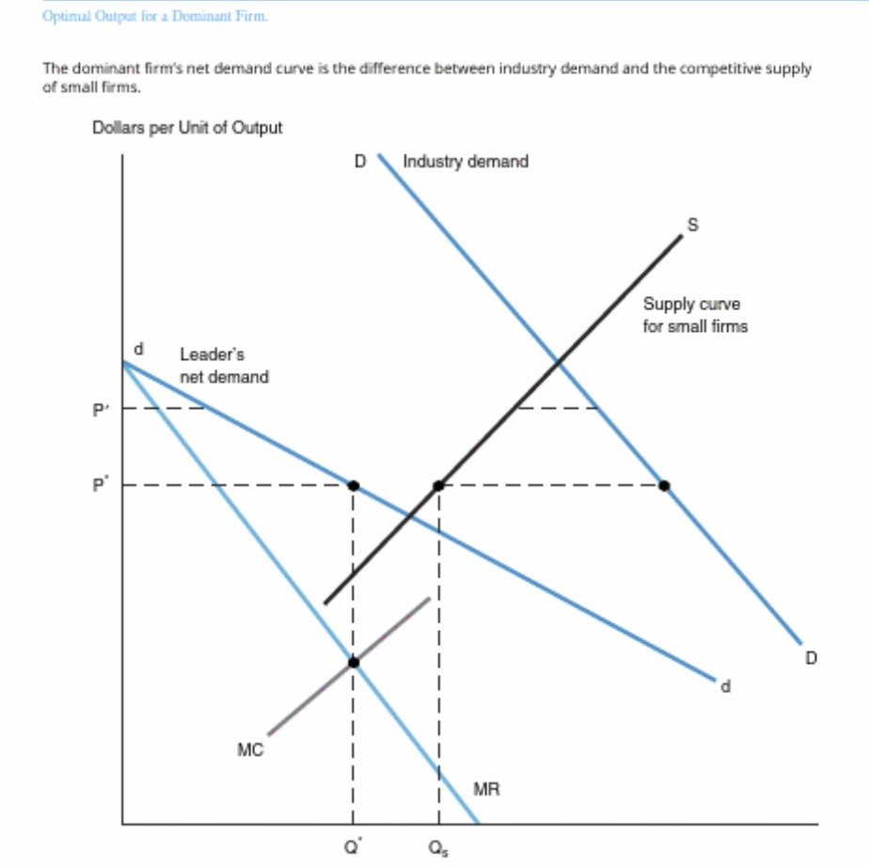
Figure 6: Oligopoly supply and demand (Samuelson and Marks, 2015, p.277)
The kinked demand curve model presupposes a company setting its pricing strategy based on its competitors' responses to anticipated price increases. This is one method for incorporating strategic concerns into a company's decisions. Unfortunately, the willingness of businesses to react aggressively to price reductions is precisely what keeps prices steady. Price reductions shall not be tried if they are anticipated to result in additional price reductions. Nevertheless, the kinked demand curve model is insufficient. It does not clarify why the kink occurs at P *. Neither does it excuse the competitors' price-cutting tactics. A comprehensive model must include a more thorough treatment of strategic behaviour (Samuelson and Marks, 2015, p.282). The oligopolistic market is the most prevalent market structure in the present world. The primary examples are:
- Media sector - The media industry is also a form of oligopoly. Comparatively, in India, over 90 per cent of this industry is dominated by leaders such as The Tribune, ABP news, etc., and the choice of one producer ultimately influences the decisions of other companies.
- Information technology sector - This industry is a prime example of an oligopoly. The global market for computer technology is dominated by two companies, Apple and Windows. Due to the global economic expansion, no other companies are attempting to enter this industry.
- Automobile industry - Taking India as an example, there are numerous vehicle industries. However, a dozen of them dominates the market. Examples include Hyundai and Maruti. The automobile industry is an instance of an organised oligopoly. Because here, standards and prices are maintained by an artificial authority (analyticssteps.com 2021).
Conclusion
Evaluation of demand and supply is a qualitative method that helps managers by enabling them to see the "big picture." It is a qualitative method for predicting trends in competitive markets and other marketplaces, such as variations in the prices of a firm's products and other items (both substitutes and complements) and the expenses of required resources (Baye and Prince, 2017, p.31). Demand and supply have shaped the structure and types of the market. Market structure is the differentiation of needs/industries depending on rivalry, product diversity, ease of entry and exit, degree of mutual interaction, and other factors. The five market system types are perfect competition, monopolistic competition, oligopoly, duopoly, and monopoly are the concept of market structure, and it is relevant to both economics and marketing. The market structure has a significant impact on decision-making. The choices made by market participants, such as buyers and sellers, differ amongst marketplaces (Learn business Concepts, 2022).

Reference list:
Analyticssteps (2021) What is Oligopoly: Types, Characteristics and Examples. Available at: What is Oligopoly: Types, Characteristics and Examples | Analytics Steps
(Accessed: 6 October 2022)
Baye, M.R. and Prince, J. (2017) Managerial economics and business strategy. Ninth edition. New York, NY: McGraw-Hill Education.
Corporate Finance Institute (2022) Market Structure. Available at: Market Structure - Overview, Distinct Features, Types (corporatefinanceinstitute.com)
(Accessed: 25 September 2022).
Economics help (2019) Monopolistic Competition – definition, diagram and examples. Available at: Monopolistic Competition - definition, diagram and examples - Economics Help
(Accessed: 4 October 2022)
Economic Thoughts with Glenn (2012) Comparing Market Structures. Available at: Economic Thoughts with Glenn: Comparing Market Structures
(Accessed: 13 October 2022)
Intelligent Economist (2022) Duopoly Market Structure. Available at: Duopoly Market Structure - Intelligent Economist
(Accessed: 4 October 2022)
Intelligent Economist (2022) Monopoly Market Structure. Available at: Monopoly Market Structure - Intelligent Economist
(Accessed: 9 October 2022)
Kapunda, S., M. (2017) Industrial and Development Economics: An African Perspective. CODESRIA,
Keat, P.G., Young, P.K.Y. and Erfle, S.E. (2014) Managerial economics : economic tools for today’s decision makers. Seventh edition. Harlow, England: Pearson Education Limited.
Learn Business Concepts (2022) Market Structures – overview, Features, Types, Examples. Available at: Market Structures - Overview, Features, Types, Examples (learnbusinessconcepts.com)
(Accessed: 13 October 2022)
Market, Power In and Competition (2021) Partnership for Market Readiness - Costa Rica ProgramPartnership for Market Readiness Technical Papers Washington, D.C: The World Bank, pp. 309.
MNMECONOMICS (2011) Duopoly and residual demand. Available at: Duopoly and residual demand | mnmeconomics (wordpress.com)
(Accessed: 4 October 2022)
Samuelson, W.F. and Marks, S.G. (2015) Managerial economics. Eighth edition. Hoboken, NJ: Wiley.
Ruffin, R.J. (2009) Oligopoly, The Princeton Encyclopedia of the World Economy. Princeton: Princeton University Press
Sloman, J. et al. (2019) Economics for business. Eighth edition. Harlow: Pearson.
XPLAIND.com (2022) Perfect Competition. Available at: Perfect Competition | Definition | Characteristics | Example (xplaind.com)
(Accessed: 29 September 2022)
Zhelobodko, E. et al. (2012) ‘MONOPOLISTIC COMPETITION: BEYOND THE CONSTANT ELASTICITY OF SUBSTITUTION’, Econometrica, 80(6), pp. 2765–2784. Available at: https://doi.org/10.3982/ECTA9986.

