Student name: George – Anton Anghel
Student ID Number: 2509533
Programme of study: Certificate in Higher Education Business Skills for the Workplace
Module name: Employability and career development
Module code: LCLM4005
Lecturer name: Dr Inderjit Grewal

Mock Interview
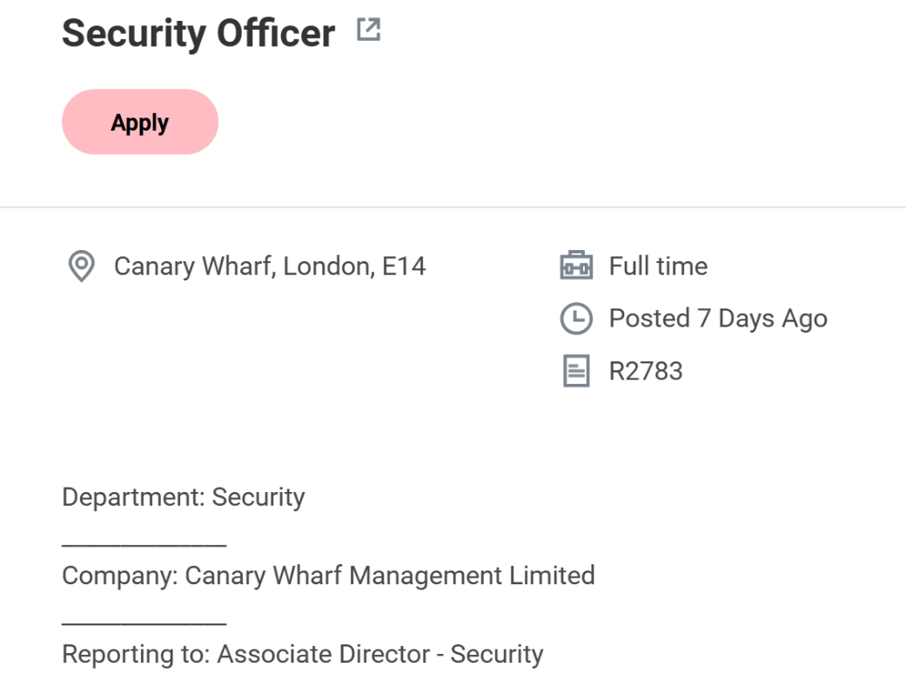

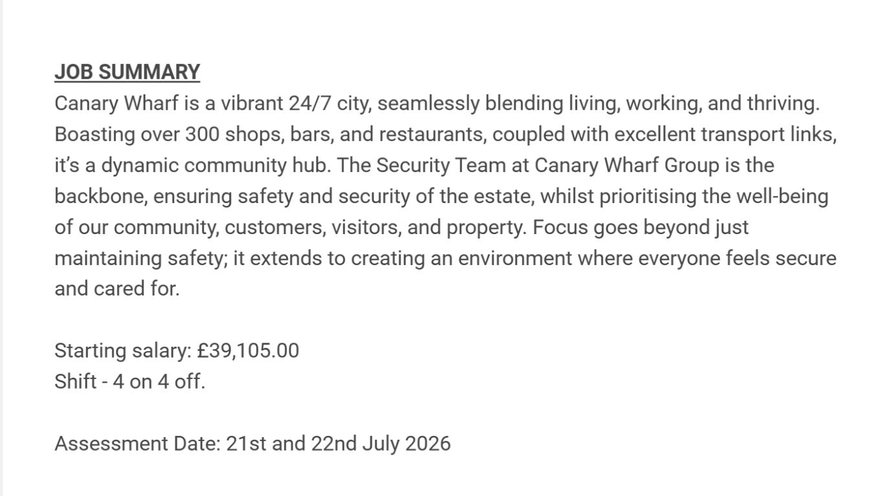

,
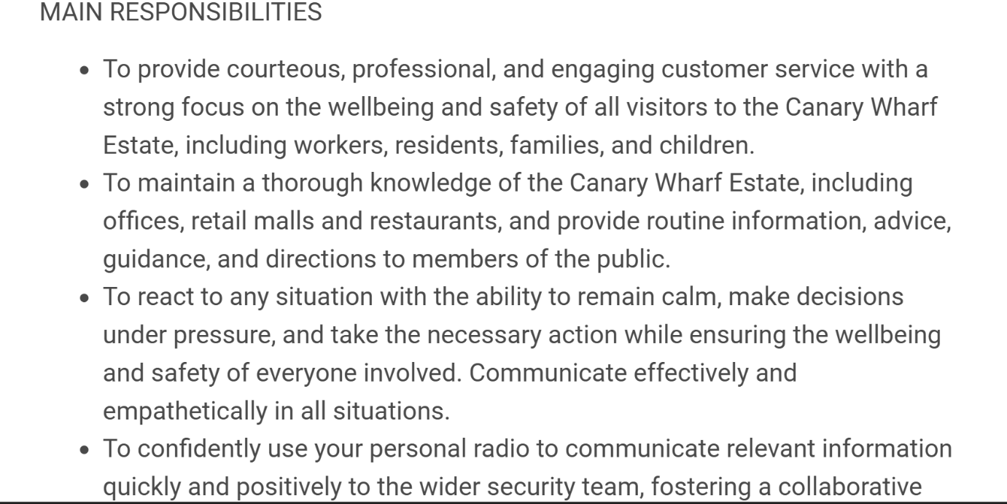
,
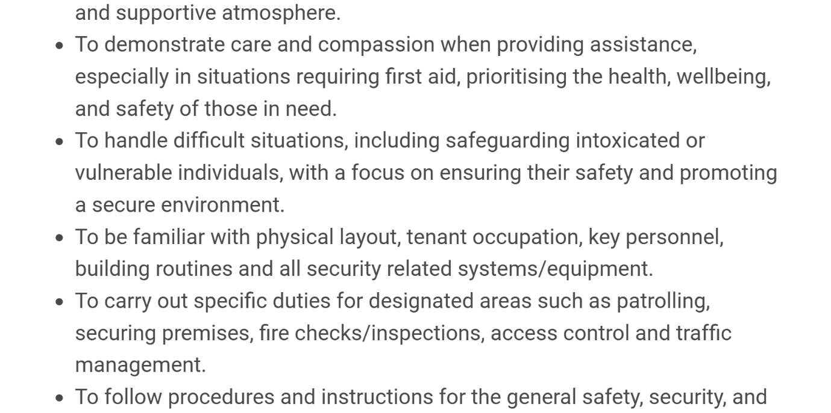
,
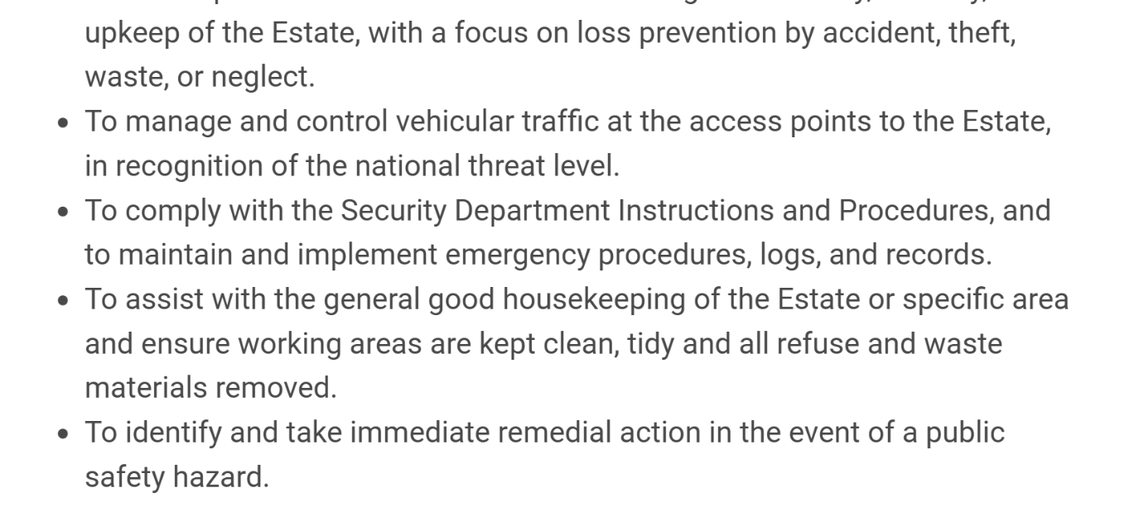
,
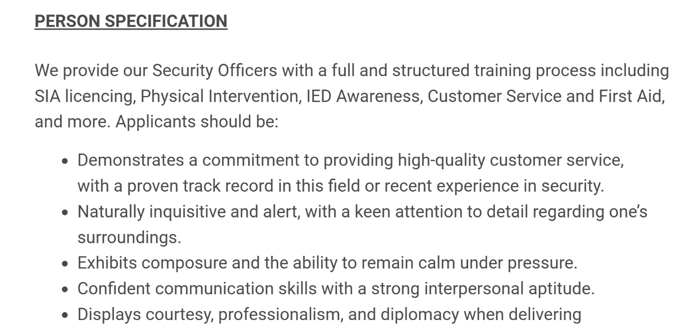
,
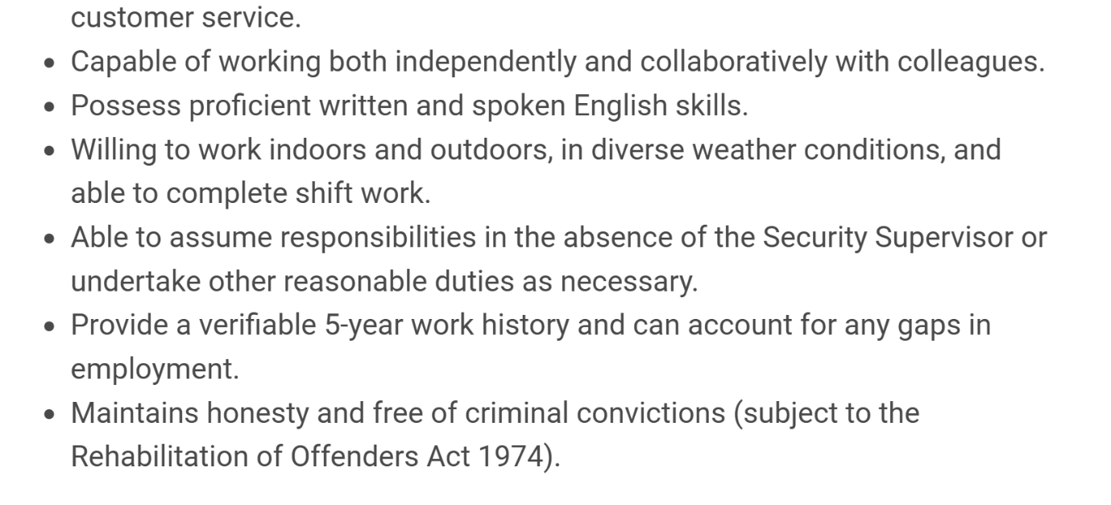

Cover Letter
George – Anton Anghel
Reporting to: Associate Director Security
Canary Wharf Management Limited
Canary Wharf London E14
15/07/2026

Dear Hiring Manager,
I am writing to apply for the Security Officer position at Canary Wharf Management Limited. I am currently working in security, and I have experience in maintaining a safe and secure environment. I hold a valid SIA Door Supervisor License and CCTV License, and I have experience in CCTV monitoring, access control, patrolling and dealing with different situations.
I am a reliable and professional person who can stay calm under pressure and handle difficult situations in a positive way. My previous experience as a hotel receptionist has also helped me to improve my communication and customer service skills, as I have experience dealing with different types of people.
I am interested in this opportunity because I would like to use my security skills in a professional environment like Canary Wharf, where I also live and study.
I can work well on my own and also as part of a team. I always maintain a good standard of security and provide a helpful service. I am always punctual and well-presented.
Thank you for taking the time to consider my application. I look forward to hearing from you.
Yours sincerely
George – Anton Anghel

CV:
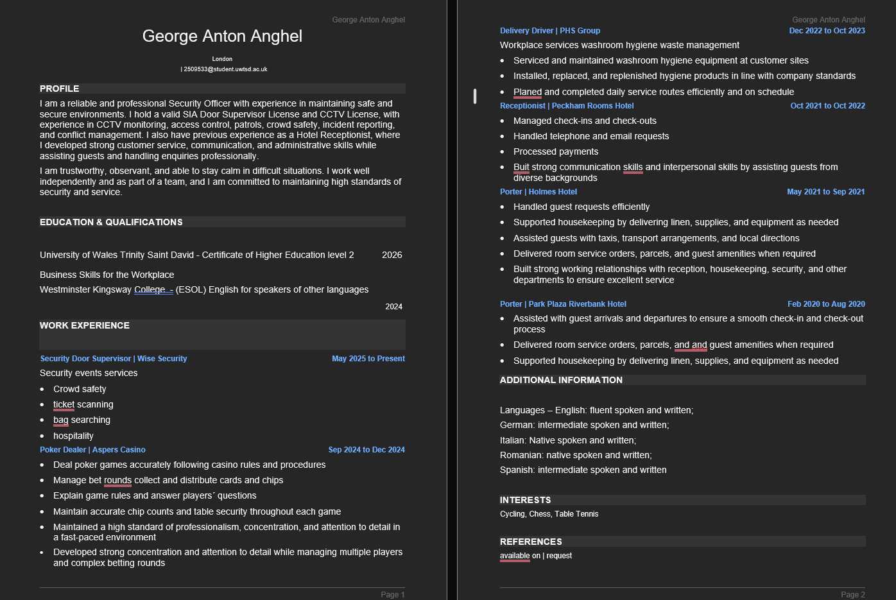

Advert available at: https/https://canarywharf.wd103.myworkdayjobs.com/en-US/CanaryWharf/details/Security-Officer_R2783
References available upon request.

