Programme: Cert HE Business Skills for the Workplace
Module: Employability and Career Development
Module Code: LCLM4005

1. Curriculum Vitae (CV)
CONTACT DETAILS
Name:
Address:
City, State, ZIP Code:
Email:
Phone Number:
Date:
PROFILE
Brings leadership experience acquired in a fast-moving food production setting. Experienced in the management of hygiene groups, sustaining audit-compliant and food safety, COSHH and sanitation standards. Skilled in cross-functioning with production, engineering, quality and technical departments. Among other things, it is my ambition to get promoted to a Hygiene Shift Manager to assume complete responsibility for the hygiene operations and help with the constant improvement.
EDUCATION
University of Wales Trinity Saint David
- CertHE in Business Skills for Workplace
- Modules Include:
  - Employability and Career Development, Business Communication
  - Introduction to Management and Digital Skills for the Workplace
General Secondary Education (GCSE Equivalent)
- Mathematics: Achieved
- English: Achieved
- Other subjects taken in the ordinary secondary school curriculum
KEY SKILLS
- Supervision and cleanliness leadership. Deep clean coordination and line changeover assistance
- Good understanding of COSHH, mechanisms and motivation for best practices
- Participation is highly attentive and capable of solving problems
- Capacity to operate 4 on/ 4 off rotating day/night shift
- Relaxing, dependable and results-oriented leadership manner
PROFESSIONAL EXPERIENCE
- Hygiene Supervisor: Food Manufacturing Industry
London, UK
- Current Role
- Supervise hygiene operatives across production and high-care areas
- Lead daily and weekly cleaning activities, ensuring completion of hygiene schedules
- Assist in intensive cleans, line dismantling and re-assembly in partnership with the engineering teams
- Monitor usage of chemicals, impose COSHH regulations and promote safe working environments
- Perform hygiene inspections, make audits and customer-visit preparations
- Educate new personnel on hygiene practices, chemical safety and site policies
- Communicating hygiene goals, problems and information at interdepartmental levels
- Notify deviations on reports and investigations of matters of hygiene
- Recommend the cleaning process, equipment and cleaning performance improvement
- Assist in production commencement by certifying sanitation and equipment preparation
This position has enhanced my leadership skills, problem-solving capacity and knowledge in a high-level food safety organisation, experience that will make me ready to be a shift manager.
PRIOR EXPERIENCE
- Hygienic Operative Food Manufacturing.
London, UK
- Conducted regular and profound cleans to site hygiene standards
- Adhered to specific cleaning food safety and handling chemicals
- Exposure to preparing audit and hygiene documentation
- Experience in working with production, engineering and technical departments
- Capacity to enhance hygiene
- precautions and recorded fulfilment
- Stored and used cleaning chemicals safely and in accordance with COSHH
- Audits and verification activities were supported by hygiene supervisors
EDUCATION
Higher Education
- University of Wales Trinity Saint David
- CertHE in Business Skills for Workplace
Food Safety Training and Certifications:
- Level 2 or Level 3 Food Safety
- COSHH Training
- HACCP awareness
ADDITIONAL SKILLS
- Experienced with hygiene schedules, following master cleaning systems
- Knowledge of allergen controls and high-care hygiene practices
- Good communication and leadership approach
- Keeping of correct records and preparation of audits
- Easily comprehends the standards of food manufacturing in the UK
PERSONAL QUALITIES
- Trustworthy and sure decision-maker
- High level of responsibility and ownership
- Approachable team leader who is supportive
- Driven by quality and unremitting improvement
- Convenient working life and nights, days and extended shifts
INTERESTS
- Team leadership development
- Process improvement
- Food hygiene, innovation and industry standards
- Individual well-being and fitness

2. Cover Letter
Name:
Address:
City, State, ZIP Code:
Email:
Phone Number:
Date:
Hiring Manager
Taiko Acton
W3 7XR
West London
Dear Hiring Manager,
I am addressing to show my interest in the position of Hygiene Shift Manager at Taiko in Acton. My present experience as a Hygiene Supervisor and effective working experience in food manufacturing hygiene processes have made me confident that I can seamlessly enter this position and add to the high standards that Taiko receives.
Under my current position, I oversee hygiene tasks in all production sites, deep clean support, chemical usage and proper completion of cleaning schedules in an accurate and safe fashion. I get involved with the day-to-day hygiene activities and I closely coordinate with the engineering, production and quality team and this has enabled me to develop a strong appreciation of cross-department coordination. The experience has influenced my capacity to handle people, solve issues within a limited time and ensure adherence to internal and external hygiene standards.
I am well conversant with COSHH, cleaning agents and food safety rules and I know that I must ensure that my standards are audit-ready at all times. I am actively involved in the preparation of audits, review of documentation and training of teams to make sure that we are up to the customer and BRC standards. Throughout my time, I have also made additions to the measures of hygiene processes by spotting areas of inefficiency and assisting in adopting safer or more productive ways of operating.
The thing that makes me feel inspired about the position at Taiko is that I will be allowed to assume full control of the hygiene activities and will guarantee that the team provides outstanding cleaning and food safety services. I like to inspire others, set clear expectations and make them confident in what they are doing. My leadership philosophy is based on leading by example, ensuring a high level of presence on the floor and ensuring that I stand by the team in the event of any operational issues. I can work 4 on 4 off shifts and day and night shifts and I live in London, so Acton has been a good commute.
I also like the innovativeness and quality of Taiko and would feel honoured to work there. The fact that the company is dedicated to the sustainability, growth and well-being of its employees also makes me very fond of it. The opportunity to develop in the business and introduce a continuous improvement in hygiene and food safety is of interest to me in particular.
I would be glad to transfer my experience, dedication and leadership style to your Hygiene team. Thank you for considering my application. I would like to speak more about my suitability during an interview.
Kind regards,

3. Job Advertisement
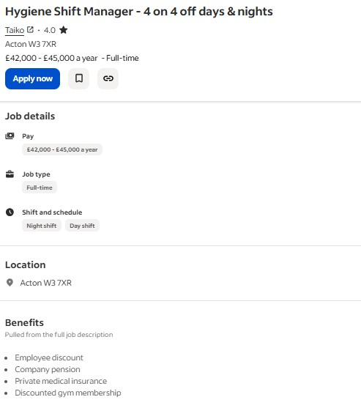
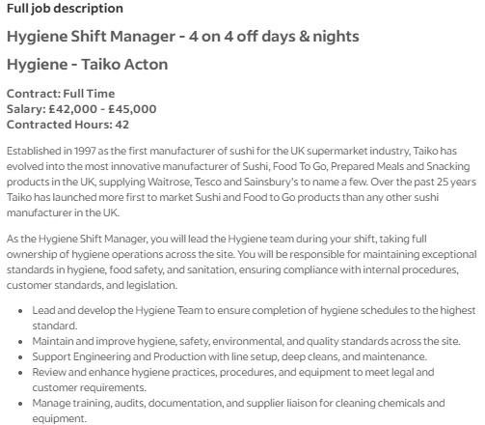
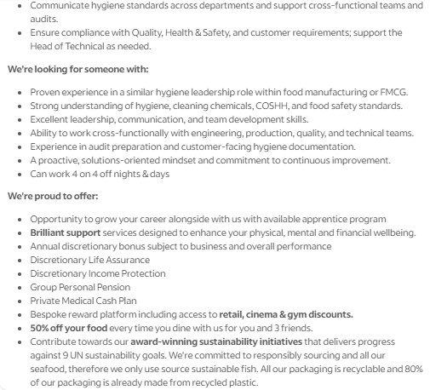
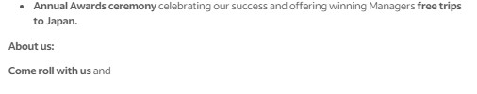
(Indeed, 2025)

Reference List
Indeed (2025). Hygiene Manager Work, jobs in London (with Salaries) | Indeed United Kingdom. [online] Indeed.com. Available at: https://uk.indeed.com/jobs?q=hygiene+manager&l=London%2C+Greater+London&from=searchOnHP%2Cwhereautocomplete&vjk=fd46958095021d4e [Accessed 15 Nov. 2025].

