Student Name: Ayesha Khan
Student Number:2129615
Module Code: LCHS4004_BIRM
Module Name: Public Health
Lecturer Name: Dr Aishat Bakre

Introduction:

Chickenpox is a virus; it is also known as varicella, a highly contagious infection caused by the varicella zoster virus. Chickenpox is a viral illness that causes a blister-like rash. The rash first appears on the face and trunk or anywhere and then spreads throughout the body. The first description of chickenpox was provided by Giovanni Filippoin the 16th century.
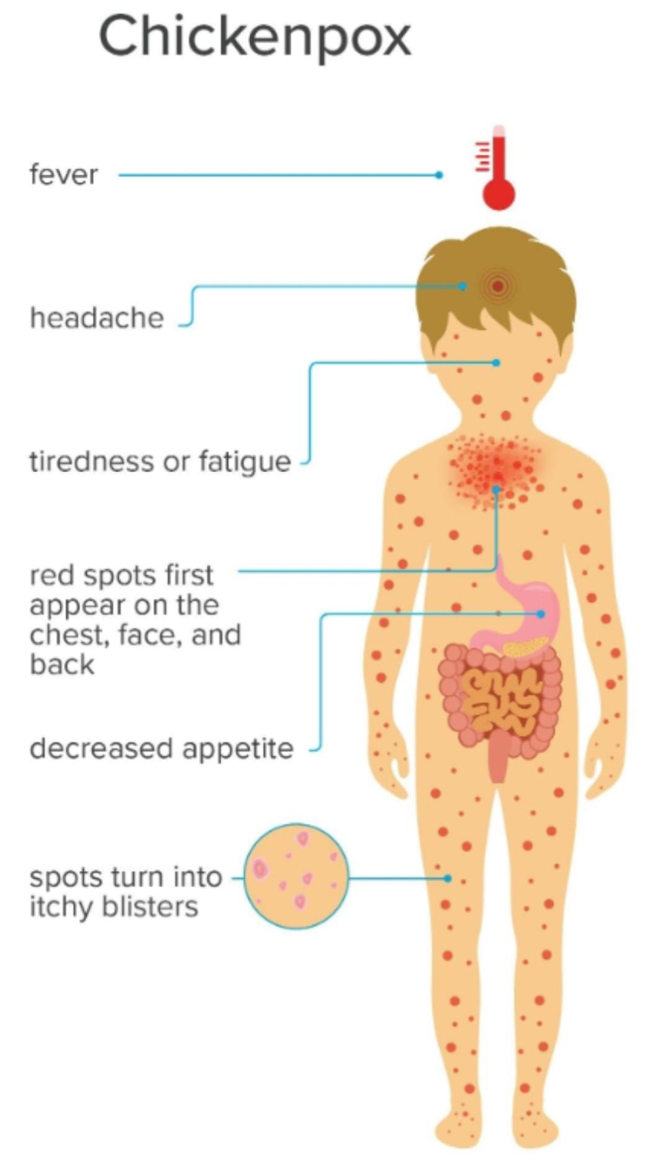
Image credit: Stephen Kelly, 2018
Chickenpox is most commonly a childhood illness; chickenpox vaccine was introduced in 1995. It is an airborne disease which spreads easily by coughing and sneezing of an infected person. It has various stages, and its recovery period is almost 1 to 2 weeks. As such there is no cure for chickenpox but it resolves within a week or two weeks. The immune system becomes weak because of this virus. This primary infection is most seen in children under 10 years old, but adults tend to suffer more severely than children.

- Strategies used in the UK to measure the incidence of the disease:
In England, chickenpox vaccination is offered currently only to non-immune healthcare workers. It is severe complications of this disease, including death, continue to occur in the UK and Ireland. In the UK, the vaccine is given to adults and children over the age of 1 year. The annual average rate for chickenpox was 1.6 cases per 1000 consultations per week, an average of 3 to 4 deaths each year since 1980.
The diagnostic method of chickenpox is the use of polymerase chain reaction (PCR) to detect VZV in skin lesions. If red spots, scabs, vesicles are present then this is the best for sampling. All vaccines in the UK are assessed for their cost-effectiveness to ensure that the health budget spent on services which provide the greatest health benefits for the population.
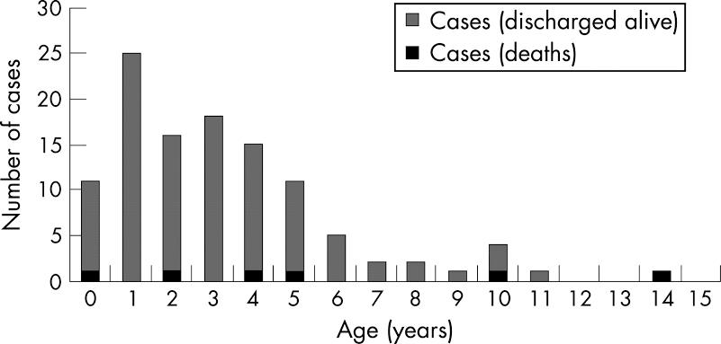
Routine mass infant vaccination at 90% coverage, Catch-up strategy: infant strategy with catch-up (at 80% coverage) targeted at susceptible 2–11-year Olds in the first year. Adolescent strategy: routine vaccination of 11-year-old susceptible (at 80% coverage). Using a realistic age structured (RAS) transmission dynamic model to predict the impact of vaccination on varicella and zoster. The 1998 Prescription Cost Analysis for England was used to estimate the cost of community prescribed drugs for the treatment of chickenpox. The average prescription cost per consultation for chickenpox and zoster is estimated to be £2 and £35.

- Strategies used in the UK to monitor the incidence of the disease:
There is no specific treatment for chickenpox, but there are pharmacies, remedies, medicines that can alleviate symptoms. For relieving fever or body pain the tablet or syrup of Paracetamol is used. For the ease of itching there is used calamine lotions and cooling gels. Most commonly if children are healthy then the blister crusts up and fall off naturally within one or two weeks, on the other hand weak children may have a high fever and red spots can be incredibly itchy. Monitor the incidence of chickenpox is if anyone has appeared symptoms of this disease then straight away contact your GP such as if your child has blisters on their skin, chest pain or breathing problem. Adults have a higher risk of developing complications from chickenpox. It is more dangerous for pregnant women, newborn babies, and people with a weakened immune system. There are antiviral medications licensed for treatment of chickenpox. The medication works best if it is given as early as possible. Do not use aspirin to relieve pain or fever in chickenpox because it affects the liver and brain.

- Strategies used in the UK to control the incidence of disease:
To prevent spreading and control the infection of chickenpox, isolating the children or adults from the rash starts until all the blisters crusted over, keep the children off nursery or school until the recovery. It is promising idea to avoid physical contact with others until you are fully healed. The best way to prevent chickenpox is to get the chickenpox vaccine. The vaccine is recommended for people who are not immune to chickenpox and are in close contact with people at risk of becoming seriously ill. Try to keep your fingernails trimmed short and minimize scratching to prevent the virus from spreading to others and help to prevent skin infections, wash your hands with soap for at least 20 seconds if you scratch accidentally. When child or adult is battling chickenpox, remember to keep them at home and get your child vaccinated. The vaccination is safe and effective at preventing disease. It significantly reduces the chances of getting the chickenpox virus. Use cool wet compresses or cool baths, do not rub your body, use calamine lotion, avoid itching, Cover the mouth while sneezing or coughing, use paracetamol in fever. The persons who get vaccinated have milder cases and a quicker recovery as compared to those who are not vaccinated. According to the CDC, two doses of vaccine are about 98 percent effective at preventing chickenpox. For rare condition NHS 111 will tell you what to do if you need them. Go to 111.nhs.Uk or call 111 in the UK.

Conclusion:
Varicella or chickenpox is a vaccine preventable disease occurring commonly in children, it is characterized fever and pleomorphic rash in centripetal distribution, it causes many complications if it occurs in adults. Chickenpox occurs worldwide, an airborne disease which spreads easily through coughs and sneeze of an infected person. Its incubation period is usually 14 to 17 days (about 2 and a half weeks). Get vaccinated from prevent of chickenpox infection.

References:
- O'Moore É and Howes S (2017) Guidance on Infection Control for Chickenpox and Shingles in Prisons, Immigration Removal Centers, and other Prescribed Places of Detention. In: Public Health England. 4th edition ed. London.
- Dr J Claire Cameron, health protection Scotland, Glasgow G3 7LN, Scotland, UK;
Claire.cameron@hps.scot.nhs.uk
- Carol A. Joseph and Norman D. Noah. British Medical Journal (clinical research edition) Vol.296, No.6623(Mar.5,1988)
https://www.jstor.org/stable/29529972
- Department of Health, Immunization Against Infectious disease, TSO, London, UK, 2006.
- A. M. Arvin, “Cell-mediated immunity to varicella-zoster virus,” Journal of Infectious Diseases, vol.166, no, 1
- Immunization Advisory Committee (2008), immunization guidelines for Ireland Royal College of Ireland of Physicians. Accessed 15th December 2012.
http://www.immunisation.ie/en/HealthcareProfessionals/ImmunisationGuidelines2008/
- Royal United Hospital Bath (2011) Chickenpox and Shingles Policy, Accessed 24th November 2011
http://www.ruh.nhs.uk/about/policies/documents/clinical_policies/yellow_infection_control/yellow_602_Chickenpox_Shingles.pdf

