Dylan Samuel
Work based project.
21/11/2023

Table of contents

1.Proposed title research

2.Abstract

3.Introduction and background

4.Aims and objectives

5.Literature review

6. methodology

7. bibliography

Proposed research title

What impact does the importation of materials from overseas have on a construction project in the Uk?

Abstract

This piece of research will seek to further understand the impact importing materials from overseas has on a construction project and help us understand the opinions of those who are most affected by it.

Introduction and background

Construction is a vital sector that relies heavily on the importation of materials from overseas. This research proposal aims to explore and examine the impact of importing materials from overseas on various aspects of the construction sector, including economic, environmental, and social implications. It will also be hugely beneficial to understand the impact it may have on construction professionals and their construction-based organisations.

Aims and objectives.

The aim of this piece of research is to gain a greater understanding on the impact that the importation of materials from overseas has on the economy, environment, and social environment. We will seek to understand the positives and negatives within this sector and come to a valuable conclusion on the topic overall.

- Submission of interest
The interest for this subject has stemmed from my experience on a construction project in 2023. The £8 million project included a gym renovation and the construction of a brand-new sports barn, situated in Bonymaen. The overall project was unable to be complete to the issued work programme, due to issues with the specialist contractor constructing the sports barn. A lot of delays that were presented to us were cause by imported materials such as steel and pvc fabric which were sent from Italy. This experience has sparked my keen interest in investigating the reasons for importing materials from Italy and not within the UK.
Materials such as steel and pvc plastic are known to be available to be sourced locally and within the UK. With that in mind, why do organisations still choose to use import materials to use as part of their projects?
Imported materials play such a crucial role within the industry. As part of this research, I would like to find out why the usage is so high. There can be many implications when using manufactures from overseas such as delivery delays and quality control issues. Both these factors can affect the timing, budget and quality of a whole construction project. There are difficulties and possible negative effects associated with relying too much on imported materials. Construction projects that depend significantly on foreign-sourced materials may be vulnerable to supply chain disruptions, currency volatility, and general uncertainty. In addition, worries about the environmental effects of importing building supplies are sparked by the carbon footprint involved in long-distance transportation.
The increased variety of options and prospects that come with importing materials into the UK construction sector is one of its main advantages. Construction professionals can access a wide range of materials, technology, and design solutions that may not be easily accessible domestically by leveraging global markets. This inflow of foreign capital has the potential to improve architectural design, innovate, and raise the standard of building projects all throughout the country.
To find answers as to why the levels imported materials usage is so high. I will conduct 2 interviews with a construction professional from a main contractor/client and sub-contractor with valuable firsthand experience of using imported materials. My reasoning for interviewing 2 different construction professionals is to allow me to understand both opinions and to make a comparison on the. The interview will allow me to ask relative and qualitive questions which improve my understanding of the positives and negatives of importing materials. The increased usage of imported materials is a result of the positives being outweighed by the negatives.
This piece of research will benefit my career as a construction professional. Understanding the advantages and disadvantages of using imported materials will assist me in making accurate decisions on a project to prevent any issues which I have experienced already in my short career as a trainee site manager.

Literature review

Overview of the UK construction industry
The UK construction industry has a major impact on the drive of economic growth and stability within the United Kingdom. The construction industry is one of the largest working sectors, employing millions of people. Without the construction industry, there would be no residential homes for UK residents, no commercial buildings for small- and large-scale business and also no built environment for people to carry out their everyday lives. I believe the construction industry is overlooked by many people until they are made aware of the importance and affect the industry has on the world. As many buildings have been standing for longer than many people have lived. People seem to forget how the buildings got there in the first place. A lot of time and investment has gone into all buildings constructed.
The rapid growth of the UK construction industry has been a result of several factors such as increased investment in infrastructure, the increased demand for residential homes and commercial development growth. The increased investment in infrastructure is something that must happen and is happening due to the current state of the UK. The UK population is rapidly growing due to new births and immigrants coming from overseas. The population growth rate in the UK is at 0.6% per year. The fertility rate is 1.8 births per woman, below the population replacement rate of 2.1 births per woman. However, a large part of this increase in the population is net migration, which was 626,000 in 2019. For the fifth year in a row, net migration was a larger contributor to the population change than births and deaths were. (World Population Review, 2024)
The chart below shows the increase in population from 1951 to current day. It also shows the predicted increase of population using previous data and the average percentage of growth from previous years.
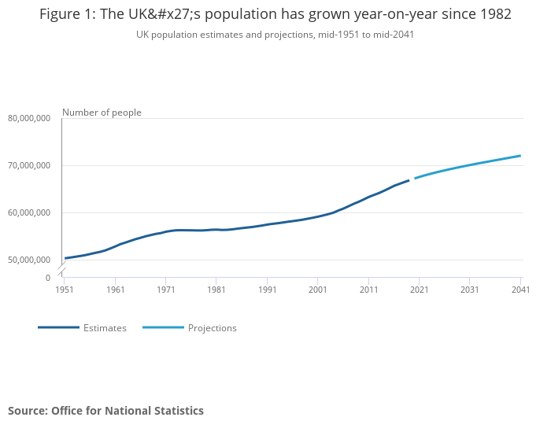
(ONS, 2021)
The UK must have the resources to deal with the increased numbers of new business’s and most importantly residents. To do this they are continuing to invest within the construction industry to create new homes and buildings. Construction new orders rose 30.5% in 2021 to £72,578 million, recovering to the highest level in over 45 years, driven by private industrial, private housing and private commercial; the only sector with negative growth was infrastructure, with the notable negative growth in electricity and roads partially offset by railways. (cy.ons.gov.uk, n.d.)

The increase of material importation

The importation of materials within the UK construction industry has become an essential component of meeting the demands of several projects and ensuring timely and cost-effective completion. The construction industry is a vital sector that drives economic growth and worldwide development. The industry relies heavily on the importation of materials to complete many developments due to the number of significant benefits of importing materials into the UK construction sector. One benefit is the access to the wider range of products and materials that may not be able to be sourced locally. With access to the international market like today, it allows for all construction professionals to select from a diverse selection of high-quality materials that meet their project specific requirements. Furthermore, imported materials often offer competitive pricing, allowing professionals associated with construction projects to create a valuation for the project and produce competitive tenders.
As a result of the significant benefits listed above the value of the imported materials into the UK has increased by over £5 billion since the 1980’s as seen on the graph below.

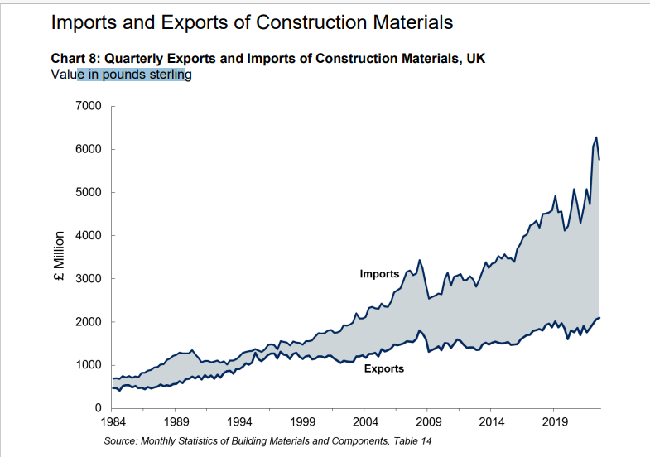

(GOV.UK, 2023)

The figures shown in the graph above also reflect on the rapid growth of the construction industry. The large number of construction projects across the UK would result in greater demand in materials also resulting in the increase in value spent on imported materials. The increase in value also reflects on the high rate of successful projects which are associated with the importation of materials. If construction projects in the UK were not benefitting from importation of materials, it would be highly likely the value spent on them would significantly decrease.

What effect did Brexit have?

Brexit was a campaign led by the UK government but voted by the public which resulted in the UK leaving Europe and becoming an independent country. Since leaving Europe, the UK has been affected in several different ways including general trading with European countries, employment, investment, and finally economic growth.
Brexit has also led to disruptions in supply chains, affecting the availability of raw materials and equipment needed for construction projects. The construction industry has been notably distressed by rising expenses for materials and goods imported from the EU. This increase in project budgets caused delays and cancellations. (buildeo, 2023)
As stated above, Brexit has resulted in the increase of project budgets and caused many delays and cancellations within the industry. The increase of project budgets is the result of the increase in cost of materials imported from European countries. Since leaving the European union, the cost of imported materials such as steel, timber and cement have increased as much as 60%. These numbers must be considered when pricing a project to prevent sudden increases and additional costs. In addition to the increase of imported materials prices, labour prices have also increased by as much as 30%. Before Brexit, 40% of the UK construction industries labour was made up from European citizens. This has decreased massively, due to workers being unlikely to get Visas to work in the country as the UK has introduced a points-based immigration system. This system was crafted by the EU-UK Trade and Cooperation Agreement (TCA) and requires workers to score a total of 70 points to work the country. (Buildsafe, 2022)

Sustainability within construction

In the construction industry, sustainability and local sourcing is becoming more and more important. As a means of reducing their impact on the environment and increasing their long-term profit, many construction businesses are focusing on sustainable practices. Companies can reduce transportation emissions, boost local economies, and create greater relationships with local suppliers by placing a higher priority on local material sourcing. Using materials that are sourced locally also helps to reduce the carbon footprint that construction projects typically generate. Using sustainable and locally sourced materials not only helps achieve environmental objectives but also appeals to communities, investors, and stakeholders that respect morality and ecologically responsible building methods.
The construction industry introduced the 7 principles of sustainable construction in 2015 in hope to reduce the industries carbon footprint and achieve the ‘building to net zero’ scheme. As part of this scheme, construction-based contractors must introduce and comply with the following principles;

- Sustainable Design
- Durability
- Energy Efficiency
- Waste Reduction
- Indoor Air Quality
- Water Conservation
- Sustainable Building Materials

Methodology

This piece of research will seek to explore the impact that importation of materials from overseas has on a construction project in the UK.
This piece of research aims to gather qualitative data from construction professionals who work within the UK construction industry and have had first-hand experience with imported materials. An interview will be held with 2 selected professionals in order to gather a well-educated opinion to help assist with the research question. As part of the interviews, there will be several questions asked. These questions will help gain a strong, valid opinion on the topic and assist in answering the research question. Both interviews will consist of the same questions. As the interviews will be held with 2 different professionals from 2 different areas within construction in am hoping to receive different answers to allow me to compare and analyse the data. Analysing both sets of data from the interview will allow me to create a professional opinion of my own which will assist me in my ongoing and future career as a construction professional.
As part of this research, there will also be qualitative data collected online from the UK government website and other trusted sources. Using the accurate statistics from the government website will help compare the opinion of the construction professional and the accurate statistics provided by the government. It will be interesting how both different types of data collected compare against one another.
The data collected from the government website will provide in depth statistics on all aspects of data collected from the importation of materials within the UK. This will range from the value of total importation to the value of specific imported materials i.e., concrete.

Primary research

Interview 1

When conducting an interview focused on the impact of imported materials on the UK construction industry, it is crucial to understand the relationship between materials and the construction sector. By exploring the significance of imported materials in day-to-day industry practices, costs, sustainability, and overall growth, we can access valuable insights into the challenges and opportunities faced by professionals in the UK construction industry. The first conducted interview was held with a representative from a large contractor. A main contractor which partakes in consistent work within the South Wales area. The Representatives has the role of a ‘senior operations manager’. As part of his role, it is vital to understand the benefits of different construction methods such as importing materials. The individual has 30+ years’ experience within the industry so has witnessed the growth and many different changes within the industry.
The interview started off with me introducing myself and providing a brief description of the topic and the aim of the interview.
Dylan Samuel: Good morning, thank you for taking part in the interview as part of my research project for my university work. This interview will include questions referring to the importation of materials and the impact it has on the UK construction industry. I would like to understand a bit more about your experience within the industry and the experience with the use of imported materials within the industry. Id like to start by asking you, what experience you have had with imported material?
Interviewee 1: Good morning, no problem! Yes of course. I have been involved within the UK construction industry for almost 35+ years. Of course, not always as a senior manager. I started my career as a bricklayer and gradually worked my way to where I am today. Over the course of my career in the industry I have only been exposed to the effects of imported materials in my managerial career. I deal with issues on site daily as the usage of imported materials seem to be increasing. Typically, from larger subcontractors which carry out work nationally and have wider access to contacts from beyond the local area.
Dylan Samuel: great! Do you believe that is it beneficial to use imported materials. If so, why?
Interviewee 1: personally, I believe that all materials should be sourced locally, when possible, to help the local economy. There are enough materials available to support local construction projects so can’t see why there is a high demand for materials from other European countries. I have not had many positive experiences with imported materials/equipment. All have had some sort of delivery delay or quality issue which then has a negative impact on my construction projects.
Dylan Samuel: what negative impact has it had on your construction projects?
Interviewee 1: programming and costs are affected most by delays and quality issues associated with imported materials. Construction projects run accordingly with tight programmes to ensure the project is delivered on time to the client. Any slight delay can have a huge knock-on effect which can cause serious implications. Delays will come at a price which the client will charge for every day late, these are called damages. At the end of the day, all construction projects are associated with money and profits. The outcome and success of a project is dependent on the amount of money made and level of satisfaction from the client. Delays caused by imported materials which could be locally sourced is something that can be avoided.
Dylan Samuel: Do you think there are any positives to using imported materials?
Interviewee 1: yes, of course. There are some materials/products not available on the UK market so the use of the international market in this case is great! But again, I believe that all materials etc should be sourced locally when possible.
  - Interview 2
The second interview held captures a different viewpoint on the use of imported materials. The interview was held with a small specialist contractor who carries out works across the UK. The contractor in which the representative works for carries out steel works, and specialist works such as sports barns and warehouses. The representative plays the role as a contracts manager for the specialist contractor.
Dylan Samuel: Good morning, thank you for taking part in the interview as part of my research project for my university work. This interview will include questions referring to the importation of materials and the impact it has on the UK construction industry. I would like to understand a bit more about your experience within the industry and the experience with the use of imported materials within the industry. I’d like to start by asking you, what experience you have had with imported materials?
Interviewee 2: good morning, no problem. As a specialist contractor we use imported materials as part of every project we complete. It plays a vital role in our high-quality and cost-effective work in which we complete across the UK. We are a specialist contractor and have been for many years. Our methods for our construction process have proven to be successful.
Dylan Samuel: Do you believe that is it beneficial to use imported materials. If so, why?
Interviewee 2: of course! Like I said, it plays such an important role in our business. We source most of our steel and other materials from countries such as Italy. we have done for many years as it has always worked for us.
Dylan Samuel: how does your company benefit from using imported materials?
Interviewee 2: as a specialist contractor the main reason for using imported materials is not because of the benefits. The main reason is accessibility. Not all materials that we use are available within the UK especially to fit the scale of some projects that we have completed. European companies offer a lot more options and larger quantities and larger scale materials. For example, you cannot get a pvc sheet the size of a football pitch manufactured in the UK without any welds. However, this can be sourced from a factory in Italy. over the years we have built an impressive relationship with manufactures of all types of materials with Europe. With this in mind, we are provided with loyalty discounts which benefits us greatly. Typically, materials from overseas come a lot cheaper than materials from the UK. so why would we change suppliers, which will only result in us spending more and reducing our profit margins.
Dylan Samuel: do you see why imported materials can have a negative impact on UK construction?
Interviewee 2: The use of imported materials has not negatively impacted us at all. Occasionally you may experience some delivery delays, but you can also experience this with UK sourced deliveries. There have been no issues with quality as we are well connected with our suppliers and have been using them for many years so we are fully confident that the materials will always be high quality.

Conclusion
After conducting two successful interviews, both offering contrasting perspectives on the use of imported materials within the UK construction industry, it is evident that there is a diverse range of opinions and considerations surrounding this topic. The interviewee with a negative stance on imported materials highlighted valid concerns regarding dependency, economic volatility, and potential risks associated with sourcing materials from overseas. On the other hand, the interviewee expressing a positive view emphasized the benefits of access to high-quality materials, cost efficiencies, and specialist materials available on the European market that are not available on the UK market.

Data analysis

The chart below shows the fast-growing upward trend in imported materials. The chart implies that the UK construction industry relies heavily on imported materials. As mentioned in the interview with interviewee 2. Not all materials/ resources are available on the UK market and for that reason construction contractors must look elsewhere. Unfortunately, the interview didn’t provide a lot of information on the cost saving benefits from sourcing materials from outside the United Kingdom. Interviewee 2 stated that he has access to loyalty discounts which benefit him enough to keep using the same suppliers.
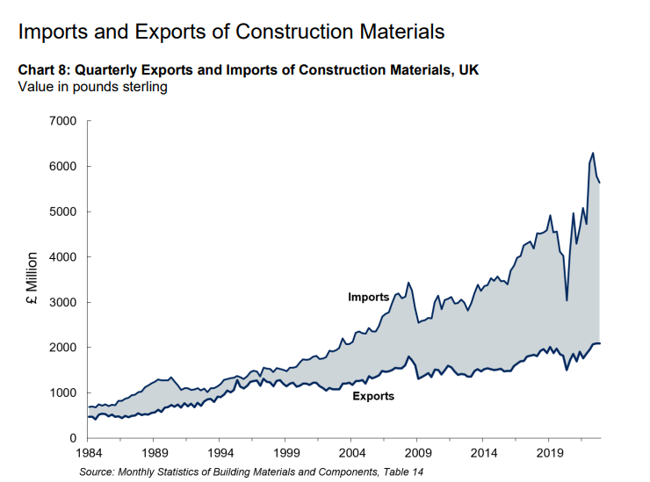

The UK has a large offering of materials available to the construction industry. The deliveries will inevitably be faster than European deliveries and the customer service/ trading standards will be as good if not better than European countries. analysing the chart below. The only reason I believe that the levels of imported materials are increasing so rapidly is down to supply and demand. The UK is only a small country with limited space and capacity to manufacture materials in comparison to the larger countries in the European union.
data shows that in 2021 UK (the latest year for which global comparisons are available) UK manufacturing output was worth some $272bn, compared to $262bn for France, but behind Italy ($314bn). To put this data in context, China is the largest manufacturing nation worth $4.9tn, followed by the United States $2.5tn and Japan $995bn. Germany, the fourth highest, remains the largest European manufacturing country $803bn. (The Manufacturer, 2023)

conclusion

As I conclude this research task on the impact of imported materials on the UK construction industry, it is clear to see that the utilisation of imported materials plays a significant role in the construction sector. I have gained a deeper understanding of the opportunities and challenges presented to professionals within the industry by conducting two beneficial interviews which have provided me with valued opinions. Hearing 2 educated and experienced opinions has provided me with information to compare which allows me to create an opinion of my own.
I now understand from the data found; the scale of the UK manufacturing industry is not comparable to other countries around the world. With this in mind, it is clear to me that not all materials will be available within the UK. therefore, to fulfil the demands of the UK construction industry it may be necessary to source materials/ resources from other countries. I am a strong believer in supporting the local economy and believe that all contractors/ business within the UK should try their upmost to source materials/ resources locally. I am grateful for carrying out this piece of research as it has helped mature my opinion on the debatable question which is often asked within the construction sector. I will carry my opinion forward with my career as a construction professional and will be confident in providing a valid opinion when questioned why I believe in my opinion.
If I was to carry out this piece of research again, I would make sure to dive deeper into the cost benefits of importing materials from overseas. This is something which I wish I was able to find out more information on. Due to limited data on the internet and books, I was unable to include any in depth statistics on the savings available. However, the importation of materials may not come with cost effective benefits but in my opinion I believe it is one of the driving factors due to the rapid increase in statistics.

Bibliography
buildeo, 2023. THE IMPACT OF BREXIT ON THE CONSTRUCTION INDUSTRY IN THE UK. [Online]
Available at: https://buildeo.co.uk/2023/04/the-impact-of-brexit-on-the-construction-industry-in-the-uk/#:~:text=Brexit%20has%20also%20led%20to%20disruptions%20in%20supply,increase%20in%20project%20budgets%20caused%20delays%20and%20cancellations.
GOV.UK, 2023. monthly statistics of building materials and components. [Online]
Available at: https://assets.publishing.service.gov.uk/government/uploads/system/uploads/attachment_data/file/1134673/23-cs2-_Construction_Building_Materials_-_Commentary_January_2023.pdf
The Manufacturer. (2023). UK manufacturing sector climbs to eighth in world rankings – Make UK analysis. [online] Available at: https://www.themanufacturer.com/articles/uk-manufacturing-sector-climbs-to-eighth-in-world-rankings-make-uk-analysis/.
World Population Review (2024). United Kingdom Population 2020 (Demographics, Maps, Graphs). [online] worldpopulationreview.com. Available at: https://worldpopulationreview.com/countries/united-kingdom-population.

