LEVEL 4 – Student Journal (750 words)

Student Name: Ioana Mihailov  Student Number: 2122611 | Module: Food & Beverage Operation  Lecturer: Laurence Blake

Topic of choice: | Ratings, Inspections and Reporting Procedures
RATINGS –
The hygiene practices are regulated by the regulations provided by the government of the UK. These rules are enforced through the Food Standards Agency to ensure safe food is provided to the consumers of the country. The food businesses should follow the HACCP method to ensure food safety. The aim behind is the same which should be followed under regulation no. 853/2004. HACCP stands for Hazard analysis critical control point and compliance is ensured by the Food standard agency (Babeker et al., 2021). This promotes the business to grow while maintaining a high quality of the food. FSA, UK also promotes safer food better business which stands for SFFB which aims for consumer food safety. SFFB pack is provided to the food business to help them manage food safety in the premise practices. The rating scheme also falls under this aim wherein the consumers are provided with stickers at the premises to provide feedback on the hygiene and handling practices in the business. These ratings help the business ensure the consumers are satisfied with the service and handling practices. The ratings also help the business strategy to improve the practices and handling in the premises (Food.gov.uk., 2022).
The rating scheme helps the consumers by providing a scale of 0-5. The 0 is the least satisfaction grading which depicts urgent attention. The 5 on the scale depicts a very good performance in that criterion. The consumers can provide these opinions on the basis of the following –
• Quality
• Culinary skills
• Food presentation
• Service
• Comfort levels
The Food standards agency ensures that businesses follow this law including restaurants, pubs, hotels, hospitals, schools, bakeries, and others. This is also ensured by the provision of training for food safety by the FSA. The ratings also help in maintaining the standards of food safety in the business (Food.gov.uk., 2022).
Figure 1: rating stickers for food business premises
(Source: Food.gov.uk., 2022)
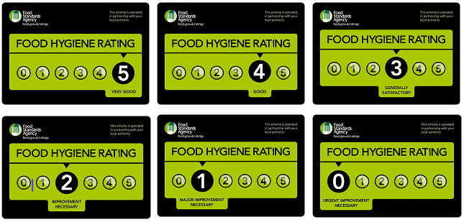
INSPECTIONS –
Inspections are done at every food business to ensure the practices are hygienic and safe as the food provided is consumed by the citizens of the UK. The professionals are authorised by the government of the United Kingdom. The professionals ensure that the practices followed in the food business are good (gov.uk., 2022). The professionals do not need appointments to inspect the premises. They can visit the premise at any time of the day to ensure the food business complied with the food laws. The professional is also authorised to take actions which include seizing the food if necessary, shutting the business on an immediate basis, and serious legal actions as well. The professional can suggest points for improvement depending upon the seriousness of the condition. Generally, the professionals see the problems as the level of hazard to the consumption. Another important factor in food safety professional checks is the food safety management system which helps in determining the measures being taken by the business to ensure food safety. The routine inspections are held twice yearly but it depends on the professionals if they are not satisfied, they are liable and authorised to visit more than twice. The routine inspections also include the caterers and food retailers. For this business, the professionals can visit any time they want to (gov.uk., 2022).
The ratings provided by food safety professional has the authority to decide the working of the business as well. The ratings provided by these professionals are generally of three types which recommend the practices being followed and the degree of improvement deemed necessary. The major parts of the business checked in the inspection include premises, kitchen, handling practices, preparation methods and most importantly the food safety management system (gov.uk., 2022).
Figure 2: Ratings by inspection professionals to the food businesses
(Source: gov.uk., 2022)
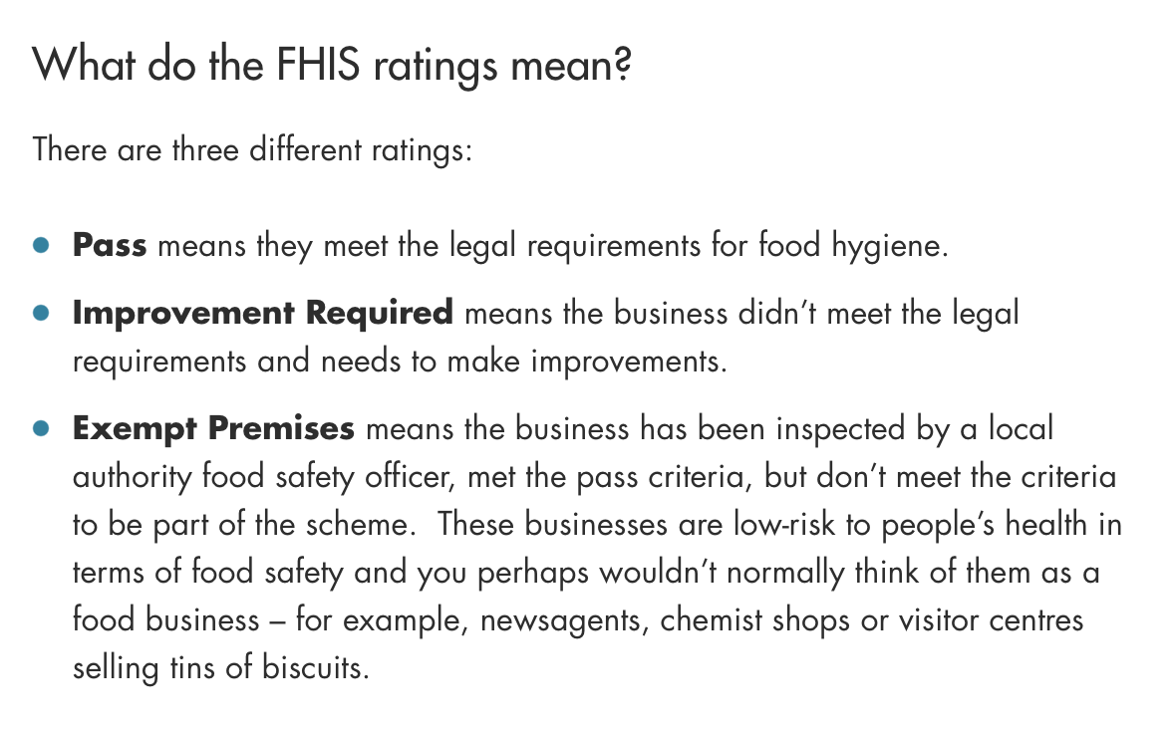

REPORTING PROCEDURES –
Consumers can report food businesses if they feel that the food business practices are hazardous to public health (food.gov.uk., 2022). The reporting procedures include complaints to the local authority. The FSA has also provided online complaint registration as well. The reasons should be liable for further actions which include food poisoning cases, allergens information mistakes, food decay signs, low standard food handling and hygiene practices, and other unhygienic operations.
The online portal contains a specific section as it concerns public health and safety. This reporting can also avoid the chances of introducing contagious diseases to the citizens of the country (food.gov.uk., 2022

REFERENCE LIST (not included in word count)
Babeker, A.M., Ahmed, A.I., Ahmed, A.R., Ebrahiem, M.A., Babeker, A.M. and Abdalla, A.A., 2021. Assessment of the extent implementing the Good Manufacturing Practices (GMPs) and Hazard Analysis Critical Control Point System (HACCP) in Sudan sugar industry factories. International Journal of Agricultural Science and Food Technology, 7(3), pp.368-373.
Food.gov.uk., 2022 Food Hygiene Rating Scheme Online available at https://www.food.gov.uk/safety-hygiene/food-hygiene-rating-scheme. Last accessed May 2022
food.gov.uk., 2022 How to report a food safety or hygiene issue Online available at https://www.food.gov.uk/contact/consumers/report-problem/report-a-food-safety-or-hygiene-issue. Last accessed May 2022
gov.uk., 2022 Food safety - your responsibilities Online available at https://www.gov.uk/food-safety-your-responsibilities/food-inspections#:~:text=You%20can%20be%20inspected%20by,business%20poses%20to%20public%20health. Last accessed May 2022
gov.uk., 2022 Food safety - your responsibilities Online available at https://www.gov.uk/food-safety-your-responsibilities/report-a-food-safety-incident. Last accessed May 2022

