
Knowledge & information management
Amazon

July 2, 2021
cHARLENE MORGAN
1906685

Contents Page

Executive Summary……………………………………………………….Pg. 2

Introduction…………………………………………………………………..Pg. 3

Task 1……………………………………………………………………………..Pg. 4

Task 2………………………………………………………………………………Pg. 7

Task 3………………………………………………………………………………Pg. 11

Conclusion………………………………………………………………………Pg. 16

Recommendations………………………………………………………….Pg. 17

References………………………………………………………………………Pg. 18

Executive Summary

Living in a fast-paced environment, Knowledge Management (KM) requires a boost in the efficiency of an organization’s decision-making ability. Throw Amazon into the mix and it can create a world of insight and how much work is needed to perform KM at a company so big. With the relevant tools, methods and typologies this report will gather various information, and display a know how of what really goes on in one of the worlds largest retailer.

Introduction
This report has been requested by Rachel Cook by 2nd July 2021. It will provide an overview of the global organisation Amazon. Following a full SWOT analysis of the Knowledge management system and how Amazon uses this in their company. The KMVC will be discussed and analytically be evaluated in the four main areas.
Greene (2021) state that knowledge management requires an orderly framework that makes a difference to individuals in an organization share, access, and update business knowledge and data.
Data can simply be defined as “facts and figures”. Guru99 (2021) say raw information like this does not mean much. Data can compromise of numbers, facts, observations, symbols and images. Without a human or machine to decipher its meaning it unfortunately does not mean anything at all. However, with information it can be processed, structured or presented in a given setting to create its importance and how meaningful it can be. Part of information becomes knowledge when it is combined with experience and insight. Information is had by each person and is a result of his or her encounter.
Alexander (2018) expresses tacit Knowledge is classed as something that comes with life experiences, it can be learnt on the job, intuition and a combination of information. It can be the information that when asked, it would be the foremost troublesome to write down, express, or display in an unmistakable way.
Looking back at the history of knowledge management McGill (2019) discloses KM was first used in the 1980’s by Peter Drucker. Some would claim that it has been around for centuries and that understanding the knowledge has constantly been crucial to human behaviour. KM only really came together in the mid to late eighties; when reaching economical, social and technological changes took place globally. Through ‘globalisation’ numerous companies began to encounter new prospects.
Knowledge is imperative since it boosts the proficiency of an organization’s decision-making capacity. To make sure that all employees have access to the overall knowledge held within the organization, a sharper workforce is created who are more able to make swift, updated decisions that benefit the company.
To develop a KM programme is to consider the needs of the business. To discuss work this typically involves reviewing the corporate strategy, departmental plans and present business challenges and utilizing to them a KM viewpoint. There are other areas in which other drivers can be used in order to plan and make a victory from:
- Enhancing Customer service
- Refining product quality
- retaining and motivating employees
- minimizing risk in business
(Skyrme Associates 2011)

Task 1
McFadden (2021) states that Amazon is a one stop shop incorporated by Jeff Bezos in July of 2005. Initially the organisation only started selling books, but it started to expand to music and video books in the late 90’s and has continued to evolve ever since. Amazon is now seen as a giant among companies. Even in times of the pandemic, customers have relied on Amazon and this can rocketed sales than ever before.
Amazon is a vast Internet-based enterprise. Hall, (2012) clarifies the online site is available in many languages and countries. It sells books, music, movies, housewares, electronics, toys, and many other products, either directly or as the go - between for other retailers.
There are five primary activities that Amazon include: BStrategy (2021) includes the following:
- Inbound Logistics - a platform used for other retailers to sell their goods/Services. Logistics help with the marketplaces, which offer services to others. This also includes shipping services to sellers through numerous branches. Having effective logistics Amazon can be put on a pedestal and have that competitive streak above others.
- Operations – are split into three different sections. North America is the first portion, it is the most profitable because is holds most of the organisation prominent brands. International phase is focusing on all clients outside of the North America, this is Amazons second largest revenue. Finally, Amazon Web Services (AWS) incorporates computing, storage, cloud infrastructure, database, and other services. It also allows the company to manage markets outside its essential activities.
- Outbound Logistics - involves storing, moving, and distributing finished products. Even though most are delivered digitally online, Amazon do have a few stores worldwide which does well on revenue and there are delivery services such as DHL, FedEx, UPS and more extraordinary it now uses drones for efficiency and convenience.
- Marketing and Sales – Investing in marketing may seem highly costly when advertising , but equally so the company has still made a tremendous profit, in sales. It remains one of the most important sources of value.
- Services – with remarkable customer service, Amazon Marketplace and Prime customers involve buyers and sellers from the platform. For sellers, it shall provide several tutorials, tools, and programs to help them get better deals. It also runs an after-sale service whereby the process is useful enough to provide customers with the best possible experience.

Amazon operates in the retail trade sector, it controls the internet retail industry. (CNN 2021).
Amazon.com, Inc. locks in within the retail deal of customer items and memberships in North America and globally. The company works through three fragments: North America, Universal, and Amazon Web Administrations (AWS) (Kambhatla 2020).
The Amazon that has been chosen for this report represents a global outlook. It will demonstrate an understanding of knowledge management and how the company uses it.
The iconic Amazon spheres lies in the heart of Seattle where Amazon headquarters foundations arise. Kunkle (2021) reveals there is a second headquarters in Virginia better known as The Helix. Both headquarters combine a sense of nature and a tranquil working environment. Amazon operates more than 175 fulfilment centres across the world the bulk are located throughout North America and Europe.

Butler and Jolly (2020) reported that Amazon has 840,000 workers when it released its 2019 annual report, however that figure has now risen to more than 1 million workers worldwide.
Amazon Staff (2021) want to create diversity and a good representation across the company. Below signifies a year-on-year progression of the workforce.
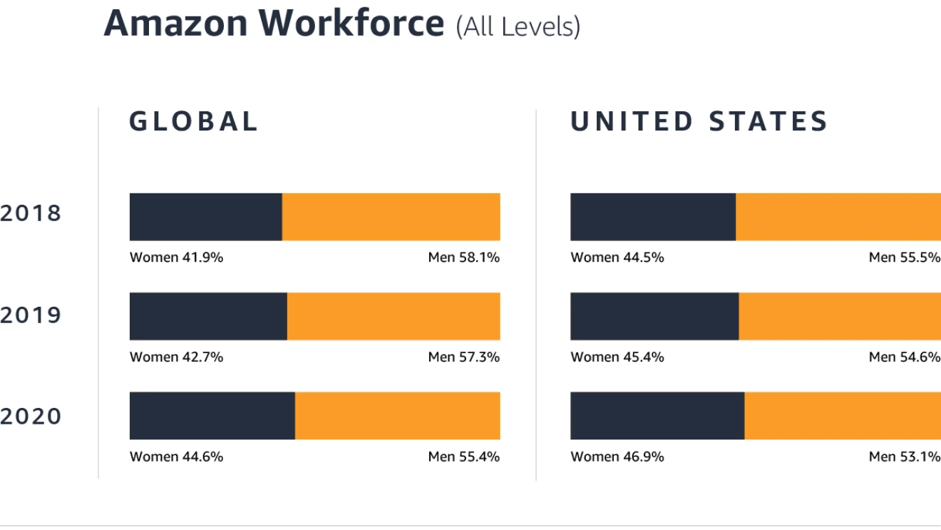
To apply for a job with Amazon there is a preference of high school qualifications, or a general equivalency diploma (GED). If these are something that the individual does not have, the company will still consider still hiring that person, because new incentives have been developed which does not require the qualifications that were once needed but will help that potential employee can the GED on the job. (Best GED Classes 2021).
‘We want our employees to be empowered to speak their minds, and be heard. Every Amazonian should feel comfortable sharing their unique perspectives, and every Amazonian should seek the perspectives of others.’
(Jeff Bezoz 2017)
(About Amazon Staff 2021).
Amazon sits in a more global hierarchy structure, to show a grading of management. Organimi (2019) say it can show a vast top-down control over global e-commerce operations. In different parts of the business the company has various operations which is essential to maintain a structure that can support the diverse and everchanging and expanding market.

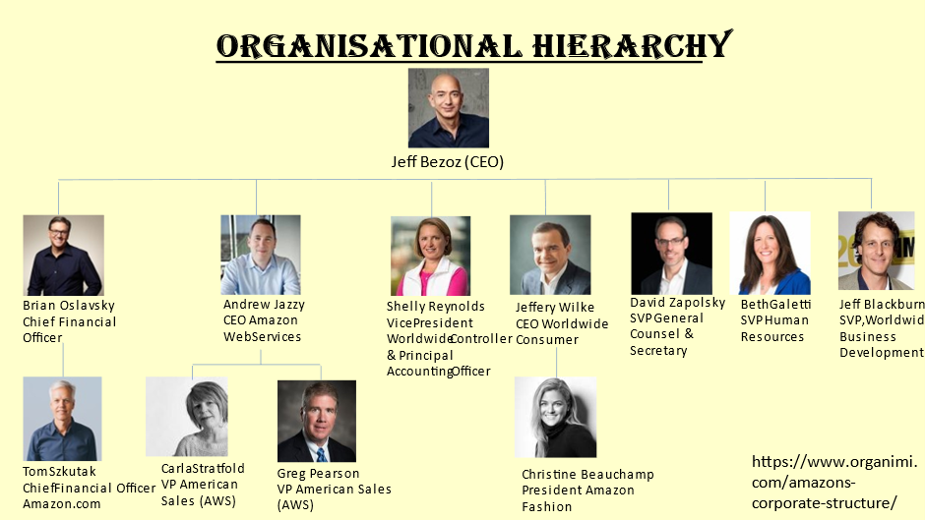
(Organimi 2019)

Task 2
Rosenburg (2014) suggests, that between Amazon and its customers a lot can be learnt from the E-learning field. Amazon uses KM principles and practices to add considerable value for their customers in several approaches: Many strengths arise from these methods here are just a few examples:
- One Portal One Interface – gives a familiarity, giving the customer a good feel approach when navigating through the website
- Personalization – The more the site is being used, the more it recognises the customers wants and desires for certain products.
- Crowdsourcing – building a knowledge of its users, Amazon can create a picture of the customers reviews and ratings.
- Feedback – having valuable responses from its customers allows Amazon to take on board valid and unpopular or popular opinion and where to improve on any given section.

Weakness
Lack of awareness - Companies are not entirely sure what KM is, or the perception of KM is very limited (e.g. SharePoint or the intranet).
Misunderstood - The KM team has unsuccessfully outlined and communicate a convincing business case. KM excessively uses far too many buzzwords, failed branding, and lingering unpleasant memories of past KM iterations.
Difficult to Measure - APQC (American Productivity & Quality Centre) has numerous assets to assist organisations to measure KM value, but this method is time-consuming and essentially to some degree subjective. When managers know KM is conveying benefits, it can be difficult to allocate a correct dollar esteem. KM can become powerless at this point.
Opportunities
Digital – KM can give the understanding of user needs and handle change with linking Km to digital transformation can help reinforce leadership.
Growing Needs - The value recommendation proceeds to develop as inaccessible work requires virtual arrangements and disorganized, hard-to-find substance obstructs development and fast choice making.
Integrated Solutions - Many cases, KM has strengthened partnerships and functions such as IT, HR, and learning. These groups can come together and deliver more consistent cross-functional services and support to end users.
Threats
Competitive Giants – always a common warning to take on board. Amazon need to make sure they always stay on the pulse, in terms of technology, policy procedures, diversity and on trend setters.
Scope - KM teams have been able to run virtual conferences, convert in-person courses to e-learning, and train employees however individuals may struggle to detach themselves from these extra-curricular activities.
Budget Cuts – With the pandemic, with money being constricted, KM need to keep fighting for the share of limited resources which are on offer. With a clear business case and focused metrics, programs will have a chance to survive and continue to success. (Trees 2020).

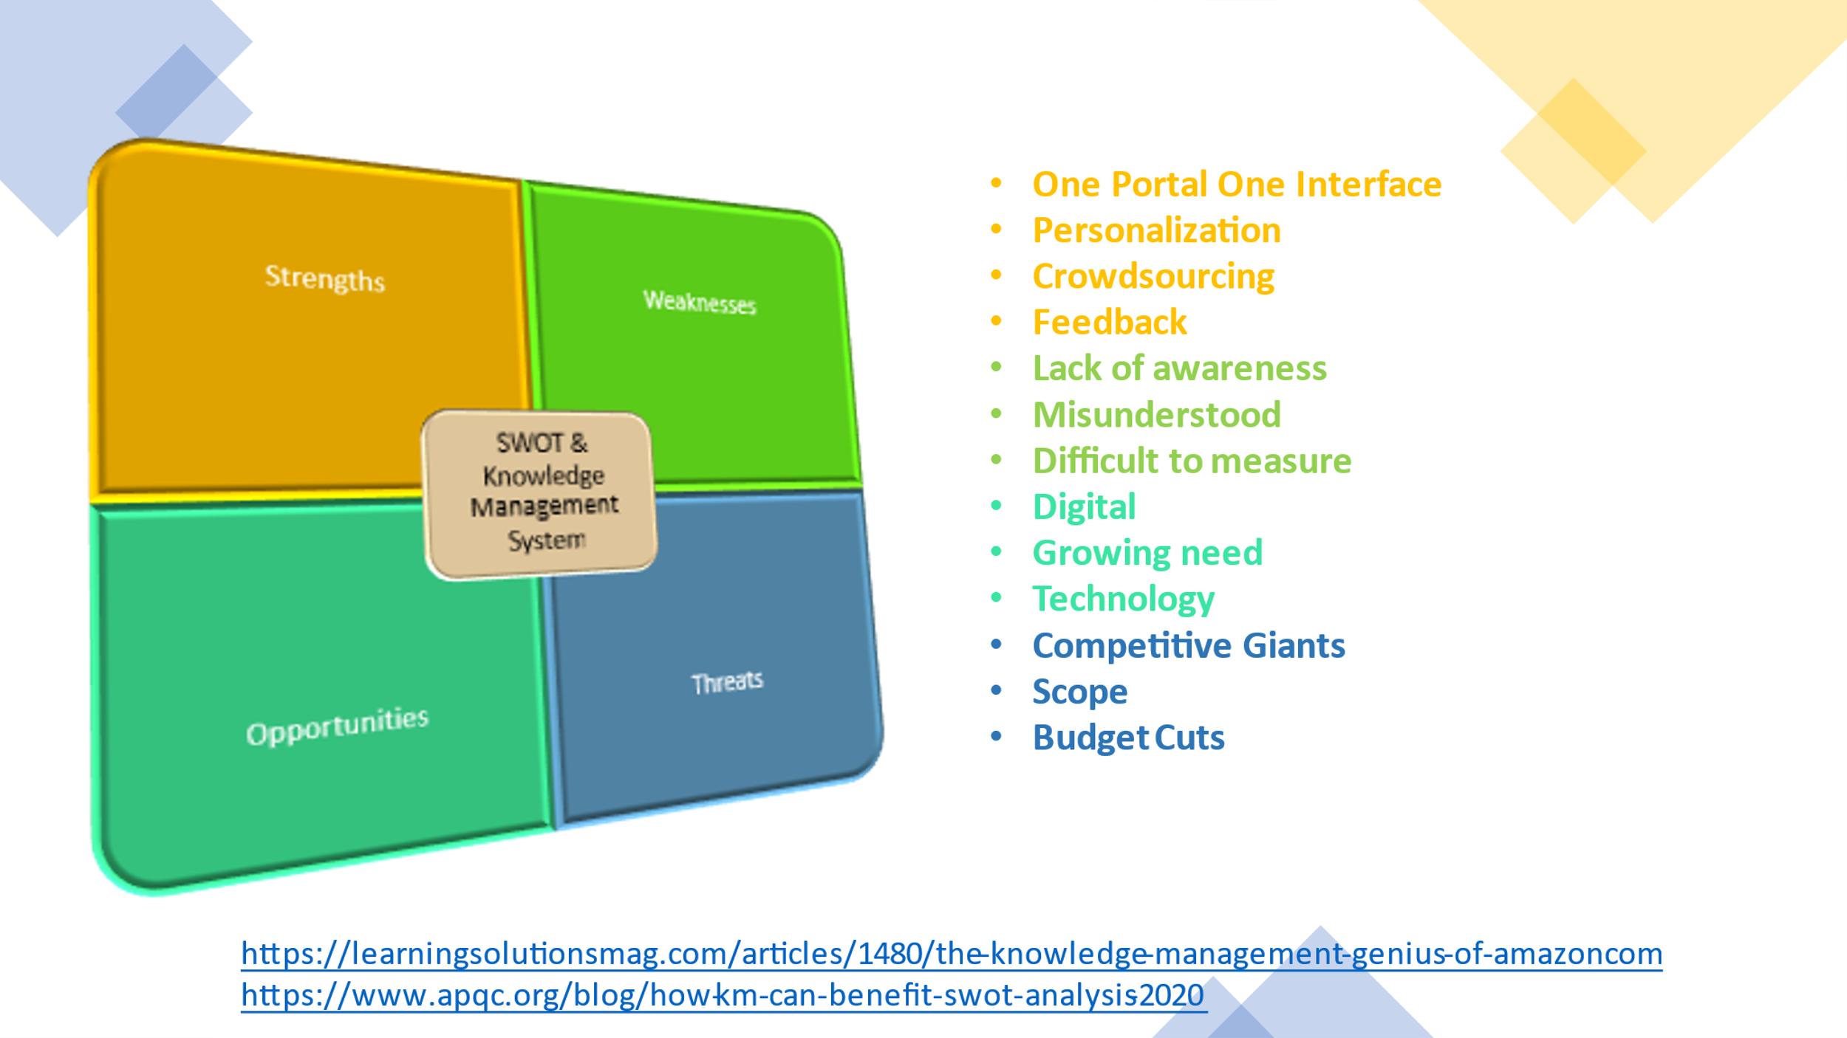
The resource-based view (RBV) is a model that sees resources as key to superior firm performance. It is a style for achieving competitive gain that emerged during the 1980s and 1990s. (Business Balls 2019).
To breakdown this model it branches out into two sections, the first is tangible or intangible which is part of all resources. Tangible refers to physical things that one can see or touch for example: machinery, land or buildings. Distribution centres or having a fleet of vehicles provide benefits but this is a short term because the resources can be purchased in an open market. Intangible is completely the opposite it focuses on skills, know how and capabilities. RBV also bases key assumptions on heterogeneous and immobility. The resources used in heterogeneous can mean it will jump from company to company and firms who are in the same position with the same external forces can lead to different resources and outshine others. No movement is made in the immobile section it is not an easy transfer in the short term, it shall also put a stop to others trying to copy ones rivals resources or strategy’s. All resources need VRIN (Valuable, Rare, Inimitable and Non-substitutable) these will cover reduced costs, rare resources are not available to other competitors, inimitably will slow down the process of cost so it can not be easily implemented by others. Non – substitutable are companies which cannot replace easily available resources, this will ultimately be costly for any rival to take charge. This all comes down to a competitive advantage this involves a company who have created a value created strategy that other rivals are not using, fundamentally it outshines all other companies (Thomas 2018).
White (2019) explains a VRIO examination of Amazon makes a difference clarify how the trade oversees to develop and support its industry position. Examining the VRIO Amazon resources and capabilities fulfil only one or some of the criteria, but assist business growth, nonetheless.

Important resources and capabilities of Amazon:
Resources and Capabilities | Valuable | Rare | Inimitable | Exploited | Implication
Brand Image | YES | YES | YES | YES | Competitive Advantage
Customer Base | YES | YES | NO | YES | Temporary Advantage
Global Presence | YES | YES | YES | YES | Temporary Advantage
Customer Loyalty | YES | YES | YES | YES | Temporary Advantage
Technology | YES | YES | NO | YES | Temporary Advantage
Product Range | YES | YES | YES | YES | Competitive Advantage
(Pratap, A. 2019)

Task 3

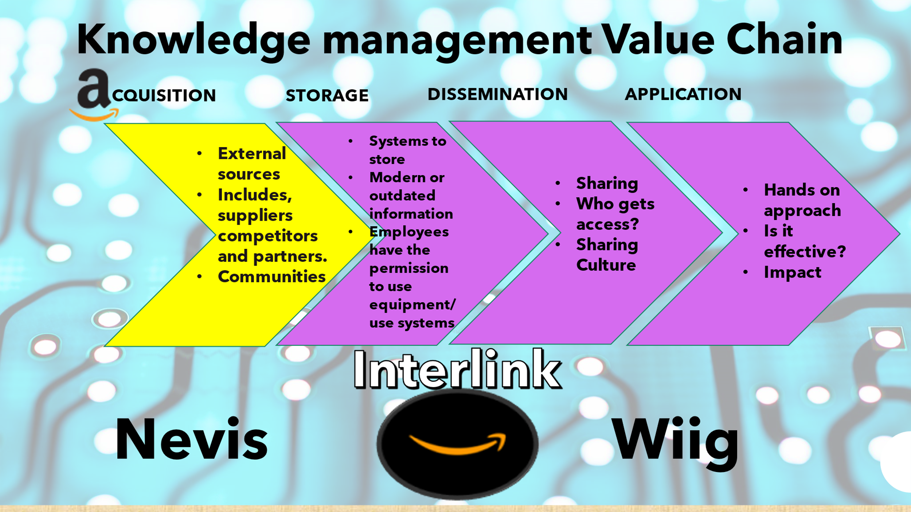

The Management value chain will help with making better decisions and save money. It shall create a process in the organisation to create, store, transfer and apply knowledge. It will enhance the capability of the company to learn from its environment and to combine knowledge into its business processes. (Eco 2016). In four different sections the value chain shall reveal the following:

Acquisition
Organizations procure knowledge in several ways, depending on the sort of knowledge they look for. The primary information administration frameworks looked for to construct corporate stores of archives, reports, introductions, and best hones. These actions have been expanded to incorporate unstructured reports (such as email). In other cases, organizations obtain information by creating online master systems so that representatives can “find the expert” within the company who is well-informed. Moynihan and Payo (2019) disclose the greatest acquisition of Amazons company is the supermarket Whole Foods it allows the company to test its distribution and sales strategies. Another acquisition which has exceeded the company’s profitability and economic benefits is Amazons Web Services (AWS) this has endorsed the company to incorporate video services (processing, storage, packaging, distribution, etc.)
Storage
Knowledge storage incorporates the creation of database. Employees need to be able to access documents, patterns and expert rules, so these should be stored away appropriately and be accessible when staff may need it at hand. By letting the expert systems help businesses preserve the knowledge that is needed it will combine its knowledge into organisational practices and culture. AWS note it shall use a simple storage service (aka cloud storage) which offers industry-leading scalability, data availability, security, and performance. This implies clients of all sizes and businesses can utilize it to store and secure any amount of information for a variety of knowledge , such as websites, mobile applications, support and re-establish, record, project applications and huge data analytics. (AWS, 2021).
Dissemination
Using such tech as Portals, e-mail, instant messaging, wikis, social business tools, and search engines technology have included to an existing cluster of collaboration apparatuses for sharing calendars, documentation, data, and design.
The workers of Amazon can connect in their management, which guides to knowledge sharing. They too have meetings with senior administration and coordinate gatherings with bosses to ensure that information flows easily. An investment has been made where employees will be trained in new skills and be required to work in a variety of evolving positions in fields such as data mapping, data science, and business analysis. (Georgescu 2019).
Application
If knowledge is not applied in terms of facing practical problems the company will not add any business value, regardless to what type of knowledge it is. Organisational knowledge must be part of a management decision which can be situated in systems for support. If new knowledge occurs this must also be constructed into a corporation’s process and key application procedure.
Armidon and Skyrme’s (1997) Know-why hypothesis is utilized as relevant information and vision. At this time, it can go through the KMVC, establishing procedures are ready and reactions to shareholders needs are actioned.

Nevis supports the value chain, its structure sustains three out of the four elements linked to the method. Its acquisition helps with the development of skills, insights and relationships. Dissemination will involve what has been learned along the way and application will amalgamate learning so it can be available and be widespread to innovative situations. Different types of knowledge can be classified into sections, facts, intuitions, judjement and procedural. (Cook 2021).
Uniting another factual knowledge typologist is Wiig (1993), this method compromises of truth and convictions, viewpoints and ideas, judgment and desires, strategies and know- how (Anand 2011). Knowledge acquisition validates that is beneficial in a technological manner because it is customized for that individual’s needs.
Amidon & Skyrme (1997) present the six know hows, one in particular helps more with the KMVC which is the know – that, this is relevant to Amazon has everything is very much scientific led. Amazon has updated the corporate management values successfully introduced by Frederick Taylor at the dawn of the 20th century and set out in the 1911 book The Principles of Scientific Management. ... By demanding better working conditions, employees at Amazon are challenging its trade model. (Iossa 2018).
Facts
Experience
Learning
The kind of knowing that forms intuitive decision making – these are the understandings of what know – that have to offer.

SECI MODEL
Knowledge management Tools (2010) state, Nonaka and Takeuchi introduced the SECI model which has become the foundation of knowledge creation and transfer theory. It is recommended that knowledge types can be merged and converted, showing how knowledge is shared and created in the firm. This is based on two types of knowledge explicit and tacit.
Explicit knowledge is the organized set of data which can be recognized, recorded, put away and shared. In a simplistic manner it can be seen as an easy to write down or capture any data.
If an individual can gain something from the surroundings, circumstances, incidents, patterns, observations, etc. then it shall be known as personal experience, which structures the foundation for Tacit Knowledge. A basic way of making this easier is something that is difficult to teach and to capture.
To deliver the key to be successful Amazon uses the electronic world, of e-business combing this with managing relationships and context, these are of upmost importance in the productive use of tacit knowledge. (Tibben, Sangal, Gonsalves, 2006).

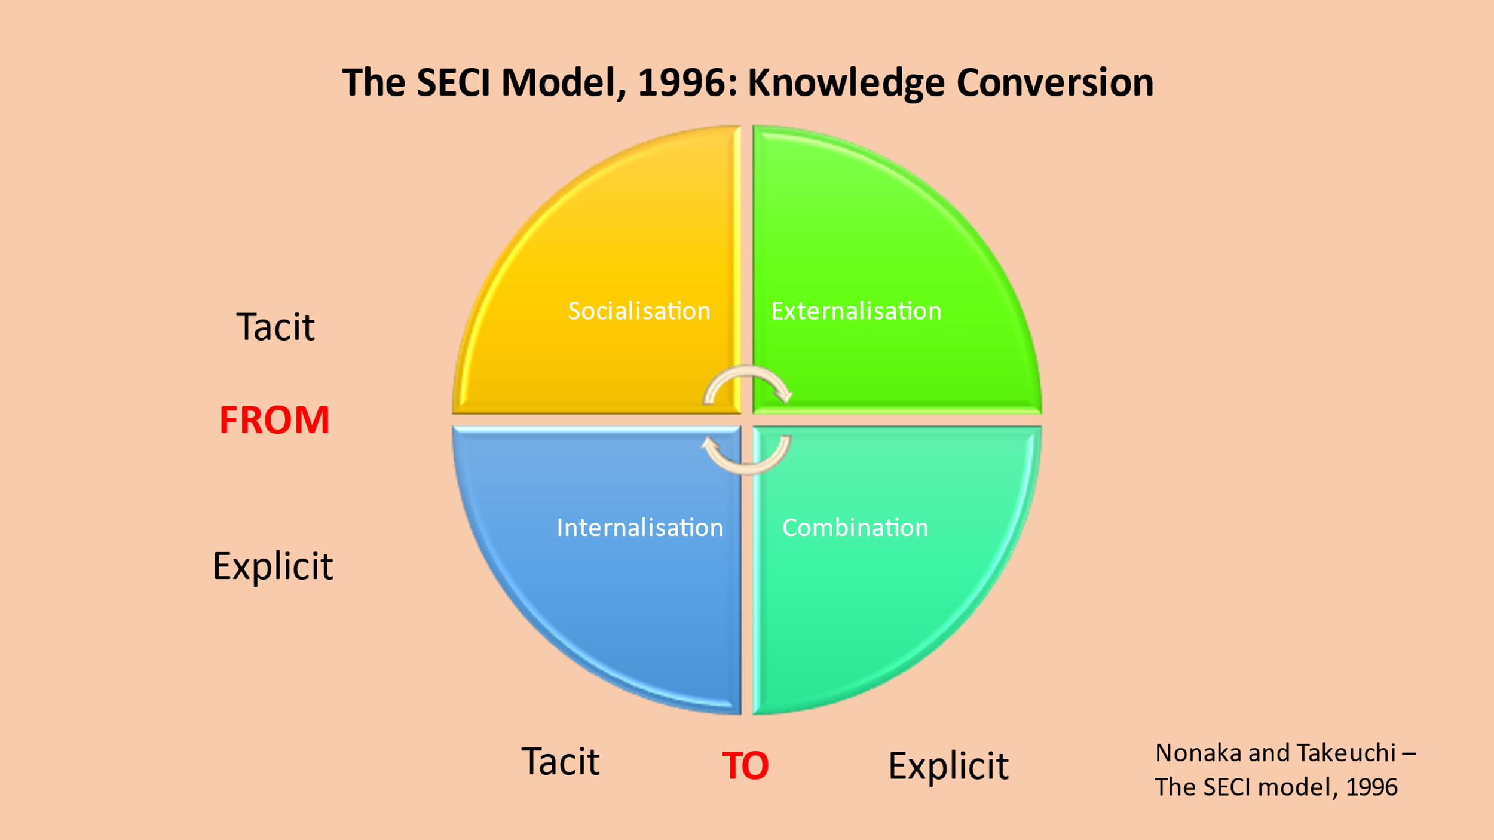
These four main areas include the following:
Socialisation This is a tacit to tacit approach is the primary process between individuals, it is experimental in the fact that new knowledge can be created and converted through shared experiences and communities of practice with employees it can be known as a rare and imitable process
Externalisation this style is a tacit to explicit way. When tacit information is codified and put into records (Amazon.com site, aps, social media links and emails,) so it can effortlessly be shared through other firms. Systems can obtain the appropriate data from customers and Amazon.com use to personalise the customers shopping experiences.
Combination forms an explicit to explicit manner. Numerous resources of accumulated information are combined to create new knowledge/improvements within the company. Amazon employs on a large scale therefore if communication and disseminating significant knowledge and information was given, it would create a more systematic development and transfer the right improvements to the organisation.
Internalisation happens when an exchange is taken care of by a person instead of directing it out to somebody else. This procedure may apply to trade and business dealings, or to the corporate world. (Chein 2021). Additionally, an organisation can try to innovate or create learning through the socialisation process. (Cook 2021).

Conclusion

Considering Amazon’s approach to knowledge management it is well known that the company is a cut above the rest when it comes to the customer service, it has been excelling since the late 90s when Amazon took a chance on e-commerce. Core knowledge is used in terms of applying a single interface to meet the needs of all its users, whilst finding it easy to index and find. Amazon has gained and added diversity to its business from humble begins of selling books to creating a range of product lines. (Document 360 2019).
Effective knowledge can really help Amazon with the ever-growing expansion of business as it can become more complex. To look in terms of the future a team should be brought together with a united knowledge management system that can help employees make smarter, quicker business choices. (Cook 2019).

“Knowledge has to be improved, challenged, and increased constantly, or it vanishes.”
Peter Drucker (Goodreads 2021).

Recommendations

The limitations here are needed to get a hold of the ever-growing fleet of staff Amazon has created, it’s produced a phenomenal number of employees and therefore according to data, which was analysed by the Times, Amazon was failing staff. Scammell (2021) exposes that 3% of its hourly colleagues were indeed leaving the company each week, which were giving an employee turnover of almost 150% per year. Amazon will never have a short fall of people wanting to work, but employees must have basic rights to for example, overworked or better working conditions.

References

About Amazon Staff (2021) Diversity, equity and inclusion at Amazon Available at: https://www.aboutamazon.co.uk/diversity (Accessed: 27 June 2021).

Alexander, R. (2018) Different Types of Knowledge: Implicit, Tacit, and Explicit Available at: https://bloomfire.com/blog/implicit-tacit-explicit-knowledge/ (Accessed: 15 June 2021).

Amazon Staff (2021) Our workforce data Available at: https://www.aboutamazon.com/news/workplace/our-workforce-data (Accessed: 28 June 2021).

AWS (2021) Amazon S3: Object Storage Built to Store and Retrieve any amount of Data from anywhere. Available at: https://aws.amazon.com/s3/ (Accessed: 30 June 2021).

Best GED Classes (2021) Does Amazon Check for High School or GED? Available at: https://bestgedclasses.org/does-amazon-check-education/#google_vignette (Accessed: 28 June 2021).

Business Balls (2019) Resource Based View Available at: https://www.businessballs.com/strategy-innovation/resource-based-view/ (Accessed: 29 June 2021).

Butler and Jolly (2020) Amazon steps up hiring spree with push for 7,000 new staff in UK Available at: https://www.theguardian.com/business/2020/sep/03/amazon-steps-up-hiring-spree-with-push-for-7000-new-staff-in-uk (Accessed: 28 June 2021).

Chein, J. (2021) Internalization Available at: https://www.investopedia.com/terms/i/internalization.asp#:~:text=Internalization%20occurs%20when%20a%20transaction,than%20in%20the%20open%20market. (Accessed: 1 July 2021).

CNN Business (2021) Amazon.com Inc Available at: https://money.cnn.com/quote/profile/profile.html?symb=AMZN (Accessed: 16 June 2021).

Cook, A. (2019) What Is Knowledge Management? 5 Ways It Can Bolster Your Business Available at: https://tettra.com/article/what-is-knowledge-management/ (Accessed: 1 July 2021).

Cook, R. (2021) ‘Week 8: Nonaka and Tekuchi, Explicit and Tacit Knowledge Conversion, The SECI Model’. BMSW5106: Knowledge and Information Management. PowerPoint. (Accessed: 1 July 2021).

Document 360 (2019) The Very Best Knowledge Management System Examples Available at: https://document360.com/blog/best-knowledge-management-system-examples/ (Accessed: 1 July 2021).

Eco (2016) The Knowledge management value chain Available at: https://siteeconomics.blogspot.com/2016/10/the-knowledge-management-value-chain.html (Accessed: 28 June 2021).

Georgescu, P. (2019) Amazon Delivers For Its Employees Available at: https://www.forbes.com/sites/petergeorgescu/2019/12/18/amazon-delivers-for-its-employees/?sh=36e524b06caf (Accessed: 1 July 2021).

Goodreads (2021) Peter F. Drucker > Quotes Available at: https://www.goodreads.com/author/quotes/12008.Peter_F_Drucker (Accessed: 1 July 2021).

Greene, J. (2021) What is knowledge management, and why is it important? Available at: https://www.atspoke.com/blog/knowledge-management/knowledge-management-importance/ (Accessed: 15 June 2021).

Guru99 (2021) Difference between Information and Data Available at: https://www.guru99.com/difference-information-data.html (Accessed: 15 June 2021).

Hall, M. (2012) Amazon.com Available at: https://www.britannica.com/topic/Amazoncom (Accessed: 24 June 2021).

Iossa, A (2018) Work according to Amazon Available at: https://www.equaltimes.org/work-according-to-amazon#.YN7467uSnIU (Accessed: 1 July 2021).

Kambhalta, G. (2020) What is Amazon’s Industry? Available at: https://findanyanswer.com/what-is-amazons-industry (Accessed: 16 June 2021).

Knowledge Management Tools (2010) The SECI Model and Knowledge Conversion Available at: https://www.knowledge-management-tools.net/knowledge-conversion.php (Accessed: 30 June 2021).

Kunkle, F. (2021) Amazon unveils Helix building as heart of campus in Arlington Available at: https://www.washingtonpost.com/dc-md-va/2021/02/02/amazon-arlingon-headquarters-helix/ (Accessed: 27 June 2021).

McFadden, C. (2021) A Very Brief History of Amazon: The Everything Store Available at: https://interestingengineering.com/a-very-brief-history-of-amazon-the-everything-store (Accessed: 24 June 2021).

McGill, C. (2019) A Brief History of Knowledge Management Available at: http://www.tvsits.com/white-papers-articles/brief-history-knowledge-management/#:~:text=%27Knowledge%20Management%20(KM)%20is,and%20effectively%20using%20organisational%20knowledge.&text=KM%2C%20as%20a%20term%2C%20was,discipline%20since%20the%20early%201990%27s (Accessed: 29 June 2021).

Moynihan and Payo (2019) These are the acquisitions that have made Amazon the giant it is today Available at: https://www.businessinsider.com/acquisitions-that-made-amazon-the-giant-it-is-today-2019-6?r=US&IR=T (Accessed: 28 June 2021).

Organimi (2019) Amazon’s Organizational Structure Available at: https://www.organimi.com/amazons-corporate-structure/ (Accessed: 27 June 2021).

Pratap, A. (2019) STRATEGIC ANALYSIS OF AMAZON Available at: https://notesmatic.com/strategic-analysis-of-amazon/ (Accessed: 30 June 2021).

Rosenburg, M. (2014) The Knowledge Management Genius of Amazon.com Available at: https://learningsolutionsmag.com/articles/1480/the-knowledge-management-genius-of-amazoncom (Accessed: 28 June 2021).

Scamell, R. (2021) Amazon staff turnover so high, execs feared it would run out of new people to hire – report Available at: https://www.verdict.co.uk/amazon-staff-turnover-rate/ (Accessed: 1 July 2021).

Skyrme, D. Associates (2011) Strategic Priorities: Drivers. Available at: https://www.skyrme.com/kmroadmap/drivers.htm (Accessed: 1 July 2021).
Thomas, R. (2018) Business Strategy Review - Resource Based View: L3 Available at: https://www.youtube.com/watch?v=5cDOpGNK24s (Accessed: 29 June 2021).

Tibben,W. and Sangal, K. and Gonsalves, S. (2006) Unlocking the secrets of Amazon: Understanding tacit knowledge and its implications for e-business Available at: https://ro.uow.edu.au/cgi/viewcontent.cgi?article=10306&context=infopapers (Accessed: 30 June 2021).

Trees, L. (2020) How KM Can Benefit from a SWOT Analysis in 2020 Available at: https://www.apqc.org/blog/how-km-can-benefit-swot-analysis-2020 (Accessed: 29 June 2021).

White, L. (2019) Amazon VRIO Analysis – Competitive Advantages, Core Competencies Available at: https://www.rancord.org/amazon-vrio-analysis-competitive-advantages-core-competencies (Accessed: 30 June 2021).

Anand, A. (2011) ‘Understanding Knowledge Management: a literature review’ International Journal of Engineering Science and Technology (IJEST), Vol 3, pp. 928. Available at: https://d1wqtxts1xzle7.cloudfront.net/34556554/knowledge_LR.pdf?1409194891=&response-content-disposition=inline%3B+filename%3DUnderstanding_Knowledge_Management_a_lit.pdf&Expires=1622723206&Signature=fIAAEND6I~RnLCI3Z8xJIwko5Ze2TmjZUcRbqsxK8D00yLy35HHxqtDsVvydJpno9K~Lk9xtXA7gCnLqvTJYj~FKTR~fQBw4lDoRjnYPVVKGxS7V0ujTGz6iQkK~ANdE09JC4gm~oV6rluaKmH~~VVQ82~MTQaEtOOaw0EnPVuogMYydIfUScRkkI~5qe6p5~~GN7GYvVYXihwgopBPbBHFnQ2sWAccWi9529bIZkCwDn25QQViEHA2ycIj0TfYclcQEJiO2VN19Mm0OLjnrY2KPwXCDgHGo0zIbpFrQMTdtUha1D6lPk64~bSBN~XnEywazg0G0jgxvNuCNxOhoEw__&Key-Pair-Id=APKAJLOHF5GGSLRBV4ZA (Accessed: 1 July 2021).

