The role of a professional in the future of the workplace

Developing Professional Practice
BMBM5005
Jordan Richards
1701620

This essay will discuss and critically evaluate the role of a professional in the accounting field and how AI may affect the future importance of such individuals. There will also be a discussion regarding AI within fields unrelated to accounting to show AI is already being used and how far it has already come since its conception.
Machinery is already being widely used within the manufacturing and warehousing fields where they are capable of autonomous movement (Marr, 2019) which can perform simple tasks which will no longer require human input. Although these machines are currently created to perform simple tasks there are forms of AI being created that are able to complete more complex tasks, an example of this is the car created by tesla, which is capable, to a relatively good degree, of driving itself without human input. It is possible for these cars to drive themselves due to the use of multiple sensors on the car in all directions and using data from “millions of miles of real-world driving” (Tesla, 2016) to ensure the safety of these cars. There will be different degrees of impact once AI becomes more developed and can take on more advanced tasks, a good example of a potential industry that could be affected relatively soon is in industries centred around driving. The CEO of tesla, Elon Musk, stated in 2019 that he is planning to create a fleet of “robotaxis” which could essentially make manned car hailing services obsolete (Nikolaev, 2019). This is only one sector that could be hit severely by the introduction of an advanced AI and may be the first, but it will not be the last to be hit.
The World Economic Forum has taken a survey showing the potential stable, new, and redundant roles that will be caused by the implementation of AI, this can be seen in table 1. Accounting and accounting related roles were found to be redundant as they are believed to be “susceptible to advances in new technologies and process automation” (World Economic Forum, 2018) but other sources believe that only certain areas of these role will be made redundant and that the focus for these professionals will just switch to different areas within these fields (MTI College, 2018) stating that AI will take on the majority of tedious tasks that may normally take a long time to complete and would mean that these professionals will be able to focus on more important areas of their work. The introduction of AI would make accountants that still use traditional accounting methods, such as paper-based bookkeeping, which is rare, would be made more redundant as these methods are already dated compared to more modern methods. Professionals within the accounting industry will need to adapt and learn to work alongside this new technology in order for their business to be successful in the future as if they do no they will be competing with more efficient business who will be able to provide as good if not better results in a much shorter period.
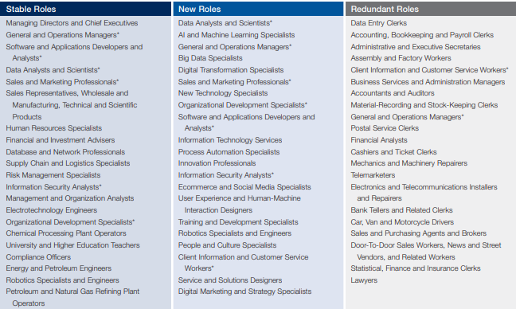

The accounting profession currently relies heavily on technology and is predicted to be one of the most impacted professions with the development of AI, although this doesn’t have to be a bad thing as “employment for accountants is expected to grow 10 percent through 2026” (MTI College, 2018). Although the implementation of AI could potentially be positive for the field it would mean that some of the lower-level positions could be affected negatively due to the ease of some of the tasks that would normally be completed by such individuals. The implementation of AI would increase the quantity and quality of data analysis as it is capable of processing huge amounts of data and can do so at a high level (Washy, 2019). AI would also reduce the amount of errors made as small errors can be easy to be made and can easily go unnoticed, but an “AI can detect errors immediately and ensure your books are always accurate” (Washy, 2019) this would mean that traditional bookkeeping will likely be replaced by AI and will reduce the number of traditional bookkeepers that would be required.
It is likely that qualified professionals will be needed to overlook these processes, even though they are relatively simple, to ensure that if any mistakes are made, they can be examined and fixed hastily. As stated previously, AI will be able to perform many of the more simple tasks and even some complex one, but accountant will still be required in order to communicate this information to clients who still may not be able to understand the information processed by the AI. The accountant would also be required to analyse and draw a conclusion from any of the information that the AI would provide as the AI would not be able to complete this. It is likely that many accountants would be expected “to move their roles into consulting and advising” (Rana, 2020) so they would be able to take the most advantage of automation to help their business grow.
The introduction of AI into the accounting field will have some negative and positive effects, some of which have already been discussed previously, the 3 main benefits that may be seen by the introduction of AI are that “Large data volumes - they can process huge amounts of data (structured and unstructured – more than humans ever could”, “Complex and changing patterns - they can pick up weaker or more complex patterns in data than we can” and finally “consistency - they can be far more consistent decision-makers” (ICAEW, 2018) these will all increase the speed and efficiency of more simple tasks that may take a lot of time because of the amount of information that is needed to be processed, these tasks can be completed in a fraction of the time it would take an accounting professional to do and it will provide the same outcome. In regards to consistency, AI would not have the same limitations as a human as they would not become tired or bored when completing these tasks whereas it is a possible to become tired and bored which may affect how well they would perform these tasks. One key negative point in regards to AI is that “Machine learning is not a general AI and models are not particularly flexible” (ICAEW, 2018), the machines can be created to complete a certain task and how to do these tasks well but are not able to adjust themselves should something change regarding the task they have been made to complete. There is also the potential of other more unique situations that an AI model may not have been created to complete this task, and even when machine learning is more advanced it is still not likely that a machine learning will be able to make a logical decision about a problem that it has not come across before, meaning that there will still definitely need to be qualified professionals with the knowledge and ability to make decisions regarding more unique problems that may arise.
In conclusion, the introduction may have a large affect on the world as a whole and may lead to many changes needed to be made in order for individuals working in any field to be able to continue working within their specified field. The primary focus of this essay was to discuss the effects that AI would have on the accounting field and it can be seen that professionals working will be affected in some way, be it for better or worse, but should these individuals be willing to adapt and grow alongside these new technologies there will still be a place for them in the field. The most negatively affected areas within the accounting field are those that work on more simple and repetitive tasks, such as bookkeeping, which an AI would be able to complete with little difficulty. There will still be a requirement for some individuals in these fields for any unique issues or to oversee the performance of an AI and to ensure that it continues to perform as required, these individuals will not be as in demand as they are at the current point in time though. On the whole, the larger introduction of AI into the accounting profession would seem to have a positive affect in the field and would lead to businesses being a lot more efficient with their resources.

References
ICAEW, 2018. Artificial intelligence and the future of accountancy, London: ICAEW.
Marr, B., 2019. Artificial Intelligence In The Workplace: How AI Is Transforming Your Employee Experience. [Online]
Available at: https://www.forbes.com/sites/bernardmarr/2019/05/29/artificial-intelligence-in-the-workplace-how-ai-is-transforming-your-employee-experience/
[Accessed 5 August 2020].
MTI College, 2018. How Artificial Intelligence (AI) Impacts Accounting. [Online]
Available at: https://mticollege.edu/blog/business/accounting-technician/artificial-intelligence-accounting/
[Accessed 5 August 2020].
Nikolaev, K., 2019. Why Elon Musk’s Genius Tesla Strategy Will Make Lyft & Uber Obsolete. [Online]
Available at: https://www.ccn.com/why-elon-musks-genius-tesla-strategy-will-make-lyft-uber-obsolete/
[Accessed 5 August 2020].
Rana, R., 2020. How Artificial Intelligence Will Impact the Accounting Industry?. [Online]
Available at: https://www.acecloudhosting.com/blog/artificial-intelligence-impact-accounting/
[Accessed 5 August 2020].
Tesla, 2016. All Tesla Cars Being Produced Now Have Full Self-Driving Hardware. [Online]
Available at: https://www.tesla.com/en_GB/blog/all-tesla-cars-being-produced-now-have-full-self-driving-hardware
[Accessed 05 August 2020].
Washy, G., 2019. How artificial intelligence will change the way accountants work. [Online]
Available at: https://www.accountingtoday.com/opinion/how-ai-will-change-the-way-accountants-work
[Accessed 5 August 2020].
World Economic Forum, 2018. The Future of Jobs Report, Geneva: World Economic Forum.

