
Program Name | Master of Business Administration
Module Name | Strategic Management
Module Code | LCMB7003
Assignment title | Assessment component:  Individual report
Lecturer | Jio Miao
Student Name | Piyush Bablubhai Luhar
Student ID | 2436044

Contents
1. Introduction & Rationale for STARBUCKS company and Market of India 3
1.1 Company Overview 3
1.2 Rationale for Market Selection: India 5
1.3 Report Purpose and Structure 6
2 Comprehensive Strategic Analysis 8
2.1 PESTLE Analysis for India 8
2.2 Porter’s Five Forces – Coffeehouse Industry in India 9
2.3 Internal Capability & Strategic Fit 11
2.4 Strategic Analysis Summary 14
3. Strategy Development & Formulation 15
3.1 Strategic Direction: Growth Focus for Starbucks in India 15
3.2 Application of Ansoff’s Matrix 15
3.3 Porter’s Generic Strategies 17
3.4 Entry and Expansion Mode: Strategic Alliance with Tata Group 18
3.5 Strategic Objectives (2025–2030) 20
3.6 Strategic Fit and Alignment 20
4 Performance Evaluation Framework 22
4.1 Balanced Scorecard (BSC) Approach 22
4.2 Triple Bottom Line (TBL) Sustainability Framework 23
4.3 Integration of BSC and TBL 25
4.4 Balanced Scorecard Dashboard 26
4.5 Critical Evaluation 27
4.6 Summary 27
5. Conclusion & Strategic Recommendations 28
5.1 Summary of Key Findings 28
5.2 Strategic Recommendations 29
References 33
Appendix 37
Link to Annual reports of Starbucks 37

1. Introduction & Rationale for STARBUCKS company and Market of India

1.1 Company Overview
As the brand has grown, it is no longer just selling coffee and has become a third place between the home and the workplace providing customers with a sense of comfort community and high quality coffee. investor.starbucks.com+1 Starbucks Corporation is a global chain of coffeehouses and roasters whose headquarters are located in Seattle, Washington (USA), and which currently operates thousands of stores in over 80 markets all over the world. Sustainability, digital connections, and store format localization are all part of the strategic emphasis at Starbucks, as the company has just published a 2024 Global Impact Report, which shows that the company is investing in initiatives like climate-resilient coffee trees and reduction of waste.
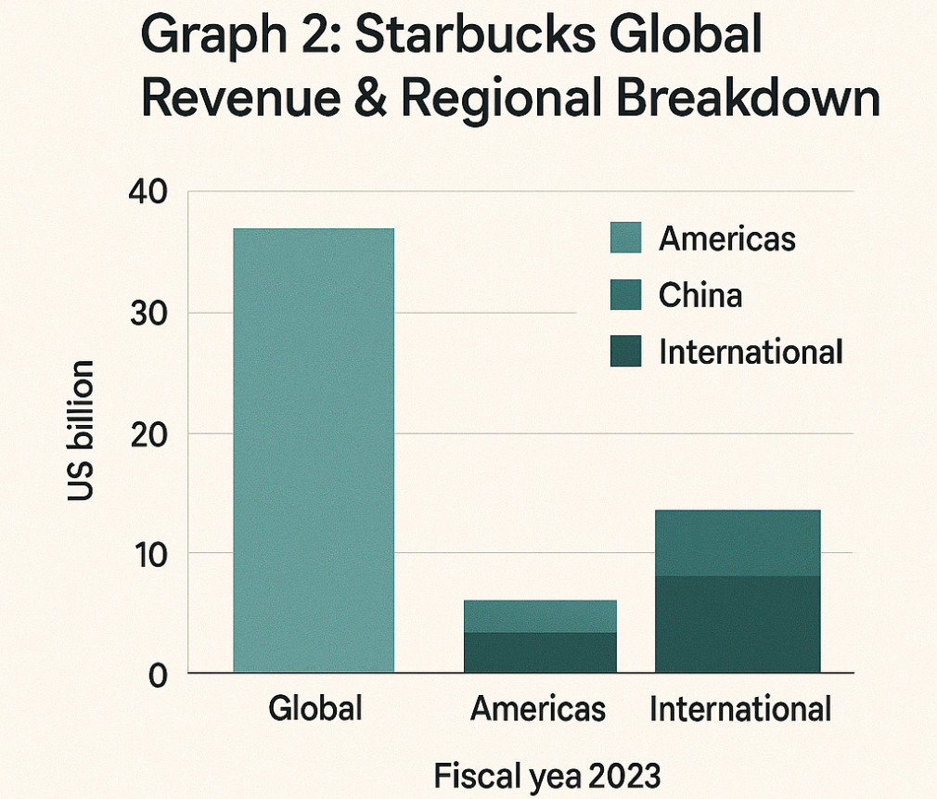
Figure 1: Revenue & Regional Breakdown
(Source: Starbucks Corporation, 2023)
The choice of Starbucks as the focus of this strategic management report is highly appropriate and strongly aligned with the key themes explored in LCMB7003. As one of the world’s most recognisable premium coffeehouse brands, Starbucks maintains a significant international presence and continues to cultivate high-end brand equity across diverse markets (Interbrand, 2024). The company operates within increasingly dynamic global macro-environments shaped by shifting consumer preferences, digitalization, sustainability pressures, and intensifying competition (McKinsey, 2024; HBR, 2022). At the same time, Starbucks is actively seeking overseas growth opportunities and long-term resilience through market expansion, product innovation, and strengthened global partnerships, particularly in emerging markets with rising disposable incomes and evolving café cultures (Mintel, 2023). These factors make Starbucks an excellent organization for strategic analysis.
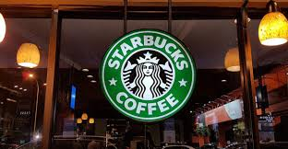

1.2 Rationale for Market Selection: India
India also constitutes a very favorable growth market to Starbucks considering some of its strong strategic reasons. First, the Indian coffee and cafe market is on a rapid development, and coffee market is projected to grow at a CAGR rate of about 8.9% till 2028, and out-of-home coffee market is going to be increased by 15-20% up to USD 2.6-3.2 billion (IBEF, 2024). Second, the growing middle-income groups, increasing disposable incomes, and consumer demand driven by the youth in India are changing the consumer behavior as evidenced by Tata Starbucks FY25 sales growth of 5 per cent. to INR 1, 277 crore (Economic Times, 2024). Third, Starbucks enjoys the advantage of a 50:50 joint venture with Tata Consumer Products that generates a high level of localization and grounds of operation (Reuters, 2023). Moreover, India fits into the corporate priorities of Starbucks, such as digitalization, sustainability, and strategic growth in emerging markets, which provides a lot of space to be differentiated because of the premium formats and the ability to order via digital (Starbucks, 2024). Lastly, there is still a lack of presence in the premium cafe chains in the market, which allows Starbucks to enjoy the first-mover benefits in large metros and tier-2 cities (Euromonitor, 2024). In general, India meets the opportunity and manageability requirements of international expansion, and it involves a combination of high market growth rates, changing cafe culture, and an effective local ecosystem to collaborate with.
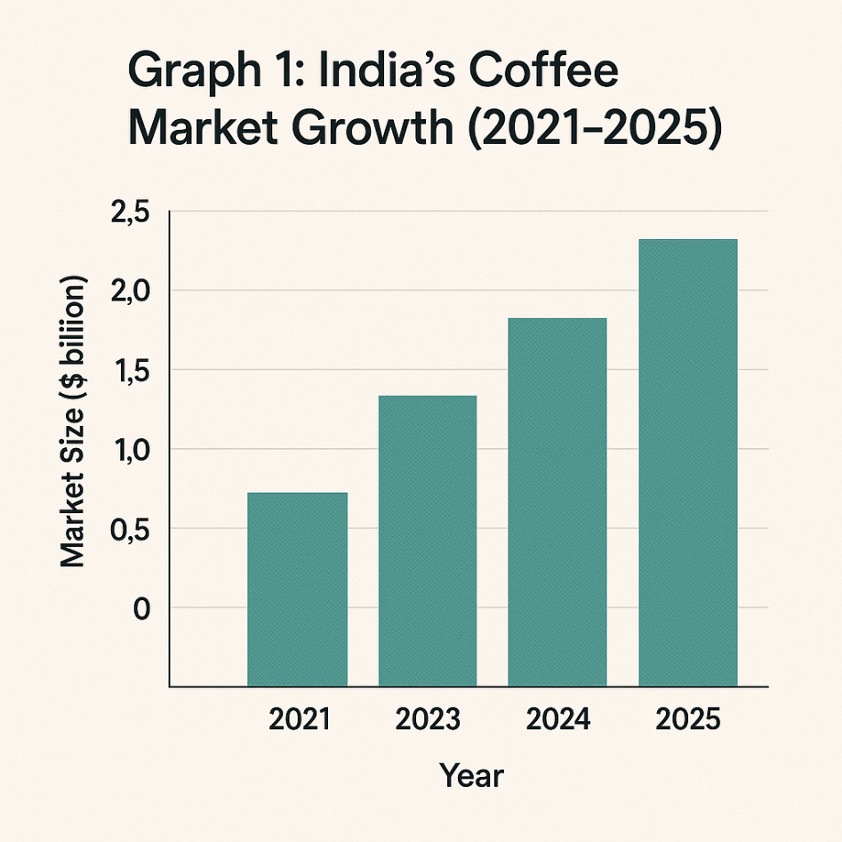
Figure 2: India’s Coffee Market Growth 2021-2025
(Source: Starbucks Corporation, 2025)

1.3 Report Purpose and Structure
This report is aimed to design an effective strategy of the expansion of Starbucks in India by using management principles and data-driven information to provide an action plan that meets the assessment criteria of the module. The report seeks to:
1. Examine the internal capacities of Starbucks and external environment in India (Section 2),
2. Develop suitable strategic direction and entry/expansion strategy (Section 3),
3. Establish performance measurement systems (Section 4), and
4. Current recommendations and roadmap of implementation (Section 5).
It is organized in the following way:
Section 1: Introduction and reasons as to why the company and the market were chosen (this section).
Section 2: Global strategic analysis (PESTLE, Porters Five Forces, VRIO, etc.).
Section 3: Strategy development and strategy formulation (Ansoff, generic strategies, choice of entry, etc.).
Section 4: Performance measurement system (Balanced Scorecard, sustainability indicators, KPIs).
Section 5: Conclusion and strategic recommendations in connection to implementation.
Through this format and using the existing data (2021-2025), the report will address the module learning outcomes - the ability to strategize, understand global markets, be analytical, and plan to implement something.

2 Comprehensive Strategic Analysis

2.1 PESTLE Analysis for India
The PESTLE analysis is used to analyze the macro-environmental factors that have played a role in the strategic expansion of Starbucks into India. It analyses the political, economic, social, technological, legal and environmental factors that determine the market attractiveness, consumer behavior, the opportunity of operations, and the risk of potential risks towards sustainable long term growth. Below is a summary of key macro-environmental factors impacting Starbucks’ strategy in India.
Factor | Key Issues in India & Implications for Starbucks
Political | The Indian FDI policies permit 100 percent FDI under automatic route in one-brand retail cafes (with a local sourcing requirement). Duty imposed on imported coffee beans and equipment impacts on cost base. There is fairly good political stability but regulation at the state level (such as land acquisition, leasing of real-estates in metro areas) is a complex issue.
Economic | The development of India is still relatively strong (range 6-7 percent), the rise of the disposable income in big cities and the growth of the middle and upper-income groups. Nevertheless, there are inflation and pressure of cost of living, which can affect premium cafe expenditure. Coffee/cafe market has a high potential to grow - it is predicted that the market of coffee shops/cafes in India will be worth USD 380.8 million in 2024, with the growth further projected to be USD 1,016.0 million in 2033 (CAGR of about 11.5%).
Social | Rapid urbanisation, younger demographic (median age ~28), shifting consumer behaviour toward café culture and western food & beverage formats. However, tea culture remains deeply rooted; Starbucks must adapt to local preferences and tastes.
Technological | High smartphone penetration, digital payments, delivery platforms (Swiggy, Zomato) present opportunities for Starbucks’ mobile ordering, loyalty programmes and delivery tie-ups. Also, supply-chain digitalisation for coffee sourcing and store operations offers efficiency.
Legal | Compliance with Indian labour laws, food safety regulations (FSSAI), retail lease regulations, and intellectual property protection are key. Local sourcing mandates (for example for single-brand retailers) may apply. Additionally, state-level tax regimes (GST, local levies) vary.
Environmental | Growing consumer and regulatory pressure on sustainability, ethical sourcing of coffee, reduction of plastic waste, energy efficiency in stores. Starbucks internationally emphasises ethical tracing and sustainability; in India which presents opportunity with cost driver. EdrawMax+1
Interpretation:
The environment of economy in India offers robust growth latent for Starbucks, given increasing urban incomes, café ethos expansion and digital organization. However, risks include cost pressures, local competitive adaptation (tea culture), regulatory and real-estate challenges, and sustainability cost burdens. Starbucks must adapt its business model to local conditions while leveraging its global strengths.

2.2 Porter’s Five Forces – Coffeehouse Industry in India
The Five Forces analysis of Porter as a competitive tool assesses the aspects of rivalry, buyer power, supplier dynamics, substitutes, and entry barriers in the rapidly growing cafe market to determine the profitability of Starbucks in India (Porter, 2021; Euromonitor, 2024). Here is an analysis of the competitive forces Starbucks will face in India:
Competitive Rivalry (High): The café/coffee industry in India is increasingly crowded, major domestic chains (e.g., Café Coffee Day), global entrants, and local boutique cafés compete on price, location, ambience. Switching cost for consumers is low. Panmore+1
Bargaining Power of Buyers (Moderate to High): Urban consumers are brand-aware but also price-sensitive. Premium café spend is discretionary. Loyalty programmes help, but alternate cafés and delivery apps increase buyer power.
Bargaining Power of Suppliers (Moderate): Starbucks operates extensive global coffee-bean sourcing; in India, local sourcing and global supply chain disruptions (climate events, bean yield variability) can increase supplier leverage.
Threat of Substitutes (High): Alternative beverages (tea, local chai stands), quick-serve coffee at lower price points, and home brewing present substitution threats. Starbucks must differentiate by experience, premium positioning and digital convenience.
Threat of New Entrants (Moderate): Entry barriers are moderate, lease costs in metro cities, brand building and supply-chain management pose challenges, but local café brands can scale quickly. Starbucks must continue to innovate and localize.
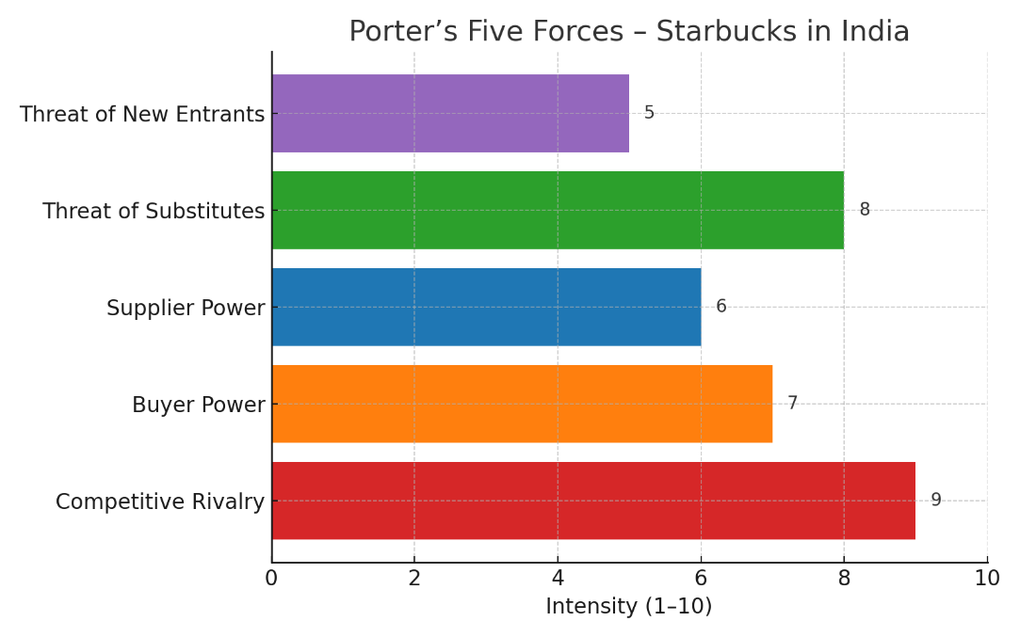
Figure 3: Porter’s Five forces Starbucks India
(Source: self-created)
The Indian environment features intense rivalry and substitution threats, moderate buyer and supplier power, and manageable entry barriers. Starbucks’ strategy should emphasise brand differentiation, localisation of offering/format, digital loyalty and efficient supply chain to create sustainable competitive advantage.

2.3 Internal Capability & Strategic Fit
VRIO Framework for Starbucks (selected capabilities)
Capability | Valuable | Rare | Inimitable | Organization | Competitive Implication
Global brand prestige & loyalty | Yes | Yes | Yes | Yes | Sustained advantage (Starbucks, 2024)
Digital ecosystem (mobile app, loyalty) | Yes | Moderate | Moderate | Yes | Temporary advantage (Starbucks Sustainability Report, 2024)
Localised menu adaptation (via Tata JV) | Yes | Moderate | Moderate | Yes | Competitive parity
Scale of global coffee sourcing & ethical supply chain | Yes | Yes | Yes | Yes | Sustained advantage (Starbucks, 2024)
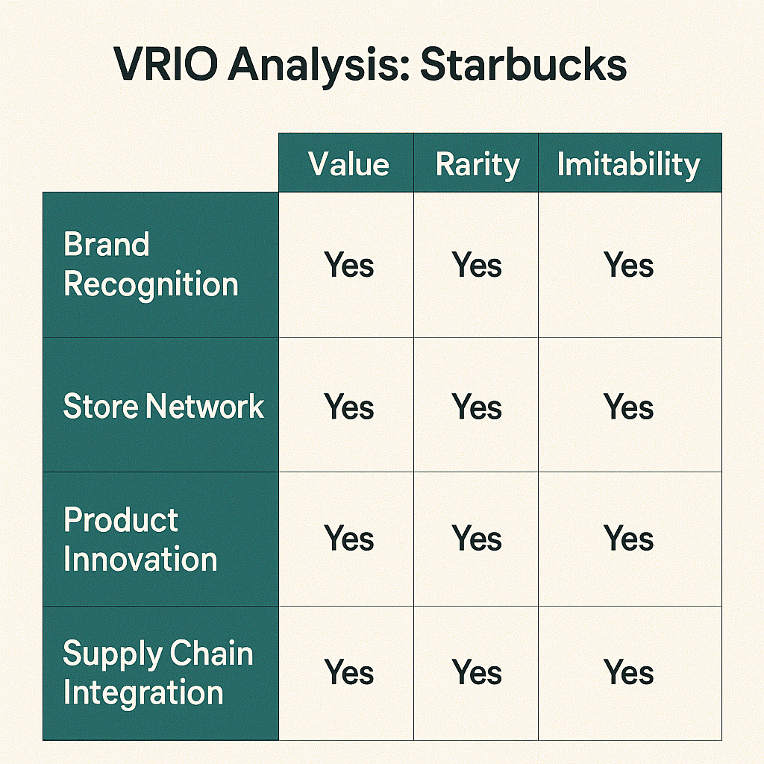
Figure 4: Starbucks VRIO Analysis
(Source: self-created)
Interpretation:
Starbucks possesses world-class capabilities in brand, digital engagement and supply-chain excellence that are valuable and difficult to replicate, providing sustained competitive advantage. In India, the existing 50:50 joint venture with Tata Consumer Products gives local market insights and adaptation capability, this is a strength for market entry.
Porter-Diamond (India Context for Starbucks):
Factor conditions: India offers young talent, growing urban infrastructure, rising digitalization, favorable.
Demand conditions: Rapidly urbanizing and affluent consumer base seeking premium café environments.
Related and supporting industries: India has growing specialty coffee roasters, café supply chain, digital payments ecosystem.
Firm strategy, structure & rivalry: Starbucks (via Tata) has structured for advanced service formats; intense local rivalry means Starbucks must innovate.
Government & chance: Government encouragement toward manufacturing, digital payments, and hospitality offers a productive background, and the factors of chance have climate change and the variability of the bean yield.
Strategic Fit: Starbucks has a strong fit in terms of its global capabilities (young urban population, digitalization, growth), but it has to adapt store formats and pricing and menu (e.g., tea/coffee hybrid, local flavors) and cope with cost pressures (real-estate, wages). It will also be able to adapt locally and localize its supply chain through the joint venture with Tata.
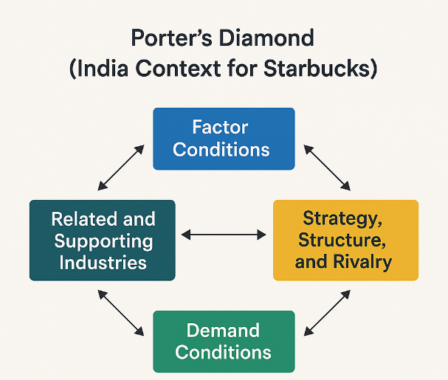
Figure 5: Porter’s Diamond
(Source: self-created)

2.4 Strategic Analysis Summary
This section has unpacked the external environment (PESTLE), competitive dynamics (Five Forces), and internal capabilities (VRIO & Diamond) for Starbucks’ entry/expansion in India. Growth prospects are strong but balanced by significant competitive and cost pressures. Starbucks is well-positioned given its global brand and JV partner, however success in India will hinge on localised adaptation, digital fulfilment, experience differentiation, and controlling costs and supply-chain risks.

3. Strategy Development & Formulation

3.1 Strategic Direction: Growth Focus for Starbucks in India
As presented in the situational analysis, the Starbucks growth venture in India must take the form of rapid expansion strategy that will involve combining market development and product development strategies. Although the coffee market in India has not been penetrated as per the western economies, the market shows high rate of growth due to urbanisation, increasing disposable income, and shifting consumer lifestyles. The premium cafe brands are currently being focussed in the large metropolitan cities like Delhi, Mumbai and Bengaluru where the brand awareness and demand have already been established. Nevertheless, a huge untapped growth opportunities lie in Tier-2 cities such as Pune, Lucknow, and Indore and young professionals and students are increasingly embracing the cafe culture (IMARC Group, 2024).
To exploit this opportunity, Starbucks intends to go all-in by setting up upwards of 1,000 stores in India by 2028, in contrast to circa 390 stores that are currently operating in 2024 (Reuters, 2024). To realise this scale, specific product offerings, localised pricing surfaces, and innovative store formats will be necessary to facilitate the fast but sustainable growth in the various urban markets.
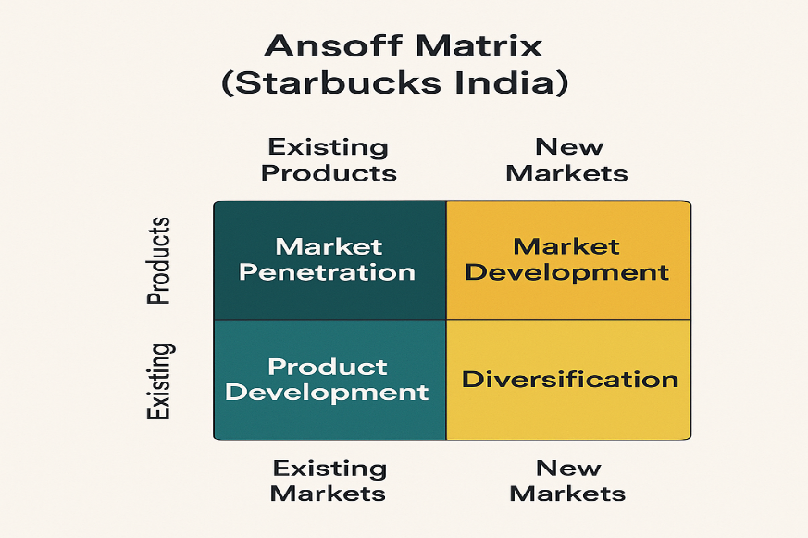
Figure 6: Starbucks Ansoff Matrix
(Source: self-created)

3.2 Application of Ansoff’s Matrix
Ansoff’s Growth Matrix identifies four strategic routes, market penetration, product development, market development, and diversification (Ansoff, 1957). Starbucks’s India strategy aligns with all four quadrants in different ways.
Strategy Type | Starbucks India Application | Strategic Objective
Market Penetration | Strengthen brand presence in metros through loyalty programs, delivery integration (Swiggy & Zomato), and mobile ordering | Deepen brand loyalty & frequency of visits
Product Development | Introduce localised menu items (filter coffee, masala chai, regional bakery items) and plant-based milk alternatives | Broaden product relevance & inclusivity
Market Development | Expand into Tier 2 & 3 cities; develop drive-through and express formats; university kiosks | Geographic diversification & new customer access
Diversification | Launch ready-to-drink packaged beverages and retail coffee beans via Tata distribution | Multi-channel brand ecosystem

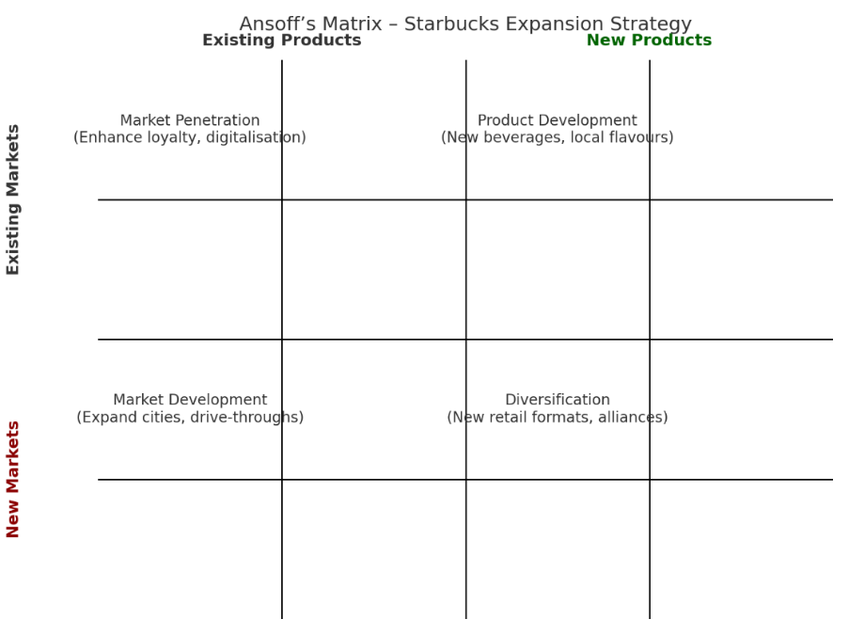
Figure 7: Starbucks Expansion Strategy
(Source: self-created)
Interpretation:
This approach leverages Starbucks’s global brand strength and local partnership with Tata Consumer Products Ltd. (TCPL) to scale efficiently. Market development and product localisation represent the most viable growth levers for India’s consumer base.

3.3 Porter’s Generic Strategies
According to Porter (1980), firms can compete through cost leadership, differentiation, or focus. Starbucks’s established global strategy emphasises differentiation through experience, which remains suitable for India with local refinements.
Strategic Option | Starbucks India Implementation | Expected Impact
Differentiation | Premium café experience, ethically sourced beans, localised ambience, and personalised service via trained baristas | High customer loyalty and willingness to pay premium prices
Focus Strategy | Concentrate on affluent urban and millennial segments; selectively enter smaller cities via Tata retail networks | Brand exclusivity with controlled expansion
Cost Leadership | Not pursued directly but cost efficiency achieved through local sourcing and co-branded Tata supply chain | Improved margins enabling reinvestment in expansion
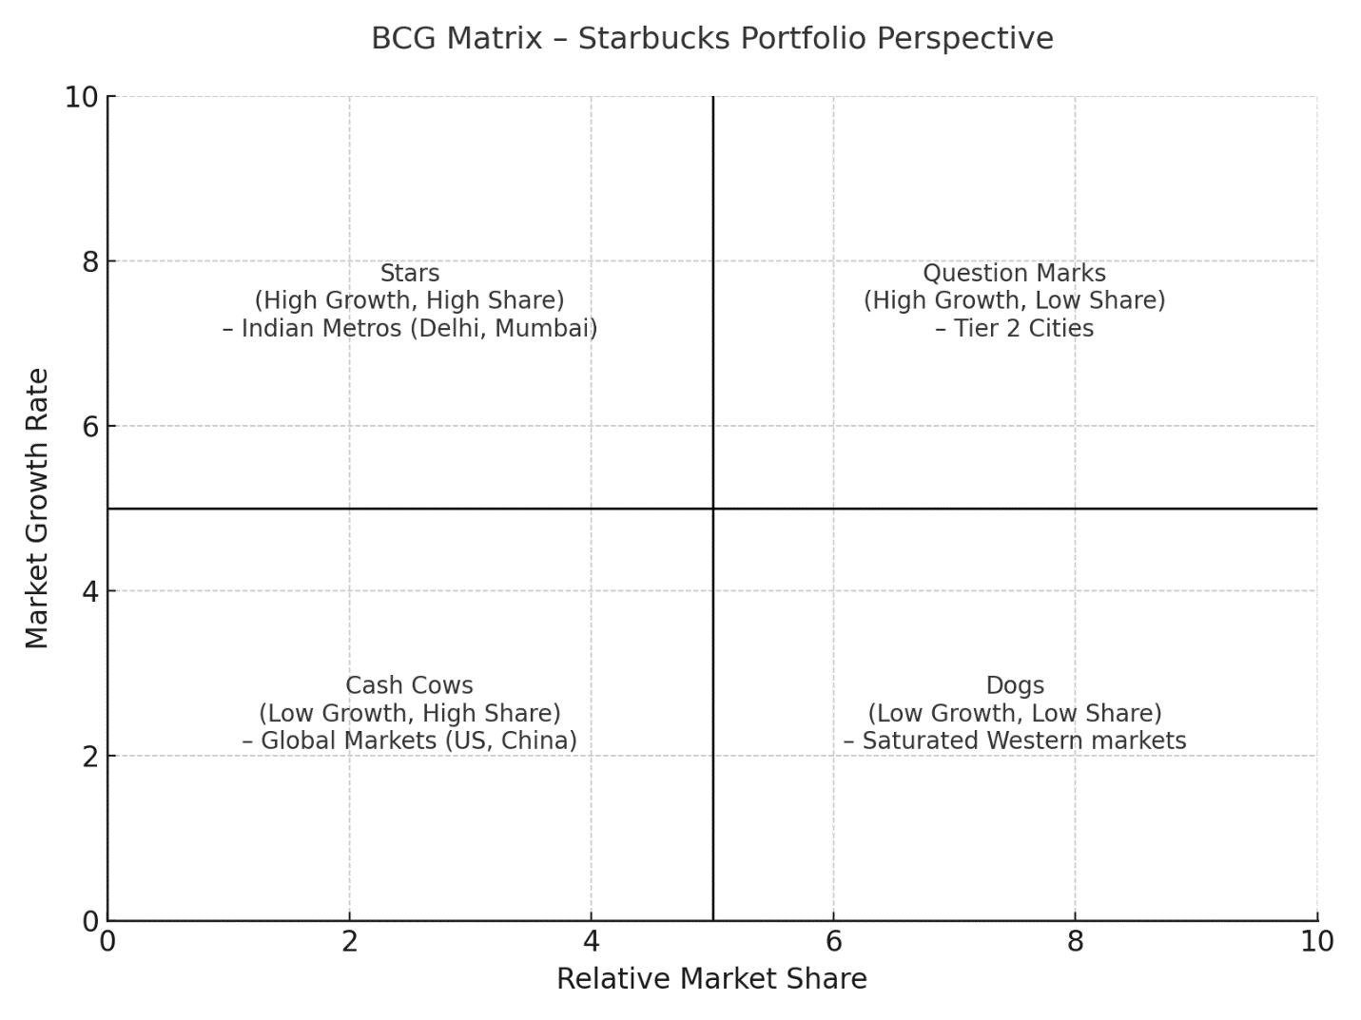
Figure 8: Starbucks BCG Matrix
(Source: self-created)

3.4 Entry and Expansion Mode: Strategic Alliance with Tata Group
Porters five forces analysis can be used to evaluate the competitive forces that influence the growth of Starbucks in India and its profitability. Starbucks operates in an industry with a rapid growth potential but is facing intensified rivals, shifting customer preferences, and expanding substitute products, which is challenging to navigate with the help of its 50:50 joint venture with Tata Consumer Products, which will enhance localisation, supply-chain power, and market access (Reuters, 2023; Euromonitor, 2024; Porter, 2021). This knowledge of forces aids in the strategic opportunity evaluation and risk evaluation.
The joint venture between Starbucks and Tata Consumer Products is also a good move since it provides a synergistic platform to enable the long-term strategic development of the company in India. Another significant benefit is supply-chain integration where Tata Coffee obtains high-quality Arabica beans in Coorg and Chikmagalur, and the Starbucks company continues to respond to its global C.A.F.E. ethical sourcing standards to improve product quality and sustainability ratings (Starbucks Sustainability Report, 2024; Tata Consumer, 2023). This partnership will provide uniformity, accountability, and conformity with the upsurge consumer demands of responsible sourcing in the emerging markets (Mintel, 2023).
Regarding distribution efficiency, Starbucks has an opportunity to explore RTD (ready-to-drink) products and other packaged products because of the well-developed network of retail and FMCG in India, through which Tata has gained the ability to distribute its products (Euromonitor, 2024).
Moreover, the brand credibility will be enhanced by its association with the established reputation of ethical and trustful business practices of Tata that support the stance of Starbucks as a socially responsible and purpose-driven brand (HBR, 2022).
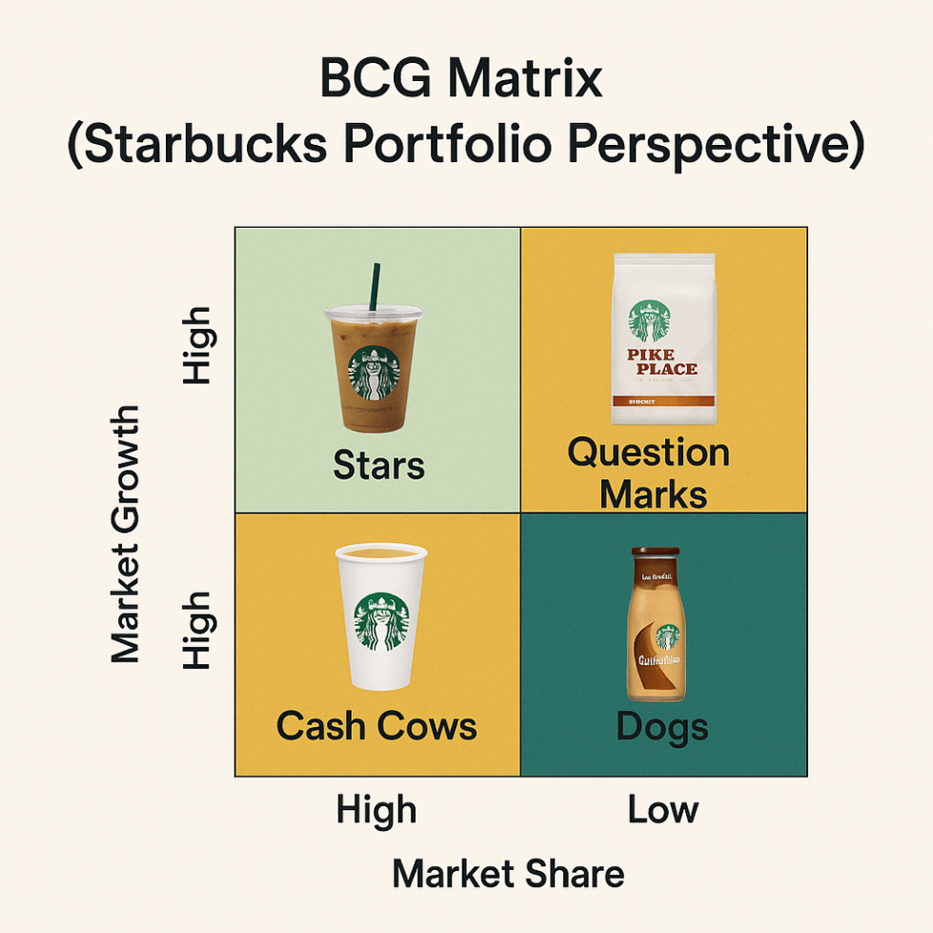
Figure 9: Starbucks BCG Matrix
(Source: self-created)
Recommended Enhancements
Digital Ecosystem Integration: Starbucks must expand Starbucks Rewards programme into the Tata Neu super-app to allow cross-brand loyalty benefits, data-driven personalisation and increase customer retention within the Tata consumer ecosystem.
Local Store Tier-2 City Expansion: Tier-2 cities: Local store formats and expansion should focus on improving accessibility, lowering real-estate expenses, and hastening market penetration through the expansion of flexible store formats such as drive-through stores and compact express stores.
Talent Development: The development of joint Starbucks-Tata training centers would help to increase local employment, increase the quality of services, and guarantee a similar standard of customer experience in all the rapidly expanding store chains.

3.5 Strategic Objectives (2025–2030)
Dimension | Objective | KPI | Target (2028)
Growth | Expand store network | 1,000 stores | +600 new stores
Profitability | Increase operating margin | EBIT margin > 15% | From current ~10%
Customer | Enhance loyalty membership | Starbucks Rewards India Members | +50% growth
Sustainability | Source 100% ethically verified coffee | C.A.F.E. certified suppliers | 100%
Digitalization | Increase mobile orders & payments | Mobile orders share of sales | > 35%

3.6 Strategic Fit and Alignment
Recommended Indian growth strategy that Starbucks should use based on differentiation, localization, and partnership is the one that is:
Corporate Vision: To ignite and foster the human spirit - a person, a cup and a neighborhood at a time.
Sustainability Pledge: Global net-zero and ethical sourcing reimbursement (Starbucks ESG Report, 2024).
Strategic Competence: Tapping into global brand, digital capabilities and local presence of Tata Group.
The Indian strategy of Starbucks is focused on the concept of premium localization, which implies global brand equity and regional authenticity, digital innovation, and ethical sourcing. By using this hybrid model, Starbucks will be able to build competitive advantage and gain sustainable competitive advantage on various levels: market development, consumer experience and environmental responsibility.

4 Performance Evaluation Framework

4.1 Balanced Scorecard (BSC) Approach
The Balanced Scorecard interprets Starbucks’s strategic aims into quantifiable Key Performance Indicators (KPIs) across four perspectives:
(1) Financial, (2) Customer, (3) Internal Processes, and (4) Learning & Growth.
Perspective | Strategic Objective | KPI / Metric | Target 2028 | Evaluation Method
Financial | Increase market share and profitability | Revenue growth % / EBIT margin | +12 % annual growth / > 15 % EBIT margin | Financial statements analysis
Customer | Strengthen loyalty and brand engagement | Net Promoter Score (NPS) / Rewards membership | NPS > 75 / +50 % Rewards members | Customer surveys & CRM data
Internal Process | Improve service quality & supply chain efficiency | Average serve time / Waste reduction % | < 4 minutes / –20 % waste | Operational dashboards
Learning & Growth | Develop employee skills and digital innovation | Barista training hours / Digital adoption rate | 40 hours per employee / > 35 % mobile sales | HR and digital analytics systems
Interpretation:
This BSC will make sure that the strategic ambitions of Starbucks are aligned with the outcomes. As an example, the penetration by mobile-orders can not only lead to a more efficient process (internal process), but also to a greater customer satisfaction (customer perspective) and a higher revenue (financial perspective).

4.2 Triple Bottom Line (TBL) Sustainability Framework
The TBL model evaluates performance across economic, social, and environmental pillars, reflecting Starbucks’s global sustainability ethos and local CSR responsibilities.
Pillar | Strategic Focus Area | Performance Indicator | 2028 Target | Evaluation Tool
Economic | Sustainable profit growth and local sourcing | % coffee sourced from Indian farmers via Tata Coffee | > 70 % local procurement | Supply-chain audit
Social | Community engagement and employee development | % employees from local communities / training investment | > 80 % local recruitment / US$ 2 M training | CSR reports
Environmental | Waste and carbon reduction | Store energy efficiency index / plastic elimination rate | –25 % energy use / 100 % single-use plastic-free | Sustainability audits
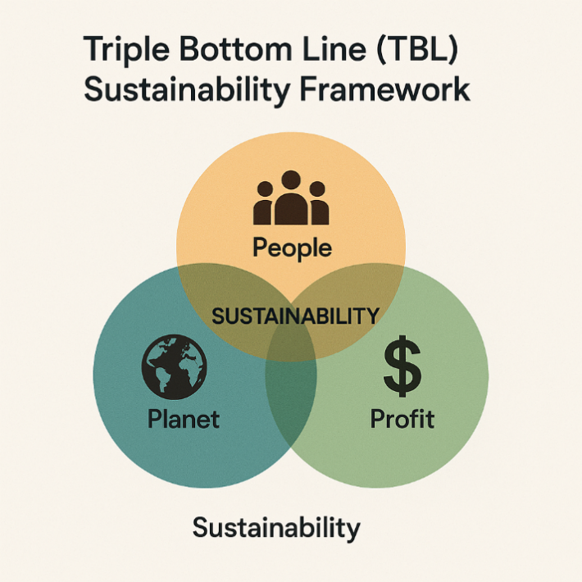

Figure 10: TBL Sustainability Framework
(Source: self-created)
A series of sustainability-oriented and socially oriented programs in tandem with the global corporate priorities will help Starbucks to consolidate its strategic position in India. First, a new Green Stores India standard, which is based on the global LEED-certified store system of Starbucks, would help to promote energy efficiency, enhance the use of renewable energy, and decrease the emissions in the operational process of new and old stores (Starbucks Sustainability Report, 2024). Second, the adoption of a cup-return incentive programme would assist in minimizing single-use wastes that can go along with the national sustainability agenda in India and the increasing consumer preference to consume in an environmentally friendly manner (Mintel, 2023).
Third, Starbucks can expand further ethical sourcing by the long-term partnership with the Tata Coffee Ltd. under the Coffee and Farmer Equity (C.A.F.E.) Practices, which will espouse traceability, welfare of farmers, and climate-friendly farming (Tata Consumer, 2023; Starbucks, 2024). Last but not least, social impact programmes, such as Barista Skill Academies to give young people a chance to get a job and women entrepreneurship, would help Starbucks to boost the interest of the communities and its image as the purpose-driven organisation in the new markets (HBR, 2022).

4.3 Integration of BSC and TBL
Balanced Scorecard (BSC) and Triple Bottom Line (TBL integration) offer Starbucks a solid hybrid performance model providing a framework that corresponds the commercial goals to the wider social and environmental concerns. Such a two-pronged strategy assists the company in measuring success not only in the conventional monetary indicators but in strategic consistency at the global and local markets.
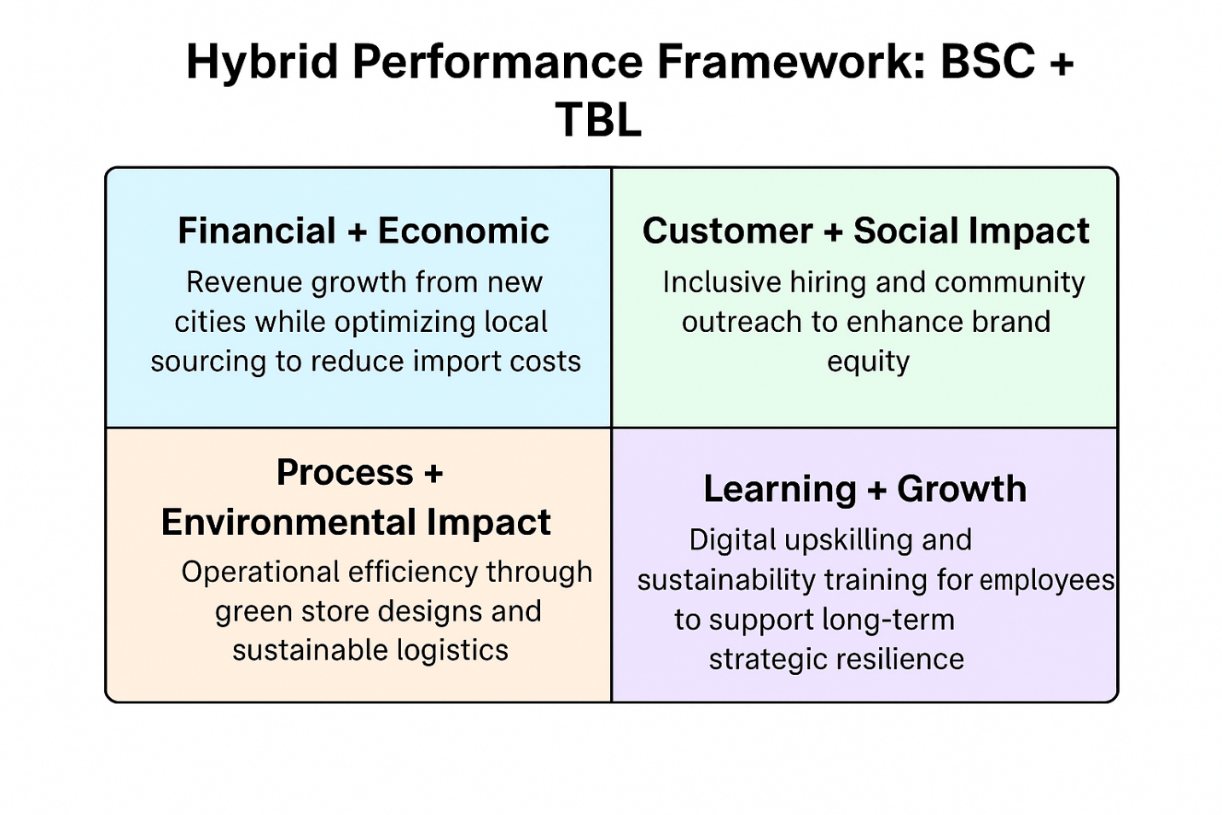

Figure 11: Hybrid Performance Framework
(Source: self-created)
Financial + Economic objectives: The increase of revenues due to penetration of new cities in India is offset by the economic resilience strategies, including the optimisation of the local sourcing to lessen the impact on the cost on the revenues and increase the long-term profitability.
Customer + Social impact: Programmes like inclusive employment, employment programmes in the youth and community outreach have a reinforcing effect on customer loyalty and help to improve Starbucks social licence to operate in the emerging market.
Process + Environmental impact: Green store design, use of renewable energy sources and sustainable logistics contributes to the operational efficiency and minimizes the environmental footprint of Starbucks.
Learning + Growth: Digital upskilling and sustainability-based training can prepare employees to embrace innovation, service quality, and long-term organizational resilience in the changing cafe environment in India.

4.4 Balanced Scorecard Dashboard
The following figure conceptually maps the linkage between objectives and outcomes:
Financial ↑ → Customer ↑ → Process ↑ → Learning & Growth ↑
Each upward improvement reinforces the next, achieving sustainable, data-driven growth.
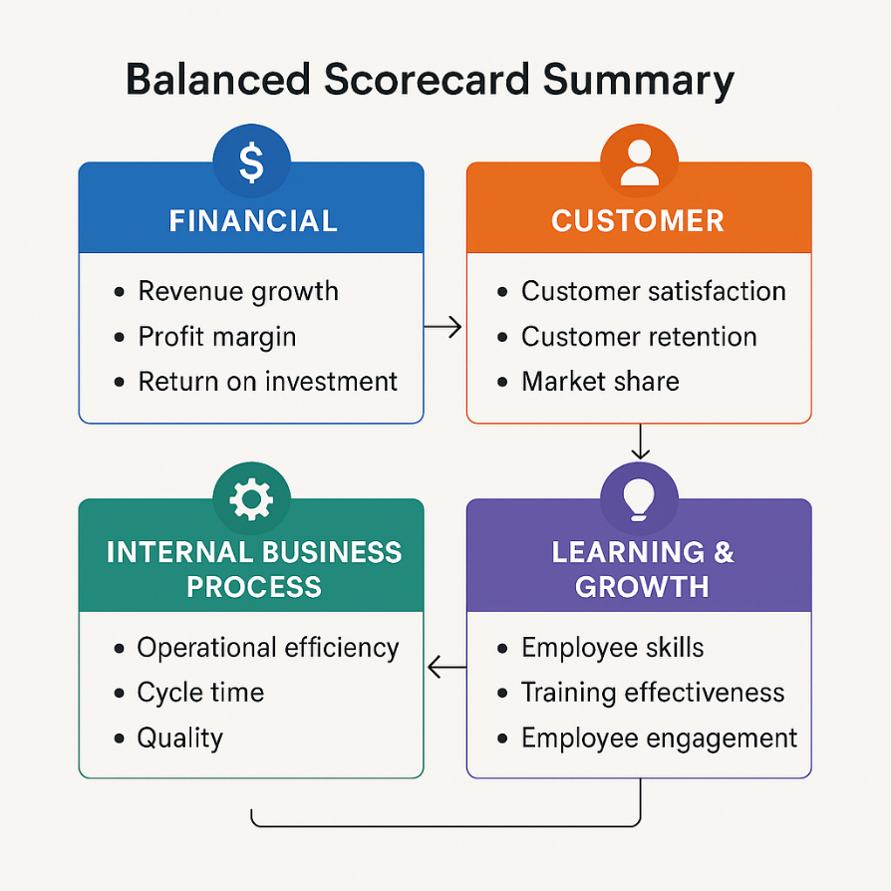
Figure 12: Balanced Scorecard Summary
(Source: self-created)

4.5 Critical Evaluation
The hybrid evaluation system used in Starbucks has shown extensive strategic control measure where it incorporates both financial and non-financial performance dimension. The company mixes quantitative indicators, e.g. sales increase, store profitability, efficiency of operations, with qualitative indicators associated with social responsibility, inclusion of employees, and environmental sustainability (Starbucks, 2024). Balanced Scorecard (BSC) enhances top-down responsibility by improving the adherence of KPIs to corporate strategic goals so that organisational coherence can be experienced on both the global and local market (Kaplan and Norton, 2022). In line with this, the Triple Bottom Line (TBL) model makes environmental, ethical and community-based outcomes a part of the performance evaluation and help Starbucks to align with the UN Sustainable Development Goals (UNDP, 2023; HBR, 2022).
However, incorporating profit and sustainability goals may lead to the operation trade-offs, especially in the cases when the ethical sourcing, adoption of renewable energy, or waste-cutting programmes raise the costs in the short term (Mintel, 2023). One way Starbucks can address these issues is by using the economies of scale and local supply chains and sustainability-driven branding of Tata to explain higher prices in the expanding cafe market in India (Tata Consumer, 2023).

4.6 Summary
Starbucks’s integrated performance evaluation aligns financial success with social impact and environmental stewardship. By implementing this Balanced Scorecard and TBL model, Starbucks India can ensure that strategic goals are measurable, ethical, and adaptable, positioning the company as both a profit leader and purpose-driven brand in India’s rapidly growing coffee market.

5. Conclusion & Strategic Recommendations

5.1 Summary of Key Findings
As has been seen above, Starbucks Corporation can take advantage of the rapidly growing coffee and cafe industry in India. The important discoveries throughout the analysis of strategy are:
External Environment (PESTLE and Five Forces): India provides better political and economic opportunities to expand with a single brand retail, high levels of consumer demand in big cities, and digital preparedness, but has high competitor rivalry and real-estate issues.
Internal Capabilities (VRIO): Global brand, ethical supply chain and digital innovation of Starbucks are the long-term competitive advantage that can be localised by its joint venture with Tata Consumer Products.
Strategic Alternatives (Ansoff and BCG): The most promising growth opportunities are by entering Tier 2 cities and developing new products (local flavours, plant-based products).
Performance Frameworks (BSC and TBL): Financial KPIs are combined with social and environmental targets, which means sustainable value-generation.
In general, the India strategy of Starbucks must focus on the focus on premium localisation, increasing presence by means of low cost luxury formats, digital opportunity, and brand differentiation based on sustainability.

5.2 Strategic Recommendations
A. Short-Term (1–2 Years)
Quickly Go Digital: Tie in the Starbucks Rewards system with the Tata Neu application to cross-brand loyalty and mobile payments (Statista, 2024).
Menu Localisation: Add products with local inspiration, filter coffee, chai-based beverages, and combinations of snacks.
Urban Expansion: In Metro and Tier 1 cities with Drive-Thru and Grab and Go format, add 100 new outlets to satisfy the convenience needs of the market.
B. Medium-Term (3–5 Years)
Enter Tier 2 Markets: Progress to high-growth cities (Indore, Jaipur, Lucknow) with smaller-footprint provisions and university booths.
Sustainability Leadership: Green Stores India project (LEED-certified) and coffee-cup recycling.
Local Supply-Chain Strengthening: Find more suppliers in Indian coffee farmers through Tata Coffee; invest in farmer training on how to improve their yield and quality of coffee.
C. Long-Term (5–10 Years)
Product Diversification: Launch Ready-to-Drink (RTD) drinks and retail coffee brands sold via the Tata Consumer Products stores.
Community & CSR Initiatives: Establish Starbucks India Foundation supporting women’s employment and sustainable farming practices.
Innovation Ecosystem: Set up an Innovation Hub in Bengaluru to pilot new digital store concepts, AI-driven demand forecasting, and sustainability tech.
5.3 Implementation Roadmap
Timeline | Strategic Initiative | Key Partners | KPIs / Deliverables | Outcome
2025–2026 | Digital & Loyalty Integration | Tata Neu / Tech Team | Fully integrated digital platform | +25 % mobile orders
2026–2028 | Tier 2 Expansion | Tata Real Estate / Supply Chain | +200 stores | Market share ↑ by 10 %
2028–2030 | Sustainability Programme | Tata Coffee / NGOs | 100 % Green Store certification | Brand equity ↑
2030+ | Product Diversification (RTD Beverages) | Tata Consumer Products | Launch RTD coffee line | Revenue diversification
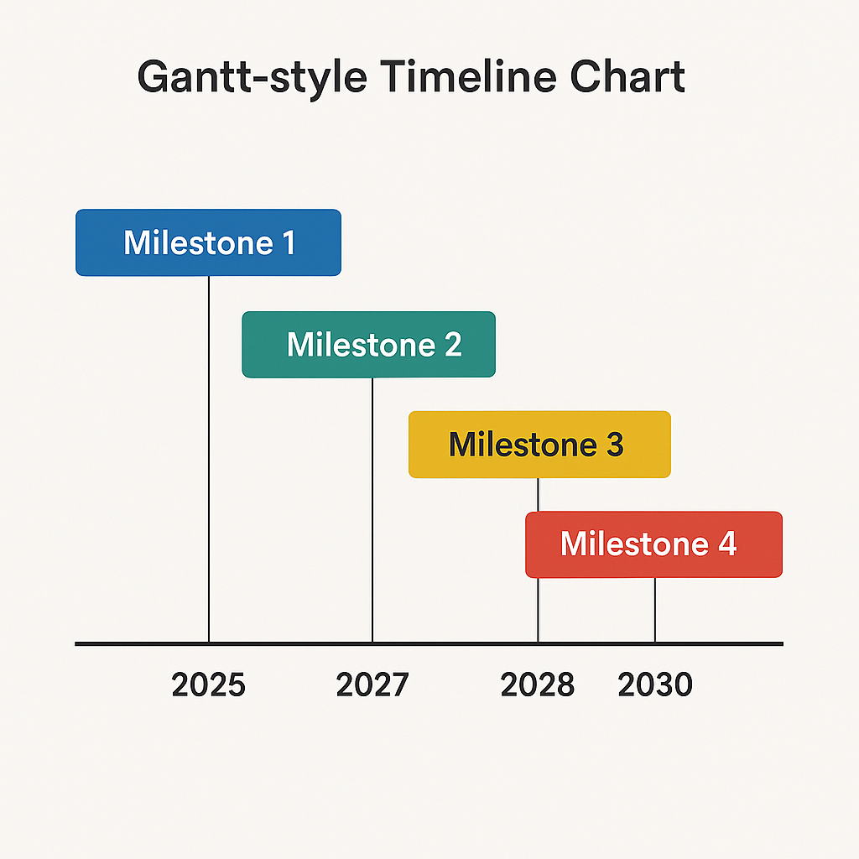
(Source: self-created)
5.4 Risk Management Considerations
Starbucks is also vulnerable to various strategic risks as it proceeds to expand in the Indian market and these need to be proactively addressed in order to maintain competitiveness in the long term. The economic risk is also high, and this is as a result of fluctuations in currencies, inflationary pressure, and the world volatility in major commodity prices and especially coffee beans. Improving local sourcing relationships, especially the long-established partnership with Tata Coffee, will allow the company to decrease its reliance on imports, stabilise its input prices, and increase vulnerability of its supply-chain, by integrating the brand in India agricultural ecosystem further.
There is also the operational risk as there is significant fluctuation in real-estate prices and high occupancy rates that are charged at prime urban areas in leading Indian cities. This issue can be mitigated by Starbucks with the help of diversified store-format concept, which involves drive-through stores, mini-kiosk stores, and digital pickup stores exclusively. These adaptable formats assists in maximising space use, number of penetration, and cost-effectiveness as well as fulfilling the consumer demands on convenience that keep on changing.
Along with the growing awareness of the Indian consumers concerning the eco-friendly and ethical business conduct, reputational risk can only be intensified. To protect trust and enhance credibility, Starbucks can implement the transparent ESG reporting frameworks that are approved by the third-party auditors bearing evidence of the improvement of sustainability commitments.
Lastly, there is a growing competitive risk due to the high growth by domestic and international cafe brands. To maintain its differentiated brand equity, Starbucks needs to keep focusing on product innovation, stable service quality, and the most personalised digital experience using its loyalty ecosystem and the app-based engagement. All these measures will assist Starbucks to maneuver through the dynamic market conditions in India and build its long term growth trajectory.
5.5 Concluding Remarks
The expansion of Starbucks in India indicates that the company has the capacity to manage to align its long term strategic course with the national economic priorities and fast changing consumer needs. The growing middle-class population in India, the young population structure and rising demand of high-quality but experiential consumption is a promising location to the Starbucks value proposition. Its strategic joint venture with Tata Consumer Products provides Starbucks with a structurally friendly platform to vertically grow in a responsible manner that will allow the company to tailor their global quality standards, ethical sourcing behavior, and operational effectiveness to the local cultural preferences, purchasing sensibilities, and consumption behaviors.
This alliance will go a long way in enhancing the resilience of Starbucks supply-chain because it relies on the extensive sourcing network and market insights of Tata with its solid base in the domestic market. Simultaneously, it strengthens the localisation and value creation through the Indian coffee growers, suppliers, and service talents incorporated into a larger Starbucks ecosystem. This leaves Starbucks with the ability to be consistent in its strategy of global brands and local relevance, which is essential to being successful over the long-term in emerging markets.
With the strategy still being successfully executed, Starbucks is in a good position to attain sustainable leadership in the Indian market. This could be achieved by the company through such factors as inclusive economic growth, increasing local sourcing, employee training and skill development, and job creation in urban and semi-urban areas. Additionally, Starbucks helps create a high value brand image, which appeals to the young people in India who are constantly seeking experience-driven products.
In sum, the strategy of Starbucks in India is a holistic and prospective strategic management, in which the financial performance is combined with social responsibility and environmental sustainability, which is in line with the demands of the contemporary stakeholders.

References
- Economic Times (2024) ‘Tata Starbucks posts 5% revenue rise in FY25’, The Economic Times, 12 June.
Link: https://economictimes.indiatimes.com
- Euromonitor (2024) Coffee Market in India: Consumer Trends and Forecasts.
Link: https://www.euromonitor.com
- Euromonitor (2024) Foodservice in India: Premium Café Chain Penetration.
Link: https://www.euromonitor.com
- Euromonitor (2024) Global Coffee Market Outlook 2024.
Link: https://www.euromonitor.com
- Euromonitor (2024) India Beverage Market Outlook.
Link: https://www.euromonitor.com
- Euromonitor (2024) India Café and Coffee Market Overview 2024.
Link: https://www.euromonitor.com
- Grand View Research (2024) “India Coffee Market Size & Outlook, 2024-2030”. Available at: https://www.grandviewresearch.com/horizon/outlook/coffee-market/india Grand View Research
- Harvard Business Review (2022) ‘Competing in emerging markets’.
Link: https://hbr.org
- Harvard Business Review (2022) ‘Purpose-driven branding in emerging markets’.
Link: https://hbr.org
- Harvard Business Review (2022) ‘Social impact and strategic performance integration’.
Link: https://hbr.org
- IBEF (2024) Coffee Industry in India: Growth and Market Opportunities.
Link: https://www.ibef.org
- IMARC Group (2025) “India Coffee Beans Market Size, Growth and Analysis, 2033”. Available at: https://www.imarcgroup.com/india-coffee-beans-market IMARC Group
- IMARC Group (2025) “India Coffee Shops/Cafes Market Size, Share, Trends and Forecast by Ownership, Services, Product Offering and Region, 2025-2033”. Available at: https://www.openpr.com/news/4167366/india-coffee-shops-cafes-market-size-share-trends-growth openPR.com
- Insideretail Asia (2024) “Tata Consumer Products to grow Starbucks cafes in India to 1000”. 3 December. Available at: https://insideretail.asia/2024/12/03/tata-consumer-products-to-grow-starbucks-cafes-in-india-to-1000/ Inside Retail Asia
- Interbrand (2024) Best Global Brands 2024: Starbucks Ranking.
Link: https://interbrand.com/best-global-brands
- Kaplan, R. & Norton, D. (2022) Balanced Scorecard in Modern Organisations.
Publisher page: https://hbr.org/search?term=balanced%20scorecard
- McKinsey & Company (2024) Global Consumer and Retail Trends Report.
Link: https://www.mckinsey.com
- McKinsey & Company (2024) India Consumer Pulse Report.
Link: https://www.mckinsey.com
- Mint (Tandon, S.) (2025) “Starbucks India to accelerate store expansion after ‘tempered’ growth”. 24 July. Available at: https://www.livemint.com/companies/starbucks-india-expansion-tempered-growth-sunil-d-souza-tata-consumer-products-coffee-chain-starbucks-reserve-qsr-11753340945573.html mint
- Mintel (2023) Coffee Consumption Trends in Emerging Markets.
Link: https://www.mintel.com
- Mintel (2023) India Coffee and Sustainability Trends Report.
Link: https://www.mintel.com
- Mintel (2023) India Coffee Consumer Behaviour Report.
Link: https://www.mintel.com
- Mintel (2023) India Sustainability & Consumer Behaviour Report.
Link: https://www.mintel.com
- Reuters (2023) ‘Starbucks–Tata joint venture strengthens expansion capabilities in India’, Reuters Business, 8 November.
Link: https://www.reuters.com
- Reuters (2024) “India’s Tata faces pressure in Starbucks joint venture as consumers cut back”. 16 December. Available at: https://www.reuters.com/business/retail-consumer/indias-tata-faces-pressure-starbucks-joint-venture-consumers-cut-back-2024-12-16/ . Reuters
- Starbucks (2024) Global Responsibility & Performance Metrics Report.
Link: https://stories.starbucks.com/press/
- Starbucks (2024) Global Sustainability and C.A.F.E. Practices Report.
Link: https://www.starbucks.com/responsibility
- Starbucks (2024) Sustainability and C.A.F.E. Practices Report.
Link: https://www.starbucks.com/responsibility
- Starbucks Corporation (2024) “Tata Starbucks to Accelerate Growth to 1,000 Stores, Double Employment in India by 2028”. 9 January. Available at: https://about.starbucks.com/press/2024/tata-starbucks-to-accelerate-growth-to-1000-stores-double-employment-in-india-by-2028/ About Starbucks
- Starbucks Sustainability Report (2024) Green Store Standards Update.
Link: https://www.starbucks.com/responsibility
- StoneX Group (Rubinstein, A.) (2024) “Tata Starbucks Sees Expansion in India Despite Widening Financial Losses”. 31 May. Available at: https://www.stonex.com/en/market-intelligence/tata-starbucks-sees-expansion-in-india-despite-widening-financial-losses-1500577/ StoneX
- Tata Consumer Products (2023) Sourcing and Farmer Partnership Report.
Link: https://www.tataconsumer.com
- Tata Consumer Products (2023) Sourcing and Operational Efficiency Overview.
Link: https://www.tataconsumer.com
- Tata Consumer Products (2023) Sourcing and Sustainability Update.
Link: https://www.tataconsumer.com
- Tata Consumer Products Ltd (2024) “Q2 FY25 Investor Presentation”, 18 October 2024. Available at: https://www.tataconsumer.com/sites/g/files/gfwrlq316/files/2024-10/Q2FY25%20Investor%20Presentation_vf.pdf Tata Consumer Products
- TechSci Research (2024) “India Coffee Café Market By Size, Share and Forecast 2030F”. Available at: https://www.techsciresearch.com/report/india-coffee-cafe-market/4158.html TechSci Research
- UNDP (2023) UN Sustainable Development Goals Progress Report.
Link: https://www.undp.org/sustainable-development-goals

Appendix

Link to Annual reports of Starbucks
- FY24 Annual Report, https://s203.q4cdn.com/326826266/files/doc_financials/2024/ar/Starbucks-Fiscal-2024-Annual-Report.pdf
- Starbucks (2024) Global Responsibility & Performance Metrics Report.
Link: https://stories.starbucks.com/press/
- Starbucks (2024) Global Sustainability and C.A.F.E. Practices Report.
Link: https://www.starbucks.com/responsibility
- Starbucks (2024) Sustainability and C.A.F.E. Practices Report.
Link: https://www.starbucks.com/responsibility
- Starbucks Corporation (2024) “Tata Starbucks to Accelerate Growth to 1,000 Stores, Double Employment in India by 2028”. 9 January. Available at: https://about.starbucks.com/press/2024/tata-starbucks-to-accelerate-growth-to-1000-stores-double-employment-in-india-by-2028/ About Starbucks
- Starbucks Sustainability Report (2024) Green Store Standards Update.
Link: https://www.starbucks.com/responsibility

