University of Wales Trinity Saint David
School of Engineering
Can FEA Replace Physical Testing?
James Gregory
P148409
BEng (Hons) Mechanical Engineering
18/04/2020
Advanced Stress Analysis & FEA
M6X00420

Table of Contents
1 List of Figures II
2 Introduction 1
3 Why Company’s Adopt FEA Alongside Physical Testing? 2
4 How a Physical Test May Be Correlated to an FE Model? 7
5 Can (or should) FEA Replace Physical Testing? 12
6 Conclusion 14
7 References 15
8 Appendices 20
8.1 What is FEA? 20

List of Figures
Figure 1: Typical wind turbine static test (MTS Systems Corporation, 2012; CompositesWorld, 2010) 3
Figure 2: Typical wind turbine dynamics test (MTS Systems Corporation, 2012; Steel, 2016) 3
Figure 3: Blade test scene (Chen, et al., 2014) 5
Figure 4: Final external failure of blade at transition region (Chen, et al., 2014) 5
Figure 5: Failure modes detected at suction side (SS) of the blade: laminate fracture (LF), delamination (DL) & debonding (DB) (Chen, et al., 2014) 5
Figure 6: (LEFT): FE global shell model with applied loads; (RIGHT): Local solid model with applied loads calculated from shell element model (Chen, et al., 2014) 6
Figure 7: Final failure predicted from FE simulation. (LEFT) LF at blade shells; (RIGHT) DL and DB failure (Chen, et al., 2014) 6
Figure 8: Effect of different material degradation on final failure prediction. (a) LF Present; (b) FL Nagesh; (c) DL&DB Present; (d) DL&DB Nagesh (Chen, et al., 2014) 6
Figure 9: Detailed model flowchart of V&V process (Thacker, et al., 2004) 9
Figure 10: Experimental set-up (Babawarun, et al., 2019) 11
Figure 11: CAD model of blade demonstrating three test points and boundary condition (Babawarun, et al., 2019) 11
Figure 12: Three stress contour cases determined by the FE simulation 11
Figure 13: Applications of FEA, from left to right: aircraft’s bearing bracket, electrical cabinet and shell and tube heat exchanger (Harish, 2020) and (COMSOL, 2015). 20

Introduction
As competitiveness, productivity and efficiency increase in the engineering and manufacturing sector, companies are discovering innovative ways to develop and introduce products to market, in progressively shorter time, while reducing product life cycle (Reche, et al., 2019). The Product Development Process (PDP) is a critical stage in companies and involves taking a product from concept to production to market, and is often associated with engagement from key customers and suppliers (Cooper, et al., 1997). The development of a new product, whether for personal, commercial or industrial use, will involve a benchmark which should be considered, including time scale, product quality, production costs, customer expectations and product requirements and regulations. For this reason, good PDP is essential (Santiago, et al., 2017).
Nonetheless, the introduction of Computer-Aided Engineering (CAE), in particular, Finite Element Analysis (FEA), has been widely adopted and dramatically transformed PDP (Hamri, et al., 2010). Engineers can now analyse simple and intricate designs effortlessly while in the form of adaptable 2D or 3D Computer-Aided Design (CAD) models, yielding quick turnaround times and prompt implementation of results (SAE International, 2020). When used appropriately, FEA can become a magnificent productivity tool, assisting engineers in reducing production time, prototypes, experiments and cost. However, as of yet, FEA is not a requirement in the PDP, whereas conventional methods, for instance, physical testing is, and are therefore still dominant; and also a preferred choice, particularly for studying a components behaviour and collecting, and analysing data (Uniscient, 2017).
This report explores FEA and the role it plays in the product development of wind turbine blades: specifically, how FEA corresponds and correlates to conventional physical testing methods, which are primarily preformed on rotor blades. In order to understand and determine this, three questions will be answered, which will explore why and how FEA is used and the role it will have in the future of blade testing:
- Why Company’s Adopt FEA Alongside Physical Testing?
- How a Physical Test May Be Correlated to an FE Model?
- Can (or should) FE Analysis Replace Physical Testing?

Why Company’s Adopt FEA Alongside Physical Testing?
The development of FEA for studying wind turbine blades presents an economical and sustainable alternative to manufacturing new and maintaining existing blades. Companies in this industry financially benefit from FEA due to increasing costs associated with physical testing as blades become larger (Veers, et al., 2003; Overgaard & Thomsen, 2009). Finite Element (FE) tools are frequently used due to their ability of predicting complex loads, whereas for a laboratory test, only idealised loads can be imposed (Freebury & Musial, 2000). Conventional experimental tests are often performed in FEA due to the simplicity of assessing the simulation and results, as well as analysing why blades fail prior to their expected lifespan (Marín, et al., 2008). FEA has established itself in the design stage and allows companies to introduce innovative, efficient and robust blades, as well as promote accurate designs (Mahendran, 2007). Furthermore, FEA can analyse complex loads or conditions that cannot be implemented or measured physically (Zhang & Pan, 2009).
To stimulate confidence in designs, turbine blades are subjected to various structural tests such as static, dynamic, crash and modal. These tests are mandatory to ensure current blade specifications are consistent with actual blade performance, according to the International Electrotechnical Commission (IEC) standard IEC 61400-23:2014 (Malhotra, 2010). However, physical testing is considered time consuming, expensive and often times ineffective and inaccurate, with specialist equipment needed (Ferrari, 2009). This is why FEA is typically integrated alongside laboratory testing, because it is a quick substitute which enables engineers to replicate and simulate structural tests effortlessly, in a short period of time and with no extra costs; in addition to, predicting the same behaviours that are being analysed physically. The simulation results gathered are used to validate experimental results and express a level of accuracy for the existing FE model (Peeters, et al., 2018). A reliable FE model, can provide accurate predictions of structural behaviour and performance before the actual blade undergoes production; in addition to, identifying opportunities for blade optimisation and eliminating the need to conduct further physical tests, thus, saving development time and costs (Abdullah, et al., 2016).

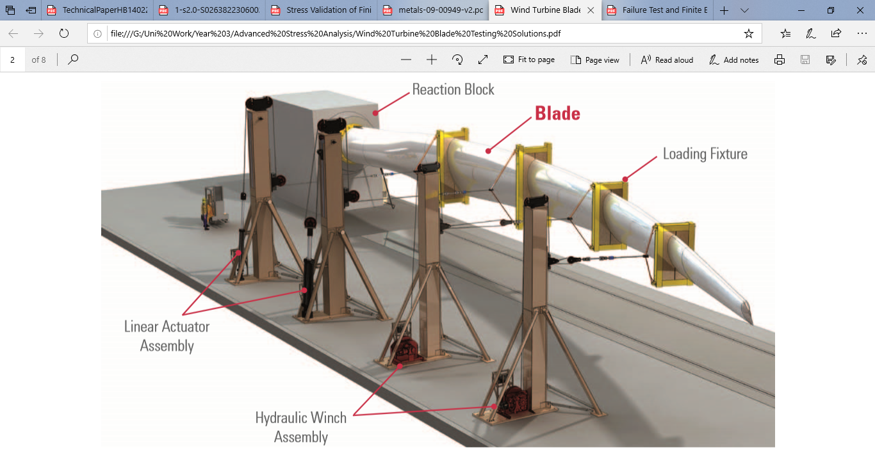
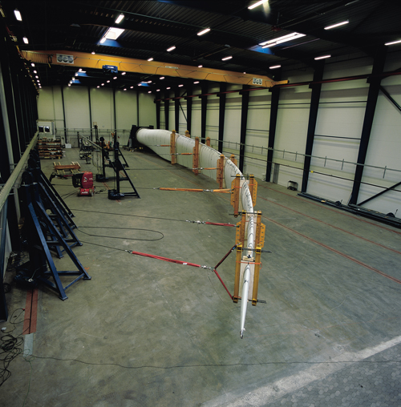
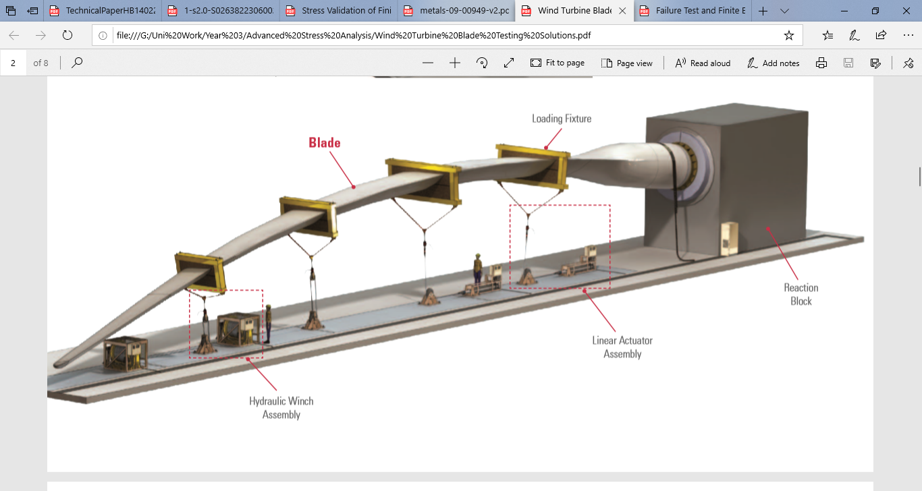
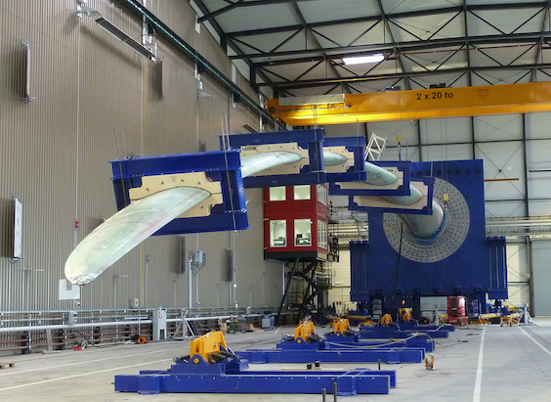
Figure 1: Typical wind turbine static test (MTS Systems Corporation, 2012; CompositesWorld, 2010)

Figure 2: Typical wind turbine dynamics test (MTS Systems Corporation, 2012; Steel, 2016)

Engineers use FEA alongside physical testing to analyse the blades structural integrity and global behaviour, for instance: eigenfrequencies, tip deflections, and global stress/strain levels (Jensen, et al., 2006). In addition, determine structural displacements, stresses and strains, and heat transfer for a given load; as well as perform non-linear buckling, modal, deformation and crash analysis (Laird, et al., 2012). This enables engineers to understand the behaviour of the blade and predict its failure characteristics and mechanisms prior to undergoing physical testing. Similarly, using FEA to replicate physical tests and verify whether results from the simulation closely or exactly relate to conventional testing results and real-world conditions. FE simulations typically predict results, for instance, global stiffness and stresses with good accuracy, due to a simple shell model used to represent global behaviour of the blade (Abraham, et al., 2016). A major benefit of using FEA is that, once the model is built and calibrated, engineers have greater control and flexibility testing the blade under actual wind conditions (Tenguria, et al., 2010).
A study was conducted by (Chen, et al., 2014), to investigate and analyse an experimental failure test of a 52.3 m long composite wind turbine blade, under static loading with help from FE simulation. The experimental setup was as follows: two sets of static bending tests performed. The first test followed full-scale test requirements for wind turbine blades according to certification bodies, and the second test was performed with intention of overloading the blade until failure. FEA was then used to complement the experiment by assisting in the post-mortem process to clarify and gain an insight into the failure of the blade, such as: failure characteristics, processes and mechanisms, through Progressive Failure Analysis (PFA) and global-local blade modelling. The final conclusion of the study showed that during the structural tests, the blade failed catastrophically due to total loss of load-bearing capacity under flap-wise bending. Major failures such as: delamination, debonding, laminate fracture, and shear web failure were located at the transition region of the blade. The tests were reconstructed in an FE simulation, where a CAD model of the blade was built, and the loading history was numerically reproduced. As a result, the complex failure characteristics observed at the transition region were competently predicted in the FE simulation, using PFA techniques and global-local modelling. The global-local modelling approach proved capable and effective in determining the failure behaviour, while reducing complications in modelling an entire blade.

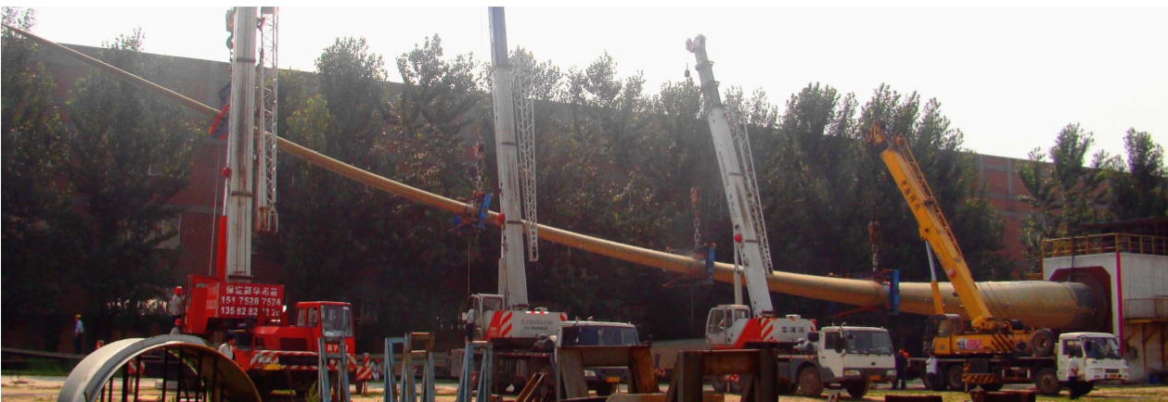
Figure 3: Blade test scene (Chen, et al., 2014)
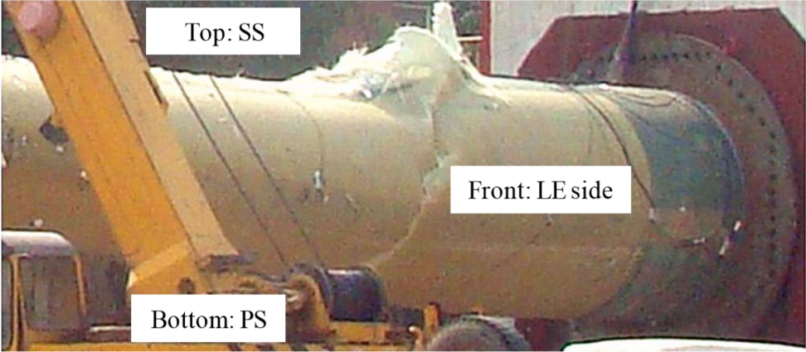
Figure 4: Final external failure of blade at transition region (Chen, et al., 2014)
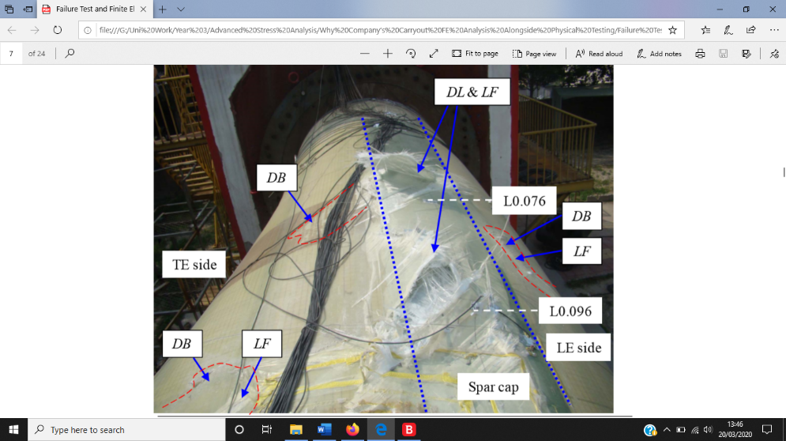
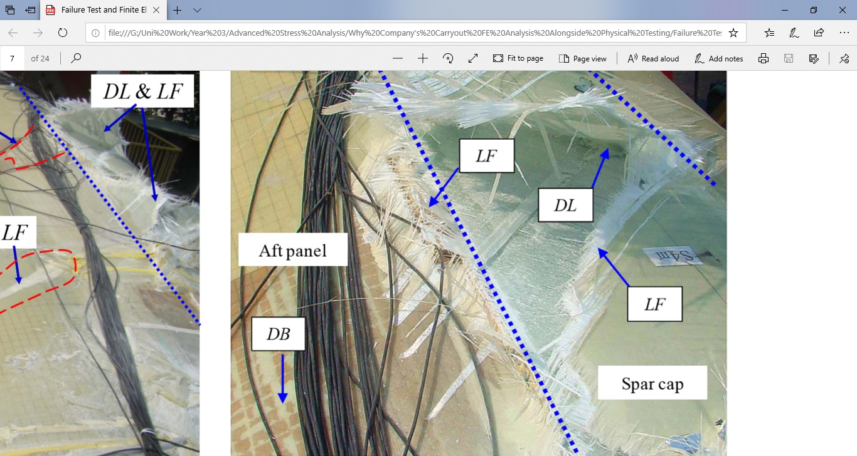
Figure 5: Failure modes detected at suction side (SS) of the blade: laminate fracture (LF), delamination (DL) & debonding (DB) (Chen, et al., 2014)

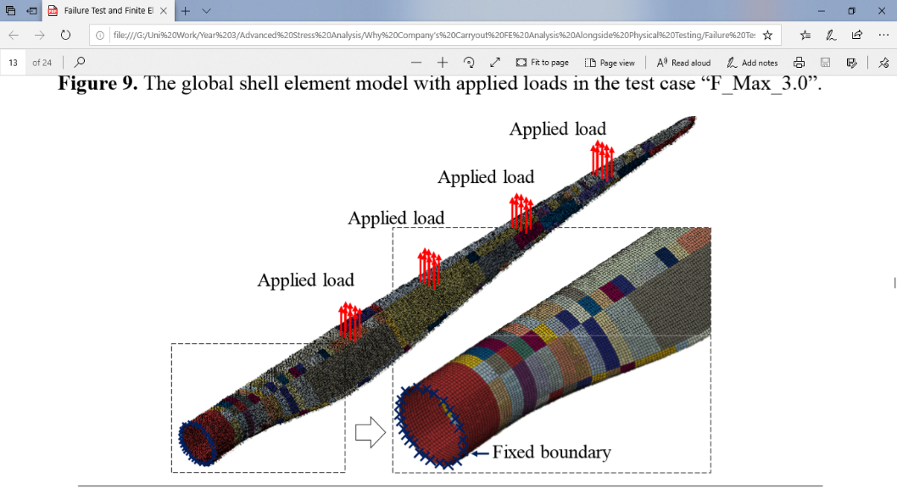
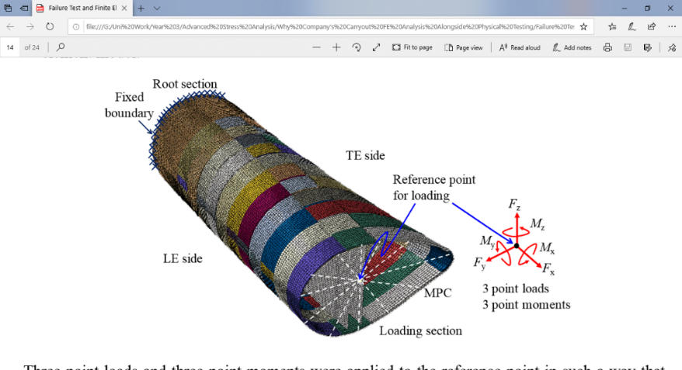
Figure 6: (LEFT): FE global shell model with applied loads; (RIGHT): Local solid model with applied loads calculated from shell element model (Chen, et al., 2014)
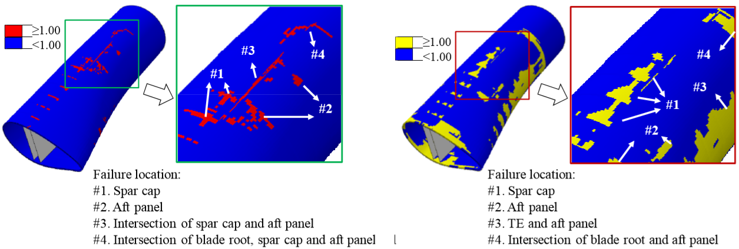
Figure 7: Final failure predicted from FE simulation. (LEFT) LF at blade shells; (RIGHT) DL and DB failure (Chen, et al., 2014)

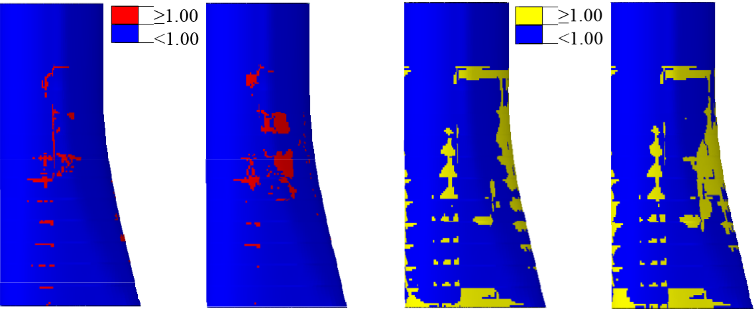
Figure 8: Effect of different material degradation on final failure prediction. (a) LF Present; (b) FL Nagesh; (c) DL&DB Present; (d) DL&DB Nagesh (Chen, et al., 2014)

How a Physical Test May Be Correlated to an FE Model?
As the need to constantly reduce cost, prototypes, experiments, along with, optimising rotor blades, FEA is becoming a standard, but essential part of today’s PDP. Motivated by lightweight designs and reducing the number of physical tests has become an ambition for manufacturers, though, to achieve this requires a balanced correlation between physical testing and FEA. Still, a correlation between these methods can be problematic due several reasons, for instance: measurement approximations, boundary conditions, combination of loads, safety factors, size and scale of blade, meshing strategies etc. In addition, irregularities with results are more likely to occur with physical testing as a result of tolerances with measuring apparatus, defective equipment, and human and random errors. Thus, these anomalies can turn the correlation into a laborious, expensive and time-consuming process (Altair Engineering, 2016).
Verification and Validation (V&V) is a procedure imposed to correlate FEA with physical testing to develop trustworthy computational models that can make engineering predictions; provide confidence in designs and reduce the time, cost, and risk associated with experimental testing. Furthermore, the V&V process enables engineers to measure uncertainties for both physical and simulation results, so the reliability and predictive accuracy of the model can be assessed and measured (Thacker, et al., 2004). Figure nine, illustrates the general procedure of V&V during model development and demonstrates how numerical simulation and physical testing correlate to develop a reliable computer model. Before beginning the procedure, a conceptual model must be agreed between experiment and simulation by considering aspects of the blade, computational objectives and degree of agreement between results. Tests conditions are then created to achieve information needed to V&V the model (Vakilzadeh, 2013).
The simulation (right) part of figure nine, is the development of mathematical models which emphasises the physics and consists of constitutive laws and conservation equations as Partial Differential Equations (PDEs) which determine boundary and initial conditions. The mathematical equations represent computer models, which are implemented using discretization methods, such as; Finite Difference (FD) or Finite Element Methods (FEM) and solved using numerical techniques. Here, verification considers the mathematics of the model and removes errors by comparing numerical solution with benchmark solutions. In addition, eliminating errors from the computer code (code verification) and measuring and reducing errors introduced by discretization, and numerical algorithms (calculation verification). Finally, a study involving different theories, for example: probability theory is conducted to analyse the influence of uncertainties introduced by the numerical algorithm, modelling strategy and other assumptions on the simulation (Babuska & Szabó, 2011).
The experimental (left) side of figure nine, is the development of a physical experiment to gather information to validate the computational model. Therefore, assumptions made on conceptual model previously should be clear during the experiment and pre-test calculations should be performed to determine effective locations for sensors. The experimental test provides evaluation data, in addition to quantifying test-to-test variation, for test samples. Uncertainty quantification is then carried out to assess the effect of measurement and construction errors, as well as, design tolerances. Once both experimental and simulation uncertainties are quantified, validation begins. Validation considers the physics of the model and establishes (to a degree) if the model accurately represents real-world conditions and expected performance. If the validation outcome is unsatisfactory: either the model or experiment will be revised and involve assessing, and possibly adjusting boundary or initial conditions, parameters or assumptions of the simulation, or alternatively, changing the test design or measurement system to improve the reliability of experiment outcome to the simulation outcome (Koutromanos, et al., 2018).

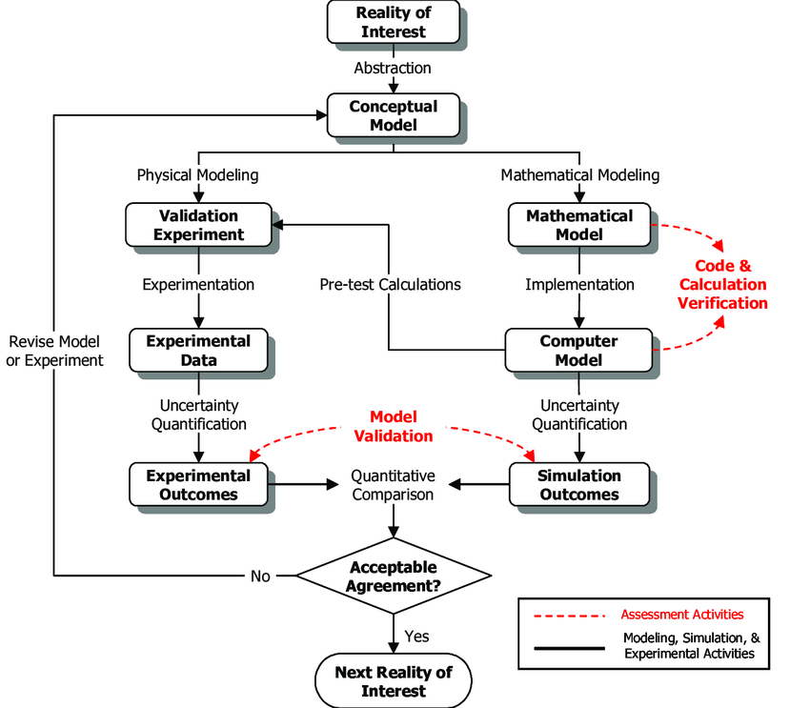
Figure 9: Detailed model flowchart of V&V process (Thacker, et al., 2004)

A study was conducted by (Babawarun, et al., 2019), they performed a structural static bending test on a 1.12 m long wind turbine blade in the flap-wise direction. The experimental setup was as follows: two load cases, a mass and an aerodynamic load were placed on the blade in order to verify if it was capable of withstanding sustained wind loads. A mass load in the form of weights were placed along sections of the blade, namely at: 350, 750 and 950 mm from blade root, followed by an aerodynamic (wind) load between 2.94 m/s and 12.75 m/s, which was applied parallel to the flap-wise direction. A CAD model of the blade was built and FEA performed to analyse the behaviour of the blade during simulated structural tests. The final conclusion of the study showed that during the structural tests, three different strains were measured, namely at: 350, 750 and 950 mm from the blade root. The results were measured and recorded during six loading, and five unloading conditions. The results gathered from the simulations were validated against experimental results and it was observed that the FEA results accurately reflected, and agreed with the physical test results, to within 5% error for two test loads cases. The third load case produced moderately higher percentage errors, below 25% of experimental results. The stress and strains identified in both the experimental and simulation results fell within 23% margin of error, and the first and second load cases presented a maximum percentage error of 5% and 1%. Therefore, representing a good correlation and validation between experiment and simulation results.

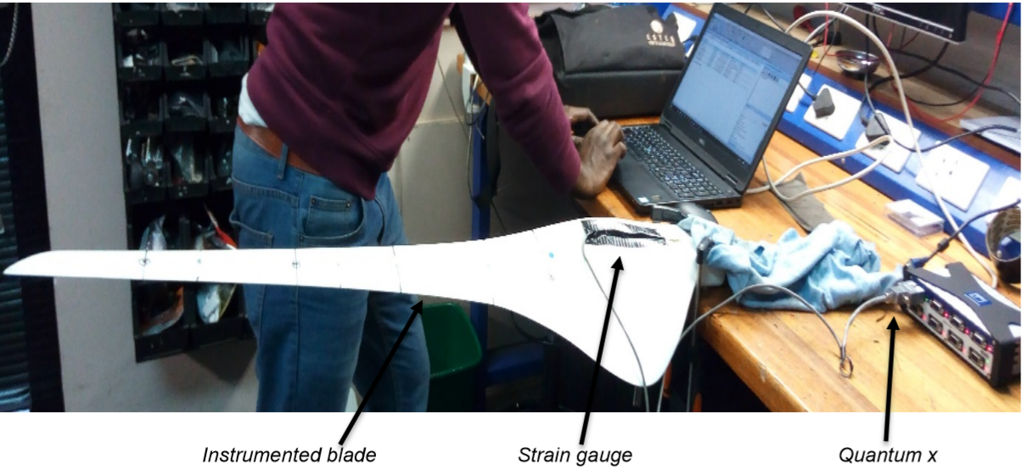
Figure 10: Experimental set-up (Babawarun, et al., 2019)
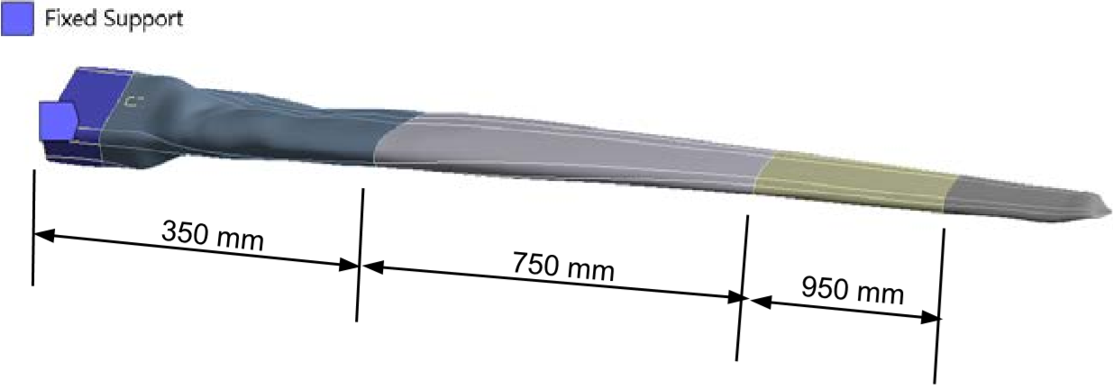
Figure 11: CAD model of blade demonstrating three test points and boundary condition (Babawarun, et al., 2019)

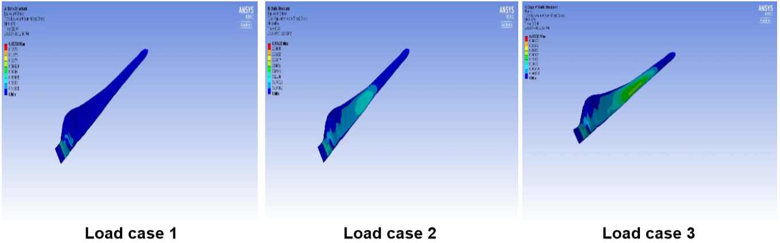
Figure 12: Three stress contour cases determined by the FE simulation
(Babawarun, et al., 2019)

Can (or should) FEA Replace Physical Testing?
FEA has advanced since its introduction in the early 1940s and today, become a critical tool in the PDP of wind turbine blades. With many benefits to offer it is an integral part of product design and enables engineers to, dramatically, bring down development time and associated costs. In addition, predict defects at early stages of design, along with providing engineers the freedom to implement innovative ideas onto FE models. With today’s technology, FEA has developed the ability of anticipating the behaviour of rotor blades with an acceptable amount competency, accuracy and reliability (Schubel & Crossley, 2012). As FEA advances further in the future, important questions remain regarding the practice of physical testing currently considered both a requirement and preferred choice among manufacturers, as well as, a means of validating stimulation results (Vyas, 2015).
- Can FEA replace physical testing in the future?
- Will FEA develop enough to understand and respond to real-world conditions accurately?
- If it is possible, what drawbacks limit FEA from becoming a requirement or a standard for product testing?
Although physical testing is an indispensable method and improves confidence in designs, it can often delay the PDP because of its close association with the design process. Nonetheless, it is mandatory and in order to certify wind turbine blades, must undergo physical testing to comply with performance requirements as stated by the IEC; in addition, demonstrate they are reliable, safe and durable. Furthermore, unbeknownst to engineers, a potential blade design may fail to meet requirements: contain defects or raise issues about manufacturability and maintainability. However, physical testing identifies these complications and presents them to engineers along with increasing confidence throughout the development process because it certifies the design and reduces risk and uncertainty. Therefore, it is crucial to product development (Tahera, et al., 2017). Despite this, physical testing is a lengthy, monotonous and costly process and delayed or undesirable results can compromise project schedules (Tahera, 2014).

The issue with physical testing is that it can be more expensive, time consuming and require a larger work force, particularly more so if the prototype fails during testing and needs to be redesigned, rebuilt and retested. Furthermore, if the blade is larger, experimental testing becomes less feasible and financial budgets can restrict engineers to a certain number of tests (King, 2017). Another significant limitation of physical testing is that the conditions of the test and equipment available are limited, whereas, FEA is more flexible and can vary loading, material and constraints over a range of alternatives at low cost. It is expensive to replicate a range of conditions with physical testing, therefore, often making it less desirable. Consequently, using FEA to design structural tests is useful, in addition, helps identify conditions that could or will cause failure and that might be overlooked in physical testing. More focus in FEA can, dramatically, reduce cost and better test the limits of rotor blades (Heisig, et al., 2010).
FEA is a suitable alternative to building and testing a physical prototype and saves time, effort and money by reducing physical tests needed, however, it does not completely eliminate the necessity for laboratory testing. There are a number of significant limitations concerning FEA and other FE tools, which affects their pre-eminence over this method, such as they cannot simulate exact physical conditions, because the method is based on mathematical approximations, numerical errors, for example, number of significant digits, rounding-off and truncation errors limit the models results: as well as, the need for ample computing power and reliable software. Consequently, these limitations can cast doubts over FEA and restrict it from completely replacing physical testing. However, what FEA will do is limit the number of prototype tests needed and provide design insight to optimize the component. Nevertheless, as technology progresses so does the capabilities of numerical simulation, which continues to improve with each new version of the software and better simulates real-world conditions (King, 2017) .

Conclusion
The aim of this study was to explore FEA and the role it plays in the PDP of wind turbine blades. In particular, how it is used alongside and correlates with, conventional testing methods during the product development cycle. Moreover, determining whether FEA and other numerical simulations will completely replace physical testing in the future.
From conducting this study, it was discovered that although FEA is not mandatory, engineers willingly use it alongside laboratory testing to validate experimental results and vice versa. It provides engineers a chance to view the behaviour and performance of the blade from a different perspective, and with technology more modern; in addition, gain an insight into opportunities for blade optimisation, which could provide a break-through for more efficient and sustainable blade designs. Furthermore, FEA is often correlated with physical testing, by means of conducting a V&V process, which enables engineers to indicate a level of predictive accuracy between the experimental and simulation tests, as well as, accurately represent real-world conditions and intended blade performance. However, although FEA is a prevalent tool, which has found acceptance among engineers in studying wind turbine blades, and many other components for that matter; questions and doubts still remain that overshadow the capability, accuracy and reliability of the method. The disadvantages that FEA can bring along with it, such as, mathematical approximations, numerical errors, computing power, unreliable software; it cannot fully replicate and simulate real-world conditions, these are factors which could have significant impact on the failure of the blade.
Therefore, laboratory testing still remains as a preferred choice among manufactures at the moment. However, as technology becomes more advanced, computational power improves and software becomes more reliable, FEA may become a more viable option and could potentially set a new standard of testing, not just for wind turbine blades but many other components.

References
Abdullah, N. A. Z., Sani, M. S. M., Rahman, M. M. & Zaman, I., 2016. Correlation of numerical and experimental analysis for dynamic behaviour of a body-in-white (BIW) structure. Cyberjaya, EDP Sciences, p. 1.
Abraham, K. P., H, S. & Tony, A., 2016. Finite Element Analysis of Wind Turbine Blade. International Journal for Research in Applied Science & Engineering, February, IV(2), p. 470.
Altair Engineering, 2016. Paper: Strain Gauge Correlation of CAE & Test Results and Analyzing the Root Cause of Any Deviation. [Online]
Available at: https://web.altair.com/strain-gauge-correlation-of-cae-test-results-and-analyzing-the-root-cause-of-any-deviation-download
[Accessed 31 March 2020].
Babawarun, T., Ngwangwa, H. & Ho, W. H., 2019. Stress validation of finite element model of a small-scale wind turbine blade. Journal of Energy in Southern Africa, 22 May, XXX(2), pp. 89 - 95.
Babuska, I. & Szabó, B., 2011. Introduction to Finite Element Analysis: Formulation, Verification and Validation. 1st ed. Chichester(West Sussex): John Wiley & Sons.
Branner, K. et al., 2017. Materials for Wind Turbine Blades: An Overview. Materials, November, X(11), p. 4.
Cecchel, S., Ferrario, D., Mega, F. & Cornacchia, G., 2019. Correlation between Numerical and Experimental Structural Resistance of a Safety Relevant Aluminum Automotive Component. Metals, 29 August, IX(9), p. 2.
Cecchel, S., Ferrario, D., Panvini, A. & Cornacchia, G., 2018. Materials and Design. Lightweight of a cross beam for commercial vehicles: Development, testing and validation, 10 April, CXLIX(1), p. 123.
Chen, X., Zhao, W., Zhao, X. L. & Xu, J. Z., 2014. Failure Test and Finite Element Simulation of a Large Wind Turbine Composite Blade under Static Loading. Energies, 10 April, VII(4), pp. 2274 - 2295.
CompositesWorld, 2010. Upsizing blade test regimes. [Online]
Available at: https://www.compositesworld.com/articles/upsizing-blade-test-regimes
[Accessed 3 December 2020].
COMSOL, 2015. Analyze Thermal Effects with the Heat Transfer Module. [Online]
Available at: https://www.comsol.com/heat-transfer-module
[Accessed 19 March 2020].
Cooper, M. C., Lambert, D. M. & Pagh, J. D., 1997. Supply Chain Management: More Than a New Name for Logistics. The International Journal of Logistics Management, VIII(1), p. 1.
Element Materials Technology, 2020. Finite Element Analysis (FEA) Services. [Online]
Available at: https://www.element.com/materials-testing-services/finite-element-analysis
[Accessed 17 March 2020].
Ferrari, A., 2009. Science and Technology for the Safeguard of Cultural Heritage in the Mediterranean Basin. Cairo, Ferrari, Angelo;, p. 389.
Freebury, G. & Musial, W., 2000. Determining equivalent damage loading for full-scale wind turbine blade fatigue tests. Reno, Office of Scientific and Technical Information (OSTI).
Gosz, M. R., 2017. Introduction. In: Finite Element Method: Applications in Solids, Structures, and Heat Transfer. Boca Raton(Florida): CRC Press, p. 1.
Hamri, O., Léon, J. C., Giannini, F. & Falcidieno, B., 2010. Computer Aided Design and Finite Element Simulation Consistency. Journal of Mechanical Engineering, LVI(11), p. 728.
Harish, A., 2020. Finite Element Method – What Is It? FEM and FEA Explained. [Online]
Available at: https://www.simscale.com/blog/2016/10/what-is-finite-element-method/
[Accessed 19 March 2020].
Heisig, P., Clarkson, J. & Vajna, S., 2010. Modelling and Management of Engineering Processes. London, Springer-Verlag London.
Jensen, F. M., Falzon, B. G., Ankersen, J. & Stang, H., 2006. Structural testing and numerical simulation of a 34 m composite wind turbine blade. Composite Structures, 12 July, LXXVI(1-2), p. 52.
King, R. H., 2017. Finite Element Analysis with SOLIDWORKS Simulation. 1st ed. Mason(Ohio): Cengage Learning.
Koutromanos, I., McClure, J. & Roy, C., 2018. Fundamentals of Finite Element Analysis: Linear Finite Element Analysis. 1st ed. Chichester(West Sussex): John Wiley & Sons.
Laird, D., Montoya, F. & Malcolm, D., 2012. Finite Element Modeling of Wind Turbine Blades. Reno, American Institute of Aeronautics and Astronautics.
Lee, D.-C. & Han, C.-S., 2008. CAE (computer aided engineering) driven durability model verification for the automotive structure development. Finite Elements in Analysis and Design, 2 December, XLV(5), p. 324.
Mahendran, M., 2007. Applications of Finite Element Analysis in Structural Engineering. Chennai, QUT.
Malhotra, P., 2010. Advanced Blade Testing Methods for Wind Turbines, Amherst: University of Massachusetts Amherst.
Marín, J. C., Barroso, A., París, F. & Cañas, J., 2008. Study of fatigue damage in wind turbine blades. Engineering Failure Analysis, 29 February, XVI(2), pp. 656-668.
MTS Systems Corporation, 2012. Wind Turbine Blade Testing Solutions. [Online]
Available at: https://www.mts.com/cs/groups/public/documents/library/dev_005130.pdf
[Accessed 19 March 2020].
Overgaard, L. C. T. & Thomsen, O. T., 2009. Structural collapse of a wind turbine blade. Part A: Static test and equivalent single layered models. Composites Part A: Applied Science and Manufacturing, 23 October, XLI(2), pp. 257-270.
Peeters, M., Santo, G., Degroote, J. & Paepegem, W. V., 2018. Comparison of Shell and Solid Finite Element Models for the Static Certification Tests of a 43m Wind Turbine Blade. Energies, 25 May, XI(6), p. 1.
Pepper, D. W. & Heinrich, J. C., 2017. Introduction. In: The Finite Element Method: Basic Concepts and Applications with MATLAB, MAPLE, and COMSOL. 3rd ed. Boca Raton(Florida): CRC Press, p. 1.
Rao, S. S., 2017. Preface. In: S. Merken & M. Nate, eds. The Finite Element Method in Engineering. 6th ed. Oxford(Oxfordshire): Butterworth-Heinemann, p. XV.
Reche, A. Y. U., Canciglieri Junior, O., Estorilio, C. C. A. & Rudek, M., 2019. Integrated product development process and green supply chain management: Contributions, limitations and applications. Journal of Cleaner Production, 25 November, CCXLIX(1), p. 1.
SAE International, 2020. Finite Element Analysis (FEA) for Design Engineers. [Online]
Available at: https://www.sae.org/learn/content/pd531241/
[Accessed 29 March 2020].
Santiago, G. et al., 2017. Application of product development process (PDP) in the construction of vertical axis wind turbine with movable blades. Vancouver, The University of British Columbia, p. 430.
Schubel, P. J. & Crossley, R. J., 2012. Wind Turbine Blade Design. Wind Turbines, 6 September, V(9), pp. 3425-3449.
Steel, W., 2016. Substructure Testing Paving the Way to Longer Wind Turbine Blades. [Online]
Available at: https://www.renewableenergyworld.com/2016/02/09/substructure-testing-paving-the-way-to-longer-blades/#gref
[Accessed 6 March 2020].
Tahera, K., 2014. The Role of Testing in Engineering Product Development Processes, Karlsruhe: The Open University.
Tahera, K., Earl, C. & Eckert, C., 2017. A Method for Improving Overlapping of Testing and Design. IEEE Transactions on Engineering Management, 13 February , LXIV(2), pp. 179 - 192.
Tenguria, N., Ahmed, S. & N D, M., 2010. Design and Finite Element Analysis of Horizontal Axis Wind Turbine blade. International Journal of Applied Engineering Research (IJAER), I(3), p. 501.
Thacker, B. H. et al., 2004. Concepts of Model Verification and Validation, Los Alamos: U.S. Department of Energy.
Thacker, B. H. et al., 2004. Concepts of Model Verification and Validation, Los Alamos: Office of Scientific and Technical Information (OSTI).
Uniscient, 2017. Basic Course On Finite Element Analysis. [Online]
Available at: http://uniscient.com/Training_FEA.html
[Accessed 30 March 2020].
Upadhyay, P., 2012. The Role of Verification and Validation in System Development Life Cycle. IOSR Journal of Computer Engineering (IOSRJCE), V(1), p. 17.
Vakilzadeh, M. K., 2013. Calibration and Reduction of Large-Scale Dynamic Models - Application to Wind Turbine Blades, Gothenburg: Chalmers University of Technology.
Veers, P. S. et al., 2003. Trends in the Design, Manufacture and Evaluation of Wind Turbine Blades. Wind Energy, 3 June, VI(3), p. 245–259.
Vyas, K., 2015. Can Simulation Tools Replace Physical Tests Completely?. [Online]
Available at: https://www.designworldonline.com/can-simulation-tools-replace-physical-tests-completely/
[Accessed 16 April 2020].
Zhang, J.-P. & Pan, L.-l., 2009. Three-dimensional modeling and aeroelastic coupling analysis for the wind turbine blade. Nanjing, Institute of Electrical and Electronics Engineers (IEEE).

Appendices

What is FEA?
The FEM is a numerical technique used to perform FEA to accurately solve complex engineering and physics problems, as well as understand and measure natural physical phenomena like structural behaviour, heat and mass transfer, fluid flow behaviour, acoustics and electromagnetism (Pepper & Heinrich, 2017). The technique has become well-established and predominant and considered the best approach in solving a diverse range of practical problems efficiently and effectively (Gosz, 2017). Furthermore, FEA has become an area of active research, not just for engineers but for scientists and mathematicians. One of the reasons for its popularity within engineering is because of its ability to solve various problems simply by changing the input data (Rao, 2017).
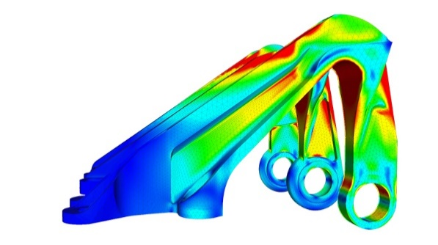
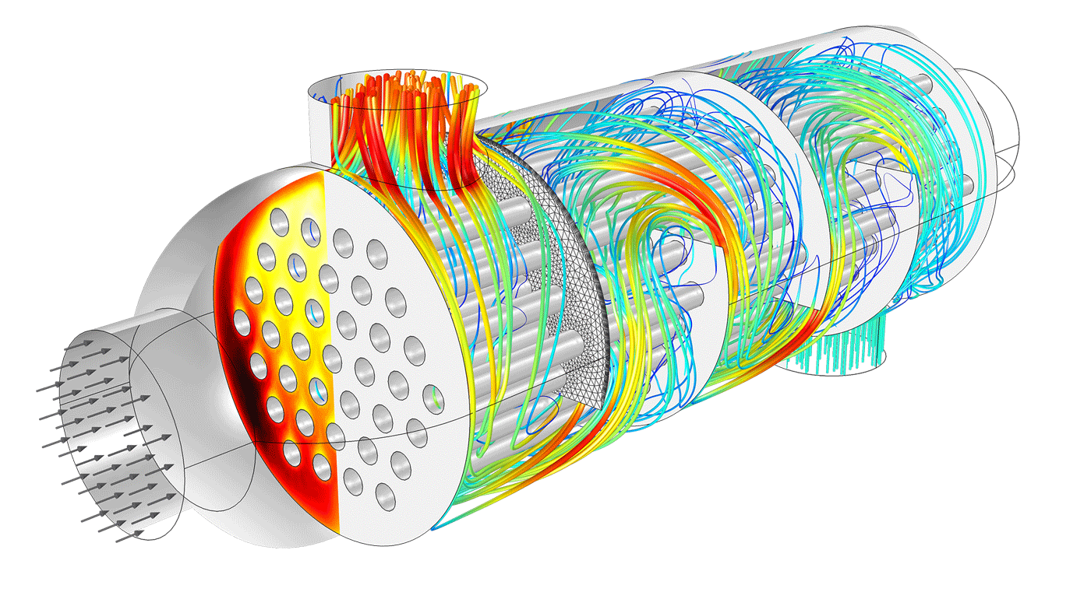
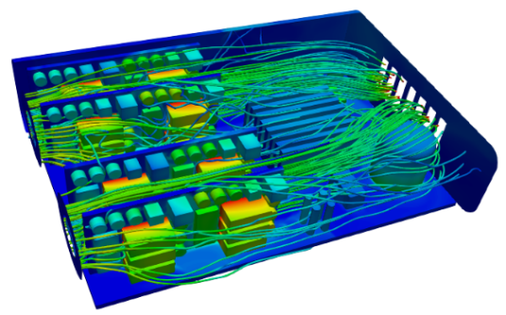
Figure 13: Applications of FEA, from left to right: aircraft’s bearing bracket, electrical cabinet and shell and tube heat exchanger (Harish, 2020) and (COMSOL, 2015).

