
Matthew Alessandro Andrew Evans 2319368
DVLA (Driver and Vehicle Licensing Agency)
August 2026
Centralising Test Data Generation to Reduce False Positives in Critical Government Document Systems
Research Proposal

Table of Contents
Figures 2
Tables 2
1. Introduction 3
1.1 System context: 3
1.2 Entity Relationship Diagram 4
2. Background to the Proposed Research 5
3. Aim & Objectives 7
4. Methodology 8
4.1 Research Methodology 8
4.1.1 Philosophy 9
4.1.2 Approach 9
4.1.3 Strategies 10
4.1.4 Risks & Limitations 11
4.1.5 Ethical Issues 12
4.1.6 Validity, Reliability & Generalisability 12
4.1.7 Data Evaluation Methods 14
4.2 Development Methodology 15
4.2.1 Software Development Methodology OR Other Relevant Major Methodology 15
5. Resources and Planning 16
5.1 Hardware Resources 16
5.2 Software Resources 16
5.5 Project Plan 17
6. Personal Reflection 20
7. References 21

Figures
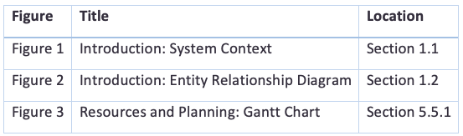

Tables
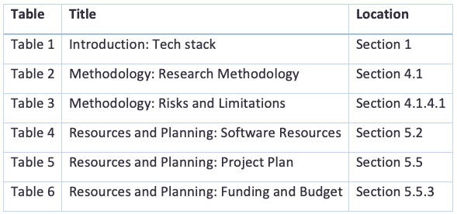
I confirm all Figures and Tables are my own work and were designed using Microsoft Word table layout and Draw.io website.

1. Introduction
The DVLA maintains records of over 50 million drivers and 40 million vehicles in Great Britain. As part of casework operations, the Drivers Medical Group alone produces approximately 200,000 letters per month across over 1,000 letter types [1]. The documents outline licensing decisions, medical fitness assessments, and legal requirements to the British public.
The Document Generation Utility (DGU) is a cloud-native system replacing legacy Word macro-based document generation. It consists of three independently deployed and tested services:
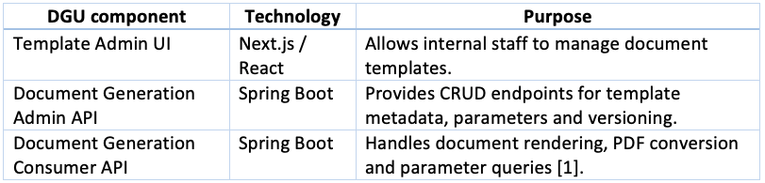
Table 1.

1.1 System context:

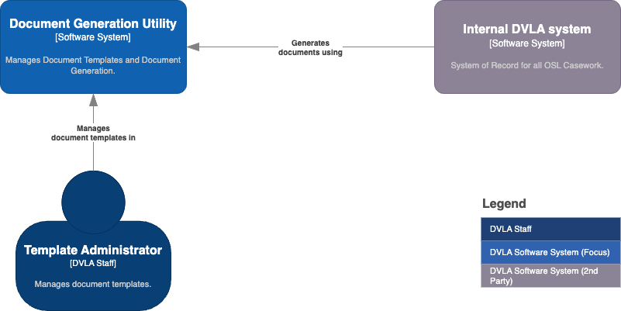
Figure 1.
The DGU domain model is hierarchical and complex. Below is the associated ERD diagram.

1.2 Entity Relationship Diagram
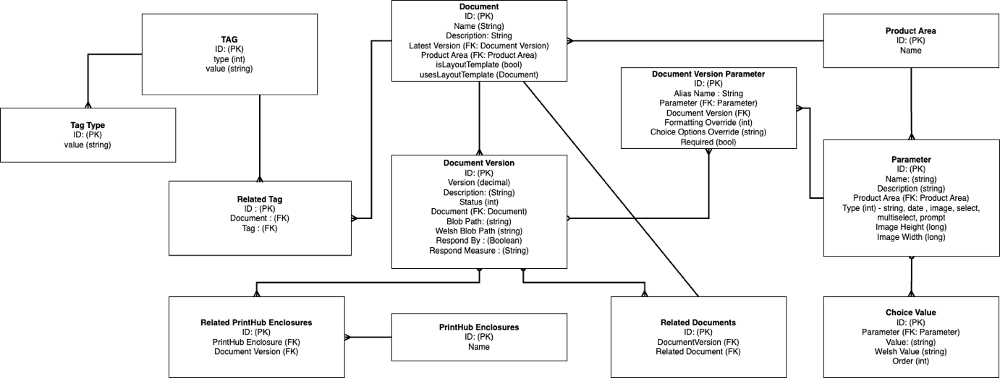
Figure 2.

As a Software Development Engineer in Test (SDET) for the Utilities team at the DVLA, I am well placed to conduct this research because I have strong knowledge of DGU. I am responsible for the automation test packs covering all three DGU components and maintain the test data generation code this project aims to improve. I have also experienced tests passing when they should have failed and understand the domain model, API contracts and data constraints.
The Utilities team maintains three independent DGU test packs, each generating its own data for similar purposes. This duplicated logic has led to inconsistencies, including data that violates domain constraints, entity relationships or realistic production scenarios. This can cause false positives, where tests pass without exercising code paths where defects may exist. In a system serving millions of people, undetected defects could result in incorrect licensing decisions or response deadlines on letters.
This project is applied research with an experimental development component, producing both a practical artefact (a Ruby gem) and empirical evidence of its effectiveness.

2. Background to the Proposed Research

Jia and Harman [4] established mutation testing as the primary measure of test suite effectiveness, defined by the ability of test to detect artificially injected faults. Their survey of over 390 studies found mutation score to be the most reliable proxy for real fault detection. However, effectiveness depends on test data exercising the system under realistic conditions. Zhu, Hall, and May [5] argue that "the choice of test data is crucial to the effectiveness of testing," noting that inadequate test inputs can make even high-coverage test suites ineffective at finding defects.
Spadini et al. [6] identified "test smells" that provide false confidence in system correctness. Relevant examples include the "mystery guest" smell, where test data is disconnected from the domain, and the "eager test" smell, where tests verify too much with little precision. Their study of 1,163 test files found a significant correlation between test smells and post-release defects. Both are worsened by inconsistent or unrealistic test data. Newman in his book Building Microservices [7] highlights that divergent test data between services sharing a domain model can leave integration defects at service boundaries undetected. He advocates contracts that test data should respect.
Meszaros author of Unit Test Patterns [8] describes the "Object Mother" pattern for test data generation, providing a single source of pre-configured test objects. The FactoryBot library by thoughtbot [2] popularised this in Ruby through a domain-specific language for defining factories. Brookes-Thomas's Faker Maker [3] extended this with integration to the Faker gem for realistic random payload generation known as factories. However, as Meszaros notes, these tools focus on single-entity generation and do not enforce cross-entity constraints or hierarchical integrity. For a domain model such as DGU, with nine interconnected entity types, conditional fields, typed constraints and referential integrity requirements, flat factories alone are insufficient.
Claessen and Hughes [9] introduced property-based testing to specify invariants across generated data, ensuring generators do not produce invalid output regardless of input combinations. Evans, author of Domain-Driven Design [10], emphasises that domain invariants must be preserved across all representations of domain objects, including test data. Freeman and Pryce, authors of Growing Object-Oriented Software [11], advocate data-builders that "make it trivial to create valid test data and difficult to create invalid data", recommending the Builder pattern for test object construction.
The Builder design pattern, described by Gamma et al. in Design Patterns: Elements of Reusable Object-Oriented Software [12], separates object construction from representation, allowing the same process to create different representations. Refactoring.Guru [13] highlights its value when objects require multiple construction steps and configurations.

Several creational patterns were considered for the gem:
- Factory Method [12]: Defines an interface for creating objects but is limited when objects have many optional or conditional fields, leading to excessive parameters or overloaded methods.
- Abstract Factory [12]: Creates families of related objects but relies on predefined configurations, limiting flexibility when overriding individual fields.
- Prototype [12]: Creates objects by cloning existing instances but risks carrying stale or unsuitable values into new test scenarios.

The Builder pattern is the strongest fit because it supports step-by-step construction through a fluent interface, allows different field combinations per invocation, and can enforce domain invariants at build time [11][12]. Freeman and Pryce [11] advocate it for test data construction, arguing that it improves readability by showing only fields relevant to each scenario. Fowler, author of Domain-Specific Languages [14], describes it as ideal when "the construction process must be separated from the representation", aligning with the need for test data to match different API contracts (Admin API versus Consumer API) while sharing the same domain model.
Existing research has not fully explored how inconsistent test data across distributed test packs affects false positive rates in production-critical systems. Most studies focus on unit testing within a single system rather than multi-service integration testing, where inconsistencies can spread across service boundaries. This research addresses this gap by measuring the impact of test data inconsistency and evaluating a centralised Builder-pattern-based gem as a possible solution.

3. Aim & Objectives
Aim: To investigate how inconsistent test data contributes to false positive test results in the DVLA Document Generation Utility, and to evaluate whether a centralised, domain-constraint-enforcing Ruby gem measurably improves test effectiveness.
Objectives:
- To audit the three existing DGU test packs, identifying and classifying all instances of inconsistent test data with a count for each category.
- To measure the false positive rate caused by inconsistent test data, expressed as a percentage of the total test suite.
- To design and build a shared Ruby gem using the Builder pattern that enforces domain rules by default, meeting DVLA Gem Standards with at least 80 percent test coverage.
- To evaluate the gem by comparing mutation scores before and after adoption, targeting at least a 5 percent improvement in defect detection.
- To produce practical recommendations for when a centralised test data approach is appropriate in multi-service systems.

4. Methodology

4.1 Research Methodology

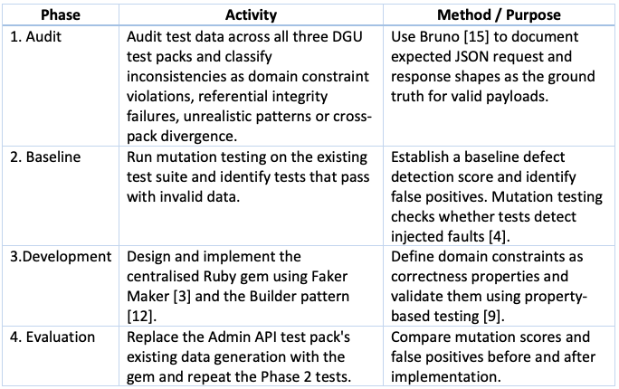
Table 2.

4.1.1 Philosophy
This research is positivist. I chose this because the data I am collecting is numerical and objective, as per the following:

- False positive rates
- Mutation scores
- Constraint coverage counts
- Lines of code

These figures can be reproduced by any researcher using the same tools and codebase, making the findings credible and defensible.
The advantage of a positivist approach is that the before-and-after design produces clear results that either support or disprove the hypothesis. I will define all success metrics before collecting data.
The disadvantage is that numbers alone cannot show how developers feel about using the tool. To address this, I will complement the measurements with informal observations of developers' experiences when adopting the gem. The study is therefore primarily quantitative with a small qualitative element, making it a mixed-methods approach. The positivist (quantitative) side covers the code audit, mutation testing, false positives and constraint coverage. The phenomenological (qualitative) side is limited to developer observations and provides supporting context.

4.1.2 Approach

This research is deductive because I already have a hypothesis based on problems I observe at work, such as inconsistent test data causing tests to pass when they should fail. I will test this hypothesis by measuring outcomes before and after introducing the Papermill gem, with results either supporting or disproving it.
The advantage of a deductive approach is that the problem and success criteria are clear from the start, making the results easier to interpret. I will define all metrics before data collection to ensure there is no ambiguity about success.
The disadvantage is that it may miss unexpected findings. If the baseline analysis reveals unexpected patterns, such as one type of inconsistency causing significantly more false positives, I will use inductive reasoning to explore them further. These findings will not form the main conclusion but may inform future research.

4.1.3 Strategies

4.1.3.1 Literature Review (Justification of research strategies)

The literature review shows that inconsistent test data can cause false positives and supports the two strategies used to investigate the problem. Jia and Harman [4] show that mutation testing is an accepted way to measure how well a test suite detects faults, supporting its use as the primary evaluation method.
Freeman and Pryce [11] and Gamma et al. [12] establish the Builder pattern as a suitable approach for creating valid test objects, supporting software development as the intervention. A case study was rejected because the research requires active change rather than passive observation. Action research was also rejected because the project aims to produce a measurable outcome rather than an ongoing cycle of reflection.

4.1.3.2 Strategy 1 – Software Development

Software development is used to build the Papermill gem, which is the intervention being evaluated. Without a working tool, there is nothing to test the hypothesis against. The gem has clearly defined features that can be built and tested incrementally using Feature Driven Development, making this strategy a practical fit for a single-developer project.

4.1.3.3 Strategy 2 – Experiment

An experiment is used to measure whether the intervention works. The same test suite is run against the same source code before and after adopting the gem, and the mutation scores and false positive rates are compared. This produces clear numerical evidence of cause and effect, which directly answers the research question.

4.1.4 Risks & Limitations

4.1.4.1 Risks

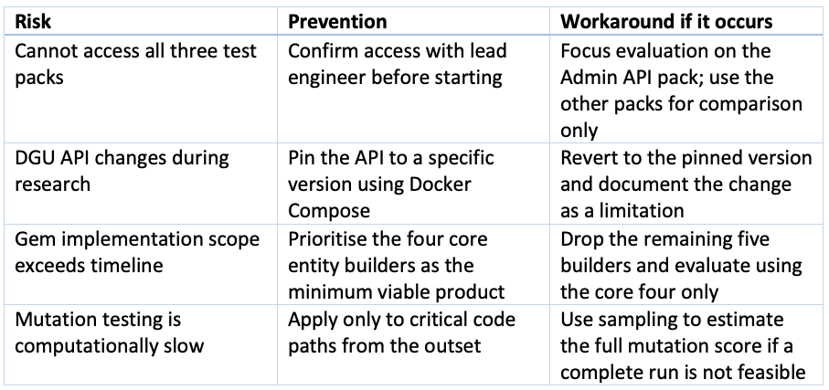
Table 3.

4.1.4.2 Limitations

This study examines one system at one organisation, so the findings may not apply elsewhere. As I wrote the test packs being evaluated, there is also a risk of bias when assessing my own work. I will reduce this by using automated measurements rather than personal judgement. Improvements in scores may also result from test clean-up rather than the gem itself. To control for this, I will measure constraint enforcement separately, as this can only come from the gem.

4.1.5 Ethical Issues

There are no significant ethical concerns. No participants are involved, so there is no risk of physical or mental harm, and no personal data is collected.
The main risk is reputational, as the research evaluates existing DVLA test code, some of which I wrote. Findings will be presented as opportunities for improvement rather than criticism. All assessments will use objective automated measurements rather than opinion. The dissertation will also be reviewed by the lead engineer before submission to ensure no confidential or damaging information is disclosed.
All work will take place in isolated test environments and will not affect live DVLA systems.

4.1.6 Validity, Reliability & Generalisability

4.1.6.1 Validity
I believe this is a good way to investigate the problem. Mutation testing is an established, objective measure of how well a test suite detects faults [4], and it has been used in academic research for this purpose for decades. False positives are identified using a clear, repeatable definition: a test that passes with invalid data but fails when the data is corrected. Every measurement in this study is numerical and tool-generated, so it reflects the actual behaviour of the code rather than the researcher's opinion.

4.1.6.2 Reliability

A different researcher would likely get the same results. All measurements come from automated tools run against fixed source code. The code audit uses a defined taxonomy of inconsistency categories, so any researcher following the same checklist on the same files would find the same issues. The mutation testing tool produces the same score for the same code every time it runs. There is no subjective judgement involved in the primary data, which makes the results highly reproducible.

4.1.6.3 Generalisability

The findings apply to any software system where multiple test packs independently generate data for a shared domain model, and where defects have a significant impact on users. This pattern is common in government digital services, financial systems, and healthcare platforms. The specific tool built (the Papermill gem) is DVLA-specific, but the principles, the inconsistency taxonomy, and the measurement approach can be applied to similar problems in other organisations.

4.1.7 Data Evaluation Methods

4.1.7.1 Data Collection

Five types of data will be collected:
- Inconsistency counts: the number of test data issues found in each test pack, grouped by category (for example, invalid parameter types, missing foreign keys)
- False positive identification: for each inconsistency found, a binary result showing whether correcting the test data causes the test to fail
- Mutation scores: the percentage of injected faults detected by the test suite, measured before and after adopting the gem
- Constraint coverage: a count of how many domain rules are enforced by the test data generation, before and after
- Lines of code: the amount of test data generation code in each test pack, before and after
All data is collected automatically using code analysis tools and the mutation testing tool. No surveys or human participants are needed.
The minimum data needed is a complete audit of the Admin API test pack with mutation scores measured before and after. If the other two test packs cannot be accessed, they will be left out and noted as a limitation. Any mutation results that fail to compile or time out will be removed before analysis.

4.1.7.2 Data Evaluation

The main analysis is a paired comparison of mutation scores before and after adopting the gem. Practical significance is defined as at least a 5 percent improvement. Results will be presented as bar charts showing before and after scores, tables showing inconsistency counts by category, and a constraint coverage summary showing which rules are enforced under each approach.

The experimental hypotheses are:

- H0: There is no significant difference in mutation score between the current approach and the gem
- Ha: The gem produces a significantly higher mutation score

4.2 Development Methodology

I will use Feature Driven Development (FDD) to build the Papermill gem. FDD suits this project because each entity builder is a clearly defined feature that can be built, tested, and released independently. I will work through the feature list one builder at a time, running the full test suite after each one is complete.

I will also use property-based testing to verify that the gem never produces invalid data, regardless of what overrides are passed in. This gives stronger confidence than testing with fixed examples alone.

4.2.1 Software Development Methodology OR Other Relevant Major Methodology
Feature Driven Development based on practices in book A Practical Guide to Feature-Driven Development [17] is used because it is an Agile approach designed for small single-developer projects with well-defined features. Each entity builder in the gem is a self-contained feature with clear inputs, outputs, and acceptance criteria. FDD allows me to deliver working features incrementally and adjust scope if the timeline becomes tight, dropping lower-priority builders without affecting the core functionality that the evaluation depends on.

5. Resources and Planning

5.1 Hardware Resources
A standard macOS development workstation issued by DVLA, with Docker Desktop and internal AWS credentials for running DGU services locally. I will use RubyMine by JetBrains as the IDE. I will also install relevant plugins, such as MongoDB support.

5.2 Software Resources

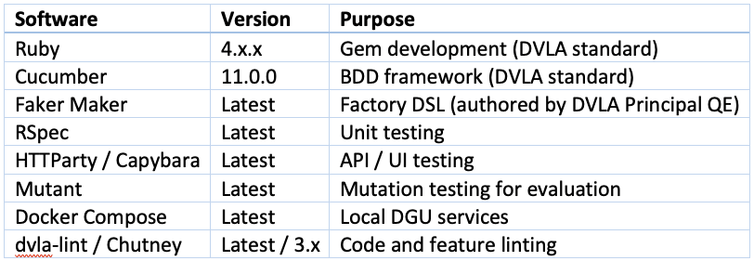
Table 4.

5.5 Project Plan
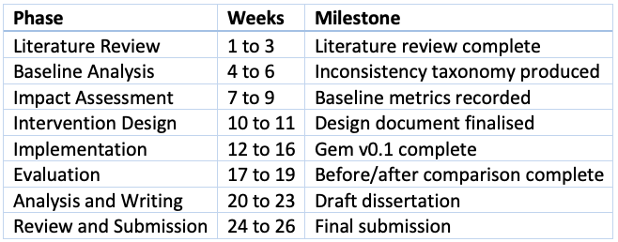
Table 5.

Milestones: Interim Viva (Week 12), Report Submission (Week 24), Final Viva (Week 26). Each phase is timeboxed with approximately 20 percent contingency buffer.

5.5.1 - Gantt Chart
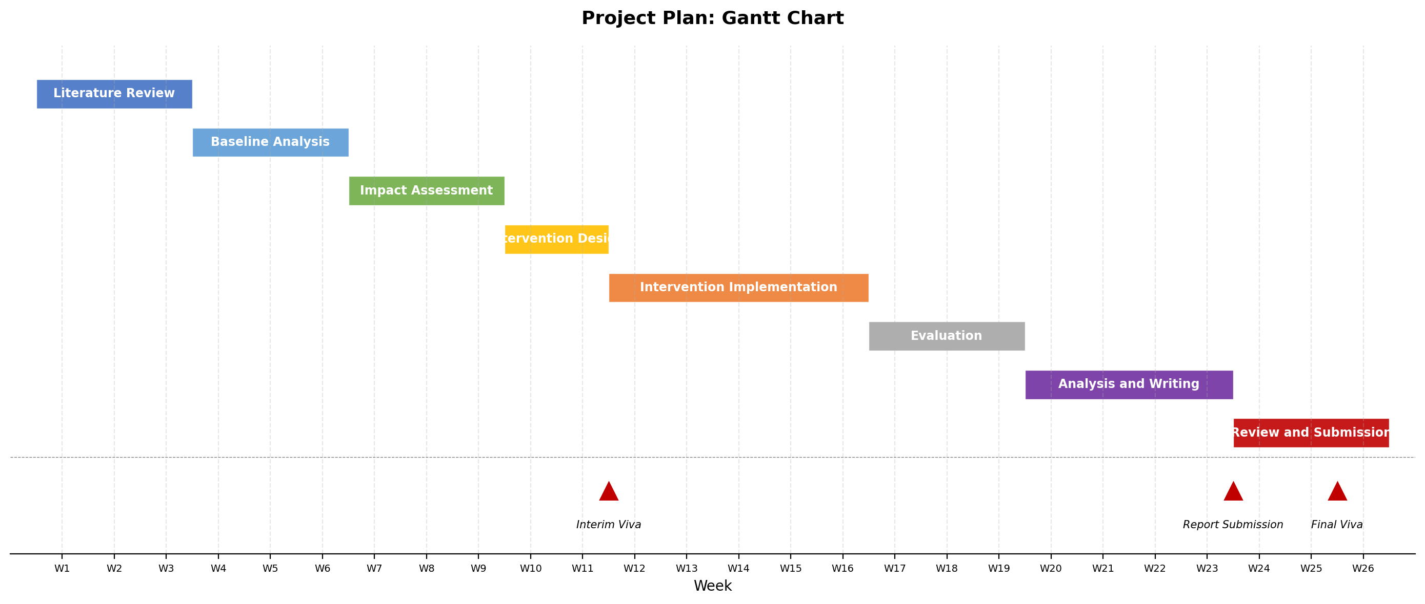
Figure 3.
Milestones:
- ▲ IV (Week 12): Interim Viva
- ▲ RS (Week 24): Report Submission
- ▲ FV (Week 26): Final Viva

5.5.2 - MoSCow Prioritisation

The following MoSCoW prioritisation defines the minimum viable project and optional extensions:
Must have (essential for success):
- Baseline audit of the Admin API test pack with inconsistency taxonomy
- Gem implementing Builder pattern for core entities (ProductArea, Document, DocumentVersion, Parameter)
- Before-and-after mutation score measurement
- Written dissertation with findings
Should have (important but not critical):
- Full 9-entity builder coverage
- Property-based tests for all correctness properties
- Baseline audit extended to Consumer API test pack
Could have (optional enhancements):
- Integration with all three test packs
- Informal developer feedback on gem usability
- Constraint coverage heatmap visualisation
Won't have (excluded from scope):
- Public open-source release of the gem
- UI-level test data generation via Capybara
- Automated deployment to production test environments

With the resources, tooling, and timeline now established, the following section provides the full reference list for all sources cited throughout this proposal.

5.5.3 Funding and Budget
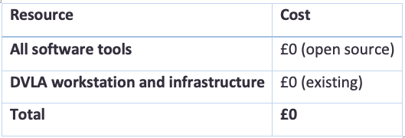
Table 6.

5.5.4 Success Criteria
- Taxonomy of inconsistency categories produced with frequency counts
- Gem implemented to DVLA standards with minimum 80 percent coverage
- Measurable improvement of at least 5 percent in mutation score
- Dissertation completed and submitted on time

6. Personal Reflection
Working on this proposal has linked my day-to-day engineering work with academic research. I have experienced the frustration of inconsistent test data firsthand, including tests passing in CI when they should fail. Framing this as a research question has given me a structured approach to solving a real problem and introduced me to new ways of working.
I feel confident tackling this as my final year project because it directly relates to my professional role. I have access to the necessary systems and support from the Principal QE, lead engineer and colleagues. The main challenge will be controlling the scope through disciplined MoSCoW prioritisation. I also recognise that academic writing differs from writing code, so I will need to improve my skills in presenting quantitative findings and drawing valid conclusions from data.

7. References

[1] DVLA Casework Engineering, "Document Generation Utility: System Design Document," Internal technical document, DVLA, Swansea, UK, 2024. (Access restricted to DVLA intranet).
[2] thoughtbot, "FactoryBot," GitHub. [Online]. Available: https://github.com/thoughtbot/factory_bot. [Accessed: Jun. 2025].
[3] N. Brookes-Thomas, "Faker Maker," GitHub. [Online]. Available: https://github.com/BillyRuffian/faker_maker. [Accessed: Jun. 2025].
[4] Y. Jia and M. Harman, "An analysis and survey of the development of mutation testing," IEEE Trans. Softw. Eng., vol. 37, no. 5, pp. 649–678, Sep./Oct. 2011.
[5] H. Zhu, P. A. V. Hall, and J. H. R. May, "Software unit test coverage and adequacy," ACM Comput. Surv., vol. 29, no. 4, pp. 366–427, Dec. 1997.
[6] D. Spadini, F. Palomba, A. Zaidman, M. Bruntink, and A. Bacchelli, "On the relation of test smells to software code quality," in Proc. IEEE Int. Conf. Software Maintenance and Evolution (ICSME), 2018, pp. 1–12.
[7] S. Newman, Building Microservices: Designing Fine-Grained Systems, 2nd ed. Sebastopol, CA, USA: O'Reilly Media, 2021.
[8] G. Meszaros, xUnit Test Patterns: Refactoring Test Code. Boston, MA, USA: Addison-Wesley, 2007.
[9] K. Claessen and J. Hughes, "QuickCheck: A lightweight tool for random testing of Haskell programs," in Proc. 5th ACM SIGPLAN Int. Conf. Functional Programming (ICFP '00), 2000, pp. 268–279.
[10] E. Evans, Domain-Driven Design: Tackling Complexity in the Heart of Software. Boston, MA, USA: Addison-Wesley, 2003.
[11] S. Freeman and N. Pryce, Growing Object-Oriented Software, Guided by Tests. Boston, MA, USA: Addison-Wesley, 2009.
[12] E. Gamma, R. Helm, R. Johnson, and J. Vlissides, Design Patterns: Elements of Reusable Object-Oriented Software. Reading, MA, USA: Addison-Wesley, 1994.
[13] Refactoring.Guru, "Builder," Design Patterns. [Online]. Available: https://refactoring.guru/design-patterns/builder. [Accessed: Jun. 2025].
[14] M. Fowler, Domain-Specific Languages. Boston, MA, USA: Addison-Wesley, 2010.
[15] Bruno, "Bruno: Open-source API client," GitHub. [Online]. Available: https://github.com/usebruno/bruno. [Accessed: Jun. 2025].
[16] DVLA Quality Engineering, "Gem Standards," Internal standards document, DVLA, Swansea, UK, 2024. (Access restricted to DVLA intranet).
[17] S. R. Palmer and J. M. Felsing, A Practical Guide to Feature-Driven Development. Upper Saddle River, NJ, USA: Prentice Hall, 2002.
[18] Q. Luo, F. Hariri, L. Eloussi, and D. Marinov, "An empirical analysis of flaky tests," in Proc. 22nd ACM SIGSOFT Int. Symp. Foundations of Software Engineering (FSE '14), 2014, pp. 643–653.
[Figures] All figures are my own designs.
[Tables] All tables are my own designs.

