FORGOTTEN RELGIONS OF NIGERIA

With a population of 218 million people Nigeria is a country with diverse people and cultures. Over half the population are Muslim, 46% are Christian, and the remaining are labelled as ‘Traditional African Religions’. But what exactly are Traditional African Religions? In a 2015 interview Jacob Olupona defined TAR (Traditional African Religions) as
indigenous or native religious beliefs of the African people before the Christian and Islamic colonisation of Africa. Indigenous African religions are informed by one’s ethnic identity, and where one’s family came from in Africa.
Before the colonisation of Nigeria there were many major ethnic groups, some were Hausa, Yoruba, Fulani, Igbo and Tiv. However, in the 11th century, Islam was brought by traveling merchants and immigrants from North Africa and became the dominant religion in many african kingdoms and communities forgot their traditional ways. Later in the 14th century Christianity was pushed into Nigeria due to the slave trade forcing people to convert to their ways. Because of this, over the years many african cultures have died out and been forgotten. This essay shall focus on the two remaining indigenous ethnic groups still alive in Nigeria today –Yoruba and Igbo.

Yorubaland is the homeland of the Yoruba people and is one of the largest ethnic groups in Africa. The Yoruba traditional religion, strongly believes in one supreme God, Olodumare. All-knowing, all-powerful, genderless, and eternal, Olodumare is the supreme ruler of the heavens, and the source of all creation, virtue, and knowledge. There are no images, art, or shrines of Olodumare, and no sacrifices are made in their name, this is because Olodumare is not directly worshipped. Olodumare is a colossal force who does not interfere with human affairs, but instead acts through The Orishas (Olodumare’s sons and daughters).
There are over 400 Orishas to worship, so each family will have an Orisha they feel most connected to. The most worshiped Orisha are: Oduduwa, the divine king, leader, and father of the Yoruba race. An omnipotent being and the creator of physical reality. Shango is the most powerful and feared of all the gods. He controls thunder, lightning and justice and has a mighty axe used to bring prosperity and wealth to people. In addition, he has the ability to strike down thunder and lightning on those who offend him. Shango is an example of a real historical king who was important and impactful enough to become an Orisha upon death. Ayangalu was the first drummer from Yorubaland. He was so good at his art people began deifying him upon death. It is seen as a great honour to possess drumming skills in Yorubaland as it means Ayangalu himself has deemed you worthy. Oshun is the Goddess of fertility, beauty, love, and divinity and can predict people’s destiny. She is the only one allowed to directly communicate with Olodumare. These are just a fraction of the very rich and diverse array of Orishas the Yoruba worship, the exact number of Orishas is unknown, many Yoruba proclaim, ‘as many as you can think of, plus one more’. The quantity is thought to be sacred and innumerable.

The Yoruba creation story has multiple different variations, all slightly differing in detail, the 2 most accepted and followed are centred primarily around Olodumare. Olodumare sent Obatala on a mission to create something big and beautiful. Obatala accepted and came up with a plan. He forged a gold chain and descended from the heavens upon it holding nothing but a snail shell full of sand, a palm nut, and a chicken. Some say it was actually a leaf with loose earth, a white hen and pigeon. He poured the sand out the snail shell creating a pile and through the chicken down which landed atop the sand. The chicken then began to spread the sand around, creating the continents. Obatala proceeded to place the palm nut into the sand and soon the continents were covered in vegetation. Looking around and feeling like his job was complete, Obatala got drunk on palm wine. After a few days he began to feel lonely, so he moulded figurines out of clay, then pleaded
Hear me, Olorun, you are like a father to me. I have created figures out of clay, but only you can breathe life into them and make them into living people. I ask you to do this so that I can have human companions in life.
these then became the first humans on earth.
Some say that Obatala’s attempt in creating human life was unsuccessful, but instead Olodumare Himself went on to create the first human being, Oreluere, in heaven who climbed down the chain to greet Obatala. Olodumare felt as though Obatala job was incomplete, so he sent Oduduwa down from heaven to finish creating earth. It only took Oduduwa four days to complete his task therefore the Yoruba calendar has only a four-day week and Oduduwa is seen as the father of the Yoruba people.

Known for their rich culture and traditions, the Yoruba people often celebrate through festivals, these are a time for people to come together and enjoy food, music, dancing, and other cultural activities. Some of these festivals are: The Osun festival, a two week-long festival held in West Nigeria in celebration of the river goddess Oshun (the Goddess of fertility). During this time, participants re-affirm their allegiance to the King, and offer sacrifices and prayers to the deity. A cleanse of evil, called ‘Iwopopo’, is led by the King through the streets on the first day of the festival. After the cleansing the Ina Ouju Merindinlogun ritual can begin. This is the lighting of a 16-burner lamp by the King admits drumming, singing, and dancing. This ritual symbolically serves to rekindle the bond between the deity and the people. However, the major highlight is the carrying of the Calabash (a fruit) across town by a voluntary female virgin. The fruit contains sacrifices intended to be made in the virgins’ honour as offerings to the Osun goddess. As she walks to the river, the people see her as a representative of the Goddess and cast their prayers and problems upon her.
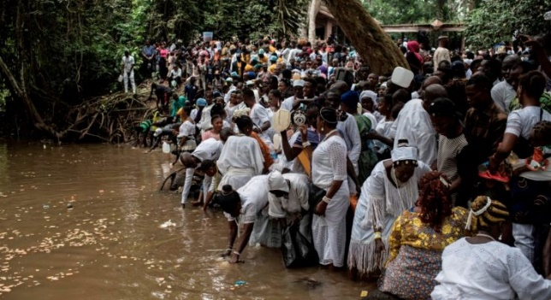
Here, in Figure 1, you can see the Yoruba people at the Osun River honouring the Goddess.

Figure 1

Another festival celebrated is The Gelede festival which is dedicated to the Gelede masquerades who represent powerful female deities and ancestral spirits. During this festival vibrant art is displayed and music, dance and theatre is performed along with drumming and singing. Colourful costumes and masks depicting animals, spirits or historical figures are worn. The main purpose of this celebration is to educate the community, conveying moral lessons, historical narratives, and social critiques. The key aspect of the event is recognising and celebrating women’s roles and contributions in Yoruba society.
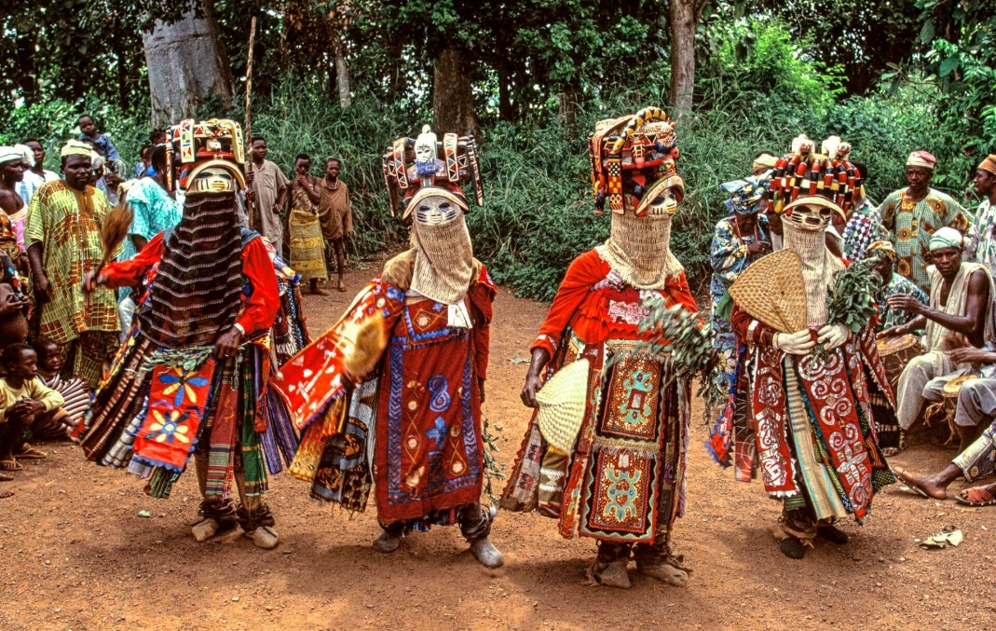
Here in Figure 2, you can see the Gelede Masquerades depicting animals and ancestors.

Figure 2

These are just a few of the many Yoruba festivals that are celebrated throughout the year. Yoruba festivals are a time for people to come together and celebrate their culture and tradition. They are also a time to honour the Yoruba Gods and Goddesses and to celebrate the Yoruba way of life.

The origins of the Igbo are shrouded in myths and legends but oral traditional and arkeological evidence have shown us many things about the culture. Like Yoruba, the Igbo people believe in one supreme being, Chukwu. He is all-powerful and the creator of heaven, earth, and everything within. Chukwu also does not intervene in minor human matters, like Oludumare, so Igbo people will pray to his Alusi (deities) instead. Each Alusi represents unique aspects of the human experience and has specific powers and responsibilities. The main Alusi worshiped in Igbo religion are Ala, who is the earth goddess. She represents fertility and the abundance of land. She helps in the sustaining of life and ensuring the well-being of humanity. Igbo pray to Ala if they seek agricultural prosperity and harmony with nature. Amodiaha is the most powerful Alusi, representing thunder and lighting, he is believed to be able to control the forces of nature, particularly storms and is often called upon when in need of protection and justice. Ikenga is a very important God for the Igbo people, as he is the God of personal power. Ikenga helps every Igbo fulfil and reach their individual achievements, bringing great success and empowerment. Anyawu is the divine sun goddess. Symbolising warmth, light, and vitality she is regarded as a source of life and energy, and she is often called upon when nurturing and healing qualities are needed. These are just some of the many divine beings that the Igbo people attribute to the harmony and success of their daily endeavours and their community.

The Igbos creation story describes how Chukwu established the order and harmony of the world. The Gods and Goddesses lived in peace and harmony in the heavens until jealousy and greed infiltrated their minds. To solve this problem, Chukwu came up with a plan to divide the heavens into equal parts, with each God and Goddess having a domain of their own. Igwe and Ala were given the domain of earth and sky, and these were the ones who formed mankind. They created eight people, four male, four female. They taught mankind the act of procreation, birth, childhood, adulthood, parenthood, and ancestor-hood. The original eight humans created were pure in body and spirit, but when they started to have children, each human had different traits, and soon jealousy and greed started to grow. The Igbo community, which was the beauty of the gods began falling apart. The original eight were not affected, for they were too pure. Because they were seen as the wisest in the Igbo society all the people held a meeting overseen by them in which the original humans formed a master plan. Their plan called for each of the original eight to create a ritual to restore people to the purity and values of society. Each created a ritual to restore to society the value that they represented. After that, the original humans returned to live with Igwe and Ala and from there they became the messengers between the people of earth and the spiritual world.

Again, like the Yoruba, Igbo people have many festivals annually. Each tribe has its own cultural traditions and music is the main ingredient to their celebrations: Igbos’ most famous celebration is known as the New Yam Festival, hosted in South-Eastern Nigeria. It is an age long celebration, dating back to the beginning of Igbo culture and it helps bring together the individual communities as they are all dependent on Yam. People will present newly harvested yams to Chukwu and the ancestors of the land, thanking them for sustaining the life of the farmers through a successful planting season.
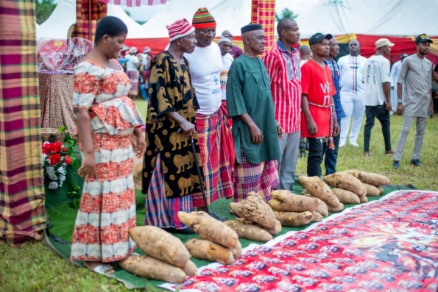
Here in Figure 3, you can see the Igbo farmers presenting their newly grown yams to Chukwu and the ancestors. They will grow many but select onlu a few to offer. They will then wash and present them on fresh carpets as to not dirty them.

Figure 3

The Ofala festival is a two-day celebration in October after the king has finished a retreat called ‘Inye Ukwu na Nlo’. This is where he undergoes spiritual purification for the good of the community. The king emerges during Ofala to bless his subjects and say prayers for the community acting as a rite of renewal for the king.
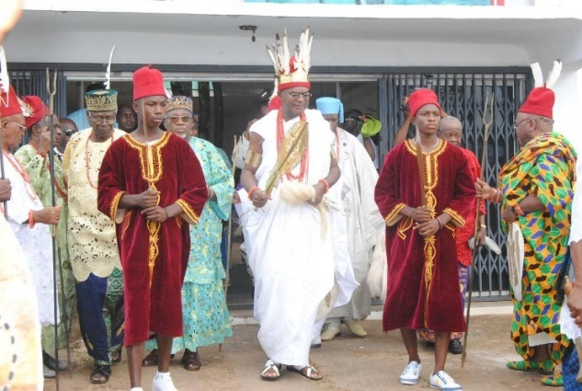
Here in Figure 4, you can see the king emerging with his cabinet after his spiritual purification.

Figure 4

The most anticipated festival is the Iwa Akwa Festival. This only happens once every 3 years and it is directed to the young men who have come of age. Here they are initiated into manhood and given opportunities to make their contributions in social, cultural, and political affairs for the community.
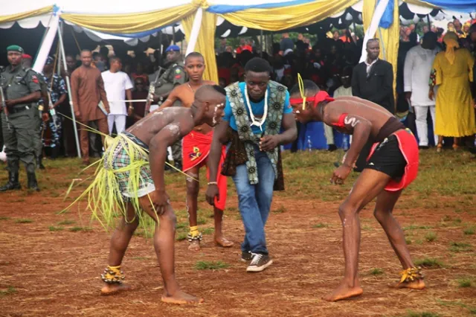
In Figure 5, you can see two young men wrestling to prove their worth to the community.

Figure 5

In conclusion this essay has discussed the remaining major ethnic groups in Nigeria. Although few cultural religions remain, many are still followed worldwide. Traditional African Religions like Yoruba and Igbo are not only important to the people as their own identity but are also a very important part of our own world history. It is important to acknowledge and celebrate TAR’s not only for the people now, but also for future generations to be able to learn their own religious heritage.

Bibliography

Arogbonlo, Israel, Osun Festival: Amazing Facts About ‘Arugba’, The Calabash-Carrying Votary Virgin (2023) <https://tribuneonlineng.com/osun-festival-amazing-facts-about-arugba-the-calabash-carrying-votary-virgin/> [accessed 7 January 2024]

Chiorazzi, Anthony, The Spirituality Of Africa (Massachusetts, 2015)

Cogito, Who Are The Yoruba People? [video]. 2022 <https://youtu.be/h3TDrwQgkEE?si=ZXQUmdHE-MLIFTTf> [accessed 1 January 2024]

Erskine, Noel Leo, The Memory Of Africa, (Oxford Academic, 2014), p. 34

Fourhundredandone, + Orishas (2022) <https://www.fourhundredandone.com/orishas> [accessed 7 January 2024]

Hellovaia, Hausa Kingdom (n.d.) <https://www.hellovaia.com/explanations/history/modern-world-history/hausa-kingdom/> [accessed 9 January 2024]

InlandTown Editor, The Story Of Creation According To Igbo Mythology (2022) <https://www.inlandtown.com/the-story-of-creation-according-to-igbo-mythology/> [accessed 6 January 2024]

McKinnon, Andrew, ‘Christians, Muslims And Traditional Worshippers In Nigeria: Estimating The Relative Proportions From Eleven Nationally Representative Social Surveys.’ Review of Religious Research, 63 (2021), 303-315 (p. 304)

n.n, Our Travel And Tour [Blog] <https://outravelandtour.com/2017-ofala-festival/#google_vignette> (2017) [accessed 9 January 2024]

n.n, The Osun Osogbo Festival [Article]. <https://fatherlandgazette.com/the-osun-osogbo-festival/> (2022) [accessed 9 January 2024]

n.n, Yoruba Creation Myth, (n.d.) p. 4

Old World Gods, Exploring Igbo Mythology Gods And Goddesses: Divine Tales From Nigeria’s Rich Culture (2023) <https://oldworldgods.com/other/igbo-mythology-gods-and-goddesses/> [accessed 7 January 2024]

Omordia, Rebeca, ‘African Classical Music And The African Concert Series’, (2019) p. 4. <https://www.proquest.com/docview/2305787683/fulltextPDF/F4DFE15F362A48FEPQ/1?accountid=130472&sourcetype=Magazines> [accessed 9 January 2024]

Oschmann, Stefan: Forest Masquerade [Online Museum]. <https://africaonlinemuseum.org/map/benin/gelede-masks/photos/ > (n.d.) [accessed 9 January 2024]

Polyglot Wiki, Language/Yoruba/Culture/Traditional-Festivals (2023) <https://polyglotclub.com/wiki/Language/Yoruba/Culture/Traditional-Festivals#google_vignette> [accessed 9 January 2024]

Solomon, Everything You Need to Know About The Osun-Osogbo Festival (2016) <https://hotels.ng/travel/everything-you-need-to-know-about-the-osun-osogbo-festival/> [accessed 2 January 2024]

Ukandu, Stephen, Cultural Display As Igbere Community Celebrates New Yam Festival [Article] <https://ikengaonline.com/2022/09/24/cultural-display-as-igbere-community-celebrates-new-yam-festival/> (2022) [accessed 9 January 2024]

World History Edu, 12 Most Popular Yoruba Gods And Goddesses <https://www.worldhistoryedu.com/12-most-popular-yoruba-gods-and-goddesses/> [accessed 1 January 2024]

Andrew McKinnon, ‘Christians, Muslims And Traditional Worshippers In Nigeria: Estimating The Relative Proportions From Eleven Nationally Representative Social Surveys.’ Review of Religious Research, 63 (2021), 303-315 (p. 304).
Anthony Chiorazzi, The spirituality of Africa (Massachusetts, 2015).
Hellovaia, Hausa Kingdom (n.d.) <https://www.hellovaia.com/explanations/history/modern-world-history/hausa-kingdom/> [accessed 9 January 2024].
World History Edu, 12 Most Popular Yoruba Gods And Goddesses <https://www.worldhistoryedu.com/12-most-popular-yoruba-gods-and-goddesses/> [accessed 1 January 2024].
Ibid.
Ibid.
Ibid.
Fourhundredandone, + Orishas (2022) <https://www.fourhundredandone.com/orishas> [accessed 7 January 2024].
Cogito, Who Are The Yoruba People? [video]. 2022 <https://youtu.be/h3TDrwQgkEE?si=ZXQUmdHE-MLIFTTf> [accessed 1 January 2024].
Noel Leo Erskine, The Memory of Africa, (Oxford Academic, 2014), p. 34.
n.n, Yoruba Creation Myth, (n.d.) p. 4.
Noel Leo Erskine, The Memory of Africa, (Oxford Academic, 2014), p. 34.
Israel Arogbonlo, Osun Festival: Amazing Facts About ‘Arugba’, The Calabash-Carrying Votary Virgin (2023) <https://tribuneonlineng.com/osun-festival-amazing-facts-about-arugba-the-calabash-carrying-votary-virgin/> [accessed 7 January 2024].
Solomon, Everything You Need to Know About The Osun-Osogbo Festival (2016) <https://hotels.ng/travel/everything-you-need-to-know-about-the-osun-osogbo-festival/> [accessed 2 January 2024].
n.n, The Osun Osogbo Festival [Article].<https://fatherlandgazette.com/the-osun-osogbo-festival/> (2022) [accessed 9 January 2024.]
Polyglot Wiki, Language/Yoruba/Culture/Traditional-Festivals (2023) <https://polyglotclub.com/wiki/Language/Yoruba/Culture/Traditional-Festivals#google_vignette> [accessed 9 January 2024].
Stefan Oschmann: Forest Masquerade [Online Museum]. <https://africaonlinemuseum.org/map/benin/gelede-masks/photos/ > (n.d.) [accessed 9 January 2024].
Old World Gods, Exploring Igbo Mythology Gods And Goddesses: Divine Tales From Nigeria’s Rich Culture (2023) <https://oldworldgods.com/other/igbo-mythology-gods-and-goddesses/> [accessed 7 January 2024].
Ibid.
Ibid.
Ibid.
InlandTown Editor, The Story of Creation According to Igbo Mythology (2022) <https://www.inlandtown.com/the-story-of-creation-according-to-igbo-mythology/> [accessed 6 January 2024].
Rebeca Omordia, ‘African classical music and The African Concert Series’, (2019) p. 4. <https://www.proquest.com/docview/2305787683/fulltextPDF/F4DFE15F362A48FEPQ/1?accountid=130472&sourcetype=Magazines> [accessed 9 January 2024].
Stephen Ukandu, Cultural Display As Igbere Community Celebrates New Yam Festival [Article] <https://ikengaonline.com/2022/09/24/cultural-display-as-igbere-community-celebrates-new-yam-festival/> (2022) [accessed 9 January 2024].
n.n, Our Travel And Tour [Blog] <https://outravelandtour.com/2017-ofala-festival/#google_vignette> (2017) [accessed 9 January 2024].
Ibid.
Ibid.

