
University of Wales Trinity Saint David

What are the challenges for an e-commerce strategy in the retail sector?
Qualitative research methods
Oussama Hajjaji
Supervised by: Dr Suman Saha

Abstract
After the tremendous success in the early 21st century of online businesses like Amazon, eBay and Alibaba, companies’ head-management started seriously taking the power of internet in helping business succeed, since then electronic business never stopped growing. However, entering into the world of electronic commerce requires the adoption of an e-business strategy.
This paper comes with a purpose to uncover the challenges of e-commerce in the retail sector specifically; it will describe the drivers for e-commerce adoption to companies leaders, advantages and disadvantage of the strategy, and its impact on the overall business performance. The thesis will investigate also critical topics like how implement a winning e-strategy and gain a competitive advantage over your competitors. In order to have a very clear image on e-commerce strategies and e-business, a case study on Zara e-strategy have been driven.
E-commerce and retail sector are a winning combination, either if the business is small or big, there is an appropriate implementation method functional to boost the departments of the business and achieve success. This paper will try to present a clearer image of e-commerce strategy in order to map out the concept for companies thinking to put the strategy into practice.

Table of content
Abstract 2
Introduction: 5
Background of the study: 5
Research Problem 6
Research aim and objectives 7
Research questions: 7
Methodology: 7
Research approach: 7
Research method 8
Data collection 9
Research ethics 10
Research model outline 11
Literature review and theoretical background: 12
Introduction 12
Definition of e-commerce and keywords 13
E-commerce 13
Strategy 13
Retail sector 14
Identifying literature gap 14
The impact of e-commerce on business performance in the retail sector 15
Obstacles for e-commerce 18
Pros and cons of opting for an e-commerce strategy 19
Advantages for traders (Chow, 2014): 19
Disadvantages for traders (Chow, 2014): 20
Advantages for Customers (Chow, 2014): 20
Disadvantages for customers (Chow, 2014): 21
How companies can implement an e-commerce strategy? 21
E-commerce strategy implementation tasks: 22
Further discussion and case study 25
Can E-Commerce Help Organisations Build a Competitive Advantage over competitors? 25
What are the future prospects of electronic commerce? 26
Facts and statistics: 26
To which extent e-commerce is a competitor to high street shops? 27
Case study on ZARA e-commerce strategy 29
Automated Tactics and integrated stock management 30
Tapping into RFID technology 30
Customers are co-creators at Zara 31
Definitions of qualitative and quantitative research: 32
Differences between qualitative and quantitative research 33
Similarities between qualitative and quantitative research methods: 34
Which you found easier to use (and why)? 35
Which you would prefer to use in your doctoral research, and why? 35
Conclusion 36
References: 37

Part one: Research plan

Introduction:
In this chapter, the work of this thesis is put into an overall context. It begins by introducing the concept of electronic commerce and strategy, define the research problem and then outline issues and requirements in form of aim and objectives to make clear the goal of the thesis. This chapter concludes with a thesis outline.

Background of the study:
The beginning of the 21st century was seen as the IT revolution (Reilly, 2003). The Internet was for science, army and academic uses only at the start (Peter, 2004). However, as communication and data have no geographical boundaries online, individuals have access to all resources and data online, and it is nowadays a prevalent fact seeing individuals reading, studying, socializing and shopping online (Hess, 2012). This inexorable digital trend was rapidly put on the market. Thus, in this borderless setting, the intuitive businessmen saw the infinite opportunity of doing business. It is therefore leading the fresh trend towards entrepreneurship: Starting an e-business that uses electronic intermediaries in particular the Internet to conduct company (Gunawardana 2006).
E-commerce has not stopped appearing and evolving since then, it reshapes several of social life and then business, if companies want to be successful on the marketplace; they have to adjust their strategies up to date (ChiChu, 2008). This research will attempt to set the effect of electronic commerce on retail firms, the factors why these firms have to begin the e-commerce adoption process or not. The advantages and obstacles associated with this method will be taken into consideration. An extensive literature and secondary data research will be carried out for this purpose.
This subject was selected as the author discovered his stake in e-commerce during his role at The Conran Shop as an e-commerce assistant, also because e-commerce has been in constant growth and development in recent years and is a significant center of concern either academically or professionally.

Research Problem
This paper will discuss how a strategy of e-commerce can help organizations grow their market share, boost turnover, brighten brand recognition, improve their image, and make the process of doing trade easier, faster and much less expensive using an e-commerce strategy. The research will also address the traditional concerns of why, how and when to bring into action the strategy. It will also show the advantages and disadvantages of turning digital.
Due to business dynamism and ever-developing technologies, some businesses have to implement e-commerce (Xu & Quaddus 2009). Electronic commerce offers opportunities for stronger links with partners and customers, extensive data exchange and unique customers solutions. Obviously, during the implementation phase, there will be many distinct obstacles to implementation; this will require a real faith in the potential results and outcomes that this digital strategy will achieve.
The importance of the subject "Challenges of an ecommerce strategy in the retail sector" and the factors why I chose to investigate this field will shortly be provided below:
- I decided to concentrate the research on retail sector firms, first of all because retail is the main economy growth driver, and shapes the lifestyle of people, e-retail will satisfy busy people needs, whether they are instant (ready food), daily (groceries) or just for pleasure (shopping).
- Retail sector has a huge economic contribution anywhere in the world, in the United Kingdom for instance economic output in the retail industry amounted to 92.8 billion in 2017 (5.0 percent of the complete UK), jobs in the retail industry was 2.8 million in 2017 (9.5 percent of the total UK), and 319,125 retail companies were operating in 2018 (5.6 of the total UK). (Sources: Economic output: ONS, GDP low level aggregates data, August; Employment: ONS, Business register and employment survey, 2018; Businesses: BEIS, Business population)

Research aim and objectives
The study aims to explore the impact, obstacles and advantages of implementation of e-commerce in retail companies, the research will also attempt to address questions on and use it to get a competitive advantage over competitors, the following tasks will be conducted for this purpose:

- Critically review previous publication about electronic commerce strategies.
- Drive a literature review about the perceived pros and cons of e-commerce adoption.
- Discuss the future prospects of e-commerce
- Directing a case study to a successful e-commerce strategy implementation by a company operating in the retail sector

Research questions:
The following research questions are set:
- What are the advantages and disadvantages of going digital
- What is the impact of e-commerce on business performance (retail businesses case)
- How companies can recognize and employ a winning e-commerce strategy for their industry?

Methodology:

Research approach:
Literature identifies three principal methods to research–deductive, inductive and abductive. Scanning and analysis of previous literature can characterize a deductive method, deriving from the theory's logical findings in the manner of hypotheses and prepositions. Hypotheses and prepositions will be empirically evaluated at the subsequent point and results will be presented to prove or decline the claims. The deductive approach follows the model case / results / rule. The inductive method, on the other hand, is focused on opposed techniques remark leads to the model–results / case / rule. Abductive method is a combination of inductive and deductive and uses distinct processes from rule to result to case (Kovács & Spens 2005).
First of all, a deductive strategy is appropriate for this study, as electronic commerce has been widely reviewed and some theoretical framework was developed. Second, it is possible to describe the new perspectives on e-commerce challenges.
Therefore, I will first review the literature in my thesis, and then use it and organize it to get the responses to my research problems. The data will then be linked and used in a wider context, again relating to the literature that was previously examined to address the study issues that were put earlier.

Research method
The literature identifies various research methods –quantitative, qualitative and mixed research. The quantitative technique relies mainly on the deductive element of the research or theory and hypothesis testing. The technique includes collecting and analyzing numerical data. The qualitative method on the other hand is defined as a subjective technique less numerical emphasising expression, description and meanings. A wider approach to the research question is presumed by qualitative method (Bryman & Bell 2007).
This study seeks to investigate the challenges of structuring a retail business e-commerce strategy, and its impact in the retail sector overall business performance.
This thesis will use a qualitative research method, the chapters that are going to be dealt with require analyzing a variety of document, summing up and extracting the relevant data out of the broad data.
The paper begins with a general context in which the definitions are explained, of e-commerce, e-business strategies and its impact on business, and pros and cons of electronic commerce. Then introduces the implementation strategy, how to get a competitive advantage out of your strategy, and then discuss some important e-commerce related sub-questions. This thesis will also employ relevant existing documents and literature.

Data collection
There are two types of data collection, secondary data referring to information already gathered by another person during another study or research, mostly from books, journals, revues, government studies, organisational documents or some trusted Internet sites, primary data collection that relates to data gathered by the researcher such as from interviews or surveys (Bryman & Bell 2007).
This research is aimed at addressing the challenges of structuring a retail e-commerce strategy and its impact on retail business performance as a whole.
Multiple secondary sources of data were used in this paper – books, journals, articles, governmental documents, official statistics, international statistics, and information from companies websites.
Secondary data is often gathered for other reasons by scientists or organizations, but is valid to be employed for the author's document intent. The function of secondary data is growing in business and management (Zikmund, 2010). According to Crawford (1997) secondary data has countless benefits, obtaining secondary data is faster than collecting primary, and by doing so the researcher can get a much clearer image of the issue than relying completely on personal sources.
The selected qualitative method requires getting a first-class overall image of electronic commerce. Theoretical analysis and previous research provides opportunities to enhance knowledge and better formulate questions of the interview. In the mean time, it will be more precise analysis and conclusion. This is the primary reason why my thesis uses secondary data.
Also, Well-developed data collection methods and skilled scientists provide much more precise information than any student can get.
Several secondary data sources like books, publications, articles, statistics, official statistics, public documents and information from websites of companies were used in this article.

Research ethics
When undertaking thesis research, a range of ethical principles must be drawn into account. The rules of ethics underline the need (a) to do good (known as beneficence) and (b) not harm (known as non-malfeasance). These ethical principles in practice include:
- Obtaining informed consent from prospective study respondents;
- Minimizing the danger of damage on members;
- Protecting anonymity and confidentiality of the members;
- Avoiding the use of disappointing methods; and
- Offering participants the freedom to withdraw from studies.
These principles mainly have to be used when carrying out primary data collection in the dissertation research (Ethicsguidebook.ac.uk, 2019).
The use of secondary data is often intended to alleviate the researcher of the burden of ethical approval and sometimes completely ethical thinking. However, the whole method of research involves ethical factors whether primary data is used or not. It begins with the study's original layout, which should be aimed for the public good (and at least not harm) and proceeds until outcomes are communicated, which have to guarantee, publicness, replicability and transparency (Tubaru, 2016).
The use of secondary information is in itself a extremely ethical exercise: by maximizing the importance of any (public) investment in information compilation, decreases the strain on participants, guarantees the replicability of the results of the study and hence higher transparency of research processes and quality of studies. However, secondary data importance is fully understood only if these advantages outweigh the hazard particularly in terms of individual re-identification and disclosure of delicate information (Marianna, 2013).
In this thesis ethics are considered, and for this to happen, the use of secondary data for this purpose was regarded to meet important ethical requirements (Tubaru, 2016):
  - Before release, data should be de-identified.
  - Consent may be reasonably presumed to study topics
  - The assessment results must not permit the re-identification of participant
  - The employment of information must not lead to any distress or harm.

Research model outline
This dissertation uses a deductive approach. Consequently, the results of the studies and the theoretical background are based on theories and analysis of previous literature (Gupta, Shaheen and Prathap Reddy, 2018). The qualitative method is used because the aim of the research is to describe rather than measure. Secondary data is obtained from the Internet, newspapers, books, articles, and formal statistical publication regarding data collection. My methodological approach is summarized and illustrated in Figure 1 below; it also shows the main points of the thesis and the working process.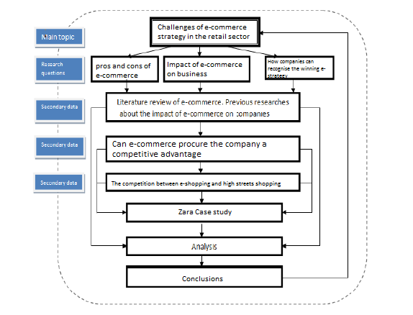

Literature review and theoretical background:

Introduction
The objective of this chapter is to provide a theoretical basis for a stronger comprehension of the notion of e-commerce. The section starts by defining the terms and outlines the literature gap. The concept development is defined. Attention is given to the influence of e-commerce on business performance and the pros and cons of e-strategy. The second part is focused on the process of implementation of the strategy to the company.

Definition of e-commerce and keywords

E-commerce
Electronic commerce relates to a variety of internet business operations for products and services. It also concerns any type of business operations in which the partners connect electronically rather than through physical contacts or immediate physical contact. E-commerce is generally linked to Internet buying and sellingor any transaction linked to the transfer of properties or permission to use products or materials via a computer-mediated network. Although common, this concept is not thorough enough to address the recent developments in this new and radical form of business (Goldstein and O'Connor, 2002). A more comprehensive concept is: e-commerce is the use of electronic communications and digital information processing technology in company operations to generate, transform and redefine value-creating interactions between or among organisations and people (Rainer, K. & Cegielski, 2011).

Strategy
The study is as implicated with electronic commerce as with strategy. A corporate strategy is the decision model in a firm that establishes and exposes its goals, purposes or objectives, generates the main measures for attaining those objectives and identifies the variety of business to be pursued by the company, the type of economic and human organization to be pursued or intended to be pursued, and the nature of the non-economic and economic contribution to be pursued by its customers, workforce, shareholders and community (Andrews, 1999).
A obviously thought out implementation strategy for e-commerce should be worked out before an organisation dives into the Internet business universe. It's not as easy as it might sound; e-commerce needs an advanced content management system and a strategy that incorporates a lot of different components. To start with, e-commerce requires specialized purchasing, billing and support systems along with processes for customers’ relationship management. A marketing endeavor of quality is essential. Underpinning it all is a high performance website that requires careful management and professional development. Opting for an e-commerce strategy means adjusting the current corporate strategy radically (Gottschalk, 2005).

Retail sector
Retail is described in this context as sales by retailers directly to end customers, including spending on products (in-store and online), Retail is a big and very varied sector: in size and business structure, what is sold and to whom, where and how distributors function. Sold products differ from daily necessities to luxurious high-end products. Industry areas differ significantly in the predominant size of companies (small, medium, big) and the number of individuals employed (uk, 2017).

Identifying literature gap
Many scientists or scholars have conducted numerous researches on -commerce strategies and e-commerce. Many of them pointed to the beneficial impact of e-commerce on businesses, and some pointed to difficulties in implementing e-commerce and corporate obstacles to e-commerce, with very few research focusing on e-commerce in the retail industry (Adenwala, 2014). Despite some organizations ' hard financial issues, e-commerce in the retail industry continues to grow, as businesses firmly think in its beneficial effect on the company's distinct services. After them, the industry is adopting use of B2B (business to business) and B2C (business to consumer). E-commerce altered the methods of business from a traditional manner to a modern way, i.e. electronic commerce via internet and other online transaction software, the traditional manner is still being followed by other industries (Cruz-Cunha and Varajao, 2011). Web is changing consumer behaviour as well as becoming less loyal, taking less time to select and consume goods (Su, 2017). Because the sector is a choice-oriented business, businesses can give their clients a enormous decision without worrying about racking the products on display shelves or searching for enormous business facilities to show their multiple product ranges, a well-developed website and a large warehouse would do the job. It also enables the business to introduce diverse new methods to meet customers needs and provide them with data through the internet and numerous value-generating techniques such as value extraction, value addition value creation, and value-capture (Deloitte, 2017).
Due to adoption of e-commerce in the retail sector, companies are becoming more powerful players, as they can choose the products they can advertise for in few minutes, advertise for the products using their own website, reach and contact customers using their database and more (Gallup, 2016).
The literature review shows several knowledge gaps in the e-commerce strategy's challenges on businesses and what are the factors that will have an effect on overall business performance as a result of the structuring of the e-commerce strategy, One of the researchers investigated the critical e-commerce success factors, another study entitled ― The Impact Of E-Commerce On Business Value In Service Organisations (Mairaj Salim, 2002), presented conclusions focused on the impact of e-commerce in the brand Image, customer service, product promotion and time to market.
An article on −Critical Factors Classification for corporate e-commerce adoption (Hassan M, n.d) emphasizes factors influencing corporate decision-making on e-commerce. Two primary categories result from classification: internal and external influences. Internal factors are within the company while external factors are primarily environmental (Saleem Shaikh., 2015).
This dissertation addressed three research questions; it is believed that they address the literature gap identified:
(1) What are the advantages and disadvantages of going digital?
(2) What is the impact of e-commerce on business performance (retail businesses case)
(3) How companies can recognize and employ a winning e-commerce strategy for their industry?

The impact of e-commerce on business performance in the retail sector
Over the past couple decades; many companies have recognized the need to perform business electronically, including retail organizations. E-commerce can take many forms including Business-to-Business (B2B), Business-to-Consumer (B2C), Business-to-Business to-Consumer (B2B2C), and Consumer-to Business (C2B) transactions (Oracle 2012).
B2C is our primary focus, B2C operations are taking place between an organization and its customers. An example of B2C is a transaction between a customer buying a product from ZARA or eBay.
To understand why most businesses are looking for an e-commerce strategy if they have resources, we need to demonstrate the drivers of online business adoption.
Adoption of e-commerce by companies is driven by benefits for various organizational departments. Above all, they are worried about how profitability will be affected by the advantages of doing business electronicaly (Thomas and Simmons, 2010). The two key methods to attain this are:
- Potential for enhanced income from enhanced reach to a bigger client base and promoting loyalty and repeated sales amongst clients.
- Reduction of costs achieved by electronically delivering services. Reduction includes staff costs, transports costs, and cost of materials.
A global research conducted on businesses in the United Kingdom, the Republic of Ireland, Germany, Sweden, France, Italy Canada, the United States, Japan and Australia, sought to assess some of the factors why businesses adopt e-commerce. The answers provide helpful insight into the issues being discussed by many companies today. The various drivers are respectively as follow (Ashik Shah, 2019):
    - Reduce costs / increase efficiency / profit
    - Improve interaction with customers and connections
    - keep up with external progress
    - Improve internal communication
    - keep up with competitors / competitive pressure
    - Increase data access
    - Improve communication with distributors
    - Standardize / simplify processes
    - Customer requirements
    - Increase client base and market share
    - Boost sales
Chaffey (2009) splits electronic commerce advantages into tangible and intangible benefits. While tangible are linked to higher turnover, lower expenses and measurable market growth, intangible advantages are difficult to identify and access. But they are obviously connected to the tangible. For example, shortening the life cycle of the company's product development can guide to cost savings and stronger clients requirements and eventually enhanced profits (concrete advantages).
Table 1: Tangible and intangible benefits from e-commerce
Tangible benefits | Intangible benefits
- Increased sales from new sales leads to enhanced income from:  - New markets, new clients  - Existing clients (repeating sales)  - Existing clients (cross-selling)  - Marketing cost reductions from:  - Quicker customer service  - Internet sales  - Less advertising and advertising expenses.  - Reduction of supply chain costs from more effective business routine procedures. | - Image communication  - Brand enhancement  - Faster, more reactive marketing communications including Public Relations  - Faster product development lifecycle allowing quicker response to market needs  - Better customer service  - Learning for the future  - Meeting customer requirements to have a website  - Identifying new partners, better supporting existing partners  - Better management of marketing and customers information.  - Feedback on products from clients
Chaffey (2009)

Obstacles for e-commerce
After Arendt (2008), the small businesses encountered higher problems in discovering electronic commerce solutions than bigger companies, Companies are supposed to closely calculate the risk and possible profits of adopting electronic commerce. Moreover, in all aspects of company enterprises, their fresh approach requires substantial adjustments. If the sceme is not in lining with the general missions of the company, the outcome could be catastrophic–poor customers experience and poor investment return. The risk is particularly greater for small companies because they are most of the times suffering from low capital and laack of knowledge. There are also many security problems, issues with shipping and order delay (Arendt 2008).
The obstacles to e-commerce implementation, however, are numerous, but they differ from small to companies, the table below classifies them by category.
Table 2: Barriers for e-commerce adoption (adapted from Arendt,2008)
Category | Barriers | Sources
Management and strategy | Lack of awareness  Lack of long term business strategy  Lack of innovation culture  Resistance of top management | Duan (2012), Arendt (2008)
Cost and financing | Lack of finance resources  Long process of return on investment | Fillis et al (2003), Arendt (2008)
Skills and training | Lack of experience and knowledge | Arendt (2008)
The supply chain | Usuitability for the business  Lack of time | Arendt (2008)
Technology choices | High level of complexity  Lack of time | Arendt (2008)
Security and reliability | Business risk  Security factors | Oh K-Young et al. (2012)
Source: Arendt (2008)
Another major obstacle is the top management's unwillingness to implement a new strategy. Duan (2012) has proven the powerful correlation between top management support and adoption level. The power decisions are concentrated in the owner or manager in small businesses and their understanding of the prospective advantages is essential to implementing more advanced e-commerce levels (Fillis et al. 2003; Duan 2012).

Pros and cons of opting for an e-commerce strategy
In latest years, research on perceived e-commerce advantages has increased. However, the findings are distinct because of the variations between the countries, the businesses types and the sort of industry they are in.
It is true that the benefits of e-commerce are divided into tangible and intangible, as illustrated above by Chaffey (2009). Here we can split advantages and disadvantages into two parts, for companies and for customers.

Advantages for traders (Chow, 2014):
- Possibility to compete with bigger companies: Due to small expenses incurred by a virtual shop small companies are confronting with one less barrier in penetrating the markets already dominated by the large companies.
- 24/7 contact with customers: An online website can inform customers about the company details and products and can process orders all around the clock, no staff night shifts required.
- International markets penetration: Online world doesn’t have borders, websites can still be accessible from the other side of the world, and with international payment means like Visa or MasterCard, a purchase can be made easily from anywhere in the world.
- Cutting costs: Personnel costs, marketing costs, business premises rent, bills and many more costs decrease dramatically when adopting an e-commerce strategy.
- Saving a private database: With online cookies, a website can retain all the customer preferences, and perform a one-to-one direct marketing to tempt costumers for more purchases.

Disadvantages for traders (Chow, 2014):
- Fraud: Online payment may sometime be fraudulent; a client may lie regarding his identity or his payment details.
- Security: A company with no Enterprise Resources Planning “ERP” system don’t worry much about its administration and sensitive confidential data, an online system is always exposed to external threats.
- Launching and integrations costs: An e-commerce strategy is not just a website; it is a combination of many components like a good Supply chain system, a good ERP system, a good e-commerce platform, and good following up and more. Launching costs could be expensive for small or medium companies.

Advantages for Customers (Chow, 2014):
- 24/7 Website availability: very practical for busy people, they can purchase by night or anytime they are free
- Facilities: No need to go downtown to shop, you can get more choice online and place order your order
- Unrestricted Access to information and products: The apparition of the electronic commerce gave a new meaning of the term ‘globalization’. In order to buy handcrafted items from Madagascar it is not necessary to travel to Madagascar anymore, only find it online and click.

Disadvantages for customers (Chow, 2014):
- Security : One of the mean reasons why some people still hesitate to use online commerce is them afraid of providing their personal credit card details, or delivering sensitive information that could be a threat on them, these problems are more common with old people. Absence of human contact is a disadvantage as well.
- Delay: Some orders are instantly delivered (like food), others are delivered within few days (like clothes), but some orders can take up to 90 days (like furniture), and that is an annoying and weak point to consider.
- Access to technology: It is not a very important concern anymore in developed countries, but in under-developed countries internet penetration degrees are not that high. Access to technology issue can arise with literacy or poverty as well.

How companies can implement an e-commerce strategy?
This chapter's primary goal is to create a conceptual framework that will assist executives in managing e-commerce problems in the strategic planning method. The stability of a structure is required in the rapidly evolving e-commerce setting. A systematic technique for e-commerce planning will decrease the expense of compulsory testing and advertising errors. If the management objective is to guide an organization's funds to attain organizational objectives efficiently and effectively (Griffin, 1999), (Murphy, 2000); then the requirements of good management will not be met by a poorly constructed prototype business strategy.
This section will discuss strategic planning process measures, review ecommerce company issues, and discuss the significant factors that leadership needs to understand as they build a strategic strategy for e-commerce.
Regular strategic planning process steps have to be carried out by any company in order to get the best result from the e-commerce strategy, the steps are mentioned below:

Strategic planning is complex, time-consuming and laborious. An organisation must therefore allocate time and resources to the process of strategic planning. It is worth the effort since a good game plan will hold an organization together as it pursues its mission. E-commerce strategy implementation stages will be described and evaluated now that the strategic planning method has been mentioned.

E-commerce strategy implementation tasks:
E-Commerce will enable an organisation to expand into new markets without expensive investments in facilities. It enables clients 24 hours a day, 7 days a week to obtain information and purchase products (24/7). Operating 24/7 is prohibitive but comparatively cheap on the Internet than brick and mortar business. In brief, time and space limitations on the Internet are reduced. It is not without major difficulties to pursue Internet-based business. Building and maintaining a fully functional website is expensive. Furthermore, a website may get lost in a sea of other websites as Internet real estate is not limited by physical limitations.
A website must therefore be marketed. Therefore, prior resource allocation to the project, a site strategy must be established with clear measurable goals.
This chapter will discuss how e-commerce problems can be linked to strategic planning.
A obviously scheduled ecommerce implementation strategy should be considered before an organisation dives into the internet business world.
In addition, e-commerce investments should be preceded by a strategy. Below is a list of e-business problems under the five executive strategic missions. The list is not intended to be exhaustive. It is designed to help the reader know how, while adhering to the strategic methodology; business website scheduling can be done. It will be helpful to review the previous strategic duties in connecting management's business strategy with the execution of e-commerce:
- Task 1 — Develop a vision and mission: at this stage, only the majority of macro e-commerce problems are regarded. Philosophical issues as well as external and internal settings are being explored. For a current business that expands into e-business, the vision and mission probably won't alter, but a fresh SWOT should be done. An e-business SWOT analysis can reveal distinctive opportunities and threats (Mann, 2001).
- Task 2 - Setting long-term organisational goals: here we look at how progress can be defined and measured. Choosing which metrics to monitor and track over moment is a difficult task. (Collins, Rossetti, & Watson, 2000). Executives in this region need to examine e-industry standards for assistance. If the organisation has traditional customers stores as well as an Internet outlet, when computing measurable goals, executives should consider the interaction effect of Web-based revenues on physical places.
- Task 3 - Formulating a detailed strategy: This assignment will include a big amount of problems concerning e-commerce. Before they start administering a major strategic web-based project, managers must be qualified in e-business methods. The web-to-database interface is crucial. An elaborate front end does not replace a correctly built system for managing databases. Data is a precious asset if managing decision-making data can be queried.
- Task 4 - Strategic choice and implementation: This stage is where the theory's logic meets reality's chaos. Even the finest conceptual strategy is meaningless without an operational strategy's skilled hands-on implementation (Plant, 2000). During an ecommerce implementation, employees with e-business knowledge will be highly useful. Do not underestimate the importance of excellent network engineers, database and application programmers. Delivering a business system internet based raises safety to an incredibly important level. Only skilled employees will remain one step ahead of hackers and others who may interrupt a web-based business's stability.
Training for employees is critical. A web-based business system will not be used to its full functionality without proper training. Wide-spread implementation of a correctly built and installed system, however, can produce significant benefits. Intuitive Surgical Inc., for instance, is a manufacturer of surgical devices requiring complicated product documentation. Implementing a web-based data collection scheme reduced its products shipping period by 20 percent (3 days) and other significant costs (Roberts, 2000). Therefore, after a good execution, an e-business should not rest. To maintain it new and up-to-date, a website must be updated frequently.
- Task 5 - Evaluate performance and start corrective modifications: Management must track advancement towards strategic goals through its plans. Changes should be made if goals are not met. A strategy needs to be adequately flexible to accommodate changes that will put back the organisation to its missions.
To classify e-business problems into strategic classifications is not an effort to overlook the interaction effect between issues and categories. The aim of this exercise is to assist executives to believe about e-commerce problems systematically and rationally. Managers must bear in mind that the existence of the Internet must be completely in line with the organization's business strategy. Bricks and clicks should operate together to enhance the organization's customer experience and add value.

Further discussion and case study

Can E-Commerce Help Organisations Build a Competitive Advantage over competitors?
With the process of economic globalization and the development of information technology, e-commerce as a new business model has increasingly had an impact on people's lives. The emergence of e-commerce is changing the previous business model, not only expanding enterprise marketing channels and reducing enterprise operating costs; more essential is the mode of electronic business to enhance communication between upstream and downstream enterprises in the supply chain and foster cooperation between enterprises (Francisco, William, Jay, 1995).
Compared to the traditional business model, e-commerce has the power as streamlined distribution, reduced costs, no time constraints and other benefits, while at the same time, e-commerce also has the benefits of less investment, simple to know, efficient business, according to the "China SME e-commerce development report," information indicate that revenue in the SME's has risen considerably. Commerce development of operating income for small and medium-sized enterprises has risen considerably, the growth of company revenue in SMEs engaged in e-commerce is almost 1.35 times that of comparable businesses not engaged in e-commerce.
Kim (2005) investigated the impact of information technology on the productivity of companies and confirmed that the technology can actually bring advantages. David and Lorna (2004) evaluated more than 40 Canadian, Chinese, Japanese and Mexican SMEs that are developing e-commerce on the global sector. The outcome demonstrates that electronic commerce is capable of reducing product and service costs in a distinctive manner, combining data and capital at the same time, and then raising the competitive advantage of the company.
Shao and Cai (2005) conducted empirical research on the performance of corporate listings in China on e-commerce; findings indicate that the application for e-commerce has a beneficial impact on revenue growth.
To sum up, most scholars and researchers agree that e-commerce will have positive impact on enterprise performance and consequently will procure the firm with a competitive advantage. The examples above shows in different ways the competitive advantages a company can get well using e-commerce.

What are the future prospects of electronic commerce?
The roots of e-commerce can be traced back to the 1960s, when companies started sharing business documents with other companies using Electronic Data Interchange (EDI). Following the increase in the amount of new customers exchanging electronic records in the 1980s, eBay and Amazon revolutionized the electronic commerce sector in the 1990s (Shahriar, 2011).
With mature markets in Western Europe and North America and the development of economies in East Asia and Latin America, the internet retail industry is becoming increasingly global, with development levels anticipated to double the former over the next five years (Lee, 2016).
With simple stream between smart phones, tablets, laptops, and stores, customers encounter a smooth shopping experience. Regardless of finishing the transaction, they already include various digital touch points to their shopping experience.

Facts and statistics:
EMarketer estimates worldwide ecommerce will increase to $3,535 trillion by 20.7 percent in 2019. Despite its evidently powerful development pace, 2019 will face a decrease from the past two years when ecommerce rose 28.0% in 2017 and 22.9% in 2018. By 2021, eMarketer expects worldwide e-commerce to be close to $5 trillion, although development levels will drop below the limit of 20 percent starting in 2020.
Diagram 3: Retail e-commerce sales worldwide
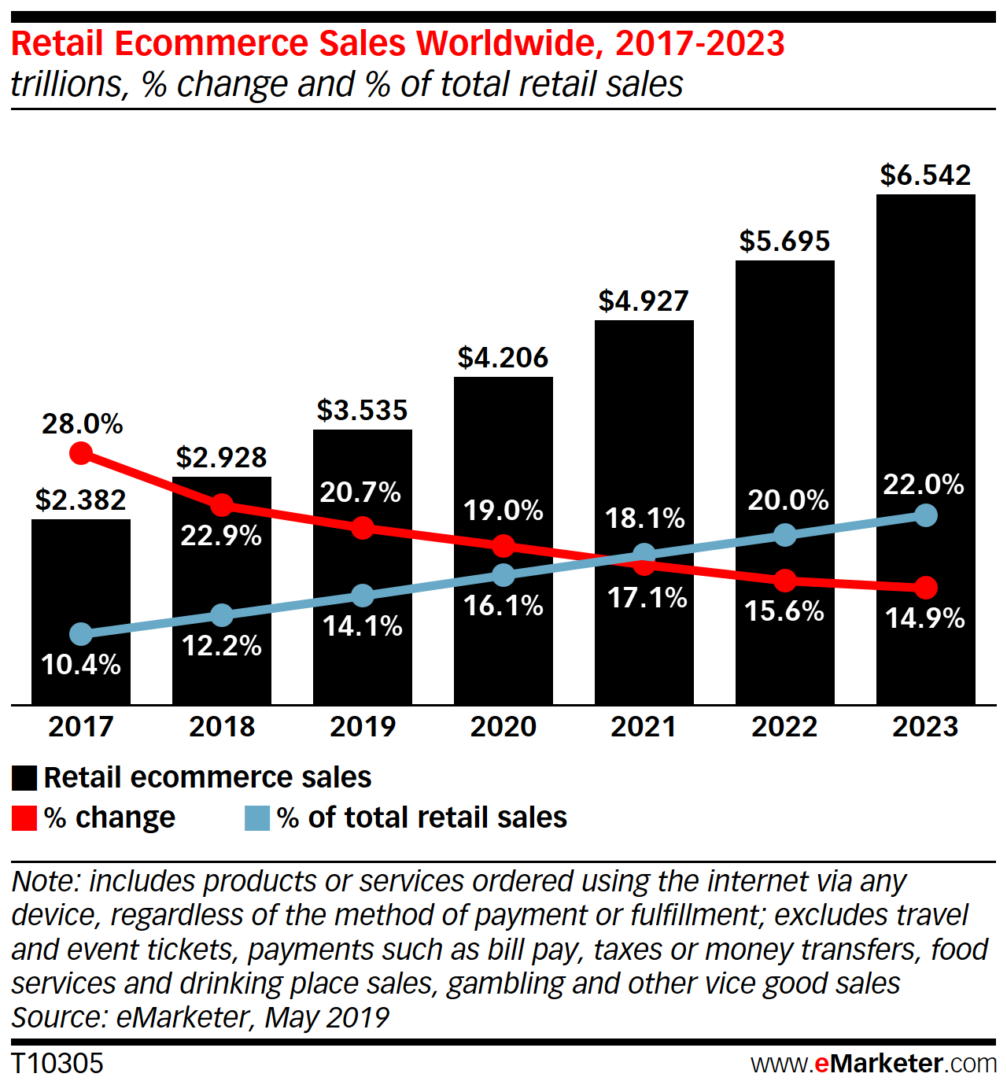
(Lipsman, 2019)
In 2019, Asia-Pacific will continue to guide the global growth charge for e-commerce. EMarketer expects the region to grow to $2,271 trillion from 25.0 percent, representing 64.3 percent of worldwide ecommerce expenditure. Latin America and Middle East / Africa will encounter the same growth levels of 21.3 percent year-over-year, mildly above the worldwide average, whereas North America (up 14.5 percent) and Western Europe (up 10.2 percent) are laggards (Lipsman, 2019)

To which extent e-commerce is a competitor to high street shops?
As e-commerce sales continue to expand, there is a question of whether e-commerce will eventually overtake or substitute physical shop sales entirely. While the unexpected nature of tech advances and consumer behavior complicates long-term predictions, we describe several main patterns below which we think will mark medium and long-term development in e-commerce.
Figure 1: Forecast of E-commerce Sales and Share of Total Retail
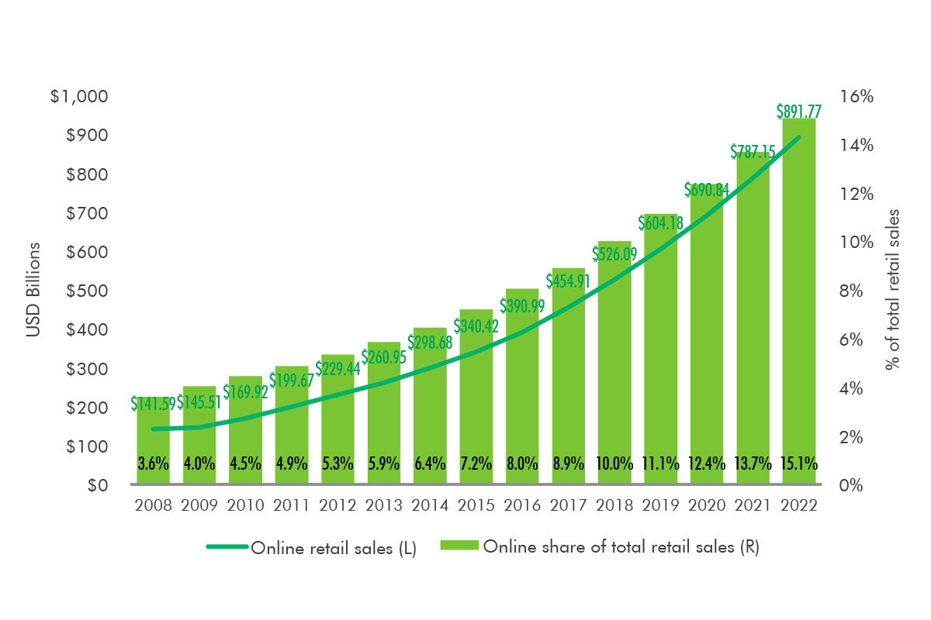
(CBRE, 2019)

E-commerce’s share of total retail sales is expected to go up from 8.9 percent in 2017 to slightly above 15 percent in 2022, counting nearly $892 billion
Figure 2: Digital-impacted Retail Sales
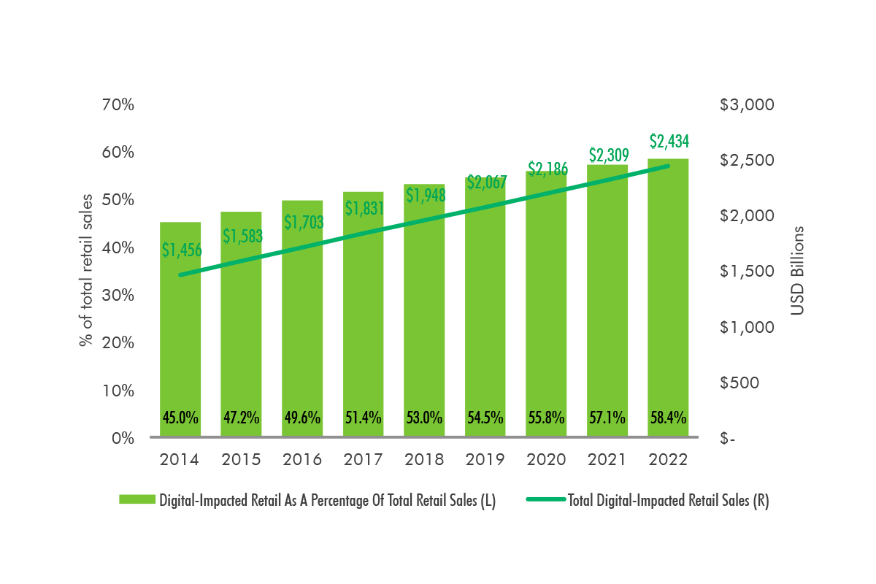
(CBRE, 2019)
However, it is anticipated that digital-impacted retail sales, including online purchases and in-store purchases by customers using a digital platform to research or browse, will grow even higher. Digital-impacted revenues are projected to reach more than $2.4 trillion, representing more than 58% of complete retail revenues by 2022 (Figure 2) (CBRE, 2019).
We can understand from the data above that e-commerce retail is still decades away from replacing high streets shops shopping or retailing, but on the other hand it has a huge impact on buyers’ decisions over a product or a purchase.

Case study on ZARA e-commerce strategy
Zara dominates the scene when it comes to high-street fashion brands. The brand is at the heart of providing the latest trends in fashion, high-quality products and incredible affordability, especially for customers. So, how did the company develop to become the world's number one fashion dealer from modest beginnings— not to mention setting global standards for success with their Zara e-commerce channel?
As Amancio Ortega once said: “The customer has always driven the business model…”
This is the secret of Zara's success in e-commerce. Being an e-commerce success requires more than getting a excellent products range with trending designs. Over the years, online shopping has developed and everybody buys online.
This has motivated Zara's e-commerce extension approach and has led to expanding the e-commerce arm of the brand to exist in more than 41 countries. In 2018, Zara ecommerce announced that it would give the same-day service to its clients in cities where both shops and e-commerce have been established.
The e-commerce platform of Zara and its use of technology to improve the experience of shoppers is the key to the competitive advantage of the brand. Here are some of the highlights of how the brand rose to the top of the globe of internet fashion successfully:

Automated Tactics and integrated stock management
Zara's e-commerce strategy utilizes an automated marketing platform to send shoppers relevant and timely messages about everything from order status updates to back to stock notifications, and so on. The brand maintains its communication on target and private, responding to shopping requirements and internet behaviour throughout the entire client journey.
Besides getting a Zara e-commerce website that contains loads of products pictures, excellent sizing tips and data and is extremely simple to access, Zara's mobile app is also user-friendly and easy to use. And, it's only improving (Pigeon, 2019).

Tapping into RFID technology
Zara also includes the latest technology in order to fulfil internet orders from clients with stock to meet instructions on the same or next day. This is achieved by using the "radio-frequency identification" RFID and integrated inventory management presently accessible in 25 countries in Zara shops. Indeed, by 2020, Isla lately announced that the embedded stock management scheme will be adopted by all countries where there is a physical shop presence.
Following the latest marketing technologies and trends, Inditex announced in 2018 that it is investing in logistics robotics as its companies continue to grow their internet presence in order to achieve fresh economies and have a growing number of orders to meet. Naturally, Zara is at the heart of this development. The company has started developing a fresh idea of shop — using robots to supply goods ordered from neighbouring stores to clients (Pigeon, 2019).

Customers are co-creators at Zara
How precisely does Zara proceed to meet the recent trend fashion requirements of its online and offline clients in such a quick and effective way? Simple, unlike any other product in the fashion sector, Zara uses a marketing strategy — basically using clients as "co-creators."
This is how it works: The brand is technology-focused and utilizes its deep-data model not only to anticipate what its clients want, but also to use internet customer feedback to generate and impact the recent developments in design. Then they get these products to sell rapidly in their stores and internet platform— for a fraction of the price of what other designer products pay. In reality, this same marketing strategy is used by all eight of Inditex's main retail products. It's so easy. It's the genius, too (Pigeon, 2019).

Part 2: Reflective essay

Definitions of qualitative and quantitative research:
Qualitative research is defined as a study that gives ideas and an insight into the problem. It is an unstructured method of explorative research that studies some extremely challenging phenomena that cannot be understood by quantitative research, although it generates ideas or theories for eventual quantitative research.
Qualitative research is used to obtain a detailed insight into human behaviors, attitudes, intentions, and motivations, through observation and interpretation, to identify the ways in which people think and feel. It is a method of research in which the researcher values the participants' points of view more deeply. Case studies, embedded theory, ethnography, history, and phenomenology are forms of qualitative research.
On the other hand, quantitative research is a methodologically based form of research that produces digital data and facts. It is designed to determine a cause-and-effect relationship between two factors using mathematical, computer and statistical methods. Research is also known as experiential research because it can be accurately measured.
The data collected by the researcher can be categorized, or measured in units of measurement. Graphs and tables of raw data can be constructed with the help of quantitative research, which facilitates the analysis of results by the researcher.
Quantitative and qualitative-can designate several things, in particular data or techniques of collection and processing of these data. For example, in the case study, the collected data are mostly qualitative (speech, text, video, photos), but they can also be quantitative (word frequencies, measurements). The modes of collection of these materials are diverse: interviews / semi or non-directive interviews, ordinary conversations, observation, study of written or visual documents, etc. The questionnaire is sometimes used in a case study, but it only occupies a secondary position. Conversely, in marketing, questionnaire surveys, telephone, internet, allowed the field of consumer behavior to develop based on increasingly sophisticated multivariate processing techniques. If some of the data collected are qualitative, they will then be transformed into nominal variables, so exploited using appropriate quantitative techniques (for example, factorial correspondence analysis); in short, quantitative research refers to work whose data is statistically analysable. Finally, for most researchers, talking about quantitative research means studying large, well-selected samples, whereas qualitative research usually involves only a few cases, or even a single one (Yin, 1991). Qualitative work has frequently been assimilated to an earlier (exploratory) phase of quantitative research (Evrard, Pras and Roux, 1997.

Differences between qualitative and quantitative research
The distinctions between qualitative and quantitative research can be established clearly on the following basis:
Qualitative research is a survey methodology that improves our understanding of the social sciences and humanities in order to identify how people think and feel. A scientific and experimental research method used to create digital data, using statistical, logical and mathematical techniques, is known as quantitative research.
Qualitative research is more holistic in nature, and quantitative research is more distinctive.
Qualitative research takes a subject-based approach because the researcher is closely involved, while the quantitative approach is factual, the researcher does not interfere and tries to refine the observations and analysis on the subject to respond to the survey.
Qualitative research is an exploratory process. Unlike quantitative research, which is conclusive research..
The reasoning used to synthesize data in qualitative research is inductive, whereas in the case of quantitative research, reasoning is deductive.
Qualitative research is based on targeted sampling, in which a small sample size is selected to allow for a thorough understanding of the target concept. In addition, quantitative research relies on random sampling. in which a large representative sample is chosen to extrapolate the results to the entire population.
Verbal data are collected during qualitative research. Conversely, in quantitative research, measurable data is collected.
The qualitative research survey is process-oriented, which is not the case for quantitative research.
The elements used in the analysis of qualitative research are words, images and objects, while that of quantitative research is a numerical datum.
Qualitative research is conducted to explore and discover ideas used in ongoing processes. Unlike quantitative research, the goal is to examine the cause-and-effect relationship between variables.
Finally, the methods used in qualitative research are in-depth interviews, focus groups, and so on. In contrast, quantitative research methods are structured interviews and observations.
Qualitative research develops the initial understanding while quantitative research recommends a final action plan.

Similarities between qualitative and quantitative research methods:
For Bryman (2012) the similarities between qualitative and quantitative research can be summarized in nine items, both are:
- Concerned about data reduction;
- Want to respond to research questions;
- Seek to relate data analysis to research already published;
- Are concerned with the variation;
- Treat frequencies as a springboard for analysis;
- Seek to ensure that deliberate distortions do not occur;
- Argue for the importance of transparency;
- Address the issue of error;
- Are concerned that research methodologies should be appropriate to research questions.
In addition to the list of this author we could add that in both approaches the researchers are looking for:
- Syntheses and patterns;
- Systematisation of the analysis of the data;
- Thoroughness of the conclusions
- Relevant application and reflection on the implications in the specific areas of science, technology and society.
- Looking at both lists we recognise the standards of science itself, to which we should add that both methodological approaches are concerned with ethical and citizenship issues.

Which you found easier to use (and why)?
Which technique is better than the other has always been debated. The reason it is not yet settled is because each one has its own strengths and weaknesses that effectively differ depending on the topic the investigator wishes to address. This brings us to the following issue: "What technique should be used in a particular topic?" If your study intends to digitally discover the response to a query, then quantitative research should be used. However, if you want to clarify further in your study why this specific incident occurred, or why this specific phenomenon occurs, then you should use qualitative research.

Some studies use both quantitative and qualitative research to complement the strengths of each other. For example, if your study aims to know that human behavior is dominant towards a particular object or event while at the same time examining why this is the case, then this study is ideal for using both methods.

Which you would prefer to use in your doctoral research, and why?
I would rather use a mixed research method. The word ' mixed research methods ' is widely recognized for studies that incorporates both qualitative and quantitative data in a single study (Wisdom et al., 2012, Creswell and Plano Clark, 2011).
It is very likely that the thesis will use published companies experiences, books, case studies, surveys, interviews and the author's own experience in e-commerce obtained at his position as an e-commerce assistant. A mixed research method allows the researcher to be more flexible about the chapters and the data he want to put in the research.

Conclusion
Retail can be considered as the backbone of economies, developing the market would be of good effects to the economy as a whole.
In conclusion, the results shows that investing in an e-commerce strategy is one of the most important factors to achieve success for companies, competitive advantage can also be achieved largely depending on whether the company will effectively well use the technology. As demonstrated earlier, implementing an e-commerce strategy comes with many benefits to the business and its customers, and has heavy impact on the overall performance of the business. The strategy implementation is not easy or very affordable, but it is definitely worth it, the stages and steps of introduction have been described.
It's safe to tell e-commerce is going to keep growing at a significant pace. This is primarily owing to the ever-increasing technological advances and the ongoing number of companies linking to the Internet. E-commerce investment will allow them to catch up with the market competition and proceed to meet client requirements.
Also, to demonstrate a concrete e-commerce strategy and its outcomes, a case study has been driven on ZARA, this has helped making a clearer image of how to create and manage a dominating e-commerce strategy in the retail sector.

References:
- Reilly, E. (2003). Milestones in computer science and information technology. Westport, Conn.: Greenwood Press.
- Peter, I. (2004). The beginnings of the Internet. Net history. [online] Available at: http://www.nethistory.info/History%20of%20the%20Internet/beginnings.html.
- Hess, K. (2012). BREAKING BOUNDARIES. In: 1st ed. https://www.tandfonline.com/doi/full/10.1080/21670811.2012.714933.
- Gunawardana, K.D. 2006. The Impact of firm-based characteristics on Adoption of E-commerce in SME in Sri Lanka. [viewed 22.02.2012]. Available: http://www.sjp.ac.lk/research
- ChiChu, S. (2008). Evolution of e-commerce Web sites: A conceptual framework and a longitudinal study.
- Xu, J. & Quaddus, M. (2009). E-Business in the 21st Century: Realities, Challenges and Outlook. SGP: World Scientific Publishing Co., [Online] Available: http://site.ebrary.com/lib/kaubib/Doc?id=10422509&ppg=301
- Kovács, G. & Spens, K. (2005), Abductive reasoning in logistics research, International Journal of Physical Distribution & Logistics Management, Vol. 35 Iss: 2
- Bryman, A. & Bell, E. (2007). Business research methods. 2.ed. Oxford University Press
- Zikmund, W. (2010). Business research methods. Mason, OH: South-Western Cengage Learning.
- Crawford, I. (1997). Marketing Research and Information Systems. Food and Agriculture organization of the UN, [Online] Available: http://www.fao.org/docrep/W3241E/W3241E00.htm
- Ethicsguidebook.ac.uk. (2019). Home | Welcome. [online] Available at: http://www.ethicsguidebook.ac.uk/ [Accessed 11 Sep. 2019].
- Tubaru, P. (2016). Research ethics in secondary data: what issues?. [online] Data Big and Small. Available at: https://databigandsmall.com/2015/10/18/research-ethics-in-secondary-data-what-issues/#wrapper
- Marianna, M. (2013). What are the major ethical issues in conducting research? is there a conflict between the research ethics and the nature of nursing?. [online] Hsj.gr. Available at: http://www.hsj.gr/medicine/what-are-the-major-ethical-issues-in-conducting-research-is-there-a-conflict-between-the-research-ethics-and-the-nature-of-nursing.php?aid=3485.
- Gupta, M., Shaheen, M. and Prathap Reddy, K. (2018). Qualitative techniques for workplace data analysis.
- Goldstein, A. and O'Connor, D. (2002). Electronic commerce for development. Paris: OECD.
- Rainer, K. & Cegielski, C.(2011). Introduction to Information Systems: Enabling and Transforming Business. Third Edition. Jonh Wiley & Sons Inc.
- Andrews, K. (1999). The concept of corporate strategy. New York, N.Y.: Primis Custom Pub.
- Gottschalk, P. (2005). E-business strategy, sourcing, and governance. Norwood Mass.: Books24x7.com.
- uk, P. (2017). Retail Sector Report. In: Parliament uk. London.
- ADENWALA, M. (2014). IMPACT OF E-COMMERCE ON BUSINESS PERFORMANCE: A STUDY WITH RESPECT TO TRAVEL INDUSTRY. 1st ed. Mumbai: School of Management, D Y Patil University.
- Cruz-Cunha, M. and Varajao, J. (2011). E-business issues, challenges and opportunities for SMEs. Hershey: Business Science Reference.
- Su, B. (2017). The evolution of consumer behavior in the digital age. [online] Medium. Available at: https://medium.com/analytics-for-humans/the-evolution-of-consumer-behavior-in-the-digital-age-917a93c15888.
- Deloitte, C. (2017). Transformation of traditional retailer in the era of New Retail. 1st ed.
- Gallup, B. (2016). E-Commerce Strategies. [online] Business.lovetoknow.com. Available at: https://business.lovetoknow.com/e-commerce-business-online-business/e-commerce-strategies.
- MairajSalim, The Impact Of E-Commerce On Business Value In Service Organisations, Aligarh Muslim University Aligarh (India), 2002.
- Hassan M. Selim, Critical Factors Classification for Firm Adoption of E-Commerce, College of Business & Economics, United Arab Emirates University, Al Ain, United Arab Emirat
- Saleem Shaikh. (2015). Business Environment. Pearson India.
- Oracle. 2012. 2012 B2B E-Commerce Survey: Results And Trends. [viewed 29.02.2012]. Available: www.oracle.com/us
- Thomas, B. and Simmons, G. (2010). E-commerce adoption and small business in the global marketplace. Hershey, Pa: Business Science Reference.
- Ashik Shah, N. (2019). Formulating an e-commerce strategy for success. Ph.D Thesis. Loughborough University Institutional Repository.
- Chaffey, D. (2009). E-business and e-commerce management – Strategy, implementation and practice. Fourth Edition. Prentice Hall
- Arendt, L. (2008). Barriers to ICT adoption in SMEs: how to bridge the digital divide? Journal of Systems and Information Technology, Vol. 10 No. 2, 2008, pp. 93-108
- Duan, X. (2012). Evaluating the Critical Determinants for Adopting E-Market in Australian Small-and-Medium Sized Enterprises, Management Research Review, Vol.35, No 3-4
- Fillis, I., Johansson, U., Wanger, B. (2003). A Conceptualization of the opportunities and barriers to e-business development in small firms, Journal of small business and Enterprise development, vol.10, number 3
- Oh, Ka-Young, Anderson, A. & Cruickshank, D. (2012). Perceived barriers towards the use of e-trade processes by Korean SMEs, Business Process Management Journal, Vol. 18 No. 1, 2012
- Griffin, R. W. (1999). Management, 6th edition. Houghton Mifflin, Boston, MA.
- Murphy, Robert M. (2000). “Strategic Leadership vs. Strategic Management: Untying the Gordian Knot.” 2000 Academy of Business and Administrative Sciences Conference Proceedings.
- Mann, Charles C. (2001). “Pumping Up the Volume.” Forbes.
- Collins, Terry R., Manuel D. Rossetti & Julie A. Watson (2000). “The Use of Metrics as a Strategic Management Tool.” 2000 Academy of Business and Administrative Sciences Conference Proceedings.
- Plant, Robert T. (2000). E-Commerce: Formulation of Strategy. Prentice-Hall, Upper Saddle River, NJ.
- Roberts, Bill (2000). “Faster, Smarter, Better.” Internet World, January 15, volume 6.
- Francisco, M.; William, F.; Jay, B. Information Technology and Sustained Competitive Advantage: A Resource-Based Analysis. MIS Q. 1995.
- Kim, D.; Cavusgil, S.T.; Calantone, R.J. The role of information technology in supply-chain relationships: Does partner criticality matter? J. Bus. Ind. Mark. 2005
- David, A.J.; Lorna, W. The e-business capability of small and medium sized firms in international supply chains. Inf. Syst. e-Bus. Manag. 2004.
- Shao, J.; Cai, Z. Empirical Research for the Effect of Electronic Commerce Initiatives on Firm Performance. Sci. Technol. Progr. Policy 2005.
- Shahriar, M. (2011). The Evolution and Development of E-Commerce Market and E-Cash. 1st ed. [ebook] Available at: https://www.researchgate.net/publication/263230383_The_Evolution_and_Development_of_E-Commerce_Market_and_E-Cash [Accessed 16 Sep. 2019].
- Lee, I. (2016). Encyclopedia of e-commerce development, implementation, and management.
- Lipsman, A. (2019). Global Ecommerce 2019. [online] eMarketer. Available at: https://www.emarketer.com/content/global-ecommerce-2019.
- CBRE (2019). How High Will E-commerce Sales Go?. [online] CBREUS. Available at: http://www.cbre.us/real-estate-services/real-estate-industries/omnichannel/the-definitive-guide-to-omnichannel-real-estate/by-the-numbers/how-high-will-e-commerce-sales-go.
- Pigeon, C. (2019). How ZARA Dominates the Ecommerce Fashion Industry. [Blog] blog.contactpigeon. Available at: https://blog.contactpigeon.com/zara-ecommerce/ [Accessed 16 Sep. 2019].

