DS 1 Template

My Screenshots/Photos
- Please add 4–6 screenshots or photos of your digital life.
- You can use your phone or laptop.
- For each screenshot, write one or two sentences explaining what it shows.

Screenshot/Photo 1
[Insert Photo/Screenshot below]
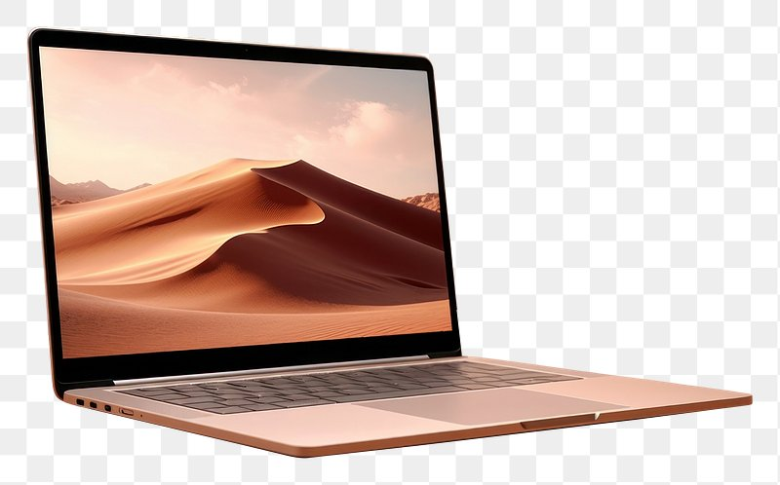
I use a laptop every day for work and business, research and education, personal use, entertainment. Using my laptop to manage my emails, organise my day, online learning, web research, listen to music, shop online, pay bills. Sometimes I attend to video conferences, to learn new skills.
Orbit365 (n.d.)

Screenshot/Photo 2
[Insert Photo/Screenshot below]
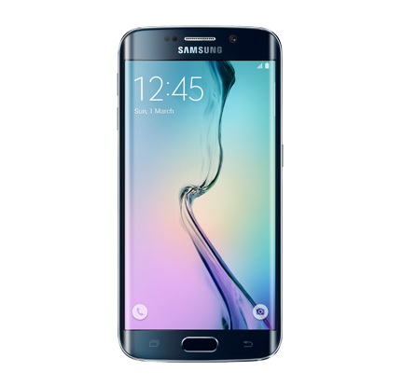
I use a mobile phone every day for communication, organising my day, navigation and travel, entertainment, media, banking, payments, photography. Sending text messages, making voice calls, using apps like WhatsApp or email. Setting alarms, taking notes, checking maps for travel or driving. Checking bank accounts, transferring money, paying for items. Watching videos, reading news articles, capturing photos and videos.
Telefónica Communication Team (2026)

Screenshot/Photo 3
[Insert Photo/Screenshot below]
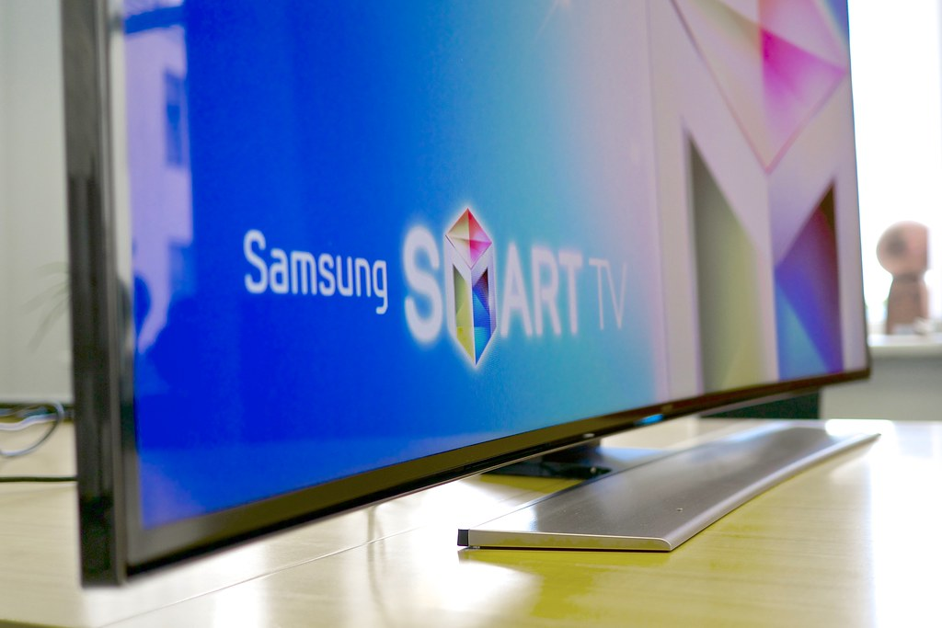
My Smart TV uses are mix entertainment and a little daily information. I use widgets like local weather, calendar financial events, sport events. Connect my laptop or phone directly to tv screen to answer emails or join video calls. I also use it for connecting to apps like Netflix, YouTube. Watching movies, series and sport events.
Olin (n.d.)

Screenshot/Photo 4
[Insert Photo/Screenshot below]
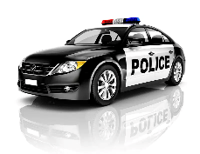
Modern cars help our life a lot now days. Most of them have got top technology that gives access to the internet. That gives a big help for our daily routine.
World Economic Forum (n.d.)

Screenshot/Photo 5
[Insert Photo/Screenshot below]
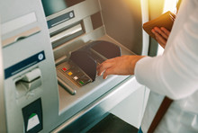
I use ATM machines for cash withdrawals , deposit cash or checks, balance check, pin updates. They offer the most secure transactions, free to use. Also quick access when they are placed in shopping area.
Investopedia. (2024).

Screenshot/Photo 6
[Insert Photo/Screenshot below]
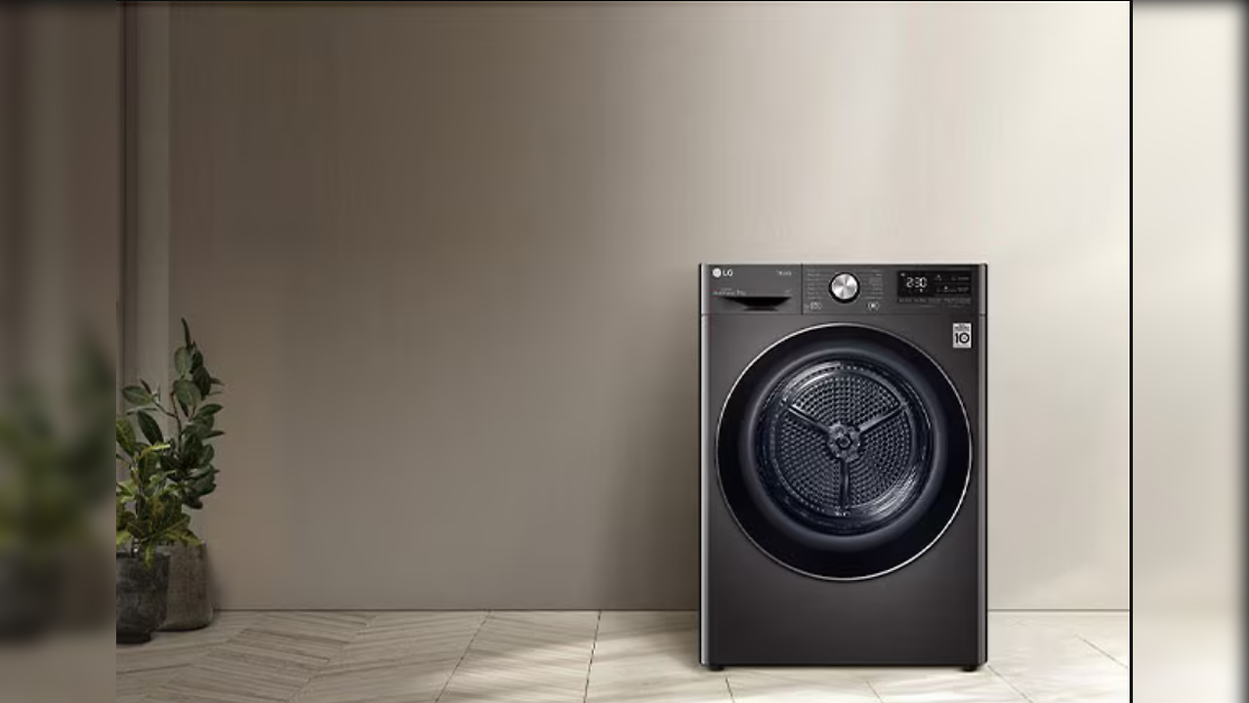
I like the new digital washing machine because of the new automated sensors, custom programs and remote smartphone control. They have standard and quick washes very helpful, sensor load, scheduling. Also adjust automatically water levels and detergent amount.
Morgan, T. (2024).

My Short Reflection
- Write 5–8 simple sentences about your digital life.
- You can use the sentence starters below if helpful.
I use digital tools, first, because of their efficiency. They help with accomplish my daily tasks and goals faster.
I feel confident when I use them, knowing that my day will be faster.
I want to improve the way I use them, by learning how to use it better, so I can make my daily routine more efficient.
I sometimes feel nervous because I do not know exactly how to use them.
I hope this module will help me to make me learn the best way to use my digital skills in improving daily use of them.

Sentence starters
- I use digital tools to …
- I feel confident when I …
- I want to improve …
- I often use these tools: …
- I sometimes feel nervous about …
- I hope this module will help me …
- Digital skills are important for me because …
You can write more if you want.

Submission Checklist
Before you submit, please check:
​​​ ☒ I added 4–6 screenshots
☒ I wrote short sentences for each screenshot
☒ I wrote my short reflection
☒ My work is my own
☒ My file opens correctly
​​☒ My file opens correctly

Referencing
Orbit365 (n.d.) The best laptop for everyday use. Orbit365. Available at: https://www.orbit365.co.uk/blogs/news/the-best-laptop-for-everyday-use (Accessed: 18 October 2026).
Telefónica Communication Team (2026) Main uses of smartphones. Telefónica. Available at: https://www.telefonica.com/en/communication-room/blog/smartphone-uses/ (Accessed: 18 October 2026).
Olin (n.d.) What is a Smart TV and how does it work? Available at: https://olin.es/en/blog/what-is-a-smart-tv-how-it-works/ (Accessed: 18 October 2026).
World Economic Forum (n.d.) 3 ways intelligent cars positively impact daily mobility. Available at: <https://www.weforum.org/stories/supply-chains-and-transportation/3-ways-intelligent-cars-positively-impact-daily-mobility> (Accessed: 18 October 2026).
Investopedia. (2024). Automated Teller Machine (ATM). Available at: https://www.investopedia.com/terms/a/atm.asp (Accessed 18 October 2026).
Morgan, T. (2024). Smart washing machines: 6 genuinely useful features that make life easier. Which?. Available at: https://www.which.co.uk/news/article/smart-washing-machines-useful-features-that-make-life-easier-azXWy4Z6PCot (Accessed 18 October 2026).

