

UNIVERSITY OF WALES TRINITY SAINT DAVID

International Business MBA
Marketing Management LCMB7024

Marketing Environment Analysis and Strategic Growth of BHP
Assessment component 1: Marketing Environment Analysis
Lecturer: Taonga Kaonga Sobere-Snithers

Student: YUVRAJ KUMAR SAH
Student ID: 2612706
Submission Date: 22 October 2026
Word Count: 2,664

Table of Contents

Executive Summary………………………………………………………………. 3
Marketing Environment Analysis and Strategic Growth of BHP ……………. 4
Task 1: Marketing Environment Analysis……………………………………………………………….. 4
1.1 Introduction …………………………………………………………….. 4
1.2 Natural Environment……………………………………………………… 5
1.3 Political-Legal Actors…………………………………………………….. 5
1.4 Technological Actors…………………………………………………….. 6
1.5 Critical Synthesis…………………………………………………………. 7
Task 2: Strategic Growth and Competitive Positioning……… 8
2.1 Strategic Growth Approach……………………………………………… 8
2.2 Competitive Advantage………………………………………………….. 9
Task 3: Managerial and Professional Reflection……………… 11
Conclusion…………………………………………………………………………. 12
References………………………………………………………………………… 13

Executive Summary
Metals and mining companies face growing pressure from climate change, decarburization, technological development and stakeholder expectations. This report analyses Broken Hill Proprietary (BHP) through three external marketing environment actors: the natural environment, political-legal actors and technological actors. The natural environment receives greatest emphasis because land, water, energy and climate risks directly affect mining feasibility, costs and community trust.
Copper demand creates an opportunity as electricity networks and electrification expand, but demand growth does not guarantee superior returns or a customer premium. BHP reported FY2026 copper production of 1,953 kt and copper underlying EBITDA of US$18.2 billion, equal to 54% of Group underlying EBITDA (BHP, 2026a). BHP also identifies higher realised copper prices as the primary driver of the increase in copper earnings. These results demonstrate copper’s strategic importance, not that lower-carbon products will command higher prices. Regulation can increase compliance costs while encouraging better risk management. Technology can reduce environmental impacts, but only when suitable, reliable and financially justified.
The report recommends product development through a customer-facing, independently verified lower-emissions copper offer, supported by market development where buyer evidence supports it. BHP and Amazon’s 2026 pilot of environmental attribute certificates indicate commercial experimentation, not proof of broad willingness to pay (BHP, 2026b; RMI, 2026). Investment should therefore proceed through pilots with clear cost, emissions, reliability and customer-conversion thresholds. If customers do not value the attributes or assurance costs exceed benefits, BHP should priorities cost-effective operational decarbonisation instead.

Marketing Environment Analysis and Strategic Growth of BHP

Task 1: Marketing Environment Analysis

1.1 Introduction
Marketing environment analysis helps organizations identify external factors affecting how value is created and delivered (Kotler et al., 2024). In mining, environmental conditions, regulation and industrial customers influence costs, market access and demand. BHP illustrates the tension between rising demand for transition minerals and the environmental impacts of extraction. In FY2026, BHP produced 1,953 kt of copper and generated US$18.2 billion in copper underlying EBITDA, representing 54% of Group underlying EBITDA (BHP, 2026a). BHP reports that higher realized copper prices were the primary driver of the increase in copper earnings. These figures demonstrate copper’s strategic importance, but do not establish that lower-emissions copper will command a premium or that additional environmental investment will generate superior returns. Those outcomes depend on customer procurement criteria, verification costs, operational performance and competitive responses.
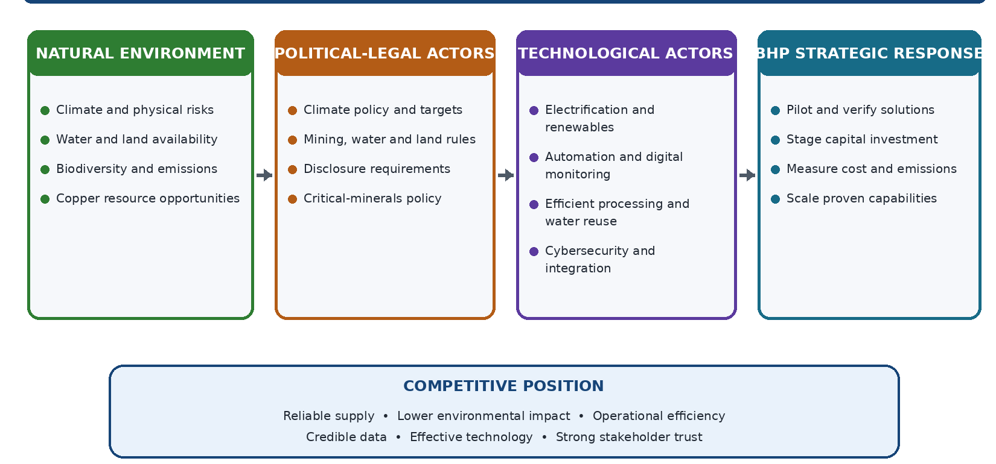
Figure 1: External marketing environment and BHP’s strategic response
Source: Author’s own illustration, informed by the literature cited in Task 1.

1.2 Natural Environment

The natural environment creates both operational challenges and commercial opportunities for BHP. Copper mining depends on land, water and energy, while climate change can disrupt production and increase costs. The OECD (2023) highlights the importance of environmental due diligence and risk management.

The IEA (2025a; 2025b) projects copper demand will increase from 26.7 million tones in 2024 to 34.1 million tones by 2040, driven partly by electrification and clean energy. However, growing demand does not guarantee competitive advantage because competitors, recycling and material substitutions may influence markets.

Lower-emissions production and traceability could create customer value, but buyers may prioritize price, quality and reliability. Peattie and Charter (2003) emphasize evidence-based green marketing. BHP should disclose site-level emissions and water outcomes, distinguishing operational emissions from the wider lifecycle footprint to avoid misleading claims.

Renewable energy, electrification and water efficiency may improve resilience but require investment. Therefore, BHP should prioritize environmental improvements that reduce risks, strengthen resource efficiency and support compliance while maintaining cost competitiveness. Transparent evidence is essential to credible sustainability claims.

1.3 Political-Legal Actors
Political-legal actors shape BHP’s conditions through climate policy, permits, land and water rules, biodiversity requirements and disclosure standards. The Paris Agreement
influences national climate policies, while the European Critical Raw Materials Act seeks to strengthen strategic mineral supply chains (UNFCCC, 2015; European Commission, 2024). BHP’s Climate Transition Action Plan should be assessed against reported progress and independent evidence (BHP, 2024). Regulation can raise costs, but predictable rules may reward companies that anticipate change. Effects vary by jurisdiction and asset.
International Financial Reporting Standards (IFRS) S2 highlights the importance of disclosing climate-related governance, strategy, risk management, metrics and targets (IFRS Foundation, 2023). The challenge for BHP is to respond when rules differ across jurisdictions and evolve at different speeds. Early investment may be costly if policy develops slowly; delaying action may create higher future costs, weaken resilience or restrict market access.
BHP should prioritize investments that remain useful across several policy scenarios, including reliable emissions data, energy efficiency, water management and operational improvements. Staged investment gates can release further funding only when projects demonstrate measurable benefits. This limits the risk of committing substantial capital too early without assuming that inaction is cost-free.
Compliance must be distinguished from competitive advantage. When reporting and minimum standards become common, compliance alone is unlikely to differentiate BHP. Advantage is more likely when requirements become repeatable capabilities that reduce costs, manage risk and support reliable production, consistent with Hart’s (1995) view of environmental capabilities. Reporting can also expose poor performance; expenditure creates value only when it protects access, reduces risk or improves decisions.
Regulation can be threat or opportunity depending on enforcement, asset exposure and timing. BHP should assess effects on cost, investment, trust and market access, prioritizing actions that remain useful across policy scenarios.

1.4 Technological Actors
Technological actors influence BHP’s ability to improve productivity while reducing the environmental intensity of mining. Relevant developments include renewable electricity, electrification, automation, advanced mineral processing, water reuse and digital
monitoring. These can lower emissions and improve resource efficiency, but their value depends on technology maturity, site conditions, infrastructure and total cost (BHP, 2025; IEA, 2025A).
BHP should evaluate technologies according to operational needs rather than adopting innovation for its own sake. Electrification may reduce diesel use where suitable equipment and charging infrastructure exist; digital monitoring may identify energy losses, equipment faults and water inefficiencies. However, implementation can require capital, staff training and system integration. A promising technology may fail to deliver value if it disrupts production or cannot be maintained reliably.
BHP should test selected technologies at pilot sites before wider deployment. Each pilot needs a baseline and targets for emissions, energy or water use, reliability, maintenance and unit cost. Verified results can distinguish genuine improvements from unsupported sustainability claims(Hart, 1995). Scaling should occur only when outcomes are operationally robust and financially justified.
Technology choices should also consider compatibility and vendor dependence. Proprietary platforms may create switching costs, while rapid change can make systems obsolete. BHP should assess interoperability, cyber security, data quality, supplier resilience and staff capability alongside the business case. Collaboration can build expertise, but internal teams must be able to challenge supplier claims(Barney, 1991; Teece, 2007).
Technology alone is unlikely to provide lasting advantage because competitors can acquire similar systems. BHP reported operational greenhouse gas emissions intensity of 1.6 tCO-e per tone of copper-equivalent production in FY2025, using an operated-assets reporting boundary (BHP, 2025). Rio Tinto reported 6.1 tCO-e per tone of copper-equivalent production for 2025 on an equity basis (Rio Tinto, 2025).
These figures are not directly comparable: organizational boundaries differ, and asset portfolios, production mixes and calculation methods may also affect the results. They should not be used to claim that one company is definitively more efficient. A valid comparison would align reporting boundaries, emissions scopes, electricity accounting and copper-equivalent production methodology, then use independently verified, like-for-like asset data. Until then, BHP should benchmark emissions intensity alongside renewable electricity, water efficiency, unit cost and production reliability without presenting the published figures as a definitive ranking.

1.5 Critical Synthesis

The actors are interconnected: water scarcity and extreme weather affect continuity; political-legal rules turn environmental concerns into obligations and costs; and technology determines which responses are feasible. BHP should compare options by lifecycle cost, verified environmental outcomes, and reliability and stakeholder effects. These criteria can conflict because emissions-reducing technology may require capital, cause downtime or depend on external infrastructure. Site-specific, staged decisions are more defensible than a uniform global solution.
Environmental performance also affects BHP’s social license to operate because mining can affect land, water and local communities. Freeman’s (1984) stakeholder approach supports including these relationships in strategic decisions, rather than assessing projects solely through financial returns.
BHP should translate this wider analysis into a consistent investment appraisal covering compliance, physical resilience, financial returns and stakeholder impacts. Comparable
site-level indicators and transparent data limitations are important because group averages can conceal differences between assets, while Scope 1 and 2 emissions exclude much of the value chain. Decisions should therefore combine measurable operational outcomes with meaningful engagement with affected communities and Indigenous groups.

Task 2: Strategic Growth and Competitive Positioning

2.1 Strategic Growth Approach
Ansoff’s Matrix (1957) distinguishes market penetration, product development, market development and diversification. It does not assess environmental credibility, willingness to pay, investment risk or imitation, so BHP must combine it with competitive analysis and investment appraisal.

Market penetration could improve productivity, asset utilization and reliability in existing copper markets. However, it does not itself create a differentiated lower-carbon offer, and higher output without lower environmental intensity could increase regulatory and reputational risks. BHP should link productivity to measurable emissions, water-intensity or unit-cost improvements. Product development is preferred, but routine efficiency improvements are not automatically new products under Ansoff.
BHP should test a customer-facing copper offer with assured emissions information and traceability if buyers confirm these attributes affect procurement. It qualifies as product development if the offer materially changes for existing markets. Buyers may prioritize price, quality and supply security, while rivals may copy the credentials. Test customer acceptance and assurance costs before scaling.

A pilot should compare the offer with conventional supply and establish a baseline. Decision gates should assess data quality, incremental costs, customer conversion, reliability and regulatory requirements. Set targets in advance; redesign or stop projects that miss thresholds, regardless of money already spent.

Market development could target customers and regions investing in grids, renewable and electrification. Yet market growth does not prove demand for BHP’s offer. Interviews, procurement criteria and competitor benchmarking should identify segments that value traceability or lower emissions. Partnerships can help, but BHP remains responsible for data quality.

Diversification carries greater risk because it involves new products and markets. BHP’s potash expansion shows portfolio growth, not that every adjacent opportunity will succeed. Further diversification should be selective, capability-linked and supported by risk-adjusted returns; unrelated ventures could divert capital from decarburizing existing operations.

Pilot study should begin at selected sites with reliable baselines and a defined customer use case. Specify environmental targets, costs, production impacts, assurance needs and customer outcomes. Relevant teams should review results together. Release funding in stages only when environmental benefit, cost, safety and reliability meet pre-agreed thresholds.

Product development should lead, supported by market development and selective diversification. If buyers do not value the attributes, assurance costs outweigh benefits, or improvements cannot be demonstrated, BHP should defer the offer and prioritize operational improvements. This avoids assuming a premium and reduces sunk-cost bias.

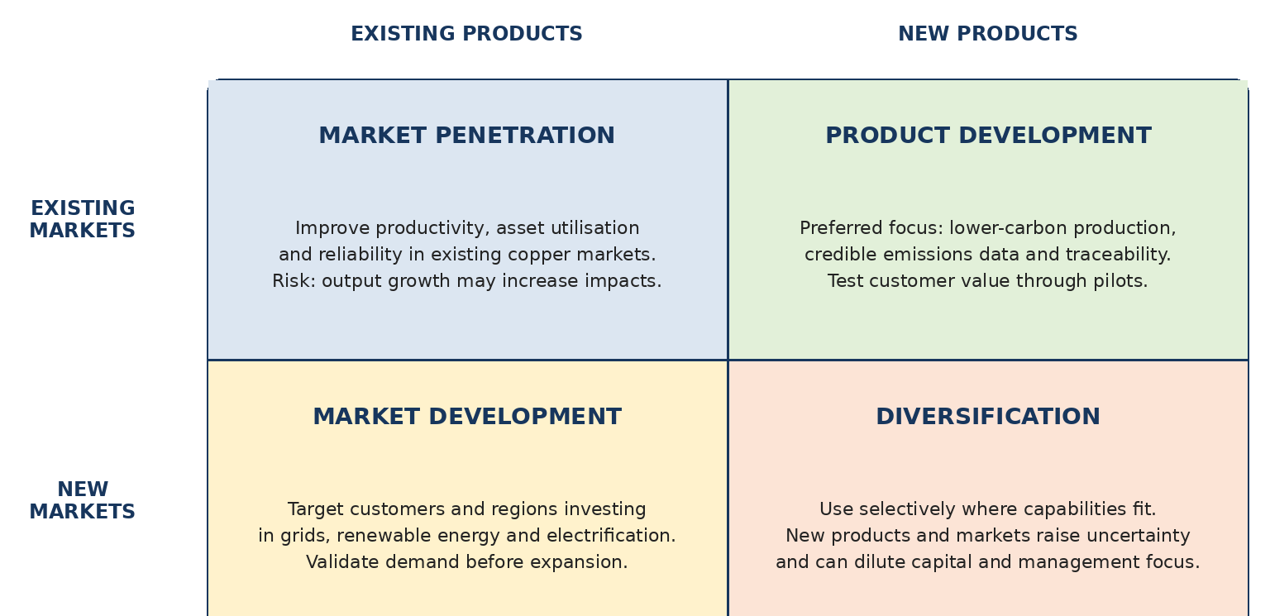

Figure 2: Ansoff Matrix applied to BHP’s strategic growth options
Source: Author’s application of Ansoff (1957) to BHP’s strategic options.

Porter (1985) distinguishes cost leadership from differentiation. BHP’s scale may support cost control, while verified environmental performance may differentiate its offer. Barney (1991) stresses valuable, rare and hard-to-imitate resources; Teece (2007) adds that capabilities must adapt as markets and technology change. BHP must combine reliable supply, assurance, efficient operations and customer relationships.

2.2 Competitive Advantage
BHP’s FY2026 results demonstrate the strategic importance of copper within its portfolio. The company produced 1,953 kt of copper and generated US$18.2 billion in copper
underlying EBITDA; copper contributed 54% of Group underlying EBITDA (BHP, 2026a). However, BHP identifies higher realized copper prices as the primary driver of the increase, so the result demonstrates financial significance and favourable market conditions rather than proving that lower-emissions copper itself creates additional value. BHP also reported a 33% reduction in operational Scope 1 and 2 greenhouse gas emissions from its adjusted FY2020 baseline for operated assets (BHP, 2026a). This is evidence of progress against its stated operational measure, but it does not establish a lower full lifecycle footprint or customer willingness to pay.

BHP should connect verified site-level environmental performance to procurement requirements, cost, reliability and measurable customer outcomes before claiming a differentiated market position.

BHP should not assume that buyers will pay more simply because copper is lower carbon. In September 2026, BHP and Amazon announced a pilot to buy and sell environmental attribute certificates for lower greenhouse gas emissions associated with copper concentrate and cathodes produced at Escondido (BHP, 2026b). The pilot is intended to test a framework for recognizing emissions reductions in copper supply chains, including safeguards against double counting. It provides evidence of commercial experimentation with a major downstream buyer, but it does not establish sector-wide willingness to pay or prove that the model will be profitable.

BHP should assess the pilot using evidence of customer conversion, contracted volumes, certificate pricing, and verification costs and emissions integrity. Rio Tinto’s START initiative also illustrates supplier efforts to improve product traceability, but such initiatives do not independently demonstrate a price premium. BHP should charge a premium only where buyer evidence shows that the additional value exceeds assurance and delivery

costs; otherwise, operational abatement may be preferable. Other mining firms may have comparable scales, and reporting is becoming standardized. BHP’s defensible position must combine expertise, operating systems and verified environmental performance rather than rely on scale alone.

Barney’s (1991) resource-based view asks whether capabilities are valuable, rare, difficult to imitate and supported by the organization. Rarity may be temporary when rivals can buy similar equipment. Teece (2007) adds that capabilities must be adapted as markets and technology change. BHP should avoid both extremes: pursuing
environmental improvement at any cost can undermine returns, while focusing only on short-term costs can increase regulatory and physical climate risks.
Management must balance financial and environmental outcomes. Measures should include unit cost, capital expenditure, emissions, water efficiency, customer retention and tender success. Each needs a baseline, owner and threshold. Lower emissions alone do not prove success if costs rise, reliability falls or customers do not value the result. A project without a premium may still be worthwhile if its risk-reduction value is explicit.
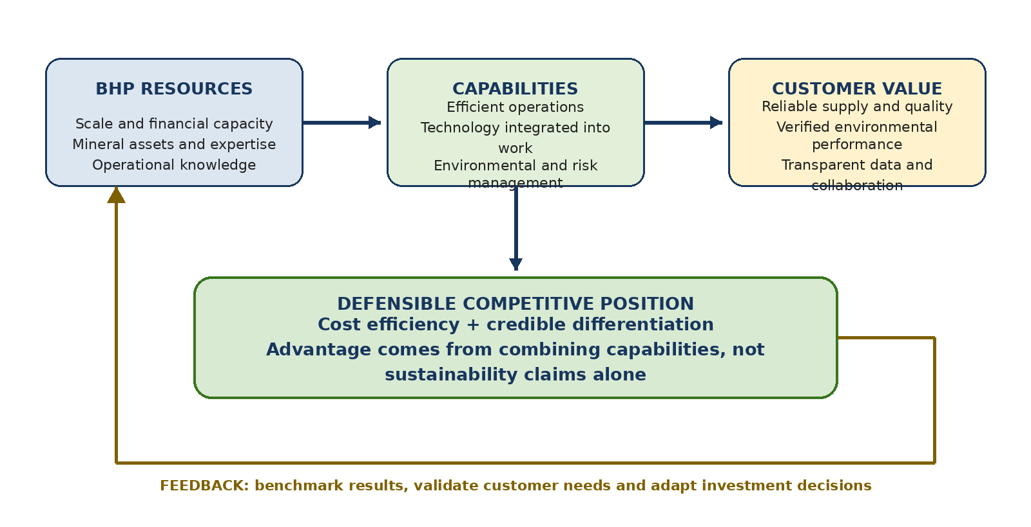

Figure 3: Building and Sustaining Competitive Advantage at BHP
Source: Author’s synthesis based on Porter (1985), Barney (1991) and Hart (1995).

Task 3: Managerial and Professional Reflection
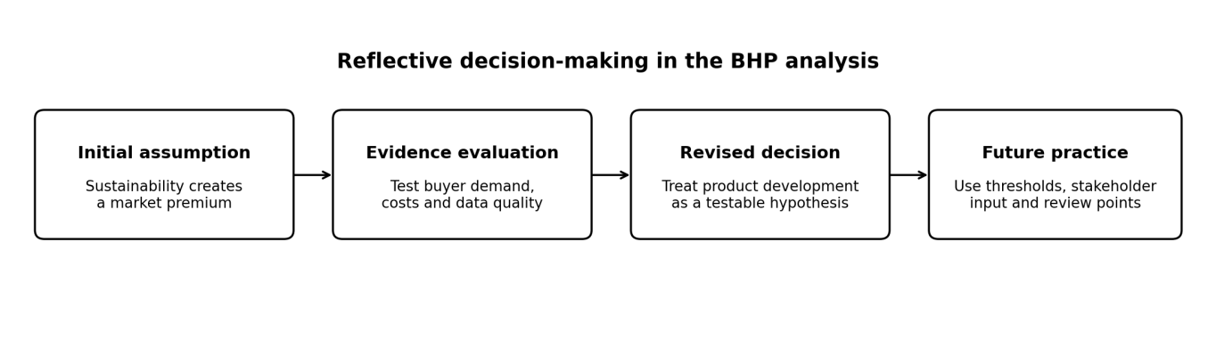Figure 4: Reflective decision-making in the BHP analysis
Source: Author’s own illustration based on Task 3 reflections.
I selected BHP because it illustrates the challenge of balancing demand for transition minerals with the environmental impacts of extraction. Initially, I viewed sustainability mainly as a reputational benefit and response to regulation. Analysing the natural, political-legal and technological environments challenged this assumption. I now
recognize sustainability as a strategic issue whose value depends on operational risks, stakeholder trust and commercial outcomes. This changed my approach from asking whether an initiative appears environmentally positive to examining its evidence, beneficiaries and costs.
The analysis showed me that external factors interact. Water scarcity and extreme weather can disrupt production; regulation can create formal obligations, and technology influences which responses are feasible. I also learned that compliance does not automatically create competitive advantage when competitors face similar requirements. Although marketing environment frameworks helped structure my analysis, they could not replace contextual judgment or consideration of implementation constraints.
Applying Ansoff’s Matrix, Porter’s competitive strategy and Barney’s resource-based view helped me compare growth options. However, I initially favoured lower-emissions copper as a differentiated product without sufficiently testing customer demand. I later recognized that success depends on buyer priorities, credible environmental verification and implementation costs. The BHP–Amazon pilot indicates that a commercial mechanism is being tested, rather than proving that customers generally will pay a premium (BHP, 2026b; RMI, 2026). I therefore revised my recommendation: product development should be treated as a hypothesis requiring procurement evidence and financial validation.

A limitation of my analysis was its reliance on secondary sources, including corporate disclosures that may emphasize favourable performance. I also recognized that BHP’s and Rio Tinto’s emissions-intensity figures use different organizational boundaries, making direct comparison unreliable without adjustment (BHP, 2025; Rio Tinto, 2025). As a consultant, I would verify calculation methods, seek independently assured and comparable data, and interview procurement professionals and affected communities. This would help establish whether the proposed strategy reflects genuine market needs and stakeholder priorities.
Future decisions should combine stakeholder evidence with financial modelling and sensitivity analysis. I would assess capital expenditure, operating costs, verification expenses and potential contract benefits under different scenarios, including one where customers pay no premium. Pre-agreed criteria would determine whether to continue, adapt or stop a project. Environmental improvements may still create value through lower operating costs or protected market access, but these benefits must be demonstrated. I would also avoid allowing sunk costs to justify further investment.
This assignment strengthened my ability to question assumptions, evaluate evidence and communicate uncertainty. In future managerial decisions, I would distinguish verified facts from inference, consult affected stakeholders and review progress against measurable criteria. My key learning is that responsible strategic management requires defensible decisions, transparent acknowledgement of limitations and accountability for outcomes.

Conclusion
BHP’s marketing environment is shaped by natural conditions, political-legal requirements and technological change. Copper demand creates opportunities but does not guarantee competitive advantage. Product development should proceed only when verified environmental attributes matter to buyers and deliver value after assurance costs. BHP should test demand, benchmark comparable sites and scale pilots only when environmental performance, reliability, costs and customer outcomes meet agreed thresholds.

References
Ansoff, H.I. (1957) ‘Strategies for diversification’, Harvard Business Review, 35(5), pp. 113–124.
Barney, J. (1991) ‘Firm resources and sustained competitive advantage’, Journal of Management, 17(1), pp. 99–120.
BHP (2024) Climate Transition Action Plan 2024. Available at: https://www.bhp.com/ctap2024 (Accessed: 16 October 2026).
BHP (2025) Annual Report 2025. Available at: https://www.bhp.com/ar2025 (Accessed: 16 October 2026).
BHP (2026a) Annual Report 2026. Available at: https://www.bhp.com/news/media-centre/reports-presentations/2026/08/2026-annual-reporting-suite (Accessed: 19 October 2026).
BHP (2026b) ‘Industry-first pilot for lower emissions copper market’, 22 September. Available at: https://www.bhp.com/news/media-centre/releases/2026/09/industry-first-pilot-for-lower-emissions-copper-market (Accessed: 19 October 2026).
European Commission (2024) European Critical Raw Materials Act. Available at: https://commission.europa.eu/strategy-and-policy/priorities-2019-2024/european-green-deal/critical-raw-materials-act_en (Accessed: 8 October 2026).
Freeman, R.E. (1984) Strategic Management: A Stakeholder Approach. Boston: Pitman.
Hart, S.L. (1995) ‘A natural-resource-based view of the firm’, Academy of Management Review, 20(4), pp. 986–1014.
IEA (2025a) Global Critical Minerals Outlook 2025. Paris: International Energy Agency. Available at: https://www.iea.org/reports/global-critical-minerals-outlook-2025 (Accessed: 8 October 2026).
IEA (2025b) Copper: Outlook for Key Energy Transition Minerals. Paris: International Energy Agency. Available at: https://www.iea.org/reports/copper-2 (Accessed: 8 October 2026).
IFRS Foundation (2023) IFRS S2 Climate-related Disclosures. Available at: https://www.ifrs.org/issued-standards/ifrs-sustainability-standards-navigator/ifrs-s2-climate-related-disclosures/ (Accessed: 8 October 2026).
Kotler, P., Armstrong, G., Harris, L.C. and He, H. (2024) Principles of Marketing. 19th edn. Harlow: Pearson.
OECD (2023) Handbook on Environmental Due Diligence in Mineral Supply Chains. Paris: OECD Publishing. Available at: https://doi.org/10.1787/ce7d7b2e-en (Accessed: 8 October 2026).
Peattie, K. and Charter, M. (2003) ‘Green marketing’, in Baker, M.J. (ed.) The Marketing Book. 5th edn. Oxford: Butterworth-Heinemann.
Porter, M.E. (1985) Competitive Advantage: Creating and Sustaining Superior Performance. New York: Free Press.
Rio Tinto (2025) Annual Report on Form 20-F 2025. Available at: https://www.sec.gov/Archives/edgar/data/863064/000162828026009531/rio-20251231.htm (Accessed: 16 October 2026).
Rio Tinto (n.d.) ‘START: Sustainability, Traceability and Assurance’. Available at: https://www.riotinto.com/en/sustainability/ethics-compliance/value-chain/start (Accessed: 16 October 2026).
RMI (2026) Turning Buyer Demand into Lower-Emissions Copper Production: An Initial Assessment of Book-and-Claim for the Copper Sector. Available at: https://rmi.org/resources/turning-buyer-demand-into-low-carbon-copper-production/ (Accessed: 16 October 2026).
Teece, D.J. (2007) ‘Explicating dynamic capabilities: The nature and micro foundations of (sustainable) enterprise performance’, Strategic Management Journal, 28(13), pp. 1319–1350. Available at: https://doi.org/10.1002/smj.640.
UNFCCC (2015) Paris Agreement. Available at: https://unfccc.int/process-and-meetings/the-paris-agreement (Accessed: 8 October 2026).

