University of Wales Trinity Saint David
School of Engineering

Analysis of Student Grades using Statistical Methods in Matlab
Engineering Application & Study Skills
ACMA4007
Robert Dale Gubbins
2316959
28/05/2024

Table of Contents
1 Introduction 1
1.1 Scope 1
1.2 Overview of the dataset 1
1.3 Objectives 1
2 Data Import and Summary Statistics 2
2.1 Data Import 2
2.2 Summary Statistics 3
2.3 Limitations of Summary Statistics 4
3 Correlation Analysis 5
3.1 Implications of correlation analysis 6
3.2 Hypothesis Test 7
4 Grouped Data for Exam 1, Exam 2, and O/All Results 10
4.1 Histograms 11
4.2 Ogives 12
5 Conclusion 14
6 References 15
7 Appendices 16

Introduction

Scope
The scope of this report is to apply statistical methods to analyse student grades using Matlab. By performing a range of statistical analyses on a dataset, containing student information and grades, we are aiming to gain an insight into the factors affecting student performance. The analyses will help understand the statistical techniques used in analysing such data and provide a basis for interpreting the results.

Overview of the dataset
The dataset provided for this analysis is named "student_grades.csv" and contains the following columns:
Student ID: A unique identifier for each student.
Gender: Students gender (male or female).
Age: A numerical value of the student's age.
Attendance Percentage: A numerical variable of student's attendance record as a percentage.
1st Exam Score: A numerical variable representing the student's score on the first exam.
2nd Exam Score: A numerical variable representing the student's score on the second exam.

Objectives
- Use appropriate Matlab functions to import and analyse the student performance.
- Provide summary statistics and correlation analysis based on age, attendance and exam scores.
- Utilise a hypothesis test to determine differences in performance based on gender.
- Include relevant visualisations of data including histograms and ogives to support findings.
- Summarise key findings, interpret the results and their implications.

Data Import and Summary Statistics
To begin the analysis, we need to import the dataset "student_grades.csv" into Matlab. This function reads the CSV file and stores the data in a table format, which allows for easy manipulation and analysis of the data.

Data Import
Load the Dataset: Use the readtable function to load the dataset into a Matlab table.
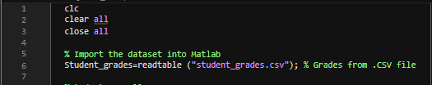
Figure 1 - readtable function.
Create overall student score: Extract the necessary columns for analysis, 1st Exam Score and 2nd Exam Score to calculate the average of the two exam scores.
Figure 2 - Calculate average exam score.
Convert table to matrix: Separate the numerical data for age, attendance, 1st Exam score, 2nd Exam score & Overall score.
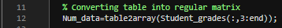
Figure 3 - Convert table into matrix.

Summary Statistics
Summary statistics provide a quick overview of the data, highlighting central tendencies and distribution. Summary statistics are computed for each of the following numerical variables, taken from the “student_grades.csv” dataset:
Age – Provides age distribution of students.
Attendance – Indicates regularity of students attending class as a percentage.
1st and 2nd Exam Score – Indicates student performance in each individual exam.
Overall Score – Indicated average performance of the students across both exams.

These numerical variables are summarised and presented using the following Matlab functions:
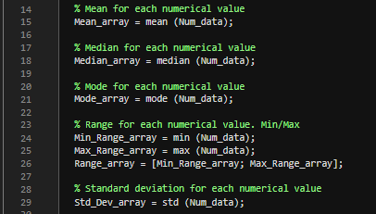
Figure 4 - Summary statistics
Mean - The mean is the average of a data set.
Mode - The mode is the most common number in a data set.
Median - The median is the middle value of the dataset.
Range – The lowest and highest values within the data set.
Standard Deviation (Std) – How much data is spread around the average.

To visualise the summary statistics a function table was created:
Table 1 - Function table
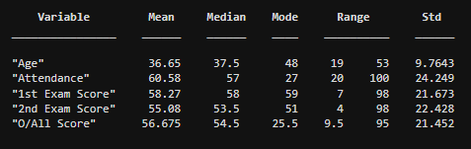

Limitations of Summary Statistics
An example of a limitation of summary statistics could be the presence of outliers. Outliers are values that sit far outside the general values of the dataset thus, affecting the end results.
In ‘Table 1’, only a single value is given for each variable. This does not provide an accurate representation of the data distribution within the entire dataset masking potentially important details.
One potential constraint of summary statistics could be the dependability of the data used to create the dataset. For instance, the results of calculating the national average using a dataset of 100 students from the same school would be erroneous because 100 students from a higher performing school would likely score higher than 100 students from a lower performing school.

Correlation Analysis
Correlation analysis is a method used to measure the strength and direction of the linear relationship between two variables. For this assignment, a correlation analysis was performed to understand the relationships between Age, Attendance Percentage, 1st Exam Score, 2nd Exam Score, and Overall Score. In ‘Figure 5’ the Matlab function ‘corr’ was used to calculate the pairwise linear correlation coefficients, and ‘corrplot’ was used to visualise the correlations seen in ‘Figure 6’. ‘TestR’ was used to flag significant correlations in the correlation matrix.
(datascientist, 2024)
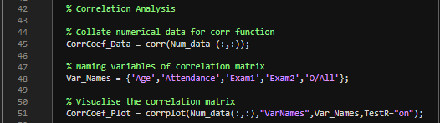
Figure 5 - 'Corr' & 'Corrplot' functions
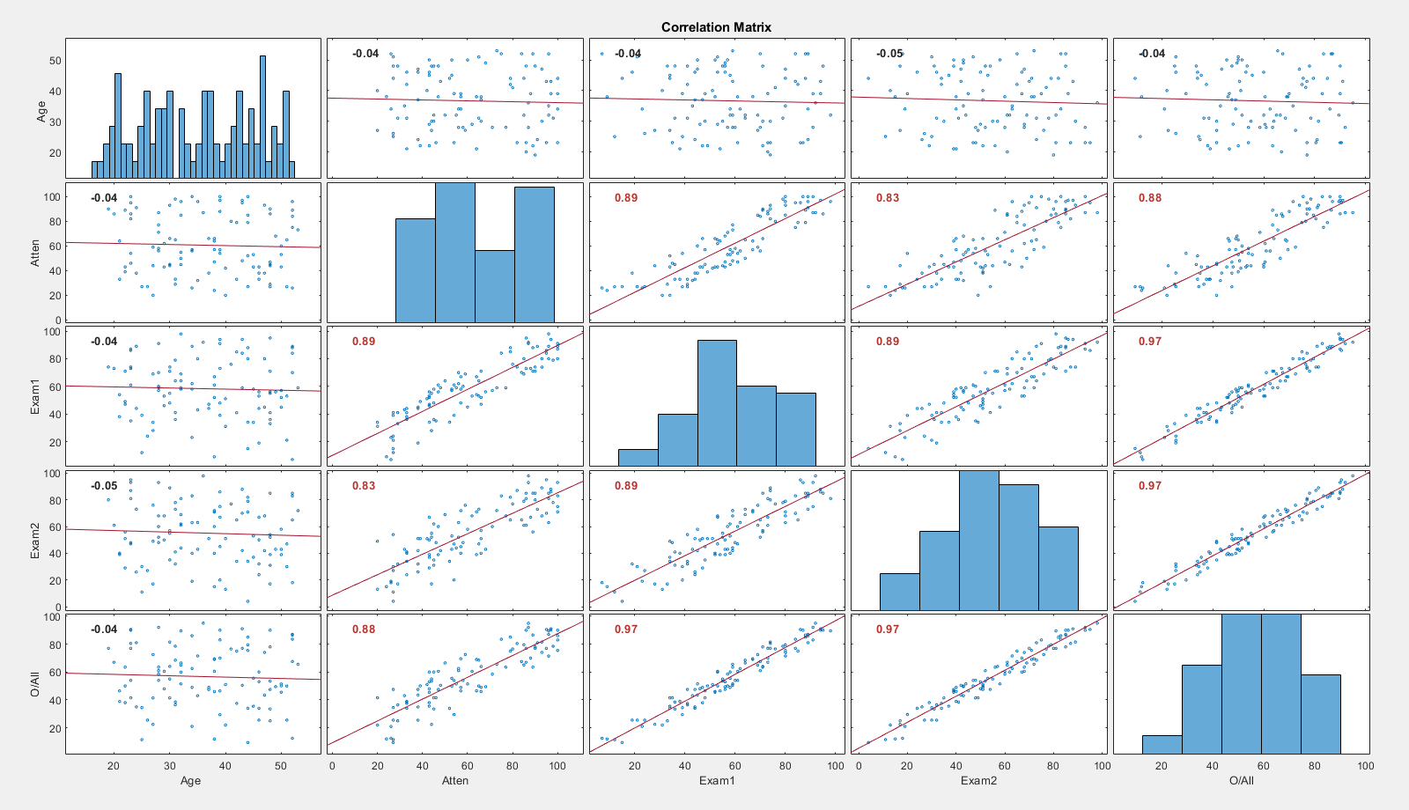
Figure 6 - Correlation matrix

Implications of correlation analysis
Pairwise correlation coefficients between the variables are provided by the correlation matrix. These range from -1 to 1:

- 1 indicates a perfect positive linear relationship.
- -1 indicates a perfect negative linear relationship.
- 0 indicates no linear relationship.
We will discuss the findings of the correlation analysis, firstly by highlighting how the variables correlate, then discuss the implications:
Age
Age against attendance: A weak correlation indicates that exam performance is not significantly affected by exam age.
Age against Exam Scores: A weak correlation indicates that exam performance is not significantly affected by exam age.
Attendance
Attendance against 1st & 2nd Exam scores: Figure 6 implies that higher attendance is correlated with higher test scores in both exams.
Attendance and Overall Score: The importance of regular attendance for academic success is shown by the strong positive association found between attendance and total score.
Exam Scores
1st Exam Score against 2nd Exam Score: A high positive correlation indicates that students who perform well on the first exam tend to also do well on the second exam.
1st Exam Score and Overall Score: The correlation shows the contribution of the first exam to the overall performance.
2nd Exam Score and Overall Score: Again, this correlation shows the contribution of the second exam to the overall score.

Implications
As we can see a strong positive link found between exam scores and attendance, school and academic institutions should uphold consistent attendance in order to enhance student performance.
The results of the first and second exams showed strong correlation, suggesting that early assessment performance can serve as a reliable indicator of future success. Teachers can use this data to recognise and assist students who might require more assistance at an earlier stage.
Finally, exam results and age are not strongly correlated, indicating academic achievement is not highly influenced by age. This suggests that rather than concentrating on age-specific tactics, assistance should be more centred on variables like attendance and performance assessment.

Hypothesis Test
To assess whether there is a significant difference in overall module results between male and female students, a common approach is to perform a hypothesis test. This test compares the means of two groups and tests the null hypothesis that the means are equal.
To conduct the analysis in Matlab, first we must organise the data so that the variables we are interested in are included in the dataset. In this case, separate male and female, and their individual corresponding overall exam results. The gender variable will be categorical, and the exam results numerical.
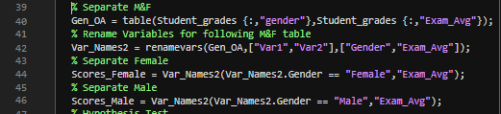
Figure 7 - Separating Male & Female
Now the data has been separated and organised, a hypothesis test can be carried out to assess significant differences in exam results between the two genders. To do this, Matlab’s ttest2 function will be used. This function tests the assumption that the two data samples come from populations with equal means. The p-value, a measurement of the evidence against the null hypothesis, is also returned by this function.
Figure 8 - Hypothesis Test

Results of the hypothesis test are shown in ‘Figure 9’
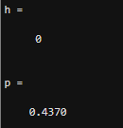
Figure 9 - Hypothesis Test Results
The results shown in ‘figure 9’ give a ‘h’ value of 0 or ‘H0’. This shows that the null hypothesis of ‘the two data samples are from populations with equal means’, can be accepted or more accurately ‘cannot be rejected’.
(OpenStax, 2024)
A p-value less than or equal to 0.05 indicates a statistically significant result, meaning the observed data provides strong evidence against the null hypothesis. In this test, the p-value of 0.4370 denotes that there is strong evidence for the null hypothesis, as the value is far greater than the 0.05 threshold.

Implications
As the null hypothesis (H0) cannot be rejected, and the P-value of 0.4370 is far greater than the 0.05 threshold this shows that any differences in mean values are unlikely to be an effect of gender. This indicates that there is no significant difference in exam results based on gender in this dataset.
As gender does not appear to be a significant factor, this allows tutors and schools to focus more on attendance and performance assessments as these factors are shown to negatively affect student performance when not upheld.

Grouped Data for Exam 1, Exam 2, and O/All Results
By grouping data for Exam 1, Exam 2 and the Overall results we can visualise the data making it easier to compare results, recognise patterns and help understand overall performance.
“Grouping of data plays a significant role when we have to deal with large data. This information can also be displayed using a pictograph or a bar graph. Data formed by arranging individual observations of a variable into groups, so that a frequency distribution table of these groups provides a convenient way of summarizing or analyzing the data is termed as grouped data”
(byjus.com,2024)
The Matlab function ‘histcounts’ can be used to determine the frequency of Exam 1, Exam 2 and the Overall results. These are grouped in classes of width 10.
’Figure 10’ shows the Matlab function for ‘histcounts’ for exam 1 only, this is repeated for exam 2 & overall score.
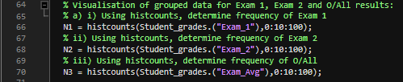
Figure 10 - 'Histcounts' function exam 1.

Histograms
To visualise the data, ’Figure 11’ shows the Matlab function for ‘histogram’ for exam 1 only, this is repeated for exam 2 & overall score.
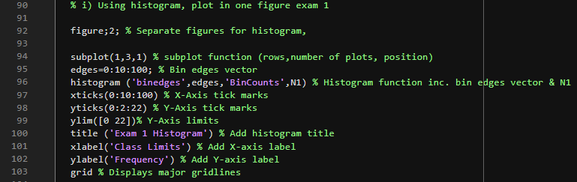
Figure 11 - 'Histogram' function exam 1.
Once repeated for Exam1, Exam 2 & Overall Score, the code in ‘Figure 11’ generates the histogram in ‘Figure 12’.
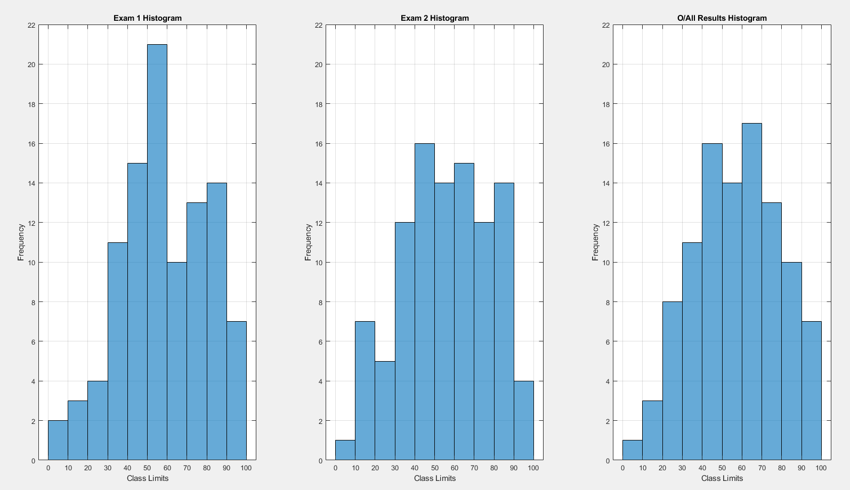
Figure 12 - Histogram for Exam 1, Exam 2 & Overall result.

Ogives
“Ogive or Cumulative Frequency Curve is a curve of a data set obtained by an individual through the representation of cumulative frequency distribution on a graph. As there are two types of cumulative frequency distribution; i.e., Less than cumulative frequencies and More than cumulative frequencies, the ogives are also of two types:
1. Less than Ogive
2. More than Ogive”
(Ogive (Cumulative Frequency Curve) and its Types, 2023)
To visualise the data for a cumulative and inversely cumulative relative frequency, ’Figure 13’ shows the Matlab function to generate an ogive graph for exam 1 only, this is repeated for exam 2 & overall score.
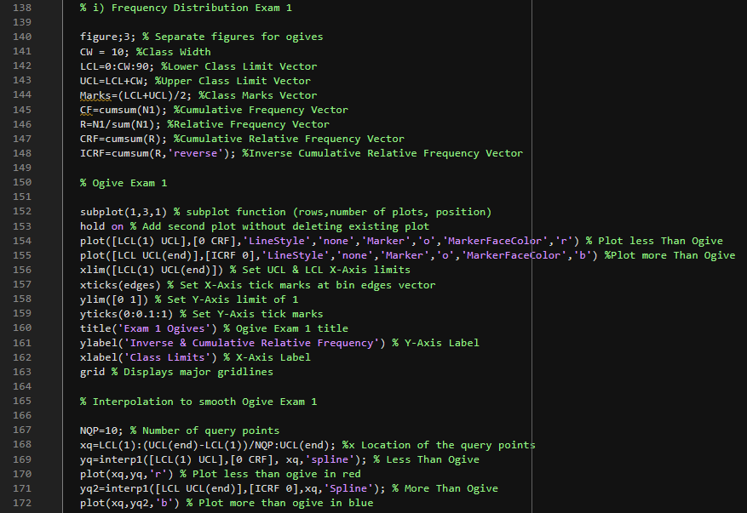
Figure 13 - Generating ogive for Exam 1
Once repeated for Exam1, Exam 2 & Overall Score, the code in ‘Figure 13’ generates the ogives in ‘Figure 12’. Note both cumulative and inversely cumulative relative frequencies are plotted.

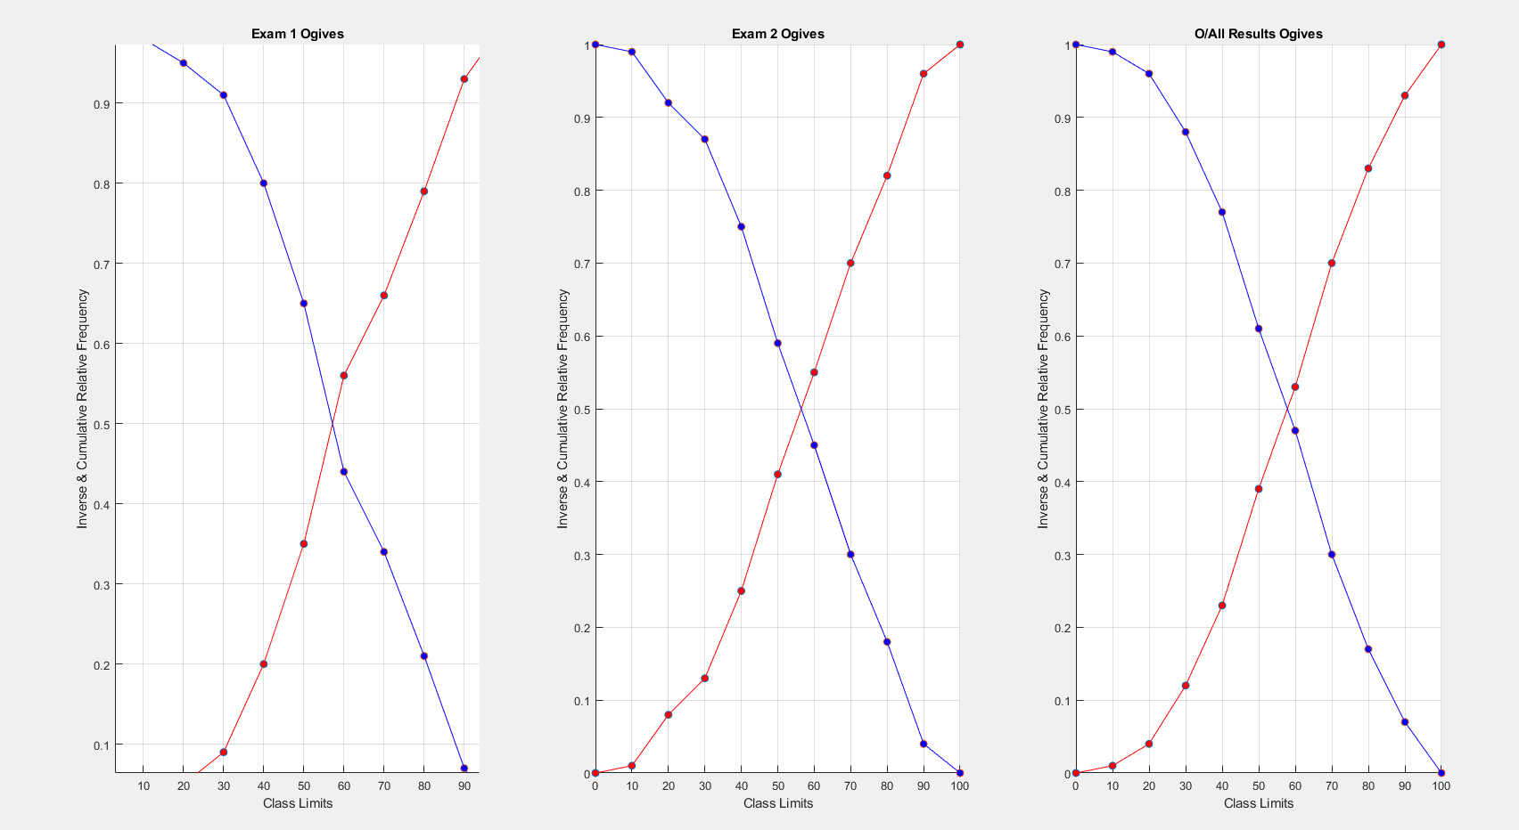
Figure 14 - Inverse cumulative & cumulative frequency ogive for Exam 1, Exam 2 & Overall
‘Figure 14’ Ogives are useful for identifying the amount of students who scored below or above a set amount as the data for each exam and overall score is clearly displayed, allowing quick comparison across the groups.
The median of the collection of data can be found using the Ogive Graph or cumulative frequency graphs. The median value is found at the x-axis, which is the point where both curves intersect.
(Testbook, 2024)

Conclusion
In summary, analysis of the student grades provided a valuable insight into the factors affecting student performance. The correlation analysis highlighted the importance of attendance with respect to exam results, whereas age did not appear to significantly affect scores. The implication of this may be that academic institutions place more emphasis on the importance of attendance.
A strong correlation between exam 1, and exam 2 scores, suggested the students who scored highly in the first exam were likely to score well in the second.
A two-sample t-test (Hypothesis test) compared exam scores between male and female students, a p-value of 0.4370 showed there was no significant difference in performance between genders.
By grouping and visualising class data in groups of 10 as histograms and ogives, we were able to recognise patterns in test scores and quickly identify the number of students scoring above and below specific scores. For overall exam results most students scored between 60-70%. Again, this information could be especially useful to schools and academic institutions as support can be allocated accordingly, to students who require the support in a timely manner.
A strength of the statistical methods used in this report are firstly the ability to summarise the dataset, allowing us to identify patterns or trends easily. Also, comparing several datasets or groups within a dataset is made simpler by condensing data into metrics like the mean and standard deviation.
Some limitations of the statistical methods used may be the lack of depth in the summary statistics due to a small dataset, which fail to give a true representation the data. Resulting in a loss of detail and potentially significant deviation in results.
As mentioned previously, vulnerability to outliers is a limitation. A single extreme value can significantly skew the mean values of the dataset, making it less representative of your data.
(Researchmethod, 2024)

References
BYJU’S, 2024.Grouping Data. [Online]
Available at: https://byjus.com/maths/grouping-data/
(Accessed: 23 May 2024)
Geeksforgeeks,2023. Ogive (Cumulative Frequency Curve) and its Types. [Online]
Available at: https://www.geeksforgeeks.org/ogive-cumulative-frequency-curve-and-its-types/
(Accessed: 24 May 2024)
Testbook, 2024. Ogive - Definition, Graph, Chart, Uses, Examples, Practice Questions and FAQs. [Online]
Available at: https://testbook.com/maths/ogive
(Accessed: 25 May 2024)
Barbara Illowsky & Susan Dean, 2020. Statistics. 9.1 Null and Alternative Hypotheses. [Online]
Available at: https://openstax.org/books/statistics/pages/9-1-null-and-alternative-hypotheses
(Accessed: 24 May 2024)
Mathworks, 2024. MATLAB The Language of Technical Computing. [Online]
Available at: https://uk.mathworks.com/help/
(Accessed: 20 May 2024)
Muhammad Hassan, Researchmethod, 2024. Descriptive Statistics – Types, Methods and Examples. [Online]
Available at: https://researchmethod.net/descriptive-statistics/
(Accessed: 21 May 2024)
Data Science, 2024. Understanding Correlation Coefficient: Definition and Applications. [Online]
Available at: https://datascientest.com/en/understanding-correlation-coefficient-definition-and-applications
(Accessed: 22 May 2024)

Appendices
clc % Clear text from command window
clear all % Removes variables from system memory
close all % Deletes current figures

%***IMPORTING DATASET INTO MATLAB & CONVERTING TO MATRIX***

% Import the dataset into Matlab
Student_grades=readtable ("student_grades.csv"); % Grades from .CSV file
%Student overall score
Student_grades.("Exam_Avg") = (Student_grades.("Exam_1") + Student_grades.("Exam_2"))/2; % Creating overall student score using Exam 1 + Exam 2 /2
% Converting table into regular matrix
Num_data=table2array(Student_grades(:,3:end)); % Seperate numerical data from Student_grades file (age,att,exam1,exam2,overall)

%***MEASURES OF CENTRAL TENDANCY AND DISPERSION***

% Mean for each numerical value
Mean_array = mean (Num_data); % create mean array from numerical data set
% Median for each numerical value
Median_array = median (Num_data); % create median array from numerical data set
% Mode for each numerical value
Mode_array = mode (Num_data); % create mode array from numerical data set
% Range for each numerical value. Min/Max
Min_Range_array = min (Num_data); % Minimum range of numerical data
Max_Range_array = max (Num_data); % Maximum range of numerical data
Range_array = [Min_Range_array; Max_Range_array]; % Range of numerical data
% Standard deviation for each numerical value
Std_Dev_array = std (Num_data); % create standard deviation array from numerical data set

%***NAMING VARIABLES & CREATING FUNCTION TABLE***
Variable = ["Age";"Attendance";"1st Exam Score";"2nd Exam Score";"O/All Score"]; % Naming variables
Mean = [Mean_array'];% Mean array for function table
Median = [Median_array']; % Median array for function table
Mode = [Mode_array']; % Mode array for function table
Range = [Range_array']; % Range array for function table
Std = [Std_Dev_array']; % Std array for function table

% Function table
Function_table = table (Variable, Mean, Median, Mode, Range, Std)

% ***CALCULATE PAIRWISE LINEAR CORRELATION COEFFICIENT & VISUALISE CORRELATION MATRIX***

% Collate numerical data for corr function
CorrCoef_Data = corr(Num_data (:,:));
% Naming variables of correlation matrix
Var_Names = {'Age','Attendance','Exam1','Exam2','O/All'};
% Visualise the correlation matrix
CorrCoef_Plot = corrplot(Num_data(:,:),"VarNames",Var_Names,TestR="on");

%***SEPARATE GENDERS & HYPOTHESIS TEST (TTEST2). INC RESULTS***

% Separate M&F by gender and overall exam score
Gen_OA = table(Student_grades {:,"gender"},Student_grades {:,"Exam_Avg"});
% Rename Variables for following M&F table
Var_Names2 = renamevars(Gen_OA,["Var1","Var2"],["Gender","Exam_Avg"]);
% Separate Female
Scores_Female = Var_Names2(Var_Names2.Gender == "Female","Exam_Avg");
% Separate Male
Scores_Male = Var_Names2(Var_Names2.Gender == "Male","Exam_Avg");
% Hypothesis Test
[h,p] = ttest2(Scores_Female{:,:},Scores_Male{:,:})
% Display test results in the command window & summarise the analysis
% outcomes
if h==0
disp(['The null hypothesis (h=0) states no relationship exists between the two variables being studied (one variable does not affect the other).' ...
'This indicates that there is no significant difference in exam results based on gender in this dataset.'])
else
disp('The alternative hypothesis (h=1) shows that there is an effect between the two variables being studied.')
end
disp (' ') % Space between statements in command window.
if p<=0.05
disp('A p-value less than or equal to 0.05 indicates a statistically significant result, meaning the observed data provides strong evidence against the null hypothesis')
else
disp('A p-value of >0.05 means we retain the null hypothesis and reject the alternative hypothesis (h1)')
end

%***VISUALISIATION OF GROUPED DATA FOR EXAM 1, EXAM 2 & O/ALL RESULTS***

% a) ***HISTCOUNTS FUNCTION***

% i) Using histcounts, determine frequency of Exam 1
N1 = histcounts(Student_grades.("Exam_1"),0:10:100);
% ii) Using histcounts, determine frequency of Exam 2
N2 = histcounts(Student_grades.("Exam_2"),0:10:100);
% iii) Using histcounts, determine frequency of O/All
N3 = histcounts(Student_grades.("Exam_Avg"),0:10:100);

% b) ***HISTOGRAM FUNCTION***

% i) Using histogram, plot in one figure exam 1

figure;2; % Separate figures for histogram,

subplot(1,3,1) % subplot function (rows,number of plots, position)
edges=0:10:100; % Bin edges vector
histogram ('binedges',edges,'BinCounts',N1) % Histogram function inc. bin edges vector & N1
xticks(0:10:100) % X-Axis tick marks
yticks(0:2:22) % Y-Axis tick marks
ylim([0 22])% Y-Axis limits
title ('Exam 1 Histogram') % Add histogram title
xlabel('Class Limits') % Add X-axis label
ylabel('Frequency') % Add Y-axis label
grid % Displays major gridlines

% ii) Using histogram, plot in one figure exam 2

subplot(1,3,2) % subplot function (rows,number of plots, position)
edges=0:10:100; % Bin edges vector
histogram ('binedges',edges,'BinCounts',N2) % Histogram function inc. bin edges vector & N2
xticks(0:10:100) % X-Axis tick marks
yticks(0:2:22) % Y-Axis tick marks
ylim([0 22])% Y-Axis limits
title ('Exam 2 Histogram') % Add histogram title
xlabel('Class Limits') % Add X-axis label
ylabel('Frequency') % Add Y-axis label
grid % Displays major gridlines

% iii) Using histogram, plot in one figure O/All score

subplot(1,3,3) % subplot function (rows,number of plots, position)
edges=0:10:100; % Bin edges vector
histogram ('binedges',edges,'BinCounts',N3) % Histogram function inc. bin edges vector & N3
xticks(0:10:100) % X-Axis tick marks
yticks(0:2:22) % Y-Axis tick marks
ylim([0 22])% Y-Axis limits
title ('O/All Results Histogram') % Add histogram title
xlabel('Class Limits') % Add X-axis label
ylabel('Frequency') % Add Y-axis label
grid % Displays major gridlines

% C) ***PLOT FUNCTION (OGIVES)***

% Using plot function, plot in one figure the more (in blue) and less
% (in red) than ogives for,

% OGIVE EXAM 1

% i) Frequency Distribution Exam 1

figure;3; % Separate figures for ogives
CW = 10; %Class Width
LCL=0:CW:90; %Lower Class Limit Vector
UCL=LCL+CW; %Upper Class Limit Vector
Marks=(LCL+UCL)/2; %Class Marks Vector
CF=cumsum(N1); %Cumulative Frequency Vector
R=N1/sum(N1); %Relative Frequency Vector
CRF=cumsum(R); %Cumulative Relative Frequency Vector
ICRF=cumsum(R,'reverse'); %Inverse Cumulative Relative Frequency Vector

% Ogive Exam 1

subplot(1,3,1) % subplot function (rows,number of plots, position)
hold on % Add second plot without deleting existing plot
plot([LCL(1) UCL],[0 CRF],'LineStyle','none','Marker','o','MarkerFaceColor','r') % Plot less Than Ogive
plot([LCL UCL(end)],[ICRF 0],'LineStyle','none','Marker','o','MarkerFaceColor','b') %Plot more Than Ogive
xlim([LCL(1) UCL(end)]) % Set UCL & LCL X-Axis limits
xticks(edges) % Set X-Axis tick marks at bin edges vector
ylim([0 1]) % Set Y-Axis limit of 1
yticks(0:0.1:1) % Set Y-Axis tick marks
title('Exam 1 Ogives') % Ogive Exam 1 title
ylabel('Inverse & Cumulative Relative Frequency') % Y-Axis Label
xlabel('Class Limits') % X-Axis Label
grid % Displays major gridlines

% Interpolation to smooth Ogive Exam 1

NQP=10; % Number of query points
xq=LCL(1):(UCL(end)-LCL(1))/NQP:UCL(end); %x Location of the query points
yq=interp1([LCL(1) UCL],[0 CRF], xq,'spline'); % Less Than Ogive
plot(xq,yq,'r') % Plot less than ogive in red
yq2=interp1([LCL UCL(end)],[ICRF 0],xq,'Spline'); % More Than Ogive
plot(xq,yq2,'b') % Plot more than ogive in blue

% OGIVE EXAM 2

% ii) Frequency Distribution Exam 2

CW = 10; %Class Width
LCL=0:CW:90; %Lower Class Limit Vector
UCL=LCL+CW; %Upper Class Limit Vector
Marks=(LCL+UCL)/2; %Class Marks Vector
CF=cumsum(N2); %Cumulative Frequency Vector
R=N2/sum(N2); %Relative Frequency Vector
CRF=cumsum(R); %Cumulative Relative Frequency Vector
ICRF=cumsum(R,'reverse'); %Inverse Cumulative Relative Frequency Vector

% Ogive Exam 2

subplot(1,3,2) % subplot function (rows,number of plots, position)
hold on % Add plot without deleting existing plot
plot([LCL(1) UCL],[0 CRF],'LineStyle','none','Marker','o','MarkerFaceColor','r') %Less Than Ogive
plot([LCL UCL(end)],[ICRF 0],'LineStyle','none','Marker','o','MarkerFaceColor','b') %More Than Ogive
xlim([LCL(1) UCL(end)]) % Set UCL & LCL X-Axis limits
xticks(edges) % Set X-Axis tick marks at bin edges vector
ylim([0 1]) % Set Y-Axis limit of 1
yticks(0:0.1:1) % Set Y-Axis tick marks
title('Exam 2 Ogives') % Ogive Exam 2 title
ylabel('Inverse & Cumulative Relative Frequency') % Y-Axis Label
xlabel('Class Limits') % X-Axis Label
grid % Displays major gridlines

% Interpolation to smooth ogives Exam 2

NQP=10; %Number of query points
xq=LCL(1):(UCL(end)-LCL(1))/NQP:UCL(end); %x Location of the query points
yq=interp1([LCL(1) UCL],[0 CRF], xq,'spline'); %Less Than Ogive
plot(xq,yq,'r') % Plot less than ogive in red
yq2=interp1([LCL UCL(end)],[ICRF 0],xq,'Spline'); %More Than Ogive
plot(xq,yq2,'b') % Plot more than ogive in blue

% OGIVE O/ALL

% iii) Frequency Distribution O/all

CW = 10; %Class Width
LCL=0:CW:90; %Lower Class Limit Vector
UCL=LCL+CW; %Upper Class Limit Vector
Marks=(LCL+UCL)/2; %Class Marks Vector
CF=cumsum(N3); %Cumulative Frequency Vector
R=N3/sum(N3); %Relative Frequency Vector
CRF=cumsum(R); %Cumulative Relative Frequency Vector
ICRF=cumsum(R,'reverse'); %Inverse Cumulative Relative Frequency Vector

% Ogive O/All Exam
subplot(1,3,3) % subplot function (rows,number of plots, position)
hold on % Add plot without deleting existing plot
plot([LCL(1) UCL],[0 CRF],'LineStyle','none','Marker','o','MarkerFaceColor','r') %Less Than Ogive
plot([LCL UCL(end)],[ICRF 0],'LineStyle','none','Marker','o','MarkerFaceColor','b') %More Than Ogive
xlim([LCL(1) UCL(end)]) % Set UCL & LCL X-Axis limits
xticks(edges) % Set X-Axis tick marks at bin edges vector
ylim([0 1]) % Set Y-Axis limit of 1
yticks(0:0.1:1) % Set Y-Axis tick marks
title('O/All Results Ogives') % Ogive O/All results title
ylabel('Inverse & Cumulative Relative Frequency') % Y-Axis Label
xlabel('Class Limits') % X-Axis Label
grid % Displays major gridlines

% Interpolation to smooth ogives O/All exam

NQP=10; %Number of query points
xq=LCL(1):(UCL(end)-LCL(1))/NQP:UCL(end); %x Location of the query points
yq=interp1([LCL(1) UCL],[0 CRF], xq,'spline'); % Less Than Ogive
plot(xq,yq,'r') % Plot less than ogive in red
yq2=interp1([LCL UCL(end)],[ICRF 0],xq,'spline'); % More Than Ogive
plot(xq,yq2,'b') % Plot more than ogive in blue

