DS 1 Template

My Screenshots/Photos
- Please add 4–6 screenshots or photos of your digital life.
- You can use your phone or laptop.
- For each screenshot, write one or two sentences explaining what it shows.

Screenshot/Photo 1
[Insert Photo/Screenshot below]
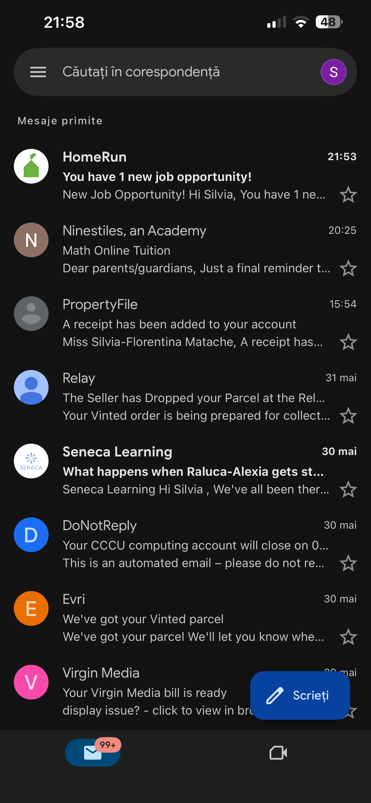
[Write what this shows of your digital life]
I use email everyday to check university work and emails from my children’s school. Thid shows email is important in my digital life because it helps me keep everything organised and communicate with others.

Screenshot/Photo 2
[Insert Photo/Screenshot below]
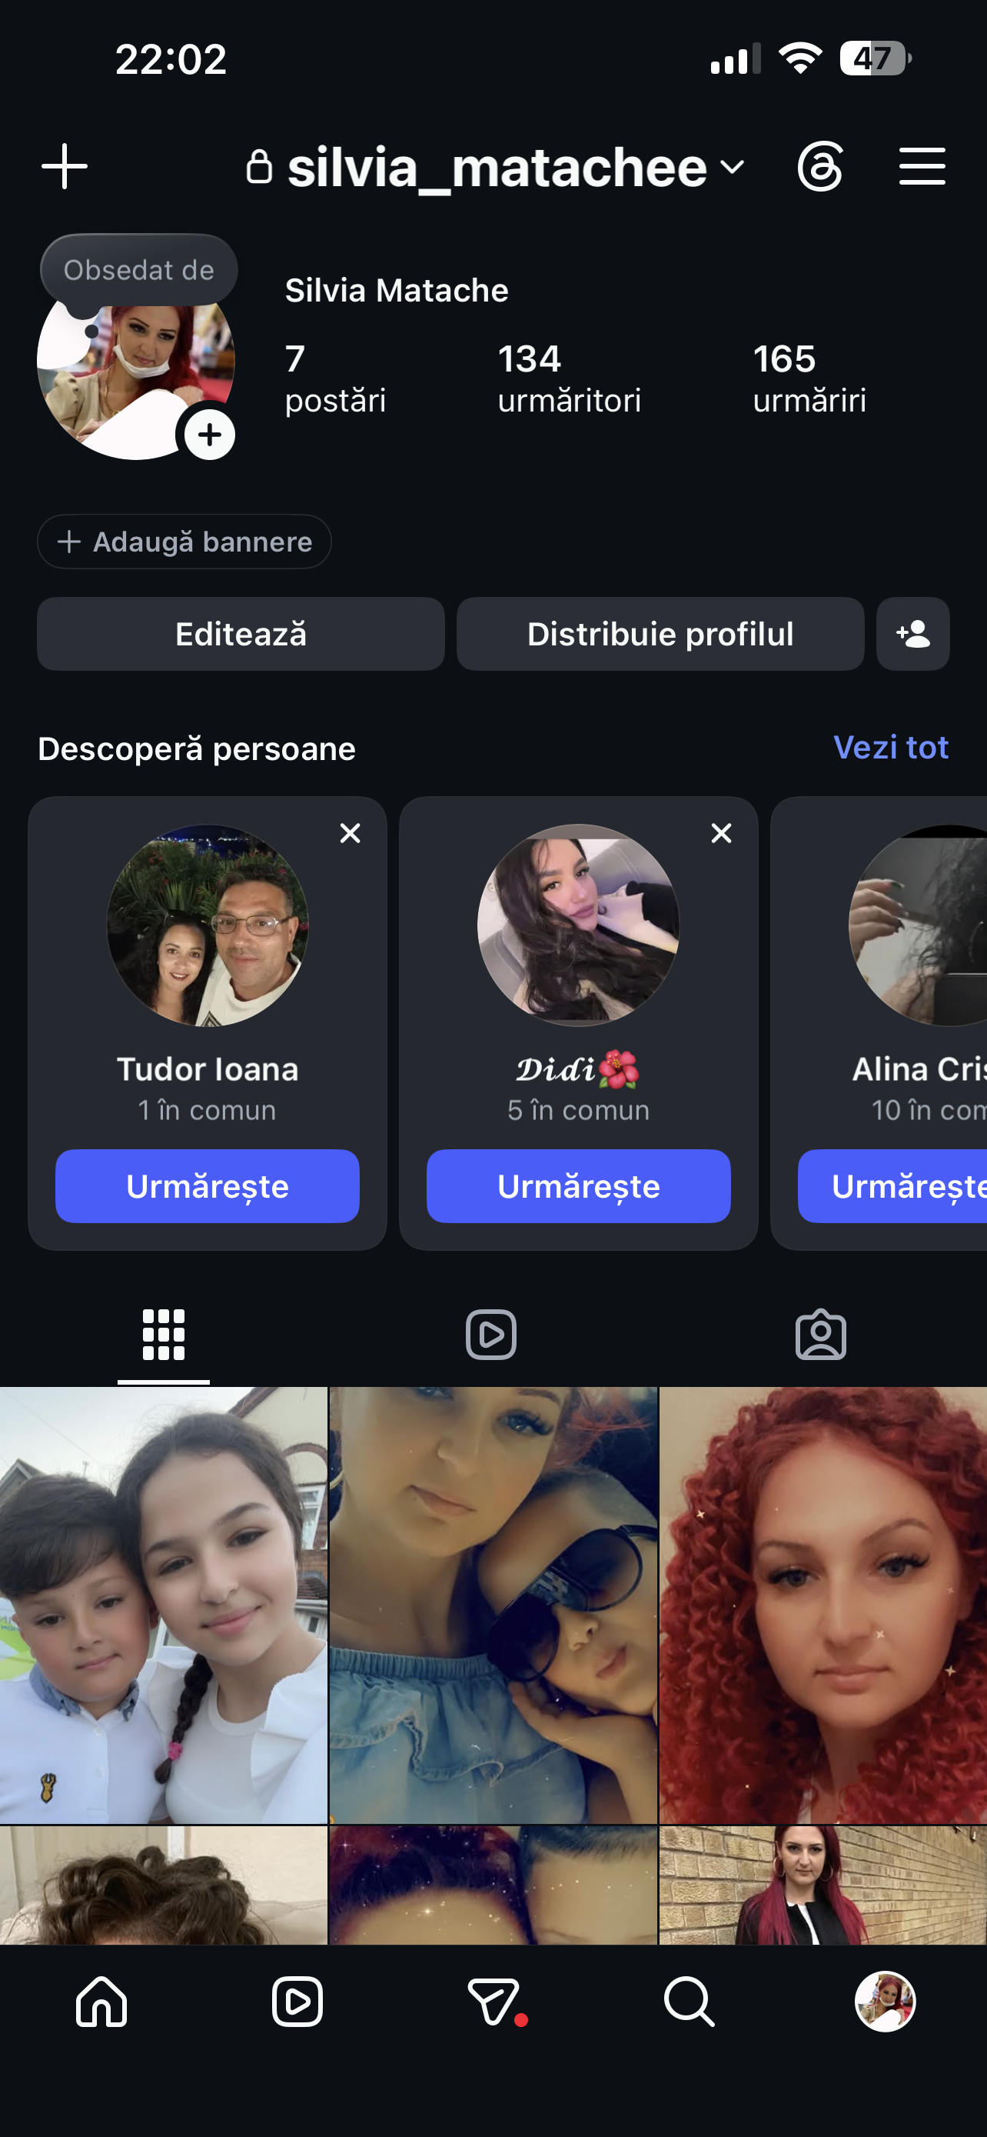
[Write what this shows of your digital life]
I use Instagram to keep up with friends, family and topics that interest me. Social media plays a roll with how I connect with people and like to do in my free time.

Screenshot/Photo 3
[Insert Photo/Screenshot below]
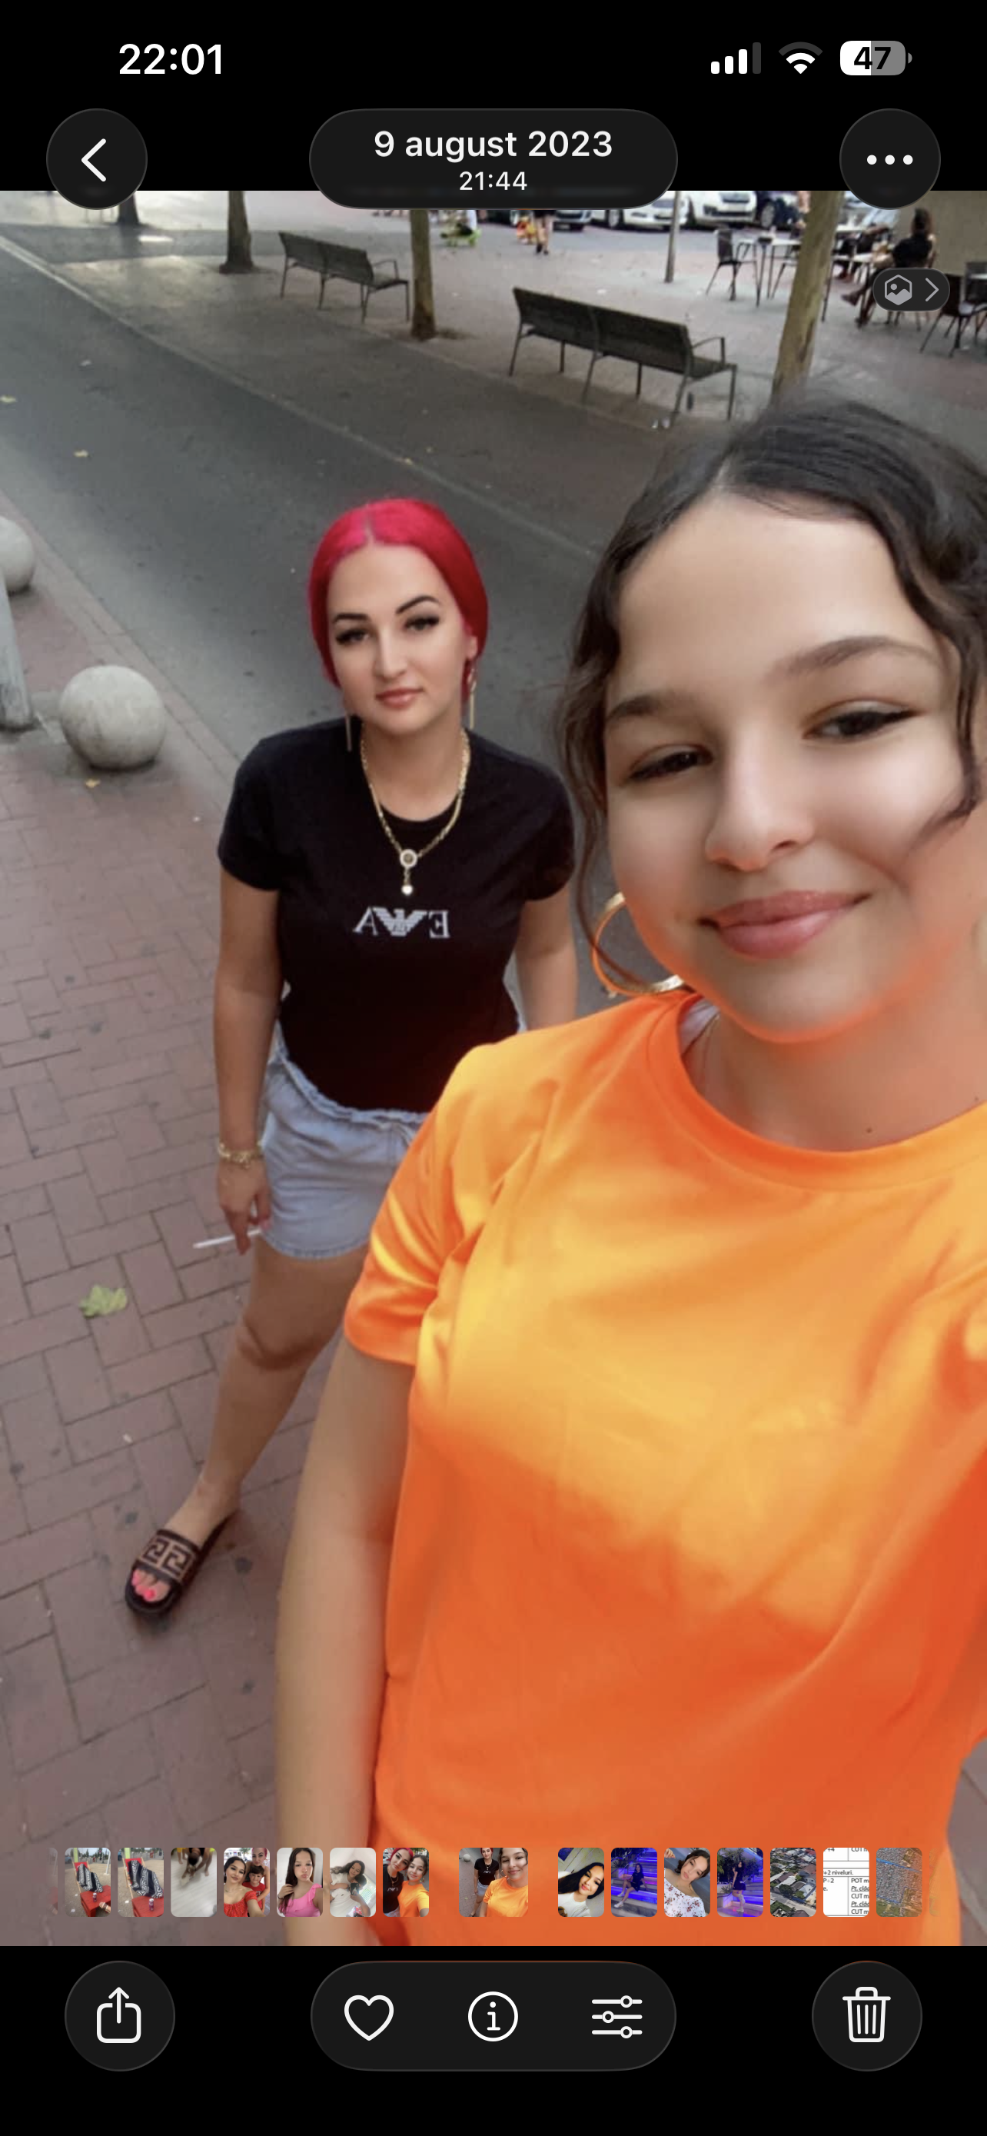
[Write what this shows of your digital life]
I take and save photos and videos of memorable moments to my phone. Technology helps me store personal memories that I can then go and look back on.

Screenshot/Photo 4
[Insert Photo/Screenshot below]
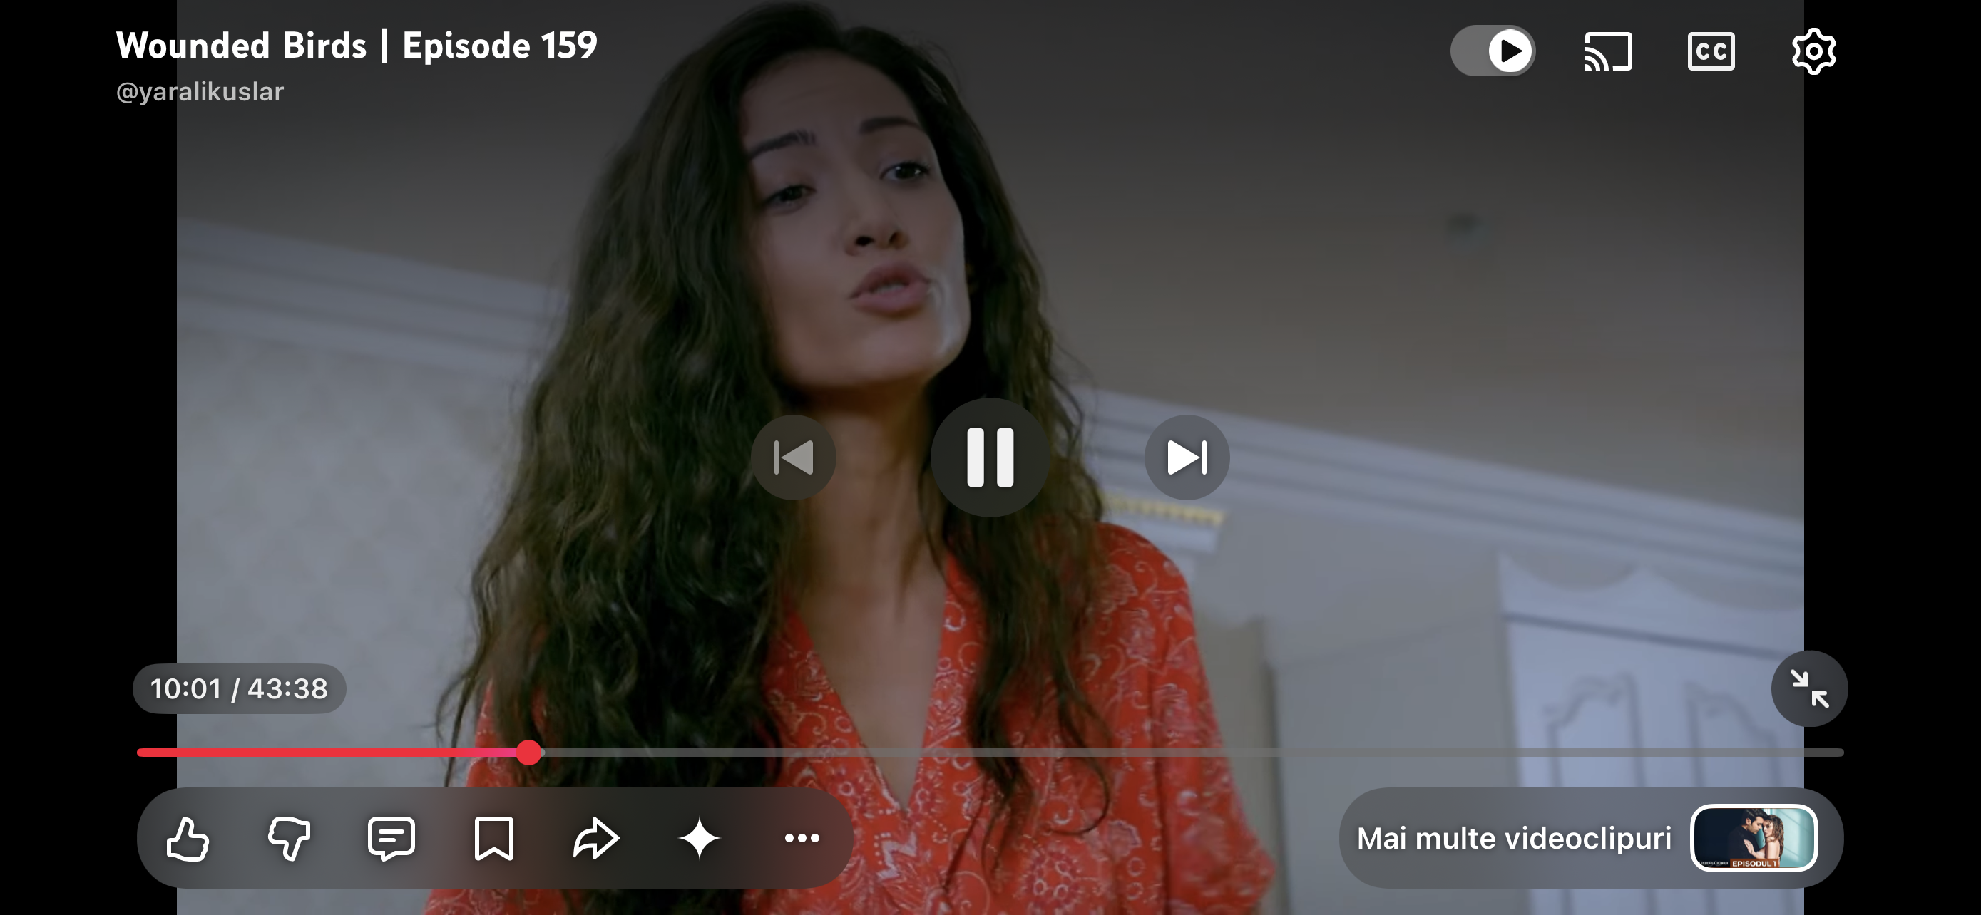
[Write what this shows of your digital life]
I watch series and movies online to relax and enjoy myself. Digital platforms are a big part In how I enjoy to spend my free time.

Screenshot/Photo 5
[Insert Photo/Screenshot below]
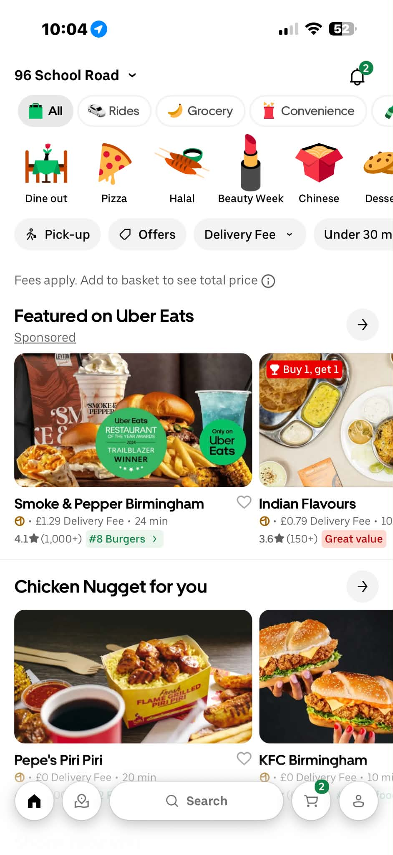
[Write what this shows of your digital life]
I sometimes use food delivery apps when I don’t have time to cook or go out. Digital services make everyday tasks more convenient when you are not available to complete them.

Screenshot/Photo 6
[Insert Photo/Screenshot below]
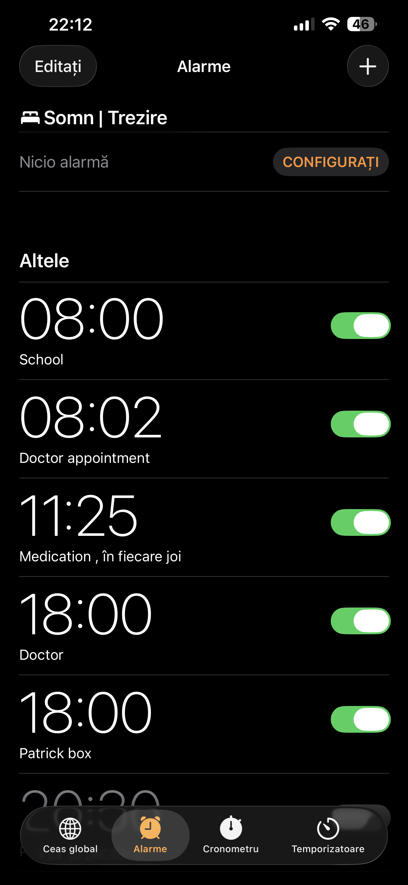
[Write what this shows of your digital life]
I use the alarm on my phone to wake up every morning and to keep track of daily tasks. My phone is an essential took that helps me go about my day and reminds me of things that need doing.

My Short Reflection
- Write 5–8 simple sentences about your digital life.
- You can use the sentence starters below if helpful.
I use digital tools everyday weather its entertainment or daily activities such as watching shows or setting reminders and alarms. I feel confident when I have everything under control. I often use it for reminders and entertainment. Digital skills are important for studying and working especially from home. I also enjoy making memories and having one place where I can find everything such as my phone rather than printed pictures that can get lost easily. Digital platforms are more convenient as u have everything you need on one device.

Sentence starters
- I use digital tools to …
- I feel confident when I …
- I want to improve …
- I often use these tools: …
- I sometimes feel nervous about …
- I hope this module will help me …
- Digital skills are important for me because …
You can write more if you want.

Submission Checklist
Before you submit, please check:
​​​ ☐ I added 4–6 screenshots
☐ I wrote short sentences for each screenshot
☐ I wrote my short reflection
☐ My work is my own
☐ My file opens correctly
​​☐ My file opens correctly

