University of Wales Trinity Saint David
School of Engineering

FESTO Cyber Physical Production System – Goods Dispatch Process Automation Development
Manufacturing Design & Technology
ACMA5002

Lewis Owen Nekrews
2008701
17/06/2022

Summary
The purpose of the report was to create a mechanically actuated gripper for a cyber physical production system. The report examines principles for design of assembly and manufacturing using tools that could aid development.
This gripper’s main function was to extract the finished assembly and transport it onto the automated guided robot. To be able to do this, it was attached to a Cobot arm, which was then used as a source of mobility.
This process would be then cycled as part of the cyber physical production system, which was intended to increase efficiency and sustainability over other practices. Deployment of this system in an industrial organization can help create new markets and innovative opportunities.
Quality function deployment was used to understand the customer needs when designing a suitable gripper and then turn those needs into engineering characteristics. It listed the attributes important to the customer, design requirements for driving those attributes and the targets for the design. The house of quality method was provided to approach this and uses a cross functional approach to organize and link the design attributes. The implementation of this method proved useful when identifying and positioning the customers expectations and focuses on the attributes when designing the gripper.
Design failure mode effects analysis looked at the potential failures in the gripper design process. It highlighted what functions were required in the design and then analyzed the risks associated with them. Identifying these risks with the gripper helped when modeling the concepts as it gave knowledge of what to consider or avoid in development. This would potentially save time and cost in an industrial environment and would prove to be more productive in project development. The failure mode effect analysis was assessed again when the completion of the final design was finished and scored on its results. This method had assisted on how to prevent any position errors in the design and analysis and how to improve them whilst referring to the resulted method.
The concept designs were created in order to have an efficient idea on what could be implemented into the final design. The designs had all different methods of performing the operation, which were ideal for visualizing the best direction to progress. Some of the features illustrated were inserted into the final design and its procedure when loading and unloading. Key details of the gripper chosen as the final design included its potential ability to grasp the product securely and its low cost in manufacturing.
The materials were specified to suit the demand in repeatability in production and the longevity of the gripper. Simulation took place to analyze where the most stress would be applied when force is included to grasp the product. This assisted in the final design in case any further support would be required to create strength.
With the final design chosen, technical drawings were created to show the finished product exploded and all the components listed in a bill of materials.
For the success of the project design and manufacturing procedure, it was essential that research was undertaken on the key principles of manufacturing and assembly processes. This analysis influenced the final result significantly with the knowledge gained.

Table of Contents
Summary 1
Procedure & Analysis 5
Methodology 6
Design for assembly 7
QFD 7
DFMEA 10
DFMEA Table 12
Concept Designs 13
Final Design 15
Final Design Procedure 16
Conclusion 20
References 21

Introduction
The aim of the assignment was too design an efficient gripping device that could prove more than capable of transferring the finished product and repeating the procedure on a mass-producing level. To further gain knowledge through applying manufacturing processes and understand its limitations.
The assumptions for creating the device would be, that there were no constraints in the material or aesthetic requirements in the design process. Also it was assumed, whereas there was no stated limit to cost for development and manufacturing for the gripper, this would have to be a considered as well as no programming limitations on how the Cobot arm operated its procedure
The cyber physical production system consists of cooperative subsystems that are all connected within a level of production. They are connected with all levels of production from the start to the end of the finished product. The term cyber physical system according to Verlag, (2017) means “ the integration of computing systems with physical processes and physical environments”.
This method of production is shown to create a safer and easier environment in technical industries due to its efficiency. Robotics can work more efficiently and accurately, boosting productivity and with the software, via sensors, they monitor the performance on constant. It also monitors the stock levels of each component on the supply chain and indicates when stock is needed.
The system required a gripping devise at the end of a Cobot arm, which was programmed to move the fully assembled mobile phone from the dispatch station and onto an automated guided vehicle. A gripper was attached onto the end of the arm to aid in achieving its operation.
It was essential that the gripper was mechanically actuated and able to handle mass production. It was not recommend using a vacuum method of gripper, as it would not be efficient enough for the procedure. The design process followed a number of methods and techniques in order to develop an efficient component to serve the task. Some methodologies researched and implemented in the assignment were, design for assembly and manufacturing and quality function development.

Procedure & Analysis
The Cobot arm and gripper were needed to complete the cycle of the system and without these the whole process would be ineffective. The designer had to create an appropriate gripper that was fully compatible with the Cobot arm and did not disrupt any of the other processes in its environment when in operation. Important considerations during the creation of the design were its practicality, it was essential that the design geometry didn’t impact negatively when manufacturing the gripper.
The key aspects were identified when evaluating the systematic process
The unloading of the assembled phone was dispatched into a station where up to four complete phones could sit and wait to be transported. This area of output was separated into two sliding departments with sensors to monitor the sections capacity. If the section had stored its maximum amount, the previous subsection would not load any more completed phones.
The Cobot arm would be triggered by the sensors on the sliding beds to indicate when ready to be removed. The Cobot arm would then proceed to move toward the phone case to remove it and relocate onto the automated guided vehicle. It is suggested by Albstadt-Sigmarington (2017) that this vehicle has a laser scanner that scans the environment and redirects its path if met with obstruction. The automated guided vehicle, called Robitino, also has object identification capabilities, meaning when the Cobot places a product on its bed, its proceeds to the invert point. When the Robotino has returned, the process is repeated.
According to Monkman, (2007) when matching the correct gripper to the project, the following characteristics should be considered:
- Orientation of the gripper in relatation to the handling equipment
- Resulting force, which depends on the masses and inertia and included centrifugal forces
- Geometry of the object and its surfaces, position of the centre of gravity
- Design the gripper jaws in connection the distribution of force, including shape and forces matching
- Surface properties of the workplace and the gripper jaw, rigidity impact sensitivity
- Environmental effecting dust and other contaminant, temperature and vibration

Methodology
Prior to commencing designing a product to perform the operation, the goal was to have a design that could attain the highest productively to the system and achieve its task with minimum effort and energy. The early development stages concentrated on two key areas, design for manufacturing and design for assembly
To ensure productivity at a maximum, designing for manufacturing would be necessary. According to Poll (2001)“design and manufacturing (DFM) is a philosophy and mind set in which manufacturing input is used at the earliest stages of design in order to design parts and product than can be produced more easily and more economically”.
To design this gripper to establish the manufacturing process would take influences mainly on the cost of component manufacture. This consisted of three main areas, fabricate materials used, direct labour to procedure and the overheads in manufacturing. Obviously the higher cost of these key areas, could impact significantly on the final process chosen if not met with justification.
Material cost was not the only influence to design but equally important was the materials ability to fabricate into the form required. Consideration needed to be given regarding the manufacturing properties of the material before design commencement. Surface finishing was to be avoided as it added significant extra cost to manufacture.
When in the design stages, it was taken into account the surface finish could prove influential to the task it is programmed to do. The tolerance required could also impact its cost for development and not only on the production operation. The higher the tolerance, the lower the cost, a factor, which was taken into consideration when executing a technical drawing of the final design.
Designing a product that could be used on multiple Cobot arms variations and jobs associated with them could be beneficial for future development and then have possibilities for use in future business or projects. The more adaptable the gripper is to the production line, then greater its value to its owner and thus may save money and time in development on designing another product.

Design for assembly
The principle of design for assembly was to reduce as many components in the assembly as possible. This was to base a design with only the essential parts needed in order for the gripper to function accordingly. As mentioned by Lu (2011) “assembly design is an important step in the product design, as it enables designers to provide a complete concept of a product that usually consist of many different components”.
This method would reduce the cost of part creation, reduce the time taken to assemble the gripper and also reduce the number of components on the assembly list. This assisted in avoiding mistakes from multiple assembly process and errors. There were fewer parts to control for the gripper before assembly.
The design identified that the gripper should have as many standard components as possible in order to save on cost of development. This would have included the main component of the assembly but could be for fastenings and other smaller assembly parts.

QFD
Essentially it was not realistically possible to have everything in a single product involving the design for X studied, therefore defining certain areas of that were focused on from the characteristics decided. The areas focused on could have impacted on other areas involved in further processes, which is why the introduction of quality function deployment and fail mod effective analysis was important in the process.
To understand the requirements of the gripper requirements, a quality function deployment was introduced to assist in translating the customers’ needs into appropriate technical requirements. The benefits according to Terninko, (2018) of QFD “results of reduced development time by a factor of 2 to 3. Reducing the number of engineering changes can significantly increase profits“.
The tool as mentioned in Tague, (2004) combined several matrixes onto one large chart in a structure of a house. Analysis information from the customers’ needs was put in rows and the requirements from engineering in the columns. The relationship of these two were put into the centre on the chart. Additional matrixes were added around the main body to assist in decisions about the new gripper.
Figure 1 shows the house of quality implemented. Identifying what the customer wants was the start step in developing this tool and helped gain an improved understanding of what they would require from the gripper. The customer requirements for the gripper would be the expectations that person would want to see in order to be satisfied with the end product. These customer specifications were important in analysis towards the success of the product.
The engineering requirements in the columns were associated with the design specifications needs. These were aspects that were to be considered when the product was in development, achieved the requirements of the customer and gave direction on possible improvement. The limits below show reasonable values for achieve requirement, the specifications values were considered from reaching the competitors referenced on the QFD.
The competitors rating value was determined through research into its specifications sheet which assisted in marking its stronger and weaker characteristics. Possible reasons for variability in ratings may have been the traits of the gripper and its functional needs for performance.
The correlation section on the top of the table identified the likelihood of getting positive improvements on another requirement or alternatively any negative impact in the gripper’s function. This also highlighted the disadvantages of putting any two requirements together in the same design.

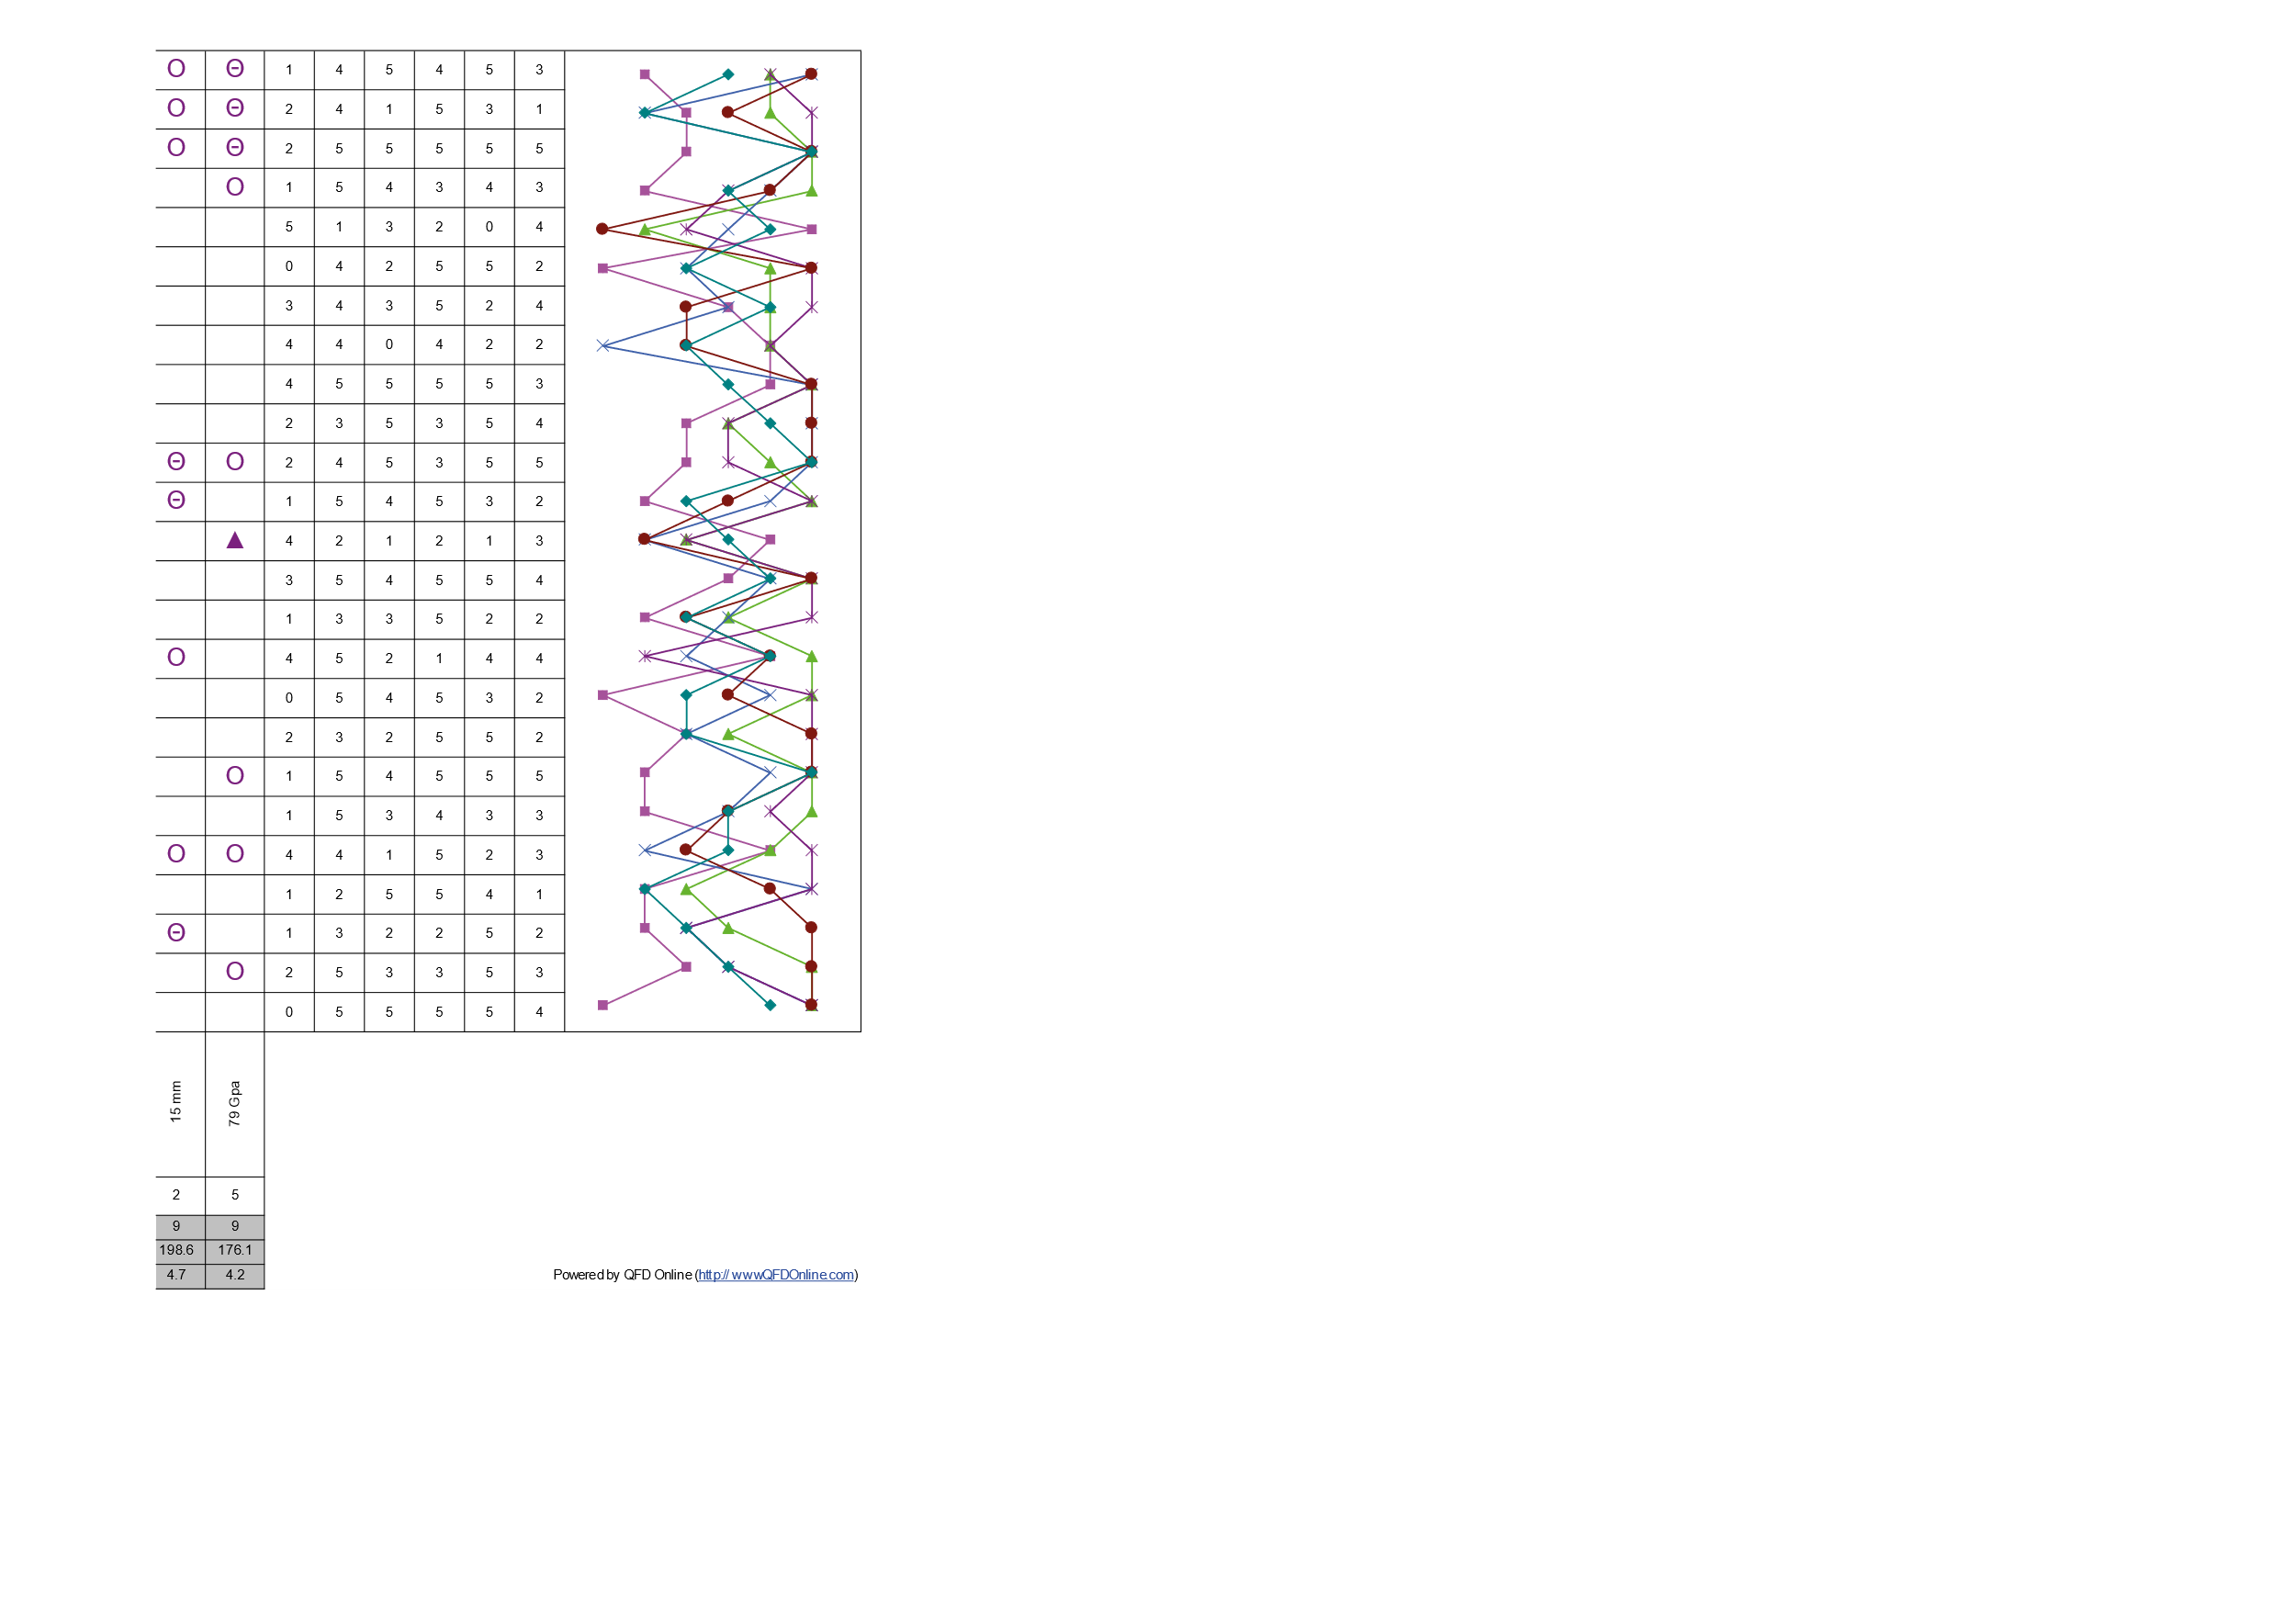
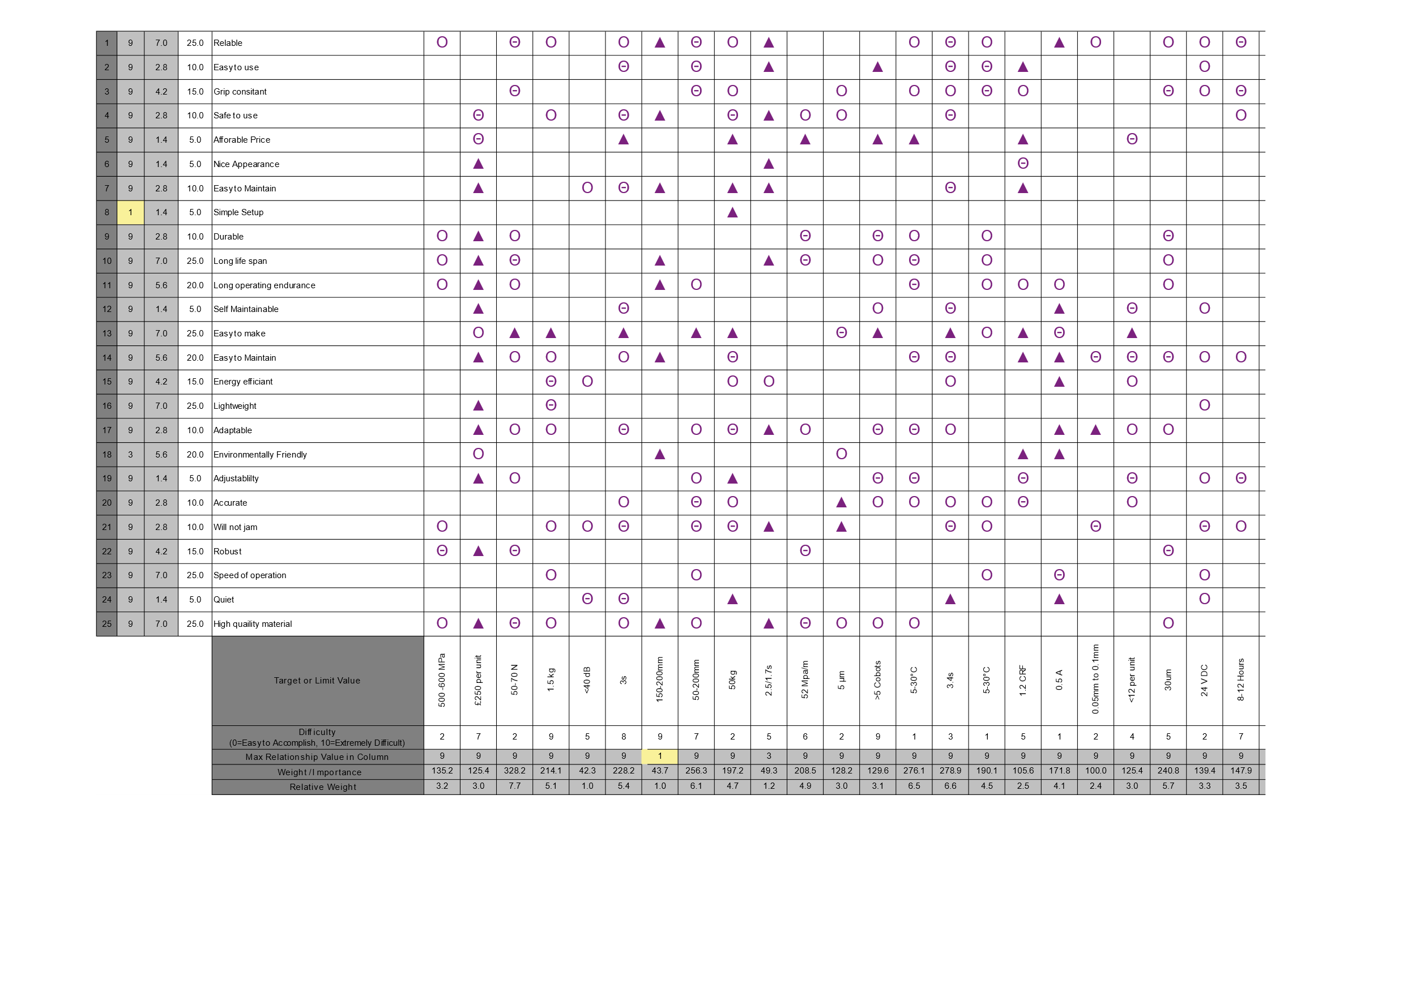
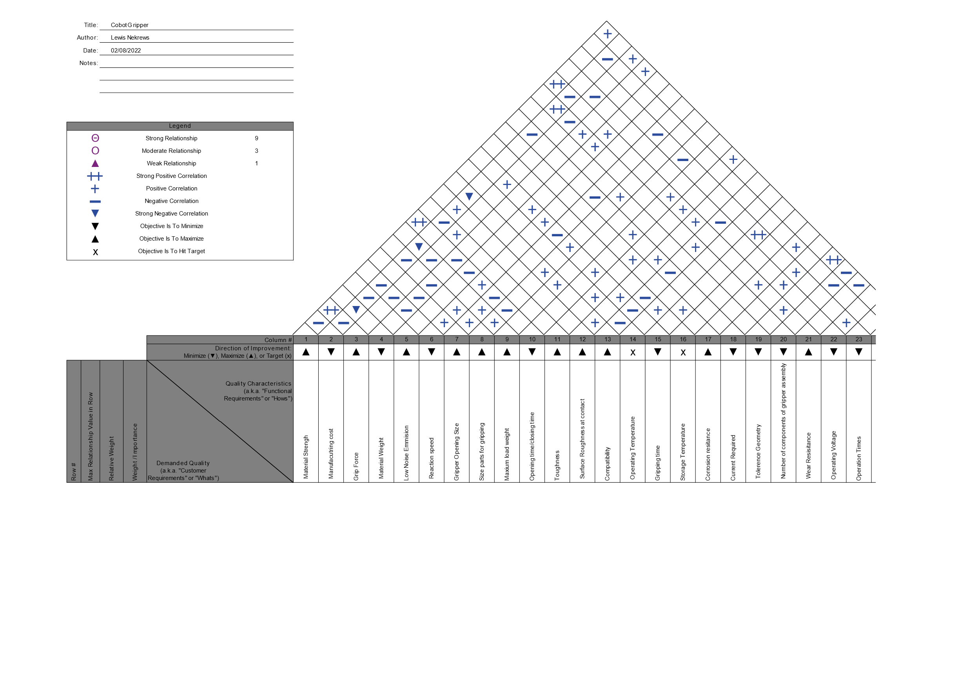
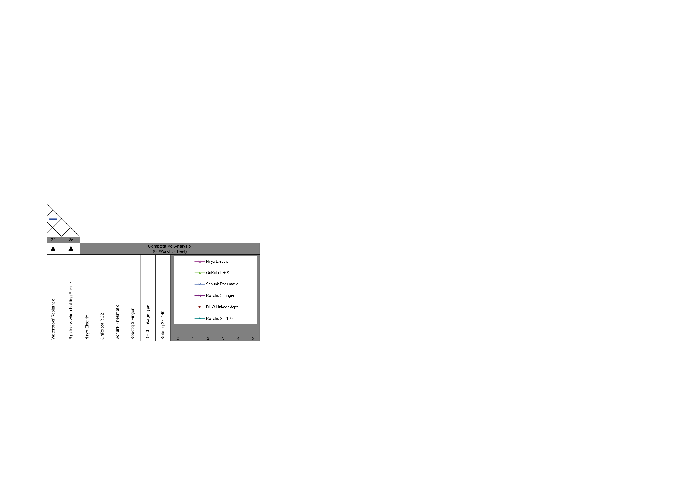
Figure 1 House Of Quality (QFDOnline,2022),RS, (2022, Wiredworkers, (2022), Schunk, (2022), Robotiq (2022), InRobots.shop(2022),

DFMEA
To understand the design of the gripper and its duty to the cyber physical production system.
Failure mod effective analysis was included for further evaluation of any potential issue that may have occurred during the operation sequence in the design. These assisted in anticipating any issues and created a design around what has been highlighted. It also increased the knowledge of any failures that may occur. The model helped identify any testing required regarding the failures mentioned and develop objectives to counteract them.
Suggested by Carlson, (2012), “the DFMEA should be a guide to the development of a complete set of actions that will reduce risk associated with the system, subsystem, and component or manufacturing / assembly process to an acceptable level”. This process demonstrated an improvement in reliability of the gripper and the cost in development. It also minimized the gripper’s failure to achieve targets in production and prevented any unnecessary maintenance.
Specifically the DFMEA was focused on the analysation and improvement of the new design. It helped identify design deficiencies and the interactions they had to the system. It improved the design process by studying the product functionality and by being critical towards quality attributes.
Prior to commencing analysis, it was suggested by Mikuliak, (2017) to set the grounds rules. This was especially important in certain area of the chart, including severity, occurrence and detection scores. These scores shown in Tables 1 to 3 will then implemented into the FMEA.
The assumption of the material consistency was noted. Another assumption made was that the programming of the Cobot arm was operating effectively when performing its operation.
After this was established then the block chart could then be created, this would effectively show the relationships between the different aspects of the designer’s gripper.
Providing the format in Figure 2, the DFMEA started with identifying the function of the gripper, which was considered one of its main purposes in the cycle. Similarly other primary gripper functions identified by the DFMEA were those of safety and reliability. Based on this analysis potential hazards or failures could have been highlighted and preventative measures and solutions explored. A major concern identified in the DFMEA is the gripper ability to hold the mobile phone securely when it is being transported. This would be considered when the final design is completed.

Table 1 Severity Score System

Table 2 Detection Score System
Table 3 Occurrence Score System

DFMEA Table
Figure 2 Design Failure Mode and Effects Analysis

Concept Designs
The initial design modelling was commenced on Solid works (2021), while referring to the previously completed models for guidance while drawing. The main objective when creating the concept designs was to create a selection of differing features and variations of Cobot gripper. Certain aspects of the design could then be used on another to create the final product.
When modelling the concepts, it was decided to avoid the modification of the dispatch station. The rationale behind this was because modifying the station permanently could have had a negative impact for future development of production processes if other products were later introduced. Modifying the station could also have damaged any future possible upgrades in gripper models, as technology advancement in robotics is progressing as explained by Gascovski (2020) who further suggested “ innovative ideas and novel hardware devises, together with some new programming techniques connected with artificial intelligence, are revolutionizing the concept of industrial automation and giving a new youth to the factory.
The concepts shown in Figure 4 to 5 did not all have the same capabilities in extracting and placing the product securely or have a high enough success rate suitable for mass production. These concepts were justified because when designing without experimenting with different characteristics, the problem will prove more difficult to resolve and solutions harder to find.
The analysis then assessed the concepts and how they performed the operation. Starting with design A, the operation intention was to program the Cobot to guide the two forks underneath the phone and then lift off dispatch. The side brackets were then activated to grasp the phone from the sides and the middle forks dropped to give clearance for the phone to be place on the robontio.
Design B chose a picking method for the front of the dispatch unit. It then moved the phone onto the robotino and the fingers slid away from underneath the phone. Design C used a similar process and were both electronically powered. In contrast to design B, design C had four fingers for more stability and was potentially more accurate.
Design D used a different approach to pick up the phone case to the other concepts. It picked from a vertical point instead, using a four finger grip against the phone. The rubber tips of the fingers were designed to push between two phones casings for greater stability.
Design E used two pincers to pick up the phone approaching from the front of the dispatch. Due to its lack of stability, the pneumatic force would be greater than the other concepts but placing the phone onto the robotitio could have proved problematic.
Figure 3 Design A, B & C
Figure 4 Design D & E

Final Design
As previously stated, one the goals in the design of the gripper was the minimizing of any non-essential components. This was taking into consideration when choosing the final design of the system and selecting a design with only linear form of movement may have been beneficial when manufacturing. As a result the final resulting design feature was similar to design E but with support forks attached to the middle bracket.
In Figure 4 the sequence of operation is shown. The concept in choosing this design was demonstrated as thus. The pneumatic air was activated and the centre forks were at full extension with the linear gripping jaws open. They then slid in between the phone and the platform using the Cobot arm. The Cobot arm then raised the phone case off the platform and the pneumatic air was released, closing the jaws of the gripper. The centre forks retracted while the main claw moved forward, the inner claw pushed the phone into the correct position and the outer claw griped the side of the phone. The Cobot moved the phone over the robotino platform and the gripper released onto it while stationed vertically above.
This process was chosen because of it only had one linear function and limited components required in the assembly as listed in Figure 6. It was also the most cost effective method of performing the operation and would require minimal training and setup. The drawing specifies each component listed in a bill of material with their quantities. It also described the weight of each component, this was important for the operation of the gripper to be effective otherwise if the gripper were too heavy, it would have been non-functioning. Universal robots, (2022) specification for the Cobot UR3 shows that the payload can be up to three kilograms, this would be sufficient as the bill of materials listed had only a maximum of zero point three kilo grams in total weight. It also gave the pneumatic gripper great gripping force to weight ratio. The specification also identified the repeatability Cobot UR3, which is zero point one plus or minus. This was ideal for the success of the operation.
The design was also more aesthetically pleasing that the concept, which has potential, added future sales value.

Final Design Procedure
Figure 5 Final Design Procedure
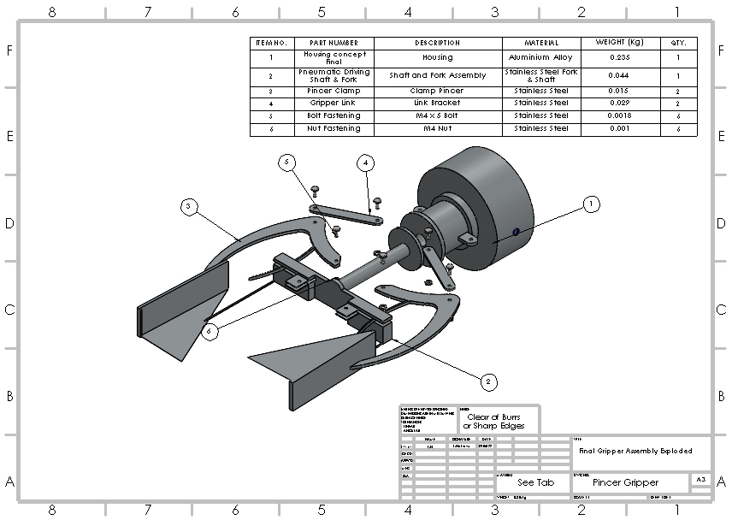
Figure 6 Exploded Drawing of Final Design
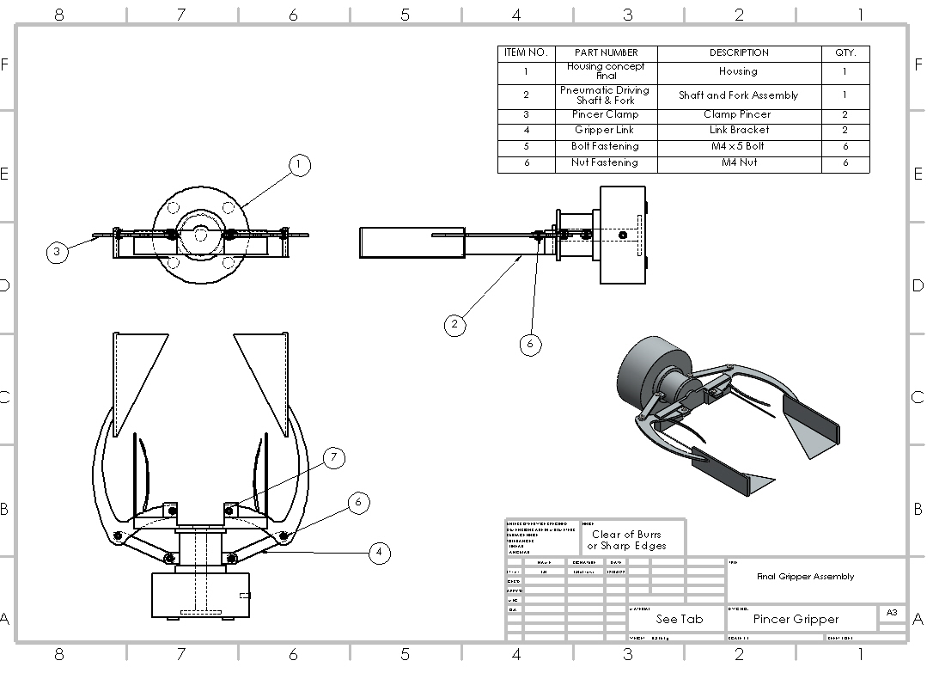
Figure 7 Final Design Assembly
The materials selected in the operation were mainly chosen for their weight and strength properties. Stainless steal was used for most of the gripper, apart from the housing unit, which is aluminium. Simulation of the loading was illustrated in solid works that shows where the most stress to the gripper is applied and the deflection points when in operation. The result show most of the stress was at the mid grip point of the assembly shown in Figure 8. The Equation 1 show how to work out the force required for the gripper when simulating. This is why it’s ideal to use a strong, durable material such as stainless to take the stressing forces in order to have a long product cycle life.

Table 4 Data for Stress Analysis
$$N X μF>W$$
$$2 X μF=mg x A$$
$$F=(mg x 4)/(2xμ)$$
$$F=Gripping Froce Required (N)$$
$$F=(0.3 x 9.81 x 4)/2x0.2)$$
$$F=29.43 N$$
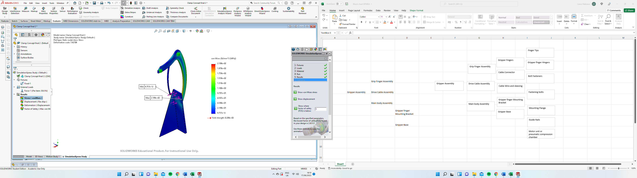
Equation 1 Force Required for Gripper(Automation, 2015)
Figure 8 Simulation of Gripper Finger

Conclusion
The main issues explored in the assignment tackled the problem given, in which the cycle physical production system required the creation of a mechanically actuated gripper. An important part of the gripper’s operation cycle was to enable it to transport an assembled mobile phone from the dispatch station to the autonomous guided vehicle. The main objectives of the project were to understand the limitation of a system and the manufacturing process, to improve an existing system and gain an increased knowledge of engineering design and manufacturing.
The expected outcome was to have a constructed analysis that would assist in the decision making process when designing a mechanical gripper and how to identify the key aspects of its functionality. The method of using quality functional development is to understand what the customer wants and transfer then into the technical goals and capabilities. Further study consisted of creating a design failure mode effects analysis chart. This was used to prevent any possible design failures when manufacturing the gripper arm and as these were identified at the beginning of the process, the customer is more likely to have an efficient product.
Also important was the creation of concept designs as these contributed to the decision of the final design by assessing their unique capabilities of performing the operation cycle. The final design was based on the concepts potential capabilities, simplicity to manufacture and install into the system.
In conclusion it could be argued that the project is important because with the correct research and gain in knowledge and manufacturing design techniques, the engineers experiences can progress into an industrial environment and implemented in other engineering problem situations.
The results showed that even with the challenge of creating a gripper for the system, that with the correct procedure and tooling, there could be a potential solution that would be effective in production.
Further recommendation would be to prototype the final design model using a three dimensional printer to prove the concept when put into an operation. The aiding of prototyping, as mentioned by Hallgrimsson, (2012), is beneficial for problem solving, idea exploration and user testing.

References
Kuhnle, H. (2017) Lecture Notes in Manufacturing Systems Design and Manufacturing Process Organisation. Cuvillier Verlag
Sharma, U (2022) Cyber-Physical Systems. Wiley
Wirtshaftsingenieurwesen, (2020), Robotino, [Online] https://wirt-ing.com/index.php/technisches-equipment/robotino, Accessed 2022, June, 05th
Monkman, G. (2007) Robot Grippers. Wiley.
Poli, C (2001) Design for Manufacturing.(2nd Edition). Elsevier Science.
Lu, C., Fuh, J. and Wong, Y. (2011) Collaborative Product Assembly Design and Assembly Planning. Elsevier Science
Terninko, J. (2018) Step-by-Step QFD. (2nd Edition). Taylor and Francis
Tague, N. R (2005),The Quality Toolbox (2nd Edition). ASQ Quality Press
Mikulak, R., McDermott, R. and Beauregard, M. (2017) The Basics of FMEA. (2nd Edition). Taylor and Francis
Carlson, C. (2012) Effective FMEAs. Wiley
Mikulak, R., McDermott, R. and Beauregard, M. (2017) The Basics of FMEA. (2nd Edition). Taylor and Francis
Solidworks (2021) Solidworks Student Edition Available at: https://www.solidworks.com/ (Accessed: 3rd June 2022).
Gascovsk, Z (2020) Mechatronics and Robotics. (2nd Edition), Arcler Press.
Universal Robotics (2022), Meet The CB3 Family, [Online] https://www.universal-robots.com/cb3/, Accessed 2022, May, 06th
Universal Robotics (2022), Technical Detail UR3, [Online] eng_199901_ur3_tech_spec_web_a4[5061].pdf, Accessed 2022, May, 06th
OnlineQFD (2022), House Of Quality [Online] http://www.qfdonline.com/archives/category/house-of-quality/ Accessed 2022, June, 17th
Automation Components (2015), Design Guidelines for Pneumatic Gripper [Online] Accessed 2022, June, 17th

RS (2022), Niryo Electric 2 Finger Large Gripper [Online] Accessed 2022, June, 3rd
Wiredworkers (2022), OnRobot RG2 Gripper [Online] Accessed 2022, June, 3rd
Schunk (2022), Schunk Pneumatic Gripper [Online] Accessed 2022, June, 3rd
Robotiq (2022), Robotiq 3 Finger Adaptive Robot Gripper [Online] Accessed 2022, June, 3rd
InRobots.shop (2022), DH- 3 Linkage- type Adaptive Gripper for DH-Robotics [Online] Accessed 2022, June, 3rd
Robotiq (2022), Robotiq 2F-140 Collaboratve Gripper [Online] Accessed 2022, June, 3rd

