MBA
Marketing Management
BMMB7012
Assignment 2
Steffan Treharne
Student number: 1705128

Table of Contents
Executive summary 3
Introduction 4
Main body 5
JD Marketing 5
Branding 5
Advertising 6
Promoting / place 6
Physical Environment 7
People 8
Product / Price 9
Ansoff Matrix 9
Market Penetration 10
Product development 11
Market Developments 11
Diversification 12
Conclusion 13
Recommendations 14
Referencing 15

Executive summary

Analysing how JD has responded to the pandemic and how the movement of consumers to online world through the use of the JD app and other innovations.

Introduction
This report will expand on the presentation that was created prior, which concentrates on consumer behaviour that has shifted over the past year because of Covid 19. As people have been sheltering from Covid, many factors such as travel, and shops that were not deemed essential such as clothing were forced to close. Due to the pandemic, there was a surge of digital consumption which dominates growth in 2021 such as the online retailer JD which this report is firmly based on. JD was created back in 1983 by John Wardle and David Maki according to jdplc.com (2021). JD is also part of the FTSE 100 and has experienced serious business revenue growth online since the pandemic according to JDPLC.com (2021) JD made £ 6,167.3 million at the end of 2020 financial year. This report will mainly focus on the development of social engagement through experiences to encourage customers to connect. Due to external environment issues, JD will need to look for ways of differentiating the customer experience to survive the pandemic, it will include producing new products and services, creating opportunities to improve the market position of the company. This report will aim to produce a new innovating customer care programme which correlates to enhancing the overall experience, this will as be mentioned augmenting JD’s market position, perception and future sustainability. This report will focus on two main points which are how JD market to their customers but also how they implement the customer journey online and in shops.

Main body

JD Marketing
During the pandemic where many retail giants such as Debenhams, Top Shop have closed, one of many reasons for this, is the company’s presence online and how they market the company. When looking at other giants within the industry, JD have managed not only survive the pandemic but managed to surpass the expectation revenue that was expected for 2020. According to marketingweek.com (2021) JD was expected to bring in an estimated £295 million but actually had a revenue income of £421 million. The article mentioned one of many reasons for this was that JD managed to keep around 70% of the consumers by transferring them from face-to-face shopping to a new online platform created through innovative digital marketing. K. Swani. Et Al. (2014) explains that innovative digital marketing is essential to businesses as it offers faster and more convenient options for consumers to purchase products. Kim. (2021) expands by suggesting that as technology advances, digital marketing will become essential part of a B2B ( Business 2 Business) and B2C ( Business 2 Consumer) marketing strategy.

Branding
There are many ways that digital innovation can meet the targeted audience such as B2C strategy, this would include branding as a key component as mentioned by the CEO of JD. According to internetretailing.net (2021) the CEO of JD Peter Cowgill explains that the close partnership JD has with its brands, they share an elevated marketplace which is built on collaborations on an international level. In turn this would create a bond with consumers through a combination of stores and online presence which in itself is branding the company. JD also creates brand awareness through many avenues such as sport events, collaborations with sporting celebrities and teams, Ries et al (1998) explains that JD is getting brand awareness by sponsorship and getting noticed, by sponsorship through teams such as Cardiff football and Leeds according to insideworldfootball.com (2020). According to Henderson and Cote, (1998) brand logo and name are used to cut through clutter by being simplistic and therefore able to grab the attention of consumers more easily. JD’s way of branding begins with its logo, the logo is very simplistic and is very well known just by using simple shapes such as a circle and lettering with a mixture of simplistic colours which are white and black. Henderson and Cote, (1998) explain that by JD creating their logo as mentioned previously they are building an image with consumers but also stakeholders by distinguish themselves from competitors such as Sports Direct.

Advertising
Another innovative strategy JD could use is, marketing with advertising techniques with the use of the 7ps of marketing created by Booms & Bitner, (1981). As previously mentioned in the presentation the average JD consumer is in the age bracket of early teens all the way to early 20’s, these are the typical age range for JD. JD overall as mentioned in the presentation are attracting these consumers by locating the stores in by the highest density of the demographical age but due to the pandemic this was not possible, so JD had to become creative an innovative solution.

Promoting / place

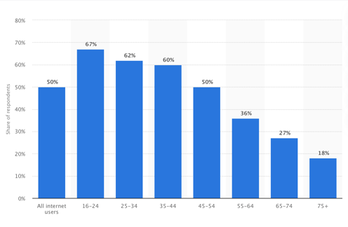
One of JD’s solutions were to look at innovating their presence on an online platform. JD’s targeted demographic age group typically uses internet and Apps more than any other demographic age. According to statista.com (2020) the graph on the left shows that the two demographical age groups use apps and social media the most in 2020. One of the best ways to promote would be the use of a current social media app such as Tik Tok. JD has looked at the latest trends and have also realised that social media apps would be a great way of promoting the company during the pandemic, especially through the use of Tik Tok and their own app to purchase clothing. According to digitalmarketing.org (2020) social media has become one of if not the most influential ways of marketing a business online. This is down to the way it digitally advertises the brand and products.
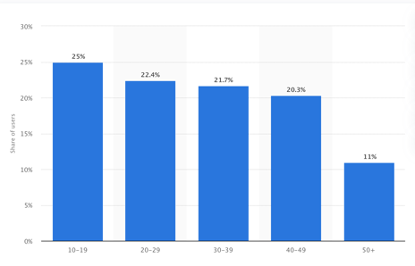
According to statista.com (2021) in the graph shown the demographic age for Tik Tok is the average age of JD’s consumers, these two demographics cover 47.4% of the overall Tik Tok usage. This also means that there’s a possibility of new demographics to target. digitalmarketing.org (2020) explains that social media’s power is commendable as it can not only reach a high amount of people, but it can also attract new potential consumers through the use of social media ads.

Physical Environment

With stores slowly reopening when writing this report, the safety of the physical environment is essential, with introduction of one-way systems, masks and anti - bacterial to JD’s stores as mandatory. Stores will become at a glance even more simplistic with a one - way system. according to insider-trends.com (2020) the one – way system in stores not only innovate store overall space design, but it will also use signage to help consumers navigate through the store whilst drawing the consumers in which in theory encourages them to spend more. The Physical environment will also have several consumer touchpoints to make the overall experience safer and better, touchpoints according to interaction-design.org (2020) are an interaction that might alter the customers experience which impacts the overall response to the company and its products and services. For JD this could be face to face in store or online experience, both online and in person for JD has been made as simple but as affective as possible and this has been shown from the revenue increase as stated in the report previously. JD can look at possible improvements to relate to new possible consumer segmentation groups and touch points could help this. According to McKinsey.com (2016) explains that touchpoints can be altered and increase experiences with such things as:

- Identify consumers journeys
- Consumers needs, expectation and desires. Links to Maslow’s hierarchy
- Understand what is working and what’s not.
- Look for opportunities to improve overall end to end experience.

People
This section does not only look at consumers but how staff and service they provide and how they interact with the consumers. One of JD’s key components to their staff is their knowledge on products, according to business.qld.gov.au (2017) explain that product knowledge is essential, by understanding the products that are offered from JD as a staff member customers respond and will be more eager to buy. This section also looks at customer service, JD offer various types of customer service such as face to face, live chat online and via app and social media this is vital not only for the business but also for the overall experience for the consumer. The type of customer service recently created not only by the pandemic but also the power of customers which links to Porter M.E. (1989) and the five forces, where consumers want easier way of interaction with customer service for conveniency and can also be linked to Maslow’s hierarchy as this creates a need and want dilemma. According to Fathollahzadeh et al. (2011) providing an excellent customer service will create customer satisfaction and have good effects on revenue for JD, Islam, Majidul et al., (2013). Explains further by saying that essential part of JD’s business is to manage customer service / satisfaction this will then create loyal customers, and this is why JD employ staff the same age as their main consumer demographics as they will be more interested in latest trends and have common interests. The effects of loyal customers linked with promoting new limited stock could persuade new consumers to buy products from JD according to Yang, Y.F. Et al. (2012).

Product / Price

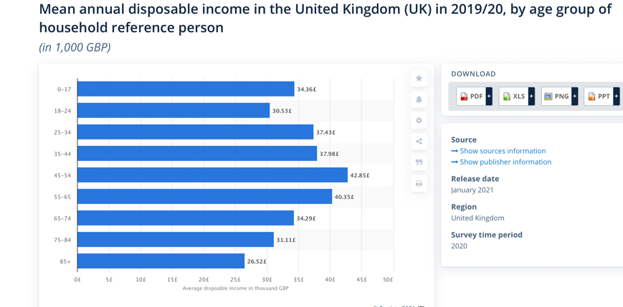
Product and price are the two main focuses of JD as they are aware that having sellable products with good prices will generate more overall revenue. With this in mind the best way to look at this would be to create a Ansoff matrix which looks at more in-depth possibilities. When Looking at both price and product JD’s average consumer, according to Statista.com (2021) JD’s targeted consumer has the lowest amount of disposable income per £1000 in the UK. Since the pandemic JD has old stock from 2020 which can be sold to consumers for a lower price. These products are still on trend due to the surge of casual ware which in turn links to Pichère, P. Et al (2015) and Maslow's hierarchy of needs. This links to Maslow, because prior to pandemic consumers needs and wants were as before but since the pandemic many consumers can now afford trends because of the movement of trend and the amount of stock available.

Ansoff Matrix

Ansoff’s matrix according to Timbrell (2019) was create by Harry Igor Ansoff who created the matrix as a tool that would help businesses like JD to visualise the products they offer and create a strategy for future growth. The matrix gives four possible routes that can create growth but with growth comes possible risks than increase.

 | Existing products | New Products
Existing Markets | Market penetration  - Adjust pricing  - Further investment into marketing.  - Updating stock  - Brand partnerships | Product development  - New products  - New partnerships
New Markets | Market development  - new demographics / segmentations  - expansion | Diversification  - producing own clothing.  - Producing own footwear and accessories

Market Penetration

JD offer a variety of products through a variation of platforms and also face to face, since the pandemic JD have not been able to sell current stock from the start of the pandemic, this means that many products are out of date in regard to fashion and trends and would need to be updated. There are two types of penetration which are slow and quick, the difference between both is down to marketing costs for items according to Ali AlJazzazen. S. (2019). Slow penetration according to Investopedia.com (2020) is that it will attract more customers to the new product by offering a lower price, this will help the product penetrate the market and potentially attract new consumers from its competitors such as Sports Direct which is linked to porters five forces.

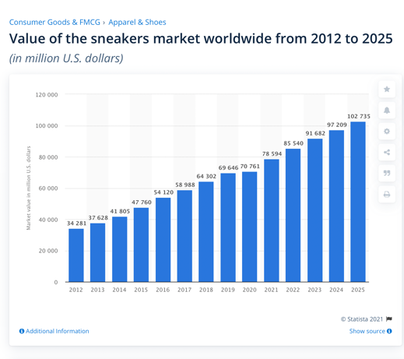
Product development
This links to Porter M.E. (1989) Porter’s five forces with bargaining powers of consumers which demands the latest trends with trends being more casual clothing as more people are spending more time at home. This also links to Pichère, P. Et al (2015). Maslow's hierarchy of needs with consumers want the latest fashion trends which in this case is casual clothing but casual clothing that has a higher end market. Products that JD could look to is the shoe industry as that’s what they specialise in. when you look at stats from statista.com (2021) for the value of the shoe industry worldwide its due to nearly triple by 2025 with an estimation of $102,735 million compared to 2012 with a value of $34,281 million. This is down to new type of consumer which are trainer collectors which make up most of this segmentation as they will purchase limited edition shoes from top brands such as Dior and Balenciaga, this leads to a new type of consumer demographic and segment for JD but also new partnerships for JD overall.

Market Developments
According to McKinsey.com (2021) the pandemic has forced a demand of change in the fashion industry by what people are wearing and JD’s product mix fits in perfect with the change that has happened which is people wearing more casual clothing. Mix the products with a slow price penetration for the stock which in turn puts the products on sale this will free up more room in warehouses for new trending stock. This is where JD can offer stock that will be quick penetration and hit new segmentation with limited edition stock such as, high end shoes and clothing which attracts a type of consumer that has a passion on such items as this, which is mentioned previously in product development. New demographics and segmentations should be looked at by JD, with their current demographics being between early teen up to 25 there are opportunities which JD are missing straight away. When looking at the bottom end of the demographics which are children, JD are missing out selling to the parents by not attracting them as possible consumers. According to Wells. J (2017) Marketers identify families as important consumers and to engage with them. Companies need to be more aware of the involvement of purchase by being empathetic and infuse JD’s brand into family life, by the use of marketing technology that can personalise the experience for all members which creates a diverse brand and brand strength, this will create a family connection through product and service created by JD.

Diversification

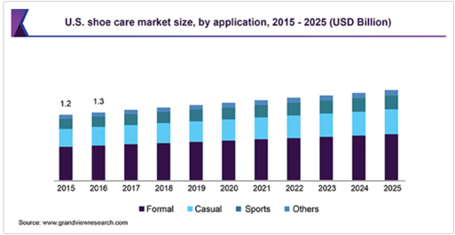
In Ansoff’s matrix JD could look at diversification through possibly producing basic own clothing and producing basic footwear and Accessories. According to Farber. D. (2019) private label products which are referred to a store brand are important as it will counter act the death of retail because the value of a company’s own brand cannot be overstated. This can be linked to Porter M.E. (1989) and the five forces and the buying power of consumers as consumers will dictate cheaper prices and in turn link to Maslow’s hierarchy. One company JD could look at either collaborating with or taking inspiration from is Boohoo which has many of its own designs which are cheaper than many other designer products available. Another possible way of diversification would be selling JD branded footwear accessories such as cleaning products, socks and laces. Looking at figures in the chart created by grandviewresearch.com (2019) the market for accessories is increasing especially for cleaning products this could help JD expand into a new market to diversify the company which will also attract new consumer segmentation.

Conclusion

To conclude this report has found that overall JD’s response to the pandemic through engagement online with consumers and the overall movement to online services has been a success through the business point of view. Through analysing concerns of possible issues from the pandemic, JD’s revenue even through the pandemic has been a success story. JD has adapted to the pandemic by cleverly targeting their age demographics through the use of online such as, Tik Tok and the creation of the JD app. The main concern for JD is attraction of new consumers for the future as mentioned in the report by Ansoff’s matrix and figures from statista.com (2021), shows their consumers have the least amount of disposable income. For the business to thrive JD would need to look at the possibility of targeting new segmentation demographics, possibly producing some of their own brand products and target to niche markets.

Recommendations

- First recommendation would be to introducing new JD own branded products, according to Teece. Et al (1997) that an introduction to own branded products would be down to dynamic capabilities which correlates to JD renewing its self-due to ever changing environment. According to Teece (1997) also mentions that companies such as JD have the dynamic capabilities to thrive by offering own branded products. From this JD will be able to generate more revenue as it would be reach out to more of its targeted audience and new segmentations with a lower income.

- Second recommendation would be for JD to look at a niche market as mentioned in the report as trainer collectors, targeting this niche market would mean JD investing in collaborations with the companies such as Yeezy, Balenciaga and Dior. According to Cloonan, M. (2018) niche markets can be profitable if the right niche market has been chosen, JD need to make sure that the demand of the products are there which will make JD be a more sustainable and a profitable business. fashionista.com (2019) explain that the niche market will be worth £95.14 billion by 2025 this is purely down to millennials with smartphones this links to JD’s move to online through the use of the JD app. JD would need to compete with companies such as Stock X to sell these new limited trainers as popularity with the culture of niche markets is increasing and now is generating private income for so many people within the age demographic JD is selling to and the possibilities of selling to older demographics with more disposable income.

- The third recommendation would to be target new consumer demographics which links to the first two recommendations but also it correlates to new possible segmentation which would be families. As previously mentioned in the report families could be a big segment as they play a big part of the overall revenue to any business. According to ONS.gov.uk (2020) families spend on average £24.50 a week which means in a year could be up to £1,274 on clothing and footwear. This would mean that JD would need to adapt its business with such things as touchpoints available and make them more family friendly and also make changes to how they market the business, so it meets the demands of the average family.

Referencing

- Booms & Bitner, (1981). Marketing strategies and organization structure for service firms. In J. H. Donnelly & W. R. George (Eds), Marketing of Services, Conference Proceedings. (pp.47-52). Chicago: American Marketing Association.
- business.qld.gov.au (2017). Knowing your products and services. https://www.business.qld.gov.au/running-business/marketing-sales/sales/skills/know-product
- CLOONAN, M. (2018). Why niche offerings are a good idea. Accountancy Ireland, 50(3), pp. 42-43.
- digitalmarketing.org (2020). The Importance Of Social Media Marketing. https://www.digitalmarketing.org/blog/the-importance-of-social-media-marketing
- Farber. D. (2019). Why Private Label Products Will Be the Savior of Retail. https://medium.com/new-markets-insights/why-private-label-products-will-be-the-savior-of-retail-a47e217a93f2
- fashionista.com (2019). EXPERTS PREDICT THE FUTURE OF THE SNEAKER INDUSTRY'S EXPONENTIAL EVOLUTION. https://fashionista.com/2019/03/sneaker-industry-market-trends-2019
- Fathollahzadeh, M., Hashemi, A. and M.S. Kahreh (2011) “Designing a New Model for Determining Customer Value Satisfaction and Loyalty Towards Banking Sector of Iran”, European Journal of Economics, Finance and Administrative Sciences, Vol. 28, pp. 126–138.
- grandviewresearch.com (2019). Shoe Care Market Size, Share & Trends Analysis Report By Product (Polish, Cleaning), By Application (Formal, Casual), By Distribution Channel, By Region, And Segment Forecasts, 2019 – 2025. https://www.grandviewresearch.com/industry-analysis/shoe-care-market
- Henderson and Cote, (1998). Guidelines for selecting or modifying logos. pp. 14-30
- insideworldfootball.com (2020). JD Sports takes Leeds United sleeve patch in one season sponsorship. http://www.insideworldfootball.com/2020/08/26/jd-sports-takes-leeds-united-sleeve-patch-one-season-sponsorship/
- interaction-design.org (2020). Customer Touchpoints - The Point of Interaction Between Brands, Businesses, Products and Customers. https://www.interaction-design.org/literature/article/customer-touchpoints-the-point-of-interaction-between-brands-businesses-products-and-customers
- internetretailing.net (2021). JD Sports says multichannel gave it a competitive advantage in a year of unprecedented challenges. https://internetretailing.net/strategy-and-innovation/strategy-and-innovation/jd-sports-says-multichannel-gave-it-a-competitive-advantage-in-a-year-of-unprecedented-challenges-23005
- Investopedia.com (2020). Penetration Pricing. https://www.investopedia.com/terms/p/penetration-pricing.asp
- Islam, Majidul et al., (2013). Marketing mix, service quality and loyalty - in perspective of customer-centric view of balanced scorecard approach. Accounting, accountability & performance, 18(1), pp.1–17.
- JDPLC.com (2021). Financial statements. https://files.jdplc.com/pdf/reports/annual-report-2021.pdf
- JDPLC.com (2021). Our group. https://www.jdplc.com/our-group
- K. Swani, B.P. Brown and G.R. Milne (2014). Industrial Marketing Management, 43 (5) (2014), pp. 873-881
- Kim, Kyung Hoon & Moon, Hakil, (2021). Innovative digital marketing management in B2B markets. Industrial marketing management, 95, pp.1–4.
- marketingweek.com (2021). JD Sports praises ‘deep bond’ with customers following successful ecommerce transition. https://www.marketingweek.com/jd-sports-deep-bond-customers-ecommerce-transition/
- McKinsey.com (2016). From touchpoints to journeys: Seeing the world as customers. https://www.mckinsey.com/business-functions/marketing-and-sales/our-insights/from-touchpoints-to-journeys-seeing-the-world-as-customers-do
- McKinsey.com (2021). A transformative year in the technology, trends, and tastes in fashion. https://www.mckinsey.com/industries/retail/our-insights/the-postpandemic-state-of-fashion
- Nicola Timbrell ; Chris Jennings ; Adrian Bullock, (2019). Ansoff Matrix. A Dictionary of Publishing, pp.A Dictionary of Publishing, 2019–03-21.
- ONS.gov.uk (2020). Family spending in the UK: April 2018 to March 2019. https://www.ons.gov.uk/peoplepopulationandcommunity/personalandhouseholdfinances/expenditure/bulletins/familyspendingintheuk/april2018tomarch2019
- Pichère, P., Cadiat, A.-C. & Probert, C., (2015). Maslow's hierarchy of needs.
- Porter M.E. (1989) How Competitive Forces Shape Strategy
- Ries, A. & Ries, L. (1998) The 22 Immutable Laws of Branding. First Ed. Published by: Harper Business.
- Sahoum Ali AlJazzazen, (2019). New Product Pricing Strategy: Skimming Vs. Penetration. Proceedings of FIKUSZ Symposium for Young Researchers, pp.1–9.
- statista.com (2020). Looking at social media sites or apps in the prior week in the UK 2020, by age group. https://www.statista.com/statistics/506329/looking-at-social-media-sites-or-apps-in-the-united-kingdom-uk-by-age-group/
- statista.com (2021). Distribution of TikTok users in the United States as of March 2021, by age group. https://www.statista.com/statistics/1095186/tiktok-us-users-age/
- statista.com (2021). Global sneakers market revenue from 2012 to 2025. https://www.statista.com/statistics/1017918/sneakers-market-value-forecast-worldwide/
- Teece. Et al (1997). Teece DJ, Pisano G, Shuen A. 1997. Dynamic capabili- ties and strategic management. Strategic Management Journal 18(7): 509–533.
- Wells. J (2017). Make your marketing matter to families. https://www.mycustomer.com/community/blogs/johnwells/make-your-marketing-matter-to-families
- Yang, Y.F. and M. Islam (2012) “The Influence of Transformational Leadership on Job Satisfaction: The Balanced Scorecard Perspective”, Journal of Accounting & Organizational Change, Vol. 8, No. 3, pp. 386–402.

